InClass 12 – Firebase Product App
ISCO 12 – Mobile App Development
Wilder Edwards | Nov 3, 2026 | Android Emulator (Medium Phone, API 36)
Flutter 3.47.8 / Dart 3.13.7 / cloud_firestore 7.1.0

1. What I built
A one-screen Flutter app that keeps products in Cloud Firestore. It has a search box, a min/max price filter, a list of cards, and a + button that opens a create form. Each card has edit and delete icons. Each card shows the name, the price, and the document ID.
- Collection: products (name string, price number)
- Create and update through a validated bottom sheet
- Delete from the card, with a snackbar showing the deleted ID
- Search is case-insensitive substring on the name
- Price filter is inclusive and stacks with the search
- Live data from collection.snapshots() through StreamBuilder

2. Test evidence
All of this ran on the emulator against the real project my-product-app-d03af.

T1 – Create and read back
I tapped +, typed Pumpkin Spice Loaf and 9.99, then saved. The sheet closed itself. The new card appeared with no refresh. The ID GDHkc9tNeHqX9AJc4BsM came from Firestore.
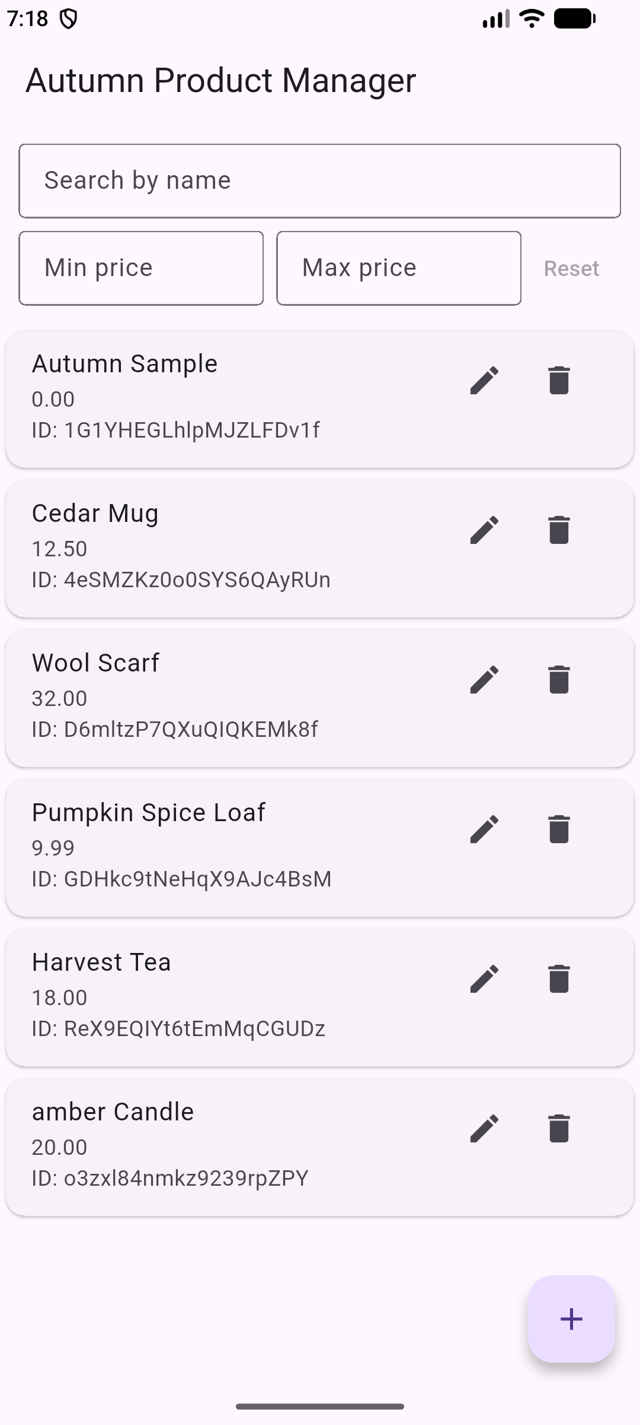
Fig 1 – New product 9.99 with its generated ID.

T2 – Live update
The app was sitting on the list. I changed Cedar Mug from 12.50 to 14.75 by calling the Firestore REST API. That is the same as editing the doc in the console. The card changed within a couple seconds. I never touched the phone.
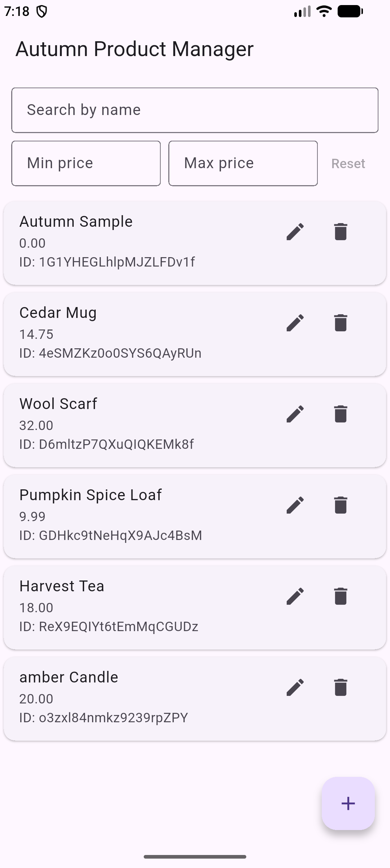
Fig 2 – Cedar Mug now 14.75, same doc ID.

T3 – Edit, duplicate name, delete
The edit sheet opened pre-filled. I changed the price to 15.00 and saved. Then I added a second Cedar Mug at 30.00. Both showed up with different IDs, since the ID is the key, not the name. I deleted the 30.00 one. The snackbar named its ID and the 15.00 one stayed.
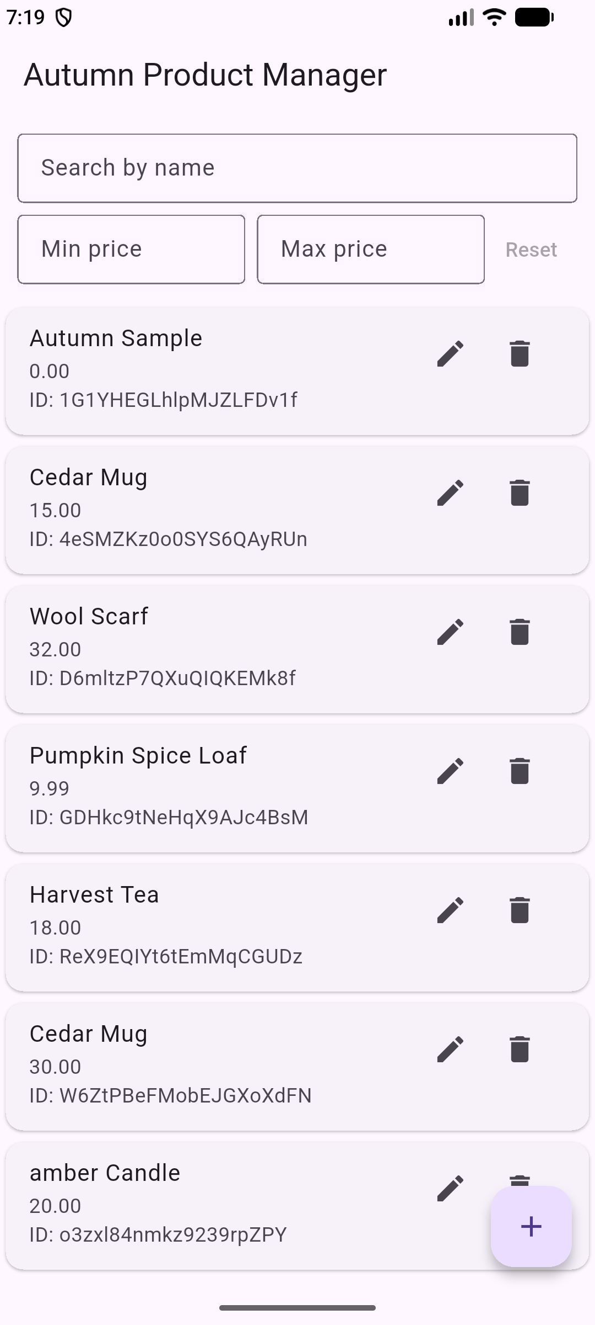
Fig 3 – Two Cedar Mugs, different IDs.
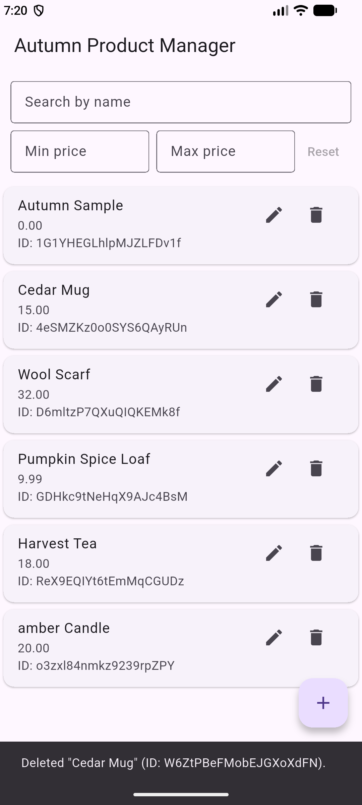
Fig 4 – Delete snackbar names the removed ID.

T4 – Search
Lowercase cedar returned Cedar Mug, so the match ignores case. A name that does not exist gives the empty state, not a blank screen.
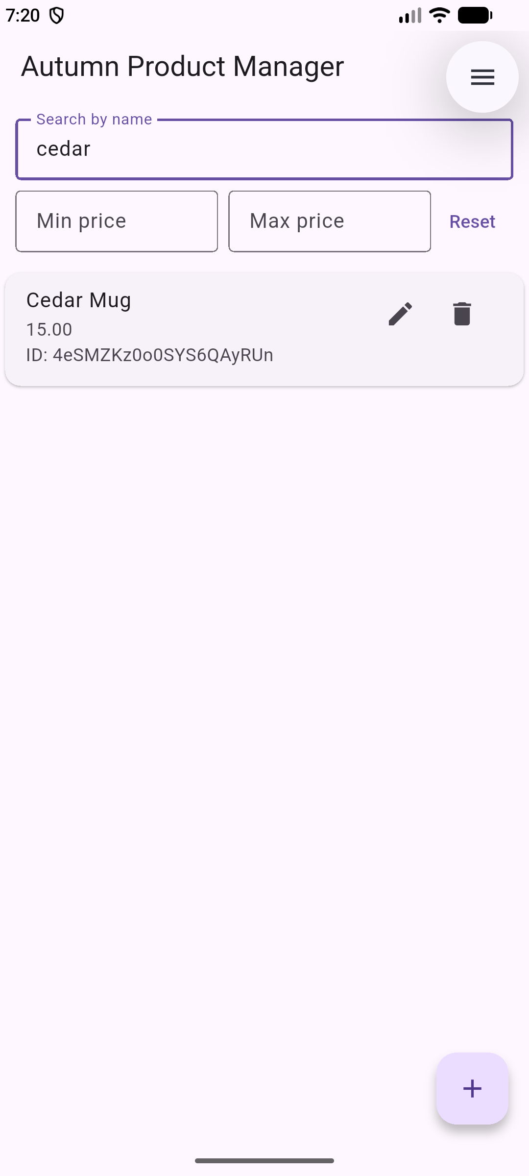
Fig 5 – Lowercase search matches.

T5 – Price range and combo
Min 12.50 and max 20 gave Cedar Mug, Harvest Tea, and amber Candle. The 20.00 item stayed, so the max bound is inclusive. Autumn Sample, Pumpkin Spice Loaf, and Wool Scarf dropped out. Then I added harvest on top and only Harvest Tea was left.
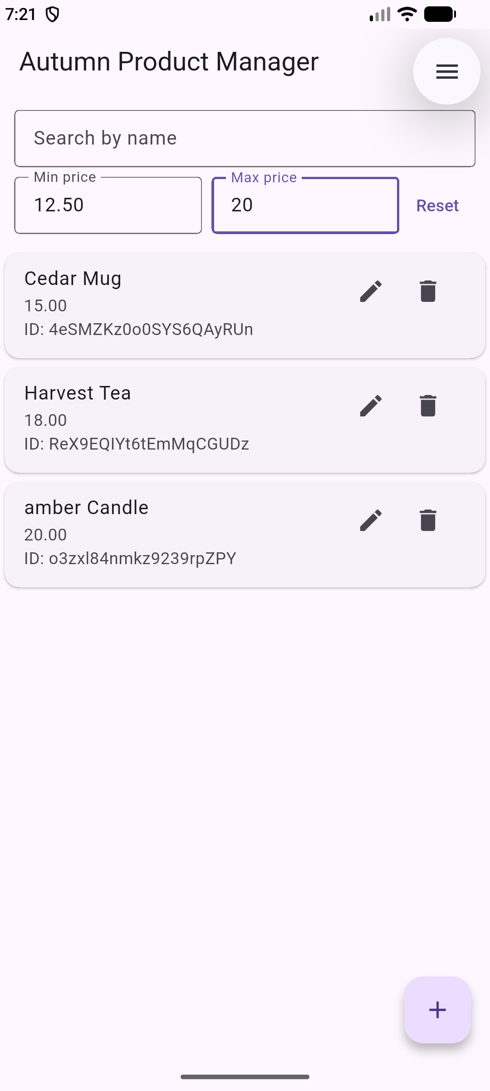
Fig 6 – 12.50 to 20 inclusive.
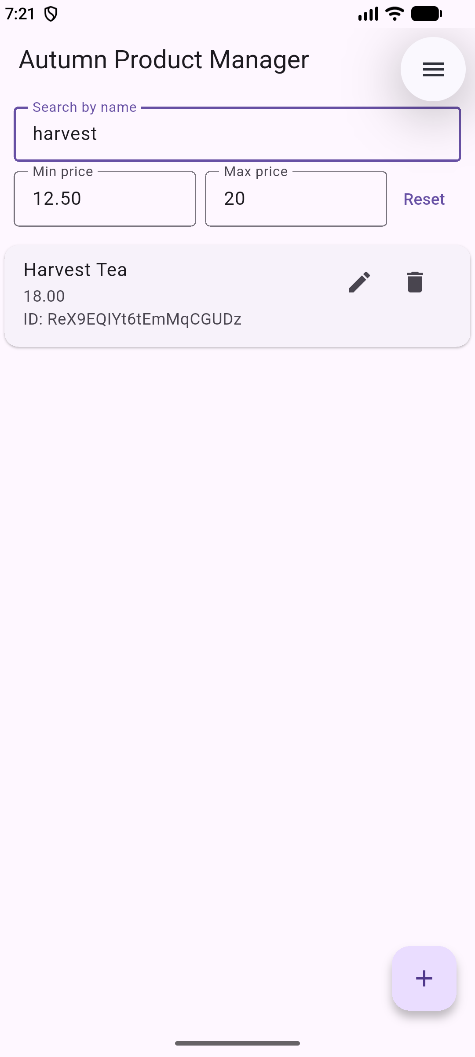
Fig 7 – Same range plus harvest.

T6 – Invalid input
Min 30 with max 20 shows a red error and hides the list. Typing abc says the min must be a number. Saving an empty form blocks the write and marks both fields.
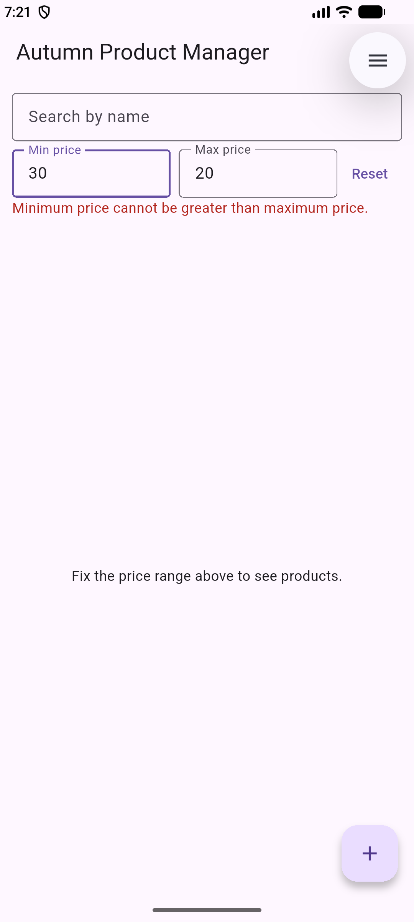
Fig 8 – Min greater than max.
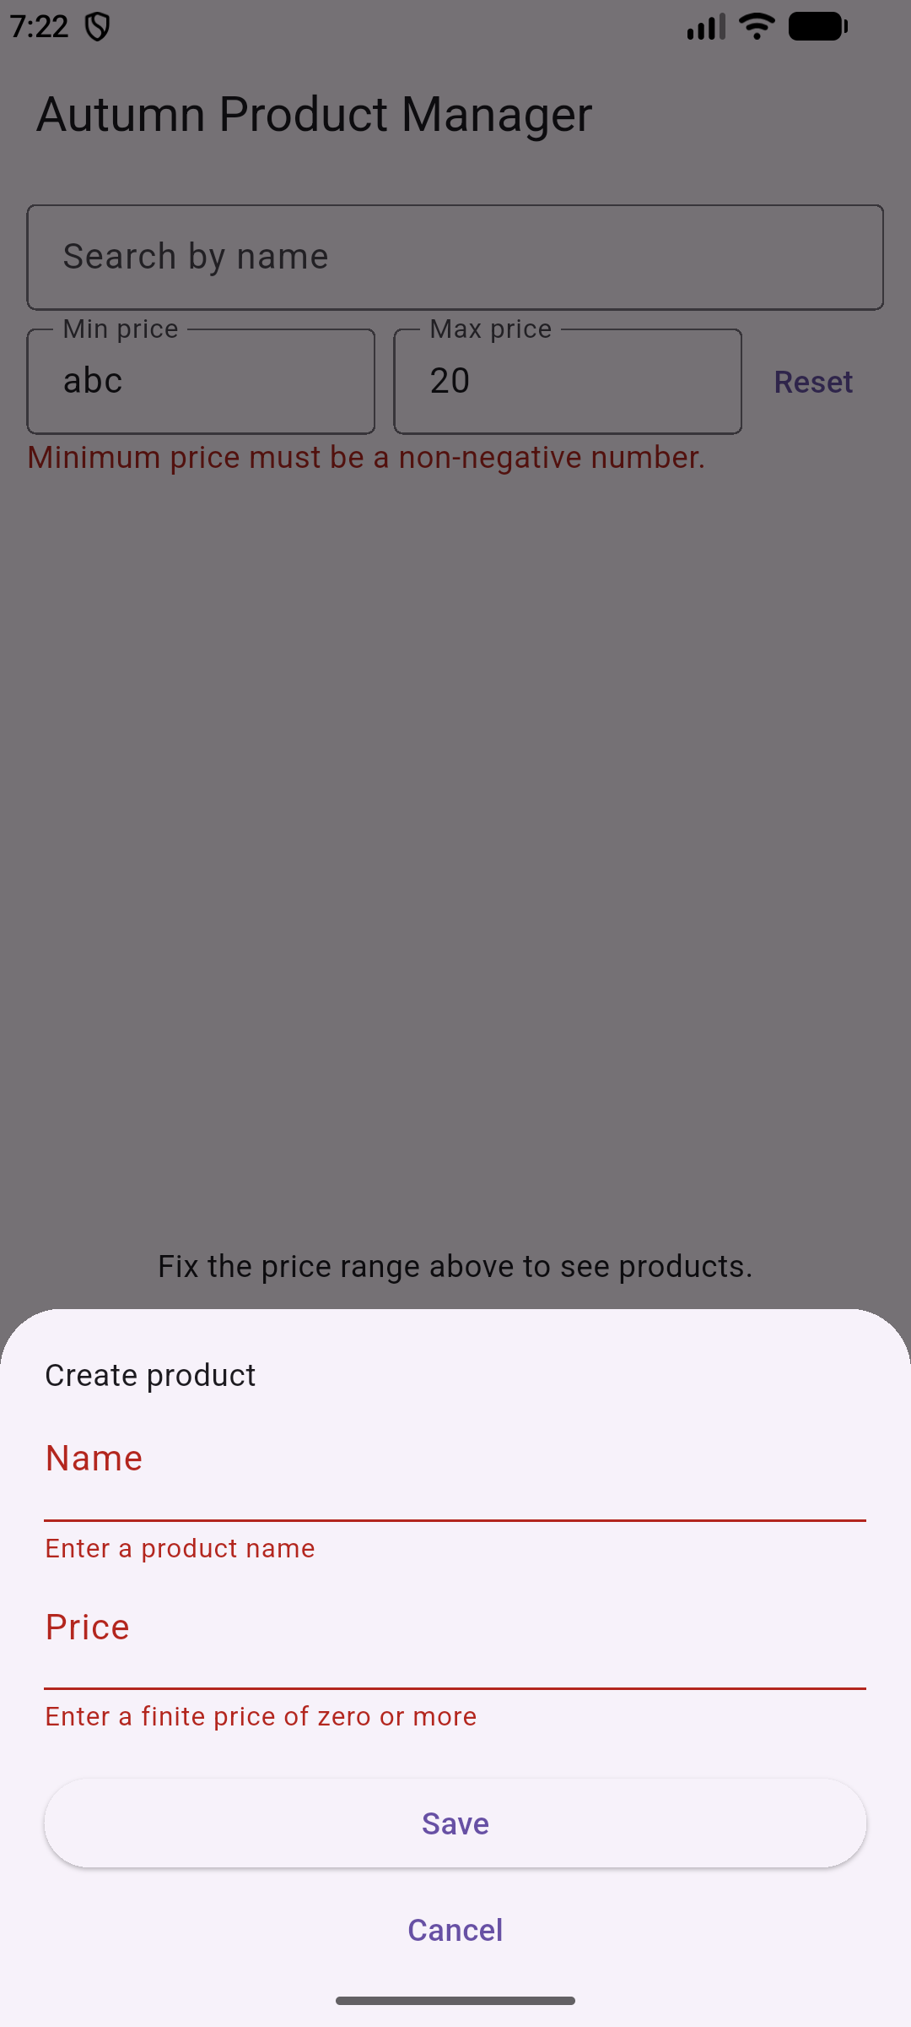
Fig 9 – Empty form blocked.

T7 – Offline
I turned on airplane mode, force-stopped the app, and opened it again. It sat on the splash and never drew the list. The cache is there and persistence is on by default, but Firebase.initializeApp() does not return on a cold start without network here. So the app never got far enough to read the cache. Writes made offline would queue and sync later.
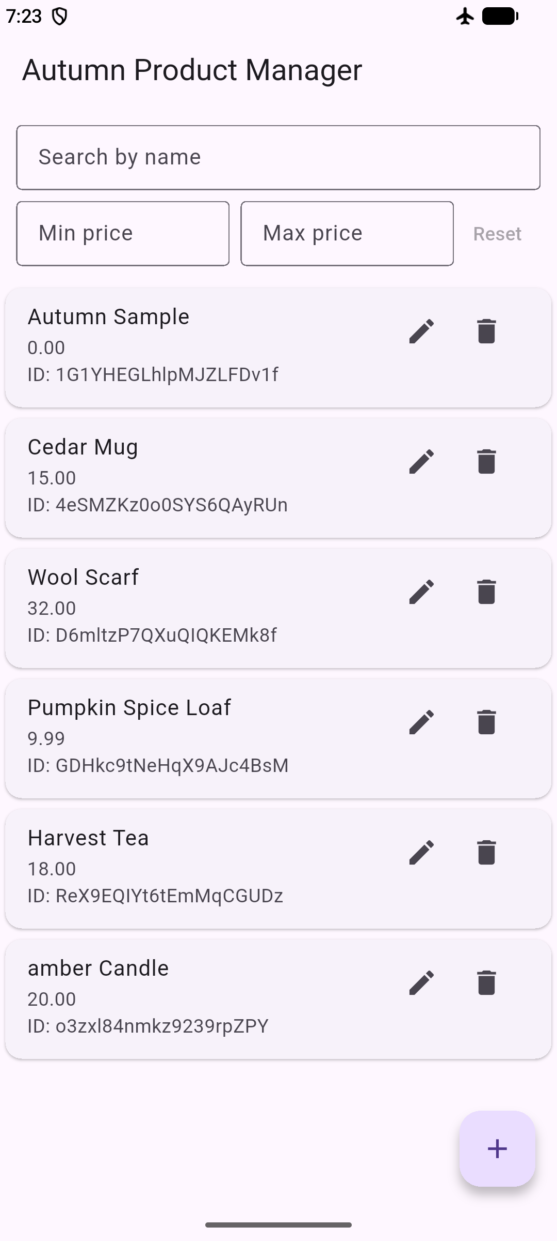
Fig 10 – Airplane mode cold start, stuck on splash.

T8 – Access failure
I cleared the app data so there was no cache. Same result as T7, it stayed on the splash. The error branch in _buildList is what handles a denied read. It shows 'Products could not load. Check connection and permissions.' I did not deploy deny rules to the live project, so this one is checked in code, not observed.

Fig 11 – No cache, no network, splash again.

3. Answers

Q1 – Initialization order
Firebase.initializeApp() uses a platform channel. Channels only work after the Flutter binding exists. That is why ensureInitialized() comes first. Skip it and you get an error about the binding not being initialized, and the app dies on the splash.

Q2 – StreamBuilder vs FutureBuilder
I used StreamBuilder on snapshots(). A FutureBuilder holds one value and stops. It would not see a price change unless I rebuilt the future by hand. The stream pushes a new snapshot on every change, which is why T2 updated untouched. The cost is one open listener while the screen lives.

Q3 – NoSQL vs SQL
Firestore is a document store. There is no fixed schema and no tables. Each document is a JSON-like map, and two docs in one collection can have different fields. SQL has a defined schema and joins. Here you nest or duplicate data and pay with extra reads. My name field is a plain string in each product doc, and the doc ID is the key.

Q4 – Test mode
Test mode allows read and write for anyone with the project ID and API key. The key ships in the app. So anyone who installs the APK can edit the whole database. It also expires, which makes a working app start failing later. I left the workshop rules in place because this is a throwaway project. The real fix is rules scoped to the collection plus request.auth checks and a field validation on write.

Q5 – Validation
The form checks that the name is not blank after trim and that the price is a finite number of zero or more. The filter bar rejects non-numbers, negatives, NaN, Infinity, and min greater than max. When reading, bad docs are skipped and shown as invalid instead of crashing. Whitespace surprised me. Three spaces looks valid but is empty after trim. Client checks are only for the user, so the rules need the same checks.

Q6 – 10,000 products
Now the whole collection streams to the phone and my loop does the filtering. At that size it is a big download, a big rebuild on every keystroke, and a lot of reads. The fix is to push the work to Firestore. Use a prefix range for the name, a price range, and limit plus startAfter for pages. That needs a composite index. A real substring search is not supported by simple where clauses, so you would store keyword arrays or use Algolia.

Q7 – Listeners
A listener keeps a connection open. It sends one full snapshot, then only changes. Latency is under a second on good wifi and worse on mobile data or after a reconnect. Every delivered doc counts as a read, so a busy collection burns quota. Each listener is also a socket, which costs battery. I would keep one listener per screen, scope it with where and limit, cancel it in dispose, and use a one-shot get() where live data is not needed.

Q8 – firebase_options.dart
It is the file flutterfire configure writes. It holds the project ID, API key, app ID, and bucket per platform. main() passes currentPlatform into initializeApp(). Generating it means I never hand-copy IDs, and the right config is picked for each platform. The values are not server secrets. The rules and App Check are the real protection.

Q9 – Adding stock
There is no schema, so new writes just include stock: 0. Old docs simply lack the key, so I would read it as a nullable number and fall back to 0. The list already does this kind of check for name and price. To backfill, one script or Cloud Function can add stock to every doc missing it. New fields should start optional so old app versions do not break.

Q10 – Offline vs local storage
Firestore persistence is on by default on Android. It keeps the last snapshots and queues writes, then replays them when the network returns. A local sqlite file or shared_preferences would also work offline, but you write all the sync and conflict code yourself. Two devices editing one product would clobber each other. The Firestore trade-off is less control over what is cached, and a cold cache with no network gives the T8 case instead of data.

