
Lifting Weights
Strengthening Bodies, Empowering Minds

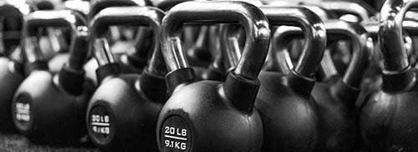
Welcome to Lifting Weights!
At Lifting Weights, we believe that strength isn't just about building muscles—it's about building confidence, resilience, and mental toughness. Whether you're a beginner or an experienced lifter, we provide a welcoming, supportive environment to help you achieve your fitness goals.

Our Services:
- Personalized Training Plans: Tailored workouts to suit your goals, fitness level, and preferences.
- Group Classes: Join our energetic group sessions for motivation, fun, and teamwork.
- Strength Coaching: Specialized coaching for powerlifting, bodybuilding, and other strength-based goals.
- Nutrition Guidance: Expert advice on fueling your body for maximum strength and recovery.

Join the Lifting Weights Community Today!
- Start Your Journey: New members receive a free consultation and workout session.
- Stay Connected: Follow us on Instagram and Facebook @LiftingWeights for tips, success stories, and special offers.

