- 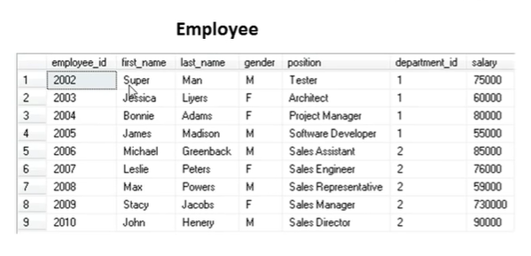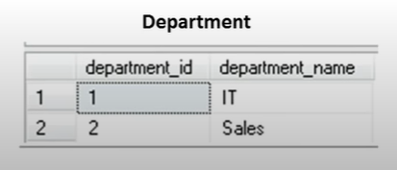

- Return employee record with max salary
select * from employee where salary = (select Max(salary))
- Select highest salary in employee table
select Max(salary) from employee

- Select 2nd highest salary in employee table
select Max(salary) from employee where salary Not In (select Max(salary) from employee)


- Select range of employee based on id
select * from employee where employee_id between 2003 and 2008
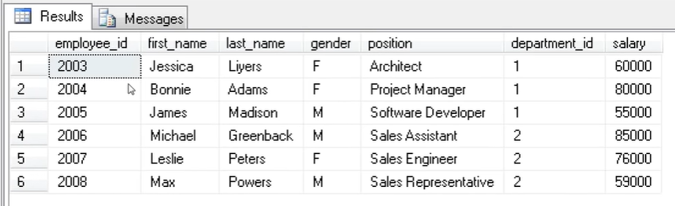

- Combine two table based on common department_id
select * from employee inner join department on employee.department_id = department.department_id

- Foreign key vs primary key
Two tables are relational,
Primary key is the field that uniquely identifies every different record,
Foreign key is just the field used to link two tables together
两个table通过foreign key 和primary key 链接起来，其中有foreign的叫child table, 包含primary key的是parent table.
在这个例子中， Employee (child table)的department_id是foreign key, Department(parent table)的department_id是 primary key.

