i.Abstract:

This lab report presents a comprehensive analysis of the the development process and key components of a personal portfolio website. The report outlines the objectives, scope, tools, and technologies utilized in creating the website. It also includes screenshots to provide visual representation. The findings demonstrate the successful implementation of the project and highlight the benefits of having a personal portfolio website.

ii List of Figures:

Figure 1: Website Homepage

Figure 2: About Section

Figure 3: Services Section

Figure 4: Potfolio Section

Figure 5: Contact section

iii.List of Tables :

Table 1: Tools and Technologies Used

Table 2: Abbreviations Used in the report

iv.Abbreviation :

HTML – Hypertext Markup Language

CSS – Cascading Style Sheets

JS – JavaScript

Table Of Contents:

1. Introduction

2. Problem Statement

3. Objective

4. Scope

5. Tools and Technology

6. Screenshots

7. Conclusion

1.Introduction

The personal portfolio website serves as an online platform to showcase the skills, projects and experiences. It highlights the importance of having a personal portfolio website for showcasing skills, projects and experiences. The introduction also describes the target audience and the purpose of the website in establishing a professional online presence. It provides a centralized location for potential employers, clients or collaborators to explore a the user’s work and capabilities.

2.Problem Statement:

A personal portfolio effectively presents the creator’s achievements, skills and projects to potential employers, clients, or collaborators. The challenges faced in organizing and displaying the information in a visually appealing and user-friendly manner was hard. The challenge lies in effectively organizing to attract potential opportuinities.

3.Objective:

The objective of this project is to develop a personal portfolio website that serves as a professional platform to showcase the creator’s skills, projects, and experiences. The website aims to provide an intuitive and visually appealing user interface, making it easy for visitors to navigate and explore the creator’s work.

4.Scope:

The scope of the personal portfolio website includes designing and developing a responsive website using HTML, CSS and JavaScript. The website consists of various sections, such as About, skills and expertise, and contact information. The focus was on creating an aesthetically pleasing design, optimizing user experience through responsiveness and ensuring compatibility across different devices and browsers.

5.Tools and technology:

This section provides an overview of the tools and the technologies utilized in developing the personal portfolio website. It includes the programming languages (HTML, CSS, JS), particles libraries, and GitHub pages for deployment. Table 1 summarizes the tools and technologies used in the project. (Table 1: Tools and Technologies Used).

6.Screenshots:

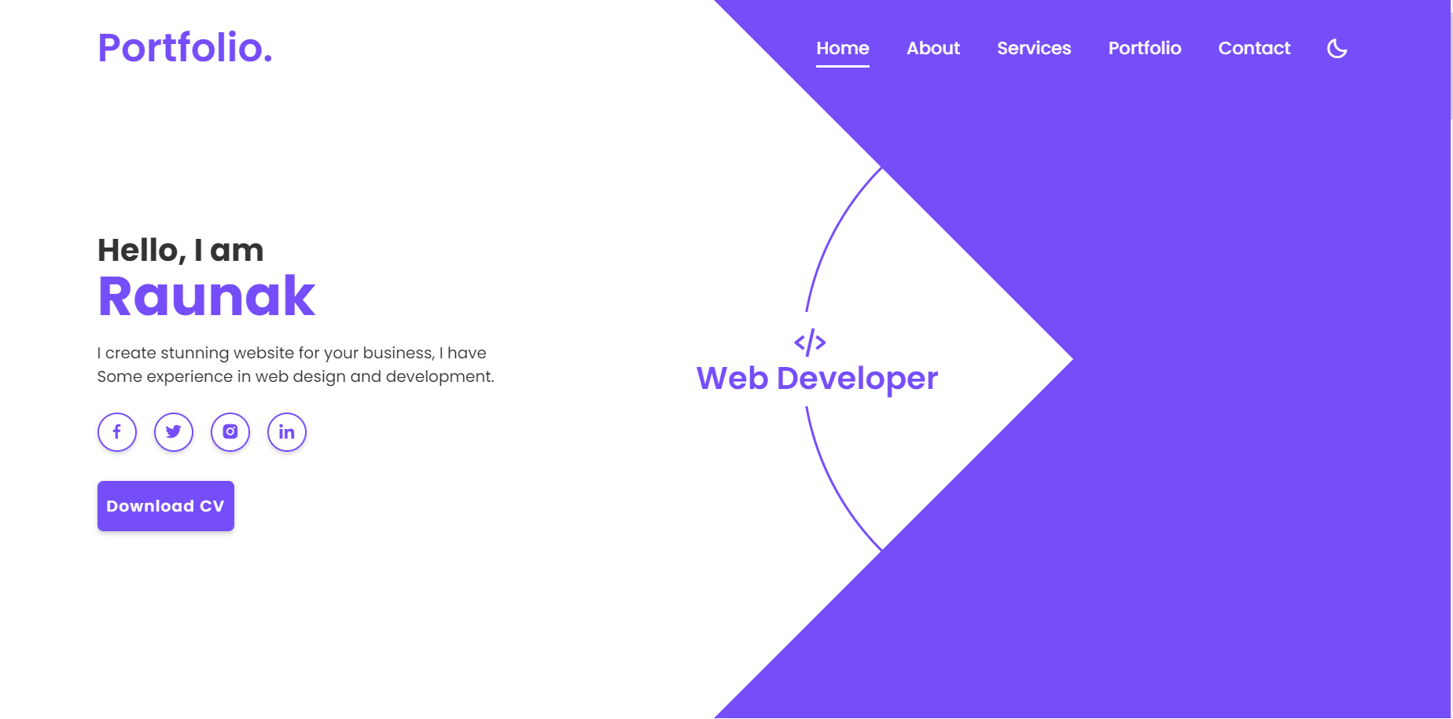

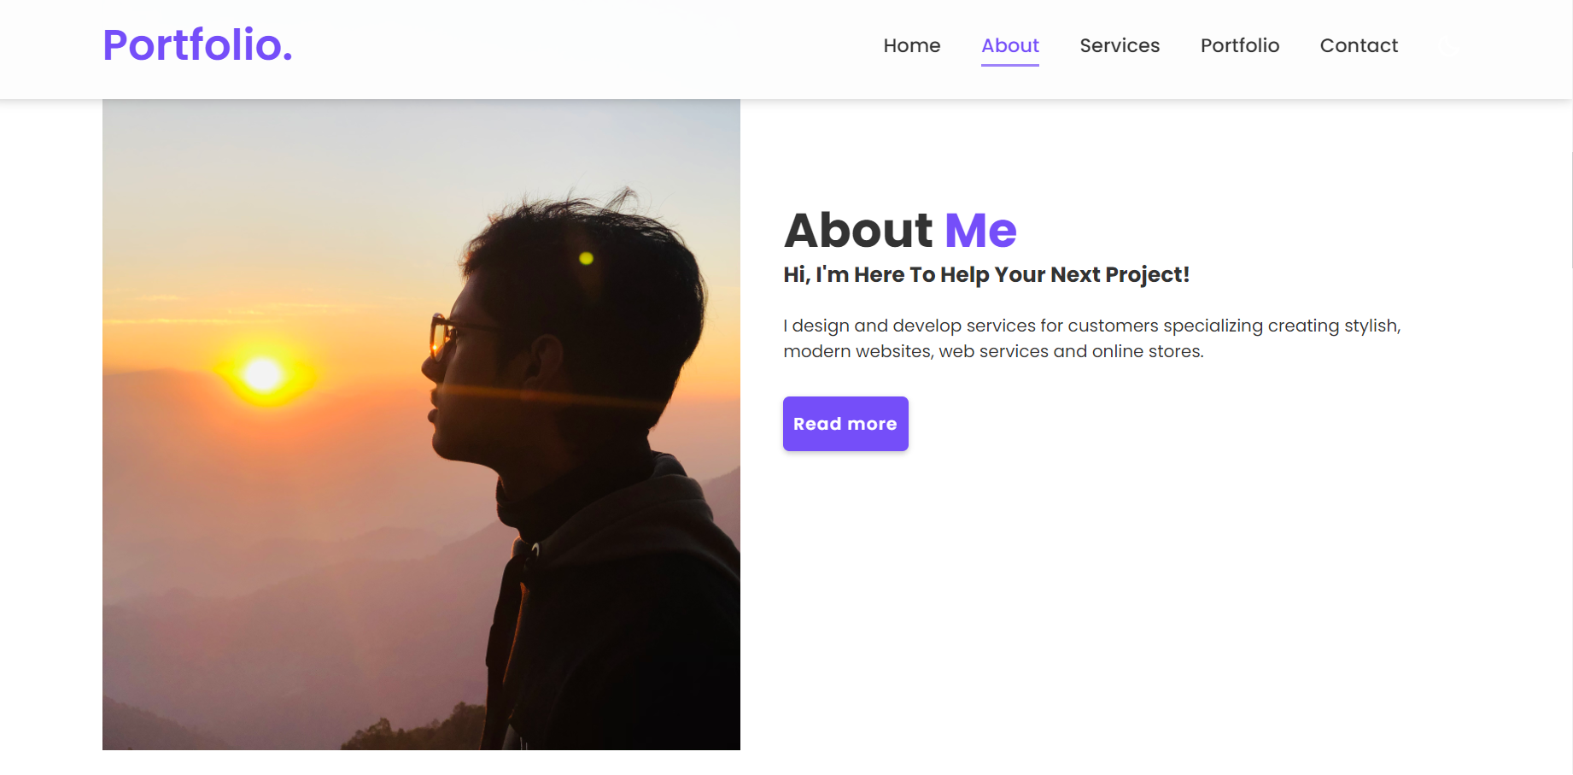

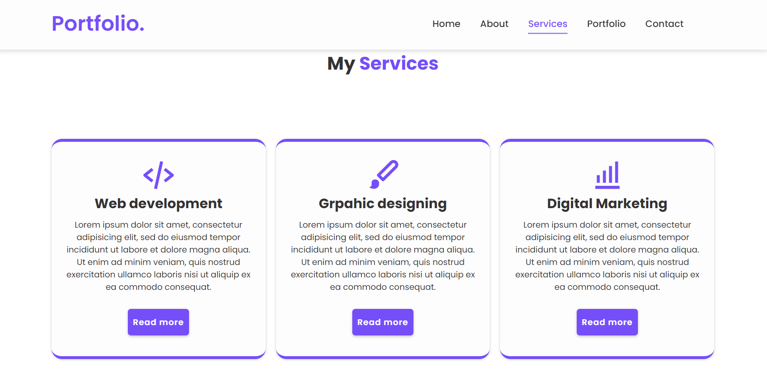

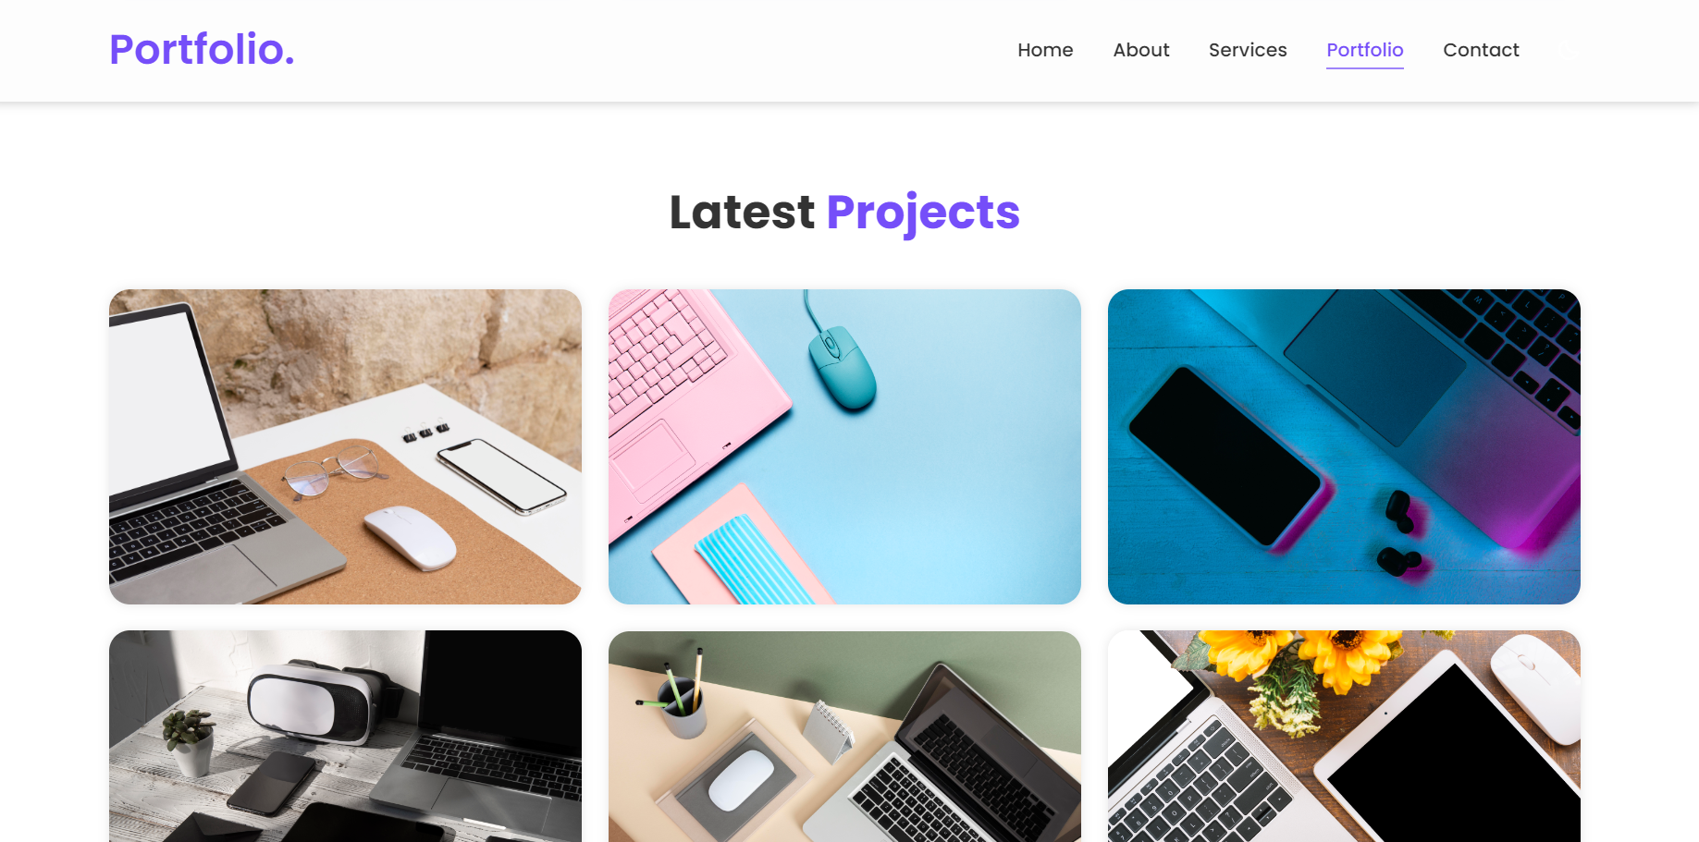

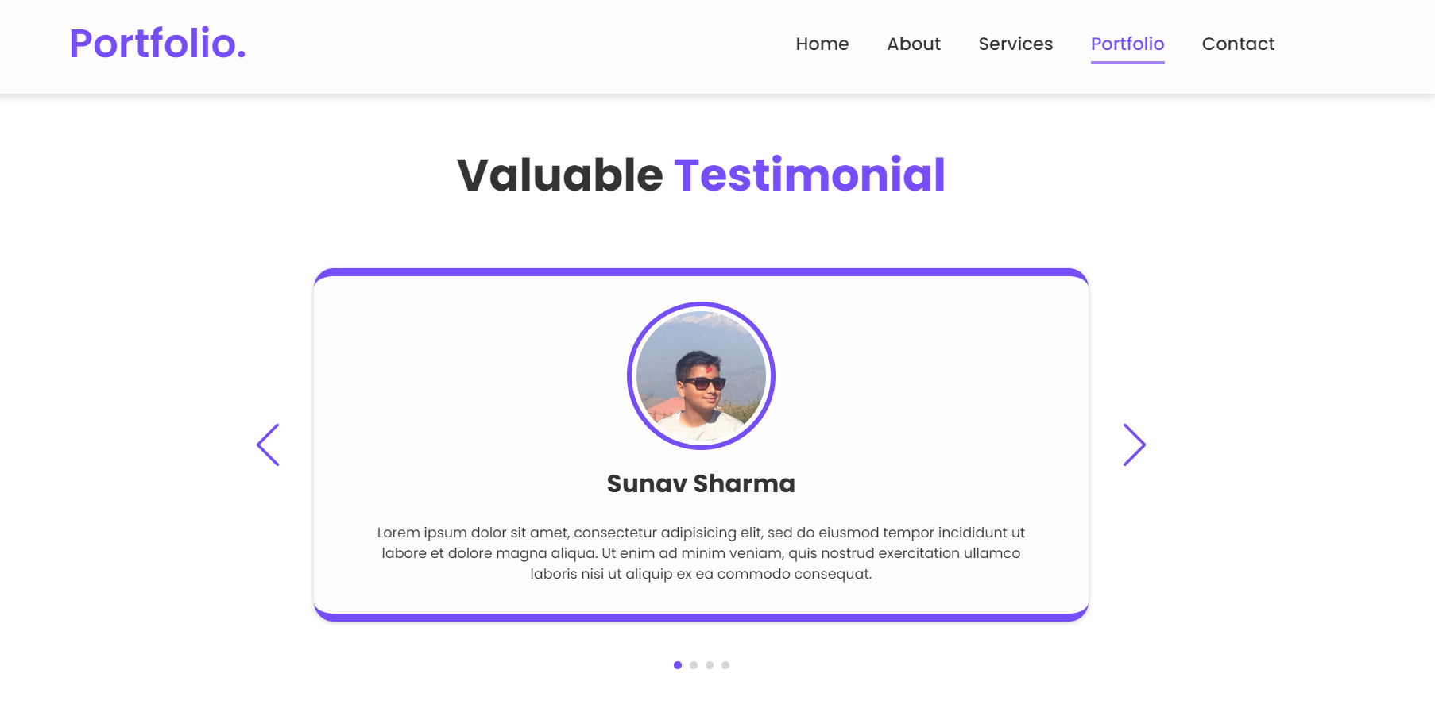

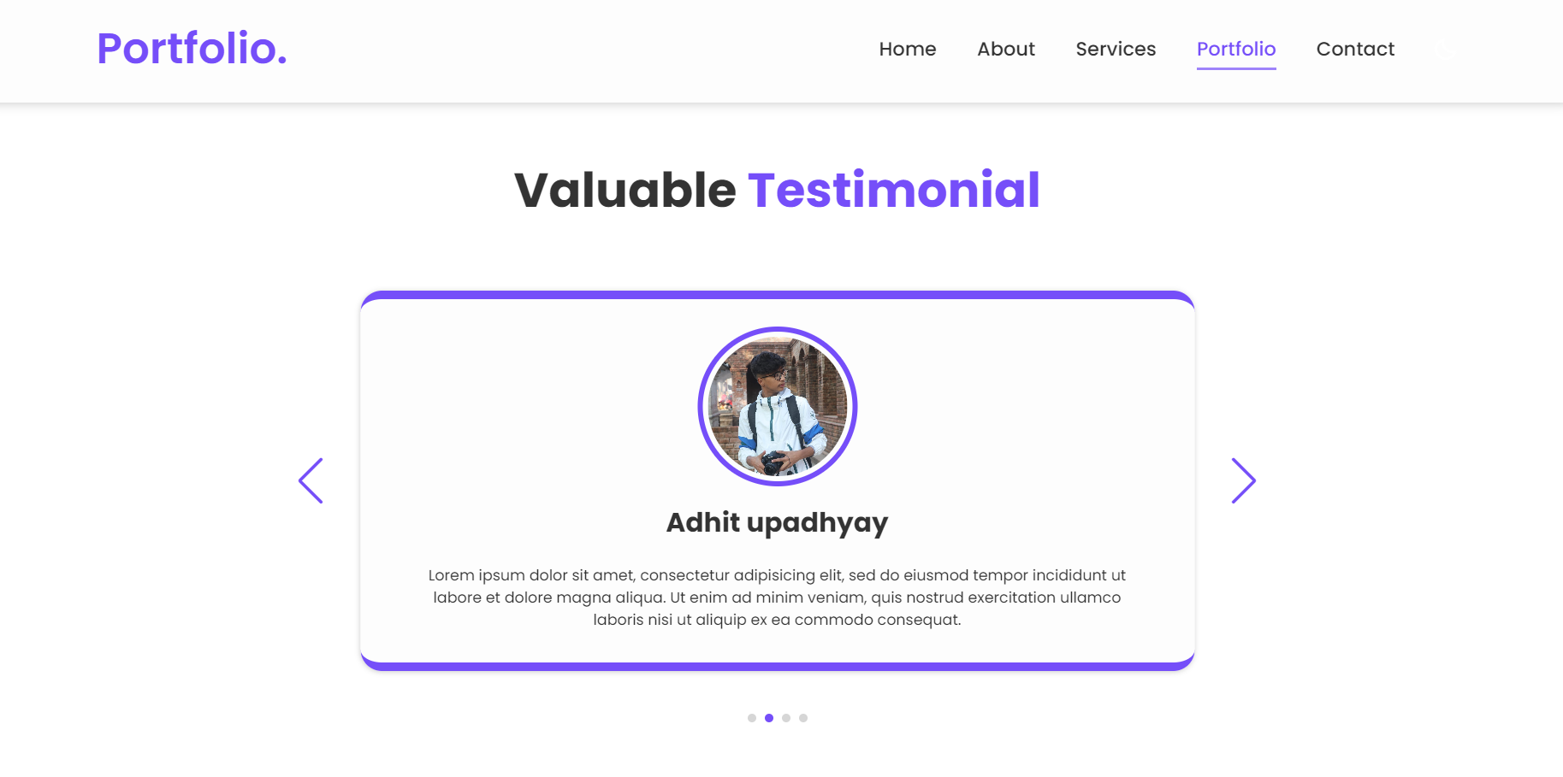

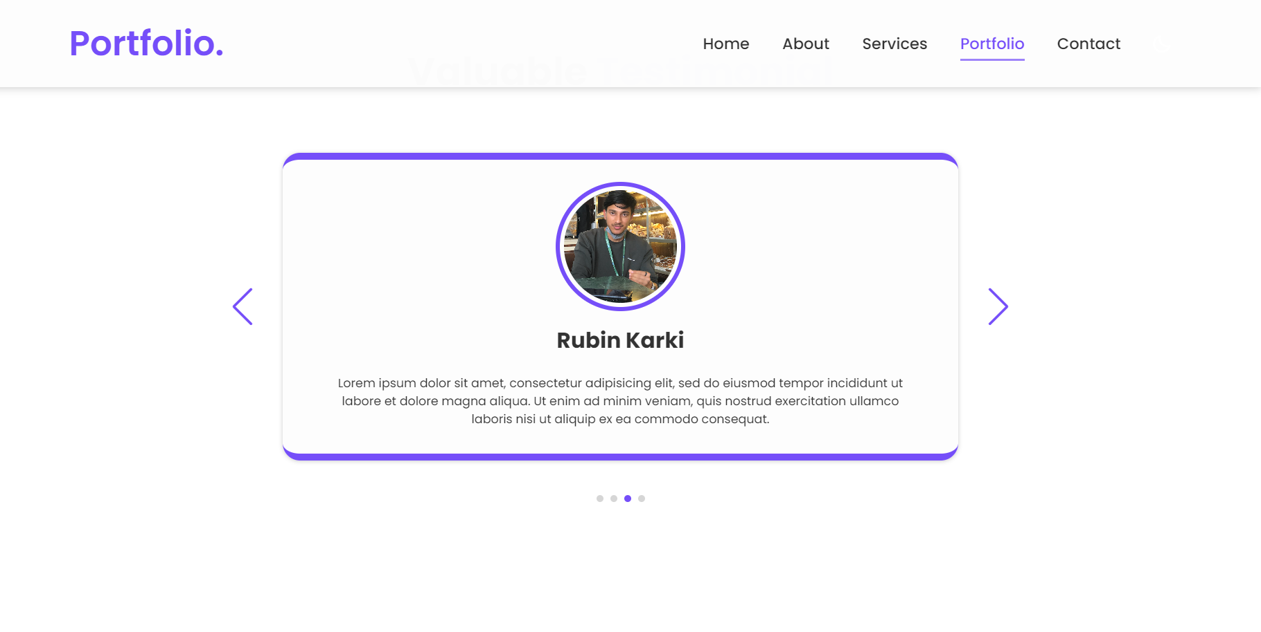

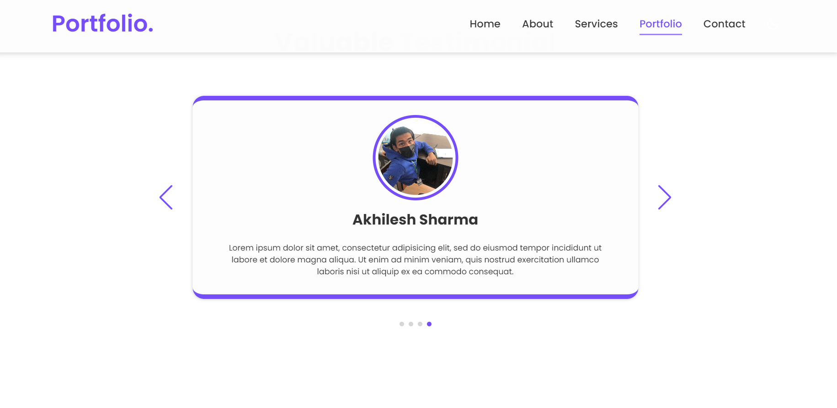

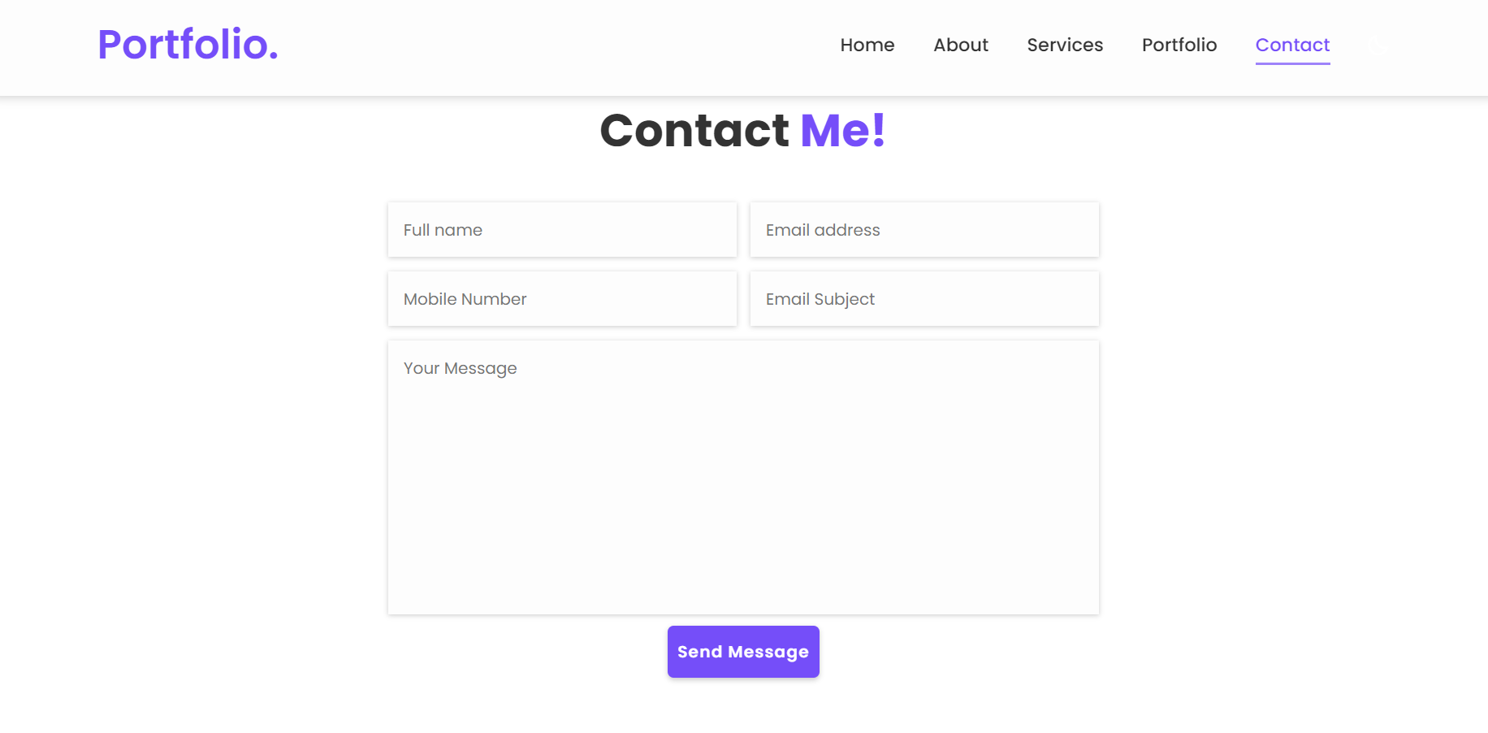

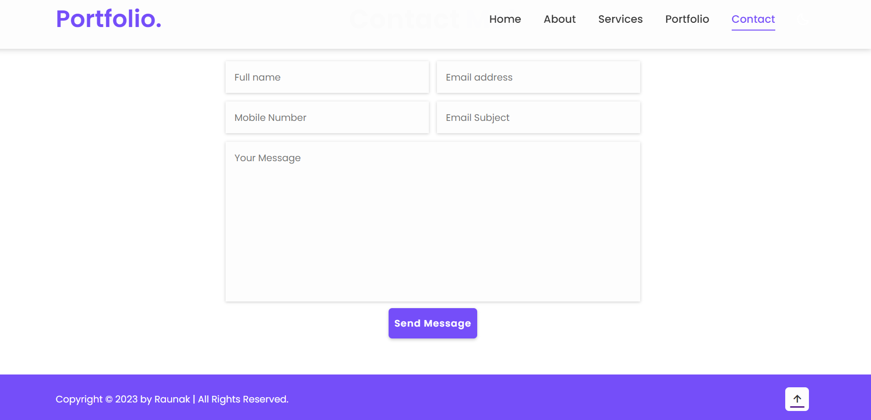

7. Conclusion:

The purpose of this project was to create a responsive portfolio website using HTML, CSS and JS and hence a website was made so that the users could navigate through the site to learn about the creators' works, skills and expertise, contact information and many more.

8. Appendix:





