|  |
| --- |
| Codeora |
| Prestige YoYo Production Reporting |
| System Installation |

|  |
| --- |
| Thomas Kempton, Hekar Khani, & Samuel Lewis  12/3/2012 |

Table of Contents

Visual Studio Support 2

ASP.NET MVC 3 2

Application Deployment 3

Web Deployment 3

Queue Reader Deployment 4

# Visual Studio Support

## ASP.NET MVC 3

In order to open the system solution in Visual Studio 2010, it is required that you install the ASP.NET MVC 3 package from <http://www.asp.net/mvc/mvc3>. Once that is installed, the NuGet package manager should download all required libraries upon initial build. If, for some reason, this does not work you will need to navigate to the root folder of the solution (PrestigeYoYo) and run the command *.nuget\NuGet.exe install src\Web\packages.config -OutputDirectory packages*.

# Application Deployment

## Web Deployment

We recommend that, for web deployment, you use the Web Deploy extension for IIS from <http://www.iis.net/downloads/microsoft/web-deploy>.

Once Web Deploy is installed, you can build a deployment package from Visual Studio, which will create a deployable zip of the web application.

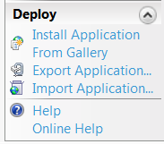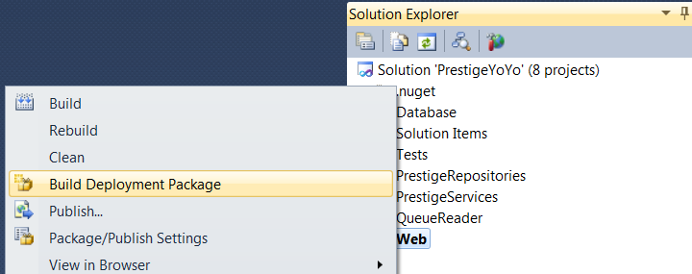

Once you have a deployment package, open IIS and select Import Application on the Deploy menu. There is a very simple install wizard that can be used to configure connection strings. The first time the application is run from the browser the database will be created and populated with some default data. Debug configuration will populate the database with default data and a dummy schedule. Release configuration will only create the initial root user account. Please note: the database account will require the appropriate permissions to create and alter databases on the Microsoft SQL Server, as the Entity Framework handles database creation and initialization.

Both configurations create the default root account with username and password both set to ‘root’.

## Queue Reader Deployment

Deploying the queue reader is simply copying the binary output folder to the host machine. It is required that you change the application configuration to point to the appropriate message queue and database connection.