Because of the way that SQL has been setup in lab 2A314, you will need to do a number of things to the SOA-Registry files when you place them on the lab computers to work on. If you install them on your own machine (at home or laptop) you may need to complete some (or all of these steps) as well …
- Unzipping the Assign1-SOA file
  - You must unzip the files to the C: drive (not your network share (G: drive))
  - And because the files are contained in a ZIP – you need to set permissions on the SOA folder
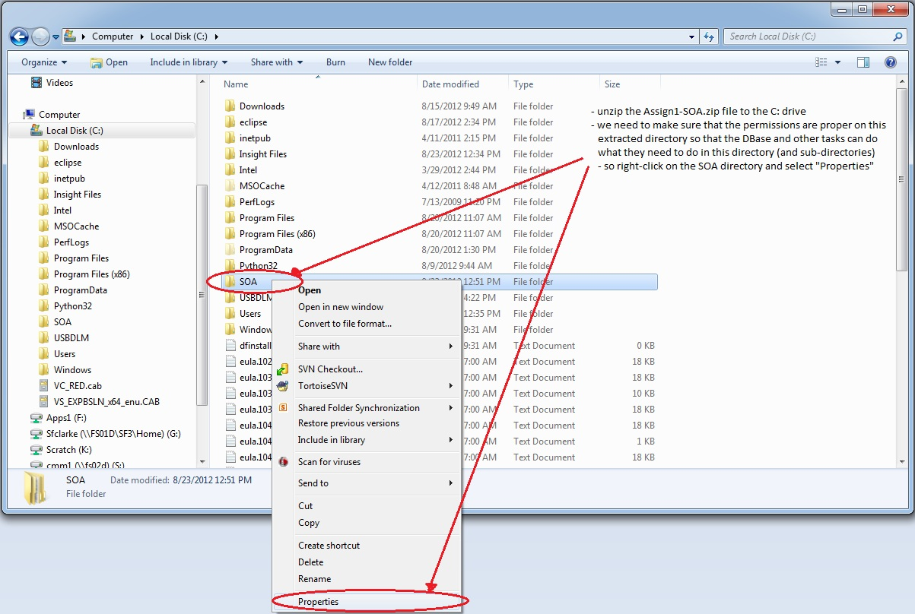
- Ensure that the SOA folder (all subfolders and files) are not read-only
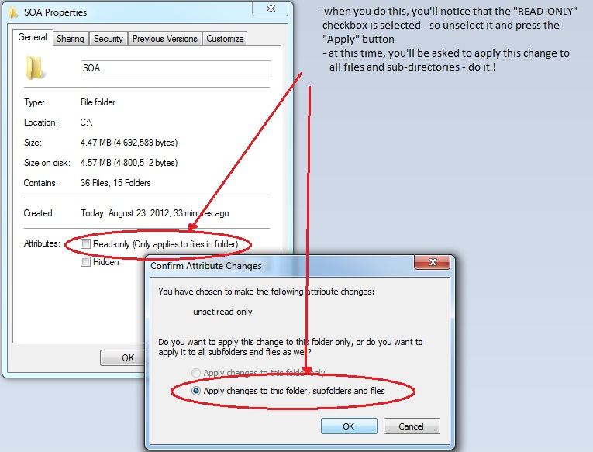
- When you run the sample client application, the SOA-Registry server and you own applications – you will be running them as a “user” on the lab computer. Files are modified (database and log files) – so it is important that the lab computer’s “User” group be given full-control of the SOA folder.
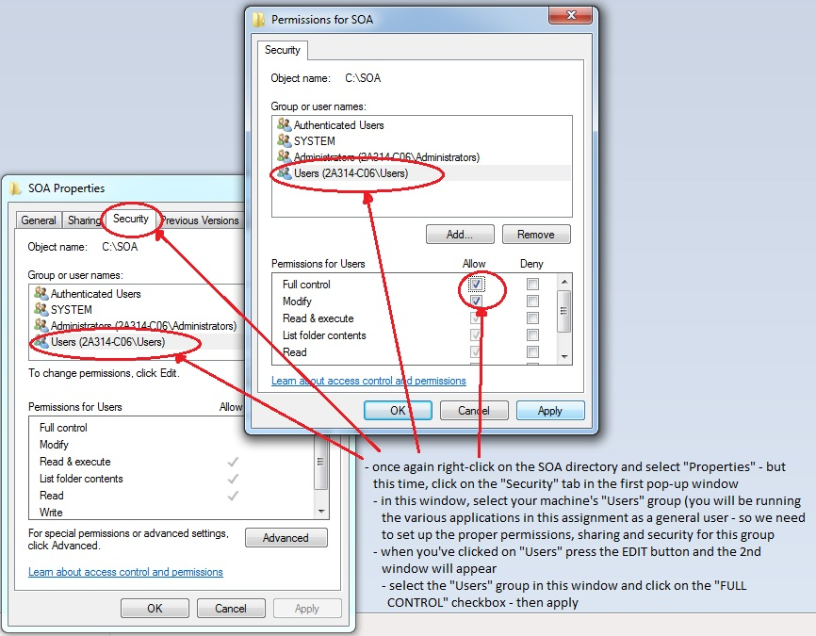
- Now let’s modify the MSSQLSERVER settings – first in the SQL Configuration Manager …
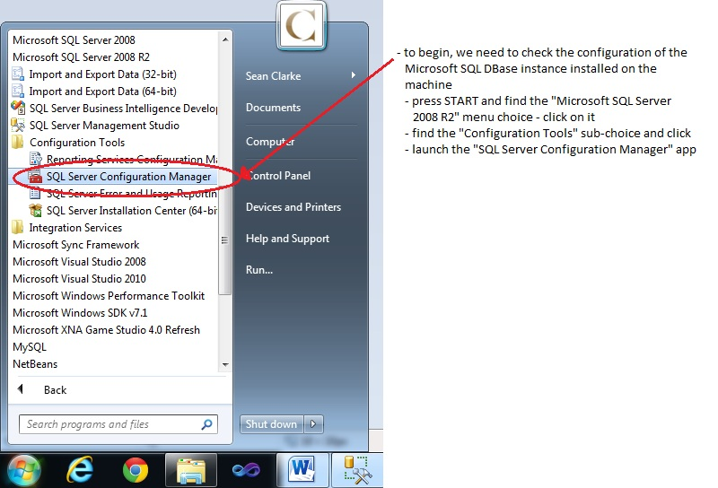
- The SOA-Registry server application “talks” to its backend database over TCP/IP – you need to enable this protocol on the 64-bit MSSQLSERVER instance. A number of setting changes like this, require the MSSQLSERVER service to be restarted …
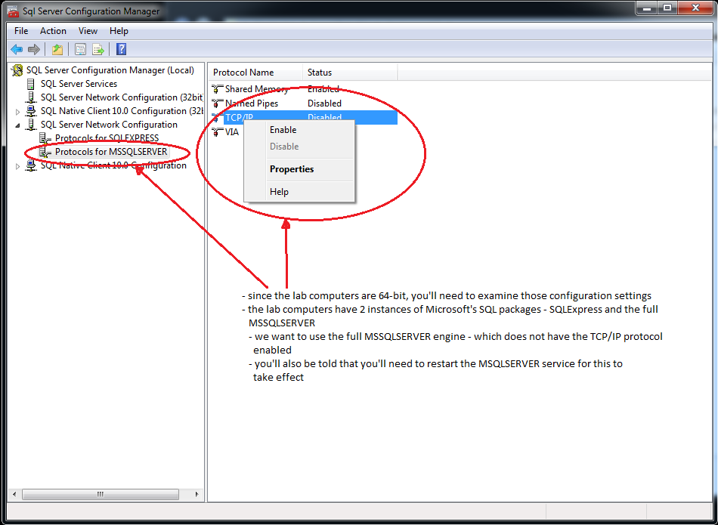
- This is how to restart the MSSQLSERVER Dbase service …
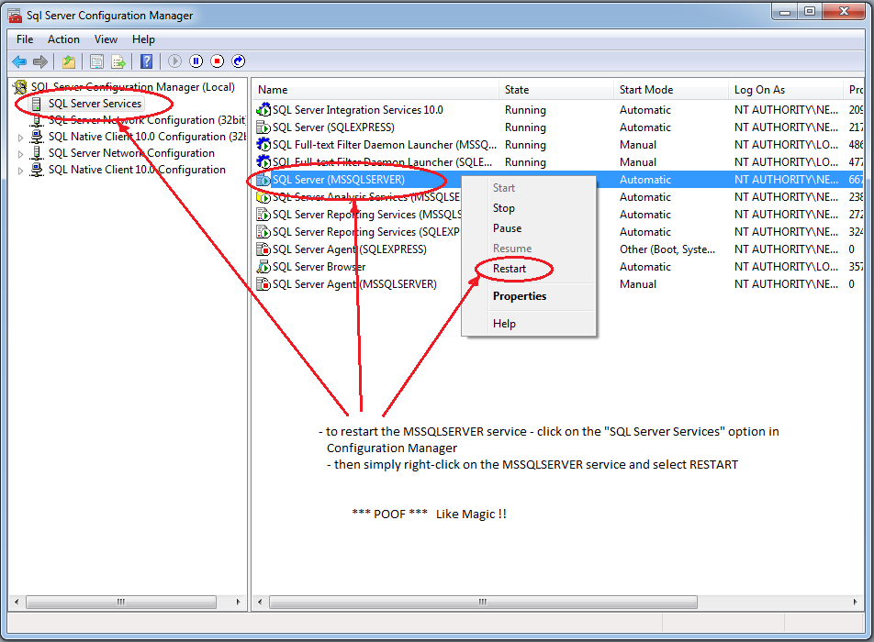
- Now we need to make sure that MSSQLSERVER instance is listening for TCP communications on port 1433
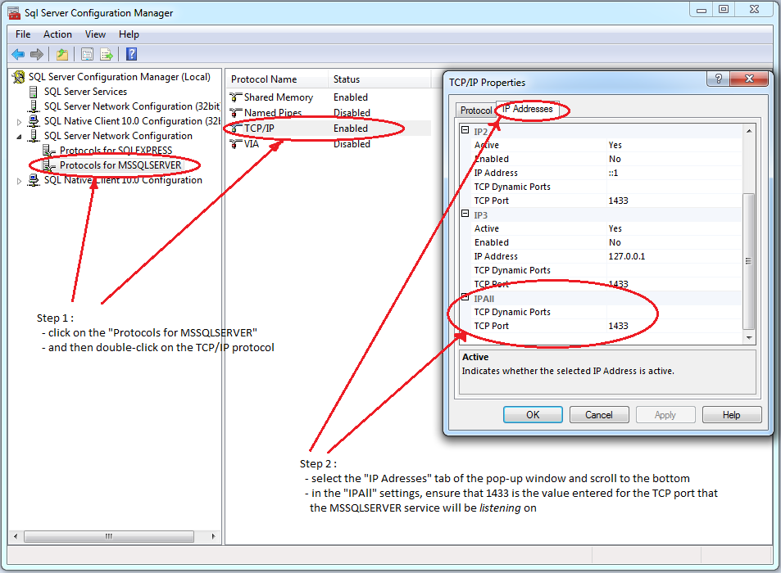
- Finally, you’ll need to ensure that MSSQLSERVER instance has TCP/IP enabled for any client applications – for any C# applications you may want to write that need to talk to the DBase
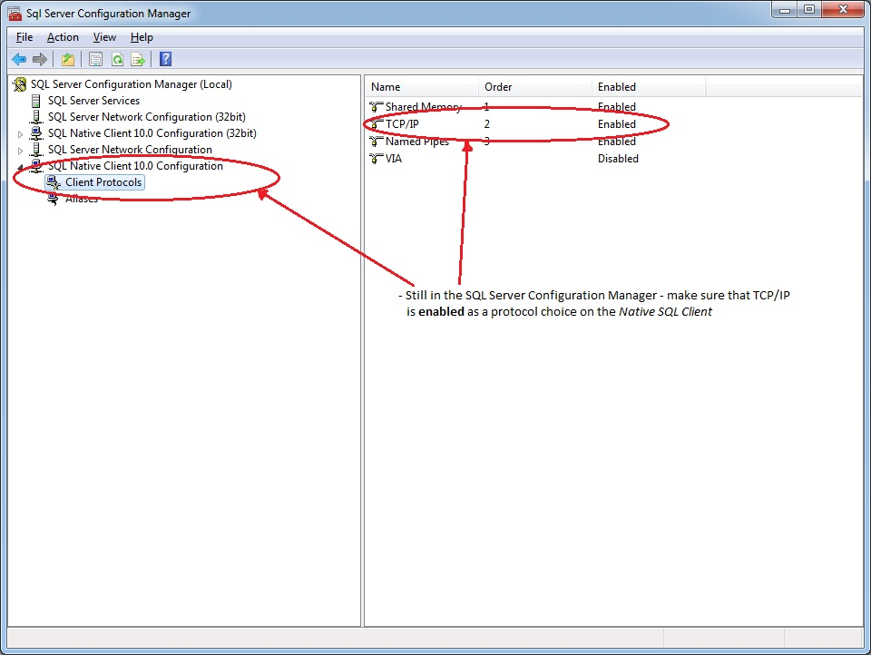
- Now you are ready to attach the provided SOA-Registry database and begin developing and playing in Thorton’s SOA.
  - Launch the SQL Management Studio to do this
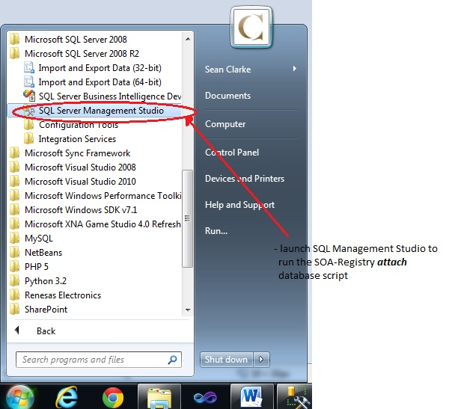
  - Log into the MSSQLSERVER instance
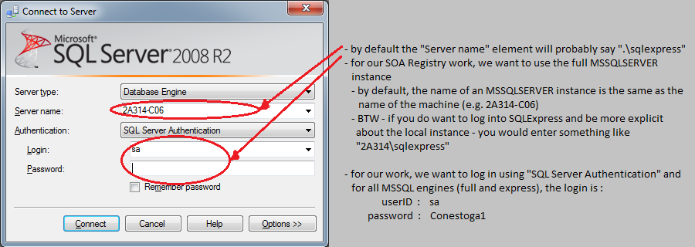
  - open and run the C:\SOA\Runtime\SOA-Registry\database\scripts\attachSOARegister.sql script

- Prepare the rest of the SOA-Register and Sample-Client command scripts and configuration files as indicated in C:\SOA\Runtime\README.txt

