SOA Assignment 2

# Application Diagram

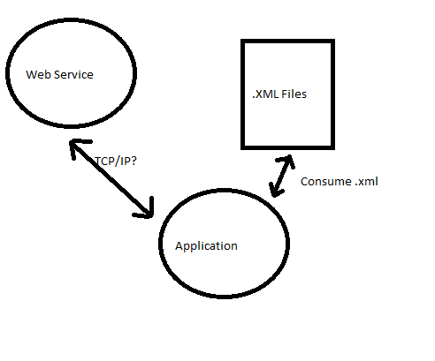

# Application Functional Description

## Application

1. Drop Down of Services
   1. On application initialization, it prompts for directory containing .xml files to consume.
   2. As each xml file is consumed, it will fill a class for that web service containing all the information relevant to it.
      1. Parameters, location, etc.
   3. When a new service is selected from the drop down, it will use this class to populate the UI. (Possibly create a dictionary or something that contain information about each of the web services methods.)
2. Send Button
   1. On click, validate user input.
      1. If valid send data to web service.
         1. Display response
      2. If invalid alert user.

## XML File

1. Need to come up with a scheme for it.