EXTENSION REPOSITORY AND MANAGEMENT SYSTEM

MA. SHARA FE P. VERGARA
ARNEL T. DELA TORRE
JOECEL H. SALGADO

SUBMITTED TO THE ADMINISTRATION, FACULTY AND STAFF
OF CENTRAL PHILIPPINES STATE UNIVERSITY
IN PARTIAL FULFILLMENT OF THE
REQUIREMENTS FOR THE
DEGREE

BACHELOR OF SCIENCE IN INFORMATION TECHNOLOGY

JUNE 2025

APPROVAL SHEET

This capstone project entitled “EXTENSION REPOSITORY AND MANAGEMENT SYSTEM” prepared and submitted by ARNEL T. DELA TORRE, JOECEL H. SALGADO AND MA. SHARA FE. P. VERGARA in partial fulfillment of the requirements for the degree Bachelor of Science in Information Technology (BSIT) is hereby recommended for acceptance.

GLORYBE E. ALLEGRE, MIT ___________
Adviser Date Signed

ELYSA JANE S. ARLOS, LPT
Technical Critic Date Signed

Accepted as partial fulfillment of the requirements for the degree Bachelor of Science in Information Technology (BSIT) with a rating of ____.

CHRISTI MYR L. CHU RAYMUND A. CELIS, LPT
Member, Interrogation Board Member, Interrogation Board

Date Signed Date Signed

DEBBIE LOU B. ENQUILINO, MAED, LPT
Chairman, Interrogation Board

Date Signed

Recommending Approval:

CHESTER L. COFINO, PhD. ANGELIE ROSE L. LUMBA, PhD.
Dean, College of Computer Studies Director for Research

Date Signed Date Signed

GRENNY I. JUNGCO, PhD.
Vice President for Academic Affairs

Date Signed

APPROVED:

ALADINO C. MORACA, PhD.
President

Date Signed
DEDICATION

Mr. Joemarie A. Salgado
Mrs. Rutchie H. Salgado
Mr. Romel N. Dela Torre
Mrs. Annabelle T. Dela Torre
Mr. Felix S. Vergara
Mrs. Sheba P. Vergara

ACKNOWLEDGEMENT
We begin by giving all glory and praise to our Almighty God for granting us the strength, wisdom, and perseverance to complete this thesis. His divine guidance, endless grace, and unwavering presence carried us through every challenge and obstacle along the way.
To our beloved families, thank you for being our strongest foundation. Your endless love, patience, and unwavering support have carried us through this academic journey. We are deeply grateful not only for your encouragement but also for the financial support you provided, which helped sustain us throughout this endeavor. Your sacrifices motivated us to continue pushing forward and striving for excellence. This achievement is a testament to your love, dedication, and commitment to our success.
We sincerely extend our deepest gratitude to our thesis adviser, for your dedicated guidance, continuous encouragement, and insightful feedback throughout this journey. Your patience, expertise, and commitment to our growth as researchers have been instrumental in the development of this study. We are truly thankful for the time, effort, and unwavering support you have generously shared with us.
Lastly, to everyone who lent a helping hand, in ways big or small, please accept our heartfelt gratitude. Your kindness, support, and encouragement will never be forgotten.

ABSTRACT
This research study describes the development of Extension Repository Management System (ERMS), which is a digital document repository that manages the storing, managing, archiving, and retrieving digital documents. It aimed to develop and implement a functional Extension Repository System such as automating the manual process of filing out the CCS extension documents, develop a system that can organize a document filing system for the extension program, facilitating efficient document storage and retrieval processes, create a user-friendly platform to upload and manage documents of CCS extension programs, and develop a system that secure access control and document security within the extension program. Based on the results of the survey conducted after the deployment of the Extension Repository Management System, the effectiveness and usability of the system, feedback was collected from selected users including faculty and extension coordinators. System functionality, user interface, ease of use, and accessibility was used to measure user satisfaction and overall performance was excellent.
Overall, when we assessed the system’s quality through testing, it showed off solid functionality, ease of use, and security. It hits the mark by cutting down on data errors, making document access smoother, and beefing up security with features like limiting user access to specific folders and documents that the admin shares. Considering the positive evaluation outcomes and high levels of user satisfaction, it is recommended to further improve the user experience and support ongoing development, Categorized Folder Management, User Interface Enhancements, and Summary Report for Admin-Only Editable Programs this are the three that need to improve.
TABLE OF CONTENTS
PAGE
TITLE PAGE i
APPROVAL SHEET ii
DEDICATION iii
ACKNOWLEDGEMENT iv
ABSTRACT v
TABLE OF CONTENTS vi
LIST OF FIGURES viii
LIST OF TABLES ix
LIST OF APPENDICES x
CHAPTER I. THE PROBLEM AND ITS SCOPE 1
Introduction 1
Problem Statement 3
Objectives 3
Significance of the Study 4
Scope and Limitations 4
Definition of Terms 5
CHAPTER II. REVIEW OF RELATED LITERATURE AND SYSTEMS 7
Related Literature 8
Related Systems 30
CHAPTER III. METHODOLOGY 40
Design Method 40
Flow of the Study 43
PAGE
Functional and Non-Functional Requirements 44
Respondents 52
Environment 53
Instrument 53
Data Gathering Procedures 54
Statistical Treatment of Data 55
CHAPTER IV. RESULTS, CONCLUSION AND RECOMMENDATIONS 56
Results and Discussion 56
Findings 58
Conclusion 60
Recommendations 61
Budget Recommendation 62
Implementation Plan 63
REFERENCES 65
APPENDICES 68
BIOGRAPHICAL SKETCH 89
LIST OF FIGURES
FIGURE PAGE
- SDLC Model 41
- Flow of the Study 43
- System/ Application Flowchart 46
- System/ Application Architecture 47
- Context Diagram 48
- Data Flow Diagram 49
- Entity Relationship Diagram 50
- Use Case Diagram 51

LIST OF TABLES
TABLE PAGE
- Software Requirements (Minimum) 44
- Hardware Requirements (Recommended) 45
- Frequency Distribution 52
4 Recommended Budget for the Implementation of 62
the System

LIST OF APPENDICES
APPENDIX PAGE
A Letter Requests 69
B Sample Input-Output Reports 70

C Evaluation Tool 74

D Evaluation Results 76

E Photos During the Conduct of Evaluation with System 80
Beneficiaries

F Gantt Chart 82

G Screen Layouts 83

H Source Codes 84

CHAPTER I
THE PROBLEM AND ITS SCOPE

Introduction

The Extension Repository Management System or ERMS is a digital document repository that manages the storing, managing, archiving, and retrieving digital documents. BusinessDictionary.com defines it as “an electronic system designed to organized and manage documents. Repository manages tedious tasks such as archiving, distribution, and creation of documents.”
As technology advances, automation has become a key focus for streamlining processes, especially data exchange and interactions. The Extension Repository Management System is particularly vital in modern techniques, as it plays a crucial role in organizing and managing all records related to extension programs efficiently.
According to Kuligowski, K. (2023), a centralized digital storage area that authorized staff members can access is called a document repository. Users are given administrator status and controls for management. Organizing your document repository is one of the most crucial elements of establishing a document management system (DMS) that functions well for your business. These repositories, which are typically created with team members' needs in mind, allow users to organize papers by team, search for documents by title or keyword, and save documents in a handy folder structure. Document repositories can be considered of as either having or being a part of a DMS, which is an automated way to store, manage, and track electronic docume
snts together with workflows, output systems, and information retrieval systems. Since the repository is the primary location for all of the papers, it must be well-organized and easily accessible in order to be of any use.
Utilizing document repositories to lessen redundant data and file overflow on your desktop or local disks is one of their primary functions. By providing a single, shared storage location for all your staff members and resources, a document repository helps you avoid having duplicate papers in different departments, where they could accept unnecessary space. Additionally, a document repository makes all your documents searchable through indexing and tagging, which ensures that document retrieval is quick and efficient, no matter who is searching for the document.
Besides, an organization’s data storage body or bodies into which data has been divided deliberately for reporting or analytical purposes is a data repository. Data warehouse and data mart are sometimes used interchangeably with the term “data repository.” It is a less specific term used when referring to a certain type of medium that is designed to isolate specific population for ease in analyzing such as comprehension and business intelligence or intended specifically for reporting. For instance, you could have a data repository meant only for lease rates, energy bills, building maintenance costs, safety measures and usage levels of space but willfully exclude any workforce or business process information to single out your most expensive branch office.
The Extension Repository Management System (ERMS) is designed to automate and organize electronically the document files for extension programs. The system also allows easy uploading, management, and expediting of the completion of CCS extension documents.
Problem Statement
This capstone project aimed to automate the manual process of filing and organizing of all the records of CCS extension programs.
This study sought to answer the following questions.
1. How can the manual process of managing CCS extension documents be effectively improved to reduce inefficiencies, data errors, and time-consuming management tasks?
2. What are the essential features and requirements needed to develop a system that organizes and streamlines document filing for the CCS extension program?
3. How can a user-friendly platform be designed to facilitate the uploading and management of documents for CCS extension programs?
4. What measures should be implemented to ensure secure access control and document security within the CCS extension program's system?
Objectives

This capstone project aimed to develop and implement a functional Extension Repository System with the following specific objectives.
- To automate the manual process of filing out the CCS extension documents.
- To develop a system that can organize a document filing system for the extension program, facilitating efficient document storage and retrieval processes.
- To create a user-friendly platform to upload and manage documents of CCS extension programs.
- To develop a system that secure access control and document security within the extension program.
Significance of the Study

The result of the study will benefit the following.
To the User. Ease in filing and organizing all the records of extension program.
To the Future Researchers. This capstone project finds useful especially to IT student who planned to conduct similar study.
Scope and Limitations

This capstone entitled “Extension Repository Management System” was intended for the Central Philippines State University Main-Campus only. The system serves as a repository of all the CCS extension program’s documentation.
This study only covers the CCS extension documents and will not include other unrelated documents, also in terms of viewing documents, pdfs and images are viewable. Only the extension coordinator can access the admin side and the accreditor can only access by viewing the files with the permission of the extension coordinator.

Definition of Terms
To better understand the study, the following terms were given their operational definition.
Extension Programs. This refers to program of universities extension. To deliver extension services efficiently, the Department has opted to establish its own Extension Agenda which will serve as the framework for its regular Extension Program. (https://linguistics.upd.edu.ph/programs/extension-programs/).
Information. A cohesive collection of parts for gathering, saving, and analyzing data and for delivering information, expertise, and digital goods. The thesis title, authors, course, year, and abstracts/executive summary stored in the system. (https://www.britannic
a.com/topic/information-system).
PHP. It is a server scripting language, which is a robust tool used for creating dynamic and interactive web pages. The programming language used by the researchers in developing the system. (https://www.w3schools.com/php/).
Repository. An area where files, such as downloadable software packages or files in a source control system, are stored. This referred to the databank of all records of CCS extension programs. (https://en.wiktionary.org/wiki/repository).
Retrieve. The action or procedure of fetching, the chance of getting back, fixing, or correcting, a computer action that brings up information from a file. The process of searching and locating documents in the system to download, modify, and view. (https://www.collinsdictionary.com/dictionary/english/retrieval).
Search. Try to locate something through careful and thorough searching. The process of searching for specific documents in the system. The user uses this process to find the exact document. (https://www.google.com/search?q=search+meaning).
System. A coherent organization of interconnected elements that work together to accomplish a specific goal. The program application on, “Extension Repository Management System” developed by the researchers. (https://www.google.com/search?q=s
System).
System Administrator. An IT professional who assists in a multiuser computing environment to maintain the continuous, optimal functioning of IT services and support systems .This referred to the authorized person or user who has the total control and access to the repository system. The system administrator could be the Extension Coordinator. (https://www.techtarget.com/searchnetworking/definition/system-administrator).
Thesis. It is turned in as the last phase of a master's degree or as a culminating project for a bachelor's program. The student’s terminal requirement of the degree program they are taking is a kind of research article that draws from your own findings. (https://www.scribbr.com/dissertation/thesis/).
Undergraduate. The student who are taking their bachelor’s degree in CPSU-Main Campus. A student who has not yet received a bachelor's or equivalent degree at a college or university (https://www.google.com/search?q=undergraduate).
User Account. This includes the user's username, password, and other valuable information being compromised. A user is given an account to use a system . This referred to the account required from the user of the system get access to the system. (https://www.google.com/search?q=user+account).

CHAPTER II
REVIEW OF RELATED LITERATURE AND SYSTEMS

This chapter explores relevant articles from online sources, journals, studies, and projects implemented in various organizations, institutions, and industries.
Related Literature
According to Alokluk, J. (2019), archiving and Document Management at Taibah University: Despite the widespread use of technology, there is limited research on archiving and digital document management in educational institutions, specifically at Taibah University. A qualitative descriptive case study was conducted to investigate how digital archiving and document management are structured at Taibah University to meet the requirements of researchers, professors, administrators, and students, and to ensure secure storage and access to data. Choosing the case study design has enabled thorough examination of the data management and archiving strategy at the institution. Data analysis based on existing propositions suggests that Taibah University has a specific approach to handling electronic documents, however, they do not utilize a singular data management system. In addition, only a small selection of documents is archived, and the security of stored data is ensured in compliance with the University's regulations.
Today, information documents are confronted with the issue of an extensive volume of printed or paper-based records. Conventional archives, which involved the printing and physical storage of documents, have recently been replaced by digital archival and data management systems. These systems are designed to organize and store all the collected and potential information or documents for use in universities or colleges.
According to Paucar, L., et al., (2022), a model for the long-term preservation of Advanced Records in the Development of Higher Education: Preserving hardcopy and digital documents is not only a legal mandate but also an obligation to preserve the progressive heritage of public or private establishments. This inquiry aims to provide a proposal for the long-term preservation of higher education's computerized records by establishing an OAIS (Open Documented Data Framework)-based system that balances the needs of the Higher Innovative Founded "Juan de Velasco." An evaluation of the advanced conservation forms is conducted by assessing the current situation and confirming that the needs align with the NESTOR (Nestor Catalogue of Criteria for Trusted Advanced Storehouses) catalog of secure storehouse criteria. The most widely used models for advanced conservation are examined, together with the policies, guidelines, and standards that help to maintain them. The show's strategy is supported by an examination of local and general laws pertaining to computerized conservation, enabling it to be implemented in more creative and informative ways. The OAIS reference system serves as the basis for the long-term computerized conservation demonstrator MPDL-ISTJV, which is presented with modifications made to its functional elements to provide complete adaptability and an improvement in the validation of the mental donation overseen by Higher Innovative Organizing.
Through the implementation of the OAIS reference model and the integration of the NESTOR catalog criteria, "Juan de Velasco" can create a resilient and enduring framework for the extended preservation of advanced records. This will guarantee the safeguarding, accessibility, and availability of the institution's precious digital assets for the benefit of future generations.
According to Asadi, S., et al., (2019), understanding institutional repository in higher learning institutions: institutional repositories (IRs) have sparked interest from scholars in various fields worldwide. They have enhanced the public worth, status, honor, and exposure of researchers, as well as relevant universities. However, despite the significant and quick expansion of research in this field, there have been limited attempts to comprehensively review and incorporate the results of prior studies or to assess the status of research on IRs. This paper aims to enhance comprehension and provide a detailed analysis of the current research on IRs. This study conducted a systematic literature review (SLR) and adhered to a protocol to effectively structure the research on institutional repositories. The information was gathered from primary research published between 2007 and 2018 across six main databases: ScienceDirect, IEEE Explorer, Springer, ACM, Taylor and Francis, and Emerald insight. Several articles on IRs were examined, using specific criteria for selection, with 115 studies being included in the study. The findings from these studies showed that a lack of awareness about direct access IRs among scholars and institutions, along with insufficient information and communication technology infrastructure, were major obstacles to the growth of direct access IRs. On the other hand, the main advantages of institutional repositories were identified as improved visibility, higher local and global rankings, increased prestige, and public recognition, as well as enhanced teaching, learning, and research advancement by the institution's scholars. This paper also pointed out that most research in this field focused on the "deployment, implementation, and adoption" as well as the "benefits and challenges" of institutional repositories. The results of this study may help upcoming researchers by offering a guide of institutional repositories and emphasizing instructions for effective execution of IRs in higher education.
Research on institutional archives (IR) and its impacts is linked to the archive's expansion agenda, which emphasizes information sharing, visibility, and recognition. The IR Repository and Extension Program Repository serve as platforms for disseminating knowledge and demonstrating the impact of scientific work and outreach activities. Contributes to the development of research, provides guidance for its implementation, and addresses public issues such as awareness and technology infrastructure. Lessons learned from IR, including implementation strategies and benefits, can inform better management in expanding the program and help organizations increase the dissemination and efficiency of knowledge in their programs.
According to Paragarino, V., et al., (2016), the use of repositories digital educational resources: digital educational resource repositories have experienced significant growth and expansion over the last decade, becoming a crucial component in the evolution of higher education. This article provides a comprehensive overview of current research surrounding the utilization and acceptance of these repositories. While certain quantitative methods focus on collecting data related to the publication and use of educational materials, there remains a lack of empirical evidence to fully elucidate the different forms of adoption and utilization of educational repositories. Limited research projects are dedicated to identifying the aspects of scholars' adoption of educational resource repositories, exploring the connection between this adoption and teaching approaches, and investigating the subjective, contextual, institutional, curricular, and instructional factors influencing the various modes of usage.
As higher education evolves, digital repositories of educational resources have become essential. Similarly, extension repository management systems play a key role in software development and innovation. Both repositories function as a central platform for accessing and using resources (educational materials or software enhancements) that enhance learning and development in a particular field.
According to Maldonado, J., et al., (2016), educational digital repositories store academic materials and learning tools, enabling educators and students to access resources for virtual or in-person teaching and learning. They are valuable for distributing and assessing the quality of educational content created by teachers. This paper looks at how much universities in Ecuador use digital teaching resources and special learning object libraries, checking their growth in the last five years. It also finds out what holds them back. Schools give teachers rules to make these tools well, so they can work in different online learning systems. The goal is to see how these resources are used, the challenges faced, and how they have changed recently. It is anticipated that the conclusions reached by this analysis would enable the formulation of policies intended to encourage the production and application of high-caliber digital learning resources. It is anticipated that the conclusions reached by this analysis would enable the formulation of policies intended to encourage the production and application of high-caliber digital learning resources.
This study investigates the usage of digital educational resources and learning object libraries in Ecuadorian universities, as well as the barriers faced when using these resources. Similarly, understanding developers' usage behavior, adoption difficulties, and usage hurdles in an enhanced repository management system can improve the effectiveness of repositories and meet users' needs more efficiently.
According to Svard, P. (2017), records management: organizations are being forced to manage the various formats created by social media content generated by unconventional means, including blogs, wikis, instant messaging, collaborative tools, and social networks, as the records management environment has transformed. Numerous information management methodologies are present in the information management landscape, all of which make the claim to assist enterprises in efficiently managing their information resources. Deploying the appropriate technologies to manage an organization's information resources requires a thorough grasp of the solutions offered by the various approaches. It all comes down to giving the copious amounts of data present in the current digital environment some order and organization. Records management is the methodical handling of documents to guarantee that information and proof are handled in compliance with international standards and the legal frameworks established by various nations. As information technology advances toward "open data and big data," it is important to distinguish between data that requires stringent management beyond manipulation and data that does not. Therefore, the focus of records management is on the qualities of a real record, which include integrity, authenticity, completeness, and reliability. This chapter explains records management and its function in society.
In the information management environment, there are many strategies that help companies manage their information resources efficiently. Therefor there are many management techniques and tactics that can be used in an extension repository management system to classify, store, and retrieve software extensions according to their functionality, quality, and compatibility.
Based on the study of Ndegwa, H. (2024), on the Efficacy of Digital Preservation Practices in Institutional Repositories of Selected Public Universities in Kenya: Rapid advancements in technology have forced organization retailers to take conservation into account in order to meet their goals and objectives. The effectiveness of these initiatives is hardly documented, despite the fact that potential investors, contributors, and other partners demand evidence that the shop is admirable and believes in long-term conservation. This study aimed to increase the viability of advanced conservation techniques in the Organization Stores (IRs) of selected Kenyan open colleges. In particular, it sought to achieve the following goals: determining the types of digital assets in the regulatory repositories; evaluating the advanced conservation plans of the selected IRs; reviewing the current advanced conservation methodologies; examining the computerized conservation practices used by the IRs in the selected colleges; identifying computerized conservation obstacles in the selected open colleges' IRs; and formulating recommendations and best practices for computerized conservation in the selected IRs in Kenya. Both ISO 16363:2011: Space information and data exchange frameworks. Review and certification of dependable computerized store and ISO 14721:2011: Open Authentic Data Framework (OAIS) demonstration provided guidance for this analysis. The study adopted a practical, business-oriented perspective and employed a subjective research methodology to integrate multiple case studies into the research design. Three colleges were chosen using model purposive inspecting, and 19 respondent’s senior library administration, organization store employees, framework custodians, and ICT workers responsible for ICT-related concerns in the library were examined using master examining. Directed substance investigation was used to examine the data. Crucial information was gathered by perception surveys, interviews, and archive surveys. Triangulation, steadfastness, confirmability, and transferability were used to establish dependability. The findings established that storage facilities were in charge of overseeing computerized and half-breed data assets that were ingested into the IR without the support of needs assessments, lacking metadata, failing to take into account record designs that support long-term conservation, requiring comprehensive advanced conservation arrangements, dividing advanced conservation arranging, restricting innovation plans and budgets, failing to archive conservation activities, limited capabilities, and relying on short-term computerized conservation procedures. The analysis comes to the conclusion that the assets in the IRs may not be permanently conserved by the automated conservation techniques. The following recommendations are made: a survey of the IR's objectives, as this was thought to be a crucial step in determining the degree of advanced conservation needed; enhancements to substance determination agreements; plans and strategies for advanced conservation; a commerce demonstration for computerized conservation; partner sensitization and preparation for advanced conservation; setting up cooperatives to address computerized conservation issues; and the advancement of asset sharing. Finally, a system for optimal refinement in advanced conservation, informed by current industry metrics, is put forth.
This study examines the effectiveness of digital preservation techniques in institutional repositories of Kenyan public universities. It concludes that the techniques in use may not be sufficient to guarantee the long-term preservation of digital assets and provides suggestions for enhancement that are in line with best practices for document repository management.
According to Rimkus, K., et al., (2015), on his study entitled, “Digital Preservation File Format Policies of ARL Member Libraries” archivists oversee institutional archives, digital library collections, or digital preservation services, archivists often develop file format policies designed to extend the life of the collections under their care. Although there has been a concerted effort within the library community to promote common standards, digital preservation practices regularly vary among digital library services. To provide a broad overview of current digital preservation practices in North American research libraries, this article presents the results of a survey of file format practices among Association of Research Libraries (ARL) member institutions. Its purpose is to provide the digital preservation community with an assessment of the current reliance on common file formats in digital library collections and institutions. The authors begin by providing an overview of previous research on file formats. They then go on to detail the research technique they employed to gather and examine information on file format practices in the digital library services and archive of the ARL Library. A presentation and analysis of the results analyzing the dependability of computer program, picture, text, audio, video, tabular data, software, and presentation file formats round out the article. The data indicate that file format practices have evolved little beyond the document and image digitization standards of traditional library conversion programs, and current approaches to file format policy must be developed to meet the challenges of expanding digital archive services in research libraries. Just as archivists create file format policies to ensure the longevity of an entrusted collection, administrators and developers can use the Extension Repository Management System to set file format policies for software extensions stored in the repository. These guidelines ensure the longevity and accessibility of extensions to developers and users.
As stated by Clements, J. (2024), document management in the Education Industry Challenges: In the ever-changing scene of the instruction division, successful administration of reports and records is imperative. Legitimate administration of instructive records and records guarantees smooth operations, administrative compliance, conservation of regulation memory, and educated decision-making. The instruction segment has continuously been utilized to dealing with loads of printed material. With the expanding volume of printed material and computerized records produced by instructive teach, the require for streamlined archive administration hones has gotten to be indeed more basic and challenging. Partnering with a proficient archive transformation company prepared with the mastery and apparatuses to change conventional paper-based forms into proficient and secure computerized arrangements can help meet these expanding record administration challenges. In this web journal, we will investigate the centrality of documents/records administration in the instruction segment and dig into how joining forces with an archive transformation company can revolutionize the way instructive teach manage their profitable data assets. The instruction segment has continuously been utilized to taking care of loads of printed material. These instructive organizations tend to bargain with a wide run of archives like – representative records, budgetary archives, understudy records, instruction compliance records, and different shapes, which are put away on paper, making the forms to oversee them wasteful. Keeping these private records secure and open is an essential concern for these instructive teach. Indeed, electronic archives, if not put away legitimately, come with security dangers.
The repository systems used by extension programs are related to the emphasis on document management in education and digital preservation in libraries. To ensure compliance, accessibility, and well-informed decision-making when managing valuable information assets, extension programs must effectively manage a variety of documents, completely convert them, and select appropriate file formats for long-term storage.
According to Patil, S., et al., (2015), Planning and Implementation of Institutional Repository: Regulation Storehouses (IR) are created fundamentally for collecting, protecting, and spreading the mental yield of an institution. This information helps in sharing and learning of an institution. For the fruitful set up of an Organization Store, key arranging is required with a foreordained objective and scope as well. This paper is a case ponder of setting up a computerized Organization Store at Maharashtra Instruction Society's Founded of Administration and Career Courses (MES's IMCC), Pune an Indian Administration Founded utilizing the open-source computer program D-space. The fundamental objective of this paper is to give a guide for setting up an organization store in a scholastic institution. Moreover, it discusses about the part of custodian in setting up an advanced Regulation Store, issues confronted and major breakthroughs to cover in the wander.
The case study details the establishment of a digital institutional repository (IR) at the Maharashtra Education Society's Institute of Management and Career Courses [MES's IMCC] in Pune using D-space. The perspectives of obstacles, remarkable events, and the exchange of important data correspond with efficient repository administration techniques that are relevant to extension initiatives, promoting information exchange and well-informed decision-making in these contexts.
As stated by Dinneen, J., et al., (2019), the ubiquitous digital file: a review of file management research: Computer clients spend time each day connection with advanced records and envelopes, counting downloading, moving, naming, exploring to, looking for, sharing, and erasing them. Such record administration has been the center of numerous ponders over different areas but has not been expressly recognized nor made the center of committed survey. In this article we display the to begin with committed survey of this theme and it investigate, synthesizing more than 230 distributions from different investigate spaces to build up what is known and what remains to be examined, especially by looking at the common inspirations, strategies, and discoveries manifested by the already furcate body of work. We discover three normal investigate inspirations in the writing checked on: understanding how and why clients store, organize, recover, and share records and organizers, understanding components that decide their behavior, and endeavoring to progress the client involvement through novel interfacing and data administrations. Important conceptual systems and approaches to planning and testing frameworks are portrayed, and open investigate challenges and the noteworthiness for other investigate ranges are examined. We conclude that record administration is an omnipresent, challenging, and moderately unsupported movement that welcomes and has gotten consideration from a few disciplines and has wide significance for themes over data science.
By synthesizing findings from over 230 publications in a variety of research domains, the article's thorough review of file management practices sheds light on user behavior, influencing factors, and strategies for improving user experience—all of which serve to highlight the field's interdisciplinary significance and provide vital guidance for the design, implementation, and ongoing improvement of record repository management systems. As a result, the article makes a significant contribution to our understanding of document management practices and provides invaluable insights for future advancements in the field.
According to Gamba, M., et al., (2015), Systems Development for Records Archiving and Digital Documents Repository A Case Study, the nearness of endless communication and data these days requires the require for a framework to promptly get to and exchange information. The ponder pointed to create records chronicling and record store to overcome the boundary of server client strategy of sending the reports from one put to another and simpler information get to its partners. The Sorsogon State College in the Philippines has four campuses which are found deliberately in four districts of Sorsogon territory. Their separate from each other in some cases causes an issue especially along communication and genuine time upgrades. Common Client Interface (GUI) of the application has been built on best of all web-enabled computers and indeed to the versatile gadgets, so it requires as it were introduced web browsers to render the GUI onto their gadgets in any case of its stage and details. The establishment of web-based documenting and store on its fundamental campus empowers adherent campuses to interface to the college private server in a cost-effective way through virtual private organize that interface on best of the Web benefit supplier. This ponder overcomes the powerlessness of security by implies of permitting client qualifications to login at the private server utilizing a 1024-bit Rivest-Shamir-Adleman (RSA) private/public key trade and 256-bit Progress Encryption Framework (AES) encryption through its virtual private arrange. Substance of the transferred records were being scrambled at 128-bit to avoid intranet clients from sneaking the record substance.
At Sorsogon State College in the Philippines, the installation of a web-based document storing and archiving system improves communication and data access throughout all four of its campuses. With a Common Client Interface (GUI) that is available on web-enabled devices, the system guarantees stakeholders may easily retrieve information. Communication can be made more affordable by setting up a virtual private network (VPN) between campuses and the private server. Document confidentiality is ensured by security techniques like 256-bit AES encryption and 1024-bit RSA key exchange; 128-bit file encryption is also used for further security. This project supports safe and efficient document access, storage, and communication inside the organization in line with efficient document repository management systems.
According to Nurpandi, F., et al., (2023), analysis and design of electronic document management system (case study of faculty of engineering, Suryakancana University): Currently, there are still numerous educate and organizations that conduct conventional archive administration. Like putting away physical reports in a recording cabinet in an extraordinary room. The Workforce of Building is one of the resources inside the Suryakancana College, Cianjur. There are numerous streams of archives in the Staff of Building, particularly those related to scholastic exercises. Such as Educating Declare, Committee declare, inquire about prove, and so on. The assignment of scattered records too changes, such as for reports on lecturers' execution costs, entries for scholastic positions, and other needs. The assignment of these reports can as of now be done online, so there is no require for physical reports. With so numerous reports stream in trade forms at the Staff of Building, a framework is required that can oversee all records contained inside the Workforce of Designing. Electronic Archive Administration Framework (EDMS) can be respected as a framework that contains different sorts of reports that can be gotten to through a network and bolsters different gets too such as overhauls, and adjustments at the same time and naturally. With the EDMS, the stream of reports does not end up discouraged. Speakers can quickly get reports as before long as they are made. Although report capacity is still not well organized, EDMS has been able to help Speakers in documenting the required advanced files.
By offering a digital platform for effectively storing, managing, and accessing documents, the Faculty of Engineering's Electronic Document Management System conforms to the guidelines of a Document Repository Management System. It contributes to better document management procedures within the academic institution by improving document organization, accessibility, and collaboration.
As stated by Cumpa, C., et al., (2023), the Impact of Document Management Using Good Practices: A Literature Review: distinguishes and contributes to the understanding the relationship, significance, and benefits of applying great homes in Archive Administration in open substances. Hypothetical system: Later writing has highlighted the noteworthiness of utilizing great homes in record administration inside organizational settings. These hones include productive information organization, openness, form control, and security measures (Malekany, 2022). In any case, the exact effect, and suggestions of actualizing these hones stay a subject of progressing investigation. Design/Methodology/Approach: through a strategy of a precise audit and Meta-analysis, for which 51 inquire about articles from the final 05 a long time were chosen to be checked on, it was compiled from diverse look sources and served to react to the 08RQ raised that will permit a superior understanding. Discoveries: When checking on, the to begin with disclosures that were found were the different benefits that are gotten by utilizing great hones such as taken a toll reserve funds, and speed of benefit, among others. The comes about appear that in other nations, they as of now make utilize of them, and they gotten to be not a commitment but a portion of the propensity, from day to day notwithstanding of the division or region to which the institution is devoted to. Inquire about, Viable and Social suggestions: We recommend a future investigate plan and highlight the commitments made to official and administration instruction. Originality/Value: Report administration is an advancing space, and there is still much to reveal and comprehend with respect to its impacts on efficiency, data recovery, and in general organizational execution.
To sum up, the study highlights the significance of implementing optimal techniques in Archive Administration, like effective information arrangement, ease of access, form management, and security protocols. These practices are highly compatible with the features and advantages offered by an Extension Repository Management System in contemporary business environments.
According to Triyana, M., et al., (2023), Optimizing Educational Institutions: Web-Based Document Management: Documents, which comprise of composed or printed materials, play a significant part in instructive exercises. Private schools in Tangerang still confront challenges in proficiently storing, accessing, and overseeing instructive reports. Manual report capacity expends a critical sum of time and physical space. Hence, a technology-based arrangement is required to address this issue. This inquiries about points to create a web-based Archive Administration Framework (DMS) that permits instructors and school staff to effectively oversee, store, and get to instructive reports carefully. The computer program advancement strategy utilized is the Waterfall show, including an arrangement of stages extending from needs examination to testing and usage. The result is a web based DMS application available to instructors in the school. This application empowers instructors to see, transfer, alter, and download educating materials easily. Also, instructors can oversee their educating plans and client get to rights. The ease of use of DMS has been tried through Client Acknowledgment Testing (UAT), and clients have given positive criticism on the application. This web based DMS successfully addresses the issues related to record capacity in schools, upgrading the productive administration of instructive reports, diminishing reliance on physical archives, and expanding efficiency in the learning prepare. Subsequently, this DMS holds extraordinary potential as a profitable instrument in the instructive setting of the school.
Through technology-driven solutions and optimized processes, the web-based Document Management System adopted in Tangerang's private schools improves digital document management efficiency and user accessibility in line with research on Document Repository Management.
As stated by Zhao, D. (2024), Information Security and Privacy Protection Strategies in the Process of Electronic Archiving in the period of computerized change, electronic chronicling plays a significant part in protecting and overseeing endless sums of data. Nevertheless, as organizations progressively depend on electronic files, guaranteeing strong data security and security gets to be vital. This paper proposes a comprehensive system for improving data security and security techniques inside the electronic chronicling prepare. Drawing upon experiences from the areas of cyber security, information security, and chronicled science, our system addresses key challenges and offers commonsense arrangements to defend touchy data all through its lifecycle. Through a blend of existing writing, case considers, and expert interviews, we recognize basic vulnerabilities and propose initiative-taking measures to relieve dangers related with unauthorized get to, information breaches, and protection infringement. Our system coordinating specialized controls, arrangement rules, and organizational hones to set up a robust design that cultivates believe, judgment, and privacy in electronic chronicling frameworks. By embracing our proposed procedures, organizations can reinforce their insubordination components and maintain the standards of data security and protection in the computerized age.
Since both research and the suggested approach for improving data security and privacy in electronic archiving are concerned with guaranteeing the security, integrity, and accessibility of electronic documents, they are closely related. Document Repository Management studies aim to optimize document management practices, enhance data security, and promote trust and confidentiality in digital document repositories. The system's emphasis on initiative-taking measures, risk mitigation, technical controls, policy guidelines, and compliance is in line with these goals. The suggested system and Document Repository Management studies aim to manage and protect sensitive information in the digital age by addressing weaknesses, offering workable solutions, and creating a secure environment for electronic archives.
As stated by Toelle, E. (2021), Records Management is not a new concept for many organizations. Most government and regulated organizations employ records managers to ensure compliance with regulations, laws, and company policies regarding record retention. But in the electronic age, managing and storing records has become difficult due to the volume of data and the rapid development of document management systems.
In result, the introduction of new opportunities and problems brought about by the electronic age has transformed document management. To effectively manage their electronic records, organizations need to adjust to the digital landscape by putting strong document management plans into place, utilizing innovative technologies, and placing a high priority on security and compliance. Records managers are essential in navigating this changing environment and making sure that document management procedures meet the goals of the company and legal obligations.
According to Kamble, S., et al., (2023), the best practices in archive and Record Management in Electronic Age details of every transaction and official action that an organization creates, conducts, or receives are included in its records. In both small and large businesses, proper documentation is crucial in many fields, including business, education, health, and medicine. With so many digital record-keeping solutions available in today's electronic environment, keeping track of documents throughout time is a cinch. But getting to them fast and effectively means putting in place a methodical record-keeping system. Governance, compliance, and risk management all benefit greatly from record management. This article covers the foundations of record management and provides insightful information about its different elements. The page explains how to preserve and retrieve older papers, handle records electronically, and what software is available. In the current day, all digital records should be instantly accessible and completely under the control of historical record managers. The paper investigates how electronic media has evolved into a crucial part of information preservation and records management systems for any business to run efficiently.
In this regard, there is a close relationship between document repository management and the record management principles discussed in this article. Regardless in physical or electronic form, it entails the systematic management of documents throughout their lifecycle to guarantee that they are arranged, safely preserved, and readily retrievable. In addition to making daily tasks easier, this methodical approach helps the firm achieve more general objectives like risk management, compliance, and effective information governance.
Jaramillo, I., et al., (2023), discusses that repository for academic documents, algorithms, and data: These days, data repositories are integral parts of institutional activities. In fact, universities are the main establishments that encourage the production, administration, and preservation of a wide range of records, information, and/or initiatives. This work is done within the context of institutional needs and knowledge application by instructors and students in an Ecuadorian university's software degree program. The focus of this project is an online application that allows resource management, uploading, and downloading. This first edition concentrates on the materials for research projects, datasets, and algorithms. The scalability features have been thoughtfully incorporated to guarantee a step-by-step development of additional resource kinds and functionality, in line with educational requirements. A few of the web interfaces' features are modeled after the features of other repositories that already exist, and several functional tests have been conducted to help the university community progress past the initial stages of use. This project is being conducted in accordance with a contribution-based paradigm, wherein the agents are, in theory, institutional members. The institution's data culture will develop because of the extensive and cooperative usage of this tool. Furthermore, it is feasible to compare them from many angles thanks to the way that various university degree programs organize and collect data for study and research.
The project that is being discussed embodies key concepts for managing document repositories in educational institutions. Like successful document repository management systems, it seeks to improve resource management, encourage collaborative data practices, and facilitate institutional knowledge application. The university may establish strong research and learning environment, encourage multidisciplinary collaboration, and streamline its data management procedures by putting such a system into place.
Davis, G. (2020), explains the organization of a user's files and folders on a MacBook is covered in this chapter. Users may manage their disks, files, folders, iPhones, and iPads with the Finder. The Finder allows users to perform a variety of operations, such as copying, moving, and deleting files and folders. Users of the Finder can also open many tabs in a single window. Using the Quick Look tool, one can ascertain the contents of a file or locate the specific file they are searching for. With MacOS, files on the desktop can be arranged according to user-selected criteria using the Stacks feature. An easier-to-navigate sequence of stacks can be created by the user by activating Stacks. Additionally, the chapter covers how to configure the Sidebar and Finder Toolbar, as well as work with Zip files.
To efficiently arrange documents, users can manage files and folders on a MacBook with the help of the Finder. It supports opening multiple tabs in a single window, generating, copying, moving, and deleting files and directories, as well as using the Quick Look tool to preview files. Along with managing drives, files, and folders, the Finder also allows for easy data management and transfer between devices, including iPhones and iPads. Organization is further improved by features like Stacks, which automatically arrange files on the desktop and offer rapid access to commonly used folders and tools. You can also customize the Sidebar and Toolbar. The Finder's functions are directly related to document management since they make it easier to retrieve documents, collaborate effectively, secure data, and optimize workflow. Users may improve productivity, cooperation, and data security by organizing and managing their files with the Finder.
Related Systems
According to Cuevas, M., et al., (2022), despite the snags and challenges of the manual operations, some of the public high schools in the Philippines, particularly those in the provinces, still do not use computerized systems for the development of the system itself is costly. One of the operations of the schools is the manual archiving of 201 files that contain employees’ personal information and profile. The purpose of the research is the design and development of an online digital archive of research materials and publications of colleges Since the files are paper documents filed in cabinets and folders, there have been cases of loss of files and duplicate data, unprotected storage, difficulty downloading and updating records. Often these records must be repeated and updated for promotion and accreditation. This Electronic Document Archiving System (EDAS) was undertaken to design, implement and convert a manual to a computerized system in a public high school. Using the Waterfall model of system development, the system identified the needs of the collected information and solutions to change and update the existing manual system. The development of the system resulted in well organized, consistent, and easily searchable documents. To be more precise, the electronic archiving system turned store records (documents) into a more secure database that is easy to access and will not get damaged. It should be stressed, nonetheless, that, aside from using a digital archiving system to automate it, the most effective approach to have a proper procedure for retaining the documents is to have coordinated manual processes.
Secure, organized, and easy to use. That's what this study on Electronic Document Archival System (EDAS) and the Extension Repository Management System are all about. They're designed to create a digital space where you can safely store and manage important documents, like research papers and publications, and easily find what you need without the worries of losing or damaging them.
Okon, R., et al., (2020), stated that repositories are essential research infrastructure for research-based universities. The purpose of the research is the design and development of an online digital archive of research materials and publications at the university. The long-term solution to the need for an effective, dependable, easily accessible system for storing and retrieving scholarly materials is to be provided by this project. An institution's exposure through its scholarly outputs can be improved and the effect of its research can be amplified with a suitably sized institutional repository. This system will ease the burden and stress of research and study for students and academic staff, allowing them to focus on other daily activities, particularly when it comes to finding pertinent scholarly information quickly. Open-source software and OOADM (Object Oriented Analysis and Design Methodology) will be used in the system's development. Results from system validation tests demonstrate that the system is a workable answer to the main problems with the organization's handling and dissemination of scholarly content.
Extension Repository Management System centers on constructing and implementing a university's online digital archive for research materials and publications, which is a crucial part of the system. An Extension Repository Management System functions as a platform that oversees and structures digital repositories for research materials, publications, and other scholarly resources. The study by Okon et al. (2020) ease to establish a web-based digital archive that offers a reliable, accessible, and efficient solution for storing and retrieving academic materials.
According to Estrera, P. (2017), Electronic Document Management System for Higher Education Institution: Based on the ISO 9001 QMS, examined the present issues with document management in higher education institutions. It discovered a number of inconsistencies in the monitoring, retention, and movement of notes and files across offices. These files were the result of a number of events, including redundancy and document loss, to mention a couple. An Electronic Document Management System (EDMS) was created in response to these issues. Two methodologies, including the In-house Development Program and the Spiral Model, were used in the study. The three colleges of Capitol University Computer Studies, Business Administration, and Criminology completed and tested the EDMS. Additionally, secretaries and deans of the same colleges assessed the EDMS modules. The evaluation phase, which was further monetized to show cost-reduction solutions as a tool for their implementation, discovered disparities in the amount of time spent for the covered papers. Consequently, EDMS is acceptable in terms of cost, time, and quality. It is advised that the university's colleges all fully deploy the EDMS. It is also advised that a second study be conducted to modernize the EDMS and put it online in order to provide a centralized and effective method of document tracking and monitoring.
This research highlights the necessity of an Electronic Document Management System (EDMS) in higher education establishments, particularly in relation to the ISO 9001 Quality Management System (QMS). The study tackles the shortcomings of conventional paper-based document management procedures, including irregularities in document tracking, storage, and transfer. It is advised that the EDMS be fully deployed throughout all of the university's colleges. It can be implemented using a spiral model or an internal development program, and all three are judged to be acceptable in terms of cost, time, and quality. By offering a consolidated and effective way of document tracking and monitoring, as well as by enhancing accessibility, scalability, and integration with other systems, a future study to upgrade the EDMS and make it available online would further boost its effectiveness.
Personnel Document Management System according to Tanjina (2018), creates a platform unbiased internet application to manipulate and distribute digital documents using web browser. The mission solution's goal is to track, index, and save every paper and electronic document. through technological means as documentation. Through the provision of an environmentally friendly and methodical control of statistics for the entirety of the facts lifecycle from introduction, share, preserve, and disposal the system manages the procedures for gathering and preserving evidence and information regarding people management of any business. Authorized users are permitted to search, download content, upload files, view files, and forward mines to other users or consumers for additional security-related actions. Every action taken on information by any consumer could be documented within the gadget audit trail subsystem. Currently, the system serves as a useful fact repository in which all data and facts may be accessible by users and shared for common purposes. A security degree of ICT protection compliance process is necessary.
The PDMS, as described by Tanjina , aims to create a platform-agnostic web application for handling and disseminating digital documents, ensuring their tracking, indexing, and safekeeping. This system provides a systematic and eco-friendly control of document lifecycle stages, including creation, sharing, preservation, and disposal. It also maintains checking of user activities, ensuring security and accountability. Similarly, the ERMS talks about the challenge of storing and managing large amounts of digital content, focusing on file format management and storage device optimization. This ensures long-term preservation and accessibility of valuable digital assets. Both systems, therefore, contribute to the broader goal of efficient digital content management and preservation, each in their unique ways.
On the other hand, Server-based Document Management System according to Gandola, D. (2017), has become very beneﬁcial for handling electronic ﬁles/ documents stored by a company or an organizing. With the help of DMS, these documents can revise, classiﬁed, maintained, indexed, versioned, used, preserved, and most importantly secured. The sole purpose for this system is to assist the users with managing the documents and ﬁles. Document management system (DMS) Document management systems are electronic ﬁling cabinets that provide a framework for organizing all digital and paper documents and to make a transparency of work in each document to ease the document editing and document management. According to Jeﬀ Pickard, CEO of Lucion Technologies, a provider of document management solutions, “these systems help businesses organize all of their paper and digital ﬁles in one central locator, where everyone in the oﬃce has access.”, File repository in Server-based document management systems serve as a central repository for all your important documents that can subsequently be accessed, viewed, changed, and shared with colleagues. No more wasting hours upon hours of precious me frantically looking through stacks of folders to ﬁnd a single document. Users may work on projects with team members who are dispersed across various locations or on the go since they always have access to files and documents and from any location. Our project proposal focusses on creating a document management system where the document can be edited in real-time scenario or can be monitor be one or more users in a team and to track the changes and updates in the documents. And the target of this proposal is the users that are making a thesis, group work, or even a presentation to the organization.
The ERMS can be seen as a specialized form of DMS, specialize to manage and preserve large amounts of digital content, including files and documents, in a centralized repository. Like a DMS, the ERMS provides a framework for organizing, storing, and tracking digital assets, ensuring their accessibility, security, and transparency. By doing so, the ERMS enables efficient collaboration, version control, and auditing of digital content, making it an essential tool for managing digital extensions and repositories.
According to Mousse, A. (2022), Safeguarding digital records is a crucial undertaking. It safeguards a document's identification. In this regard, techniques (mostly cryptographic techniques) have been used to ensure that the contents of messages remain confidential and that documents signed with certificates are authenticated. Only the linguistic content of the digital document defines it. The altering and fraudulent use of documents has increased with the popularity of OCRs. In this work, we present an approach to secure the document's identification, which is based on using a code book. Information that gives the document its unique identity is stored in the codebook. The codebook is used to create a correspondence table between the many values that are connected to the elements that we think are crucial to consider while modeling a document. Our algorithm’s output demonstrates its high level of efficiency.
This study tackles the growing issue of document alteration and fraud made easier by OCR technology by presenting a novel approach to secure electronic documents: employing a codebook to protect the unique identification of the document. This approach focuses on the content and structure of the document rather than just encryption. The security and integrity of digital data can be enhanced by this technology, which is highly efficient, when added to document management systems.
As stated by Ozgur Polat, L. (2022), The process of implementing an electronic document management system (e-DMS) is a crucial step in any digital transformation process. It is an information system that facilitates the creation, distribution, filing, storing, searching, destruction, and archiving of documents pertaining to specific standards and criteria. It is common knowledge that lengthy correspondence procedures add to the workload and bureaucracy of public institutions like universities. Therefore, it is critical to choose and implement an appropriate e-DMS software that systematically supports institutions in managing the documents produced in their work processes. This chapter provides decisive support for institutional managers in the selection of appropriate software, the preparation process before an application is presented, the stages of change and the environmental benefits after the implementation of the system are presented with workflows through a real application in a university. In addition to material benefits such as time and workforce, the digital transformation of the system brings environmental and social benefits to institutions.
The ERMS is a customized document management solution designed specially for universities and institutions to efficiently manage digital extensions and repositories. By adopting an ERMS, institutions can simplify their document management workflows, minimize administrative burdens, and drive digital innovation. This system provides a structured appro0ach to digital content management, facilitating the creation, sharing, storage, and archiving of extensions and repositories, while also promoting eco-friendly practices and enhanced collaboration.
As stated by Pagayonan, S. (2021), Records Management System with Management Control: aims to develop a digital document storage and retrieval system accessible at the archive office, as well as an automated leave management system tailored for use by staff members of the company. Estancia, Iloilo is home to Northern Iloilo Polytechnic State College. This work's specific goal was to design and create a document management system and assess the target user's usability and effectiveness. The poll comprised 165 participants from the educational institution, five of them were specialists from the 2016–2017 academic year. Data was collected via a questionnaire wherein the International Organization for Standardization/International Commission 9126 model was mostly employed to solicit comments from the respondents. The aims and descriptive research design served as the foundation for the description of the respondents' observations. The system product was rated as having "very good" functionality, usability, and performance, according to the results. This noteworthy outcome indicated that the respondents were comfortably impressed with the produced system's features.
The ERMS relates to the Records Management System presented in the research, as both intend to establish a digital system for document storage and retrieval. Focused on handling digital extensions and repositories within an educational or institutional context, the ERMS can take advantage of the study's insights regarding usability and success. The research's outcome, which revealed high scores for functionality, usability, and performance, can be implemented in the ERMS, ensuring a smooth user experience and effective management of digital resources. By following a comparable strategy, the ERMS can enhance the overall user experience, including faculty members and staff, in managing and accessing digital assets, consequently raising satisfaction and productivity levels.
As stated by Montalban, L., et al., (2023), Record Management System for Office Memoranda: Currently, office memos at the Iloilo Science and Innovation College Miagao Campus (ISAT U MC) are filed manually, which results in misplaced reports and an inefficient recording system. The goal of this study is to provide a framework for record administration that will promote office memo classification according to office, individual, subject, date, and office reminder number. The goal is to provide a framework for record administration that will enable an unrestricted flow of records with information about the college's operations. To do this, the analysts developed the framework based on customer feedback until it was accepted, using the developmental prototyping technique. Additionally, the framework's assessment was in line with the ISO 25010 program quality report. According to the study's findings, ISAT U MC's present record administration procedures are a more practical framework than what is needed, particularly for important records like memos. The idea outlines the basis for a record management system that can efficiently find, record, and store records. Ten (10) IT experts and five (5) end users evaluated the framework and concluded that it was quite feasible to assemble the required requirements for developing a memoranda database capacity framework. This essay concludes by highlighting the importance of record management practices for universities like ISAT U MC. The Record Administration Framework developed in this study can improve the efficiency and suitability of managing office memos by ensuring that important records are properly filed, stored, and retrievable when needed.
Record Management System developed in the study, as both aim to create a digital framework for efficient record administration and retrieval. The ERMS, designed to manage digital extensions and repositories in a university or institutional setting, can benefit from the study’s approach to categorizing and storing records. By adopting a similar framework, the ERMS can improve the organization and accessibility of digital extensions and repositories, ensuring that important resources are properly stored, easily retrievable, and efficiently managed. This can lead to enhanced productivity and satisfaction among users, such as faculty members and staff, who rely on these digital resources for their work.

CHAPTER III
METHODOLOGY

This chapter discusses the procedures the researchers produced in developing the system, the ERMS.
Design Method
This chapter covers the strategies utilized to achieve the project's objectives and serves as a road map for the researcher, from the initial problem statement to the results and suggestions.
Agile Model

During the development of the system, the researchers used the Agile Model as one of the components of the system development life cycle, or SDLC.
In software development, the agile process model is based on iterative development. Agile processes break down tasks into smaller iterations or parts that do not involve long-term planning. Project scope and requirements are defined early in the development process. Plans for the number of repetitions, duration, and scope are clearly defined in advance. (https://www.javatpoint.com/software-engineering-agile-model)
Agile methodology in SDLC focuses on frequent software delivery, face-to-face communication with clients, efficient design to meet business requirements.

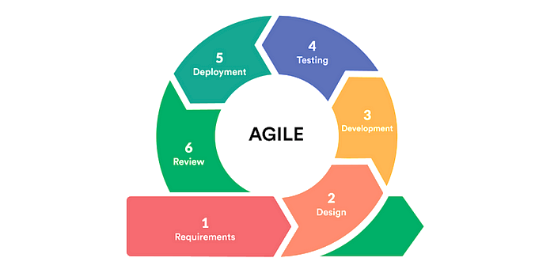
Agile methodology in SDLC focuses on frequent software delivery, face-to-face communication with clients, efficient design to meet business requirements, acceptance of anytime changes, and reduction of development time (https://www.javapoint.com/software
Engineering-agile-model)

Figure 1. Agile Model

In the process of Gathering Requirements, interviews were conducted with the Extension Coordinator of the CCS Department, who serves as the beneficiary of the system. Furthermore, crucial information was obtained from the researchers who developed the current system to ensure a complete understanding of the project requirements. The researchers began to figure out how to construct the extension repository management system as well as features to include based on the information gathered from the interviews.
Designing. In this phase, the researchers devised comprehensive strategies for building the system. They created various technical diagrams, such as the system flowchart, system architecture, context diagram, entity-relationship diagram and use case diagram, to visually illustrate the complete system workflow and features. After assessing the recommendations from the Extension coordinator, she reviewed the suggested functionalities and identified the suitable platforms and technologies to incorporate into the system. These contributions were thoughtfully taken into account to ensure the system would be both effective and user-friendly.
Development. At this point, the researchers initiated the coding process for the system using the following software like PHP, Visual Studio and XAMPP DBMS Server, facilitating the coding process. At the 60% of development, the researchers presented the system to their beneficiary for feedback. Since she was satisfied with it, they proceeded to finalize the system’s development.
Testing. The researchers conducted a series of tests to ensure the system met the specified requirements and examined to identify and fix bugs, errors, or inconsistencies, including unit testing for individual components, integration testing for system interaction, system testing for overall performance, User Acceptance Testing (UAT) to confirm it met end-user expectations and button testing and manipulation ensuring all buttons were functional and responsive once the system was uploaded to the JDC Webhost, verifying proper user interactions in the online environment.
Deployment. Before deploying the system, the researchers prepared a formal letter addressed to the beneficiary. Once approved, they visited the beneficiary to present and explain the system. The beneficiary reviewed the system, asked questions, and shared suggestions. She also requested that sample documents be uploaded and recommended enhancing the system design. The deployment marked a key step, as the system was now ready for actual use and further improvement based on user feedback.
Review. Following the deployment, the researchers conducted a review and distributed a survey to gather feedback from the beneficiaries. The system was tested in a work setting, allowing the beneficiary to explore its features and functionality. She provided comments, asked questions, and suggested improvements to enhance usability and design. The feedback confirmed that the system met its core objectives and highlighted areas for future refinement.
Process

- Letter to the Respondents

- SDLC (Agile Model)
Flow of the Study
Input
1. How can the manual process of managing CCS extension documents be effectively improve to reduce inefficiencies, data errors, and time-consuming managing task?
2. What are the essential features and requirements needed to develop a system that organizes and streamlines document filing for the CCS extension program?
3.How can a user-friendly platform be designed to facilitate the uploading and management of documents for CCS extension programs?
4.What measures should be implemented to ensure secure access control and document security within the CCS extension program's system?
Output
Extension Repository Management System

Figure 2. Flow of the Study
Input-Process-Output (I-P-O) is a structured method for capturing and visualizing all the inputs, outputs, and process steps necessary to transform inputs into outputs. The terms "I-P-O model" and "I-P-O diagram" are frequently used interchangeably to describe the method’s intended visual aspect (https://www.isixsigma.com/dictionary/input-process-output-i-p-o/).
Functional and Non-functional Requirements
This capstone project is designed to satisfy functional requirements that spell out the exact characteristics and functions which the system should have, whereas non-functional requirements identify important aspects including functionality, reliability, safety, capability, and usability.
Software Requirements

Table 1. Software Requirements (Minimum)
SOFTWARE | VERSION
Visual Studio Code | v1.89.1
XAMPP DBMS Server | v3.3.0
Google Chrome or Any Browser | 119.0.6045.214

Hardware Requirements
To support the automation of the manual process of filling out CCS extension documents, the researchers have identified the necessary hardware components. These components are essential for the system's functioning.

Table 2. Hardware Requirements (Recommended)
DEVICE | SPECIFICATIONS
Central Processing Unit (CPU) | Intel(R) Core (TM) i5-7200 CPU @ 2.50Ghz 2.71 GHz
Laptop (Lenovo) | 12.5’’ 1366x768 (HD)
Random Access Memory (RAM) | 8 GB

System Flowchart
The Extension Repository Management System (ERMS) system flowchart presents the flow process of admin and user, specifically the uploading, searching, viewing, downloading, and deleting of documents.

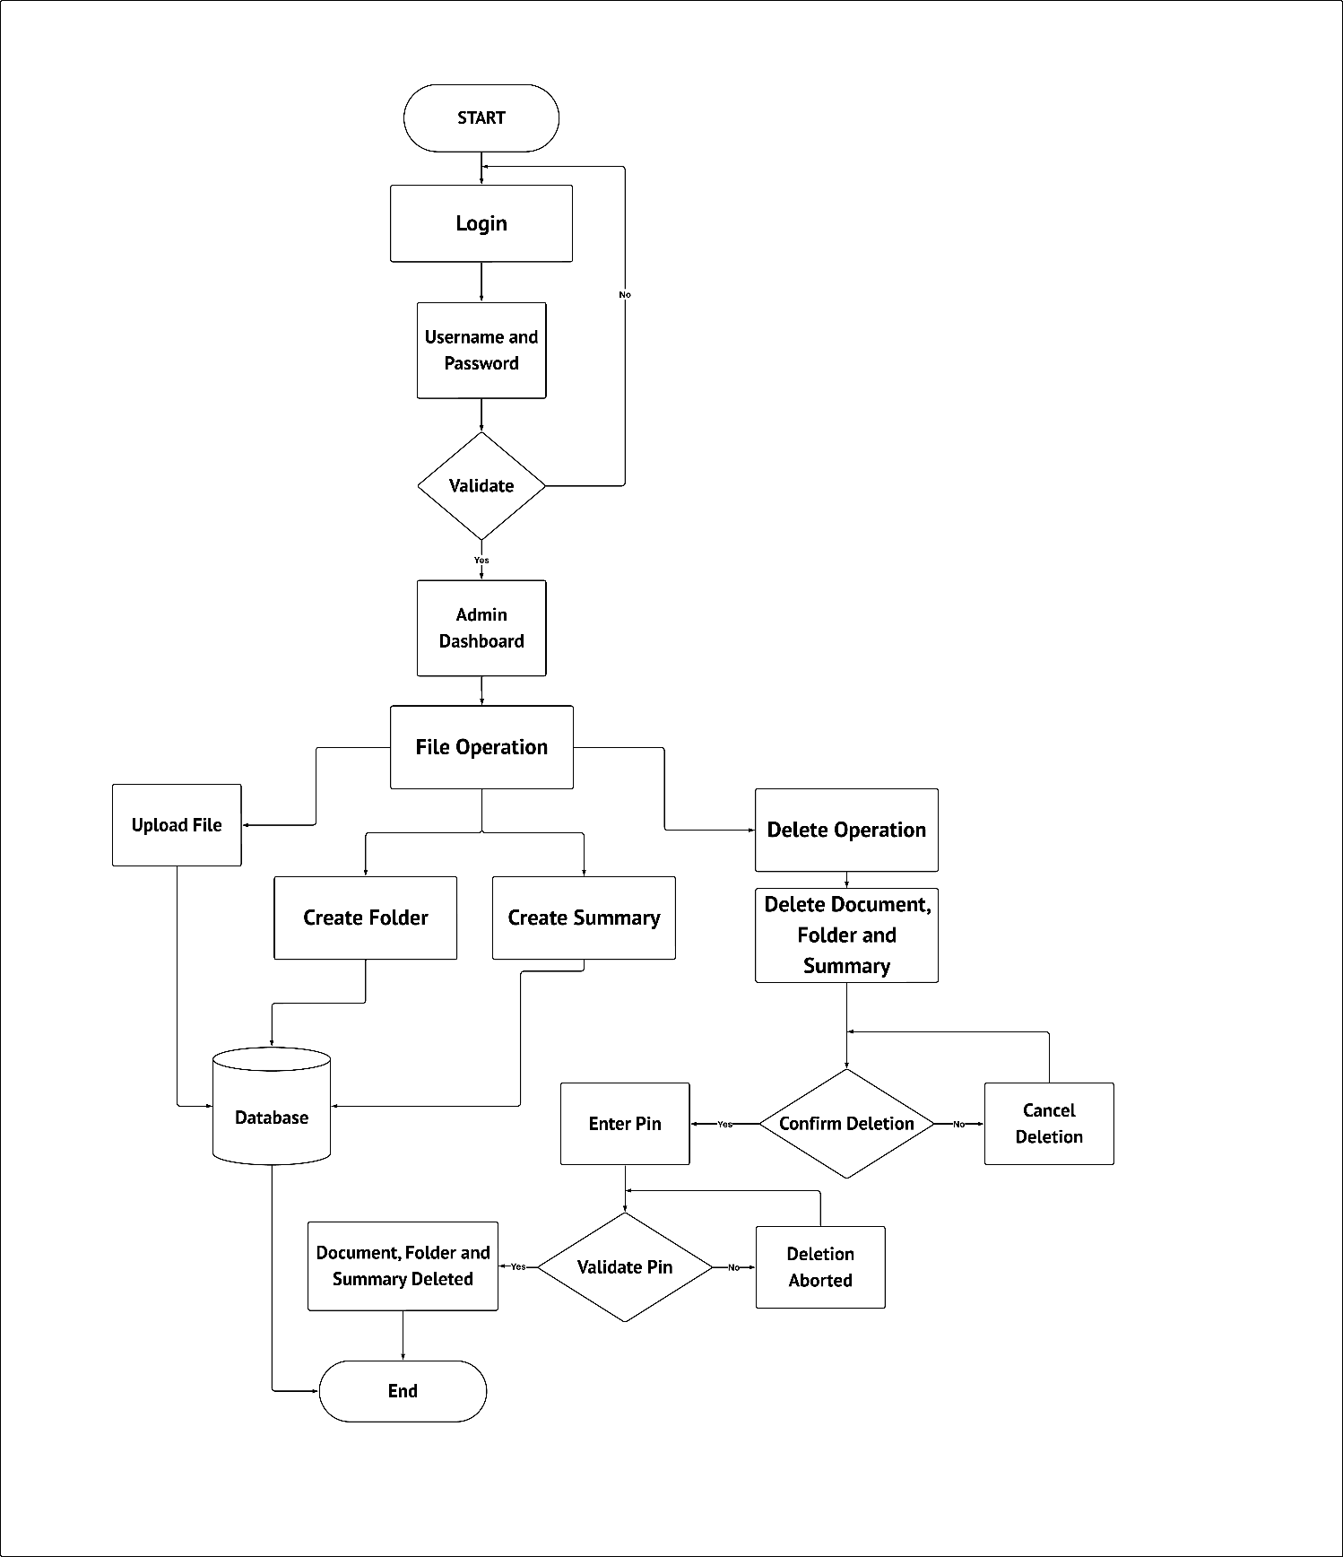

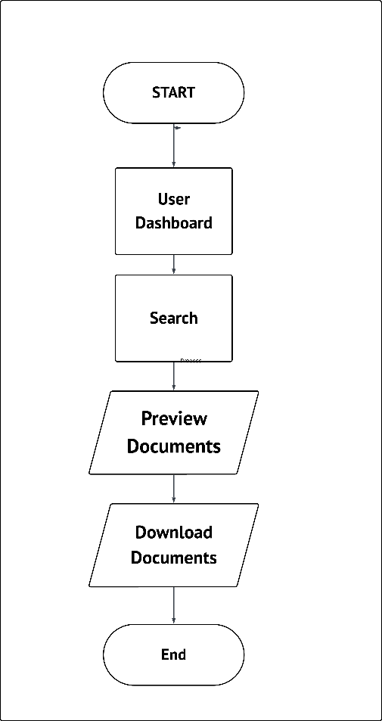

Figure 3. System/Application Flowchart

System Architecture
A conceptual model known as system architecture outlines a system's behavior, structure, and many viewpoints. It is a crucial component of system development since it directs the arrangement and design of system parts, promotes stakeholder awareness and communication, guarantees system integration, and permits scalability and adaptability. In addition, it optimizes system performance, reduces risk, and improves efficiency. (https://reqi.io/articles/what-is-systems-architecture)
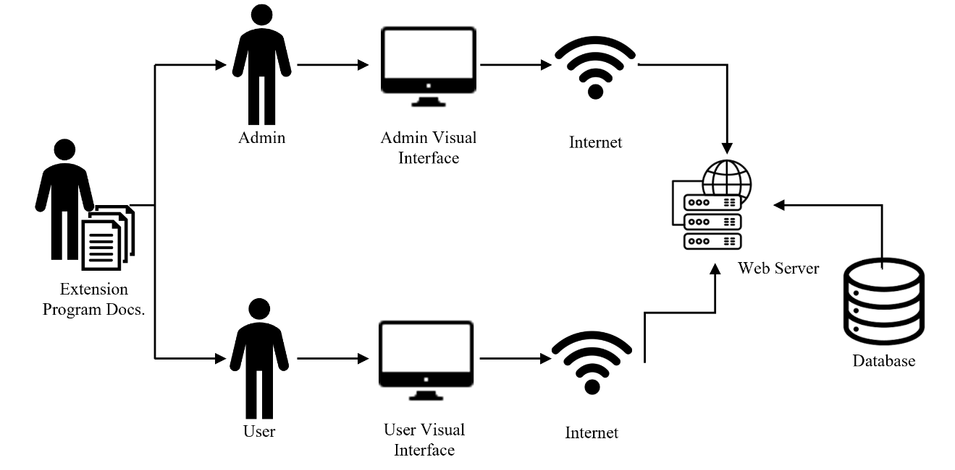

Figure 4. System/Application Architecture

Context Diagram

A Context Diagram is a high-level see of a framework. It is an essential portray implied to characterize a substance based on its scope, boundaries, and connection to outside components like partners. (https://venngage.com/blog/context-diagram/)
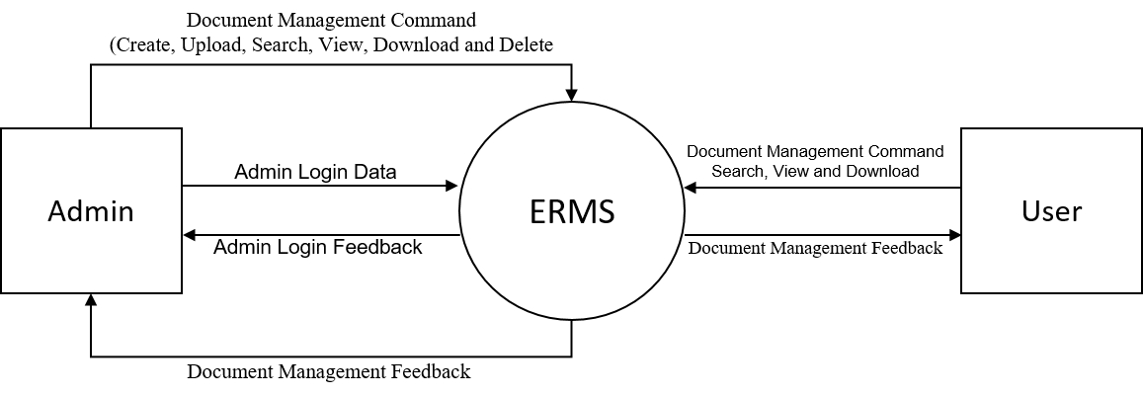

Figure 5. Context Diagram

The diagram illustrates how these two entities connect to the ERMS, which in turn handles their respective report and process through its core functionalities.

Data Flow Diagram

Data Flow Diagram (DFD) speaks to the stream of information inside data frameworks. Information Stream Graphs give a graphical representation of the information stream of a framework that can be caught on by both specialized and non-technical clients. The models empower program engineers, clients, and clients to work together viably amid the examination and detail of prerequisites.
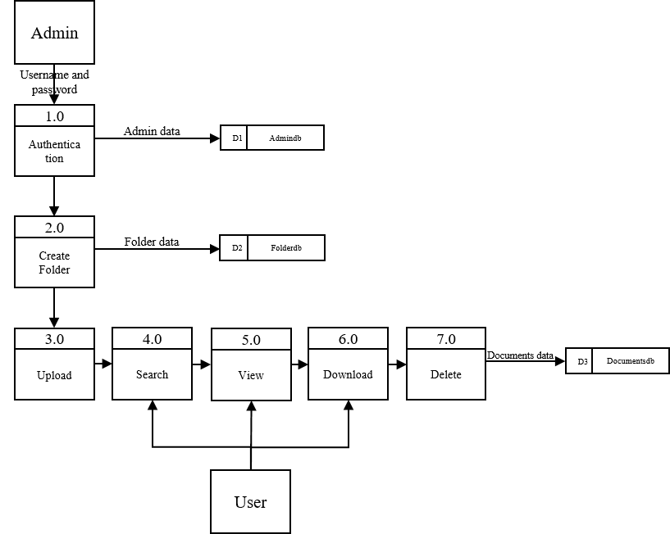

Figure 6. Data Flow Diagram

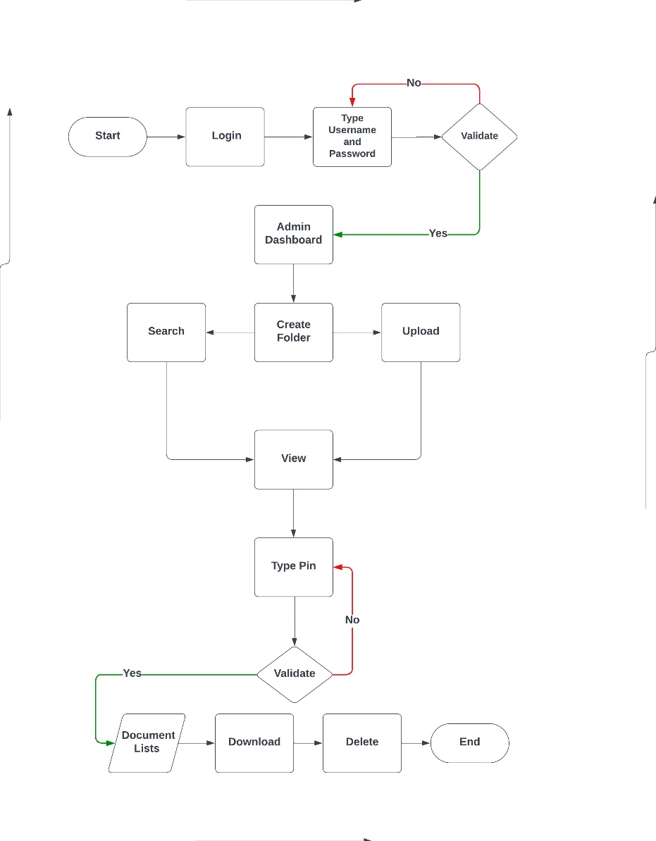
The Extension Repository Management System DFD shows how the admin and user interact with the ERMS through user authentication and document management it shows the flow of information between the system administrator, various process and data repositories, emphasizing the structure and functionality of the system.

Relationship Diagram

A substance relationship chart (ERD), known as a substance relationship demonstrate, is a graphical representation that portrays connections among individuals, objects, places, concepts, or occasions in a data innovation (IT) framework. An ERD employments information modeling methods that can help characterize trade forms and serve as the establishment for a social database (https://www.techtarget.com/searchdatam
anagement/definition/entity-relationship-diagram-ERD).
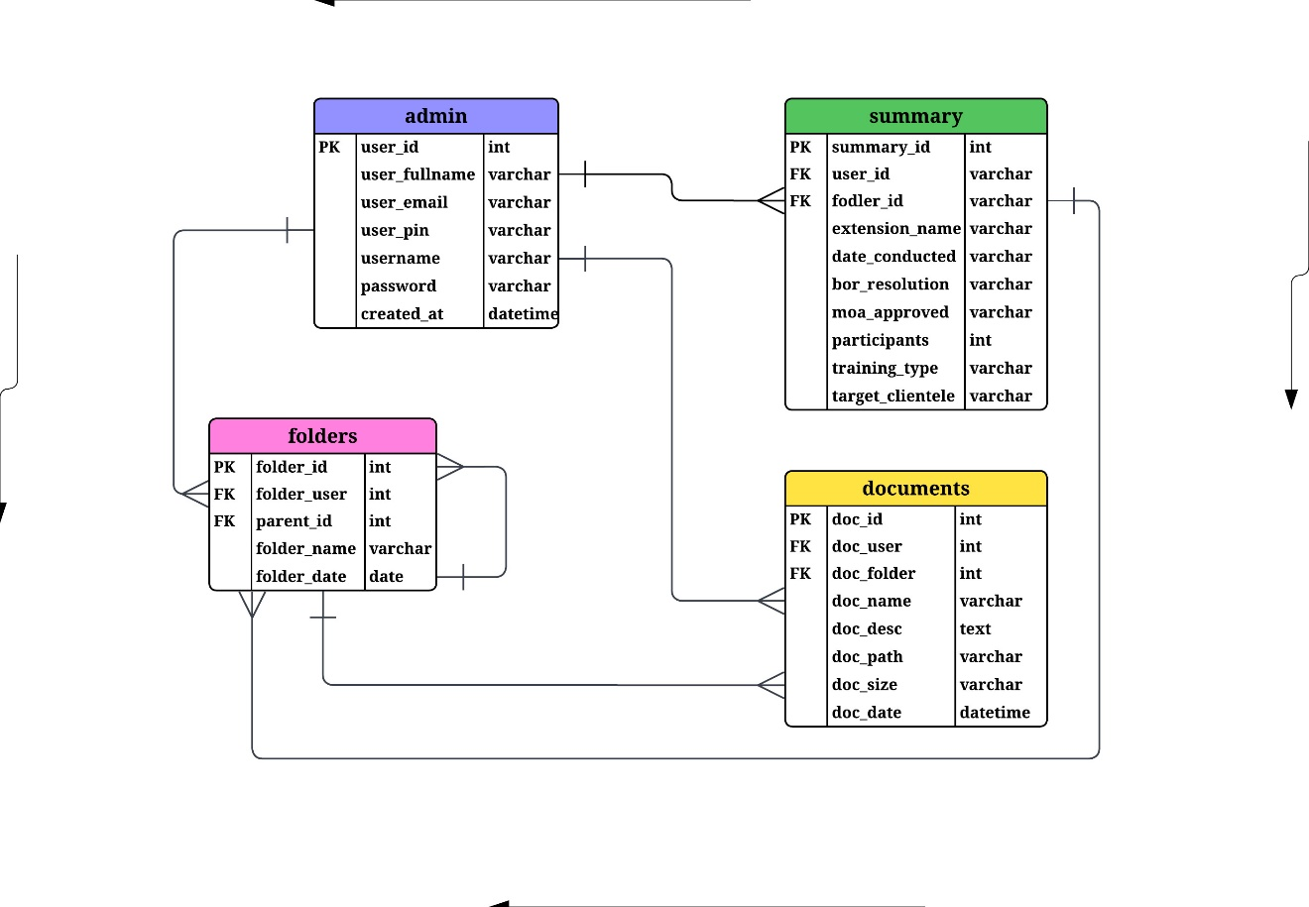

Figure 7. Entity Relationship Diagram

This figure shows the ERD of the Extension Repository Management System. Each entity consists of attributes that can be found in the database, and this figure also shows the relationship between each entity.
Use Case Diagram
A Use case diagram is a strategy utilized in framework investigation to distinguish, clarify, and organize framework prerequisites. In this setting, the term "framework" alludes to something being created or worked, such as a mail-order item deals and benefit Web location. Utilize case charts are utilized in UML (Bound together Modeling Dialect), a standard documentation for the modeling of real-world objects and frameworks. There are several benefits with having a utilize case chart over comparable charts such as flowcharts. (https://www.techtarget.com/whatis/definition/use-case-diagram).
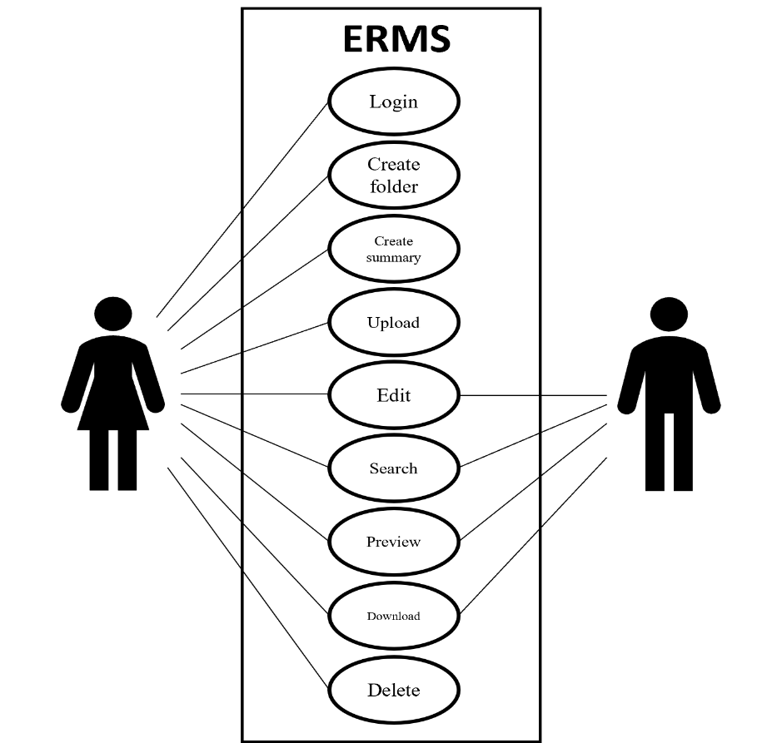

Figure 8. Use Case Diagram
The Extension Repository Management System Use Case Diagram includes features that admin and user must login first to perform actions such as creating folders, uploading documents, viewing documents, searching for specific documents, downloading selected files, and deleting unwanted document.
Respondents
Based on the table presented, admin have a total frequency of 1 with a percentage of 7%, while members/users have a frequency of 14 with a percentage of 93% and a total of 100.00% .
Table 3. Frequency Distribution
RESPONDENTS | FREQUENCY | PERCENTAGE (%)
Admin  Members/Users | 1  14 | 7%  93%
TOTAL | 15 | 100.00

Environment

This capstone project was conducted in Central Philippines State University- Main Campus at College of Computer Studies Department, which is located at Barangay Camingawan, Kabankalan City, Negros Occidental.
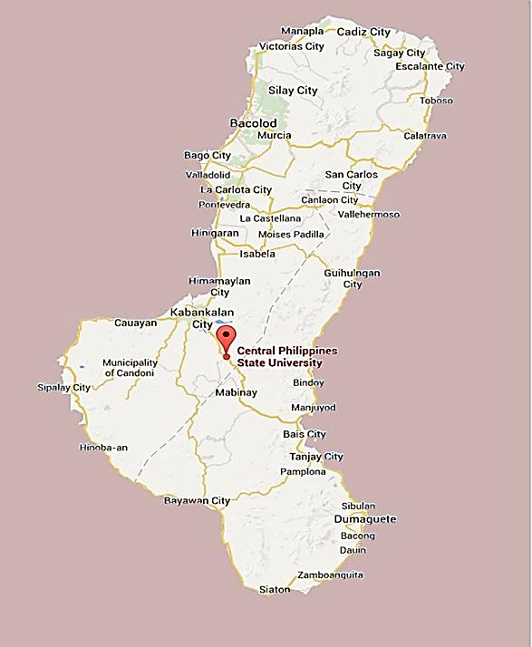

Figure 4. Environment of the Study

Instrument

The researchers used a combination of a preliminary interview, a survey questionnaire, and purposive sampling to collect data and develop and evaluate the “Extension Repository Management System.”
The gather data for the existing process, challenges, and expectations related to ERMS services and document processing, a preliminary interview was conducted with members of ERMS, which is located in the Central Philippines State University, Furthermore, a survey questionnaire was distributed to the Extension Coordinator and IT experts to collect their responses.
The current level of accessing technology, and user expectations for management platform, the questionnaire was designed following the standards established by ISO 25010. With the help of the structured questions, we were able to quantify the requirements and identify the lacking and need to enhance in the system.

Data Gathering Procedures

The researchers approach to gathering data is covered in detail in this section. First, the researchers developed the research title, which the research adviser confirmed appropriate. After validation, the research adviser's recommendations and comments were considered. A letter requesting permission to become the beneficiary of the capstone project under study was submitted to the College of Computer Studies Extension Coordinator. After it's approval, the memorandum containing the signatures of the researchers and the research adviser was attached to the dean's letter. The beneficiary was also requested to provide consent were the researchers study's objectives and their rights as respondents. On the find gathering of the data which includes the respondent’s feedback, purposive sampling was used. This is where the target respondents used the system in two whether often which, rigid evaluation as to its characteristics was done.

Statistical Treatment of Data
The analyst utilized appropriate descriptive statistical strategies adjusted with the objectives of the study and the sort of information collected to guarantee a valid and dependable examination. The information was assembled utilizing a purposive examining strategy through a organized survey overview. This measurable treatment of information guarantees that the investigation is genuine researchers have taken steps to confirm that the information meets the vital suspicious of the measurable approached connected and there is a solid understanding of the factual methods utilized. The reactions collected from the participants were analyzed utilizing the Likert Scale, taken after by the computation of the Weighted Mean to summarized and translate the respondent’s discernments of the Extension Repository and Management System. Using this strategy, the analyst was able to survey the execution of the framework and its quality characteristics such as Functional Suitability, Reliability, Usability, and others, based on the actual client feedback.
Below is the weighted mean formula used by the researchers.

x̄ = $Ʃ$fi
n

Were,

x̄ = Mean

$Ʃ$fi = frequency
N = Number of Summoned Data

CHAPTER IV

RESULTS, CONCLUSION AND RECOMMENDATIONS

The purpose of this chapter was to showcase the outcomes obtained following the implementation and testing of the Extension Repository and Management System and to explore recommendations for the extension program.

Results and Discussion

This section presents the results from the development and assessment of the ‘Extension Repository and Management System’ evaluated in relation to the project’s goals. The system was created to act as a centralized digital platform for the organization, storage, and retrieval of extension program information, ensuring effective documentation and accessibility. To evaluate the system’s effectiveness and usability, input was gathered from selected users, including faculty and extension coordinators. A widely used Likert Scale was utilized to gauge user satisfaction in several important areas: system functionality, user interface, ease of use, accessibility, and overall performance.

Table 4. Summary Table of the System Evaluation as rated by the Clients/End-Users.
SYSTEM QUALITY CHARACTERISTICS | WEIGHTED MEAN | DESCRIPTIVE INTERPRETATION
Functional Suitability | 4.73 | Excellent
Reliability | 4.63 | Excellent
Performance Efficiency | 4.78 | Excellent
Usability | 4.33 | Excellent
Security | 4.81 | Excellent
Compatibility/Portability | 4.77 | Excellent
Maintainability | 3.75 | Good
OVERALL MEAN | 4.54 | Excellent
N = 15

Based on the findings from the survey conducted following the implementation of the Extension Repository and Management System, the following key insights were obtained:
Functional Suitability achieved a weighted mean of 4.73. Indicating that the features and functions of the system effectively fulfilled the users’ requirements. Reliability received a weighted mean of 4.63. Demonstrating that the system reliability executed its intended functions without any failures. Performance Efficiency on the other hand came in with a weighted mean of 4.78. This indicates that the system provided quick and responsive outcomes under certain conditions, aligning with user’s expectations for speed and performance. Also, Usability garnered a weighted mean of 4.33. Although still considered excellent, this implies there are opportunities for enhancement to make the system more user-friendly and intuitive. Security scored the highest weighted mean of 4.81. This indicates that users had a high level of trust in the system’s ability to protect data and operations from threats such as unauthorized access, data breaches, and misuse of information. Performance Efficiency followed closely with a weighted mean of 4.78. This suggests that the system delivered fast and responsive results under specific conditions, meeting users’ expectations in terms of speed and performance. Compatibility/Portability scored a weighted mean of 4.77. The results show that the system worked well across different platforms and was easy for users to access and use. Maintainability had the lowest score with a weighted mean of 3.75, interpreted as Good. This indicates that users found the system somewhat manageable to update or modify after deployment, but improvements could be made to enhance ease of maintenance.
Findings

In this part, the researchers discuss the results obtained through the creation, execution, and assessment of Extension Repository Management System. The results tackle the main research problem.
1. How can the manual process of managing CCS extension documents be effectively improved to reduce inefficiencies, data errors, and time-consuming management tasks?
When it comes to CCS extension documents, turning a manual process into a digital one is totally doable with a document management system. This kind of system keeps everything organized in one place, so you can ditch those bulky filing cabinets and avoid the headaches of lost papers. Plus, automating tasks like data entry, sorting, and keeping track of uploads means fewer mistakes and more time saved. Finding documents is a breeze with a solid search feature, and it's designed to be user-friendly, so even if you're not tech-savvy, you won't feel lost. To boost security, adding secure logins and access controls based on user roles is a smart move. Consistent data entry and a tidy filing system also ramp up efficiency. Overall, these steps cut out unnecessary tasks, improve accuracy, and ramp up productivity, which really benefits the whole organization.
2. What are the essential features and requirements needed to develop a system that organizes and streamlines document filing for the CCS extension program?
To make organizing and filing documents for the CCS extension program a breeze, we need to include some key features. First off, having categorized folders will let us sort documents by program or activity easily. We'll also want a secure and easy-to-use upload function that can handle common file types like PDF, Word, Excel, and images. A quick search tool is a must, so users can find files using keywords or names without a hassle. It’s important to have role-based access too, which means only the right people can manage certain documents. A friendly, responsive interface will make sure everyone can use the system on desktop and mobile devices without any issues. Also editing and archiving will also keep the documents clean and organized. These capabilities, which are particularly matched for the extension program, will all assist in managing documents effectively, precisely and securely.
3. How can a user-friendly platform be designed to facilitate the uploading and management of documents for CCS extension programs?
For the CCS extension document management system, usability is just as important as functionality. Researchers learned from respondent feedback that the system must have a simple, easy-to use interface. Without a lot of guidance, it should be simple for users to upload, search, and arrange documents. It is user-friendly, even for non-techies, because user interface has straight forward navigation menus, and easy to upload documents by clicking the icons. In order for everyone to use it regardless of where they are, the design should also function properly on desktops and mobile devices. All of these usability elements are necessary to ensure that everyone can utilize the system on a regular basis and that beginners will easily learn and lead to smooth experience in managing extension files.
4. What measures should be implemented to ensure secure access control and document security within the CCS extension program’s system?
Only the Admin can log in and handle all extension document and folders in order to have a safe access control and give documents a security within the system. Although users can access, they only had limited access to the system. They can only browse and download a particular file in the shared link of the admin. Because these connections are made for restricted access, user can only view documents and unable to edit, upload, or delete anything. In this way admin can maintain strict control in managing document, safeguard private data and guarantee that users can only access files and avoid illegal changes or deletion.

Conclusion

The research findings indicate that the proposed digital document management for the CCS extension program effectively address the limitations of the previous manual process. Key improvements include centralized document storage, automated data entry, and organized file categorization, which enhance the management of extension related documentation. The system features user-friendly search functionality, secure access with role- specific permissions, and the ability to manually upload files. Users have highlighted the intuitive interface the facilitates easy adoption. Comprehensive testing revealed strong functionality, user-friendliness, and robust security, significantly reducing data errors and streamlining document access. Security is further enhanced by restricting user access to specific folders and documents as designated by the admin. While the system is reliable and effective, ongoing feedback and adjustments will ensure its continued relevance and refinement. Overall, the system provides a secure and efficient solution for managing CCS extension documents, aligning with the goals of improved management and organization.
Recommendations

Given the positive outcome evaluations as well as user satisfaction ratings, it is now recommended that the entire system of the CCS extension program be fully implemented and adopted fully in the operations of the program. To continue improving the user experience and allow further developments, the following recommendations have been made:
1. Categorized Folder Management. The system should allow users to store documents in categorized folders by programs, activities, or dates. This help to maintain order within the system and make it easy for users to find any files they need.
2. User Interface Enhancement. Change the overall visual design and interactive elements that can make the system more intuitive, user-friendly, and pleasing to the eye. This can include simple layouts designs, responsive across devices, and use of modern design trends for improving usability and accessibility.
3. Summary Report for Admin- Only Editable Programs. This feature should allow the admin to generate summary reports form the documents uploaded for admins only. This ensures that the authorized people take care of the reports and thus maintains data integrity, and provides a central way of tracking and evaluating extension programs using verified information.
Budget Recommendation

This section describes the system budget needed in other to implement the application.
Table 5. Recommended Budget for the Implementation of the System.
PARTICULARS | SPECIFICATION | QUANTITY | COST/UNIT  (Php) | TOTAL  (Php)
HARDWARE
Laptop | Lenovo Think pad X270 | 1 | 20,000 | 20,000.00
 |  |  | Sub-Total | 20,000.00
SOFTWARE
Hosting Server | JDC Host webhosting and Domain | 6 Months | 1,000  6 months | 1,000.00
Internet Connection | Any Internet Service Provider | 1 | 1,000 | 1,000.00
 |  |  | Sub-Total | 2,000.00
GRAND TOTAL 22,000.00

Implementation Plan

The researchers plan to conduct a user-friendly training to users in order to instruct the user. To make sure they understand how to use the system is the main goal of the training. And on how to share individual folder interactions with the user, allowing them to see and download only, the admin will receive training on how to upload, arrange, and manage documents. Setting access permission, creating and sharing hared links will also be covered in the training. Experience will help the admin learn. A help desk and follow-up meetings will give support, and admin input will be employed to create any necessary system enhance. Researchers begin by deploying the system in controlled environment for the admin, allowing them to create a shareable link for users, upload documents, and set permission. The admin will start sending users URLs to specific folders for viewing and downloading after making sure everything work as it should. Before the system is completely deployed, the implementation will be done progressively, starting with small documents to make sure it’s functionality and fix any problem. Support will be offered regularly to help with any challenges that may occur during this stage. After deployment, the system will be monitored continuously to make sure it’s security and smooth functionality’s admin will be in charge of maintaining they system’s security, updating and managing documents, and updating permissions for access. Based on user’s needs, regular updates will be prepared to enhance they system functionality, fix problem, and offer new features. A determined support will respond immediately to any technical problem that occur. In order to provide timely enhancement or upgrade, the system also receive regular inspections to asses functionality, performance, and user satisfaction. Further changes will direct to the admin’s input, providing that the system stays functional, secure, and keeping emerging needs,

REFERENCES

Alokluk, J. (2019). Archiving and Document Management a Taibah University: A Case Study. Computer and Information Science
Angala, D., et al., (2003). Development and Implementation of Document Management System for Ilocos Sur Polytechnic State College.
Asadi, S., et al., (2019). Understanding Institutional Repository in Higher Learning Institutions: A Systematic Literature Review and Direction for Future Research, in
Access, vol. 7, pp. 35242-35263, doi: 10.1109/ACCESS.2019.2897729.

Clements, J. (2024). Document Management in the Education Industry Challenges. Managed Outsource Solutions. https://www.managedoutsource.com/-industry.
Cuevas, M. and Casauy, P. (2022). College of Information and Computing Science. Cagayan State University-Piat Campus, Cagayan Philippines. https://doi.org/10.37502/IJSMR.2022.560.
Cumpa, C., et al., (2023). The Impact of Document Management Using Good Practices: A Literature Review. International Journal of Professional Business Review, 8(11), e04112. https://doi.org/10.26668/businessreview/2023.v8i11.4112.
Davis, G. H. (2020). Managing your Files and Folders. 128–163. https://doi.org/10/1002/
9781119683933.ch5.

Dinneen, J. D., and Julien, C. A. (2019). The ubiquitous digital file: A review of file management research. Journal of the Association for Information Science and Technology, 71(1). https://doi.org/10.1002/asi.24222.
Estrera, P. J. (2017). Electronic Document Management System for Higher Education Institution. International Journal of Innovative Science and Research Technology. Volume 2, Issue 5. www.academia.edu.
Gamba, M., et al., (2015). Systems Development for Records Archiving and Digital Documents Repository: A Case Study. JPAIR Institutional Research. (4.10.7719/irj. v4i1.303).
Gandola, D. (2017). Server- Based Document Management System. www. Academia.edu/.
Jahan, T. (2018). Personnel Document Management System. https://www.academia.edu.
Jaramillo, I., et al., (2023). Repository for academic documents, algorithms and data: A utility in an educational context. Journal of Technology and Science Education, 13(3), 761- 774. https://doi.org/10.3926/jotse.1885.
Kamble, S. and Trivedi, M. (2023). Best Practices in Archive and Record Management in Electronic Age: Approaches and Challenges. Positif. 23. 12- 20.10.37896/psj30.6/17901.
Maldonado, J., et al., (2016). Educational Repositories," in IEEE Revista Iberoamericana de Tecnologias del Aprendizaje, vol. 11, no. 2, pp. 79-86.
Montalban, T., et al., (2023). Record Management System for Office Memoranda. Zenodo (CERN European Organization for Nuclear Research). International Journal of Computer Science and Information Technology Research. Vol. 11, Issue 2, pp: (87-92), https://doi.org/10.5281/zenodo.7937015.
Mouse, A. (2022). Electronic Document Securitization based in Document Structure. International Journal of Advanced Trends in Computer Science and Engineering, 11(3),163-168. https://doi.org/10.30534/ijatcase/2022/041142022.
Ndegwa, H. (2024). Efficacy of Digital Preservation Practices in Institutional Repositories of Selected Public Universities in Kenya. https://www.researchgate.

Nurpandi, F and Firdaus, R. (2023). Analysis and design of electronic document management system (case study of faculty of engineering, Suryakancana University). 50001. https://www.researchgate.net.
Okon, R., et al., (2020). A Web Based Digital Repository for Scholarly Publication. Journal of Software Engineering and Applications, 13, 67-75. Doi:10. 4236/jsea.2020.134005.
Ozgur Polat, L. (2022). Digital Transformation Process in Selection and Implementation of an Electronic Document Management System. In O. Yildiz (Ed.), Digital Transformation and Internationalization Strategies in Organizations (pp. 62-84). IGI Global. https://doi.org/10.4018/978-1-7998-8169-8. ch004.
Pagayonan, S. M. S. (2021). Record Management System with Document Control. International Journal of Multidisciplinary Research and Analysis, 04(12). https://doi.org/10.47191/ijmra/v4-i12-23
Paragarino, V., et al., (2016). Use of Repositories of Digital Educational Resources: State- of-the-Art Review," in IEEE. vol. 11, no. 2, pp. 73-78.doi: 10.1109/RITA.2016.2554000.
Patil, Suresh and Oak, Meenal. (2015). Planning and Implementation of Institutional Repository: a case study of IMCC. https://www.academia.edu
Paucar, L., et al., (2022). Model of Long- Term Preservation of Digital Documents in Institutes of Higher Education. Communications in Computer and Information Science, vol 1593, (pp. 257–269). https://doi.org/10.1007/978- 3-031-07920-7_20
Rimkus, K., et al., (2015). Digital Preservation File Format Policies of ARL Member Libraries: An Analysis. D-Lib Magazine. 20. 10.1045/march2015-rimkus.
Svard, P. (2017). Records Management. In Elsevier eBooks (pp. 13–24). https://doi.org/10.1016/b978-0-08-100874-4.00002-8
Toelle, E. (2021). Records Management. In: Microsoft 365 Compliance. Apress, Berkeley, CA. https://doi.org/10.1007/978-1-4842-5778-4_9
Triyana, M. and Fianty, M. (2023). Optimizing Educational Institutions: Web- Based Document Management. International Journal of Science, Technology and Management.4.1653-1659.10.6729/ijstm. v4i6.976. https://www.academia.edu/.
Zhao, Dan. (2024). Information Security and Privacy Protection Strategies in the Process of Electronic Archiving. Journal of Electrical Systems. 20. 374- 380.10.52783/jes.2658.

APPENDICES

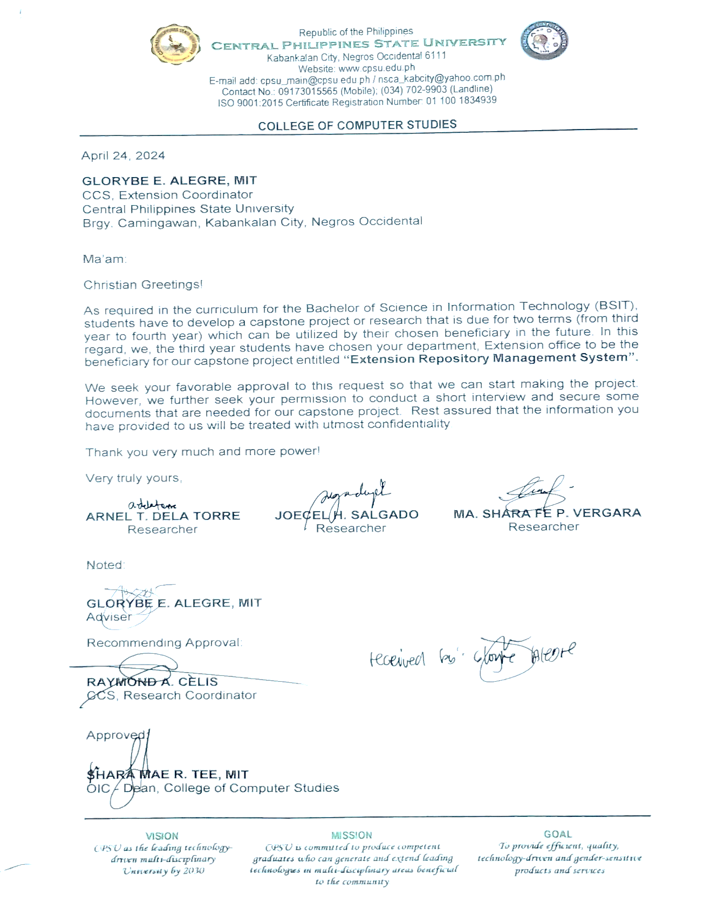
Appendix A. Letter Request
Appendix B. Input- Output Reports Input

USER DASHBOARD
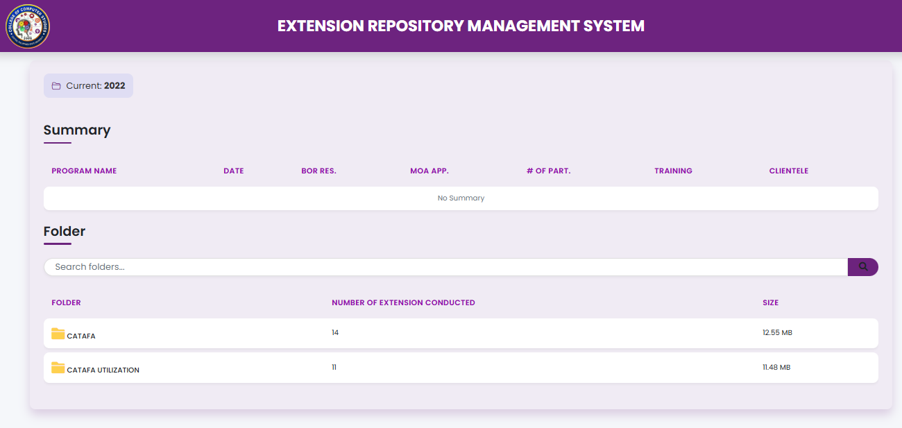

ss

USERS DOCUMENT SECTION
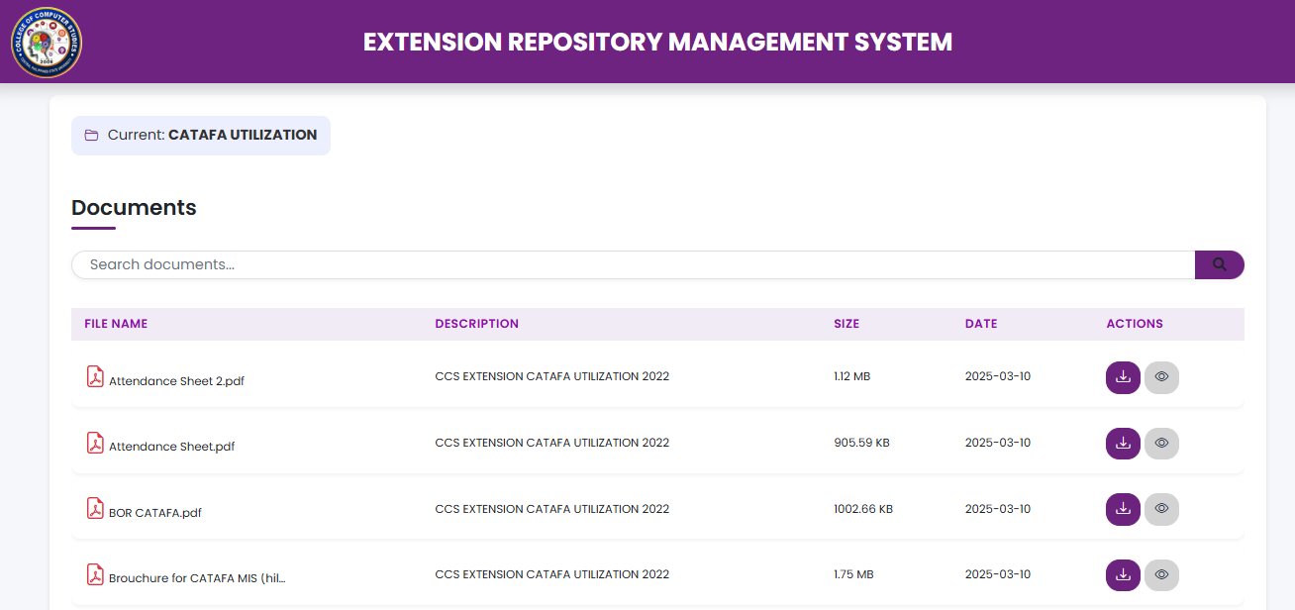

ADMIN DASHBOARD
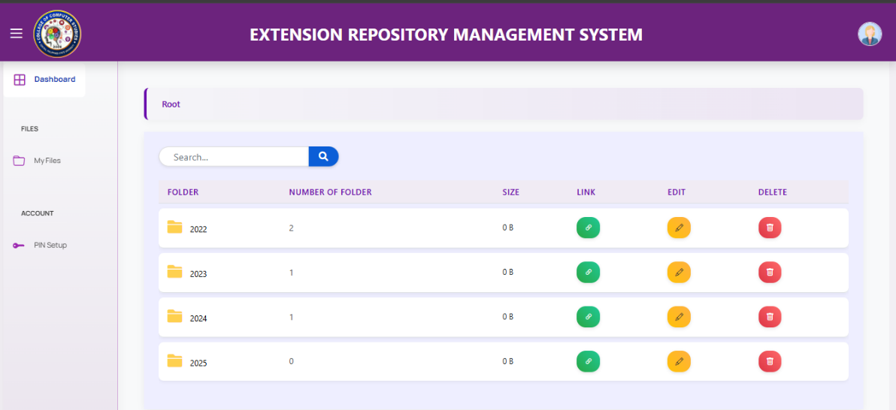

ADMIN DOCUMENT SECTION
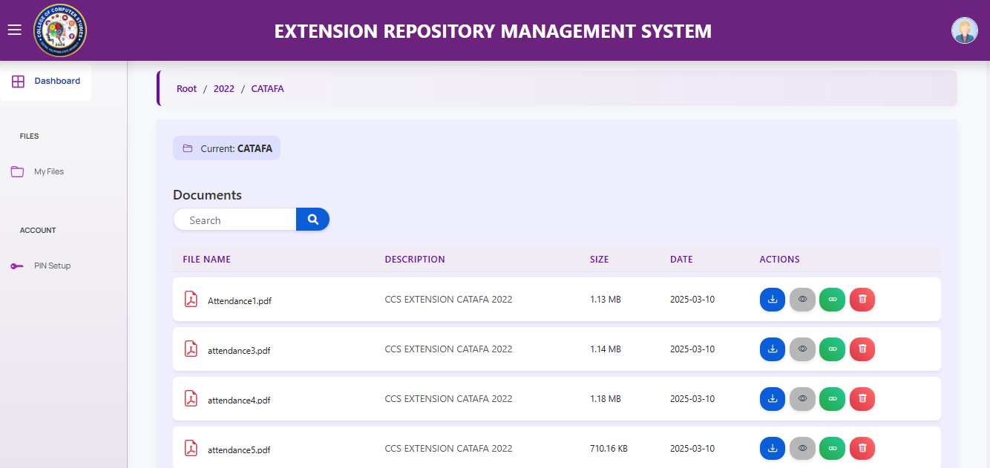

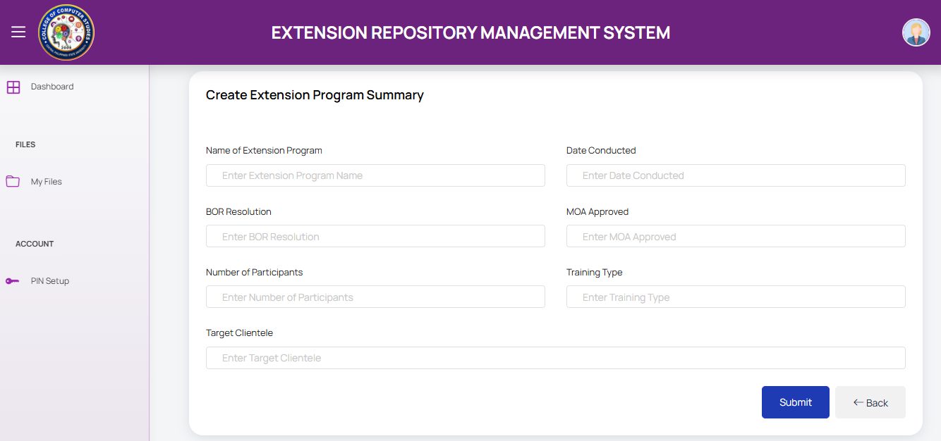
CREATE SUMMARY REPORT

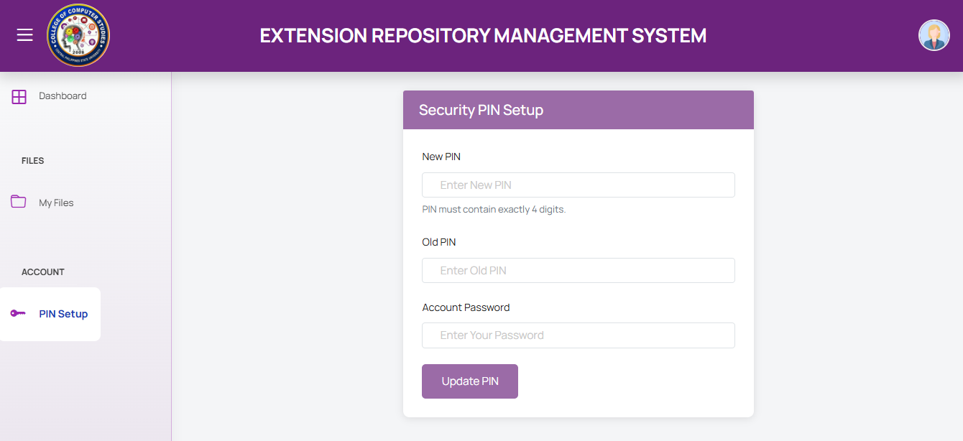
PIN SETUP

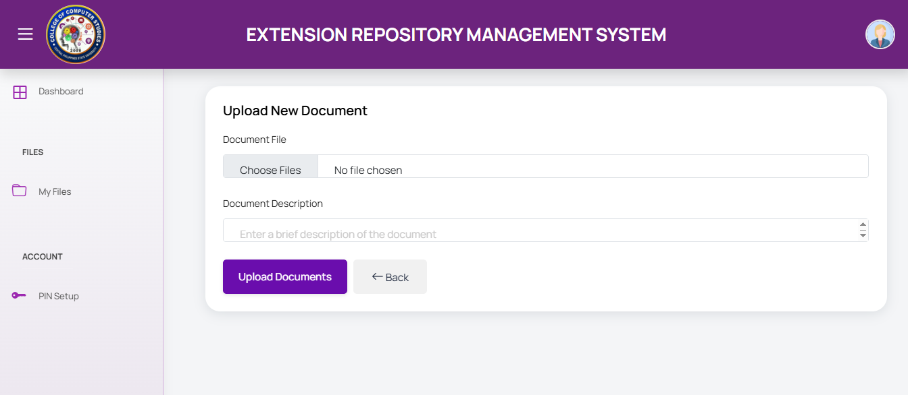
UPLOAD DOCUMENT

ADMIN LOGIN

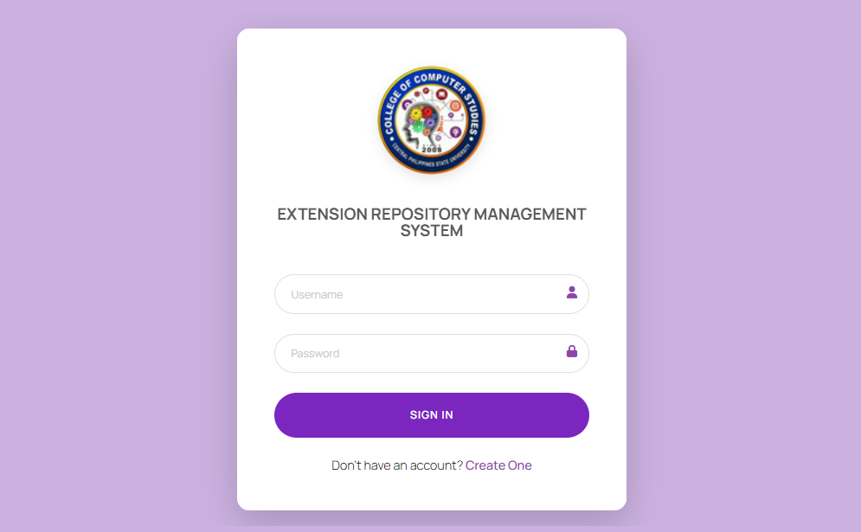
ADMIN LOGIN

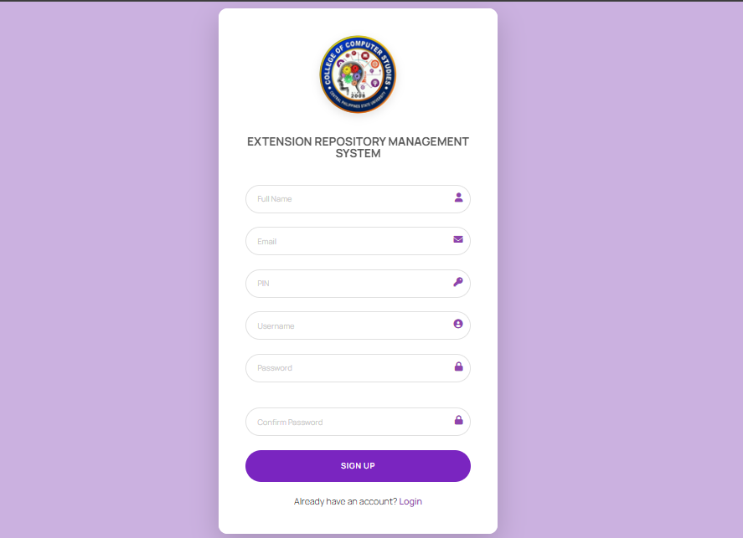
ADMIN REGISTER

Appendix C. Evaluation Tool
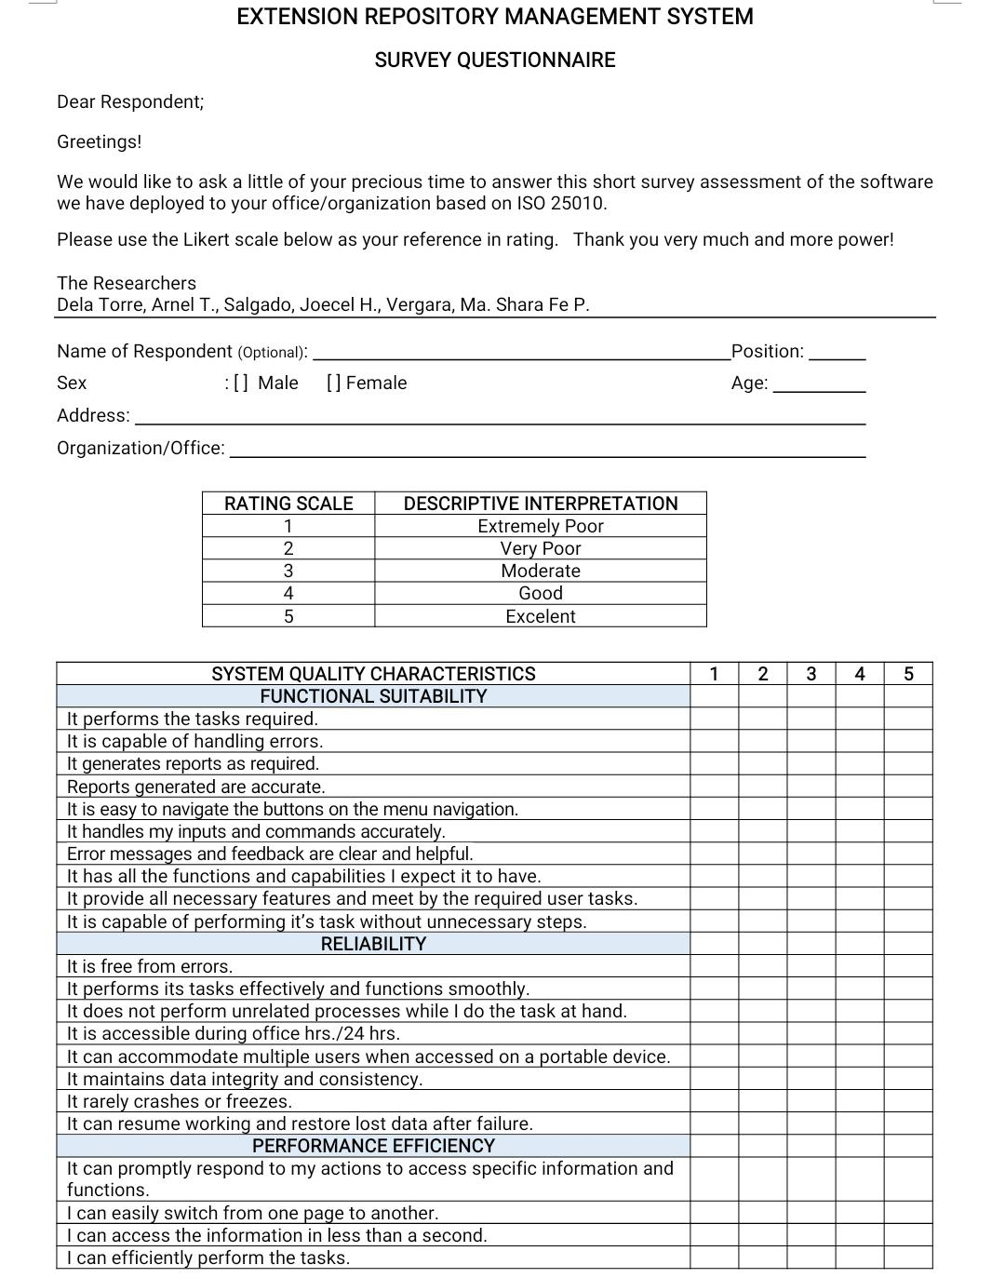

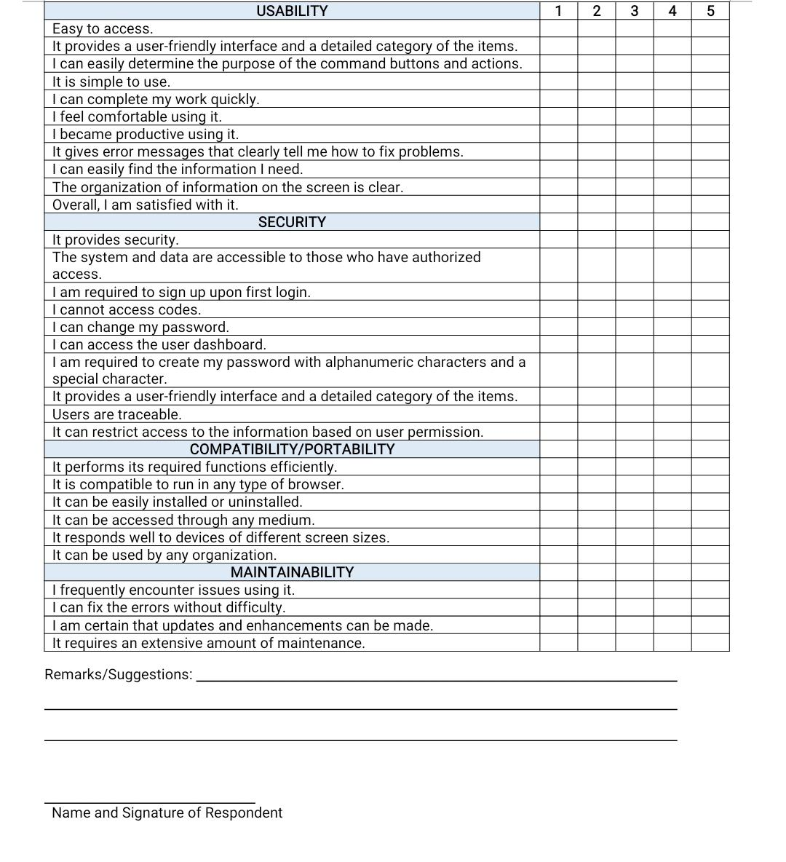

Appendix D. Evaluation Results
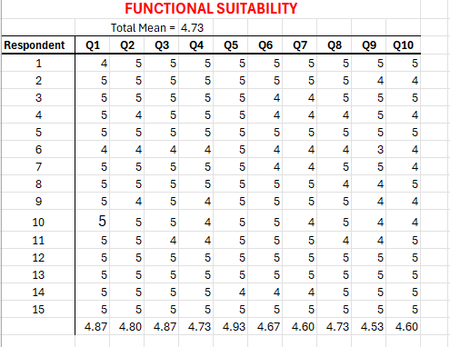

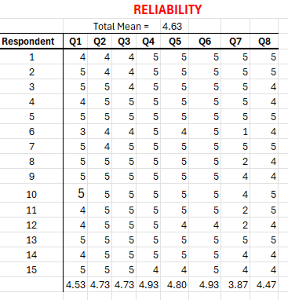
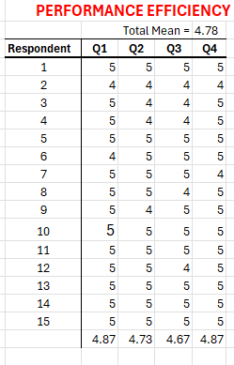

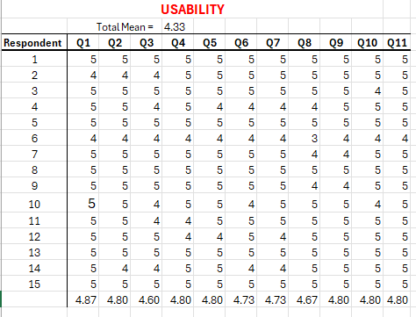
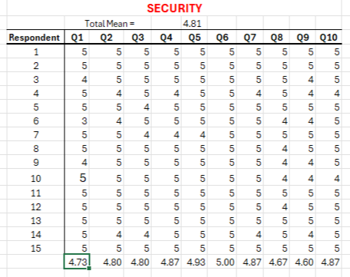
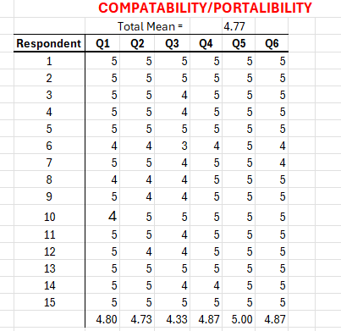

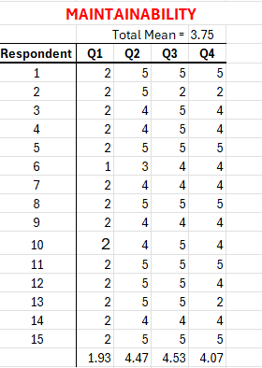

Appendix E. Photos During the Conduct of Evaluation with the System Beneficiary
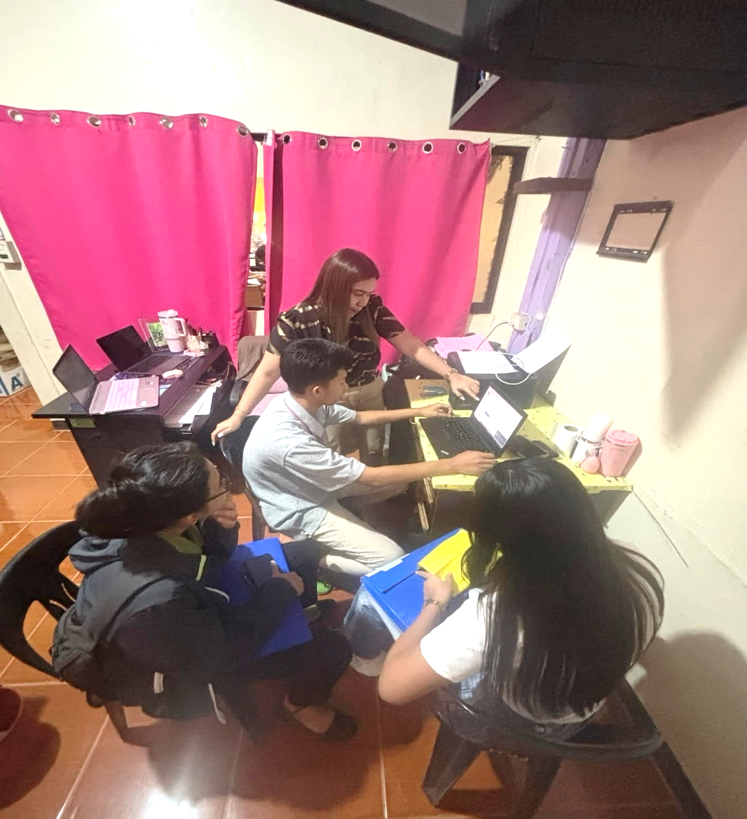
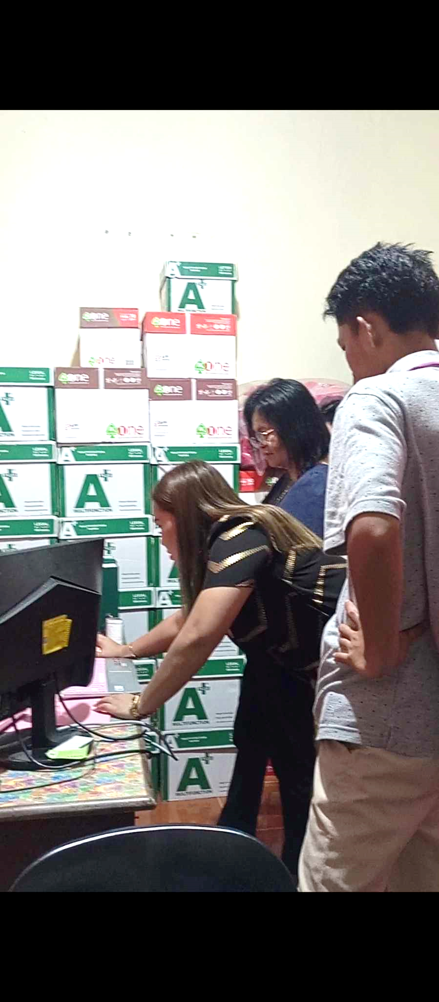
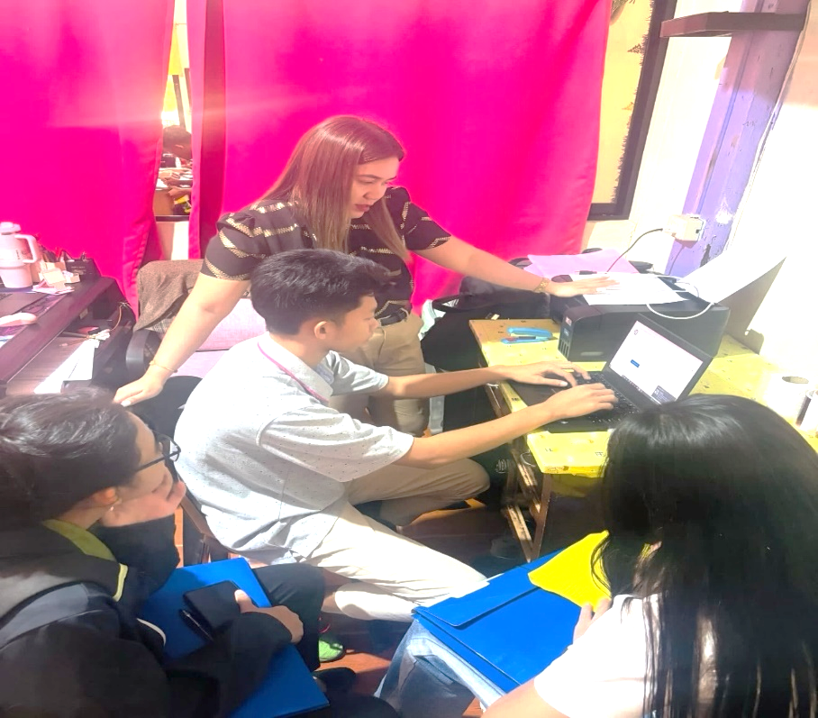

Appendix F. Gantt Chart
PARTICULARS | 2024
 | April |  |  |  | May |  |  |  | June |  |  |  |  | July
 | Weeks
 | 1 | 2 | 3 | 4 | 1 | 2 | 3 | 4 | 1 | 2 | 3 | 4 | 1 |  | 2 | 3 | 4
Title Defense
Planning
Consultation with Adviser
System/Application Development
Making of Chapter I-III
Conduct of Interview
Pre-Oral
PARTICULARS | 2025
 | January |  |  |  | February |  |  |  | March |  |  |  |  | April
 | Weeks
 | 1 | 2 | 3 | 4 | 1 | 2 | 3 | 4 | 1 | 2 | 3 | 4 | 1 |  | 2 | 3 | 4
Consultation with Adviser
Deployment of System
Survey of Respondents
Final Defense

Appendix G. Screen Layouts
USER DASHBOARD
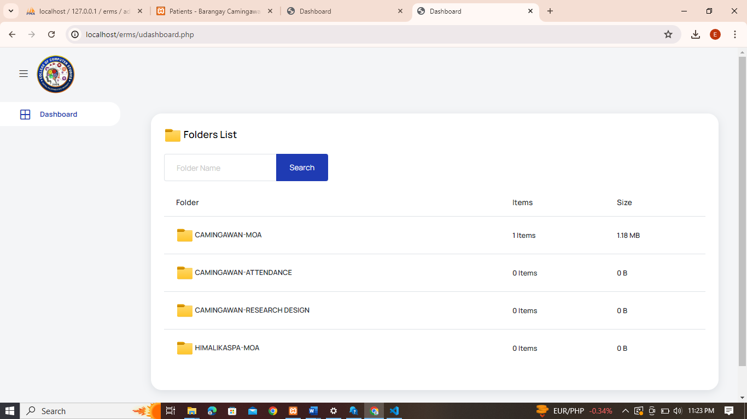

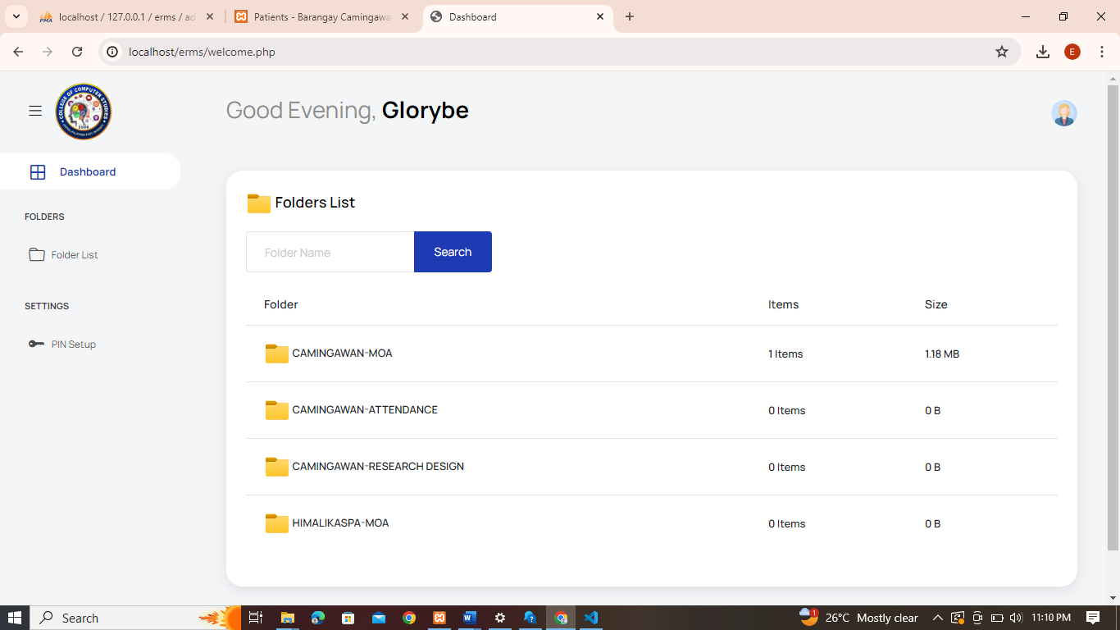
ADMIN DASHBOARD
Appendix H. Source Codes

<?php
session_start();
if (isset($_SESSION["loggedin"]) andand $_SESSION["loggedin"] === true) {
header("location: files.php");
exit;
}
require_once "config.php";
$username = $password = "";
$username_err = $password_err = $login_err = "";
if ($_SERVER["REQUEST_METHOD"] == "POST") {
if (empty(trim($_POST["username"]))) {
$username_err = "Please enter username.";
} else {
$username = trim($_POST["username"]);
}
if (empty(trim($_POST["password"]))) {
$password_err = "Please enter your password.";
} else {
$password = trim($_POST["password"]);
}
if (empty($username_err) andand empty($password_err)) {
$sql = "SELECT user_id, user_fullname, username, password FROM admin WHERE username = ?";
if ($stmt = mysqli_prepare($conn, $sql)) {
mysqli_stmt_bind_param($stmt, "s", $param_username);
$param_username = $username;
if (mysqli_stmt_execute($stmt)) {
mysqli_stmt_store_result($stmt);
if (mysqli_stmt_num_rows($stmt) == 1) {
mysqli_stmt_bind_result($stmt, $id, $fullname, $username, $hashed_password);
if (mysqli_stmt_fetch($stmt)) {
if (password_verify($password, $hashed_password)) {
session_start();
$_SESSION["loggedin"] = true;
$_SESSION["user_id"] = $id;
$_SESSION["fullname"] = $fullname;
$_SESSION["username"] = $username;
header("location: admindashboard.php");
} else {
$login_err = "Invalid username or password.";
}
}
} else {
$login_err = "Invalid username or password.";
}
} else {
echo "Oops! Something went wrong. Please try again later.";
}
mysqli_stmt_close($stmt);
}
}
mysqli_close($conn);
}
?>
<!DOCTYPE html>
<html lang="en">
<head>
<meta charset="utf-8">
<meta name="viewport" content="width=device-width, initial-scale=1, shrink-to-fit=no">
<title>Login</title>
<link rel="icon" type="image/x-icon" href="logo/logo.jpg">
<link rel="stylesheet" href="login.css">
<?php include 'partials/headtags.php'; ?>
</head>
<body>
<div class="container-scroller">
<div class="auth-form-container shadow-lg">
<div class="bg-white py-5 px-4 px-sm-5">
<div class="brand-logo text-center">
<div class="d-flex align-items-center justify-content-center">
<img src="logo/logo.jpg" alt="logo" class="mb-3 logo-image">
</div>
<h4 class="text-center system-title my-4">EXTENSION REPOSITORY MANAGEMENT SYSTEM</h4>
</div>
<form class="pt-3" action="<?php echo htmlspecialchars($_SERVER["PHP_SELF"]); ?>" method="post">
<?php
if (!empty($login_err)) {
echo '<div class="alert alert-danger rounded-pill text-center py-2">' . $login_err . '</div>';
}
?>
<div class="form-group">
<input type="text" name="username" class="form-control form-control-lg <?php echo (!empty($username_err)) ? 'is-invalid' : ''; ?>" value="<?php echo $username; ?>" placeholder="Username">
<i class="fas fa-user"></i>
<span class="invalid-feedback"><?php echo $username_err; ?></span>
</div>
<div class="form-group">
<input type="password" name="password" class="form-control form-control-lg <?php echo (!empty($password_err)) ? 'is-invalid' : ''; ?>" placeholder="Password">
<i class="fas fa-lock"></i>
<span class="invalid-feedback"><?php echo $password_err; ?></span>
</div>
<div class="mt-4">
<input type="submit" class="btn btn-block btn-primary btn-lg font-weight-medium auth-form-btn w-100 login-btn" value="SIGN IN">
</div>
<div class="text-center mt-4 fw-light">
Don't have an account? <a href="register.php" class="create-account-link">Create One</a>
</div>
</form>
</div>
</div>
</div>
<?php include 'partials/javascripts.php'; ?>
</body>
</html>


BIOGRAPHICAL SKETCH
PERSONAL INFORMATION

Name : Arnel T. Dela Torre
Nickname : Arnel
Date of Birth : May 5, 2003
Address : Brgy. Nauhang, Sipalay City,
Negros Occidental

Parents : Mrs. Annabelle T. Dela Torre
Mr. Romel N. Dela Torre

Siblings : Ariel T. Dela Torre

E-mail Address : arneldelatorre30@gmail.com
Contact No. : 09707223532

EDUCATIONAL BACKGROUND

Education School Last Attended Year Graduated

Elementary : Cantaca Elementary School 2015 Sipalay City, Negros Oriental

Secondary : Gil Montilla National High School 2021
Sipalay City, Negros Occidental

Tertiary : Central Philippines State University 2025
Brgy. Camingawan, Kabankalan City
Negros Occidental

Course : Bachelor of Science in Information Technology

AFFILIATION IN ORGANIZATIONS

Organization Position Year

Supreme Student Government Member 2021-2025
Future Leaders of the Philippines Member 2021-2025
InfoTech Organization Member 2021-2025

CPSU Catholic Youth Organization Member 2023-2025
PERSONAL INFORMATION

Name : Joecel H. Salgado
Nickname : Khay
Date of Birth : January 18, 2003
Address : Brgy. Oringao, Kabankalan City
Negros Occidental

Parents : Mrs. Rutchie H. Salgado
Mr. Joemarie A. Salgado

Siblings : Cheryl, Trisha Andrea, April Joy

E-mail Address : salgadojoecel7@gmail.com
Contact No. : 09207190905

EDUCATIONAL BACKGROUND

Education School Last Attended Year Graduated

Elementary : Kabugwason Elementary School 2015 Bacolod City, Negros Oriental

Secondary : Florentino Galang Senior National High School 2021
Kabankalan City, Negros Occidental

Tertiary : Central Philippines State University 2025
Brgy. Camingawan, Kabankalan City
Negros Occidental

Course : Bachelor of Science in Information Technology

AFFILIATION IN ORGANIZATIONS

Organization Position Year

Supreme Student Government Member 2021-2025
Future Leaders of the Philippines Member 2021-2025
InfoTech Organization Member 2021-2025
GAD Scholarship Scholar 2022-2025

PERSONAL INFORMATION

Name : Ma. Shara Fe P. Vergara
Nickname : Shara
Date of Birth : July 10, 2003
Address : Brgy. Tagukon, Kabankalan City
Negros Occidental

Parents : Mrs. Sheba P. Vergara
Mr. Felix S. Vergara

Siblings : Nino Felix, Fredy Boy, Ian Fel, Shem Philip, Sheza Faith

E-mail Address : sharavergara642@gmail.com
Contact No. : 09750267988

EDUCATIONAL BACKGROUND

Education School Last Attended Year Graduated

Elementary : McKinley Elementary School 2015 Guihulngan City, Negros Oriental

Secondary : Tagukon National High School 2021
Kabankalan City, Negros Occidental

Tertiary : Central Philippines State University 2025
Brgy. Camingawan, Kabankalan City
Negros Occidental

Course : Bachelor of Science in Information Technology

AFFILIATION IN ORGANIZATIONS

Organization Position Year

Supreme Student Government Member 2021-2025
Future Leaders of the Philippines Member 2021-2025
InfoTech Organization Member 2021-2025
KCEAP Scholarship Scholar 2022-2025

