Republic of the Philippines

**WESTERN MINDANAO STATE UNIVERSITY**

**Pagadian External Campus**

Bulatok, Pagadian City

Gas and Smoke Detector Using MQ-2 Sensor and ESP8266

Final Project

In Partial Fulfillment of the Requirements for the Degree of

BACHELOR OF SCIENCE IN COMPUTER SCIENCE

By:

JEAN KENNETH B. TADLE

DENALO, ANAMARIEL B.

CATALAN, WILFREDO

STEFANY L. DIZON

JON REY L. LUMAYAG

BSCS 2 Instructor

APRIL 2023

**CHAPTER I**

**INTRODUCTION**

We are the witnesses of rapid growth and wide application of electronic devices and systems in everyday life. The new disciplines and branches of technical sciences have emerged, which are now developing at an even faster pace. Electronic, mechanical and computer science engineering offer implementation of components that enable the development of complex systems that have a wide range of applications in industry, medicine and other fields of human life and work. Protection of human lives and health becomes a primary goal in modern conditions. The Arduino platform has an enormous potential as an educational and research tool, and represents an excellent base for designing important real-life systems. By using the Arduino platform, which consists of a physical part with a microcontroller and of a software, it is possible to design a system that is capable of protecting a human life and goods from fire and combustible gases.

**BACKGROUND OF THE STUDY**

SMOKE DETECTOR USING ARDUINO

Shiva Karthik P

Department of Electronics and Communication Engineering

Kakatiya Institute of Technology and Science

Warangal, India tulasigvt@gmail.com

Abstract- A smoke detector is a device that senses smoke typically as an indicator of fire.

Smoke detector basically works on principle of optical detection or on ionization and for

increased sensitivity for smoke detection both the methods are used .By this smoke detectors

can be used to detect the smokers in public places.However these smoke detectors in large

commercial industrial and residential are usually provided by a central fire alarm system.

smoke detection is done by MQ2 analog gas sensor. This sensor is also used to detect LPG,

i-butane ,propane, methane ,alcohol, hydrogen ,smoke. There by when ever smoke is

detected by this sensor it gives information to arduino,and the programme in the Arduino

runs and gives the information that smoke detected and buzzer buzzes in caution of smoke.

Coming to design of smoke detectors, these are typically housed in a disc shaped plastic

enclosure about 150mm in diameters and 25mm in thick, but shape can vary by manufacturer

or product line.

I. INTRODUCTION

In our daily life, we come across may

incidents that fire engulfed in industries

or in any hospitals. But we don’t focus

much on how this gas or smoke or fire

was detected. Here’s the project which

describes about how the smoke is being

detected and how it performs operations

through logistics available in market in a

scientific procedure.In this project the

detection of gases like smoke, butane ,

propane, alcohol can be detected by a

sensor named MQ-2 gas sensor. When the

gas is detected by this MQ-2 sensor , its

voltage fluctuates and when it reaches a

value 200 it indicates that as gas .So, this

need to be programmed in an Arduino uno

inorder to experiment practically , as

Arduino uno is used in various

multitasking purposes , we can use it here

for detecting smoke and need to give a

cautios buzzer or LED blinking that

smoke is detected . so this Arduino uno is

programmed in such a way that when the

smoke senor MQ-2 value reaches 200 or

above it needs to give a buzzer or light as

output.

II. OVERVIEW i& iBACKGROUND

Here’s the project which describes about

how the smoke is being detected and how it

performs operations through logistics

available in market in a scientific

procedure.In this project the detection of

gases like smoke, butane , propane, alcohol

can be detected by a sensor named MQ-2

gas sensor. When the gas is detected by this

MQ-2 sensor , its voltage fluctuates and

when it reaches a value 200 it indicates that

as gas .So, this need to be programmed in

an Arduino uno inorder to experiment

practically , as Arduino uno is used in

various multitasking purposes , we can use

it here for detecting smoke and need to give

a cautios buzzer or LED blinking that

smoke is detected . so this Arduino uno is

programmed in such a way that when the. i

SMOKE DETECTOR USING ARDUINO

Shiva Karthik P

Department of Electronics and Communication Engineering

Kakatiya Institute of Technology and Science

Warangal, India tulasigvt@gmail.com

Abstract- A smoke detector is a device that senses smoke typically as an indicator of fire.

Smoke detector basically works on principle of optical detection or on ionization and for

increased sensitivity for smoke detection both the methods are used .By this smoke detectors

can be used to detect the smokers in public places.However these smoke detectors in large

commercial industrial and residential are usually provided by a central fire alarm system.

smoke detection is done by MQ2 analog gas sensor. This sensor is also used to detect LPG,

i-butane ,propane, methane ,alcohol, hydrogen ,smoke. There by when ever smoke is

detected by this sensor it gives information to arduino,and the programme in the Arduino

runs and gives the information that smoke detected and buzzer buzzes in caution of smoke.

Coming to design of smoke detectors, these are typically housed in a disc shaped plastic

enclosure about 150mm in diameters and 25mm in thick, but shape can vary by manufacturer

or product line.

I. INTRODUCTION

In our daily life, we come across may

incidents that fire engulfed in industries

or in any hospitals. But we don’t focus

much on how this gas or smoke or fire

was detected. Here’s the project which

describes about how the smoke is being

detected and how it performs operations

through logistics available in market in a

scientific procedure.In this project the

detection of gases like smoke, butane ,

propane, alcohol can be detected by a

sensor named MQ-2 gas sensor. When the

gas is detected by this MQ-2 sensor , its

voltage fluctuates and when it reaches a

value 200 it indicates that as gas .So, this

need to be programmed in an Arduino uno

inorder to experiment practically , as

Arduino uno is used in various

multitasking purposes , we can use it here

for detecting smoke and need to give a

cautios buzzer or LED blinking that

smoke is detected . so this Arduino uno is

programmed in such a way that when the

smoke senor MQ-2 value reaches 200 or

above it needs to give a buzzer or light as

output.

II. OVERVIEW i& iBACKGROUND

Here’s the project which describes about

how the smoke is being detected and how it

performs operations through logistics

available in market in a scientific

procedure.In this project the detection of

gases like smoke, butane , propane, alcohol

can be detected by a sensor named MQ-2

gas sensor. When the gas is detected by this

MQ-2 sensor , its voltage fluctuates and

when it reaches a value 200 it indicates that

as gas .So, this need to be programmed in

an Arduino uno inorder to experiment

practically , as Arduino uno is used in

various multitasking purposes , we can use

it here for detecting smoke and need to give

a cautios buzzer or LED blinking that

smoke is detected . so this Arduino uno is

programmed in such a way that when the. i

SMOKE DETECTOR USING ARDUINO

Shiva Karthik P

Department of Electronics and Communication Engineering

Kakatiya Institute of Technology and Science

Warangal, India tulasigvt@gmail.com

Abstract- A smoke detector is a device that senses smoke typically as an indicator of fire.

Smoke detector basically works on principle of optical detection or on ionization and for

increased sensitivity for smoke detection both the methods are used .By this smoke detectors

can be used to detect the smokers in public places.However these smoke detectors in large

commercial industrial and residential are usually provided by a central fire alarm system.

smoke detection is done by MQ2 analog gas sensor. This sensor is also used to detect LPG,

i-butane ,propane, methane ,alcohol, hydrogen ,smoke. There by when ever smoke is

detected by this sensor it gives information to arduino,and the programme in the Arduino

runs and gives the information that smoke detected and buzzer buzzes in caution of smoke.

Coming to design of smoke detectors, these are typically housed in a disc shaped plastic

enclosure about 150mm in diameters and 25mm in thick, but shape can vary by manufacturer

or product line.

I. INTRODUCTION

In our daily life, we come across may

incidents that fire engulfed in industries

or in any hospitals. But we don’t focus

much on how this gas or smoke or fire

was detected. Here’s the project which

describes about how the smoke is being

detected and how it performs operations

through logistics available in market in a

scientific procedure.In this project the

detection of gases like smoke, butane ,

propane, alcohol can be detected by a

sensor named MQ-2 gas sensor. When the

gas is detected by this MQ-2 sensor , its

voltage fluctuates and when it reaches a

value 200 it indicates that as gas .So, this

need to be programmed in an Arduino uno

inorder to experiment practically , as

Arduino uno is used in various

multitasking purposes , we can use it here

for detecting smoke and need to give a

cautios buzzer or LED blinking that

smoke is detected . so this Arduino uno is

programmed in such a way that when the

smoke senor MQ-2 value reaches 200 or

above it needs to give a buzzer or light as

output.

II. OVERVIEW i& iBACKGROUND

Here’s the project which describes about

how the smoke is being detected and how it

performs operations through logistics

available in market in a scientific

procedure.In this project the detection of

gases like smoke, butane , propane, alcohol

can be detected by a sensor named MQ-2

gas sensor. When the gas is detected by this

MQ-2 sensor , its voltage fluctuates and

when it reaches a value 200 it indicates that

as gas .So, this need to be programmed in

an Arduino uno inorder to experiment

practically , as Arduino uno is used in

various multitasking purposes , we can use

it here for detecting smoke and need to give

a cautios buzzer or LED blinking that

smoke is detected . so this Arduino uno is

programmed in such a way that when the. i

Here’s the project which describes about

how the smoke is being detected and how it

performs operations through logistics

available in market in a scientific

procedure.In this project the detection of

gases like smoke, butane , propane, alcohol

can be detected by a sensor named

Here’s the project which describes about

how the smoke is being detected and how it

performs operations through logistics

available in market in a scientific

procedure.In this project the detection of

gases like smoke, butane , propane, alcohol

can be detected by a sensor named

Here’s the project which describes about

how the smoke is being detected and how it

performs operations through logistics

available in market in a scientific

procedure.In this project the detection of

gases like smoke, butane , propane, alcohol

can be detected by a sensor named

Here’s the project which describes about

how the smoke is being detected and how it

performs operations through logistics

available in market in a scientific

procedure.In this project the detection of

gases like smoke, butane , propane, alcohol

can be detected by a sensor named

Here’s the project which describes about

how the smoke is being detected and how it

performs operations through logistics

available in market in a scientific

procedure.In this project the detection of

gases like smoke, butane , propane, alcohol

can be detected by a sensor named

Here’s the project which describes about

how the smoke is being detected and how it

performs operations through logistics

available in market in a scientific

procedure.In this project the detection of

gases like smoke, butane , propane, alcohol

can be detected by a sensor named

Here’s the project which describes about

how the smoke is being detected and how it

performs operations through logistics

available in market in a scientific

procedure.In

Here’s the project which describes about

how the smoke is being detected and how it

performs operations through logistics

available in market in a scientific

procedure.In

Here’s the project which describes about

how the smoke is being detected and how it

performs operations through logistics

available in market in a scientific

procedure.In

Here’s the project which describes about

how the smoke is being detected and how it

performs operations through logistics

available in market in a scientific

procedure.In

Here’s the project which describes about

how the smoke is being detected and how it

performs operations through logistics

available in market in a scientific

procedure.In

Here’s the project which describes about

how the smoke is being detected and how it

performs operations through logistics

available in market in a scientific

procedure.In

Here’s the project which describes about how the smoke is being detected and how it performs operations through logistics available in the market in a scientific procedure. In this project the detection of gases like smoke, butane and Carbon Monoxide can be detected by a sensor named Gas and Smoke Detector Using MQ-2 Sensor and ESP8266. The Gas Sensor (MQ2) module is useful for gas leakage detection (home and industry). It is suitable for detecting H2, LPG, CH4, CO, Alcohol, Smoke or Propane. MQ2 Gas detector is calibrated to give alarm at about 2,000ppm when detecting LPG. This level is sufficient for warning because LPG becomes explosive after 20,000ppm which is 10 times the concentration. Due to its high sensitivity and fast response time, measurement can be taken as soon as possible. And also, when detecting Carbon Monoxide, The Gas Sensor alarm sounds if the sensor detects a buildup of carbon monoxide - usually before you start sensing symptoms similarity to cold or flu-like symptoms that are easy to ignore - shortness of breath, nausea, and mild headaches. With a low CO level (50 ppm. Higher carbon monoxide levels (over 150 ppm) can trigger an alarm instantly. The smoke value starting from 50 to 80 ppm can be defined as lower smoke presence. Therefore, the threshold level has been selected for this experiment is 80 ppm and 100 ppm to measure how fast the MQ-2 smoke sensor can senses and activate the buzzer. In additional, the value of 80 ppm and 100 ppm can be caused to cough, sore eyes and hard breathing. Table 1 shows the experimental result collected from three burning materials (paper, box and silky fiber). The sensitivity of the sensor can be adjusted by potentiometer. The sensor is enclosed in two layers of fine stainless-steel mesh called **Anti-explosion network**. It ensures that heater element inside the sensor will not cause an explosion, as we are sensing flammable gases. when a high concentration of gaseous fossil fuels is detected by this MQ-2 sensor, its voltage fluctuates and when it reaches a minimum threshold value that is entered by the end user, the buzzer will produce a sound.

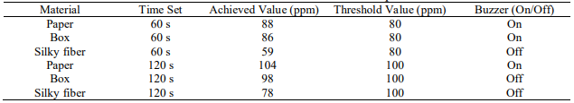Table 1. The result collected from the Experiment

In continuation of our project, we added additional module which is the ESP8266 that is very useful in our project, this module will send the data to the cloud so that we can monitor the output of our sensor wirelessly anytime, anywhere. unlike in our previous project we’re we can only monitor the output in the computer where the Arduino is connected. ESP8266 is a highly integrated chip designed for the needs of a new connected world. It offers a complete and self-contained Wi-Fi networking solution, allowing it to either host the application or to offload all Wi-Fi networking functions from another application processor. ESP8266 has powerful on-board processing and storage capabilities that allow it to be integrated with the sensors and other application specific devices through its GPIOs with minimal development up-front and minimal loading during runtime. Its high degree of on-chip integration allows for minimal external circuitry, and the entire solution, including front-end module, is designed to occupy minimal PCB area.

**STATEMENT OF THE STUDY**

Western Mindanao State University External Campus Pagadian City lacks of amenities when it comes to fire prevention. As students here, we desire a safe environment where we can pursue our education without interruption. We develop a Gas and Smoke Detector as a safety precaution for students and teachers, it is very useful in detecting smoke or other gaseous substance that can cause fire in buildings and is also harmful to human. Bursting cylinders and accidental fires have caused lots of harm to the economies in the past. This circuit triggers the alert system when smoke or gas leakage is detected. The circuit mainly uses the **MQ-2 Smoke/Gas sensor and ESP8266** to detect smoke and gas leak. This **MQ-2 gas sensor** is sensible to LPG, Alcohol, Methane and etc. It detects the presence of a dangerous LPG leak in your car or in a service station, storage tank environment. The sensor has excellent sensitivity combined with the quick response time. The sensor can also sense iso-butane, propane, LPG, and cigarette smoke. Any smoke produced by a fire or by a flammable liquid can be found using this approach.

Here are some further justifications why we choose this project:

* Prevent fire damage.
* Decreased risk of fire.
* Prevent and avoid damage of property.
* Alert everyone when a high concentration of gaseous substance is detected.

**Working of the Project**

The circuit is powered on after uploading the code, and the buzzer will produce a sound when the gas level is excessive. When the gas level exceeds it will send SMS via the SMS Gateway. This circuit will send SMS when smoke or gas leakage is detected. The circuit mainly uses the **MQ-2 Smoke/Gas sensor with ESP8266** to detect and smoke and gas leak. The sensor has excellent sensitivity combined with the quick response time.



**FLOW CHART**

**MQ2 GAS SENSOR**

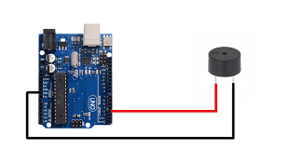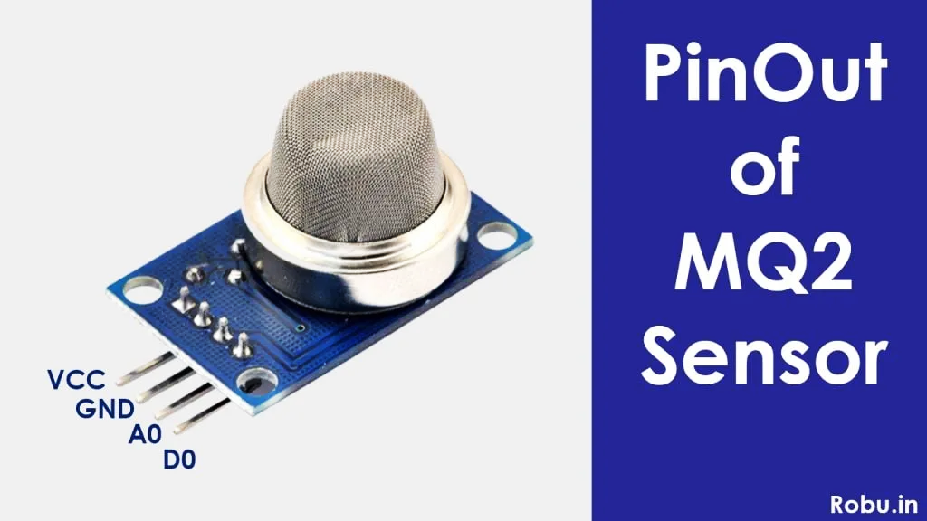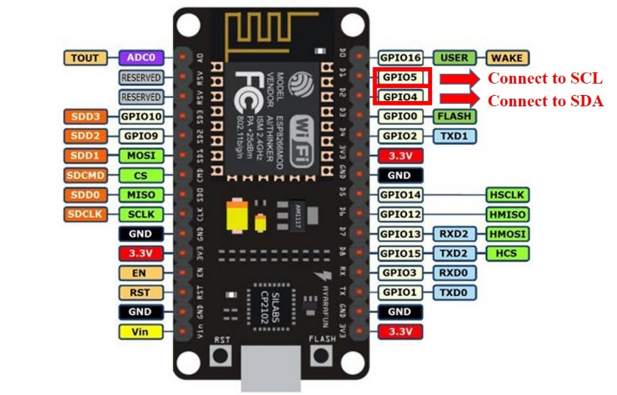

**ESP8266**

**BLYNK APP**



**Chapter II**

**Review Related Literature**

In the review of related publications, a brief summary of the material the researcher examined is given in order to further develop the concept of the monitoring system. The advocates are now able to point out specific study reports and other monitoring system components that are connected to their research. Facts and findings were also presented together with a succinct case study of the research in order to elucidate ideas linked to the systems.

A fire outbreak is usually silent and people will know about the fire only when it has spread across a large area (Circuits Today, 2015). Fire disasters account for loss of lives and destruction of property worth millions of shillings not just in a particular country but around the globe. 90%(percent) of fire damages occur due to lack of early fire detection.

**Fire Disasters and Accidents**

The most frequent accidents, those with the widest range of causes, and those requiring intervention strategies and methods customized for each incidence are fires. Material damage may just affect a small region or span a large area, depending on the type of fire and how well the intervention worked. Specific technical recommendations are made for each type of fire with reference to prevention, response, and the affected population's behavior.

**Existing Fire Detection, Control and Alarm Systems**

One of the key aspects in controlling a fire is timely detection of the fire as it has been determined earlier on in this research. The role of the fire detection alarm systems is precisely to ensure timely fire outbreak detection. This section discusses the various fire detection, control and alarm systems as well as their advantages.

A fire alarm system is intended to enable a fire to be detected at a sufficiently early stage so that people who are at risk can be made safe either by escaping from the fire or by the fire being extinguished (David Goh & Kwek, 2005). (David Goh & Kwek, 2005) in their article add that fire alarm systems protect life and property detecting a fire at an early stage, alerting and evacuating occupants, notifying the relevant personnel, activating auxiliary functions e.g. smoke controls and lift homing.

**Smoke Based Fire Alarm Systems**

A smoke detector is a device that senses smoke, typically as an indicator of fire. The contribution in development of smoke detector was from research made by Walter Jaeger in 1930. In the early 1940’s, the first smoke detector was developed by Meili and Jaeger that required high voltage power input. Then in 1965, Duane Persall created the first affordable home smoke detector that using individual battery powered that can be replace and install easily by the users. Francis Robbins Upton then invented the first automatic fire alarm in 1890 that give great contribution to today smoke alarm detector (Azmil, 2015). (Fields Fire Prevention Inc., 2011) A member of National Fire Protection Association (NFPA) categorizes smoke detectors into 3 categories namely: ionization, photoelectric and a combination of both. A smoke detector is defined as “a device that senses smoke, typically as an indicator of fire” (Gorli, 2017).

**Sensors for Fire Detection**

Sensors used in fire detection devices nowadays include a large variety of sensors due to very different applications, cost levels, detection coverage and so on (Bogue, 2013). To effectively detect a fire, several sensors have to be incorporated into one system. Some of these sensors have been discussed below.

**Optical Smoke Detectors**

A smoke detector is defined as a device that senses smoke, usually as an indication of fire. Commercial security devices provide a signal to a fire alarm control panel as a functionality of a fire alarm system, while household smoke detectors, also known as smoke alarms, basically issue a local discernible or visual alarm from the detector itself (Cote, 2006).

**Limitations of Fire Detection Systems**

There are several fire-detection, alarm and signaling-system challenges. This sub-section looks at a few of the limitations faced by fire detection devices (systems) majorly those found in smoke detectors. Nuisance alarms represent one of the most significant problems facing the fire alarm industry today and in particular smoke-based detection systems. Each year, nuisance alarms result in countless service calls and fire department dispatches, not to mention millions of dollars in fines. Left unchecked, nuisance alarms can become life threatening for a building’s occupants, as they may become confused between nuisance alarms and true emergency situations (System Sensors, 2007). Nuisance alarms are not the same as false alarms. However, since nuisance alarms and false alarms both generate an alarm signal, the two terms are often misapplied. A nuisance alarm is caused by conditions resembling smoke, but are not generated by sources of fire. Examples include dust and steam. Conversely, a false alarm is the result of conditions that do not resemble smoke whatsoever, including defective products, vandalism,

In 2007, in reference to Single- and Multiple-Station Alarms and Household Fire Alarm Systems, the NFPA 72 Technical Committee appointed a Task Group (TG) to review the effectiveness of smoke detection used in dwellings for life safety and escape. The report observed that Nuisance alarms are the leading cause of occupants disabling their smoke alarm. The report also observed that Ionization technology installed too close to a cooking appliance have a higher frequency of nuisance alarms than photoelectric type detectors. A nuisance alarm may be the activation of a properly functioning smoke detection device to a non-hazardous source not imminently threatening to life or property.

**Summary of Smoke Detectors**

It is important to continuously test smoke detectors on a monthly basis to ensure that they are still in a good working condition. Some smoke detectors come with a test button that blows smoke into the detectors. Smoke detectors should be cleaned or vacuumed to avoid dust accumulation that affects their performance. Since smoke detectors are battery powered, best practice guidelines outline that the battery should be replaced at least twice a year (Office of Prevention and Fire Control, 2014). Placement of detectors in any kind of building is key to the effectiveness of their functionality. (System Sensor, 2016) A manufacturer of smokes detectors affirms that smoke detectors should be installed in all areas of the protected premises. NPFA 72 (National Fire Alarm and Signaling Code) is a document that covers “the application, installation, location, performance, inspection, testing, and maintenance of fire alarm systems, supervising station alarm systems, public emergency alarm reporting systems, fire warning equipment and emergency communications systems (ECS), and their components” (National Fire Protection Association, 2013).

The National Fire Protection Association (2013) the further outlines that “in general, when only one detector is required in a room or space, the detector should be placed as close to the center of the ceiling as possible. Central location of the detector is best for sensing fires in any part of the room. If a center location is not possible, the detector may be wall mounted within 12 inches from the ceiling if the detector is listed for wall mounting”. Finally, smoke detectors should not be placed in excessively dusty or dirty areas, outdoors, excessively wet or humid areas, elevator lobbies and areas with combustion particles.

**REFERENCES**

[**https://pdfs.semanticscholar.org/4848/3c3e57e1d662f4b4e7f3ad67809aca2c879b.pdf**](https://pdfs.semanticscholar.org/4848/3c3e57e1d662f4b4e7f3ad67809aca2c879b.pdf)

# Honeywell Wall Mount LPG And CNG Gas Detector

[**https://www.instrukart.com/honeywell-wall-mount-lpg-and-cng-gas-detector/#:~:text=This%20LPG%20and%20CNG%20Gas,the%20detector%20sounds%20an%20alarm**](https://www.instrukart.com/honeywell-wall-mount-lpg-and-cng-gas-detector/#:~:text=This%20LPG%20and%20CNG%20Gas,the%20detector%20sounds%20an%20alarm)**.**

# What Does a Carbon Monoxide Detector Do and How Does it Work? [**https://www.safewise.com/home-security-faq/carbon-monoxide-detector/**](https://www.safewise.com/home-security-faq/carbon-monoxide-detector/)

Fields Fire Prevention Inc. (2011). Fire alarm systems. Retrieved November 2016, from Field's Fire: [http://www.fieldsfire.com/fire-alarm-systems](http://www.fieldsfire.com/fire-alarm-systems?fbclid=IwAR3fUiU5d2dUm5IbEnww5iT39ytdNXtJlTEPCldVtcPcAVPUSbvn7za7psI) Fire Equipment Manufacturers'Association. (2016). Portable Fire Extinguishers. Retrieved October 8, 2016, from Family Life Safety Oraganization: [http://www.femalifesafety.org/types-of-](https://l.facebook.com/l.php?u=http%3A%2F%2Fwww.femalifesafety.org%2Ftypes-of-%3Ffbclid%3DIwAR1fRkCIzNU1avCRiHPJ-m_esunM72e6Kawx4dAjtnYpoz-cibu_I33_v64&h=AT2hC4oC9cxleFVCrGHFLfkOlEp3ZkZN11iN3jO38_tPaEp3ccVHXcPBwpcB6XEveHk6mx0aRfbBpjD-9zTW6UwABR5JDJ-Es2GYrV9T7mxq_eTDuWSrizlRZcrCPdZ-89p5zg) fires.html Garfinkel, S., & Holtzman, H. (2005). RFID Applications Security and Privacy. Goh, R. (2014, January 28). Fire safety and Protection Systems. Retrieved December 21, 2016, from Heat detectors: [http://finalprojectfyp.blogspot.co.ke/2014/01/unit-4-heat-detectors.html](http://finalprojectfyp.blogspot.co.ke/2014/01/unit-4-heat-detectors.html?fbclid=IwAR0V5zOHdINLq13xUTLiO7aNzQ2tRtj6N92CF3jdEnoZ4VyJv9KlRlvWWGU) Goodfriend, W. (2015). Validity and Reliability: How to Assess the Quality of a Research Study . Retrieved January 2, 2017, from Study.com: [http://study.com/academy/lesson/validity-and-](https://l.facebook.com/l.php?u=http%3A%2F%2Fstudy.com%2Facademy%2Flesson%2Fvalidity-and-%3Ffbclid%3DIwAR31kvJLZrRbg5pb_Tzx0XIJr5ID8dcMcn9g1NTXSW3eEEDs1js4T_TRMdA&h=AT2hC4oC9cxleFVCrGHFLfkOlEp3ZkZN11iN3jO38_tPaEp3ccVHXcPBwpcB6XEveHk6mx0aRfbBpjD-9zTW6UwABR5JDJ-Es2GYrV9T7mxq_eTDuWSrizlRZcrCPdZ-89p5zg) reliability-how-to-assess-the-quality-of-a-research-study.html Gorli, R. (2017). World Laying Steps towards Smart Ideas. nternational Journal of Advanced Research in Computer and Communication Engineering , 6 (2). Government of Western Australia, Deparment of fire and emergency services(DFES). (2012). DFES Smoke alarm fact sheet. Retrieved November 2016, from Deparment of fire and emergency services(DFES: [https://www.dfes.wa.gov.au/safetyinformation/fire/fireinthehome/FireintheHomeFactsheets/DFE](https://www.dfes.wa.gov.au/safetyinformation/fire/fireinthehome/FireintheHomeFactsheets/DFE?fbclid=IwAR08MF8HB4-tEc7LyIrJFKViux_5wv-FX7vggS-_iNGREYAK3iLxjmHdQYk) S-Smoke-Alarm-Fact-Sheet1-Types-of-Smoke-Alarms.pdf Grinberg, M. (2012, December). Robotics, Arduino. Retrieved October 14, 2016, from Miguel Grinderg blog: [https://blog.miguelgrinberg.com/post/building-an-arduino-robot-part-i-hardware-](https://l.facebook.com/l.php?u=https%3A%2F%2Fblog.miguelgrinberg.com%2Fpost%2Fbuilding-an-arduino-robot-part-i-hardware-%3Ffbclid%3DIwAR0LTzWab215O3QADMRRt-aOhXea6WgixwTj1nXk5LvR3B6fY1I5YXbKP5E&h=AT2hC4oC9cxleFVCrGHFLfkOlEp3ZkZN11iN3jO38_tPaEp3ccVHXcPBwpcB6XEveHk6mx0aRfbBpjD-9zTW6UwABR5JDJ-Es2GYrV9T7mxq_eTDuWSrizlRZcrCPdZ-89p5zg) components Hartin, E. (2005). Fire development in a compartment. Review of basic fire behavior . Herman, S. L. (2011). Direct Current Fundamentals (Vol. 😎. Cengage Learning. Honeywell International. (2015, August). Fire Safety. Lewes, E. Sussex, United Kingdom. International Civil Defence Organization(ICDO). (2016). Man-Made Disasters-Fire. Retrieved 10 5, 2016, from ICDO: [http://www.icdo.org/en/disasters/man-made-disasters/industrial-](https://l.facebook.com/l.php?u=http%3A%2F%2Fwww.icdo.org%2Fen%2Fdisasters%2Fman-made-disasters%2Findustrial-%3Ffbclid%3DIwAR1bTtUSFbCNrWKu1j-mjwPxxi_DgDOuUH7kbDld-Xu3LACQYMX8yEHZJHg&h=AT2hC4oC9cxleFVCrGHFLfkOlEp3ZkZN11iN3jO38_tPaEp3ccVHXcPBwpcB6XEveHk6mx0aRfbBpjD-9zTW6UwABR5JDJ-Es2GYrV9T7mxq_eTDuWSrizlRZcrCPdZ-89p5zg) accidents/fire Internet Society. (2015, October). The Internet of Thigs: An Overview. Retrieved October 6, 2016, from [www.internetsociety.org](http://www.internetsociety.org/?fbclid=IwAR3qKPIqRvP1ucviysTS-CyuRIMJ8ZQPYRb7m81id2VkaiWICArs_O0g7oY) Internet Society. (2015, October). Understanding the Issues and Challenges of a More Connected World. Retrieved November 12, 2016, from Internet society: