User documentation

TheNorthRemembers™ - Customer management application

|  |  |  |  |  |  |
| --- | --- | --- | --- | --- | --- |
| **Project No.** | **Doc. ID** | **Version** | **Date** | **Author** | **Status** |
| 2018-001 | 9000 | 1.0 | 10.05.2018 | JoAn | Valid |

Table of contents

1 Scope of delivery 2

2 Getting started 2

2.1 Installation 2

2.2 Usage of application 2

2.2.1 Main window 2

2.2.2 List of Customers 3

2.2.3 Section for adding and editing customers 3

2.2.4 Section for searching customer 3

2.2.5 Section for adding and withdraw money 3

3 Operators information 3

3.1 Important information 3

3.2 Backup information 3

3.3 Reinstall and update information 3

4 Outlook and further releases 3

# Scope of delivery

The *TheNorthRemembers™ Customer management application* is delivered on an USB drive. It includes the following software components:

* Folder: TNR Customer Management Application
  + CustomerAdministration.exe
  + ListCustomer.csv
  + ProjectLib.dll
* PDF: User documentation (this document)

# Getting started

Before you start the *TheNorthRemembers™ Customer management application* read this document carefully and follow the instructions.

## Installation

1. Plug in the delivered USB drive into your PC
2. Copy the folder *TNR Customer Management Application* to a directory where you want to store the application file
3. Create a desktop shortcut:
   1. Open the folder *TNR Customer Management Application* in your chosen directory
   2. Press with the right mouse button on the *CustomerAdministration.exe* and select *Create shortcut*
   3. Now drag the created shortcut and drop it in your desktop
   4. The Application can now be started from the created shortcut
4. Start the application
   1. Enter the password: *12345* (this password cannot be changed)
   2. Press the button *Login*
   3. If the password is entered correctly, the main window of the application will be opened. Otherwise you have to try it again.
   4. Further information about the usage of the application you can find in the following section.

## Usage of application

### Main window

The main window of the application consists of the following parts:

* List of customer data
* Section for adding a new customer and editing selected customer
* Section for searching a customer
* Section for adding and withdraw money from the account

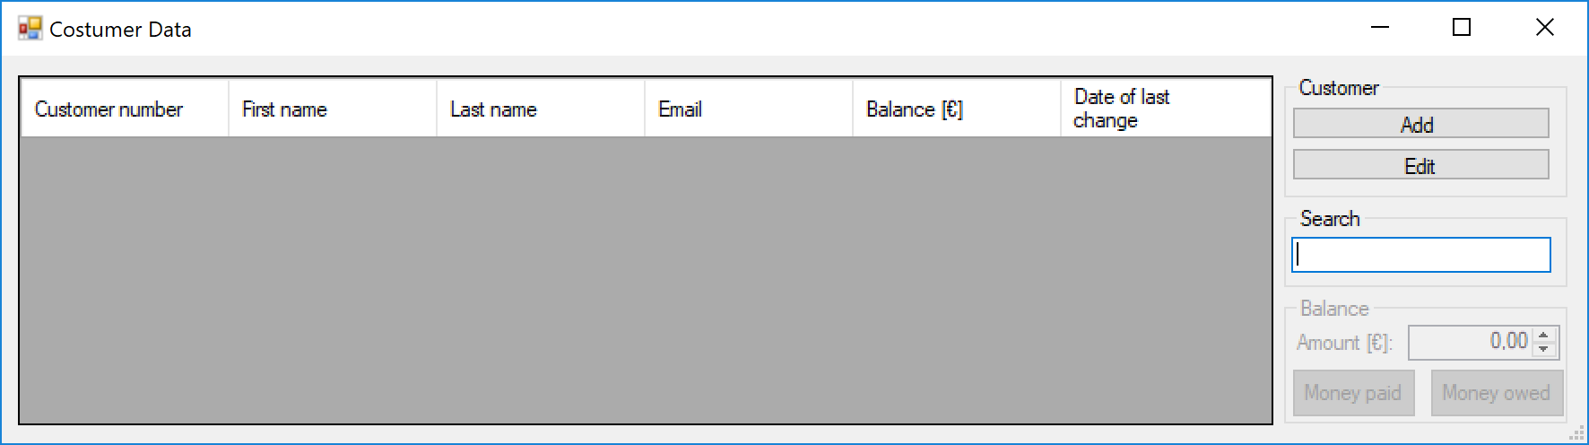

Figure 1: Main window

### List of Customers

The list contains all information of the customers. The list can be sorted by pressing one of the header buttons (e.g. the list is sorted according to first names by pressing the button *First name*). If one button is pressed a second time the order is reversed.

### Section for adding and editing customers

By pressing the button *Add* a new customer can be created. Once a customer is created, it cannot be deleted anymore. By pressing the button *Edit* the last name or the email address can be changed.

### Section for searching customer

A customer is searched by entering a part of the name and only customers who include the entered text in their names are displayed on the list. **Attention the searching algorithm is case sensitive.** The full list of customers is shown again by deleting the text in the search box.

### Section for adding and withdraw money

The select amount of money is added to the balance by pressing the button *Money paid*. And the selected amount of money is withdrawn by pressing the button *Money owed*. The selected amount of money can be changed by pressing the up and down buttons next to the text box or by entering the amount directly (only positive values are allowed).

# Operators information

## Important information

**Any changes of the data file can affect the accessibility of the data and can lead to loss of information. If the data file is damaged, please contact the support (this service is subject to charges).**

## Backup information

For a backup of the customer data the file *ListCustomer.csv* in the folder *TNR Customer Management Application* in the chosen directory, must be copied and saved in a backup folder. To access the desired backup state, just copy the backup file in the folder *TNR Customer Management Application* and replace the file *ListCustomer.csv* (**it is necessary to use exactly this name for the backup file otherwise the application is not able to access the data in the file**).

## Reinstall and update information

If the application is reinstalled or an update is install, a backup is required otherwise the customer data is lost. After reinstallation or updating the application the backup file has to be copied again in the application folder.

# Outlook and further releases

The development of the application is still going on. (e.g. in a future version of the application it will be possible to change the language).