Hand-in exercise 1

Magnus Wallgren

Will Lundström

1.

Please see checkbasic1.m for the Matlab file.

The simplex tableaus are as follows

2.

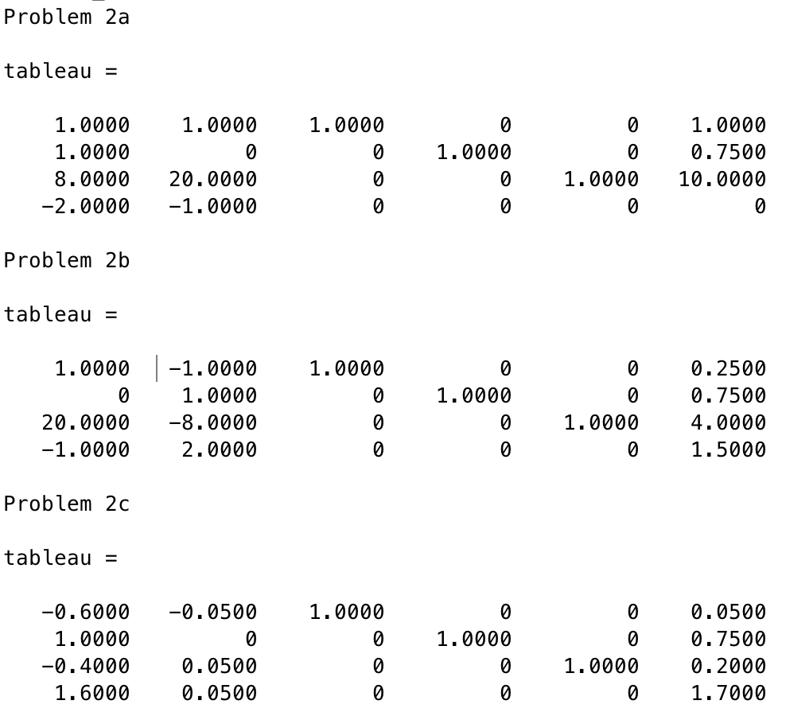

3.

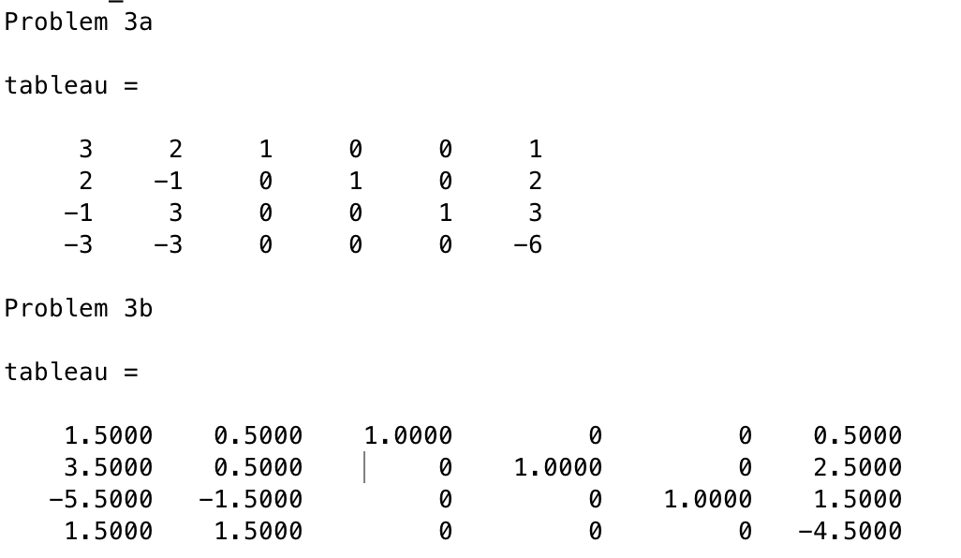

4. The solution is

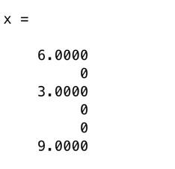

5. The solution is

???????????

6. The problem has 1 basic solution which is also feasible.

7. The problem has no solutions. This is because the system Ax = b is overdetermined, it has 3 equations but 2 unknowns. Overdetermined systems can have solutions if there are linearly dependent rows but this system does not have any linearly dependent rows.