Hand-in exercise 1

Magnus Wallgren

Wilhelm Lundström

1.

Please see checkbasic1.m for the Matlab file.

The simplex tableaus are as follows

2.

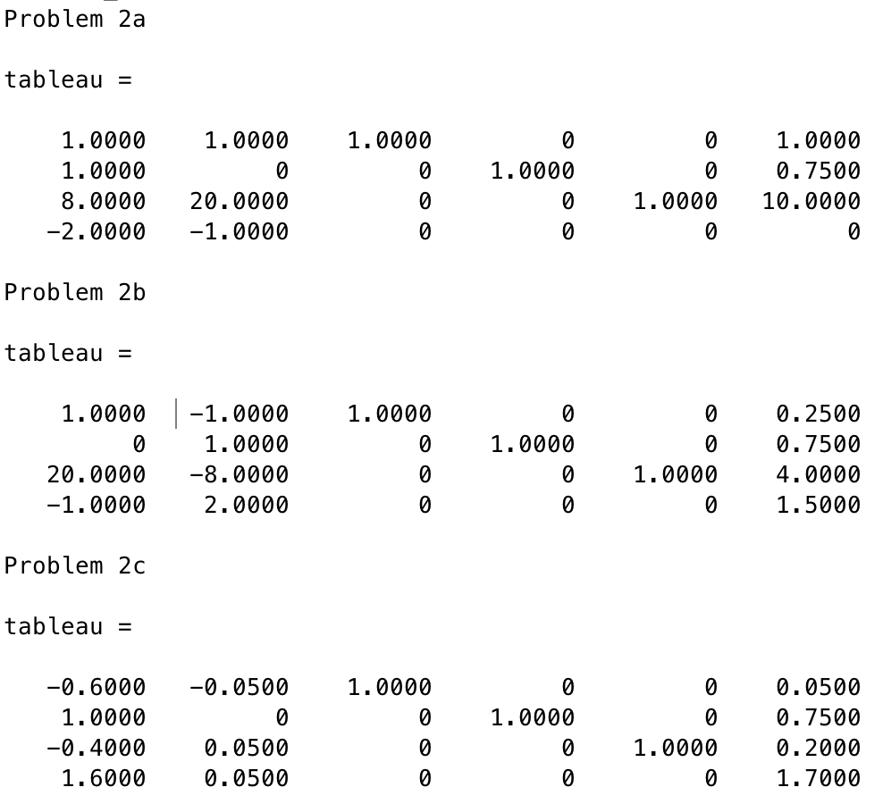

3.

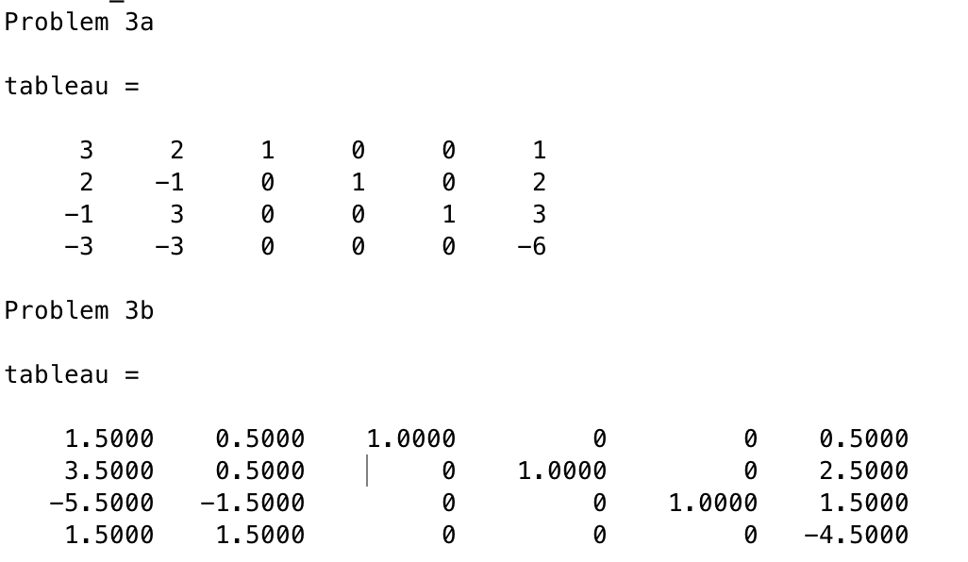

4.

To solve this problem we use the two-phase method. To use the simplex method we need an initial starting point that is a basic feasible solution. Finding a basic feasible solution is phase 1 of the two-phase method. To find one we first introduce three artificial variables ***u*** which leads to a new Linear Programming problem. The matrices ***A****,* ***b****,* ***c***for this initial problem are given in the instruction. We start from the basic feasible solution ***x*** *=* ***0****,* ***u*** *=* ***b****.* Then we create a tableau (checkbasic1.m) using the matrices and iterate using the simplex method (simplex.m) until we find an optimum. This optimum is a basic feasible solution for the original problem so in phase 2 we start with the result from phase 1, create a new tableau using the original ***A****,* ***b***and***c*** and iterate with the simplex method until we find an optimum (that doesn’t have to exist). This is the optimum for the original problem.

The optimum is

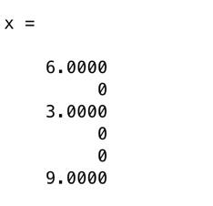

In the simplex method we have to design a method for choosing departing and entering variable. We choose the entering variable as *xi,* where *i* is the column with lowest value in the objective row of the tableau. Then we form the ratios between the values in the right hand side column and column *i*. We choose the departing variable from the row *j* with the lowest ratio. The departing variable is *uj* where ***u*** are the basic variables.

5. The initial tableau looks like this:

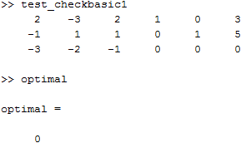

The entering variable (smallest/most negative element in the objective row) is then in column 1, and the departing variable (found in the row with the smallest θ-ratio) is in row 2.

Entering this into our manual simplex function generates the next tableau:

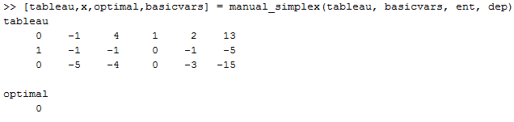

The entering variable should be in column 2, but as all elements in the pivotal column are negative, we know that there is no finite optimum.

6.

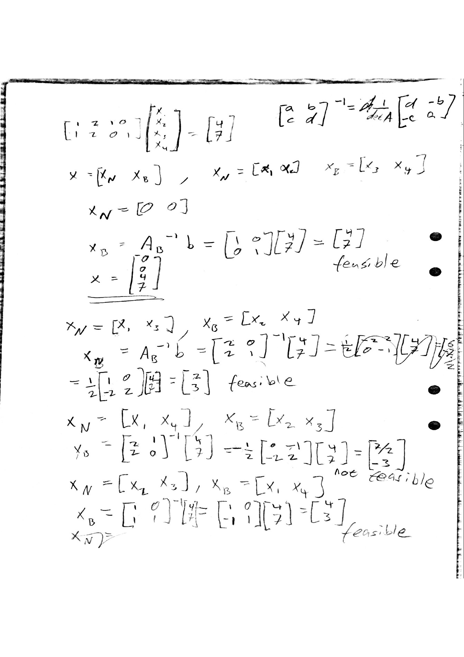

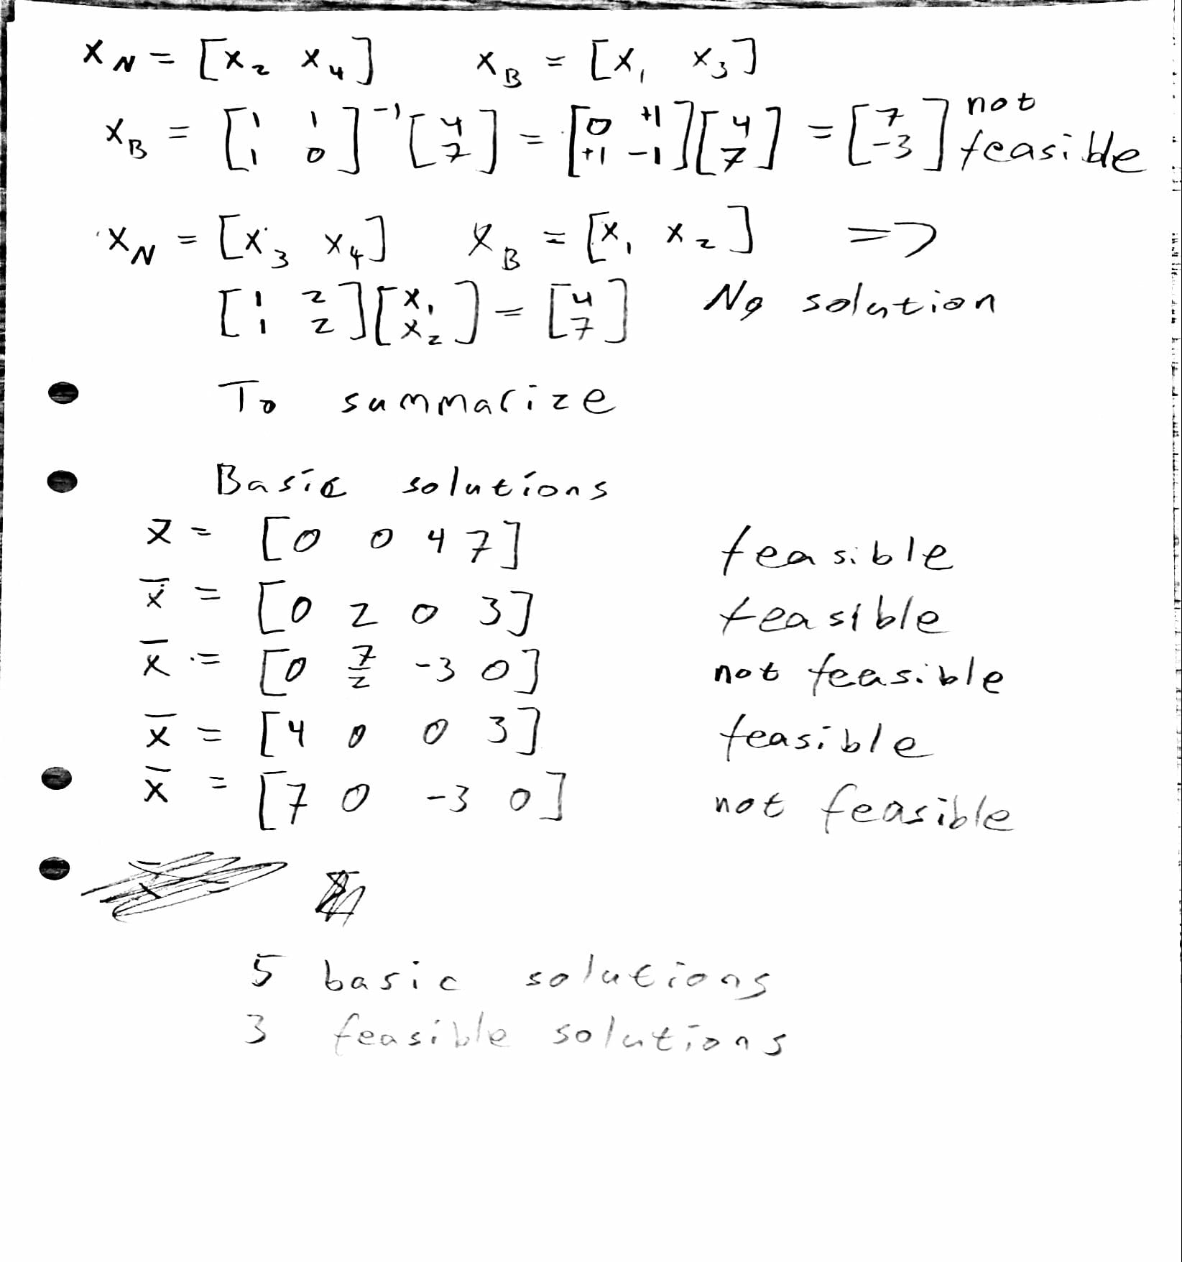

7. The problem has no solutions. This is because the system Ax = b is overdetermined, it has 3 equations but 2 unknowns. Overdetermined systems can have solutions if there are linearly dependent rows but this system does not have any linearly dependent rows.