**ItGIGls Mobile Web Application**

There's a group of friends who likes the metal and rock era when it comes to music and they really enjoy to go to gigs together. The members of this group live in the Netherlands, Belgium and Germany so it's not easy to plan these trips. They have to be up to date with the upcoming events, plan the trips and budget. One of them came up with the idea to make a simple mobile web application for the group with the gig info which everyone can see. Not to mention an ingroup chat could be handy.

Personas:

* Joosd, a very easy-going teacher.
* Simon, an office worker with very strict timelines.
* Katrin, nutritionist who is always up to date.
* Katie, who is a mom for one small.
* Sara, who is a spiritual guide and real hippy.

Scenarios:

* Joosd during his lunch break wants to check if there is any upcoming concerts.
* Simon checks the address and map on the train.
* Katrin checks tha bands name who will play next weekend.
* Katie writes to the chat to ask if someone is going to the gig.
* Sara writes to the chat that she is a few minutes late… and her web connection is not the best at the moment.

UI flow diagram:

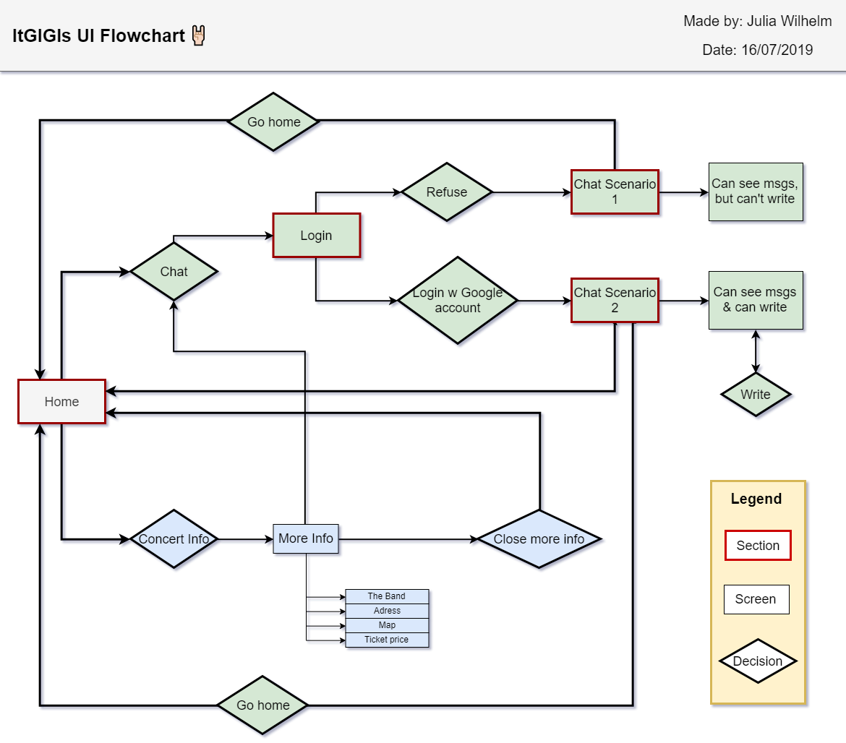

Color sceme:

<https://colorhunt.co/palette/138147>

#3c415e

#738598

#dfe2e2

#1cb3c8

Screen mockups:

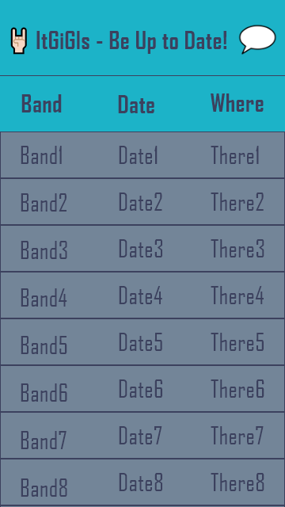 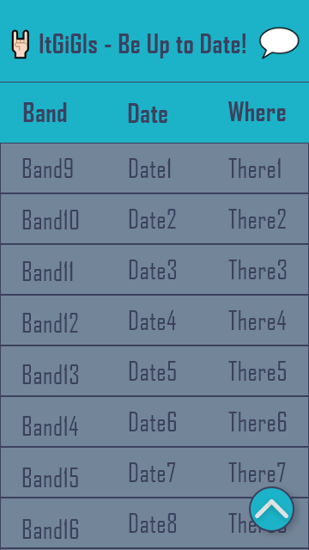

1st picture: Home Screen with band, date and country infos. 2nd picture: Same, but if you scroll down, a scroll up button appears.

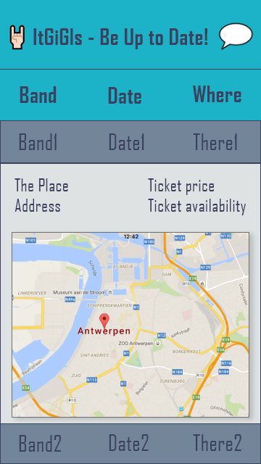

3rd picture: If you click on the band section, a map will appear with the exact address. Ticket price and availability will also appear.

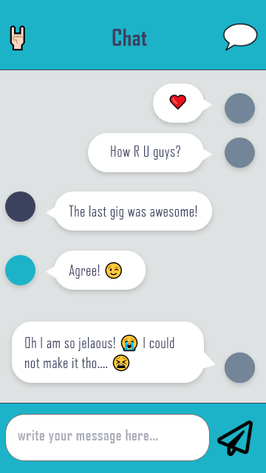

4th picture: The cat screen. You can go back to home screen by clicking on the hand.