LAB 5.2 – Asynchronous JavaScript: async/await and Error Handling

1. Lab Overview
In Lab 5.1, students practiced JavaScript variables, functions, objects, arrays, conditions, and financial transaction processing.
In Lab 5.2, students will learn how JavaScript handles operations that take time to complete. These concepts are particularly important for blockchain applications because communicating with Ethereum, waiting for wallet approval, and receiving transaction results are asynchronous operations.
Students will begin with simple console-based exercises and then build an interactive banking simulator.

2. Learning Objectives
After completing this lab, students should be able to:
- Explain synchronous and asynchronous JavaScript execution.
- Use setTimeout() to simulate delayed operations.
- Create and handle JavaScript Promises.
- Apply async and await to asynchronous functions.
- Handle errors using try, catch, and finally.
- Distinguish successful and failed asynchronous transactions.
- Develop a banking simulator that updates account balances after successful operations.

3. Lab Activities
Part | Activity | Expected Outcome
1 | Environment setup | Open PlayCode and prepare the editor
2 | Synchronous vs. asynchronous execution | Understand execution order
3 | JavaScript Promises | Simulate delayed transaction results
4 | Using async/await | Wait for asynchronous operations
5 | Error handling with try/catch/finally | Handle transaction failures
6 | Integrated Mini Project | Build an Asynchronous Banking Transaction Simulator
7 | Testing | Verify success, failure, and balance updates
8 | Student practice | Extend the simulator

Part 1. Prepare the Development Environment

Step 1. Open PlayCode
- Open your web browser.
- Visit https://playcode.io/javascript.
- Click Open the playground.
- Locate src/script.js in the file explorer.
- Open the Console panel to observe program output.
For Exercises 1–4, students only need to edit src/script.js.
PlayCode normally runs JavaScript automatically when the source code changes. Use the Refresh icon above Preview if necessary.

Step 2. Prepare a New Project
Use a separate PlayCode project for Lab 5.2, or save a copy of the Lab 5.1 project before replacing its source code.

Part 2. Exercise 1. Synchronous and Asynchronous JavaScript

Step 3. Understand Synchronous Execution
JavaScript normally executes synchronous statements in order.
Replace the code in src/script.js with:
console.log("Step 1: Start transaction");

console.log("Step 2: Process transaction");

console.log("Step 3: Transaction completed");

Expected Output:
Step 1: Start transaction
Step 2: Process transaction
Step 3: Transaction completed
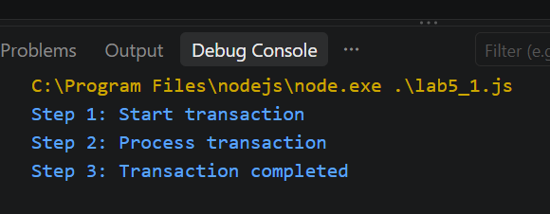
Explanation: Each statement executes before the next statement begins.

Step 4. Simulate an Asynchronous Operation
Replace the code with:
console.log("Step 1: Start transaction");

setTimeout(function() {
console.log("Step 2: Transaction completed");
}, 2000);

console.log("Step 3: Continue other operations");

Expected Output:
Step 1: Start transaction
Step 3: Continue other operations

(Approximately 2 seconds later)
Step 2: Transaction completed
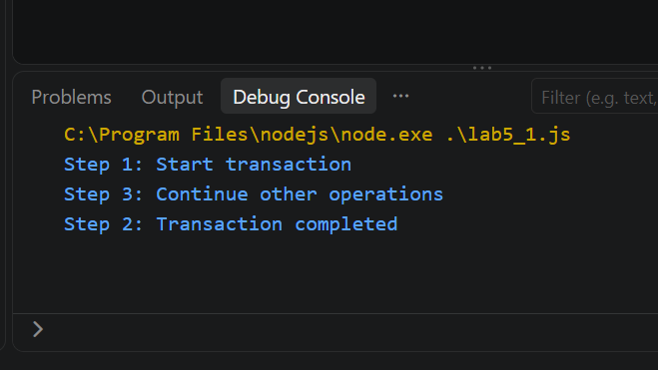
Explanation
- setTimeout() schedules a function to execute after a delay.
- 2000 represents approximately 2,000 milliseconds, or 2 seconds.
- JavaScript continues executing other statements instead of waiting for the timer callback.
Key Concept: Asynchronous programming allows an application to continue working while waiting for an operation to complete.
Student Task 1
Change the delay from 2000 to 5000 milliseconds. Run the program and explain why Step 3 appears before Step 2.
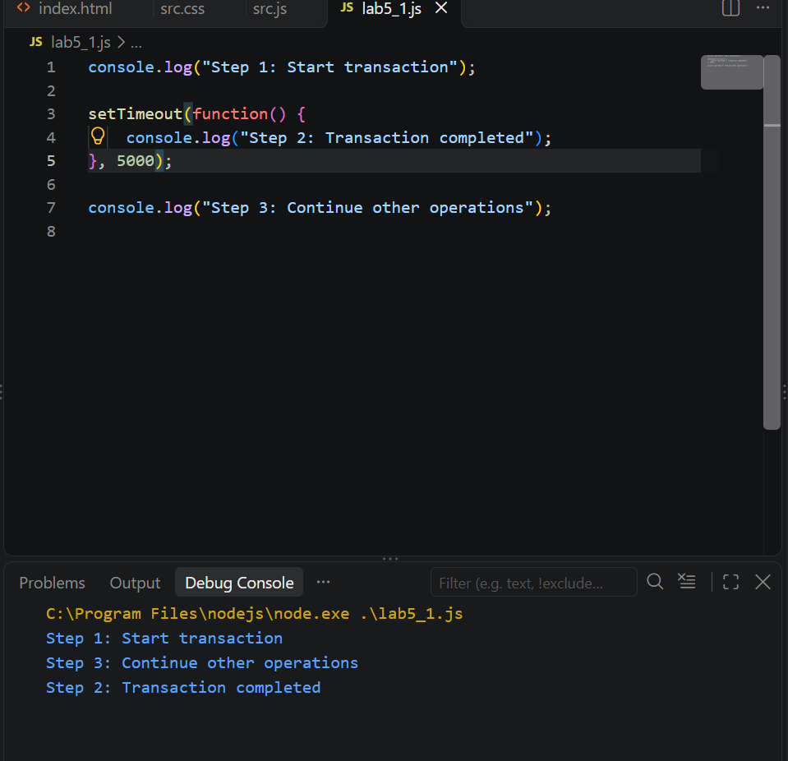
  - setTimeout() không chặn chương trình. Nó hẹn sau 5 giây mới chạy callback, còn JavaScript tiếp tục chạy dòng tiếp theo luôn.

Part 3. Exercise 2. JavaScript Promises

Step 5. Understand a Promise
A Promise represents the eventual result of an asynchronous operation.
A Promise can have three states:
State | Meaning
Pending | The operation is still in progress
Fulfilled | The operation completed successfully
Rejected | The operation failed

Step 6. Create a Promise
Replace src/script.js with:
function processDeposit(amount) {

return new Promise(function(resolve) {

setTimeout(function() {

resolve(
`Deposit of ${amount} tokens successful!`
);

}, 2000);

});
}

console.log("Starting deposit...");

processDeposit(5).then(function(result) {
console.log(result);
});

console.log("Waiting for transaction result...");

Expected Output:
Starting deposit...
Waiting for transaction result...

(Approximately 2 seconds later)
Deposit of 5 tokens successful!
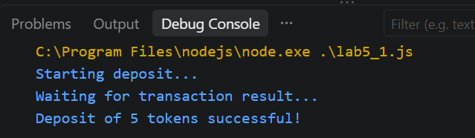
Explanation
- new Promise(...) creates a Promise.
- resolve(...) marks the operation as successful.
- .then(...) processes the successful result.
- setTimeout() simulates transaction processing time.

Step 7. Create a Rejected Promise
Replace the code with:
function processWithdrawal(balance, amount) {

return new Promise(function(resolve, reject) {

setTimeout(function() {

if (amount > balance) {
reject("Insufficient balance");
} else {
resolve(balance - amount);
}

}, 2000);

});
}

processWithdrawal(20, 30)
.then(function(newBalance) {
console.log("New Balance:", newBalance);
})
.catch(function(error) {
console.log("Transaction Failed:", error);
});

Expected Output:
Transaction Failed: Insufficient balance
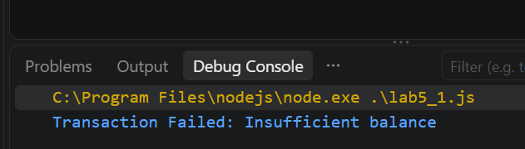
Explanation: Because the requested withdrawal exceeds the available balance, the Promise is rejected and .catch() handles the error.

Student Task 2
Change the withdrawal amount from 30 to 8.
Expected Output
New Balance: 12
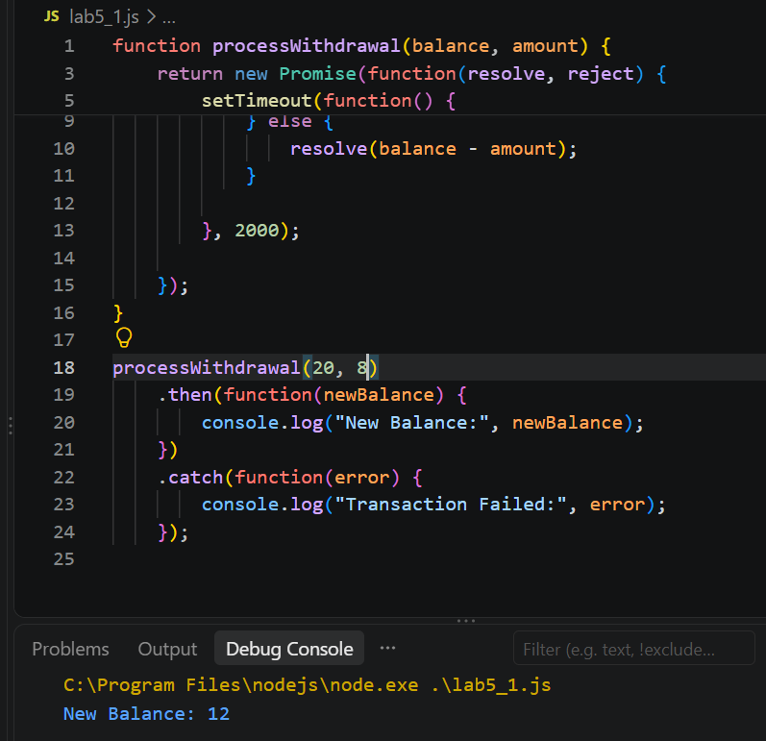

Part 4. Exercise 3. Using async/await

Step 8. Understand async and await
The async keyword declares an asynchronous function.
The await keyword waits for a Promise to settle before continuing execution within that function.

Step 9. Implement async/await
Replace src/script.js with:
function processDeposit(amount) {

return new Promise(function(resolve) {

setTimeout(function() {

resolve(
`Deposit of ${amount} tokens successful!`
);

}, 2000);

});
}

async function deposit() {

console.log("Processing deposit...");

const result = await processDeposit(5);

console.log(result);

console.log("Deposit operation finished.");
}

deposit();

Expected Output:
Processing deposit...

(Approximately 2 seconds later)
Deposit of 5 tokens successful!
Deposit operation finished.
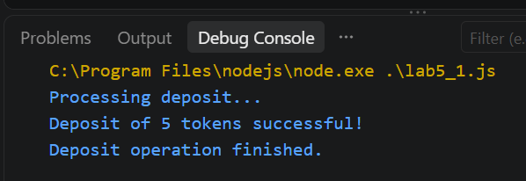
Explanation
const result = await processDeposit(5);
The deposit() function pauses at await until processDeposit(5) fulfills. Other JavaScript tasks can continue during this waiting period.

Student Task 3
Modify the program to process a deposit of 15 tokens.
Expected Output:
Processing deposit...
Deposit of 15 tokens successful!
Deposit operation finished.
The deposit result should appear after approximately 2 seconds.
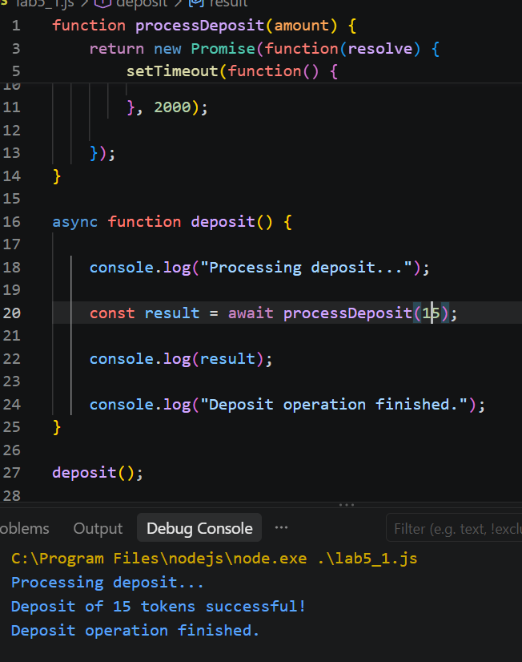

Part 5. Exercise 4. Error Handling with try/catch/finally

Step 10. Understand Error Handling
Asynchronous transactions may fail because of invalid input, insufficient funds, network problems, or user rejection.
JavaScript provides three important statements:
Statement | Purpose
try | Runs code that may fail
catch | Handles errors
finally | Runs cleanup code whether the operation succeeds or fails

Step 11. Implement try/catch/finally
Replace src/script.js with:
function processWithdrawal(balance, amount) {

return new Promise(function(resolve, reject) {

setTimeout(function() {

if (amount <= 0) {

reject(new Error("Invalid withdrawal amount"));

} else if (amount > balance) {

reject(new Error("Insufficient balance"));

} else {

resolve(balance - amount);

}

}, 2000);

});
}

async function withdraw() {

console.log("Processing withdrawal...");

try {

const newBalance =
await processWithdrawal(20, 8);

console.log("Withdrawal successful!");
console.log("New Balance:", newBalance);

} catch (error) {

console.log("Transaction Failed:", error.message);

} finally {

console.log("Transaction processing finished.");

}
}

withdraw();

Expected Output:
Processing withdrawal...

(Approximately 2 seconds later)
Withdrawal successful!
New Balance: 12
Transaction processing finished.
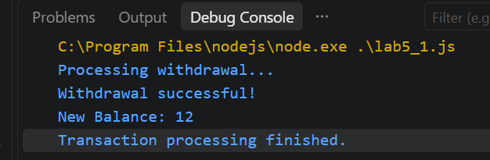

Step 12. Test Error Handling
Change: await processWithdrawal(20, 8);
to: await processWithdrawal(20, 30);
Expected Output:
Processing withdrawal...

(Approximately 2 seconds later)
Transaction Failed: Insufficient balance
Transaction processing finished.
Important: The finally block executes in both cases.
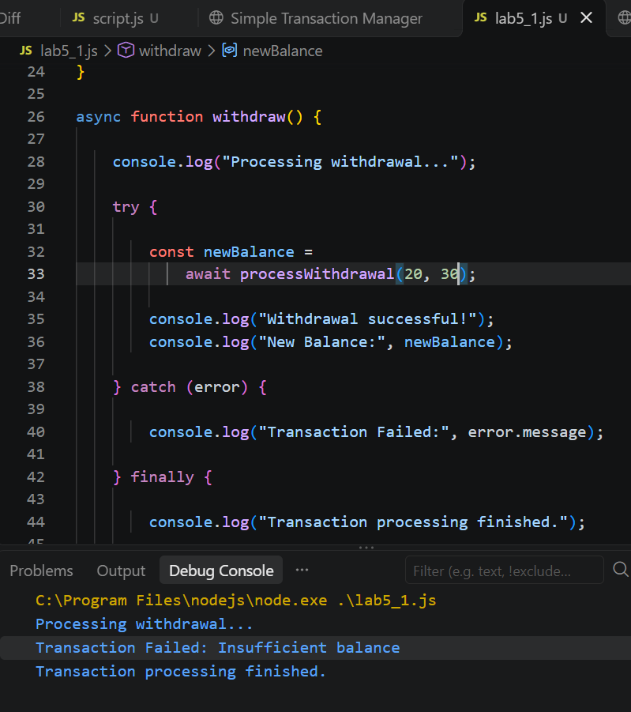

Student Task 4
Test the following withdrawal amounts:
Initial Balance | Withdrawal | Expected Result
20 | 5 | New balance = 15
20 | 20 | New balance = 0
20 | 25 | Insufficient balance
20 | -5 | Invalid withdrawal amount

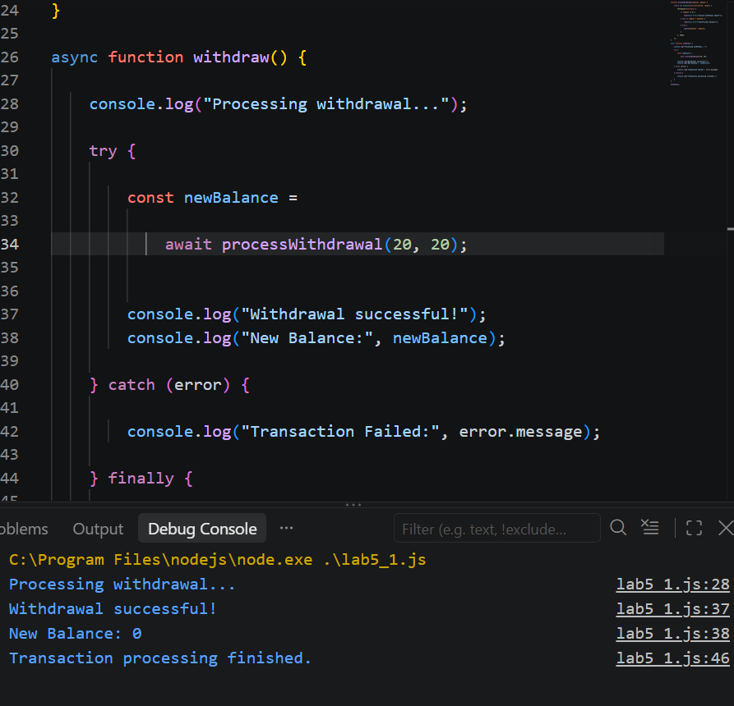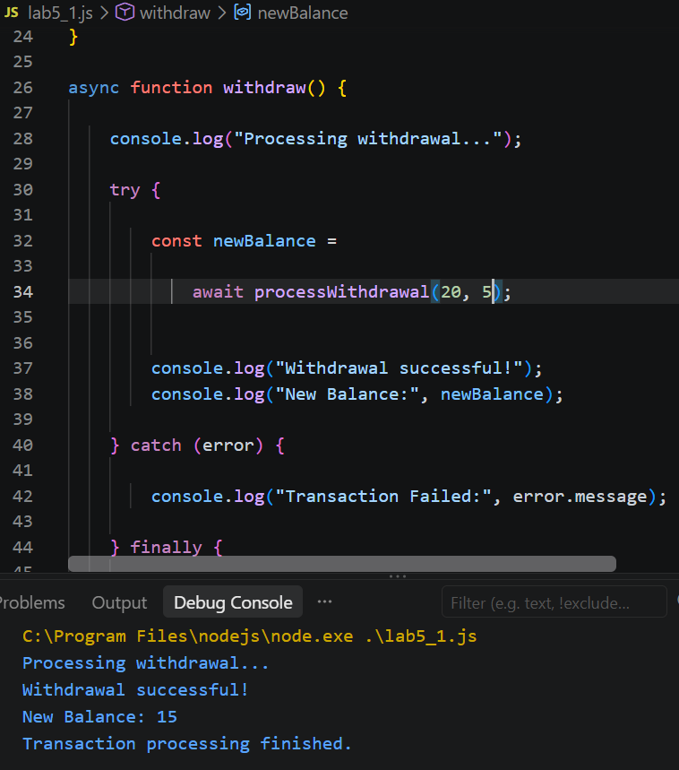
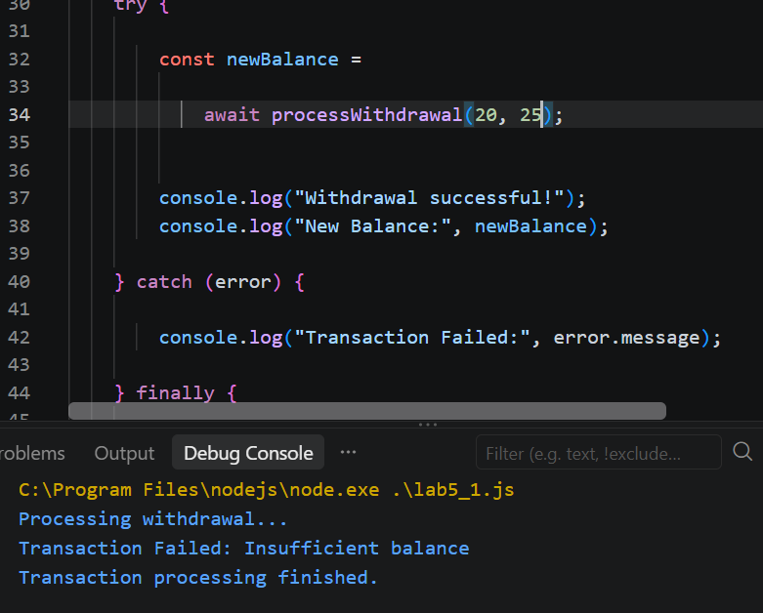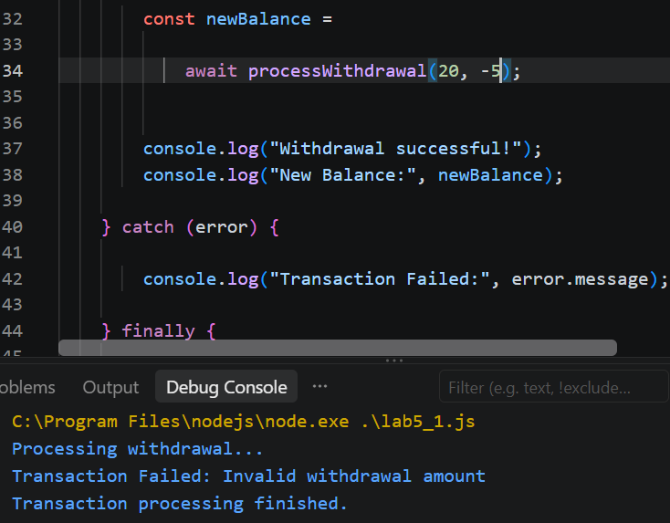

Part 6. Integrated Mini Project. Asynchronous Banking Transaction Simulator

4. Project Objective
Develop an interactive banking application that simulates delayed deposits and withdrawals.
The application must use:
- JavaScript Promises.
- async/await.
- try/catch/finally.
- Input validation.
- Asynchronous transaction processing.
- Dynamic balance updates.
- Transaction history.

5. Expected Application Interface
The application should display a current balance, an amount input field, Deposit and Withdraw buttons, transaction status, transaction history, and a Reset button.
Try the interactive example below to understand the expected behavior.

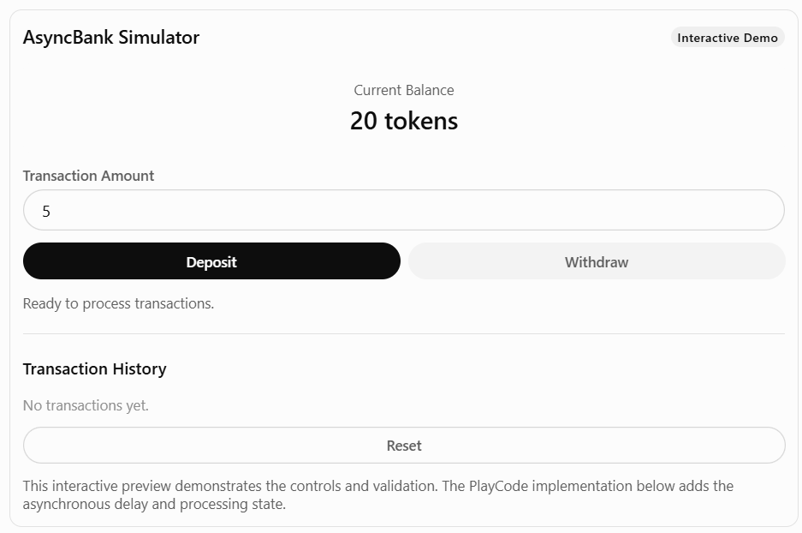

Step 13. Create the HTML Interface
Open index.html, delete the existing code, and paste:
<!DOCTYPE html>
<html lang="en">
<head>
<meta charset="UTF-8">

<meta name="viewport"
content="width=device-width, initial-scale=1.0">

<title>AsyncBank Simulator</title>

<link rel="stylesheet" href="./src/styles.css">
<script src="./src/script.js" defer></script>
</head>

<body>

<div class="container">

<header>
<h1>AsyncBank Simulator</h1>
<span class="badge">Async/Await Lab</span>
</header>

<p class="subtitle">
Simulating asynchronous banking transactions
</p>

<div class="balance-card">
<p>Current Balance</p>

<h2>
<span id="balance">20</span> tokens
</h2>
</div>

<div class="form-group">
<label for="amount">
Transaction Amount (tokens)
</label>

<input
type="number"
id="amount"
min="1"
step="1"
value="5"
>
</div>

<div class="buttons">
<button id="depositBtn">Deposit</button>
<button id="withdrawBtn">Withdraw</button>
</div>

<p id="status">
Ready to process transactions.
</p>

<hr>

<div class="history-header">
<h3>Transaction History</h3>

<span id="transactionCount">
0 transactions
</span>
</div>

<div id="history">
No transactions yet.
</div>

<button id="resetBtn">
Reset Simulation
</button>

<p class="note">
Transactions are simulated locally.
No blockchain network is used.
</p>

</div>

</body>
</html>

Step 14. Create the CSS Design
Open src/styles.css, delete the existing code, and paste:
* {
box-sizing: border-box;
}

body {
font-family: Arial, sans-serif;
background: #f5f6fa;
color: #222;
margin: 0;
padding: 25px;
}

.container {
max-width: 750px;
margin: auto;
background: white;
padding: 28px;
border: 1px solid #ddd;
border-radius: 18px;
}

header {
display: flex;
align-items: center;
justify-content: space-between;
gap: 12px;
}

h1 {
font-size: 25px;
margin: 0;
}

.badge {
background: #ede9fe;
padding: 8px 12px;
border-radius: 20px;
font-size: 13px;
}

.subtitle {
color: #666;
}

.balance-card {
background: #ede9fe;
padding: 30px;
margin: 25px 0;
border-radius: 15px;
text-align: center;
}

.balance-card h2 {
font-size: 36px;
margin: 10px 0;
}

label {
display: block;
margin-bottom: 10px;
font-weight: bold;
}

input {
width: 100%;
padding: 14px;
border: 1px solid #ccc;
border-radius: 10px;
font-size: 16px;
}

.buttons {
display: grid;
grid-template-columns: 1fr 1fr;
gap: 12px;
margin-top: 20px;
}

button {
padding: 14px;
border-radius: 10px;
border: none;
font-size: 16px;
cursor: pointer;
}

#depositBtn {
background: #2563eb;
color: white;
}

#withdrawBtn {
background: #111827;
color: white;
}

#resetBtn {
width: 100%;
margin-top: 20px;
background: white;
border: 1px solid #ccc;
}

button:disabled {
opacity: 0.5;
cursor: not-allowed;
}

#status {
min-height: 24px;
margin: 20px 0;
color: #666;
}

hr {
border: 0;
border-top: 1px solid #eee;
margin: 25px 0;
}

.history-header {
display: flex;
align-items: center;
justify-content: space-between;
gap: 12px;
}

#transactionCount {
font-size: 14px;
color: #777;
}

.transaction {
background: #f1f4f8;
padding: 12px;
margin: 8px 0;
border-radius: 10px;
}

.note {
font-size: 13px;
color: #777;
margin-top: 20px;
}

@media (max-width: 600px) {
header {
flex-direction: column;
align-items: flex-start;
}

.buttons {
grid-template-columns: 1fr;
}
}

Step 15. Implement the Complete JavaScript Logic
Open src/script.js, delete the existing code, and paste the following complete source:
/*
LAB 5.2 – Asynchronous Banking Transaction Simulator
Topics: Promises, async/await, try/catch/finally
*/

// STEP 1. Application state

const initialBalance = 20;
const processingDelay = 2000;

let balance = initialBalance;
let transactions = [];
let isProcessing = false;

// STEP 2. Update the interface

function updateDisplay() {

document.getElementById("balance").textContent =
balance;

document.getElementById("transactionCount").textContent =
transactions.length + " transactions";
}

// STEP 3. Display status messages

function showStatus(message, color = "#666") {

const status =
document.getElementById("status");

status.textContent = message;
status.style.color = color;
}

// STEP 4. Enable or disable controls

function setProcessing(processing) {

isProcessing = processing;

document.getElementById("depositBtn").disabled =
processing;

document.getElementById("withdrawBtn").disabled =
processing;

document.getElementById("resetBtn").disabled =
processing;

document.getElementById("amount").disabled =
processing;
}

// STEP 5. Validate user input

function getValidAmount() {

const amountText =
document.getElementById("amount").value;

const amount = Number(amountText);

if (
amountText.trim() === "" ||
!Number.isSafeInteger(amount) ||
amount <= 0
) {

throw new Error(
"Enter a valid positive integer amount."
);
}

return amount;
}

// STEP 6. Simulate an asynchronous transaction

function simulateTransaction(type, amount) {

return new Promise(function(resolve, reject) {

setTimeout(function() {

if (type === "Withdraw" && amount > balance) {

reject(
new Error("Insufficient balance.")
);

return;
}

if (
type === "Deposit" &&
!Number.isSafeInteger(balance + amount)
) {

reject(
new Error("Balance exceeds the supported range.")
);

return;
}

resolve({
type: type,
amount: amount,
success: true
});

}, processingDelay);

});
}

// STEP 7. Process deposits asynchronously

async function deposit() {

if (isProcessing) {
return;
}

try {

const amount = getValidAmount();

setProcessing(true);

showStatus(
"Processing deposit... Please wait.",
"#2563eb"
);

const result =
await simulateTransaction("Deposit", amount);

balance += result.amount;

transactions.push({
type: "Deposit",
amount: result.amount,
balance: balance
});

showStatus(
`Deposit successful! Added ${result.amount} tokens.`,
"green"
);

updateDisplay();
showHistory();

console.log("Deposit completed:", result);

} catch (error) {

showStatus(
"Transaction Failed: " + error.message,
"red"
);

console.error(error.message);

} finally {

setProcessing(false);

console.log("Deposit processing finished.");

}
}

// STEP 8. Process withdrawals asynchronously

async function withdraw() {

if (isProcessing) {
return;
}

try {

const amount = getValidAmount();

setProcessing(true);

showStatus(
"Processing withdrawal... Please wait.",
"#2563eb"
);

const result =
await simulateTransaction("Withdraw", amount);

balance -= result.amount;

transactions.push({
type: "Withdrawal",
amount: result.amount,
balance: balance
});

showStatus(
`Withdrawal successful! Removed ${result.amount} tokens.`,
"green"
);

updateDisplay();
showHistory();

console.log("Withdrawal completed:", result);

} catch (error) {

showStatus(
"Transaction Failed: " + error.message,
"red"
);

console.error(error.message);

} finally {

setProcessing(false);

console.log("Withdrawal processing finished.");

}
}

// STEP 9. Display transaction history

function showHistory() {

const history =
document.getElementById("history");

history.innerHTML = "";

transactions.forEach(function(tx, index) {

const item =
document.createElement("div");

item.className = "transaction";

const sign =
tx.type === "Deposit" ? "+" : "-";

item.textContent =
`${index + 1}. ${tx.type}: ${sign}${tx.amount} tokens | Balance: ${tx.balance}`;

history.appendChild(item);
});
}

// STEP 10. Reset the simulation

function reset() {

if (isProcessing) {
return;
}

balance = initialBalance;
transactions = [];

document.getElementById("amount").value = 5;

document.getElementById("history").textContent =
"No transactions yet.";

showStatus("Simulation reset.");

updateDisplay();

console.log("Simulation reset.");
}

// STEP 11. Initialize the application

function initializeApp() {

const depositButton =
document.getElementById("depositBtn");

const withdrawButton =
document.getElementById("withdrawBtn");

const resetButton =
document.getElementById("resetBtn");

if (
!depositButton ||
!withdrawButton ||
!resetButton
) {

console.error(
"Required buttons not found. Check index.html."
);

return;
}

depositButton.addEventListener("click", deposit);

withdrawButton.addEventListener("click", withdraw);

resetButton.addEventListener("click", reset);

updateDisplay();

console.log("AsyncBank Simulator is ready!");
}

// STEP 12. Wait until HTML is ready

if (document.readyState === "loading") {

document.addEventListener(
"DOMContentLoaded",
initializeApp
);

} else {

initializeApp();

}

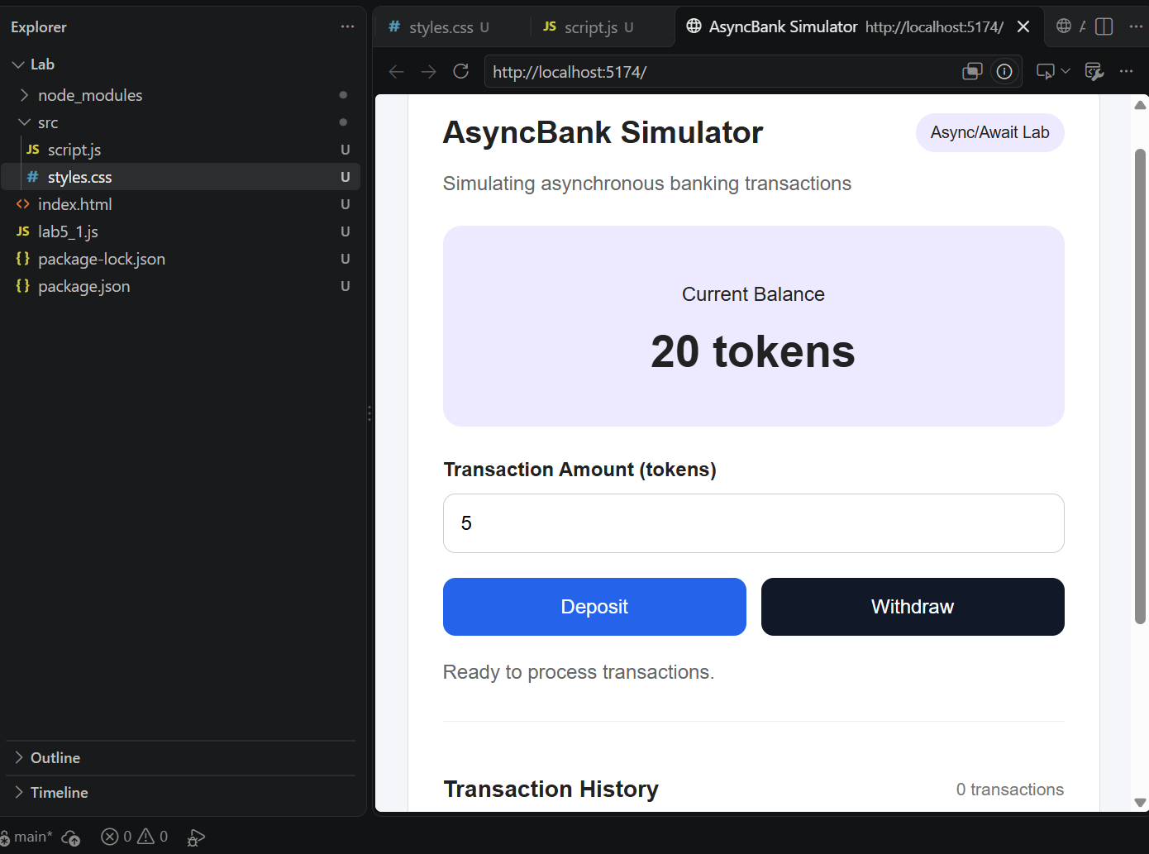

Step 16. Understand the Asynchronous Transaction Flow
User enters an amount
↓
User clicks Deposit or Withdraw
↓
Input validation
↓
Status: Processing...
↓
simulateTransaction()
↓
Promise pending for ~2 seconds
↓
Promise settles
/ \
Fulfilled Rejected
↓ ↓
Update catch(error)
Balance ↓
↓ Show Error
Save History
↓
Show Success
\ /
finally
↓
Enable Buttons
Important: The balance is updated only after the simulated Promise fulfills successfully. While the Promise is pending, the buttons and amount input are disabled to prevent overlapping transactions.

Part 7. Test the Integrated Application

Step 17. Run the Application
- Open the Preview panel.
- Refresh the application if necessary.
- Confirm that the initial balance is 20 tokens.
- Open the Console.
Expected Console Output
AsyncBank Simulator is ready!
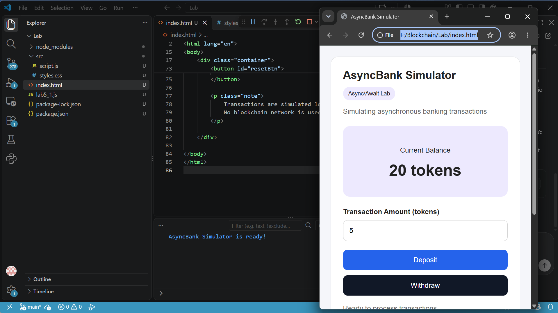

Step 18. Test Successful Transactions
Perform the following tests sequentially, without resetting between TC01 and TC03.
Test Case | Action | Expected Balance | Expected Status
TC01 | Deposit 5 tokens | 25 | Deposit successful
TC02 | Withdraw 8 tokens | 17 | Withdrawal successful
TC03 | Deposit 10 tokens | 27 | Deposit successful
Each transaction should display a processing message for approximately 2 seconds before the balance changes.
Expected Transaction History
1. Deposit: +5 tokens | Balance: 25
2. Withdrawal: -8 tokens | Balance: 17
3. Deposit: +10 tokens | Balance: 27
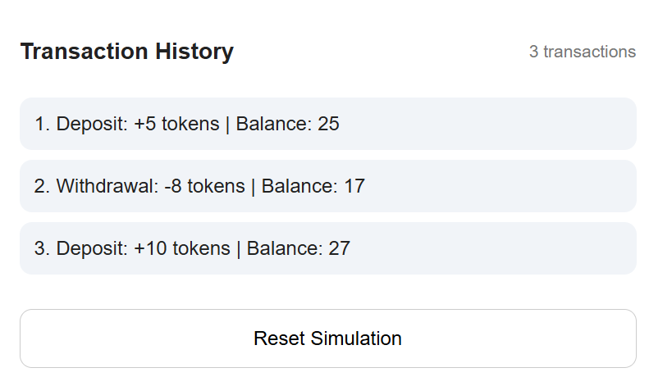

Step 19. Test Failed Transactions
Continue from the balance of 27 tokens.
Test Case | Action | Expected Result
TC04 | Withdraw 100 tokens | Insufficient balance
TC05 | Deposit 0 tokens | Invalid amount
TC06 | Withdraw -5 tokens | Invalid amount
TC07 | Deposit 2.5 tokens | Invalid amount
TC08 | Click Reset | Balance returns to 20
Failed transactions must not change the balance or appear in the transaction history.
TC04
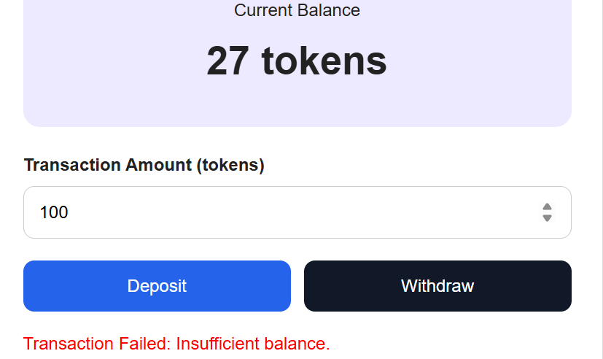
TC05
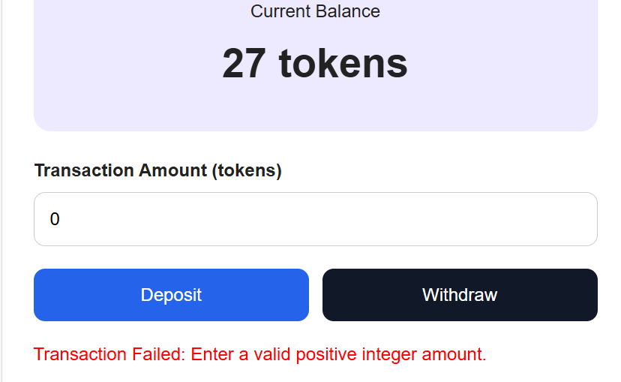
TC06
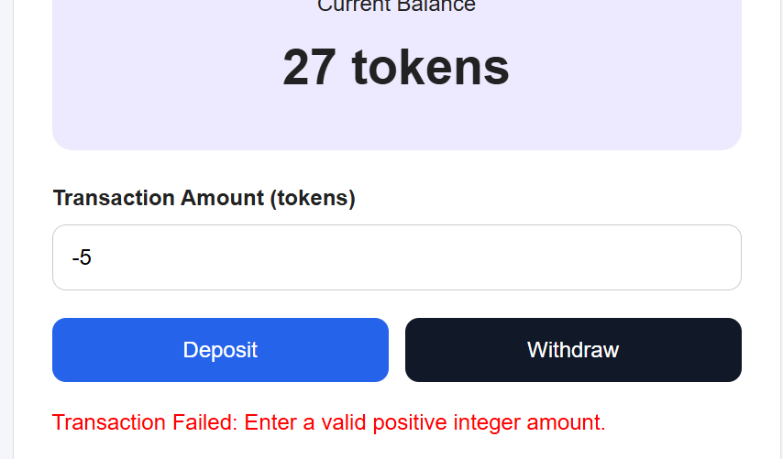
TC07
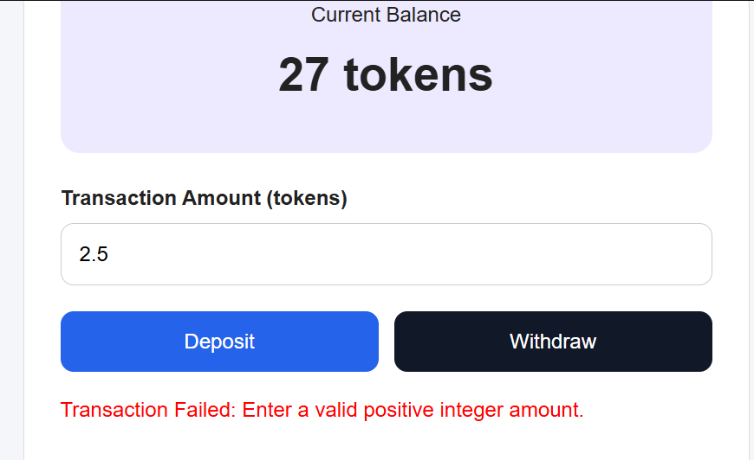
TC08
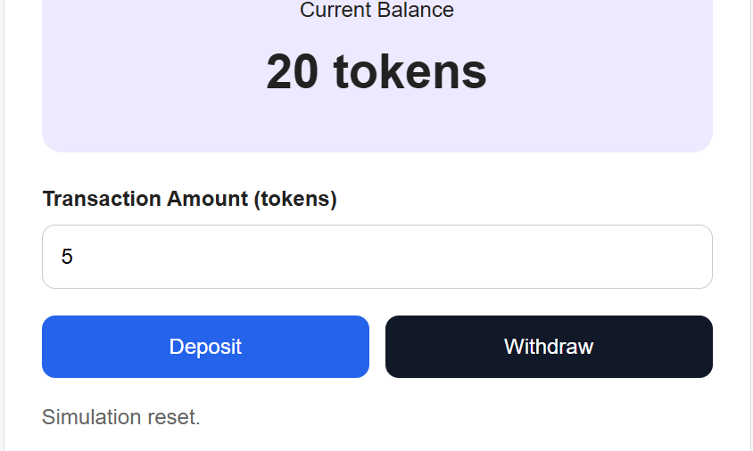

Step 20. Verify the Processing State
- Enter 5 in the Amount field.
- Click Deposit.
- Immediately observe the interface.
- Confirm that the status displays Processing deposit... Please wait.
- Confirm that the action buttons are temporarily disabled.
- After approximately 2 seconds, verify that the balance increases.

Part 8. Student Practice
After completing the integrated simulator, students should implement the following extensions.

Exercise 1. Change the Processing Delay
Change: const processingDelay = 2000;
to: const processingDelay = 5000;
Observe the processing message and explain the effect of the delay.
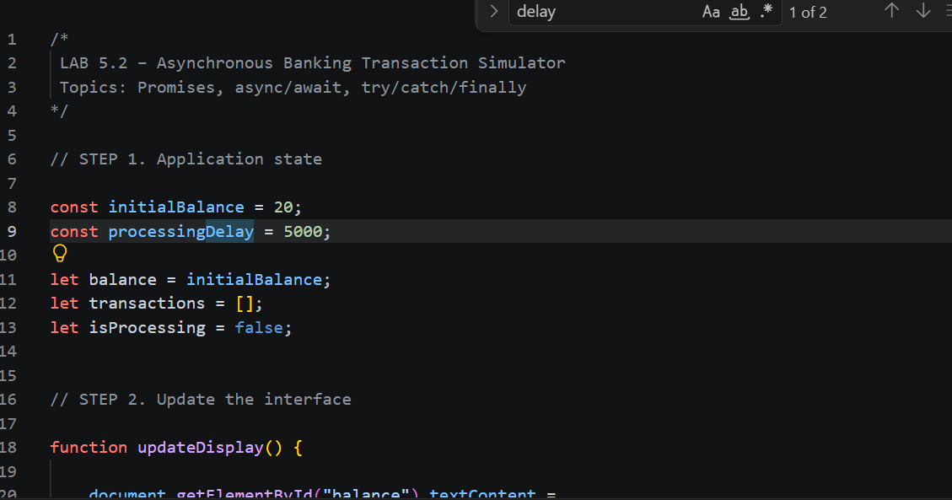

Exercise 2. Add a Maximum Withdrawal Limit
Modify the withdrawal logic to reject withdrawals greater than 50 tokens, even when the account has sufficient funds.

Exercise 3. Simulate Network Errors
Modify simulateTransaction() to support a simulated network failure:
if (Math.random() < 0.2) {
reject(new Error("Simulated network error."));
return;
}
Place this check inside the setTimeout() callback, before the success validation.
Expected Behavior: Some transactions fail with a network error. The balance and transaction history must remain unchanged for failed transactions.
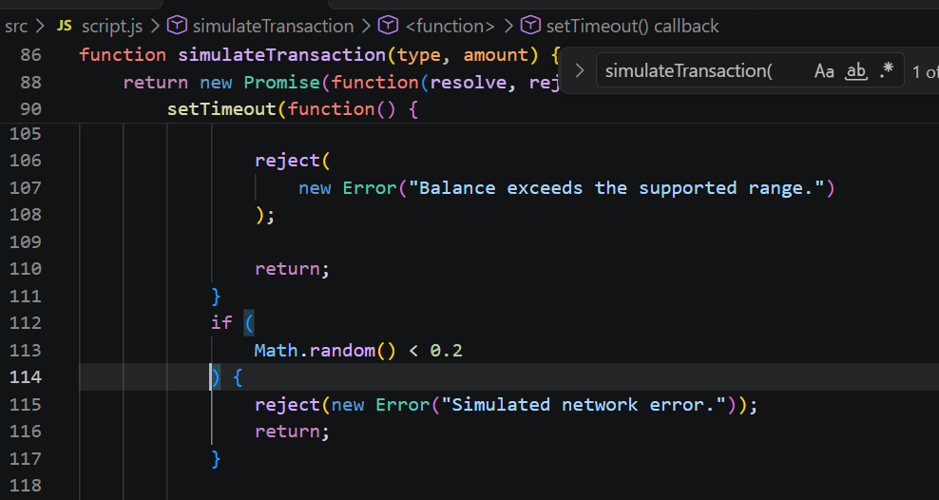

Exercise 4. Add a Transaction Processing Counter
Display the total number of attempted transactions, including successful and failed transactions.
  - Sửa trên file script.js -> thêm totalAttemp =0 -> chỉnh updateDisplay -> Deposit -> transtraction history
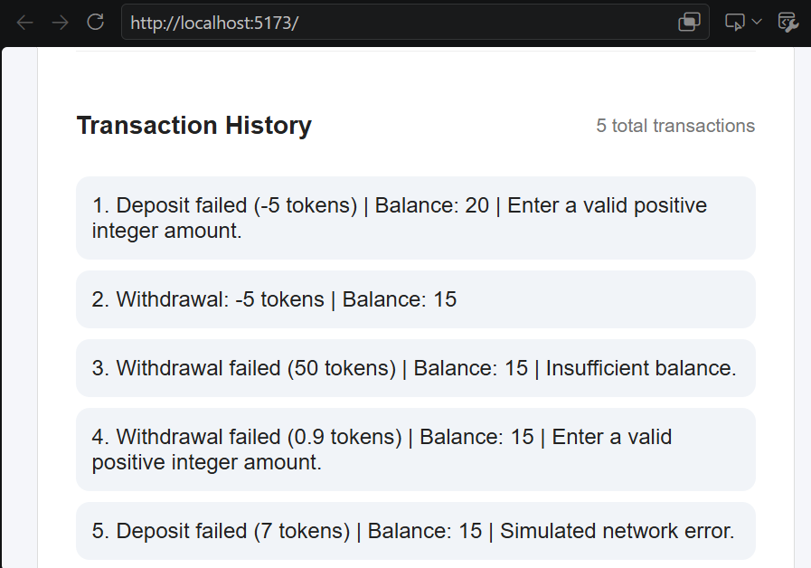

Exercise 5. Add a Retry Feature
Allow the user to retry a failed transaction. The application must not duplicate a transaction that has already succeeded.

Part 9. Lab Report Questions
- What is asynchronous programming in JavaScript?
  - Lập trình bất đồng bộ cho phép JavaScript thực hiện các thao tác tốn nhiều thời gian mà không làm gián đoạn phần còn lại của chương trình. Các tác vụ khác có thể tiếp tục trong khi chờ đợi thao tác hoàn tất.
- What is the difference between synchronous and asynchronous execution?
  - Đồng bộ: Các tác vụ được thực hiện lần lượt theo thứ tự. Mỗi tác vụ phải hoàn tất trước khi tác vụ tiếp theo bắt đầu.
  - Bất đồng bộ: JavaScript có thể tiếp tục thực hiện các tác vụ khác trong khi chờ một thao tác (chẳng hạn như bộ đếm thời gian hoặc giao dịch) hoàn tất.
- What is a Promise?
  - Promise là một đối tượng JavaScript đại diện cho kết quả thành công hoặc thất bại trong tương lai của một thao tác bất đồng bộ.
- What are the three states of a Promise?
  - Đang chờ xử lý: Thao tác vẫn đang được thực hiện.
  - Đã hoàn tất: Thao tác đã hoàn tất thành công.
  - Bị từ chối: Thao tác đã thất bại.
- What is the purpose of resolve() and reject()?
  - resolve() cho biết thao tác bất đồng bộ đã hoàn tất thành công và cung cấp kết quả của nó.
  - reject() cho biết thao tác đã thất bại và cung cấp lỗi hoặc lý do dẫn đến thất bại đó.
- What does the async keyword do?
  - Từ khóa `async` dùng để khai báo một hàm bất đồng bộ. Nó cho phép sử dụng `await` bên trong hàm và khiến hàm đó trả về một `Promise`.
- What happens when JavaScript encounters await?
  - Khi JavaScript gặp từ khóa `await`, nó sẽ tạm dừng việc thực thi bên trong hàm bất đồng bộ hiện tại cho đến khi `Promise` được giải quyết (settle). Các tác vụ JavaScript khác vẫn có thể tiếp tục chạy trong khoảng thời gian này.
- How do try, catch, and finally work?
  - try: Thực thi đoạn mã có thể gây ra lỗi.
  - catch: Xử lý các lỗi phát sinh trong quá trình thực thi.
  - finally: Thực thi đoạn mã bất kể thao tác thành công hay thất bại.
- Why does the simulator disable buttons during transaction processing?
  - Trình mô phỏng vô hiệu hóa các nút bấm để ngăn người dùng gửi nhiều giao dịch trong khi một giao dịch khác đang được xử lý. Điều này giúp tránh tình trạng giao dịch trùng lặp, cập nhật số dư không chính xác và trạng thái ứng dụng không nhất quán.
- Why should balances only be updated after successful transaction processing?
  - Số dư chỉ nên được cập nhật sau khi giao dịch thành công để đảm bảo tính chính xác của hồ sơ tài chính. Nếu giao dịch thất bại do không đủ số dư hoặc dữ liệu đầu vào không hợp lệ, số dư ban đầu phải được giữ nguyên.
- How is the simulated transaction delay related to blockchain transactions?
  - Độ trễ được mô phỏng đại diện cho thời gian chờ đợi trong các giao dịch blockchain thực tế, chẳng hạn như quá trình giao tiếp mạng, xác thực giao dịch và xác nhận khối. Trình mô phỏng sử dụng hàm `setTimeout()` để tái tạo độ trễ này mà không cần kết nối với một blockchain thực tế.
- How would async/await be used when calling a Solidity smart contract through Web3.js?
  - async/await cho phép JavaScript chờ kết quả của một tương tác với hợp đồng thông minh. Ví dụ, `await` có thể được sử dụng khi gửi giao dịch hoặc đọc dữ liệu hợp đồng thông qua Web3.js.

