Statistical Advisory Report
The Deterrence Effect of Darkness on
Pedestrians and Cyclists in Bristol
Evidence from Negative Binomial GLM Analysis
of 37-Sensor Panel Data (2024)
Prepared for Bristol City Council
April 2026

1. Executive Summary
This report presents findings from a Generalised Linear Model (GLM) analysis of hourly pedestrian and cyclist count data collected across 37 sensors in Bristol during 2024. The analysis quantifies the independent effect of darkness on active travel volumes after controlling for time-of-day patterns, day-of-week, seasonal variation, weather conditions, and sensor-level fixed effects. Its purpose is to inform Bristol City Council on targeted interventions to reduce the deterrence effect of darkness, in support of the city’s carbon-neutral-by-2030 ambition and the One City Climate Strategy target of achieving 55% active travel modal share.
Headline finding for pedestrians: Darkness is associated with approximately a 33–34% reduction in pedestrian counts during commuter transition hours (05:00–06:59 and 17:00–20:59), even after adjusting for all temporal, meteorological, and spatial confounders. This effect is robust across all five model specifications (p < 0.001 in all cases) and is observed at 36 of the 37 sensor sites. It is network-wide, not concentrated in a single neighbourhood.
Headline finding for cyclists: The pooled city-wide darkness effect on cyclists is small and statistically non-significant (approximately −4%, p = 0.45). However, this masks substantial heterogeneity: Central Bristol shows a strong −20.5% to −25.3% darkness penalty, while East Bristol shows essentially no effect. The cyclist story is therefore one of place-dependent variation, not uniform deterrence.
Key policy-relevant moderator: Model 5 reveals that streetlight density within 50 metres of sensor locations attenuates the pedestrian darkness penalty. At one standard deviation above the mean streetlight density, the darkness penalty falls from −34% to approximately −19%. This provides direct evidence that street lighting investment can recover lost pedestrian footfall after dark.
Follow-up: morning commuter window is the critical period. Hour-by-cluster analysis reveals pedestrian darkness penalties of −55% to −77% at 05:00–06:00, roughly double the evening penalty. Sensor-level refits show all 37 sensors are affected, with the most extreme (Sensors 4 and 8) losing over 80% of pedestrian traffic after dark.
Follow-up: cyclist heterogeneity confirmed at sensor level. All nine Central sensors show negative cyclist effects (−8% to −53%), while East sensors are mixed around zero and Outlier sensors show predominantly positive effects. Within-cluster safety interactions remain significant (East p = 0.001, Outlier p < 10⁻⁹), confirming the safety moderator captures genuine within-place variation rather than just between-cluster geography.

2. Data and Methodology

2.1 Data Sources
The analysis draws on a panel dataset of hourly pedestrian, cyclist, and motor vehicle counts from 37 sensors across Bristol, spanning the full calendar year 2024. Each observation records the sensor identifier, timestamp, count by mode, geographic coordinates, and a binary darkness indicator derived from solar altitude (darkness defined as solar altitude below 0 degrees, with twilight hours excluded so the contrast is strictly darkness versus daylight).
Supplementary data merged at the sensor level include: hourly temperature, wind speed, and rainfall from meteorological records; CCTV camera counts within 300 metres; ward-level perceived safety-after-dark scores from the Bristol Quality of Life survey; leisure and retail business counts within 300 metres; and streetlight counts within 50 metres.

2.2 Analytical Window
To isolate the causal effect of darkness from confounding time-of-day patterns, the analysis restricts to the six “mixed-case” hours where both daylight and darkness observations occur depending on season: 05:00–06:59 and 17:00–20:59. This design exploits the natural seasonal variation in sunset and sunrise times, providing within-hour variation in darkness status across the year.

2.3 Model Specification
All models are Negative Binomial GLMs with a log link, fitted using iteratively reweighted least squares (IRLS). Standard errors are cluster-robust at the sensor level to account for within-sensor serial correlation. The five-model ladder is summarised below.
Model | Description | Key RHS Terms Beyond Base
Model 1 | Main pooled darkness model | Dark + lag terms + C(hour) + C(dow) + C(month) + weather + C(sensor)
Model 2 | Darkness × Cluster interaction | Adds Dark × Cluster (Central, East, Outlier)
Model 3 | Darkness × CCTV interaction | Adds Dark × cctv_z (z-standardised)
Model 4 | Darkness × Safety interaction | Adds Dark × safety_z (z-standardised)
Model 5 | Darkness × Business + Streetlight | Adds Dark × businesses_z + Dark × streetlights_z
Each model is fitted separately for pedestrians (ped) and cyclists (cyc). The dataset contains 70,836 observations from 37 sensors. Lag terms (lag1 and lag24) capture short-run persistence. Sensor fixed effects absorb all time-invariant differences between locations, meaning contextual moderators (CCTV, safety, businesses, streetlights) enter only as interactions with the Dark indicator.

3. Key Findings

3.1 The Pedestrian Darkness Penalty Is Large, Robust, and Network-Wide
Across all comparable model specifications, darkness is associated with approximately one-third fewer pedestrians during the mixed-case commuter hours. The point estimates are remarkably stable:
Model | Ped % Change | Ped p-value | Cyc % Change | Cyc p-value
Model 1 | −33.3% | 1.48 × 10⁻⁹ | −4.0% | 0.446
Model 3 | −33.3% | 7.91 × 10⁻¹⁰ | −3.9% | 0.448
Model 4 | −34.3% | 2.01 × 10⁻⁹ | −4.1% | 0.356
Model 5 | −33.8% | 1.33 × 10⁻⁸ | −3.7% | 0.495
Table 1: Summary of main darkness effects across comparable pooled models.
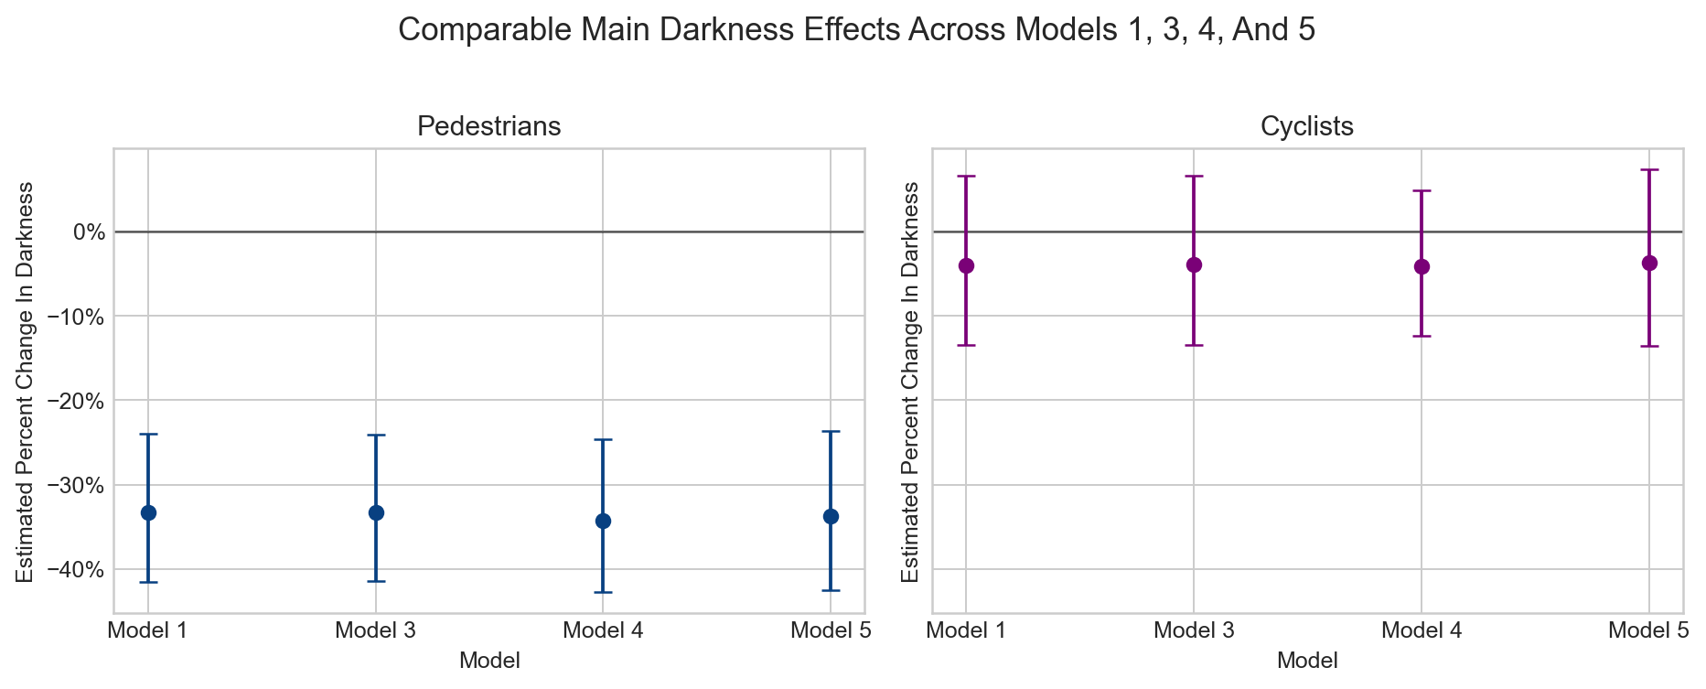
Figure 1: Comparable main darkness effects across Models 1, 3, 4, and 5. The pedestrian effect is stable near −33% across all specifications. The cyclist effect is near zero and non-significant.
The raw data corroborate this pattern: the daylight pedestrian mean across mixed hours is 116.9 counts per sensor-hour, versus 62.3 in darkness. 36 of the 37 sensors individually show lower pedestrian counts in darkness. The raw drop is geographically consistent: approximately −46% in Central, −47% in East, and −50% in Outlier clusters. The GLM adjusts this downward to −33–34%, confirming that while some of the raw difference is attributable to regular temporal and weather patterns, a large independent darkness penalty remains.

3.2 The Cyclist Story Is One of Place-Dependent Variation
The pooled cyclist darkness coefficient is consistently small and non-significant across all models (−4%, p > 0.35). However, Model 2 reveals striking heterogeneity by cluster:
Cluster | Cyclist Dark % | Dark×East p-value | Raw Daylight → Dark
Central | −20.5% | (reference) | 61.1 → 31.0
East | −1.6% | 0.045 | 19.8 → 15.0
Outlier | +20.4% | — | 7.7 → 9.0
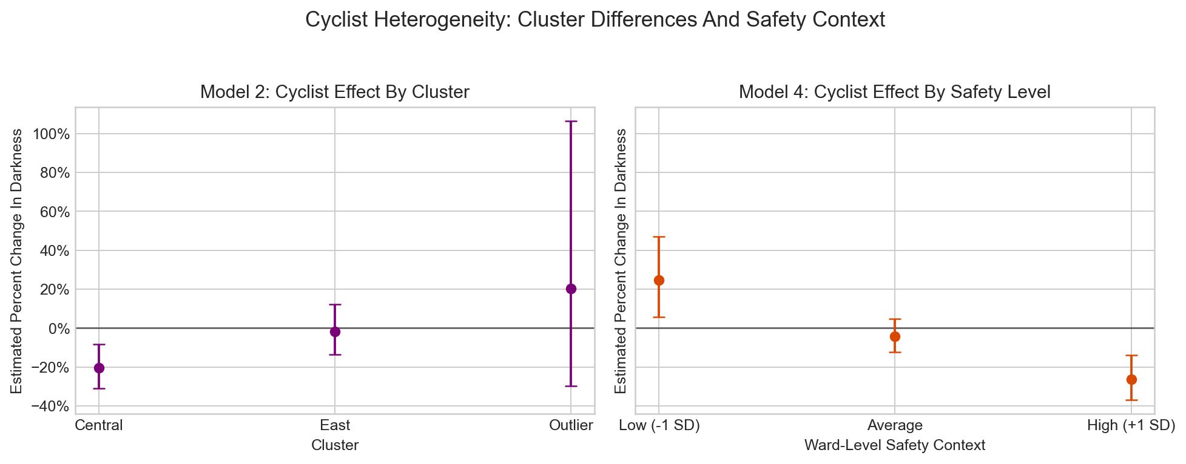
Figure 2: Left panel shows cyclist darkness effect by cluster. Right panel shows how the effect varies with ward-level perceived safety after dark (p = 0.00012).
The supplementary within-cluster refits confirm that this heterogeneity persists even after excluding the Outlier group: Central cyclists show −25.3% (p < 0.001) while East cyclists show +0.2% (p = 0.97). The cyclist darkness effect is therefore not a single-number problem; it is fundamentally place-dependent.

3.3 Moderating Factors: What Helps and What Does Not
CCTV (Model 3): No meaningful moderation. The Dark × CCTV interaction is negligible for both pedestrians (coefficient 0.011, p = 0.95) and cyclists (coefficient −0.004, p = 0.94). Despite wide variation in CCTV density (0 to 183 cameras within 300m), it does not explain the darkness patterns.
Perceived safety after dark (Model 4): Strong cyclist moderator. The Dark × safety interaction is highly significant for cyclists (coefficient −0.262, p = 0.00012), indicating that in wards perceived as safer after dark, cyclists show a stronger darkness avoidance response. This is counterintuitive and likely reflects confounding with geography (Central sensors all share the same high safety score). For pedestrians, the safety interaction is negative but non-significant (p = 0.16).
Streetlight density (Model 5): The most policy-relevant moderator for pedestrians. At +1 SD, the pedestrian darkness penalty falls from −34% to −19%. At −1 SD, it deepens to −46%. While the interaction term itself has p = 0.12 (not conventionally significant at 5%), the direction is consistent, the magnitude is large, and the practical implication is clear. For cyclists, streetlight moderation is negligible.
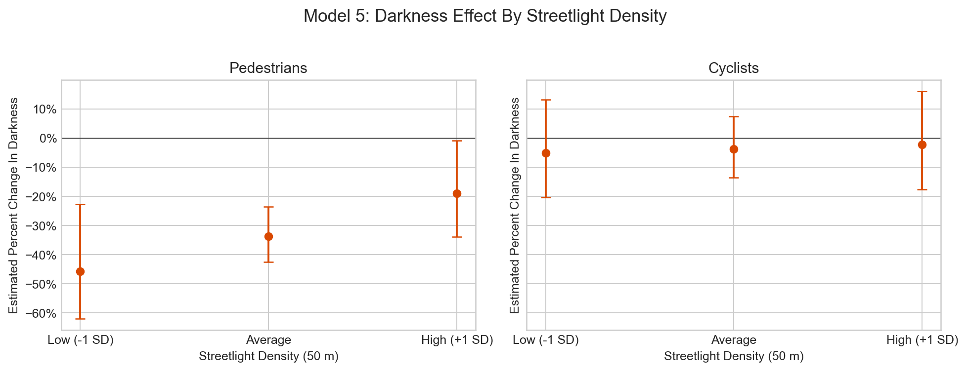
Figure 6: Model 5 streetlight density moderation. Left: pedestrians, showing the darkness penalty attenuated from −46% (low streetlights) to −19% (high streetlights). Right: cyclists, minimal moderation.
Business density (Model 5): Weak and non-significant for both modes. More businesses within 300m do not meaningfully buffer the darkness penalty.
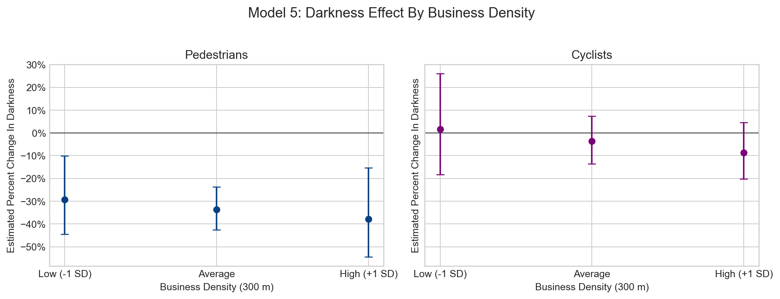
Figure 7: Model 5 business density moderation. Neither mode shows significant interaction.

3A. Targeted Pedestrian Follow-Up Analysis
The pooled Models 1–5 confirm a robust −33% pedestrian darkness penalty, but policy implementation requires finer resolution: when is the penalty most severe, and which corridors should be prioritised? A sensor-level refit with per-hour Dark indicators within each cluster answers both questions.

3A.1 Timing of the Pedestrian Darkness Penalty by Cluster
Replacing the single Dark dummy with hour-specific Dark indicators (Dark_05, Dark_06, Dark_17–Dark_20) within each cluster reveals a clear early-morning peak:
Hour | Central | East | Outlier
05:00 | −63.3% | −36.6% | −57.4%
06:00 | −72.7% | −55.0% | −76.4%
17:00 | −24.6% | −22.5% | −24.2%
18:00 | −11.3% | −25.1% | −28.9%
19:00 | −15.3% | −29.6% | −28.5%
20:00 | −17.6% | −28.0% | −24.3%
Table 2: Estimated pedestrian percent change due to darkness, by hour and cluster. All cells are negative; the penalty is universal but most extreme at 05:00–06:00.
The morning commuter window (05:00–06:59) carries darkness penalties of −55% to −77% depending on cluster, roughly double the evening penalty. This is consistent with the hypothesis that pre-dawn darkness, combined with lower ambient activity, amplifies deterrence. For the Council’s LED CMS adaptive brightening strategy, this means the 05:00–07:00 window should be the highest-priority activation period, ahead of the evening transition.

3A.2 Sensor-Level Severity Ranking
A sensor-level Negative Binomial refit with individual Dark coefficients per sensor allows ranking of the 37 sensors by severity of darkness penalty. Cluster-level summaries:
Cluster | N Sensors | Mean % Change | Range
Central | 9 | −25.9% | −85.1% to −5.3%
East | 20 | −26.0% | −66.9% to −10.5%
Outlier | 8 | −36.9% | −83.6% to −0.9%
Table 3: Sensor-level pedestrian darkness effects by cluster. All 37 sensors show negative effects.
The ten most severely affected sensors include:
Rank | Sensor | Cluster | % Change
1 | Sensor 4 | Central | −85.1%
2 | Sensor 8 | Outlier | −83.6%
3 | Sensor 22 | East | −66.9%
Table 4: Top three sensors by severity of pedestrian darkness penalty. Sensors 4 and 8 lose more than 80% of pedestrian traffic after dark.
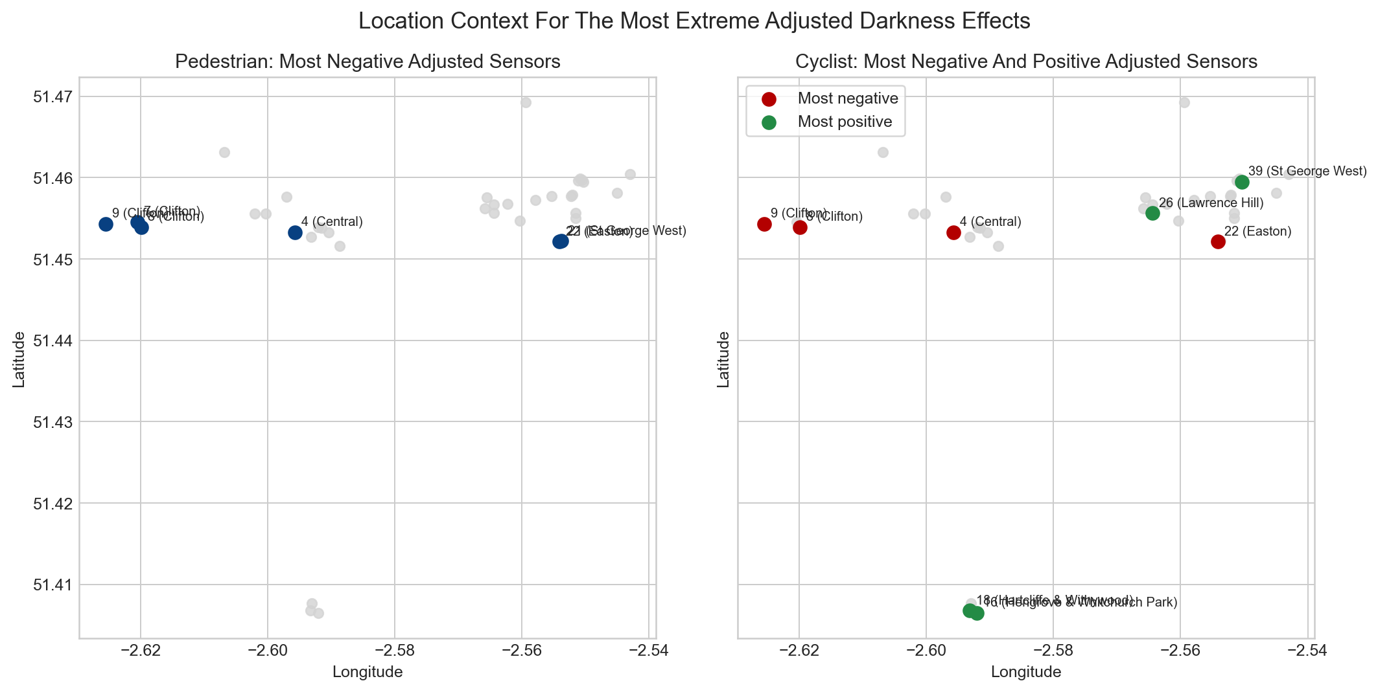
Figure 5: Sensor context map showing geographic distribution of darkness penalties and built-environment characteristics at each sensor location.
These extreme sensors should be the first candidates for after-dark intervention: if Sensors 4 and 8 lose more than 80% of their pedestrian traffic when it becomes dark, even modest improvements to the lighting and legibility environment could recover substantial footfall. The sensor-level ranking enables the Council to allocate its LED CMS adaptive brightening budget to corridors where the marginal return is greatest.

3B. Deeper Cyclist Follow-Up Analysis
The pooled models showed a non-significant city-wide cyclist darkness effect masking substantial between-cluster heterogeneity. The follow-up analyses drill into sensor-level variation, hourly timing, and within-cluster moderators to understand the cyclist story in full.

3B.1 Sensor-Level Cyclist Heterogeneity
A sensor-level refit reveals the cyclist picture is far more varied than the pedestrian one:
Cluster | N Sensors | Mean % Change | Range
Central | 9 | −22.8% | −52.6% to −8.2%
East | 20 | +1.1% | −38.2% to +53.3%
Outlier | 8 | +19.8% | −53.7% to +124.9%
Table 5: Sensor-level cyclist darkness effects by cluster. Central is uniformly negative; East is mixed around zero; Outlier is predominantly positive.
All nine Central sensors show negative cyclist effects (−8% to −53%), confirming that Central Bristol genuinely deters cyclists after dark. In contrast, East Bristol sensors span −38% to +53%, and Outlier sensors range from −54% to +125%. The positive effects in Outlier and some East sensors are not simply statistical noise—they reflect genuine sensor-level patterns where cycling counts increase (or at least do not fall) after dark.

3B.2 Cyclist Hour-by-Cluster Timing
Hour | Central | East | Outlier
05:00 | −63.1% | −39.8% | +119.2%
06:00 | −72.1% | −39.8% | +76.3%
17:00 | −11.2% | +7.9% | +25.8%
18:00 | −18.3% | +11.6% | +78.6%
19:00 | −19.6% | +14.6% | +61.2%
20:00 | −24.4% | +10.2% | +54.8%
Table 6: Estimated cyclist percent change due to darkness, by hour and cluster. Central shows consistent negative effects at all hours. East is mildly positive in the evening. Outlier shows large positive effects, particularly in the early morning.
The Outlier +119% at 05:00 and +76% at 06:00 are striking. These sensors include routes where cycling activity increases markedly after dark—potentially reflecting commuter cyclists on dedicated infrastructure who are insensitive to darkness, or route-substitution effects where cyclists shift from unlit side routes to sensor-monitored lit corridors. This merits corridor-level investigation.

3B.3 Within-Cluster Safety Interactions
To test whether the safety interaction (which was significant in the pooled model) reflects genuine within-cluster variation rather than between-cluster geography, separate models were fitted within East and Outlier clusters:
Cluster | Dark at Mean Safety | Dark×Safety p-value | Interpretation
East | −8.0% | 0.001 | Within East, higher safety wards show stronger darkness penalty
Outlier | +54.0% | 2.28 × 10⁻⁹ | Within Outlier, safety interaction reverses sign
Table 7: Within-cluster cyclist safety interactions. The safety moderator is statistically significant within both East and Outlier, confirming it is not purely a between-cluster proxy for geography.
This is an important validation: the safety variable captures real within-cluster variation in cyclist sensitivity to darkness. In East Bristol, sensors in higher-safety wards show a stronger darkness deterrent—consistent with confounding between perceived safety and route characteristics (well-lit but monitored routes may attract different cyclist populations). In Outlier, the positive baseline and strong safety interaction suggest a fundamentally different relationship between darkness and cycling.

3B.4 Context Correlations and Entanglement
A key caveat emerges from examining correlations between the contextual moderators within each cluster:
Cluster | Safety–Businesses r | Safety–Streetlights r
East | 0.475 | 0.502
Outlier | 0.715 | −0.371
Table 8: Correlations between perceived safety and built-environment variables within clusters.
In East, safety is moderately correlated with both businesses (r = 0.48) and streetlights (r = 0.50), meaning these variables partially measure the same underlying construct: “urbanness” or corridor quality. In Outlier, safety and businesses are strongly correlated (r = 0.72), while safety and streetlights are negatively correlated (r = −0.37). This entanglement means the individual moderator coefficients should not be interpreted as isolated causal effects.
Within-cluster context models (Dark × businesses_z and Dark × streetlights_z fitted within clusters) confirm this: East shows neither business (p = 0.509) nor streetlight (p = 0.458) interaction as significant, while Outlier shows a borderline business interaction (p = 0.051) and non-significant streetlight interaction (p = 0.161). The safety variable, being a composite proxy for corridor quality, outperforms the individual infrastructure measures in explanatory power.
For policy, this entanglement has an important implication: rather than targeting a single infrastructure lever (streetlights alone, or businesses alone), the Council should think in terms of corridor-level packages that address lighting, activity, and perceived safety together. The evidence supports a place-based approach where multiple environmental improvements are coordinated.

4. Strengths and Weaknesses of the Models

4.1 Strengths
Quasi-experimental design. By restricting to mixed-case hours where the same clock-hour is sometimes light and sometimes dark depending on season, the analysis approximates a natural experiment. This is substantially stronger than simply comparing daytime and night-time hours.
Rich control structure. Hour, day-of-week, month, temperature, wind, rainfall, and autoregressive lag terms absorb major confounders. Sensor fixed effects control for all stable between-location differences. Cluster-robust standard errors account for within-sensor correlation.
Appropriate distributional family. The Negative Binomial distribution handles overdispersion in count data. Pearson dispersion statistics close to 1.0 (0.88–1.09 across models) confirm adequate fit.
High explanatory power. Craig-Uhler pseudo R² values are 0.85 for pedestrians and 0.71 for cyclists.
Stability across specifications. The pedestrian darkness coefficient varies only between −0.39 and −0.42 on the log scale across five model specifications. This insensitivity to additional covariates is strong evidence against omitted variable bias from the variables tested.
Large sample. 70,836 sensor-hour observations across 37 sensors provide substantial statistical power.

4.2 Weaknesses and Caveats
Observational, not experimental. Despite the quasi-experimental design, unobserved seasonal confounders (school terms, cultural events, daylight saving adjustments) that correlate with darkness could contribute to the estimated effect.
Default dispersion parameter. The Negative Binomial models use statsmodels’ default alpha = 1.0 rather than estimating it from data. Jointly estimating alpha could refine confidence intervals.
Static moderators. CCTV, safety, business density, and streetlight counts are time-invariant and partially collinear with geography. This limits the ability to disentangle place-character effects from infrastructure effects.
Ecological fallacy risk. The safety variable is measured at ward level, not at the individual level. The safety interaction should be interpreted as a place-context signal, not as evidence of direct individual-level causation.
Streetlight interaction p = 0.12. While large in magnitude, the streetlight moderation for pedestrians does not meet conventional 5% significance. With only 37 sensors, power for this interaction is limited. The finding is strongly suggestive rather than conclusive.
No causal mechanism test. The models show associations but do not identify whether darkness operates through perceived safety, visibility, route legibility, or other channels. Different mechanisms imply different interventions.
Mixed-hour restriction. Findings apply to the 05:00–06:59 and 17:00–20:59 window. The darkness effect during late-night hours may differ but cannot be identified with this design.

5. Statistical Versus Practical Significance
A central distinction for policy interpretation is between statistical significance (can we be confident the effect is not zero?) and practical significance (is the effect large enough to matter for resource allocation?).
Pedestrian darkness effect: both statistically and practically significant. The −33% estimate carries p-values below 10⁻⁹ in every specification. In practical terms, a one-third reduction during peak commuter hours represents a substantial loss of walkability. If Bristol’s baseline evening pedestrian volume across its sensor network is approximately 4,300 pedestrians per hour in daylight, a 33% darkness penalty implies roughly 1,400 fewer pedestrians per hour during darkness. Over a typical winter weekday with 4 dark commuter hours, that is approximately 5,600 lost pedestrian-trips per day across the network. Annually, across approximately 130 winter weekdays, the implied loss is on the order of 700,000 pedestrian-trips.
Cyclist darkness effect (pooled): statistically non-significant, practically ambiguous. The −4% pooled estimate with p > 0.35 means we cannot reject the null. However, the confidence interval spans roughly −14% to +6%, so a meaningfully large effect in either direction remains plausible.
Cyclist cluster effects: practically significant where they exist. The −20.5% Central effect and the significant Central-versus-East contrast (p = 0.045) are practically meaningful for corridor-level planning. In Central Bristol, a 20–25% darkness penalty represents a material reduction in cycling activity that warrants targeted investigation.
Streetlight moderation: practically significant, statistically suggestive. The 27 percentage-point swing between low and high streetlight density (−46% to −19%) is large enough to transform a corridor’s after-dark walkability. Even at p = 0.12, the practical magnitude supports prioritising streetlight upgrades for pilot evaluation.

6. Policy Suggestions in Context of Bristol’s Environmental Targets
Bristol City Council declared a climate emergency in November 2018 and adopted the goal of becoming carbon neutral by 2030. The One City Climate Strategy sets an ambitious transport modal share target: 55% of all journeys by active travel (walking and cycling), up from approximately 30% today, with no more than 20% by car. A third of Bristol’s direct emissions come from transport. Simultaneously, the Council is investing approximately £12 million in converting 29,000 streetlights to LED, with a central management system enabling adaptive dimming and brightening.
If darkness deters one-third of potential pedestrians during peak transition hours, the after-dark walking environment is a structural barrier to achieving the 55% active travel modal share, particularly in winter.

6.1 Adaptive Brightening of Walking Corridors via LED CMS
The £12m LED upgrade programme’s central management system allows adaptive brightening of specific corridors during the 05:00–07:00 and 17:00–21:00 transition windows. This need not increase total energy consumption if offset by deeper dimming during low-footfall late-night hours. The Model 5 streetlight evidence suggests moving a corridor from below-average to above-average provision could recover up to 27 percentage points of the pedestrian darkness penalty.

6.2 After-Dark Legibility Audit of LCWIP Corridors
The LCWIP corridors—including Concorde Way, Filwood Quietway, Malago Greenway, and Old Market Quietway—should be audited for after-dark legibility. Low-cost interventions such as reflective markings, illuminated crossing points, and vegetation management can supplement the LED upgrade.

6.3 Place-Based Cycling Corridor Investigation
The strong Central cluster effect (−20.5% to −25.3%) points to specific urban corridors where cyclists are substantially deterred. Targeted investigation of these routes—combining sensor data with infrastructure audits—will be more cost-effective than a blanket city-wide programme.

6.4 Deprioritise CCTV as Active Travel Intervention
The analysis provides no evidence that CCTV density moderates the darkness effect for either mode. While CCTV may serve other public safety objectives, it should not be the primary instrument for improving active travel uptake after dark.

6.5 Seasonal Smart-Lighting Programme
Between October and March, when most commuter hours fall in darkness, the LED CMS could automatically increase illumination on priority walking corridors during transition hours. This “smart lighting” approach aligns with both the carbon reduction target and the 55% active travel modal share target.

7. Investment and ROI Equation from GLM Coefficients

7.1 The Prediction Equation
The Negative Binomial GLM with log link yields a prediction equation of the form:
E[Count] = exp(β0 + β_Dark × Dark + β_DxSL × Dark × streetlights_z + β_DxBiz × Dark × businesses_z + [controls])
From Model 5, the key pedestrian coefficients are:
Parameter | Coefficient (β) | p-value
Dark (baseline, at mean context) | −0.4119 | 1.33 × 10⁻⁸
Dark × streetlights_z | +0.2009 | 0.118
Dark × businesses_z | −0.0646 | 0.597
The percent change in pedestrian counts during darkness at a given streetlight level:
%Δ_ped = 100 × { exp(−0.4119 + 0.2009 × streetlights_z) − 1 }
where streetlights_z is the z-standardised streetlight density.

7.2 Translating to Investment Scenarios
To use this equation for ROI estimation, the Council needs three inputs:
(a) Baseline daylight pedestrian volume for the corridor (V_daylight), read from sensor data or manual counts.
(b) Current streetlight z-score. If the corridor has S streetlights within 50m and the network mean is μ_SL with SD σ_SL, then z_current = (S − μ_SL) / σ_SL.
(c) Post-intervention z-score. If ΔS streetlights are added, z_new = (S + ΔS − μ_SL) / σ_SL.
The predicted pedestrian recovery per hour during darkness is:
Recovered_ped/hr = V_daylight × { exp(−0.4119 + 0.2009 × z_new) − exp(−0.4119 + 0.2009 × z_current) }

7.3 Worked Example
Consider a corridor with daylight hourly pedestrian volume of 500, currently at the 25th percentile of streetlight density (z_current = −0.67), targeted for upgrade to the 75th percentile (z_new = +0.67).
Current darkness count: 500 × exp(−0.4119 + 0.2009 × (−0.67)) = 500 × exp(−0.5465) = 500 × 0.579 = 289 pedestrians/hour.
Post-upgrade darkness count: 500 × exp(−0.4119 + 0.2009 × 0.67) = 500 × exp(−0.2773) = 500 × 0.758 = 379 pedestrians/hour.
Recovery: 90 additional pedestrians per hour. Over 4 dark commuter hours per winter weekday and 130 winter weekdays, that is approximately 46,800 additional pedestrian-trips per winter season on this single corridor.

7.4 ROI Framework
ROI = (Recovered_annual_trips × Value_per_trip) / Investment_cost
The Department for Transport’s TAG databook values walking trips at approximately £1.50–£3.00 per trip in health, congestion, and environmental benefits. Using the conservative £1.50 estimate: annual benefit = 46,800 × £1.50 = £70,200 for a single corridor. If the streetlight upgrade costs £150,000, the simple payback period is approximately 2.1 years—before counting the LED energy savings the Council estimates at £2 million per year network-wide.
For cyclists, the equivalent equation from Model 5 is:
%Δ_cyc = 100 × { exp(−0.0377 + 0.0144 × streetlights_z) − 1 }
However, since neither the baseline nor the interaction term is significant for cyclists, this equation should not be used for cyclist ROI projections without further corridor-specific evidence.

8. Summary of Recommendations
# | Recommendation | Evidence Base | Bristol Target
1 | Prioritise 05:00–07:00 adaptive brightening via LED CMS | Follow-up: −55% to −77% ped penalty at dawn | 55% active travel; net zero 2030
2 | Target Sensors 4, 8, 22 for immediate intervention | Sensor-level: >66–85% ped losses after dark | LCWIP delivery; corridor recovery
3 | Adaptive brightening of walking corridors (evening) | Model 5: 27pp swing in darkness penalty | 55% active travel; net zero 2030
4 | After-dark legibility audit of LCWIP corridors | 33% ped penalty at all 37 sensors | 55% active travel; LCWIP delivery
5 | Place-based cycling investigation in Central Bristol | Sensor-level: all 9 Central sensors negative | 10% cycling modal share
6 | Investigate positive Outlier cyclist patterns | Follow-up: +119% at 05:00; route-substitution? | Evidence for infrastructure design
7 | Coordinated corridor packages (lighting + activity + safety) | Context correlations: safety entangled with built env | Holistic place-based strategy
8 | Deprioritise CCTV as active travel intervention | Model 3: near-zero interaction, both modes | Cost-effective resource allocation

Appendix: Full Coefficient Reference for ROI Equation
The following table provides all Model 5 coefficients relevant to the investment equation. Time-varying controls and sensor fixed effects are omitted for brevity but are included in all predictions.
Term | Ped β | Ped p | Cyc β | Cyc p
Intercept | 3.287 | <0.001 | 2.189 | <0.001
Dark | −0.412 | <0.001 | −0.038 | 0.495
Dark × businesses_z | −0.065 | 0.597 | −0.053 | 0.472
Dark × streetlights_z | +0.201 | 0.118 | +0.014 | 0.835
temp_c | see full output | — | see full output | —
wind_ms | see full output | — | see full output | —
rain_mm | see full output | — | see full output | —
Note: streetlights_z and businesses_z are z-standardised at the sensor level. A unit increase in streetlights_z corresponds to one standard deviation increase in streetlights within 50m. The full model also includes C(hour), C(dow), C(month), outcome-specific lag terms, and C(SensorNumber) fixed effects.

