Lab Sheet 2 Report
In this assignment I have NOT used GenAI tools
2025-03-07
Question 1A
X = rnorm(600, 0, 2)
hist(X, prob=TRUE, main="Histogram: X ~ N(0, 2^2)", breaks=20,
xlab="X Values", ylab="Density", col="red")
curve(dnorm(x, 0, 2), add=TRUE, col="blue")
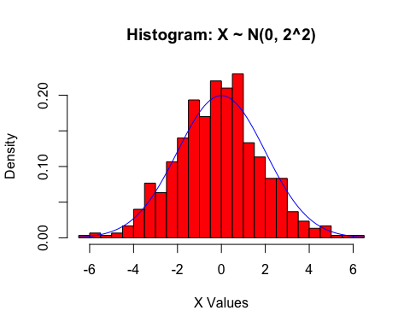
Question 1B
Y = rnorm(600, 0, 2)
S = (X^2) + (Y^2)
hist(S, prob=TRUE,main="Histogram: X^2 + Y^2", breaks=20,
xlab="S Values", ylab="Density", col="red")
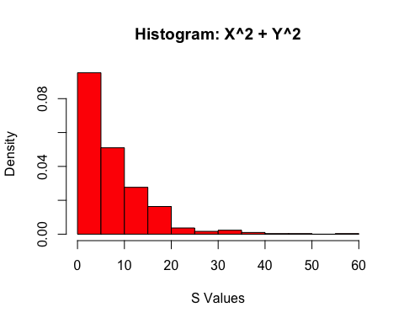
Question 1C
let Z = (X - 0) / 2 (in order to achieve standard normal distribution). Thus, Z^2 + Z^2 = 1/4 (X^2 + X^2). By the lecture notes, Z^2 + Z^2 ~ Gamma(1/2, 1), which is also known as a chi-squared distribution. Therefore, substituting this into the equation above: Gamma(1/2, 1) ~ 1/4(X^2 + X^2) and 4Gamma(1/2, 1) ~ X^2 + X^2. Also by the lecture notes, 4Gamma(1/2, 1) is equivalent to Gamma(1/8, 1) which in turn is equal to Exp(1/8). So, as X and Y are both distributed with Norm(0, 4), we can say that S:= X^2 + Y^2, ~ Exp(1/8)
hist(S, prob=TRUE,main="Histogram: X^2 + Y^2", breaks=20,
xlab="S Values", ylab="Density", col="red")
curve(dexp(x, 1/8), add=TRUE, col="blue")
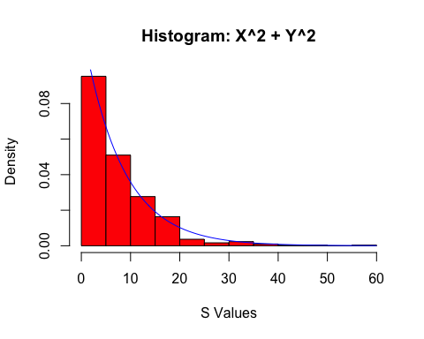
Question 1D
To further verify that the chosen distribution (exp(1/8)) is correct, we can increase the sample size from 600 to a greater value such as 10,000. This should lead to the histogram of S better matching the density function plotted.
X = rnorm(100000, 0, 2)
Y = rnorm(100000, 0, 2)
S = (X^2) + (Y^2)
hist(S, prob=TRUE,main="Histogram: X^2 + Y^2", xlab="S Values",
ylab="Density", col="red")
curve(dexp(x, 1/8), add=TRUE, col="blue")
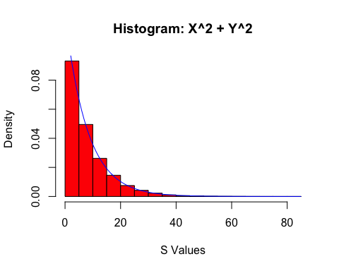
We can see that by increasing the number of samples taken, the histogram of S (X^2 + Y^2), converges even closer to the pdf curve of Exp(1/8) and thus we can be confident that our chosen pdf is in fact correct.
Question 2A
Msample = rep(0,200)
Ysample = rep(0,200)
for (i in c(1:200)){
M = sum(rexp(6,1))
Y = rpois(1, M)
Msample[i] = M
Ysample[i] = Y
}
par(mfrow = c(1,2))
hist(Msample, prob=TRUE, main="Histogram: Msample", breaks=20,
xlab="M Values", ylab="Density", col="red")
hist(Ysample, prob=TRUE, main="Histogram: Ysample", breaks=20,
xlab="Y Values", ylab="Density", col="blue")
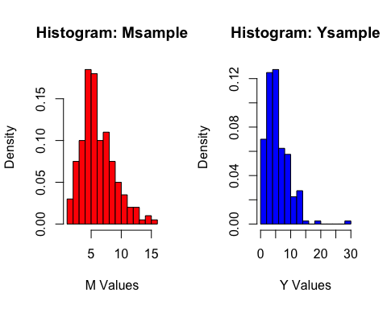
par(mfrow = c(1,1))
Question 2B
Nsample = rnbinom(200, 6, 0.5)
hist(Nsample, prob=TRUE, breaks=20, main="Histogram: Nsample",
xlab="N Values", ylab="Density", col="red")
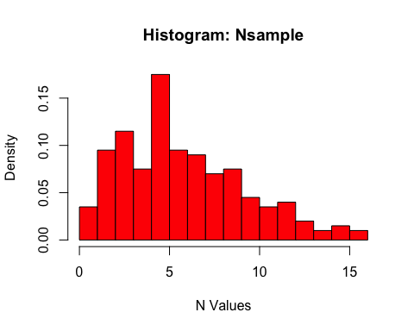
Question 2C
par(mfrow = c(1,2))
hist(Nsample, prob=TRUE, breaks=20, main="Histogram: Nsample",
xlab="N values ", ylab="Density", col="red", xlim=c(0,20))
hist(Ysample, prob=TRUE, breaks=20, main="Histogram: Ysample",
xlab="Y values", ylab="Density", col="blue", xlim=c(0,20))
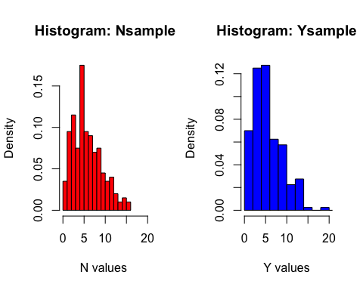
par(mfrow = c(1,1))
As we can see from the display, both the distributions are very similar, and take matching shapes. This suggests that the data supports Professor Plum’s claim, indicating that Ysample is also likely to follow a NB(6,0.5) distribution. (In order to understand this better, I explored this claim with some wider research, and discovered that a Poisson-Gamma mixture, like that of the Ysample that we calculated above, is sure enough equivalent to a Negative Binomial distribution).
Question 2D
pointsY = rep(0,20)
pointsN = rep(0, 20)
for (i in c(1:20)){
for (x in c(1:200)){
if (Ysample[x] <= i){
pointsY[i] = pointsY[i] + 1
}
if (Nsample[x] <= i){
pointsN[i] = pointsN[i] + 1
}
}
}
pointsY = pointsY / length(Ysample)
pointsN = pointsN / length(Nsample)
plot(pointsY, pointsN, main="CDFs: Ysample and Nsample",
xlab="Ysample CDF", ylab="Nsample CDF", col="red")
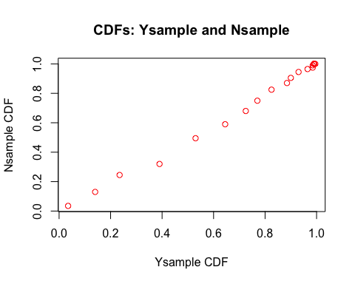
Observing the scatter plot of Ysample against Nsample, we can see that the points are very close to lying on the y = x diagonal, which suggests that the CDFs of the two samples exhibit similar behavior. This furthers the claim stated in 2C that the data supports the idea that the distributions of Ysample and Nsample are in fact related.
Question 2E
Msample =rep(0,10000)
Ysample = rep(0,10000)
for (i in c(1:10000)){
M = sum(rexp(6,1))
Y = rpois(1, M)
Msample[i] = M
Ysample[i] = Y
}
Nsample = rnbinom(10000, 6, 0.5)
par(mfrow = c(1,2))
hist(Nsample, prob=TRUE, breaks=20,
main="Histogram: Nsample \n (More Samples)", xlab="N values",
ylab="Density", col="red", xlim=c(0,20))
hist(Ysample, prob=TRUE, breaks=20,
main="Histogram: Ysample \n (More Samples)", xlab="Y values",
ylab="Density", col="blue", xlim=c(0,20))
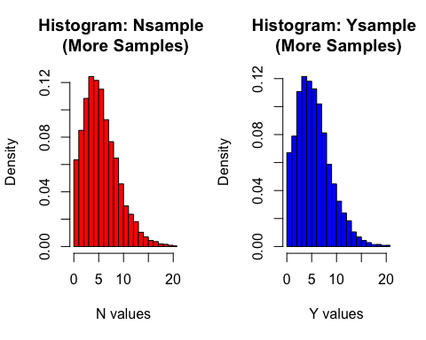
par(mfrow = c(1,1))
pointsY = rep(0,20)
pointsN = rep(0, 20)
for (i in c(1:20)){
for (x in c(1:10000)){
if (Ysample[x] <= i){
pointsY[i] = pointsY[i] + 1
}
if (Nsample[x] <= i){
pointsN[i] = pointsN[i] + 1
}
}
}
pointsY = pointsY / length(Ysample)
pointsN = pointsN / length(Nsample)
plot(pointsY, pointsN, main="CDFs: Ysample and Nsample (More Samples)",
xlab="Ysample CDF", ylab="Nsample CDF", col="red")
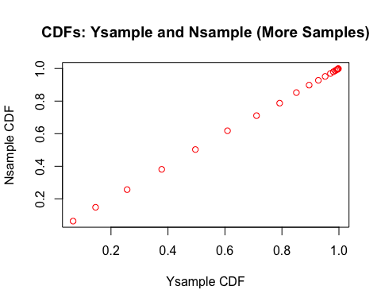
Having seen in part c) that the pdf’s for Ysample and Nsample were alike, and again in part d) that the cdf’s also appeared very similar, there is strong evidence to support Professor Plum’s claim in full. However, in order to validate this even further, we can repeat the experiment with a greater sample size - here, we have take 10,000 samples instead 200. With this increase in sample size, it can be seen in the graphs that the two samples have become even more alike, with their observed distributions appearing almost identical at a higher sample size. This further validates our claim by implying that as the number of samples taken increases, the two distributions, Ysample and Nsample, converge even closer, suggesting that the Y values do indeed follow Nsample’s distribution of NB(6, 0.5).
Therefore, based on our simulations, we have strong evidence to accept Professor Plum’s claim that Ysample follows a NB(6, 0.5) distribution.

