Lab Sheet 3 Report
In this assignment, I have NOT used GenAI tools.
willbarnard
2025-03-17
# Importing functions
add_circle=function(radius)
{
xcoord=(radius/50)*c(-50:50)
ycoord_pos=sqrt(radius^2-xcoord^2)
ycoord_neg=-sqrt(radius^2-xcoord^2)
points(xcoord,ycoord_pos,type='l',col='black')
points(xcoord,ycoord_neg,type='l',col='black')
}
pdf_f=function(x)
{
fx= (1/pi)*(1/sqrt(30^2-x^2)) +
(1/(30*pi))*log(30+sqrt(30^2-x^2)) +
(-1/(30*pi))*log(abs(x)) +
(-1/(30*pi)) +
(-x^2/(30*pi))*(1/(30+sqrt(30^2-x^2)))*
(1/sqrt(30^2-x^2))
fx
}
# Question 1A
rf = runif(500, 0, 30)
thetaf = runif(500, 0, 2 * pi)
xcoord = rf * cos(thetaf)
ycoord = rf * sin(thetaf)
plot(xcoord, ycoord, col='red')
add_circle(30)
# Question 1B
count = 0
while (count < 500){
xm = runif(1, -30, 30)
ym = runif(1, -30, 30)
if ((xm^2) + (ym^2) <= (30^2)){
points(xm, ym, col="blue")
count = count + 1
}
}
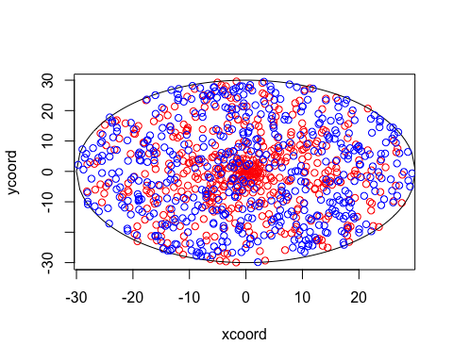
# Question 1C
# Flopsy's locations seem to be concentrated around the centre of the circle, whilst
# Mopsy's are fairly uniform throughout the entire area. This is because, in polar coordinate
# form, the area of each concentric ring increases as they move outwards. In contrast,
# Mopsy's coordinates are generated uniformly from a square grid, and so the points that
# fall inside the circle will be uniformly spread across the entire area.
# Question 1D
thetaf = runif(10000, 0, 2 * pi)
rf = runif(10000, 0, 30)
xcoord = rf * cos(thetaf)
hist(xcoord, probability=TRUE)
curve(pdf_f(x), add=TRUE)
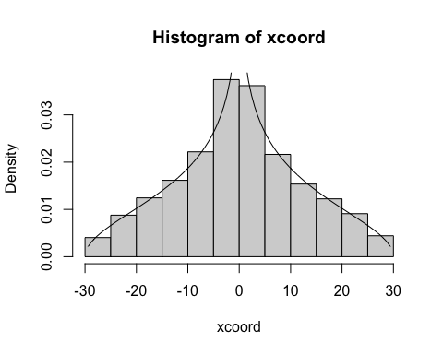
# The pdf curve matches the data. Near x = 0, the density of Xf as it at its highest point,
# which can be seen from the graph. This is matched by the histogram, with its clear peak
# at and around x = 0.
# Question 1E
distances = rep(0, 10000)
for (x in c(1:10000)){
rf = runif(1, 0, 30)
thetaf = runif(1, 0 , 2 * pi)
xcoord = rf * cos(thetaf)
ycoord = rf * sin(thetaf)
xm = 100
ym = 100
while ((xm^2) + (ym^2) > (30^2)){
xm = runif(1, -30, 30)
ym = runif(1, -30, 30)
}
distance = ((xm - xcoord)^2 + (ym - ycoord)^2)^0.5
distances[x] = distance
}
hist(distances)
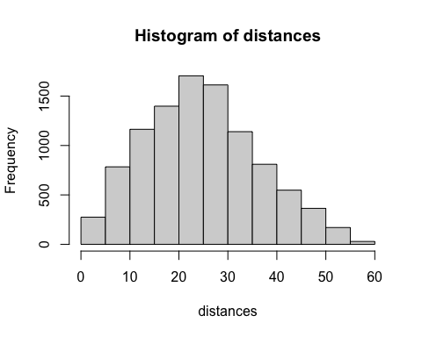
Ex = sum(distances) / length(distances)
print(paste('Expected value is: ', Ex))
## [1] "Expected value is: 24.6938701261017"
# Question 1F
indicators = rep(0, 10000)
for (x in c(1:10000)){
distance = distances[x]
if (distance < 15){
indicators[x] = 1
}
}
phat = sum(indicators) / length(indicators)
sdhat = (phat * (1 - phat) / length(indicators))^0.5
print(paste('estimated p value is: ', phat))
## [1] "estimated p value is: 0.2223"
print(paste('estimated standard deviation is: ', sdhat))
## [1] "estimated standard deviation is: 0.00415791666583158"
## (phat * (1 - phat)) / (0.001)^2 = length(indicators) = n
newN = ceiling((phat * (1 - phat)) / (0.001)^2)
print(paste('Required number of samples is: ', newN))
## [1] "Required number of samples is: 172883"
newIndicators = rep(0, newN)
for (x in c(1:newN)){
rf = runif(1, 0, 30)
thetaf = runif(1, 0 , 2 * pi)
xcoord = rf * cos(thetaf)
ycoord = rf * sin(thetaf)
xm = 0
ym = 0
while ((xm^2) + (ym^2) > (30^2)){
xm = runif(1, -30, 30)
ym = runif(1, -30, 30)
}
distance = ((xm - xcoord)^2 + (ym - ycoord)^2)^0.5
if (distance < 15){
newIndicators[x] = 1
}
}
newPHat = sum(newIndicators) / length(newIndicators)
newSDHat = (newPHat * (1 - newPHat) / length(newIndicators))^0.5
print(paste('Improved estimated p value is: ', newPHat))
## [1] "Improved estimated p value is: 0.496393514689125"
print(paste('Improved estimated standard deviation is: ', newSDHat))
## [1] "Improved estimated standard deviation is: 0.00120249301255898"

