Lab Sheet 4 Report
22180
2025-04-03
In this assignment, I have NOT used GenAI tools.
npizzas=c(
177, 305, 481, 248, 72, 277, 373, 308, 144, 392,
183, 378, 516, 158, 121, 384, 503, 181, 117, 174,
291, 701, 157, 102, 123, 356, 202, 169, 247, 172,
418, 129, 151, 266, 115, 50, 404, 418, 147, 613,
235, 200, 253, 180, 639, 203, 165, 261, 266, 224,
420, 86, 176, 609, 171, 157, 149, 240, 214, 181,
155, 192, 246, 150, 95, 236, 591, 157, 152, 269,
137, 208, 508, 133, 408, 122, 177, 77, 99, 391,
115, 84, 210, 258, 292, 253, 121, 399, 200, 273,
116, 136, 412, 774, 265, 134, 91, 356, 209, 221,
197, 123, 321, 248, 192, 628, 182, 523, 171, 301,
344, 114, 399, 232, 233, 116, 276, 113, 185, 282,
291, 214, 200, 280, 316, 234, 99, 392, 344, 116,
250, 349, 178, 279, 208, 268, 258, 243, 423, 206,
275, 313, 291, 337, 129, 180, 148, 308, 276, 422,
184, 127, 452, 205, 190, 185, 211, 408, 101, 439,
142, 74, 221, 109, 168, 249, 100, 56, 221, 275,
303, 185, 95, 581, 529, 185, 349, 133, 353, 286,
385, 222, 42, 113, 318, 360, 333, 273, 197, 235,
143, 107, 170, 263, 189, 213, 121, 487, 204, 161,
149, 258, 108, 371, 341, 217, 265, 154, 264, 202,
315, 267, 494, 200, 201, 178, 497, 353, 259, 144,
522, 769, 235, 137, 189, 355, 289, 251, 156, 324,
438, 254, 694, 837, 386, 380, 358, 108, 318, 481,
471, 84, 141, 203, 334, 297, 176, 233, 613, 220,
252, 206, 320, 230, 323, 415, 205, 87, 719, 77,
338, 217, 115, 58, 387, 311, 33, 241, 194, 236,
260, 234, 277, 83, 284, 692, 242, 794, 140, 212,
101, 59, 305, 206, 238, 329, 122, 259, 44, 137,
153, 244, 142, 135, 234, 173, 175, 442, 280, 490)
Question 1Ai
observed_x_values = npizzas
observed_x_squared_values = npizzas^2
Using the methods of moments, we know μ = E[X] = mean of x(i) values and σ^2 = E[X^2] = mean of x^2(i) values - (mean of x(i) values)^2. Using these two equations, we can first calculate μ, before substituting it into the equation for σ^2.

Question 1Aii
observed_mean_x = sum(observed_x_values) / length(observed_x_values)
observed_mean_x_squared = sum(observed_x_squared_values) / length(observed_x_squared_values)
mu_hat = observed_mean_x
sigma_squared_hat = observed_mean_x_squared - (mu_hat)^2
print(paste("Estimate for mu hat is: ", mu_hat))
## [1] "Estimate for mu hat is: 259.243333333333"
print(paste("Estimate for sigma squared hat is: ", sigma_squared_hat))
## [1] "Estimate for sigma squared hat is: 21176.7907888889"

Question 1Aiii
sigma_hat = (sigma_squared_hat)^0.5
N_value = ceiling(qnorm((1-0.001), mu_hat, sigma_hat))
print(paste("Estimate for number of orders made is: ", N_value))
## [1] "Estimate for number of orders made is: 709"

Question 1Bi
hist(npizzas, probability=TRUE, breaks=20, main="Histogram of Pizza Orders",
xlab="Number of Orders",ylab="Density",col="red")
curve(dnorm(x, mu_hat, sigma_hat), add=TRUE, col="blue")
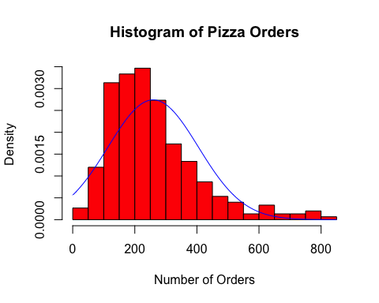
Question 1Bii
The histogram’s distribution does not match that of the assumed pdf curve. Firstly, the histogram does not follow a symmetrical distribution like that of a normal RV would, and instead is positively skewed. This for example causes the peak of the pdf to be offset from the peak of the histogram. As a consequence of this, the estimate of N is unlikely to be correct, and the current model cannot be used to model the pizza sales data accurately.

Question 1Ci
ordered_observed_x_values = sort(observed_x_values)
vals = c(1:300)
q = qnorm(vals/301, mu_hat, sigma_hat)
plot(q, ordered_observed_x_values, main="Q-Q Plot: Observed v Fitted Normal Distribution",
xlab="Observed Quantiles", ylab="Theoretical Quantiles", col="red")
curve(x*1, add=TRUE, col="blue")
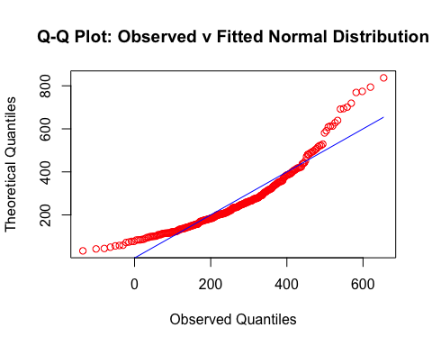
The Q-Q plot for the observed data does not seem to support the idea that the current model can be used to accurately model the pizza sales. This is because the data points do not follow the y=x trend-line, and instead exhibit almost parabolic behavior, with both the start and end of the data points being distributed significantly above the y=x line, whilst the middle of the data sits well below it.

Question 1Cii
sorted_generated_points = sort(rnorm(300, mu_hat, sigma_hat))
plot(q, sorted_generated_points, main="Q-Q Plot: Generated v Fitted Normal Distribution",
xlab="Generated Quantiles", ylab="Theoretical Quantiles", col="red")
curve(x*1, add=TRUE, col="blue") # axis??
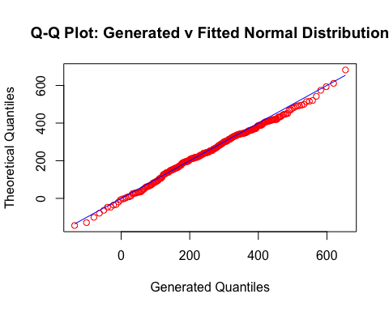
When comparing the observed data plot to that of the generated data points, we can clearly see the two curves do not match, with the generated one following the y=x line very closely, before slightly veering off for the final few data points. The two curves are likely too distinct for random behavior to account for their differences, and thus the Q-Q plots provide evidence that the current distribution can not be used to model the pizza sales.

Question 1Di
Using the methods of moments again, we have k/λ = E[X] = mean of x(i) values and (k+1)k/λ^2 = E[X^2] = mean of x^2(i) values - (mean of x(i) values)^2. Using these two equations, we can rerrange to find k and λ.
lamda_hat = observed_mean_x / (observed_mean_x_squared - (observed_mean_x)^2)
k_hat = lamda_hat * observed_mean_x
print(paste("Estimated value for lamda_hat is: ", lamda_hat))
## [1] "Estimated value for lamda_hat is: 0.0122418611921762"
print(paste("Estimated value for k_hat is: ", k_hat))
## [1] "Estimated value for k_hat is: 3.17362090166373"

Question 1Dii
N_value = ceiling(qgamma((1-0.001), k_hat, rate=lamda_hat))
print(paste("Estimate for number of orders made is: ", N_value))
## [1] "Estimate for number of orders made is: 945"

Question 1Diii
ordered_observed_x_values = sort(observed_x_values)
vals = c(1:300)
q = qgamma(vals/301, k_hat, rate=lamda_hat)
plot(q, ordered_observed_x_values, main="Q-Q Plot: Observed v Fitted Gamma Distribution",
xlab="Observed Quantiles", ylab="Theoretical Quantiles", col="red")
curve(x*1,col="blue", add=TRUE)
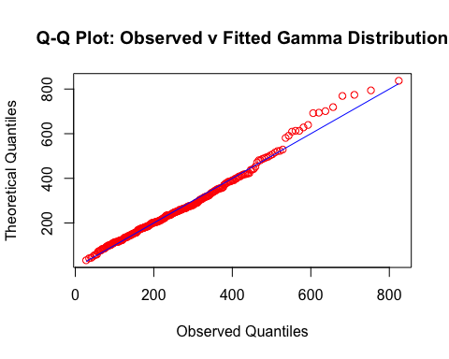
The Q-Q plot for the gamma distribution shows the data points lying much closer to the y=x line, when compared to the previous normal distribution. Much of the data exhibits linear behavior, before a few of the later data points veer slightly above the y=x line. However, given how tightly distributed most of the data is along the y=x line, this Q-Q plot provides strong evidence for the pizza sales data being accurately modeled by the gamma distribution with parameters lamda_hat, k_hat.

Question 1E
After careful analysis of the pizza sales data, I have estimated that there is a 0.1% chance of receiving more than 945 orders within a single evening. This means that on average, every 1000 days, you might experience a night where demand exceeds this number. The data shows that most evenings see between 100 and 400 orders, with a typical night being around 200. While extreme values in the data do exist, like the current maximum of 837, they are very much uncommon, and likely influenced by external factors such as seasonality, promotions, or competitor activity. Given this, I believe the plan to have capacity to produce 945 pizzas every night may be unnecessary and costly, owing to the unlikelihood of this occurring. Instead, I recommend a further investigation into historical trends in pizza sales, in order to adjust staffing and stock levels dynamically based on peak periods, such as weekends or public holidays. This would help achieve a compromise between cost-efficiency and preparedness, meaning that you can still handle the occasional spikes in pizza sales, whilst minimizing the excess waste and over-preparation.

