Sheet1HW.R
willbarnard
2025-02-18

In this assignment I have NOT used any genAI tools.

Question 1 (a)
data = plot(c(20:70), dbinom(c(20:70),size=100, prob=0.5), type='h', xlab="20 <= x <= 70", ylab= "0 <= p(x) <= 1")
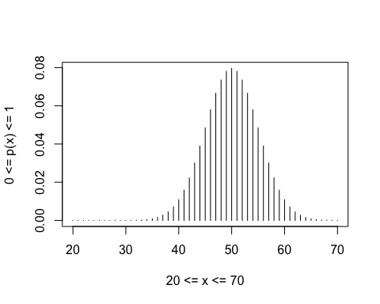
Question 1 (b)
E1_1 = pbinom(40, 100, 0.5)
E2_1 = 1 - pbinom(69, 100, 0.5)
E1_2 = pbinom(40, 100, 2/3)
E2_2 = 1 - pbinom(69, 100, 2/3)
print(paste("P(E1_1) = ", E1_1))
## [1] "P(E1_1) = 0.0284439668204904"
print(paste("P(E2_1) = ", E2_1))
## [1] "P(E2_1) = 3.92506982279661e-05"
print(paste("P(E1_2) = ", E1_2))
## [1] "P(E1_2) = 4.32401885057382e-08"
print(paste("P(E2_2) = ", E2_2))
## [1] "P(E2_2) = 0.276553851586594"
Question 1 (c) coin one (which saw 40 heads) is likely to be fair as its expected value (np) would be 50. coin two (which saw 70 heads) likely to be biased as its expected value (np) would be 66.7.
# Question 1 (d)
E3_1 = 0
E3_2 = 0
for (value in c(0:10)){
if (value %% 2 == 0){
p1 = dbinom(value, size=10, prob=0.5)
p2 = dbinom(value, size=10, prob=2/3)
E3_1 = E3_1 + p1
E3_2 = E3_2 + p2
}
}
print(paste("P(E3_1) = ", E3_1))
## [1] "P(E3_1) = 0.5"
print(paste("P(E3_2) = ", E3_2))
## [1] "P(E3_2) = 0.500008467543904"
Question 2 (a)
powers = 10^(c(1:6))
values = (1 - (1/powers))^powers
print(paste("(1-(1/n))^n for 10, 10^2, .., 10^6: "))
## [1] "(1-(1/n))^n for 10, 10^2, .., 10^6: "
print(paste(values))
## [1] "0.3486784401" "0.366032341273229" "0.367695424770964"
## [4] "0.36786104643297" "0.367877601768247" "0.367879257221066"
Question 2(b) The equation seen above will tend to 1/e as n -> infinity. Question 2(c)
p_noWinEgg = 1 - ((1/6) * (1/52))
p_noWinners = dbinom(312, 312, p_noWinEgg)
this result is approximately 1/e, as it takes the form (1 - 1/n)^n, where n is 312
print(paste("P(No Winners) = ", p_noWinners))
## [1] "P(No Winners) = 0.367289102194028"
Question 2 (d)
p_noWinners5Years = dbinom(5, 5, p_noWinners)
print(paste("P(No Winners Across 5 Years) = ", p_noWinners5Years))
## [1] "P(No Winners Across 5 Years) = 0.00668405805120504"
the distribution is Binomial, with parameters n=1560, and p=1/312.
data = rbinom(20,1560,(1/312))
barplot(data,xlab="values",ylab="frequencies")
