**Enterprise Application Development**

**Interim Report of Supermarket Information System**

**Report 1**

**Constantine 2201513130317**

**Spock 2201613130117**

**Vincent 2201613130215**

**Will 2201613130318**

**Frank 2201613130322**

**(Group 4)**

**21/10/2018**

1. Content

2. Abstract 3

3. Introduction of Group member 4

4. Meeting Minutes 5

4.1 The first meeting 5

4.2 The process of choose project. 6

4.2.1 Library information system. 6

4.2.2 Communication equipment sales management system 7

4.2.3 Video Information System 7

4.2.4 Cinema Information System 8

4.2.5 Supermarket Information System 9

5. The issue of Group Work 10

5.1 Work arrangement 10

5.2 Conference content 10

6. Conclusion 11

7. Reference 11

# 2. Abstract

This article is about the introduction of our group and the project that we have selected. In this article, it will show every member in our group, their name, role (why we choose him in this role) and the work that they have to do. Also the article will reveal the overall process of why we choose this project (supermarket information system). According to this article, we can find out what kind of data, department and step that a supermarket information system will have. Second it will show how to choose a suitable project (in the following article, it will give a few examples to analyze) and how to group division.

## 3. Introduction of Group member

As the members found their own group, our team formed smoothly. It is very honoured that introduce my group, first of all, our group’s number is 4 and then there are 5 members in the group. As for our names respectively are Will, Spock, Frank, Constantine and Vincent. Secondly, there are some roles and situations of our group members.

First of all, will is the leader of our groups, his responsibility is lead other team members to complete various tasks assigned by the superior, including organizing group meetings, making detailed plans, assigning tasks according to each team member's specialty, supervising team members to implement plans and complete tasks. He is the core of the group and the most important role, and his merit is he has the serious attitude to work and the leadership to organize other members. About his defect, he is too stubborn to not pay attention to listen to others’ suggestion. And the second member’s name is Spock, he is time keeper of group. As a result of Spock have good concept of time and he always like make some plans for every phase to be precise. His defect is that he lacks of consciousness when he spend time doing some entertainments. As for his job, he must mention us the time for group meeting, the deadline of submitting the essay and the date of giving a presentation. Therefore, Spock’s task is very important for us. It is mention that my mission is record the content of meeting every time and the executable ideas group members come up with. So my role is recorder in team. As for my merit is I have a strong summary ability to record something they said in the meetings and the presentation capacity to transform the content to some form sentence to every member. Then, another member is Frank , his role is facilitator, and his job is promote the work of our team, timely communicate effectively with members when we have disagreements, and get our project work back on track as soon as possible. Therefore, he is very skilful at communication with others, and has strong ability of persuading others. On the other hand, he is too self- centered to refuse to listen to words from other members. Lastly, group member, Constantine, his task is finish the work what has been distributed, join in every group meeting and actively cooperate with the leader to complete the mission. And then, his merit is he is very positive to cooperate with team work in many times, but he is a little lazy for the group meeting sometimes.

There is no doubt that our groups’ merit is members all have serious attitude and professional skill to finish the project to improve efficiency and save work time. And the high-level score members willing to use the knowledge sharing to help other members. For the defect is group members’ connection is too little of daily life, it is harmful to our tacit understanding cooperation.

# 4. Meeting Minutes

## 4.1 The first meeting

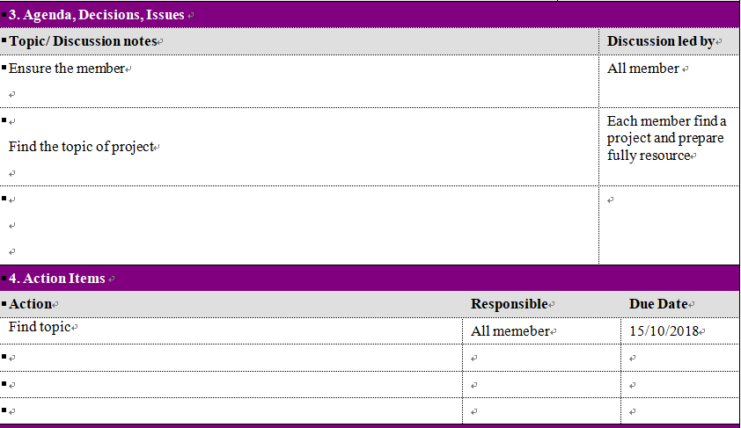

The first meeting of Group 4 is ensures the project topic and discuss the feasibility of project. Each member chooses a topic and prepares the specific requirement and factors of the project, after discuss of meeting and summary the process of choose project.

## 4.2 The process of choose project.

According to the research online, five common information management systems were discussed in group. The five common information management systems are library information system, communication equipment sales management system, video information system, cinema information system and supermarket information system. The report intends to discuss the advantages and disadvantages of the five information system, which can help group to select a system that is most feasible.

### 4.2.1 Library information system.

The library is faced with a huge amount of information for college and it is difficult for the librarians to support it. Therefore, it is necessary to establish a set of reasonable and practical library information system to unify and centralize the library borrowing information in the university.

The library information system mainly realizes the management of library book borrowing information, including reader information, book information, borrowing and returning information, and system user information.（Kashyap, 2001） Based on the above functional analysis, the main data involved in the database are as follows:

1. For Reader entity: Name, date of birth, sex, telephone number, department, registration date, type of reader (number of days to borrow, number of loans available), etc.
2. For book entity: Book ISBN, title, author, publisher, date of publication, printing times, unit price, book category, etc.
3. For the entity of book borrowing information: Readers, books borrowed, time borrowed, dates returned, Fines.
4. For user entity: User number, User name, Password.

Besides that, the system should classify books and indicate the location of each book in library. After discussion and analysis within group, members agreed that the functions and data involved in the library information system were complicated, it is difficult to set up a complete and reasonable system.

### 4.2.2 Communication equipment sales management system

The communication equipment sales management system is an advanced tool for managing customer files, sales clues, mobile phone sales activities, business reports and statistics of mobile phone sales performance. It is suitable for the office and management of the sales department of communications technology enterprises. The system will assist sales managers and salespeople to manage customer, sales and business critical data quickly.

According to analysis, the functional modules involved in the communication equipment sales management system are quite complex, which including Channel Management, Project Management, contract Management, quotation Management, sales opportunity Management, receipt Plan Management, payment Plan Management, potential customer Pool, Public Retrieval, customer Management, competitors Management, Service Management, Commodity Management, Sales management, purchasing management, cost management, task management, authority management, data import function, system monitoring, report data analysis, etc.(Tang, 2018) The difficulty of establishing the system is that the technology is new, the scope is wide, the concept is many, and the difficulty is great.

Therefore, in order to consider the perfect presentation and delivery of the end result, our group abandoned the project.

### 4.2.3 Video Information System

In view of the video information system, the video information system should include watching video, uploading video, deleting and modifying video information. The advantage of video information system is that it is simple to make, convenient and quick, and users can quickly get familiar with the function. Security is a design issue, and they are as safe as not stolen cash CARDS. But the loss of a card is low relative to the number of transactions and mass market availability is a prerequisite for success. Inside the system though, there are risks of high loss through corruption which lead to high levels of encryption and security.(John,2007). The disadvantage of video information system is that the function is too simple and the security of the information cannot be guaranteed. So we think compared to supermarket information system, video information systems are too simple, video information system only need some simple function can be completed, that doesn't accord with our team members can be assigned to the requirements of useful work. In contrast, the supermarket information system, information system needs lots of features to improve his system, we need to collect a lot of information and ideas to make our supermarket information system, So all the members of our group can do useful work.

### 4.2.4 Cinema Information System

For the cinema information system, we have also conducted the understanding and analysis. The function requirements of cinema information system include: personnel management, basic information management, film arrangement, ticket management and system management. Personnel management requires the cinema information system to be able to add, modify or delete the information of administrators and employees. Basic information management includes film ticket type, film hall information and film information. Customers can choose what they want based on their needs. Ticket management is required to deal with the cinema ticket, subscription cancellation and booking work. It can also modify the added information. System management requires the ability to backup and modify system data. About the advantages of the cinema information system, the cinema information system has high requirements for security and compatibility. The system is easy to operate, safe and reliable, and easy to maintain. The disadvantage of the cinema information system is the requirements for the database are complex. Members will have a lot of work to do, and require a lot of security and stability. Almost all small businesses engaged in consulting, marketing, sales, research, communications and other service industries have large computer networks and deploy large databases on them. Management information systems have matured and become an integral part of small businesses.（John, 2007). Compared with the new supermarket information system, the information and functions required by the cinema information system may become more numerous. The movie theater information system not only needs the information of the movie, it also needs the information of all kinds of commodities, it needs to make the list of commodities and orders, and it also needs to attach the cashier system. In view of our group's current workload, we felt that the cinema information system was not suitable for our group.

### 4.2.5 Supermarket Information System

The supermarket information system design for manage the concretely and Rationalized information of commodity and in and out information. Steeneken & Ackley (2012) states that the main functions of system are System settings, Merchandise Supplier Information Management, Staff File Management, Merchandise Information Management, Merchandise Warehouse Management, Sales Management, Sales Data Query, as well as a series of processes involving merchandise data modification and query statistics and other operations.

For business information:

Commodity, name, short time, produce place, unit, specs, pass number, pass list, Company ID, Add time

For staff information:

Name, sex, address, telephone, e-mail

For supplier of supermarket:

Company name, company short, company address, postal code, telephone, Fax, Linkman, E-mail, Bank, Band Accounts, Add Time

For Purchase information form:

Commodity ID, Company ID, Number, Price, stock date, Payment, Fact Payment, Not payment, Manage Man, Username, Add time

The function of supermarket information system can be choose very convenient and has multiple combinations. Furthermore, it is connect with our dairy life that we know more information about it and it is convenient for us to conduct field visits. Therefore, Group 4 decides to choice the Supermarket information system.

# 5. The issue of Group Work

# 5.1 Work arrangement

The indication of work arrangement is not clearly thus two members has occurred task conflict. Finally, the plan of group has to change and extends the time of work. In addition, the connection of member is not timelineness that cannot find the mistake.

The solution is leader and member should notice the information of QQ group and ask the definition of work for each member in time. Furthermore, the leader should write the mission for each member each week and show in the group to make member check information expediently and get information in time.

## 5.2 Conference content

The conference content of the first meeting is not prepared complete that missing some mission thus disorganized the work. In addition, the discussion of important topic is not enough so that the work quality cannot satisfy the work requirements.

The solution is before the conference of each weeks, leader should list the content of meeting and show it to the member. Members also need to discuss with leader that ensure the final content.

# 6. Conclusion

Group 4 finish the work plan for the first step basically. The problem of group work influence the normal work process to some extent and extend working hours, but Group member can find problem and change in time that avoid delay in work. In other hand, the work quality should be increased in the next stage. For next step, the group work is design the database and system design that would cost more time and knowledge to finfish. Therefore, the deficiency of group work should be solved in time and have a conference to discuss specialized in the beginning of next step.

# 7. Reference

1. Lindsay, J. (2007). Information Systems Design.[Online] Available

<http://www.oturn.net/isfi/5-information-systems-design.html> [Accessed: 26/ 10/ 2018].

**2.**Kashyap, M.  (2001). Classified Catalogue Code of Ranganathan: A Proposal to Makes itCompatible for Developing Compute~Based Library Information Systems. DESIDOC Bulletin of Information Technology, [online] 21(1), pp.3-19. Available at: C:\Users\胡黎明\AppData\Local\Temp\%W@GJ$ACOF(TYDYECOKVDYB.png<https://publications.drdo.gov.in/ojs/index.php/djlit/article/viewFile/3533/1949>

 [Accessed:18 Oct. 2018].

3. Steeneken, F & Ackley, D (2012) A Complete Model of the Supermarket Business［Online］.Available from: <http://www.bptrends.com/publicationfiles/01-03-2012-ART-Supermarket%20Article-steeneken-Ackley%20111226.pdf> [Accessed: 18 Oct. 2018].

4.Tang, T. (2018). Requirements Engineering Process for Sales Management System Case Study: Tin Phong Trading Co., Ltd. [online] Available at: C:\Users\胡黎明\AppData\Local\Temp\%W@GJ$ACOF(TYDYECOKVDYB.png<http://myy.haaga-helia.fi/~the7tf007/Thanh%20Thesis.pdf> [Accessed: 21 Oct. 2009].