EAD Individual Working Diary

ID: _2201613130117_, Name: _Spock_ , Group: _G4_, Week: __1__.

- Tasks Assigned last week (your detailed tasks and predicted working hours)
Detailed tasks:
We decide to analyze the requirement of supermarket information system.
Predicted working hours:
8 hours.

- Work done last week (detailed work; real working hours; communications; results like programs, diagrams, note; and anything problems)
Detailed tasks:
Prepare presentation and analyze the requirement of supermarket information system.
Real working hours:
6 hours.
Communications:
We have two meeting last week, and we assigned task about presentation in first meeting. Besides that, we analyzed the requirements and make a plan for the development of project in second meeting.
Results:
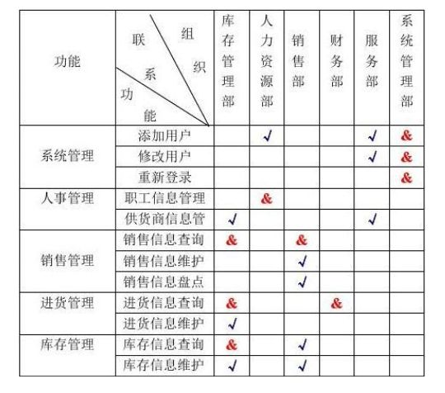

- Tasks for next week (detailed tasks, predicted working hours, potential problems)
Detailed tasks:
Using UML framework to analyze the system. On the one hand, the use case diagram should be created firstly. On the other hand, data flow diagram will be created after finish use case diagram.
Predicted working hours:
8 hours.
Potential problems:
Lack of necessary functions or objectives.

- Knowledge sharing (taught others and learnt from others)
Every member did their research and we collected it together in second meeting.

- Any thought about your group project (project management, system development, collaborative learning, or other relevant issues)
We are consider different organizational structure, and we have different opinion so that we need to analyze the flexibility.

