Frontend Inspirations:

The First Mess...
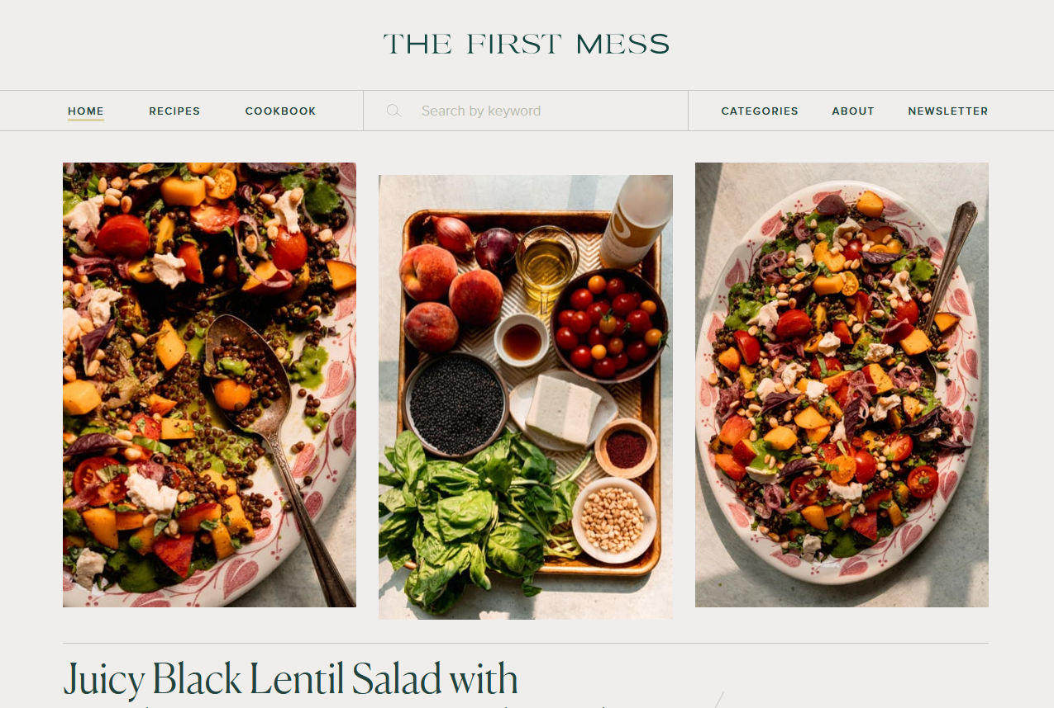
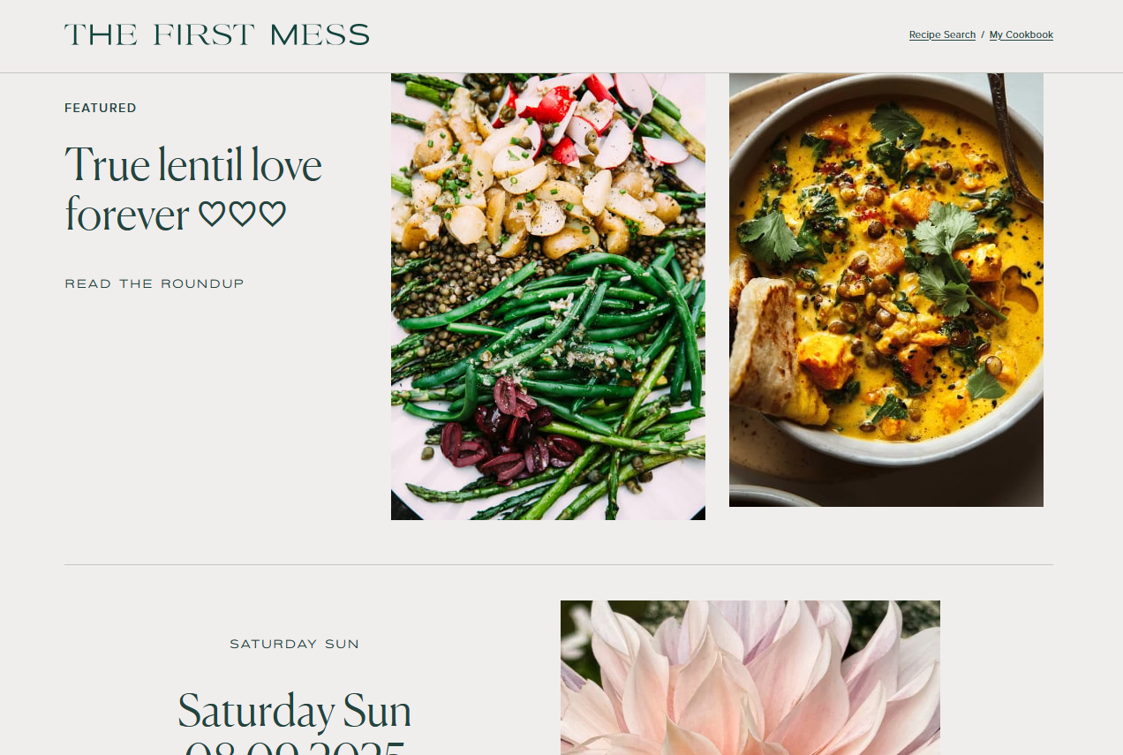
It's hard to get this one in one screen shot. Particularly notice the way that they collapse the menu when you scroll down.

I just like the colors of it and it feels creative in a way that you don't know the exact layout but it is nice to explore.

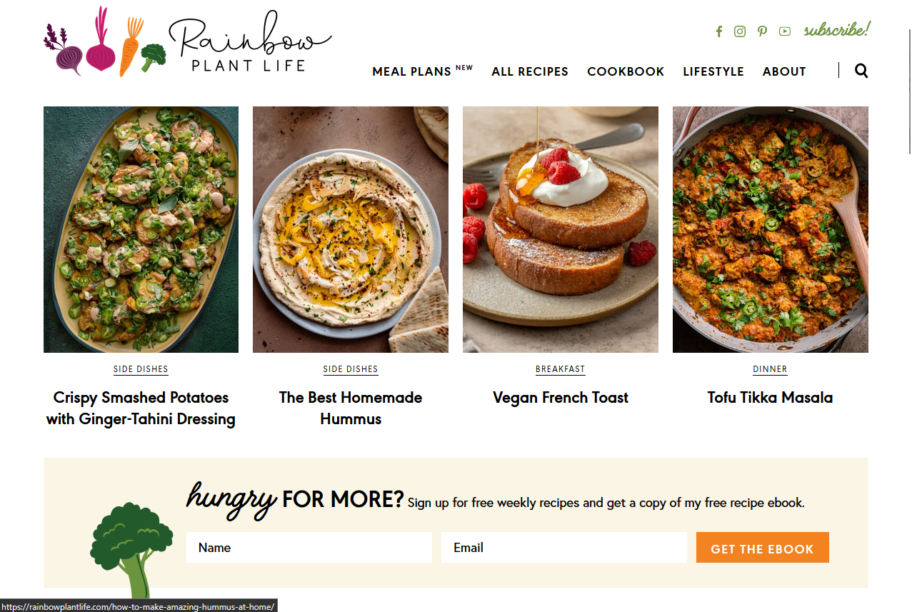
Rainbow Plant Life
I really like the double use of images to both represent a way to click for the recipe itself but also search by recipe type. This layout feels a lot more classic and standard from other ones I was looking at but it's seemed balanced and with a good color design in a way the others felt just template-y.

