Will Pond

**TASK1**

This is the C code of catall.c using the system() method that I will use in the next step.

In this section I made directories for Lab1 and make a duplicate of catall.c named task1 then, begin to change the ownership to root.

In this section I modified the permissions of task1 to be executable and make example file to use when compiling the C program.

In this section I prove that you can remove files that you do not have permission to be writable.

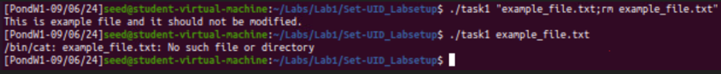

This is the C code I use for catall.c that uses the execve() method and I will use this in the following step.

In this section I made a duplicate copy of catall.c and named it task2 and begin changing the ownership to root.



In this section I modified the permissions of task1 to be executable and make example file to use when compiling the C program. Then prove that a file cannot be deleted because does not invoke the shell, so it stops the attack.

**TASK2**

This is the C code for cap.leak.c and I will use this in following steps.

In this section I am opening /etc/zzz and modifying it, then creating environment variable name test for /etc/zzz. Finally beginning to change it to root.

In this section I create a duplicate of cap_leak.c named task3, then compile the program to get the descriptor value. Next, put that in the environment variable of test. After that I did the cat command to display the context of the file of etc/zzz. Then did another environment variable name test2 with the same descriptor value to override root to access the file.

Reflection

In this Task1 was able to Invoke external programs using system() and exeve(). I observed how system() can run new programs but can be dangerous in the Set-UID programs because someone can gain access to your device and can delete files which surprised me. In the exeve() I observed that it does not only person to gain access to your device and delete files because it does not invoke shell in Set_UID programs which I found interesting. In Task2 I observed that setuid() system can revoke privileges but, in that process, it doesn’t close the file calling to leak and a normal user can exploit this vulnerability. This is the reason why you always want to close your files during your programs, so this won’t happen.