William Quinn
Dr. David Doherty & Dr. Dana Garbarski
SOCL 370
15 February 2025
Module Four: Institutional Confidence Exploratory Data Analysis
Confidence in institutions might be one of the most critical identities in assessing the health of a liberal democracy. It is likely not a coincidence that growing alarm over the health of American democracy has coincided with decline in confidence in political institutions. However, it is not just national level institutions that are of import. In Participatory Democracy Revisited Carole Pateman remarks that “Yet in Western countries popular confidence in old-established institutions is fading, voters are disaffected, trust in government is declining and a very wide gap has opened up between citizens and governments and political elites more generally.” (Pateman 15). Furthermore, it is in this article that Pateman argues the necessity for models of democracy that place particular emphasis on enabling increased citizen engagement and participation at the local level. Essentially, Pateman finds that trust in Western democratic institutions is fading and that a lack of vectors for effective participation is a primary concern.
The validity of this concern is supported by Social Capital and the Dynamics of Trust in Government in which Luke Keele finds that “trust is an evaluation of politicians and their management of the economy and responds immediately to any changes in government performance. But trust also reflects the lessons learned in civic activity and feelings of personal misanthropy. While changes in social capital will not register an effect on trust immediately, the effect on trust is substantively important” (Keele 251). Keele in this article finds that citizens are far more likely to trust (have confidence) a given institution if they are allowed means of participation.
However, given the size of democracies like America national level participation is impractical. This points to the importance of local institutions as a primary means of participation. Resultingly, it can be understood that the focus of analysis of confidence in democratic institutions should not be restricted to the realm of national level institutions but instead be shifted to the realm of local and state level institutions.
This exploratory data analysis will visually summarize institutional confidence levels across Cook County in Congress, the Illinois State Government, local government, and local police in relation to demographic features such as ethnoracial identity, gender, education, and age.
Univariate Distributions
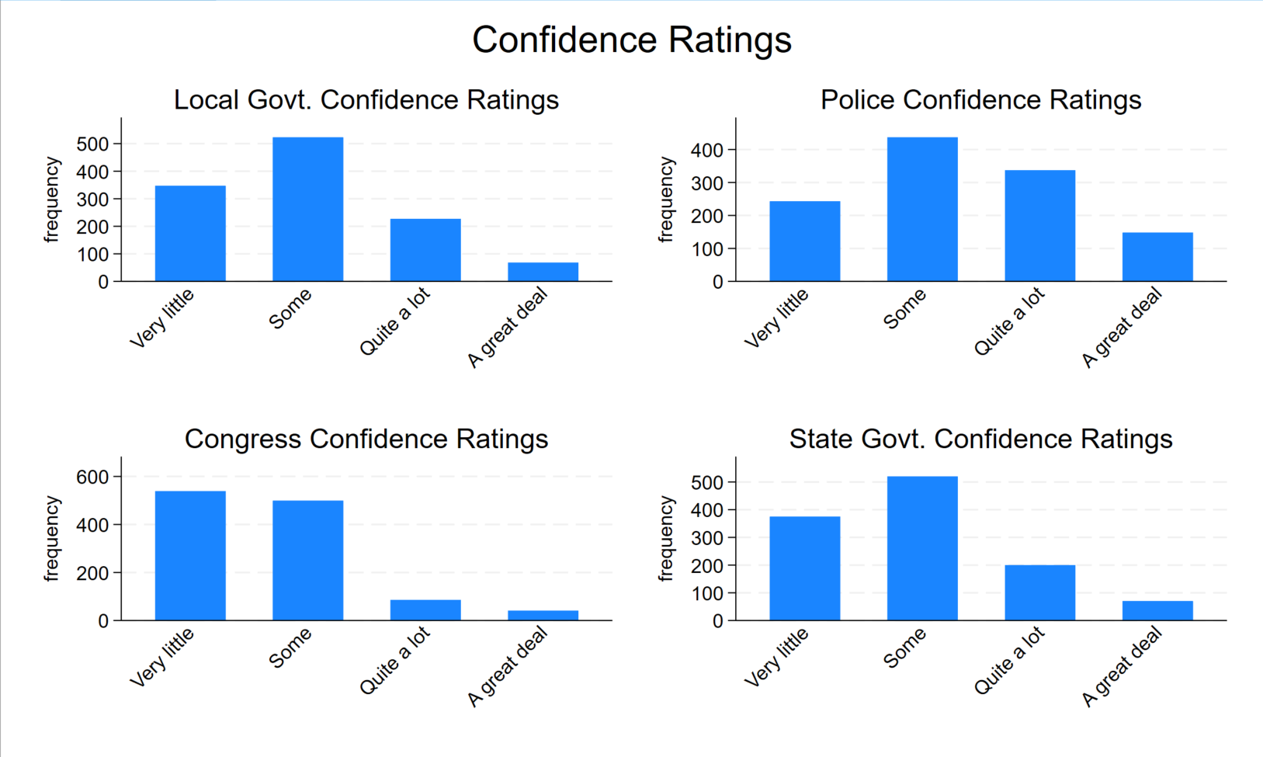
Confidence level: U.S. Congress | Frequency:
Very little | 555
Some | 510
Quite a lot | 89
A great deal | 44

Confidence level: Illinois Government | Frequency:
Very little | 388
Some | 531
Quite a lot | 206
A great deal | 73

Confidence level: Local Government | Frequency:
Very little | 359
Some | 536
Quite a lot | 231
A great deal | 72

Confidence level: Police | Frequency:
Very little | 248
Some | 449
Quite a lot | 206
A great deal | 73
From these numbers it is clear that local Police enjoy the most confidence while the U.S. Congress enjoys the least. Local government has a slight edge in confidence over the Illinois State government. However, it is not the case that local government and state government have significant correlation in responses overall. In fact, all over all confidence frequencies are statistically dependent.
Test of H0: confidence_localgov and confidence_state are independent
Spearman's rho = 0.5412
Prob = 0.0000

Test of H0: confidence_localgov and confidence_police are independent
Spearman's rho = 0.4705
Prob = 0.0000

Test of H0: confidence_state and confidence_congress are independent
Spearman's rho = 0.3684
Prob = 0.0000

Test of H0: confidence_localgov and confidence_congress are independent
Spearman's rho = 0.3596
Prob = 0.0000

Test of H0: confidence_congress and confidence_police are independent
Spearman's rho = 0.2975
Prob = 0.0000

Test of H0: confidence_state and confidence_police are independent
Spearman's rho = 0.2775
Prob = 0.0000

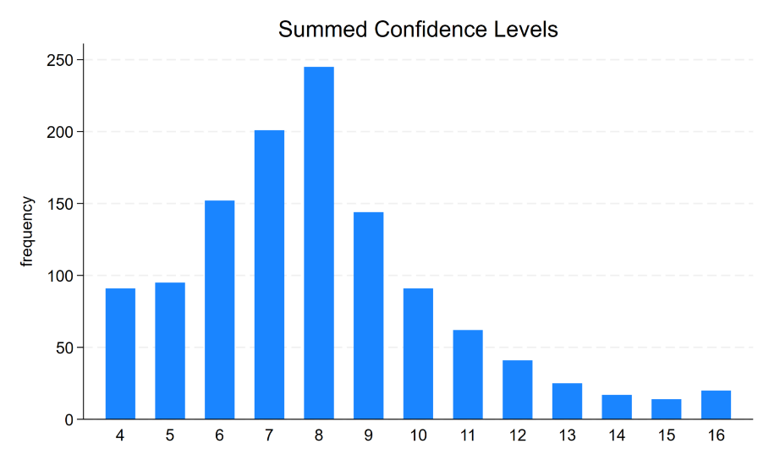
As all of these p-values are well below p = 0.05 we can reject all of these null hypothesis’. Due to this we can summarize and take the mean of these responses. As this graph indicates, confidence levels follow a right skew distribution with x̅ = 8.005 (~ a respective mean response of “some” to each category).
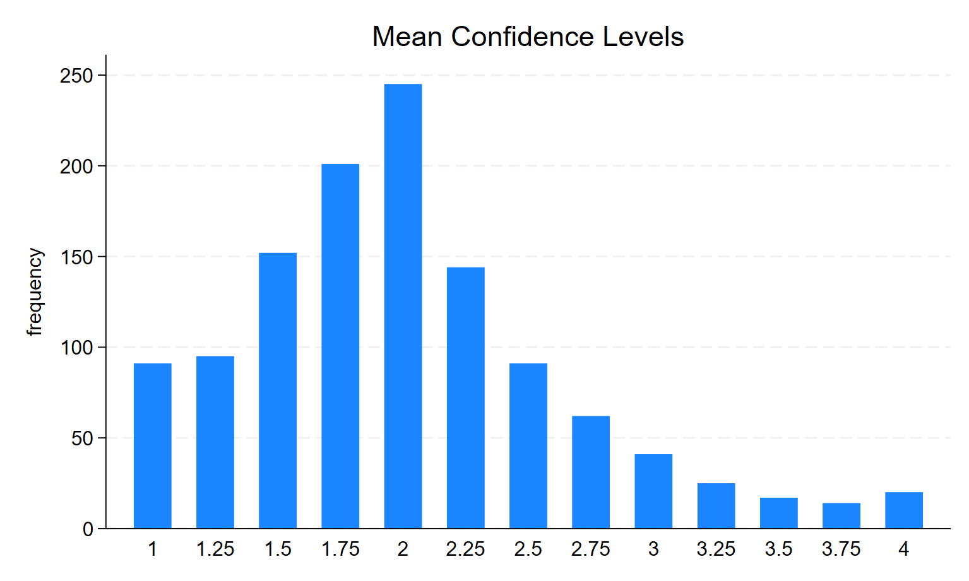

Bivariate Relationships
Bivariate – Confidence in Congress Against Demographic Characteristics
Across racial lines Congress suffers equally low confidence ratings. However, Congress does enjoy slightly more confidence with the Black community in Cook County as we can observe that this is the only group in which respondents responded with “Some” over “Very little”.

Similarly, Congress suffers nearly identically negative ratings across gender lines, with males being slightly more prone to respond with “Very little”.

Congress enjoys virtually no difference in confidence across area of residency in Cook County.

Confidence: Congress | Less than a GED | GED | Some of an Associate’s Degree | Associate Degree | Bachelor’s Degree | Graduate Degree or more
Very little | 36.84 | 42.86 | 46.99 | 44.00 | 48.77 | 46.46
Some | 63.16 | 41.84 | 41.73 | 43.20 | 41.92 | 43.36
Quite a lot | 0 | 11.73 | 5.64 | 8.80 | 7.12 | 6.19
A great deal | 0 | 3.57 | 5.64 | 4.00 | 2.19 | 3.98

Between responses of “Quite a lot” and “A great deal” Congress finds the greatest amount of confidence in those with a GED. Congress has the least support among those with a Bachelor’s Degree and above.
Congress enjoys a slight edge in favorability proportionally among those without children in comparison to those with a child. This may be correlated with the fact that favorability in institutions in general also rises as age does because people are simply less likely to have children below 18 years of age past a certain point.

Proportionally, Congress finds a similar lack of confidence among Democrats and Independts in Cook County but also finds a slight edge in favorability among Republicans, with Republicans consistent having higher percentages of support in all “Some”, “Quite a lot”, and “A great deal”.
Lastly, Congress has the lowest favorability ratings among the middle income earners but enjoys similar proportional favorability between both low and high income earners, with the two highest and lowest favorability ratings each receiving similar percentages of responses within the two groups.

Bivariate – Confidence in Congress Against Demographic Characteristics
Similarly to Congress, the Illinois state government receives highly similar confidence ratings across racial lines within Cook County, with the exception of Blacks who also give higher ratings in comparison to all other groups.
However, deviating from Congress approval ratings, differences along gender are more pronounced for state government. With female respondents giving higher marks.
State approval ratings also have largely similar response rates across residency area in Cook County.

Confidence: Congress | Less than a GED | GED | Some of an Associate’s Degree | Associate Degree | Bachelor’s Degree | Graduate Degree or more
Very little | 36.84 | 37.24 | 33.08 | 44.00 | 30.68 | 25.22
Some | 57.89 | 42.35 | 42.48 | 44.00 | 48.77 | 42.48
Quite a lot | 5.26 | 15.31 | 18.42 | 13.60 | 15.89 | 22.57
A great deal | 0 | 5.10 | 6.02 | 6.40 | 4.66 | 9.73

The Illinois state government has overall higher approval ratings in all levels of education status but sees the most ardent support among those with a graduate degree or more. Those with an associate degree have the highest concentration of those with very little support of the state government.
State government has a considerable edge among those with no children in comparison to current parents. Again, this may be correlated with age bringing about lower rates of parenthood and increased institutional support.
In an inverse relationship with Congress, the Illinois state government finds greater confidence among Democrats and Independents in comparison to Republicans. While both Indpendents and Democrats consistently responded with “Some” confidence or greater, Democrats have far lower rates of confidence which entail “Very little”.
Interestingly, unlike Congress, there is very little deviation between economic classes in regard to support for the Illinois State government.

Next Steps
As our data here is primarily categorical it is natural to look to build a logistic regression with dummy variables for all of our demographic variables. We could create a new binomial variable in which we combine groups “Very little” and “Some” against “Quit a lot” and “A great deal” if we wanted to analyze what aspects push someone from a fairly neutral state of “Some” to an explicitly supportive state of “Quite a lot”. We could also combine groups “Some”, “Quit a lot”, and “A great deal” against “Very little” in order to assess what demographic aspects are more likely to be explicitly negative. An advantage of this model is that it would be quite simple and easy to create since such a model would not need to rely on any assumptions of distribution we would not need to worry about transformations as well. However, in reducing our response variable down from four to two categories we will lose some nuance which is not ideal.
Alternatively, since our four response variables are fairly to highly correlated, we could also use the summarized or mean confidence measures and create a GLM in which we predict mean or summarized confidence against demographic characteristics. This would maintain the nuance we lose in the logistic regression. However, specifying a correct model and underlying distribution while avoiding overfitting may be a challenge. Ultimately, this is likely a more challenging path for model creation but also will likely yield a more powerful model.

Three-Way Relationships

Works Cited
Pateman, Carole. “Participatory democracy revisited.” Perspectives on Politics, vol. 10, no. 1,
Mar. 2012, pp. 7–19, https://doi.org/10.1017/s1537592711004877.
Keele, Luke. “Social Capital and the dynamics of trust in government.” American Journal of
Political Science, vol. 51, no. 2, 22 Mar. 2007, pp. 241–254,
https://doi.org/10.1111/j.1540-5907.2007.00248.x.
“Cook County Community Survey.” Cook County Community Survey, Loyola University of
Chicago, cccs.sites.luc.edu/. Accessed 9 Feb. 2025.

