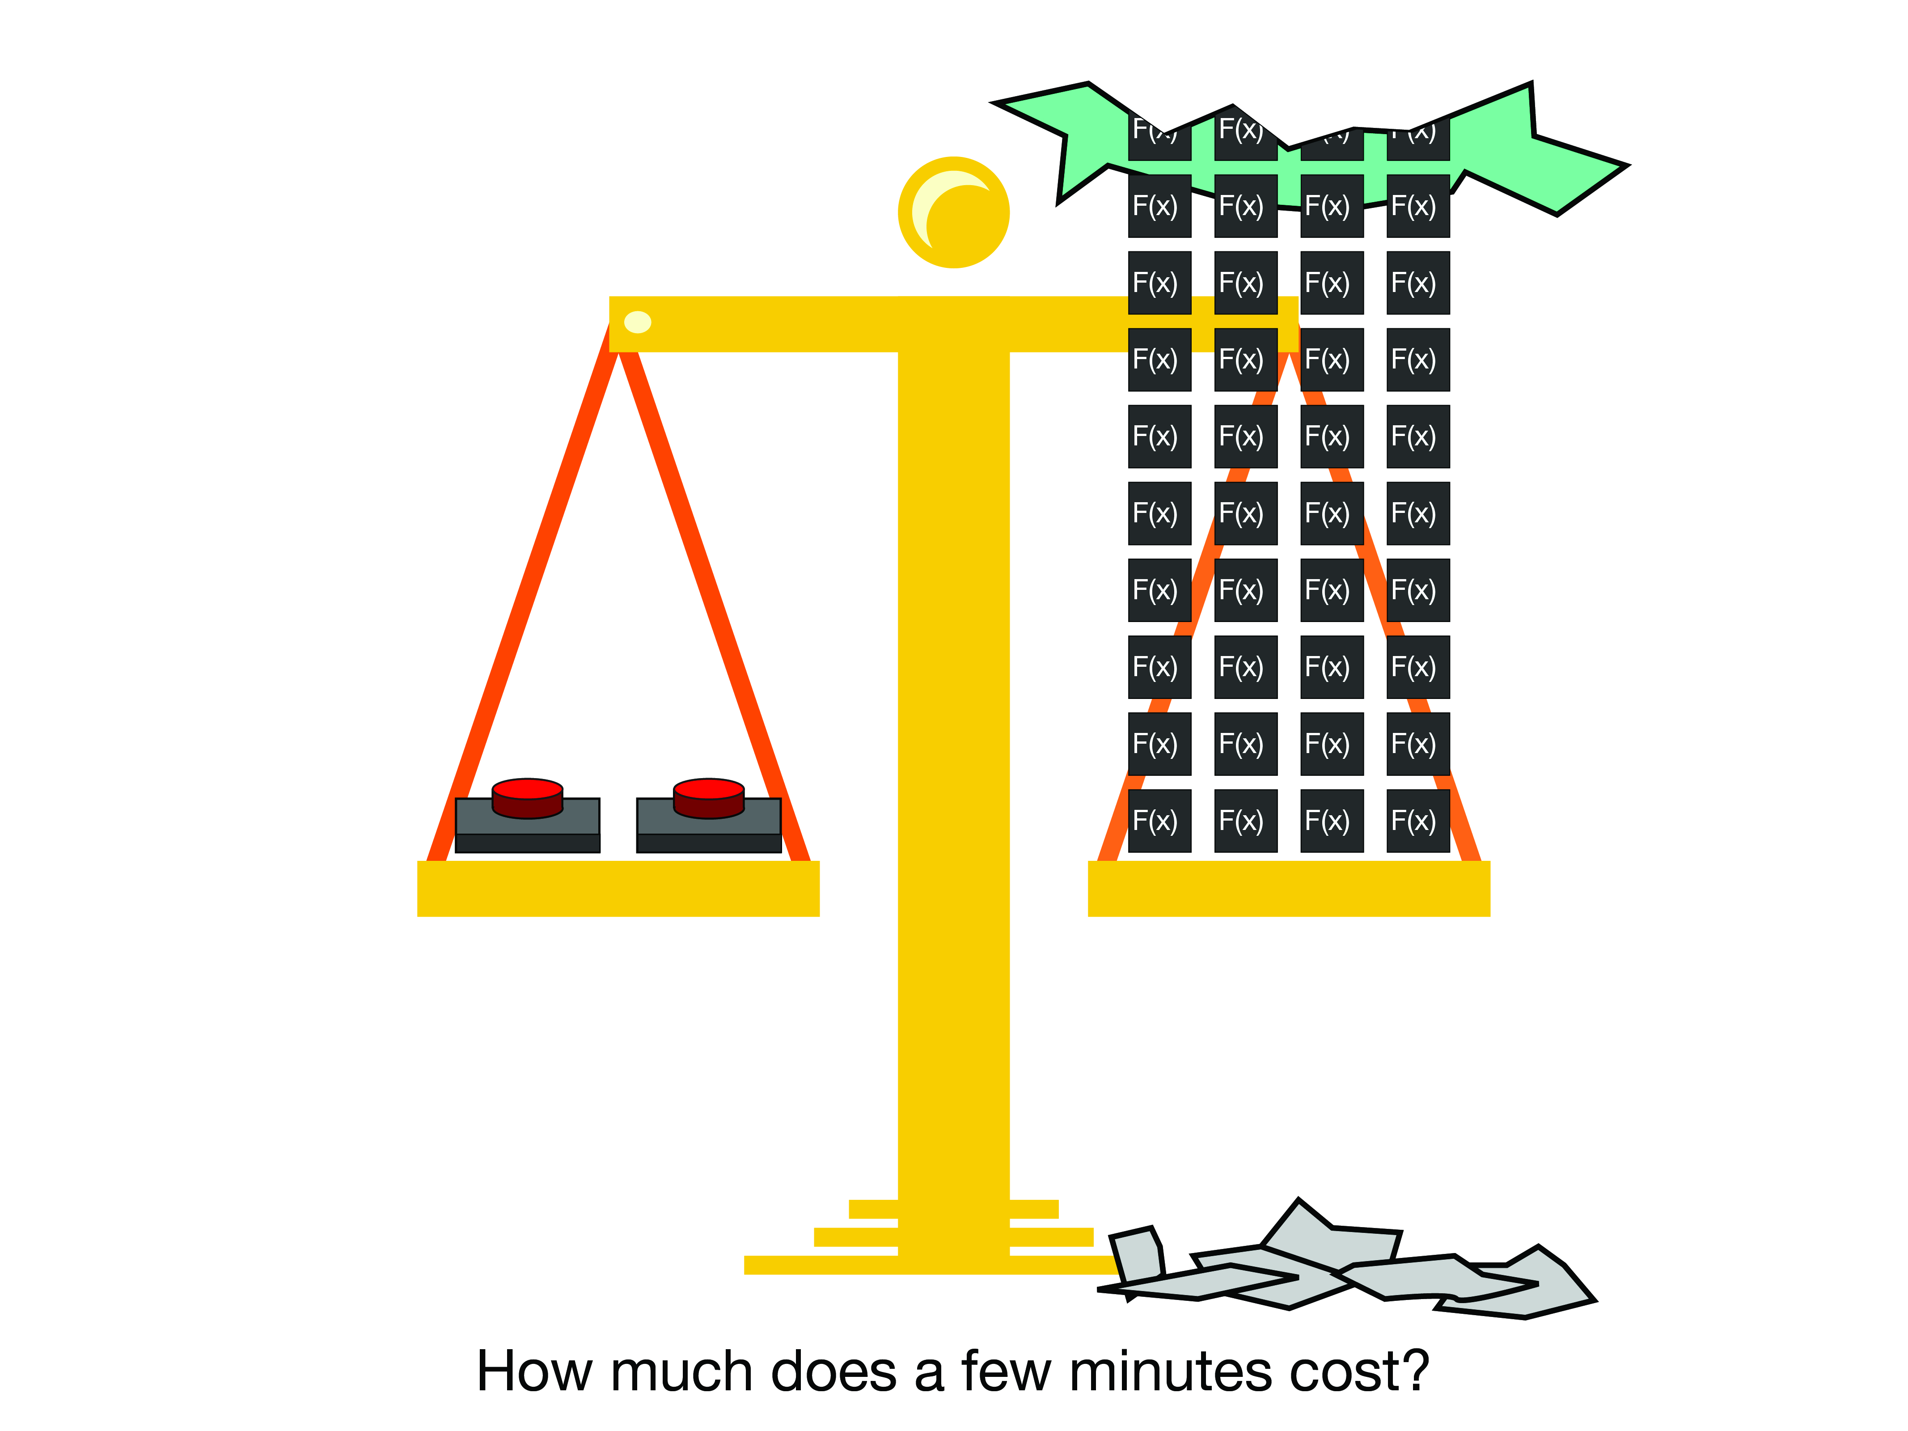

|  |  |  |  |  |
| --- | --- | --- | --- | --- |
| Cisco Dynamic RevProxy Senior Design 2018 |  |  |  | Will Rooney  Matthew King  Cecil Hutchings |

Event Generator (AWS Simulator)

Guide

# Summary

**This Document serves as a guide to using the AWS event simulator.**

# Opening the Application

## Copy and paste the following address in a web browser: <https://cseventgenerator.herokuapp.com/>

1. 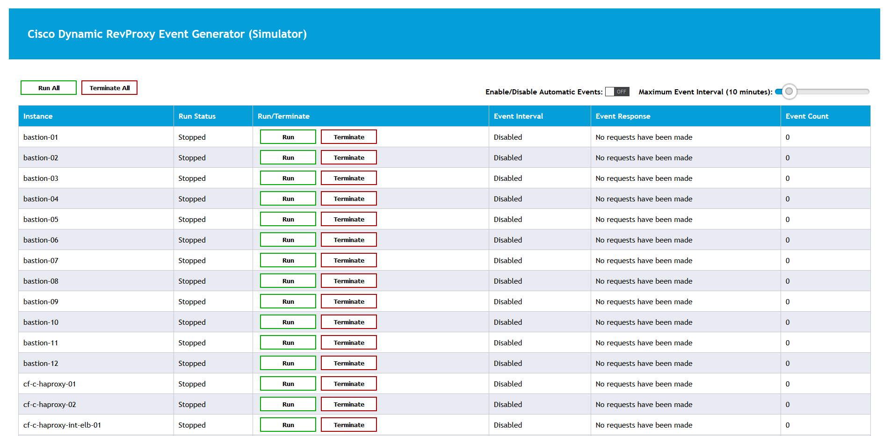**You should see something like the following:**

**Each entry in the table portrays and instance (an application/machine running on AWS). For the purpose of the simulation, run statuses are retrieved from a Server that holds the running applications and their resources. The server is meant to simulate Cisco’s dynamic reverse proxy that our team built for them. You can find more information on the server documentation.**

|  |  |
| --- | --- |
|  | Note: Run status displays are updated every 30 seconds, or whenever an event is fired off. If multiple users are running the event generator at the same time a maximum delay of 30 seconds will be present for correct run status displays. |

# Sending Events to the Server

|  |  |
| --- | --- |
|  | Note: Run status displays of instances in the event simulator will read unavailable unless the server is running. In order to get the server running follow the server instruction documentation. |

**There are two methods to simulate events being sent to the server:**

1. **Manual Send Events**
   1. 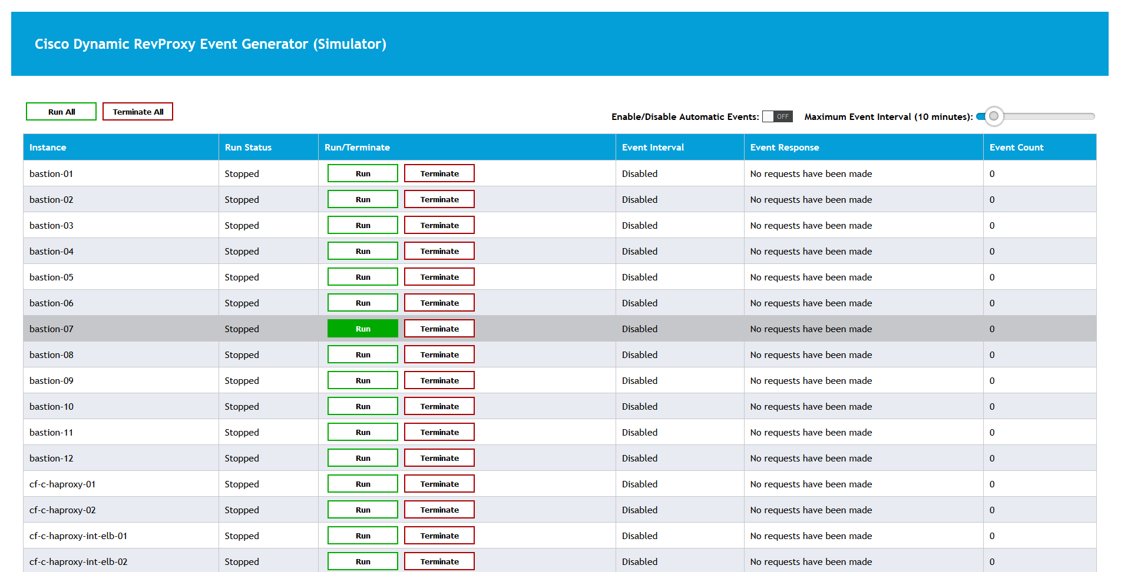**Single Instance Event  
      Under the column “Run/Terminate”, click on the button ‘Run’ to send a run event to the server for that instance. Likewise, for the ‘Terminate’ button.**
   2. **To start from a fresh slate or to populate the server with all instances, use the ‘Terminate All’ and ‘Run All’ buttons respectively.**
2. 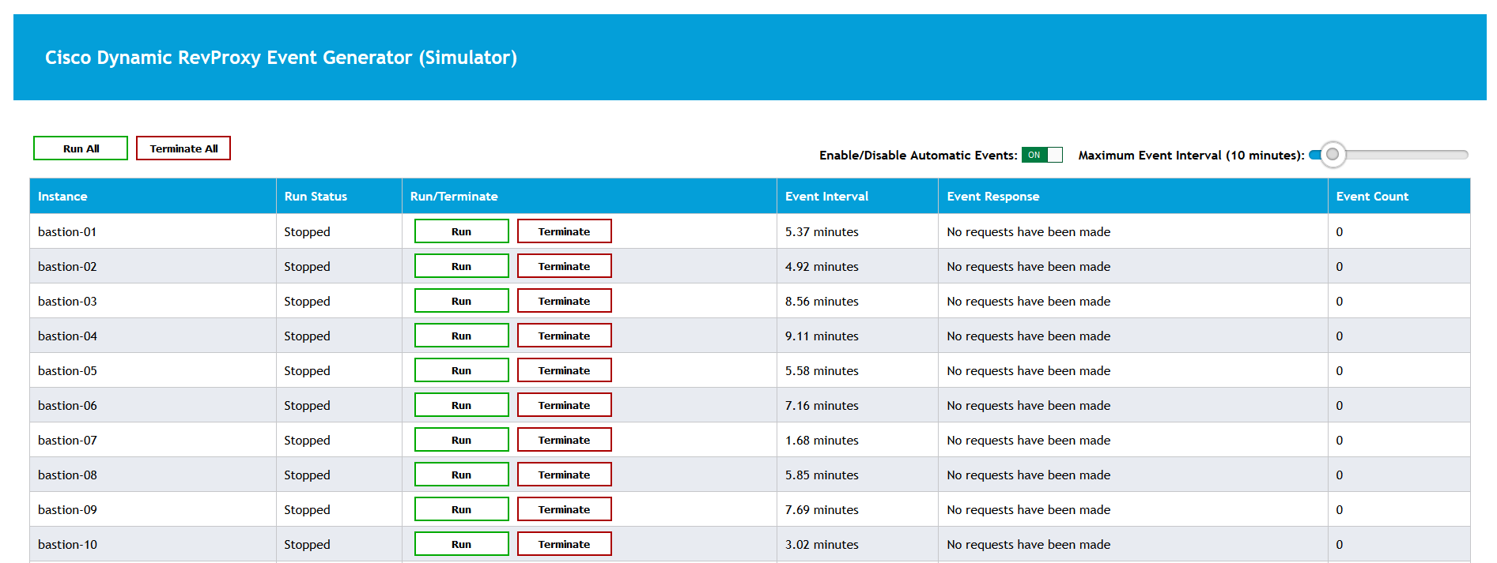**Automatic Events – To have events fire off automatically, toggle the “Enable/Disable Automatic Events” toggle button:  
   You will now see that each instance contains a duration under the ‘Event Interval’ column. This is the duration between automatic events being fired. That is, if the time runs out and the instance is running then a terminate event will fire. And visa-versa if the instance is terminated.  
     
   To change the event interval simply click and drag on the slider next to the “Enable/Disable Automatic Events” toggle. This will generate new random intervals with a minimum interval of 1 minute.  
     
   To disable automatic events click on the toggle button so that it displays ‘off’.**