**Readme**

**Individual contributions:**

1. Jashwin Acharya (X500: achar061):
   1. Implemented initial versions of the Subscribe, Publish and Unsubscribe functions
   2. Implemented article validation functions for Publish, Subscribe and Unsubscribe commands and also wrote multiple test cases to test those validation methods
   3. Implemented the complete PubSub Client command line interface along with the corresponding command line format validation functions and complete multi-thread implementations for making RMI calls and receiving published articles via UDP
   4. Implemented functionality for pinging the server every 10 seconds from the client.
2. Al Yaqdhan Al Maawali (X500: almaa009):
   1. Implemented threading and command line code base
   2. Implemented the ping function
   3. Created some J-unit tests to test the validity of the clients input in the command line.
3. William Stahl (X500: stahl186)
   1. Implemented data structures and logic for publishing to clients according to their subscriptions.
   2. Implemented initial versions of Join, Leave.
   3. Wrote tests for public methods of PubSubServer class, which includes ClientTestThread.

**Note:** We have another document called “**DesignDoc.pdf”** that details our overall system design.

**Running RMI server and clients on the same computer:**

The following steps have to executed in the order specified below for successfully running the Client(s) and server:

1. Navigate to the “src” folder in the attached zip file
2. Open 3 separate terminals in the “src” folder
3. In one terminal, type “rmiregistry 1099 &” and hit “ENTER” on the keyboard. Keep this terminal running while manually running the PubSub server and clients
4. In the second terminal, do the following steps:
   1. Type “javac PubSubServer.java” and hit ENTER
   2. Type “java PubSubServer” and hit ENTER. Upon pressing ENTER, the following message will be displayed in the terminal: “Publish-Subscribe server is ready as: PubSubServer”
5. In the third terminal, do the following steps:
   1. Type “javac PubSubClient.java” and hit ENTER
   2. Type “java PubSubClient localhost” and hit ENTER. Upon pressing ENTER, a welcome message will be shown which highlight all possible options for making RMI calls to the server

**Multiclient support:** If you want to test **multiple clients**, then you can open multiple more terminals in the “src” folder and follow **step 5 above** to have multiple clients communicate with the server. The maximum clients our application can support is 5, but new clients can join the server once an existing client leaves.

**Running RMI Server and Client(s) on different Computers:** We were having some difficulty testing the scenario where the server and clients are running on different CSE lab machines. We kept running into a “java.rmi.ConnectException” error when trying to send requests to the server and also had the rmiregistry running on both our client and server machines. This is **not** an issue when running both server and client(s) on the same computer.

**Publish-Subscribe Client Interface Usage:**

When the client file is run, you will see the following “Welcome” screen:

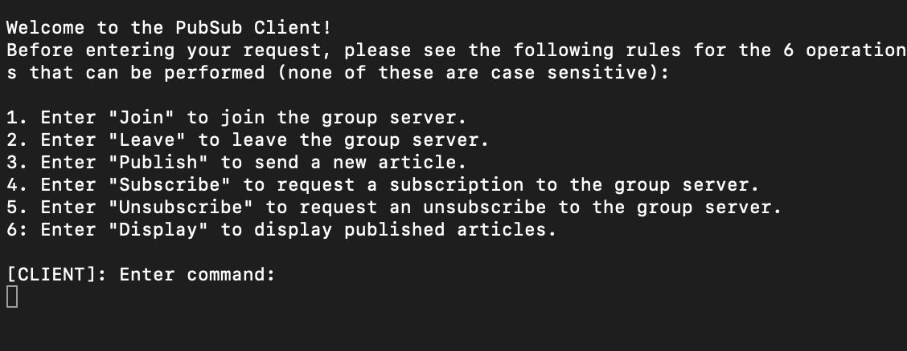

**Note:** All the commands listed below are not case sensitive i.e., “join” and “Join” have the same utility, “Publish:” and “publish:” have the same utility and so on.

**Join Command:**

Type “join” in the client terminal(s) to join the server:



Once the client has successfully joined, the server terminal will show a message such as below:

**Note:** We have added functionality for the Client to Ping the server every 10 seconds to check if the server is still live. For that reason, you will regularly see the message “Client pinged server. Server is online.” in the server terminal.

**Leave Command:**

Type “leave” in the client terminal(s) to leave the server:



Once the client has successfully left the server, the server terminal will show a message such as below:



**Subscribe Command:**

Type “subscribe: <article>” in the client terminal(s) to subscribe to a particular article:



The server responds with the following message:



**Note**: The format of the “subscribe” command matters. “subscribe: Sports;;;” is a valid command, but “subscribe Sports;;;” is **not** a valid command since the colon is missing. Also, the article being subscribed to cannot be more than 60 characters long. If the article is more than 60 characters long (120 bytes), then the client needs to type a new subscribe command with a shorter Article.

**Publish Command:**

Type “publish: <article>” in the client terminal(s) to publish an article to a group of clients:



The server responds with the following message:



**Note:** When the “publish” command is entered, the client terminal receives a response shown below:

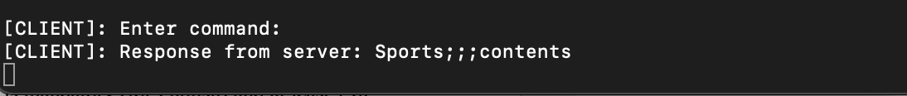

**Note:** If you attempt to publish an article type that hasn’t been subscribed to yet, then you will not get any response back from the server.

You can enter another command instantly once the response from the server is received. For example:



Once you press “Enter”, the command will be executed and you can continue entering commands as below:

Similar to the “subscribe” command, the format of the “publish” command matters. For example: “publish: Sports;;;contents” is valid but “publish Sports;;;contents” is invalid since the colon is missing.

**Unsubscribe Command:**

Type “unsubscribe: Sports;;;” in the client terminal(s) to unsubscribe from an article:



The server responds with the following message:



Similar to the “subscribe” command, the format of the “unsubscribe” command matters. For example: “unsubscribe: Sports;;;” is valid but “unsubscribe Sports;;;” is invalid since the colon is missing.

**Display Command:**

The “Display” command displays all the published articles a client has been and is currently subscribed to. Type “display” in the client terminal(s) to display all the articles as shown below:

**Unit tests Description and Execution Instructions:**

Following are the private method test cases defined in a private test method class:

1. CheckInvalidIP: 3 negative test cases for checking invalid IP addresses such as those that don’t have 4 subfields or if one of the subfields has a value greater than 256
2. CheckValidArticleForPublish: 8 positive cases where the article is valid for publishing. Articles are valid for publishing when one of the first 3 fields in the article string are populated with a value and the “contents” field is populated too
3. CheckInValidArticleForPublish: 6 negative cases where either the contents field is missing or all of the first 3 fields are missing or when an empty string is passed
4. CheckValidArticleForSubAndUnsub: 4 positive cases where the article string is valid for subscribing to and unsubscribing from. An article is valid for subscribe and unsubscribe when any one of the first three fields in the article string is populated and the contents field is missing
5. CheckInValidArticleForSubAndUnsub: 4 negative cases where the article string is invalid for subscribe and unsubscribe. The article string is invalid for subscribe and unsubscribe when the first three fields of the article string are all missing or the contents field is populated or an empty string is passed
6. CheckValidCommand: 3 positive test cases for checking the validity of the user input commands via the PubSub Client user interface. The 3 specific commands that have to be validated are publish, subscribe and unsubscribe since they always have to be followed with a colon, after which the article string is mentioned. This helps ensure the user request is correctly parsed and the article string is passed to the server for subscribe, unsub or publish
7. CheckInvalidCommand: 6 negative test cases for checking if the command format of the user input from the Client user interface is invalid, which includes wrong commands such as “pub”, “sub” or commands where the colon is missing such as “publish Sports;;;contents”

The public facing method tests are in another class, and we have included 9 tests:

1. CheckJoin: 5 negative (invalid Port/IP, already joined, etc.) cases and 1 positive case
2. CheckServerCapacity: Negative case where client is rejected from full server
3. CheckLeave: Negative cases before and after client has left (which is a positive case)
4. CheckInvalidSubscribe: Negative cases where the topic is invalid, contents are present, empty fields, using IP/Port info that hasn’t joined
5. CheckValidSubscription: Positive cases of all 6 combinations ranging from all three fields to just one of the three
6. CheckInvalidUnsubscirbe: Negative cases of unsubscribing from articles the client wasn’t subscribed to EXACTLY, invalid topics, strings, non-joined IP/Port, not confusing with other client’s subscriptions
7. CheckValidUnsubscribe: Positive cases where clients unsubscribing does not clobber each other’s subscriptions
8. CheckPing: Positive case where server is successfully pinged
9. CheckReception: Positive case where client receives content it is subscribed to and not other content.
   1. NOTE: This test uses UDP, so UDP failures may cause this test to fail

Following are the **instructions to run the test cases**:

1. Navigate to the “src” directory and open a terminal window in this directory
2. Type “rmiregistry” and click ENTER
3. Open another terminal in the “src” directory and type “./start-servers.sh” and click ENTER.
4. Navigate to the “tests” directory from the root and open a terminal window in the “tests” directory
5. In the terminal window, enter the following command to execute the tests: java -cp ./../lib/junit-4.13.2.jar:./../lib/hamcrest-core-1.3.jar:. RunTestClasses
6. If you want to re-run the tests, then terminate all open java processes by using either “pkill -15 java” in one of the terminals or press Ctrl (or Command) + C in all the terminals to stop execution. Repeat Steps 1-5 to re-run all tests

Note: Please ensure to close any existing terminals that are running the “rmiregistry 1099 &” command before executing the above tests.