START HERE — understand the B10E PSS (system · code · simulation)
*Written for a junior technical‑support engineer, by way of a functional‑safety mentor. This is the one document to read first. It takes you from zero to understanding the whole system, how the PLC code is built, and how to prove it to yourself in SILworX offline simulation. The other documents (00 glossary, 03 program reference, 04 full test procedure) are deep reference — open them only when you want more detail on one point.*
Everything in this system rests on one rule: a person and the hazard must never be in the hutch at the same time. Every line of the PLC code exists to enforce that one rule. Keep it in mind and the rest falls into place.
How to use this guide. Work through the 6 short modules in order. Each has: Learn (the idea), See it (where to look in SILworX), and Try it (a small thing to force and watch in offline simulation). Do the *Try it* steps as you read — you will understand far more by driving the code than by reading about it.
__________________________________________________

Module 1 — The whole system in one picture
Learn. B10E "HeXI" is a beamline. Part of it is a shielded room — the hutch — that can hold radiation, RF and low‑oxygen hazards. The PSS is an independent HIMax safety PLC that runs continuously and enforces the one rule. It works as a loop:
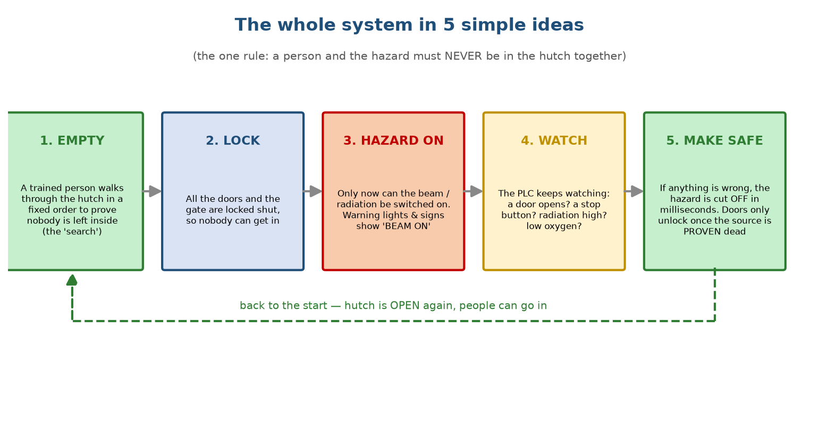
The whole system in 5 simple ideas: prove the hutch is empty (search), lock the doors, switch the hazard on, keep watching, and make safe if anything is wrong — then back to the start.
There are three ways into the hutch — a main personnel door, an entrance gate, and a service door — each with switches the PLC watches:
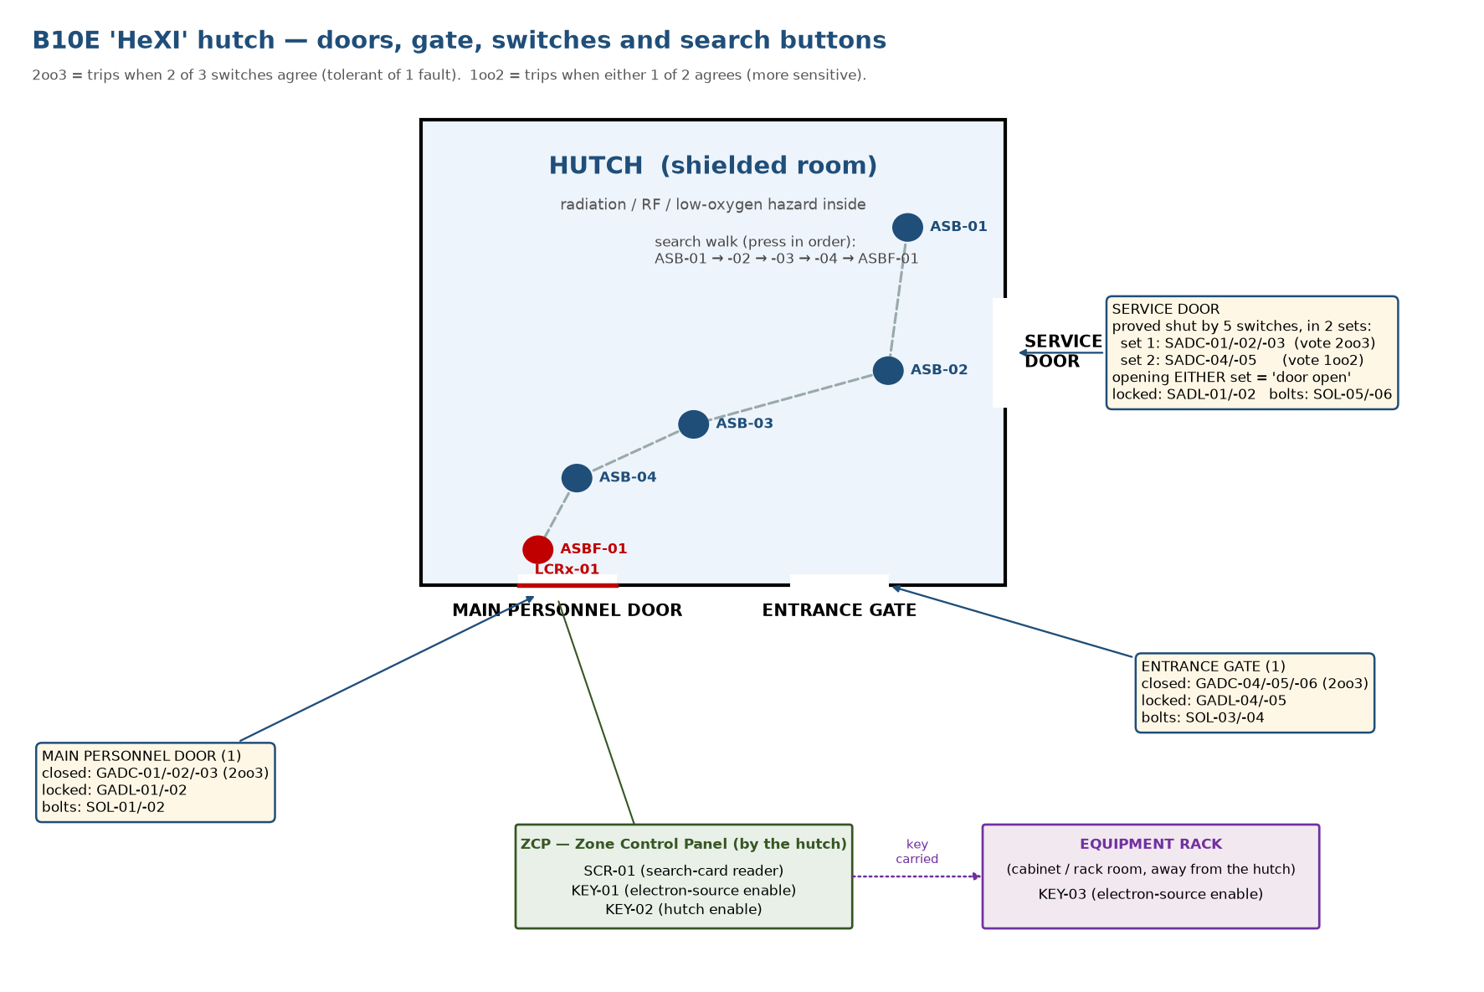
Sketch of the hutch showing the main personnel door, the entrance gate and the service door, each with its closed switches, lock switches and lock bolts, plus the light curtain, the search buttons, the ZCP panel and the equipment rack.
See it. In SILworX open the Hardware view: the whole plant is just 1 analogue‑input card, 3 digital‑input cards, 4 digital‑output cards — a few dozen switches in, a few dozen contactors and lamps out. That's it.
__________________________________________________

Module 2 — How the PLC code is organised (the part most people miss)
Learn. The program *looks* huge (713 pages), but it is only 4 kinds of block:
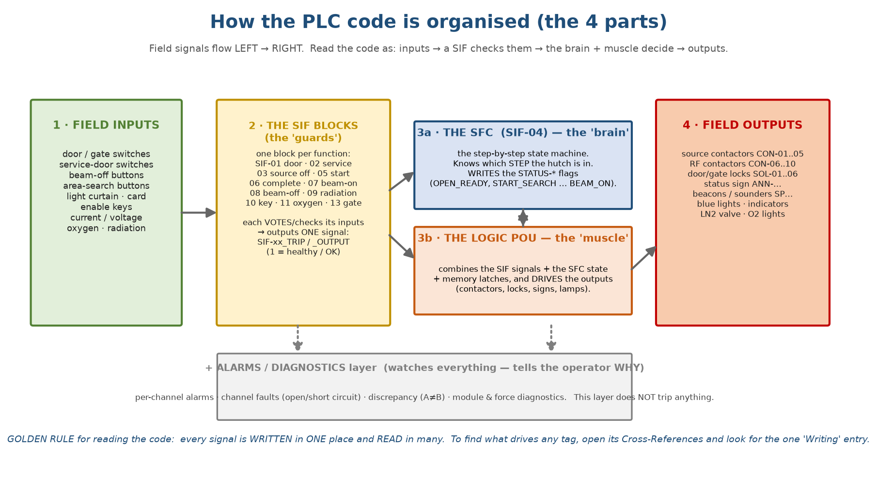
How the PLC code is organised: field inputs feed the SIF guard blocks; the SFC brain (SIF-04) and the Logic muscle decide; the Logic POU drives the field outputs; an alarm/diagnostic layer watches but does not trip.
- The SIF blocks — the "guards." One small block per safety function (SIF‑01
… SIF‑13). Each takes a few inputs, applies voting, and produces one output (SIF‑xx_TRIP / _OUTPUT / _START) meaning *"this function is healthy."*
- The SFC — `SIF‑04` — the "brain." A state machine: it sits in exactly one
step at a time (OPEN_READY, START_SEARCH … BEAM_ON) and moves on transitions. It writes the STATUS‑* flags.
- The Logic POU — the "muscle." It combines the SIF signals + the SFC state +
memory latches and drives the physical outputs (contactors, locks, lamps).
- The Alarms / Diagnostics layer. Watches everything and tells the operator
*why* — it does not trip anything. Ignore it while you learn the safety logic.
The rule that makes 713 pages readable: every signal is written in exactly one place and read in many. So to answer *"what drives this tag?"* you never read the whole program — you right‑click the tag → Cross‑References → find the one `Writing` entry. That single entry is the block that drives it.
Try it. Cross‑reference `STATUS-OPEN_READY`. You'll see many "Reading" entries and exactly one "Writing" — in B10E‑SIF‑04 (the SFC). Instantly you know the SFC owns it.
__________________________________________________

Module 3 — Read ONE function end‑to‑end (the technique you'll reuse)
Learn the method on `SIF‑05` (Search Start) — the permission that begins a search.
See it. Open Library/SIF/B10E‑SIF‑05. It is a single AND gate:
┌─ NOT( SCR-01 ) (search card)
├─ KEY-01 (electron-source enable key)
├─ KEY-02 (hutch enable key)
AND ──┼─ SADC-04 , SADC-05 (service door, 1oo2 pair)
├─ 2oo3( SADC-01/02/03 ) (service door, 2oo3 set)
└─ SIF-08_TRIP (no beam-off button latched)
│
▼
BL10E-SIF-05_START
Read it simply: all inputs true → output true. Notice the small circle (NOT) on SCR‑01 — it inverts that one input.
Key lesson (and a correction to my earlier docs): because of that inverter, `SCR-01 = 0` means *card present* (the active state), and SCR-01 = 1 means *no card*. The card‑reader input rests at 1 and goes to 0 when a valid card is read.
Follow the output. Cross‑reference BL10E‑SIF‑05_START: its one use is the SFC transition `T_1` (OPEN_READY → START_SEARCH). So this single gate is "the permission to start a search."
That's the whole technique: open a SIF page → inputs → gate → one output → cross‑reference the output to see where it's used. Repeat for any function.
__________________________________________________

Module 4 — The behaviour: the states and how they move
Learn. The hutch is always in one state (one SFC step). At power‑up it sits in `OPEN_READY` and waits.
Step (the STATUS‑* flag) | Meaning | Value at power‑up
`OPEN_READY` | idle, ready to start a search | TRUE ← it starts here
START_SEARCH | a search has begun; service doors lock | FALSE
HUTCH_ENTERED | searcher passed the light curtain | FALSE
ASB1 … ASB4 | the 4 area‑search buttons pressed in order | FALSE
STANDBY | search done, all doors locked, 180 s warning | FALSE
BEAM_ON | the hazard is live | FALSE
OPEN | end‑of‑cycle state (after beam‑off / source proven dead) | FALSE

Correction: the first step is OPEN_READY, not OPEN. OPEN is only a brief end‑of‑cycle step that loops back to OPEN_READY.
Two timers police the search: the whole search must finish within 180 s, and each step must take 5–60 s (not too fast, not too slow). Break either, press a wrong button, open a door, or hit a beam‑off → the search aborts to the start.
See it. Open the SFC pages of SIF‑04: each step is a box whose action sets its STATUS‑* flag, and between boxes are the transitions (T_1 … T_9) with their conditions.
__________________________________________________

Module 5 — Do it yourself: one clean simulation run
Start your offline simulation and open a Watch page with the STATUS‑* flags and the contactors CON‑0x:EN. Then:
A. Healthy idle — should rest at `OPEN_READY`. Force:
Force | To | meaning
GADC-01..06, SADC-01..05 | 1 | all doors/gate shut
KEY-01, KEY-02, KEY-03 | 1 | keys in
BOB-01..08 :A and :B | 1 | no stop button pressed
LCRx-01 | 1 | light curtain clear
`SCR-01` | 1 | no card *(this is the corrected polarity)*
IT-01..03_TRIP, VT-01..03_TRIP, OXMON-01..04_TRIP | 0 | analogue healthy — force the trip flags (the set‑points are fixed constants)

Pulse IOC-01-BOB:RESET, …-RDMN:RESET, …-GAS:RESET once. Expect: STATUS-OPEN_READY = 1, every other STATUS‑* = 0, all CON‑0x:EN = 0.
B. Start a search. Force `SCR-01 = 0` (present the card). Expect: STATUS-OPEN_READY → 0, STATUS-START_SEARCH → 1; service locks SOL-05/06 → 1.
C. Walk the search (wait ≥ 5 s between each):
- pulse LCRx-01: 1→0→1 → HUTCH_ENTERED
- pulse ASB-01 → ASB1; then ASB-02, ASB-03, ASB-04
- force the lock feedback GADL-01/02/04/05 and SADL-01/02 = 1, then pulse
ASBF-01 → STANDBY (SEARCHED_AND_LOCKED → 1).
D. Beam on. Wait the 180 s beam delay with the operator enable. Expect: STATUS-BEAM_ON = 1; CON‑01..10:EN = 1 (hazard live).
E. Trip it. Force GADC-01 = 0 then GADC-02 = 0 (door open, 2oo3). Expect: CON‑01/02/03:EN → 0 instantly; SEARCHED_AND_LOCKED → 0. You must run a whole new search to recover.
That single run exercises the brain (SFC), the guards (SIFs) and the muscle (Logic). The full per‑function test set is document 04.
__________________________________________________

Module 6 — The 7 things that will trip YOU up
Memorise these — they cause most of the confusion:
- OFF = SAFE ("de‑energise to trip"): an output at 0 is the safe state
(contactor open, door unlocked, valve closed).
- `_TRIP` / `_OUTPUT` signals are *permissives* — 1 means healthy/OK, they
drop to 0 to trip. (The word "TRIP" in the name is misleading.)
- `SCR-01` is inverted: 0 = card present, 1 = no card.
- The system starts in `OPEN_READY` (TRUE at power‑up), not OPEN.
- `STATUS‑*` flags are written by the SFC — to find what drives any tag, use
Cross‑References → the one `Writing` entry.
- The analogue set‑points are fixed constants (can't be forced) — in simulation,
force the `…_TRIP` flags instead.
- Two timing layers police the search: overall 180 s, and 5–60 s per step.
__________________________________________________

Where to go when you want more depth
- exact meaning of any tag → document 00 (glossary)
- exact PLC logic, page by page → document 03 (program reference)
- full test of every safety function → document 04 (SILworX test procedure)
For *understanding the system and the code*, this one document is enough. Come back to it whenever you lose the thread.

