05 · Code walkthrough — the real PLC pages, explained one at a time
*This document shows the actual SILworX logic pages (taken straight from program.pdf) with a plain explanation under each: how that piece of code works. The picture *is* the code; the words under it tell you what it does. Read it after 00_START_HERE (the big picture); use 00_TAG_GLOSSARY for any tag.*
Three reminders — they apply to every page:
- OFF = safe (outputs are de‑energise‑to‑trip).
- A `_TRIP` / `_OUTPUT` signal is a *permissive* — 1 = healthy/OK, it drops
to 0 to trip.
- Read each page left → right: inputs on the left → block(s) in the middle →
the one output on the right.
The handful of blocks you'll keep seeing (you don't need to memorise them):
Block | What it does
X_LimL / X_LimH | analogue low / high limit trip
X_2oo3_B | 2‑out‑of‑3 voter
& | AND (all inputs 1 → output 1)
>=1 | OR (any input 1 → output 1)
a small ○ on a wire | NOT (invert that signal)
RS / SR | memory latch (a trip "sticks" until reset)
TON / TP | on‑delay / pulse timer
R_TRIG | rising‑edge detector (acts on a 0→1 change)

__________________________________________________

A · The building blocks

A1 — An analogue sensor becomes a trip flag · *Analogue Inputs (p.184)*
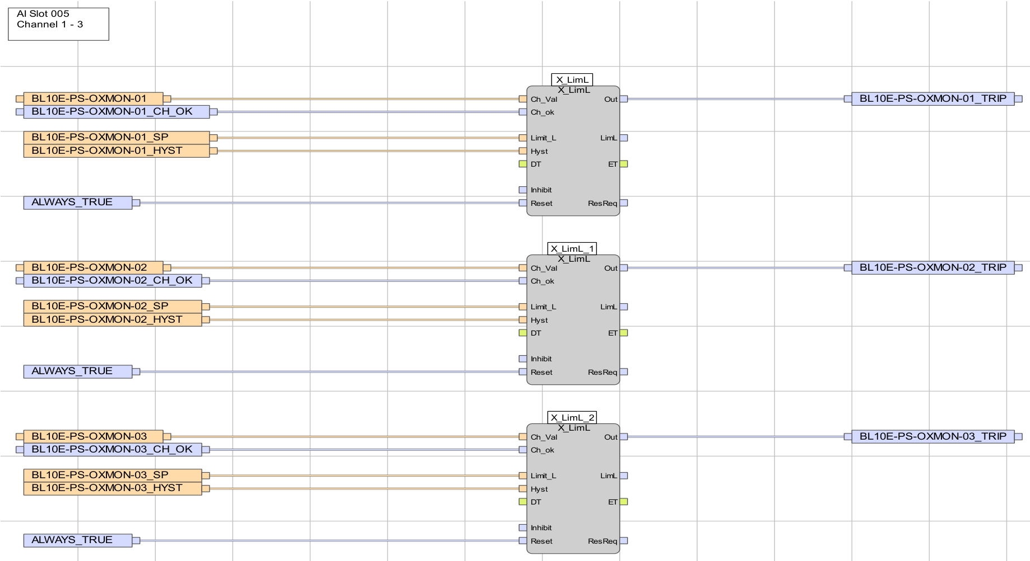
SILworX page: three oxygen channels, each feeding an X_LimL limit block that outputs OXMON-0x_TRIP.
How it works. A 4–20 mA sensor is turned into a simple 0/1 trip flag by a limit block. Here each oxygen monitor feeds an `X_LimL` ("trip when the value goes below the limit"):
- Ch_Val ← the live reading BL10E-PS-OXMON-0x
- Limit_L ← the set‑point …_SP; Hyst ← the dead‑band …_HYST
- Ch_ok ← the channel‑health flag …_CH_OK; Reset ← ALWAYS_TRUE
- Out → the trip flag `BL10E-PS-OXMON-0x_TRIP`
So OXMON-0x_TRIP goes 1 when the oxygen reading drops below its set‑point. The current/voltage channels are identical but use X_LimH ("trip when above"). The _SP/_HYST values are fixed constants — that's why, in simulation, you force the `_TRIP` flag rather than the raw value.
__________________________________________________

B · The guards — the SIF blocks

B1 — Voting + permit · `SIF‑01` General Access Door (p.291)
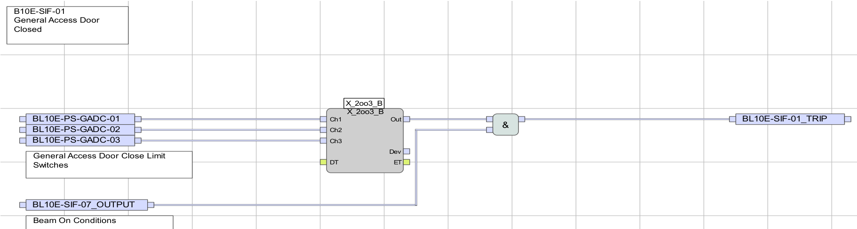
SILworX page: GADC-01/02/03 into an X_2oo3_B voter, AND-ed with SIF-07_OUTPUT, giving SIF-01_TRIP.
How it works. Three independent door switches go into one 2‑out‑of‑3 voter (X_2oo3_B):
- Ch1/Ch2/Ch3 ← GADC-01 / -02 / -03; the voter Out = 1 while **at least 2 of
3** say "shut."
- Out is AND‑ed (&) with `SIF-07_OUTPUT` ("Beam On Conditions") →
`SIF-01_TRIP`.
So the permissive SIF-01_TRIP is 1 only when the door is voted‑shut and the beam‑on conditions hold. Open 2 of the 3 switches → Out → 0 → SIF-01_TRIP → 0 → the Logic POU drops the contactors. This exact shape (3 switches → voter → AND with `SIF‑07` → `SIF‑xx_TRIP`) is reused for the gate (`SIF‑13`) and the service door (`SIF‑02`).

B2 — An AND‑gate permit (and the inverter!) · `SIF‑05` Search Start (p.344)
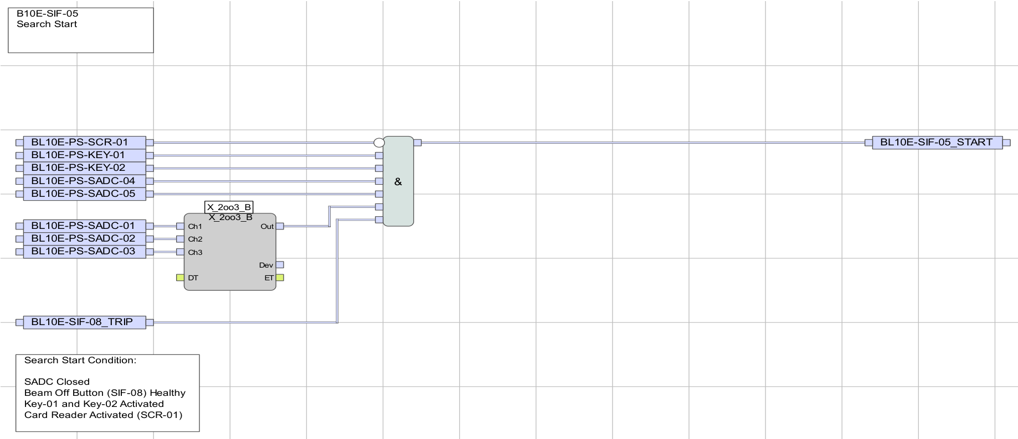
SILworX page: an AND gate with NOT(SCR-01), KEY-01, KEY-02, SADC-04/05, the SADC 2oo3 voter and SIF-08_TRIP, giving SIF-05_START.
How it works. One AND gate decides whether a search may begin. Its output BL10E-SIF-05_START is 1 only when all inputs are 1: KEY-01, KEY-02 (keys on), SADC-04, SADC-05 and the 2oo3 voter of SADC-01/02/03 (service door shut), SIF-08_TRIP (no beam‑off), and `NOT(SCR-01)`.
Look at the small circle on the `SCR-01` line — that is a NOT. So the card input is inverted: `SCR-01 = 0` means *card present* (and 1 = no card). This is the polarity that catches everyone out.
This single output is the transition T_1 that steps the SFC from OPEN_READY → START_SEARCH (see C1).

B3 — A latched trip · `SIF‑08` Beam‑Off Buttons (p.363)
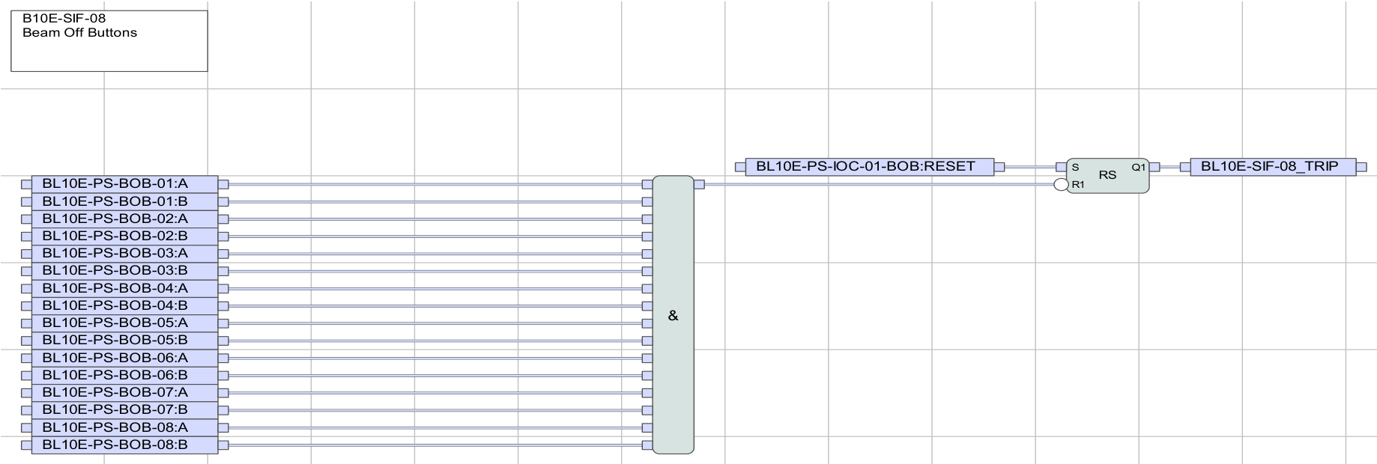
SILworX page: eight dual-channel beam-off buttons feeding an RS latch that outputs SIF-08_TRIP, reset by IOC-01-BOB:RESET.
How it works. Each of the 8 buttons has two channels (:A and :B) AND‑ed together; any button drives an `RS` memory latch:
- press → the latch flips → `SIF-08_TRIP` → 0 (trip) — and it stays there
even after you let go of the button;
- the only way back is the reset …-BOB:RESET.
That "stickiness" is a latch: a trip holds until an explicit reset — exactly what an emergency stop must do. SIF‑09 (radiation) and SIF‑11 (oxygen) use the same RS‑latch pattern, each with its own reset.

B4 — Latch + timer + manual reset · `SIF‑03` "is the source really off?" (p.303)
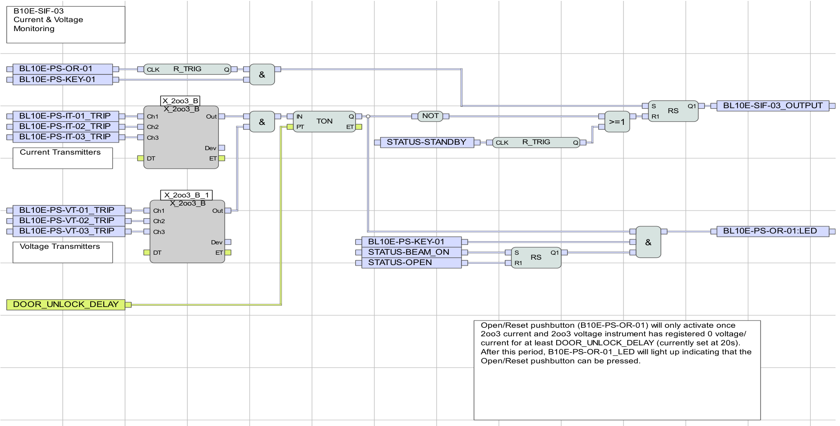
SILworX page: two 2oo3 voters for current and voltage, a TON timer of 20 s, an R_TRIG on OR-01 and an RS latch, producing SIF-03_OUTPUT.
How it works. This page proves the source is dead before doors may unlock. Inside it you can pick out:
- two 2oo3 voters — current IT‑01/02/03_TRIP and voltage VT‑01/02/03_TRIP;
- a `TON` on‑delay timer set to DOOR_UNLOCK_DELAY (20 s);
- an `R_TRIG` on the Open/Reset button OR-01, and an `RS` latch.
So the unlock permit SIF-03_OUTPUT only appears after both current and voltage have read ~zero for 20 s, the "press me now" lamp OR-01:LED lights, and the operator actually presses OR-01. This is where the *command* (key/button) and the *proof* (the transmitters) meet.

B5 — Permit + dwell timer · `SIF‑07` Beam‑On (p.356)
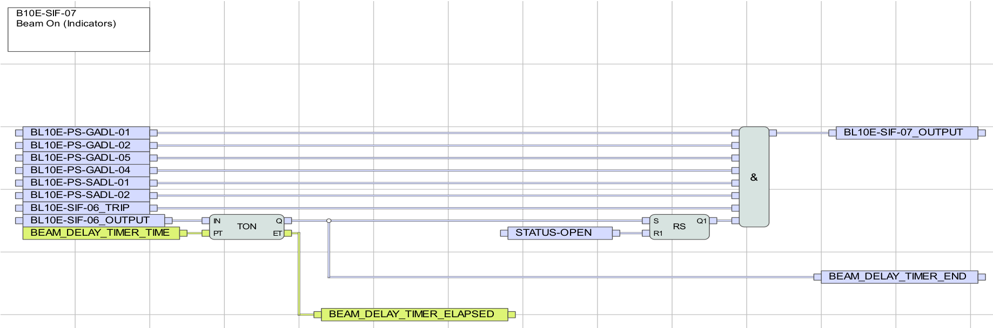
SILworX page: the door-lock feedback switches and SIF-06 feeding a 180 s TON timer and an RS latch to produce SIF-07_OUTPUT.
How it works. The master beam‑on permit. The lock‑confirmation switches (GADL-…, SADL-…) and SIF-06 feed a `TON` timer set to BEAM_DELAY_TIMER (180 s) and an RS latch → `SIF-07_OUTPUT`. So beam is only permitted once every lock is physically confirmed *and* the 180 s "radiation imminent" warning has elapsed. (Note: it watches the lock *feedback*, not the lock *command* — command ≠ confirmation.)
__________________________________________________

C · The brain — the SFC (`SIF‑04`)

C1 — The state machine: steps & transitions (p.326)
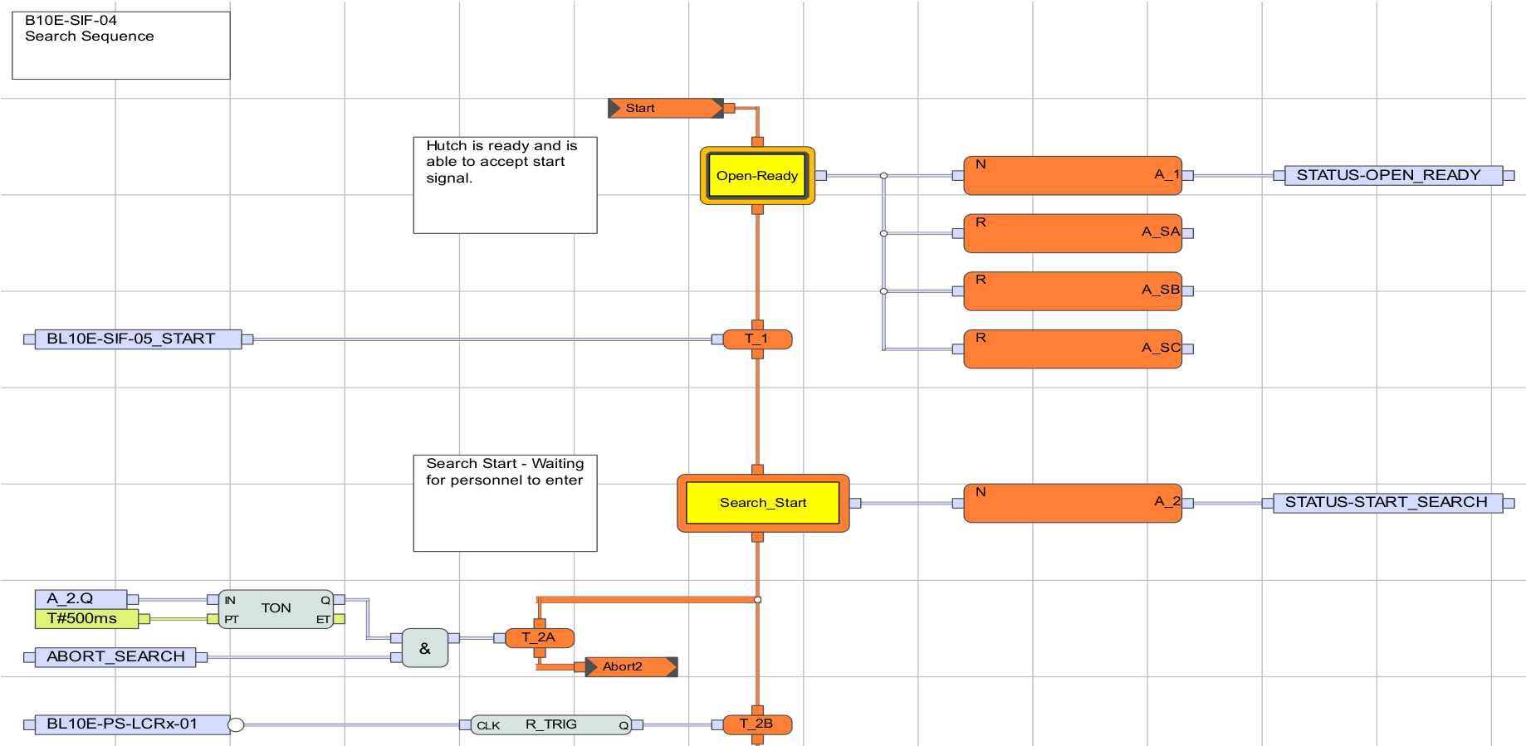
SILworX SFC page: the Start marker, the bold Open-Ready initial step writing STATUS-OPEN_READY, transition T_1 = SIF-05_START to the Search_Start step writing STATUS-START_SEARCH.
How it works. This is the SFC (the state machine). Read it top‑to‑bottom:
- Each rounded box is a step (Open-Ready, Search_Start, …). The **bold box
Open-Ready is the *initial* step** — where the program sits at power‑up.
- Each step has an action (N = active while the step is active) that **writes a
STATUS‑* flag** — e.g. Open-Ready → A_1 → STATUS-OPEN_READY.
- Between two steps is a transition (the small orange bar) with a condition.
T_1's condition is `BL10E-SIF-05_START` (from B2): when it's 1, the SFC steps from Open-Ready to Search_Start.
- The A_SA / A_SB / A_SC boxes are the abort branches.
This single chart is why only one `STATUS‑*` flag is true at a time, and it is the one place those flags are written.

C2 — What a step does: Search Start effects (p.327)
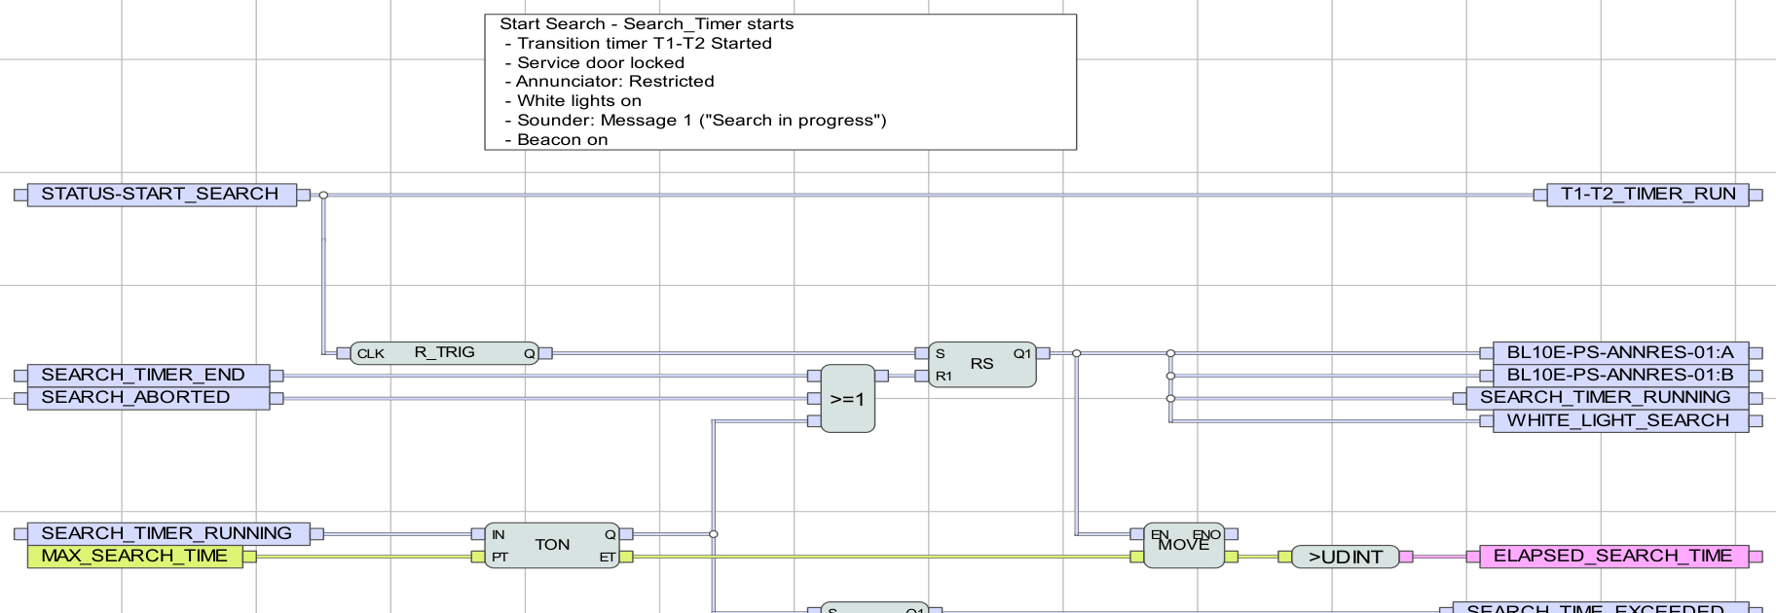
SILworX page: the Search Start step's effects — service-door lock, RESTRICTED annunciator, sounder, white lights and the search timer.
How it works. Each step has a partner page that performs its effects. While STATUS-START_SEARCH is active, this page locks the service doors, lights the RESTRICTED annunciator (ANNRES), sounds speaker message 1, turns the white lights on, and starts the 180 s search timer (SEARCH_TIMER_RUNNING). The RS latches hold those outputs for as long as the step is active.

C3 — End of the cycle: Beam On → Open (p.336)
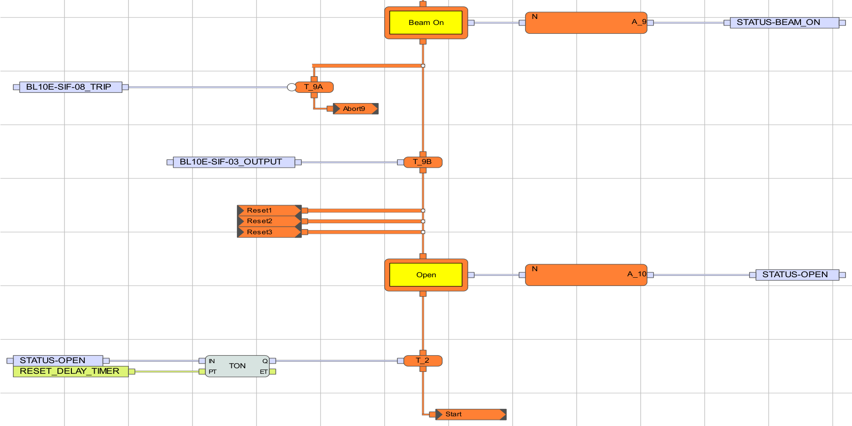
SILworX SFC page: the Beam On step, transitions T_9A (SIF-08) and T_9B (SIF-03) to the Open step, a 60 s reset-delay TON, then loop back to Start.
How it works. The tail of the chart. From the `Beam On` step, transition T_9A (SIF-08_TRIP, a beam‑off) or T_9B (SIF-03_OUTPUT, source proven dead) moves to the `Open` step. Open runs a TON set to RESET_DELAY_TIMER (60 s), then loops back to Start — i.e. back to Open-Ready. So STATUS-OPEN is true only briefly at the end of a cycle; the resting state is OPEN_READY.
__________________________________________________

D · The muscle — the Logic POU

D1 — Driving the contactors: "no silent restart" (p.267)
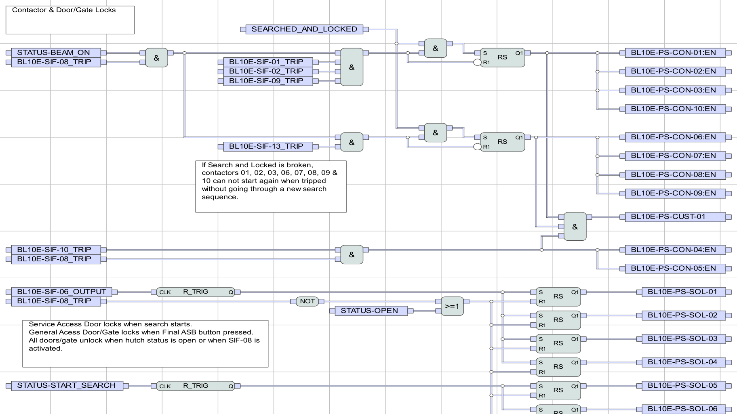
SILworX page: RS latches gated by SEARCHED_AND_LOCKED and STATUS-BEAM_ON and the SIF permissives, driving the CON-0x:EN contactor outputs, with the on-page note about needing a new search to restart.
How it works. This is where the SIF permissives + the SFC state actually switch the physical outputs. Each contactor group is built from an `RS` latch set by SEARCHED_AND_LOCKED & STATUS-BEAM_ON together with the relevant SIF permissives:
- source group `CON-01/02/03/10` ← SIF-08 & SIF-01 & SIF-02 & SIF-09
- gate/RF group `CON-06/07/08/09` ← SIF-13
- key group `CON-04/05` ← SIF-10 & SIF-08
The on‑page note says it in plain words:
*"If Search and Locked is broken, contactors 01, 02, 03, 06, 07, 08, 09 & 10 can not start again when tripped without going through a new search sequence."*
That latch is the master safety property: once a trip breaks SEARCHED_AND_LOCKED, the hazard can never silently come back — only a complete new search re‑arms it.
__________________________________________________

How to use these pages in your own SILworX
- Open the same page (its name/number is in the top‑left and bottom‑right of
each picture — e.g. B10E‑SIF‑05) in your project.
- Start offline simulation, force an input, and watch the wire colours
change through the blocks to the output — you literally *see* the logic work.
- To find what drives any signal, right‑click it → Cross‑References → the one
`Writing` entry.
That's the whole code, in ten pictures.

