Welcome to the NBA Draft Picker! To get started, simply run DraftPickerMain.java.

First, you have the option of choosing how many players you want to have recommended.

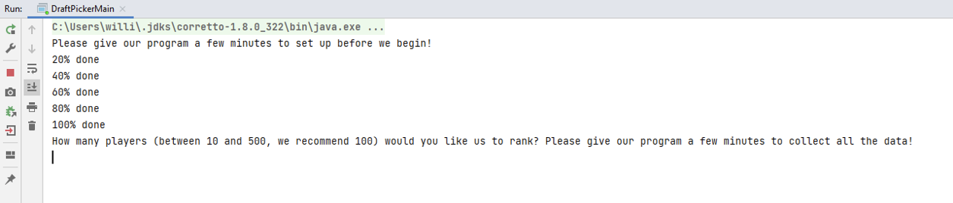

Next, you are given the option to see our recommendations for the current draft year.

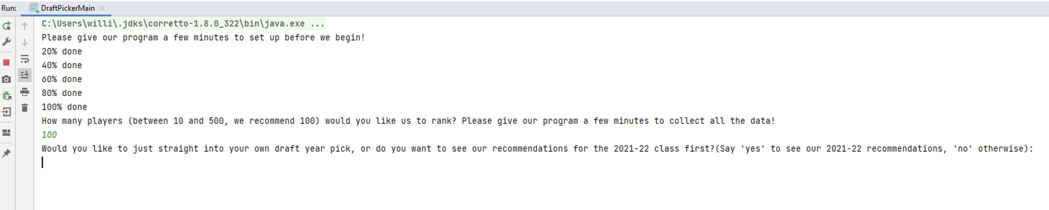

If you say yes, we will output the recommendations. If you say no, we will jump straight to letting you pick which year you want.



For any year, we will give our recommendations and also tell you how many of those players ended up landing a spot in list the top 10 players in the NBA since they were drafted.

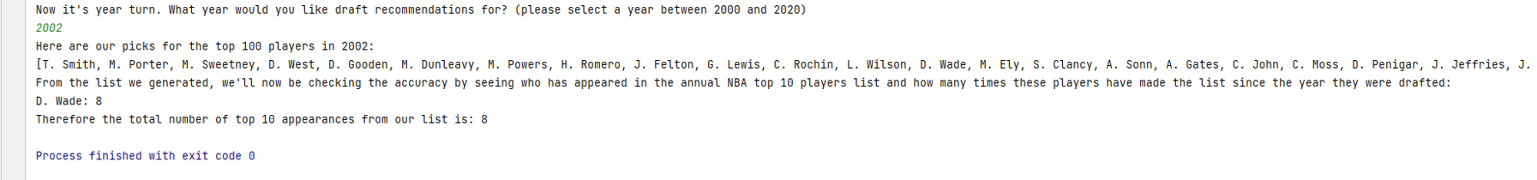

And that wraps it up! Hope you have fun testing out our NBA recommendations.