Instructions on the use of Will Petillo's narrative system. Inspired by the various writings of Chris Crawford and also Ken Levine's "Narrative Lego" talk from GDC 2014.

1 – ScriptableObject based state machine for Conversations: The left image is of a single dialog node. Create these by duplicating an existing asset, or by right clicking the project window and selecting Create => ZMD => Dialog => Node. The right image is what the player will see when they enter this particular node.
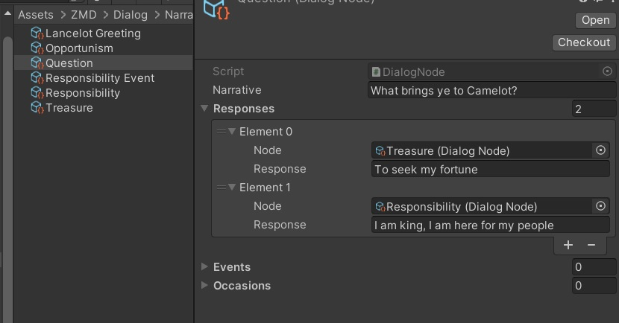
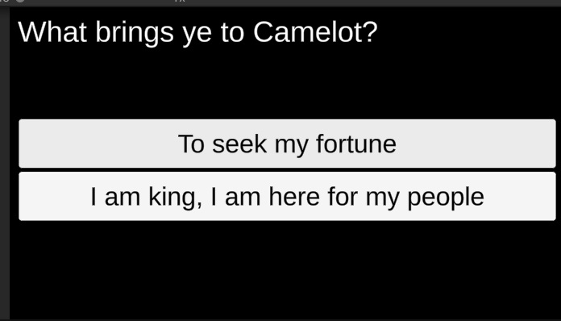
Narrative: Text that appears on the screen, or what the NPC says, on entering the node.
Responses: Add one response for each option the player can select in response to the Narrative.
Node: The next node to enter if the player selects this response.
Response: The text on the button for the response.

Each node can include any other node as a response, meaning that the system allows not only branches, but also loops, repeats, convergences, and so on. There is a special Node called "End", which will end the conversation if entered.

Right now, the system is limited to a maximum of 3 responses per node, but this could be easily extended if needed.

2 – Starting Conversations: Add new characters to the scene by adding instances of the NPC prefab to the hierarchy. During the game, enter into a conversation with a character by clicking on their sprite. When the conversation ends, the game will return to the character screen, seen below. The character screen will be replaced with something else, depending on the needs of the project.

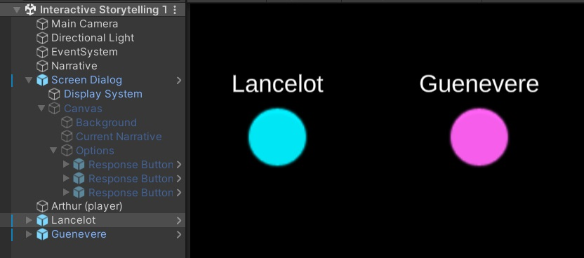

3 – ActorInfo: The starting data for an actor. Create these by duplicating an existing asset, or by right clicking the project window and selecting Create => ZMD => Dialog => Actor.

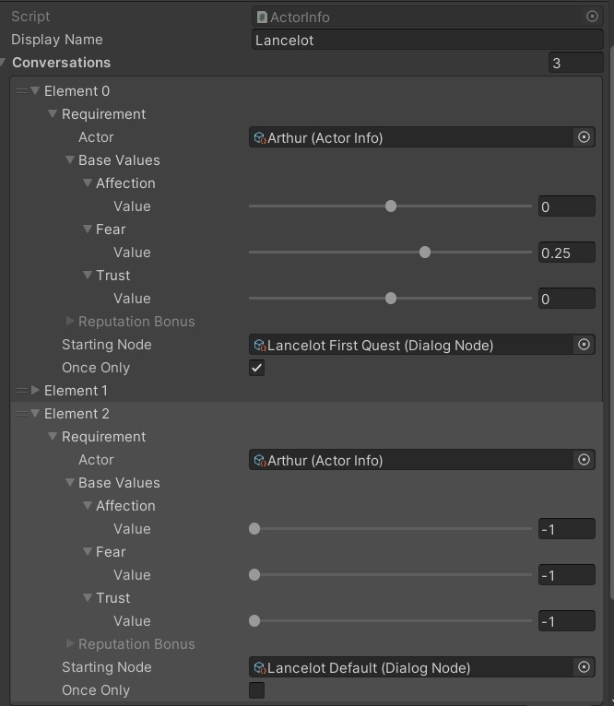
Display Name: Text that will display by character in game to identify them.

Conversations: Add one for each dialog tree the NPC can engage in over the course of the game.

Requirement - Actor: The character who can trigger the conversation, typically the player (this variable may be removed as redundant).

Requirement – Base Values: The minimum affection, fear, and trust required to enable the conversation.

Starting Node: The first node in the dialog tree for a given conversation.

Once Only: Conversation can only be accessed once.

Currently, the system looks through the conversations beginning from element 0 and picks the first one for which the requirements are met. This will probably change based on design needs.
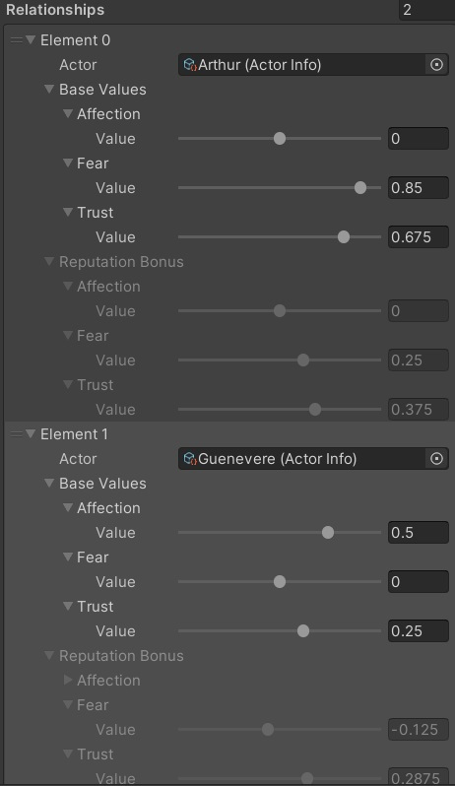
Relationships: How the NPC feels towards each actor (including the player).

Base Values come from the NPC's direct experience of the actor (preset starting values and in game events);

Reputation Bonus is calculated based on how other NPC's perceive the actor. Base Values and Reputation Bonus are added together when the NPC is making decisions.

Affection: How much the NPC like the actor. Increased by kindness and charm.

Fear: How submissive the NPC is towards the actor (negative
is dominant, zero is equal). Increased by intimidation and impressive leadership (respect).

Trust: How much the NPC trusts the actor (negative is distrust, zero is unknown). Increased by following through on promises, fair dealing, and telling the truth.

Reputation Bonus values are calculated in the OnValidate method of ActorInfo, so you can see them update in real time as you change actors' base values, mirroring, and empathy. The Base Values and Reputation Bonus in each ActorInfo ScriptableObject represent what the NPC will feel towards the other actors at the start of the game.
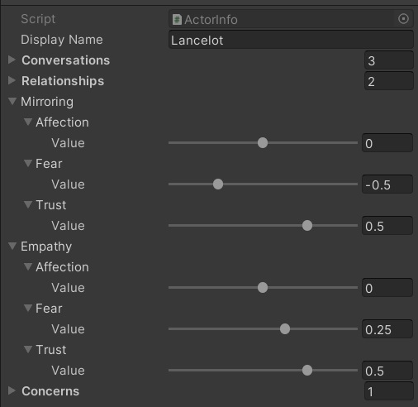
Mirroring: How an NPC feels towards the player (or another NPC) is affected by how the player feels towards them. The impact of these reciprocal effects are controlled by mirroring values. In the case of the image on the right, Lancelot's affection for other characters is not impacted by other characters' affection for him at all. Another character fearing Lancelot by 1 would decrease Lancelot's fear of them by 0.5. Another character trusting Lancelot by 1 would increase Lancelot's trust of them by 0.5.

Empathy: How an NPC feels towards the player (or another NPC) is affected by how other NPC's feel towards the player. The impact of these effects are controlled by empathy values as well as by the NPC's relationship base values towards the other NPC. In the case of the image on the right, Lancelot's affection for the player is not impacted by other characters' affection for the player. If Gallahad fears Arthur by 1 and Lancelot fears Gallahad by 0.5 then Lancelot's fear of Arthur will increase by 0.125 (1 Gallahad fear of Arthur * 0.5 Lancelot fear of Gallahad * 0.25 Lancelot fear-empathy).

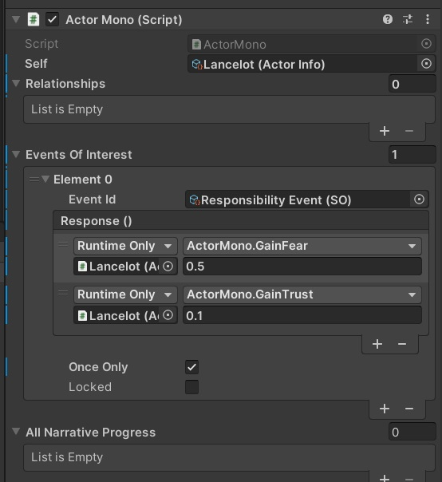
4 – Events and Responses:
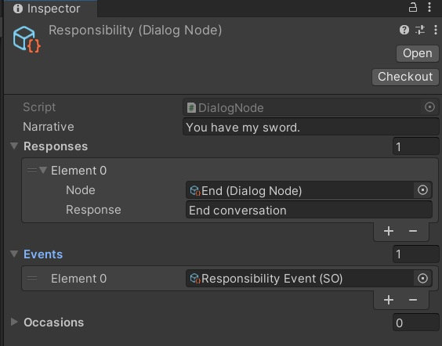
Events added to Dialog Nodes will trigger any corresponding event added to an Actor (in the hierarchy) on entering the node during conversation. Create events by duplicating an existing event or by right clicking the project window and selecting Create => ZMD => Data Types => SO Base.

In the above example, the Responsibility event triggers when Lancelot says "You have my sword," causing him to gain 0.5 fear and 0.1 trust (added to Base Values) towards the player (Arthur). If the player enters this node multiple times, the event will trigger each time, but because the Once Only field is true, the first trigger of the event will cause the Locked field to become true, which in turn will prevent the response (reputation changes) from occuring again.

This example is for illustration purposes. In general, I recommend using Occasions to change actor relationships during dialog. Events are more useful for scene changes, visual effect triggers, etc.

5 – Occasions and Concerns: Occasions added to dialog nodes will trigger relationship changes (applied to base values) on actors (in their ActorInfo asset) who have the corresponding occasion in their array of concerns. In the below example, entering the dialog node where Lancelot says "I see..." will decrease his affection for the player (Arthur) by 0.3 and trust by 0.2. Multiple NPCs may respond differently to the same occasion.
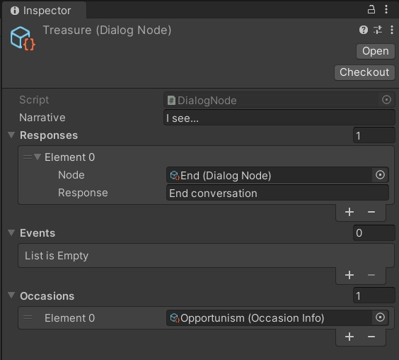
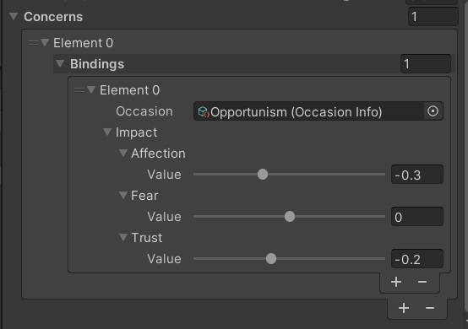
A future version of this system may add a recursive layer of abstraction to concerns, where an array of concerns may contribute to the state of a larger concern that impacts the NPC's relationship, but this feature is out of scope for the game jam.

6 – Incomplete potential features:

- Display all available conversations as a list when selecting a character to interact with, rather than automatically choosing the first available. Alternatively, there could be randomization or a best-fit calculation.
- Map that allows the player to move between rooms, where different NPCs are in each room.
- "Conversations" without an NPC, where the player chooses between options in response to text, potentially triggering events and occasions.
- Offscreen interactions between NPCs. Some forms of this are possible already:
  - Dialog nodes with a single option, labelled with generic text like "continue".
  - Dialog nodes that signify checkpoints in the game, which trigger occasions and events without an obvious connection to what is happening on screen.
- Inventory: items added to player inventory by events, which unlock new dialog options.
- Progression tracking
  - Flagging conversations and dialog nodes as reached.
  - Directing the player towards conversations that are not fully explored.
  - Triggering an event (such as Game Over) when no unexplored nodes exist.

