
https://atlas.cid.harvard.edu/

Optimal Industry Development Strategy Using Economic and Product Complexity

Singapore

─
The Economic Complexity Lab - Columbia University
Haoxian Chen, Davepriyan Gunaratnam, Rohan Macherla, Ajit Akole, Shomik Ghose, Alex Wei-Liang Ku, Sannidhya Modi, Xilin Wang, Alexandra Garcia
Optimal Industry Development Strategy for Singapore

0. Executive Summary

In this report, we aim to uncover the economic path Singapore went through during the period from 2013 to 2018. Specifically, we dive into the topic through a macroeconomic overview of Singapore from the perspective of Gross Domestic Product (GDP) and Economic Complexity Index (ECI), which reflect countries’ production capability and production structure, respectively. We find that during the period of our interest, Singapore demonstrated a low level of economic growth with an annual GDP growth rate of 3.6%, concurrent with a decrease in economic complexity as compared with other major economies in Asia.

The mixed level of economic progress during the period, we believe, can be partially explained through analysis of the economic and product complexity structure of Singapore on the industry group level, as well as the stagnant macro and microeconomic strategies. The product classification system we adopt allows us to measure the realized industry development for various industry groups and to observe that Singapore regressed in developing most of its industries during the period while its developed and emerging counterparts and economies around the globe also adopted complex and progressive paths with variable degrees of success.

Based on our analysis of the opportunity gain and a sensitivity analysis of major industry groups, Singapore could have furthered its gains by prioritizing Chemicals, Machinery and Construction in 2018. Three years later, in 2021, its focus should have shifted to the [Industry 4] and [Industry 5] industries, which are also one of the more developed industries at the time. We further note that Singapore has a slightly mismatched development strategy that indicates a moderate level of structural optimality on the complexity level, having an adjusted R-square of around -5.1% in 2018 and a . Since a significant positive correlation exists between five-year GDP growth and the structural optimality index of an economy as we define and calculate, Singapore indeed has a suboptimal growth experience as compared with fast-growing economies both on a regional scale and on a global scale, and has the potential to further its economic gains through industrial structure optimization as suggested in the paper.

The three years between 2019 and 2021 showed a significant improvement in Singapore's economic growth, boosting its position on the global scale. Its GDP recovered to above the pre-pandemic levels, and it saw a significant boost in the ECI, particularly compared to its peer countries. Its current strategy still has the viable potential upside to increase its performance and optimize its structure further.

1. Report Overview

In this report, we aim to uncover the economic path Brazil went through during the period from 2013 to 2018. Specifically, we dive into the topic through a macroeconomic overview of Brazil from the perspective of Gross Domestic Product (GDP) and Economic Complexity Index (ECI), which reflect countries’ production capability and production structure, respectively. We then analyze the industrial framework and changes of Brazil during the period based on quantitative measures such as Product Complexity Index (PCI) and Product Family Complexity Index (PfCI), followed by a detailed analysis of how such changes have matched with development strategies as quantitatively measured by opportunity gains on an industry-level. We conclude our report with macro-level results and predictions of Brazil, as deduced from regression models we have established on a global scale, which take into account countries’ stances in their product space.

2. Macroeconomic Results

2.1 GDP Ranking and Changes
As the 34th largest economy in the world ranked by GDP, Singapore has a GDP of 307 billion USD in 2013 and 364 billion USD in 2018, exhibiting an steadily increasing level of economic output. Figure 1 illustrates the time-series GDP results for major asian economies from 1999-2018, and Singapore ranks among its peers as a small but growing economy in terms of both GDP and GDP growth. During the period from 2013 to 2018, Singapore achieved an average annual growth of 3.6% in GDP. This number is slightly higher than the annual growth rate of the other four leading asian economies, which have a geometric average growth rate of 3.0% and an arithmetic average growth rates of 3.2%. Compared with more developed economies on a global scale, the annual growth rate of 3.6% is comparable to countries such as the USA which has an average annual GDP increase of around 4% during the period. The rapid economic growth, we believe, can be reflected through changes in ECI and PCI, and can be further explained by a well-chosen set of production strategies adopted by Malaysia from 2013 to 2018, which we will expand at the later stage of the report.
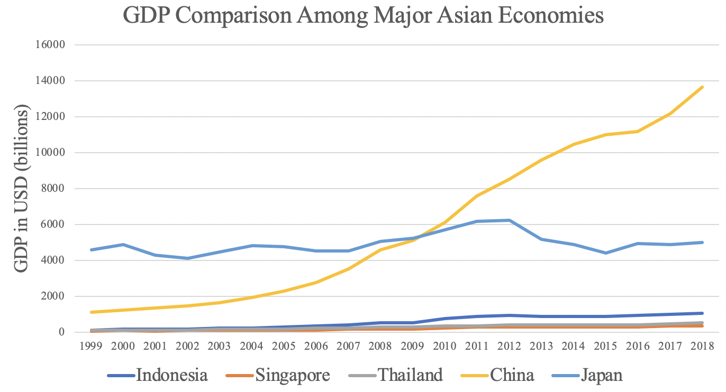
Figure 1: GDP Comparison Among Major Asian Economies

2.2 ECI Ranking and Changes
The Economic Complexity Index (ECI), as defined by Ricardo Hausmann and Cesar Hidalgo in 2009 to explain the knowledge accumulated in a country's population, exhibits a similar pattern for Singapore. As illustrated in Figure 2 below, Singapore exhibits a stably high production capability from 2013 to 2018, as measured by ECI. This is in direct contrast to the other asian economies such as Indonesia, which demonstrates a huge disadvantage in both ECI growth rate and GDP growth rate.
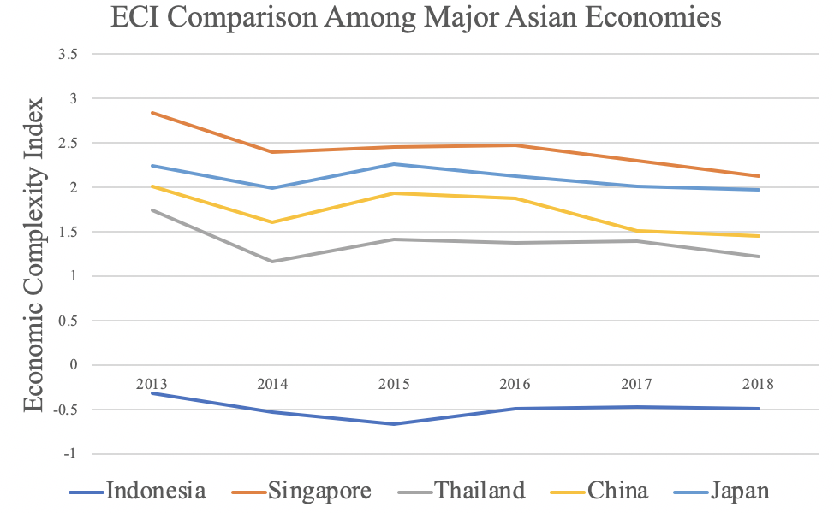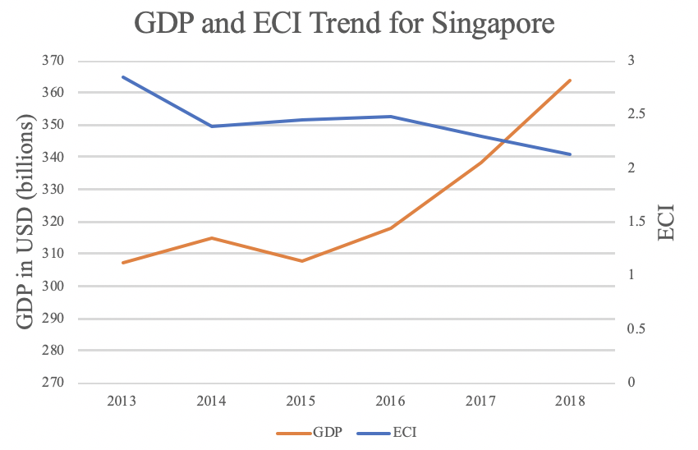

Figure 3 offers a further comparison of GDP and ECI over the entire time span from 2013 to 2018 for Singapore. The rapid increase in GDP during the period from 2015 to 2018 is accompanied by a high level of ECI, indicting the potential that the economic growth experienced by Singapore during this period might be attributed to its high ECI, or the effectiveness of the country in developing a competitive product space that helps to accumulate complicated knowledge and technology. In order to provide a more concrete answer to why this has happened, we will dive into an analysis of Indonesia’s production structure and its product space designs in the next few chapters.

3. Production Analysis

3.1 Product Categorization
Our main data source in this research is the UN Comtrade Website (https://comtrade.un.org), which provides us with valuable information on countries’ export values on an annual basis, including highly specific export data for more than 5000 categories of products. In order to have a holistic vision of the product space of a country, however, a level of categorization is required. Products in our data source are labeled from 010000-999999, with the first two-digits representing a general category to which the product belongs. Based on the 99 categories as extracted from the label, we further group the products into 18 most widely-accepted industries, as summarized in Table 1.

Note that the High-complexity Products industry group is not a distinct industry but rather an aggregated industry that encompasses the most complicated products from the most technologically-advanced industries (as measured by PCI). This industry serves as an indicator for us to quantitatively evaluate how well a country has performed in developing cutting-edge technologies and closing its technical gap with advanced economies, which has become a topic of wide concern today. Indeed, when we rank the 18 categories based on PfCI (an equivalent concept of PCI as calculated based on the 18 categorized product groups), the High-complexity Products industry has the highest PfCI among all industry groups.

Category | Description
Animals and By-products | All kinds of meat, livestock and related by-products
Vegetables, Fruits and Plants | All kinds of plants, edible vegetables and fruits
Food and Preparations | Edible preparations, raw cooking materials and appliances
Clothing and Accessories | All kinds of fabrics, filament, clothing and accessories
Textiles | All kinds of textile articles and related products
Wood Products | Book, paper and other elementary products related to wood
Metals | Mining of all sorts of raw Metals
Refined and Processed Stones | Refined or processed stone products such as pearl and ceramics
Energy Drilling and Mining | Mining industry for energy, minerals, stone materials, etc.
Daily Instruments | Basic daily instruments such as sport requisites, timing and measuring tools
Raw Manufacturing | Basic products made from plastic, rubber, leather, etc.
Chemical Manufacturing | Advanced chemical products and pharmaceutical products
Chemicals | Raw chemical materials and by-products
Machinery and Construction | Machinery and mechanical appliances, including electrical equipment
Transportation | Vehicles and locomotives including aircraft, ship, railway, etc.
Weapons | Explosives, arms and ammunition
Services and Utilities | Financial, business, legal, communication, travel Services and Utilities, etc.
High-complexity Products | Agglomeration of advanced products with highest PCIs

Table 1: Categorization of Products

We further observe a positive correlation between the GDP and the export of High-complexity Products. A higher adjusted R-square exists between GDP and High-complexity Products exports, indicating that more successful economics, as measured by GDP, tend to be those that are capable of producing and exporting High-complexity Products as we define them. The Figure 3 and 4 show the OLS results in a universe of 107 and 21 typical countries respectively.

 | High-complexity Products | Food and Preparations | Animals and By-products
Adj.R-squared | 0.075 | 0.006 | 0.002
F-statistic | 9.556 | 1.638 | 1.175
No. Observations | 107 | 107 | 107

Figure 3: OLS Regression Results of GDP against Percentage Volume of Exports

 | High-complexity Products | Food and Preparations | Animals and By-products
Adj.R-squared | 0.149 | 0.003 | -0.012
F-statistic | 4.510 | 1.059 | 0.7542
No. Observations | 21 | 21 | 21

Figure 4: OLS Regression Results of GDP against Volume of Percentage Exports

3.2 Realized Industry Development
Based on the product categorization aforementioned, we aim to capture SIngapore’s realized industry production strategy between 2013 and 2018 on a complexity level. In Hausmann and Hidalgo (2009), distance is defined to be a measure of how far a country is from a certain product not in its product space. We extend this concept to all product groups and quantify how technically equipped a country is to develop the corresponding product groups. In other words, the shorter the distance between a country and a product group, the more capable a country is in developing products within that group. Defining this net distance change as the Realized Industry Development (RID), our export data allow us to calculate and compare RID of SIngapore and the 18 product groups in 2013 and 2018 through subtraction, where a positive RID indicates a shortening of the distance (i.e., advancement of the industry), and a negative RID indicates the reverse. As ranked in Table 2, during the period from 2013 to 2018, SIngapore has focused on products with a moderate level of complexity and those requiring intermediate skills.

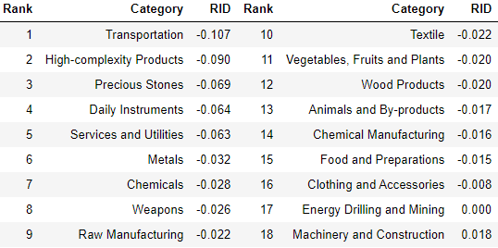
Table 2: Realized Industry Development (RID) of SIngapore

3.3 Regional and Global Comparison
Table 3 and 4 below summarize how the production strategy adopted by SIngapore compares with leading economies and a selected group of emerging economies in the world, as measured in RID. It can be directly observed that SIngapore focused on products with a lower complexity level, when compared against leading economies such as the United States and Germany, which gave a considerable level of attention to more advanced product groups such as clothing, services and utilities, and chemical manufacturing.

Ranking | France | The United States | Germany
1 | High-complexity Products | Services and Utilities | High-complexity Products
2 | Chemical Manufacturing | Weapons | Transportation
3 | Daily Instruments | Raw Manufacturing | Wood Products
4 | Animals and By-products | Precious Stones | Metals
5 | Food and Preparations | Animals and By-products | Food and Preparations

Table 3: RID Comparison across Leading Economies

Ranking | China | South Korea | Singapore
1 | High-complexity Products | Transportation | Transportation
2 | Transportation | Textile | High-complexity Products
3 | Machinery and Construction | High-complexity Products | Precious Stones
4 | Energy Drilling and Mining | Chemical Manufacturing | Daily Instruments
5 | Daily Instruments | Machinery and Construction | Services and Utilities

Table 4: RID Comparison across Emerging Economies

Table 4 further examines SIngapore’s development strategy against those of emerging economies on a global scale. Reasonably, emerging economies such as China, South Korea, Singapore and India have devoted the majority of their efforts into intermediate industry groups while developed economies such as SIngapore should have relied more on advanced industry groups. This trend holds true in general, regardless of the continent or the time period, and serves as an indicator for which phase of development a country is currently in as evaluated from its production strategy. Based on this standard, SIngapore is indeed adopting a moderate but slightly out-of-phase strategy that seeks development in industry groups with a lower level of complexity than it should.

4. Product Space Design

4.1 Suggested Development Vector
As aforementioned, distance gives us an idea of how far each new product is from a country’s current mix of exports. As defined in Hausmann and Hidalgo (2009), distance is “the weighted proportion of products connected to goods p that country c is not exporting, i.e., MCP=0.” Based on this definition, the distance between a country and any product that the country is currently exporting (i.e., the country is a significant exporter in the product as compared to global average) is zero. Similarly, opportunity gain quantifies the contribution of a new product in terms of opening up the doors to more and more complex products. Intuitively, a product that a country is currently exporting (i.e., MCP=1) has an opportunity gain of zero. And unreasonable investment on certain product p would lead to a relative decrement in export of more profitable products, and therefore lead to a negative opportunity gain of product p. The opportunity gain is not the only estimator of a country’s level of economic development. However, among countries with comparable economics strength, those having higher ECI, or in other words, more reasonable economics structure are often in better shape.

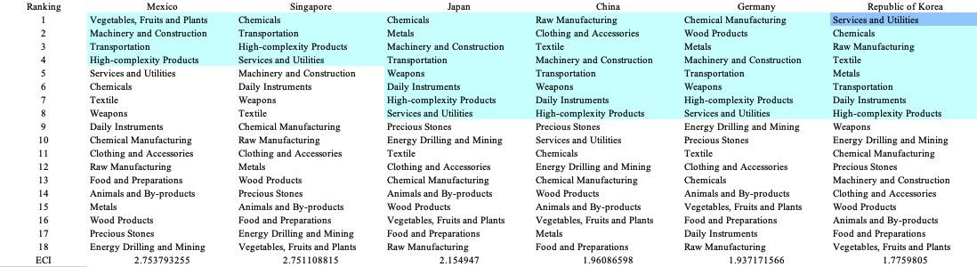

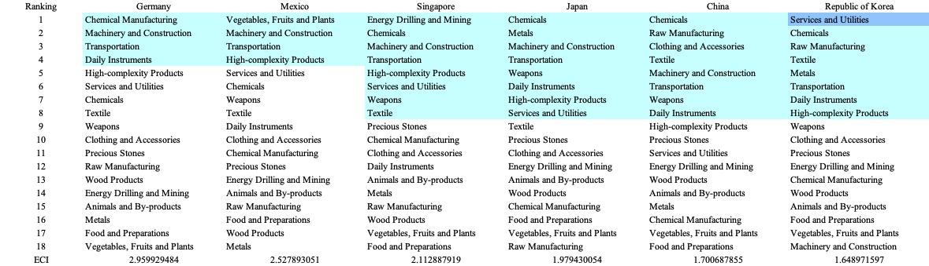
Table 5: SDV of High ECI Countries 2013(up), 2018(down)

We define the ranking of opportunity gain for a country c, as the Suggested Development Vector (SDV) of c. Table 5 shows the SDV of a selected group of leading economies with outstanding economic complexity, with the industry groups ranked in decreasing order of significance. Dark blue indicates positive opportunity gain, light blue indicates zero opportunity gains, and white indicates negative opportunity gains. The result shows that leading countries barely have any industries with positive opportunity gain. In other words, those countries are already in the most stable and efficient economic structure. Without the necessity of economic transition, those countries merely need to maintain a steady and balanced economic development. In contrast, countries listed in Table 6 have nearly half of industries with positive opportunity gain. While the economies with absolute negative ECI, such as South Africa and SIngapore, all need to develop High-complexity Products, Machinery and Construction and Daily Instruments, those with median ECI are facing a more complicated and diverse situation, such as Italy and Spain.

It can be concluded that Singapore is categorized to be a highly complex country as compared with the world’s leading economies and other major economies in Europe.

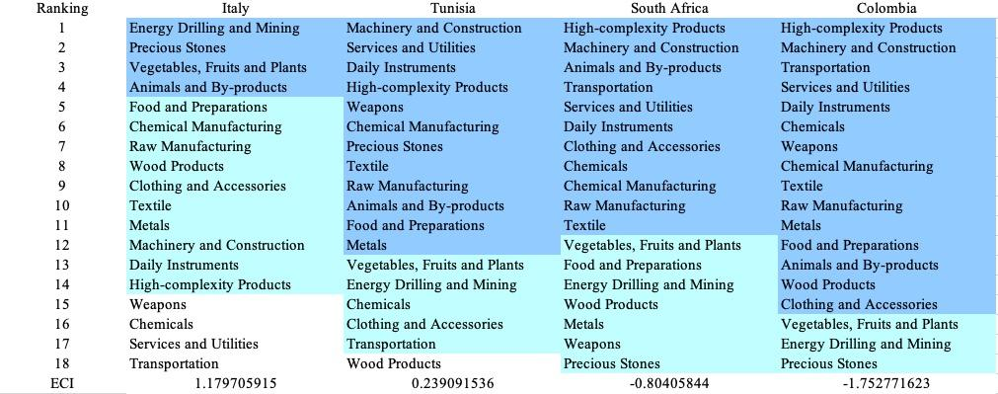

Table 6: SDV of Other Typical Countries 2013

4.2 Budgeted Industry Development Strategy and Interpretation

The optimal budgeted industry development strategy aims to solve the most efficient allocations under the budgeted constraint of different situations of heuristic total export growth. In order to obtain such an allocation portfolio, we formulate an optimization problem as the following:



where k(x) is the second largest eigenvector of $M_{CC'}$ after adding $x$ to the original export vector, C is the country that we are interested in, P is the product space, B is the heuristic budget.

If we can solve this problem, then we can know what the largest ECI that a country can improve to. Accordingly, the optimal solution $x*$ that we obtain here is exactly our optimal allocation. However, the biggest problem is that the objective function is not convex. Therefore, we cannot apply the classical tools for convex optimization on this problem. In order to solve this problem, our idea is to use greedy algorithm. The way that we apply greedy algorithm is that firstly we separate the total budget into k equal parts, and then for the first equal part we try to search for the product that can optimize our objective function by iterating through each $p∈P$. After we find the optimal product p for this equal part, we add the amount back to the export value of this product p and update the ECI for this country. If we observe that ECI does not change after iterating all the products, then we can add up one more equal part to invest. Until we find there is an ECI increment, we add the amount now to that product. The rest equal parts can be done in the same way.

However, as is known to all, greedy algorithm is a kind of local search algorithm, which is pretty possible to run into a local minimum. Therefore, for local search algorithms, one typical way is to keep it away from the local minimum is to enhance the vision of the algorithm by looking more steps forward. In our setting, whenever we obtain an increment of ECI, we mark down the required amount of export growth. Simultaneously, we continue searching for the next ECI increment point, compare the ratios of these two possibilities and pick the largest one. The ratio is defined as the following:


where ${ECI}_{p}$ is just the ECI of the country after adding some amount of export increment to product $p$, which is exactly the amount that is able to make ECI change. Also, we can express it in the way of $||$$x_{p}-x_{0}$${||}_{1}$.

In this way, we can obtain a further sighted greedy algorithm. Also, the number of parts that we would like to separate the budget into also matters. In order to solve this problem, we added a stabilizer on top of the enhanced greedy algorithm, by running the algorithm for different number of parts and selecting the portfolio with the largest ECI increment and most complex economic structure.

Besides, it is quite common that there is a surplus for the budget. To deal with the surplus, we just add it to the product which needs the least amount of dollar to make $M_{cp}$ = 1, (i.e., the smallest amount of required export increase).

Economic Panel:

As stated above, the enhanced greedy algorithm is developed mainly for solving the optimal allocation strategy. In order to visualize this allocation, an economic panel is created, consisting of a pie chart, a line chart and a table. Firstly, a pie chart is used to show the percentage of each product in the optimal portfolio. The number located in the center of the circle denotes the heuristic growth of total export, which is also our budget. For example, for the first pie chart below, it shows we should allocate 25% for food and preparations, animals and by-products, and chemicals. In addition, we should allocate 12.5% for raw manufacturing and chemical manufacturing. The lines below the pie charts show how the ECI changes during the searching process of the greedy algorithm. For example, in the last pie chart, we can see there are three components, but there are four increments in the last line chart. That is just because many equalized amounts have been invested in high-complexity products. Even though sometimes people may feel 15% and 20% is nonsense to developed countries, yet it can also give a sense of how a country should develop in the long term. Eventually, the graph in the end is just for numerical explanation for the pie charts.

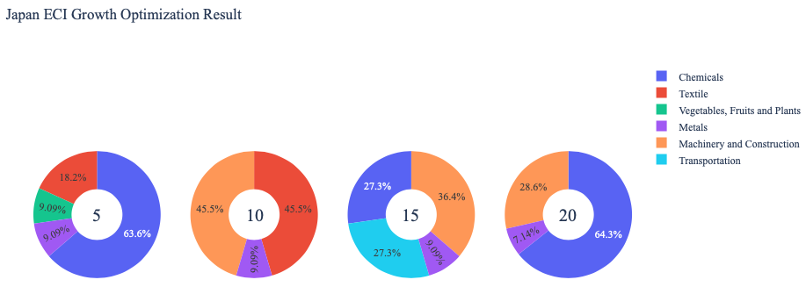
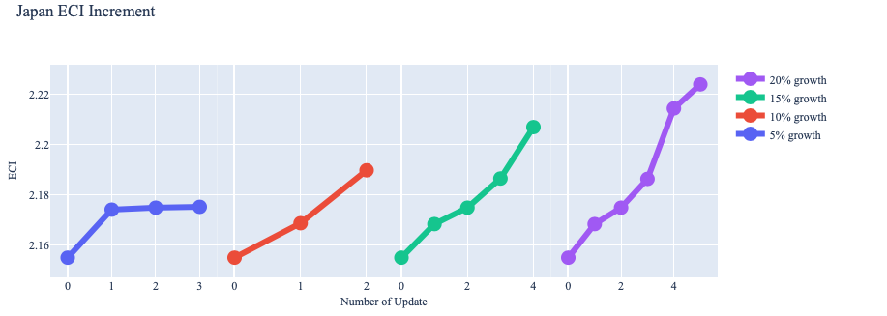
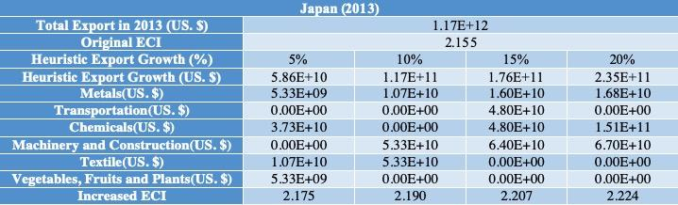

Interpretation:

Below is the economic panel for Singapore in 2013. We can see that for different percentages of heuristic total export growth, the ECI of Poland has relatively similar performance. From all the four line graphs, we see that Singapore obtains some great increment in terms of ECI. However, increasing the budget for too large an amount would not produce a higher and higher ECI. Also the optimal ECI that we can achieve is the same for each case. This means that in long terms, Singapore does not have a lot of room to improve. For the four export growth budget, the increment of ECI depends on chemicals, machinery and construction.

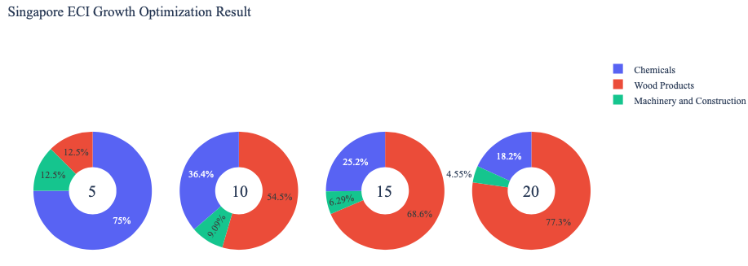

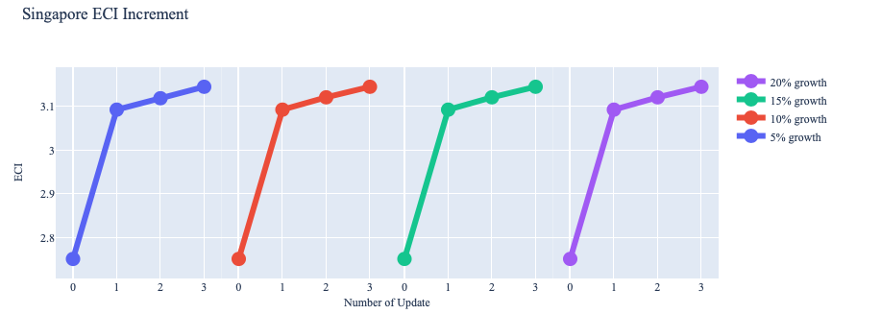
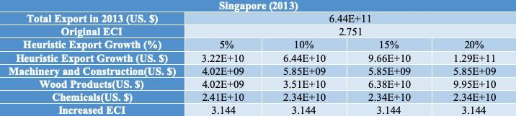

For further suggestions on Singapore’s development in the future. We also offer the optimization result of Singapore based on export data in 2018. Below is the economic panel for Singapore in 2018. We can see that for different percentages of heuristic total export growth, the ECI growth pattern of Singapore is similar to the one in 2013. From all the four line graphs, it still reaches the same optimal ECI eventually. This means that Singapore does not have a lot of room to improve, especially for the case of 5% growth, where the increment of ECI can barely be observed. However, our optimization method shows Singapore still can have gains by investing in machinery and construction, services industry and high complexity products. Therefore, for future strategy, Singapore should prioritize development of these three products in order to optimize the ECI.

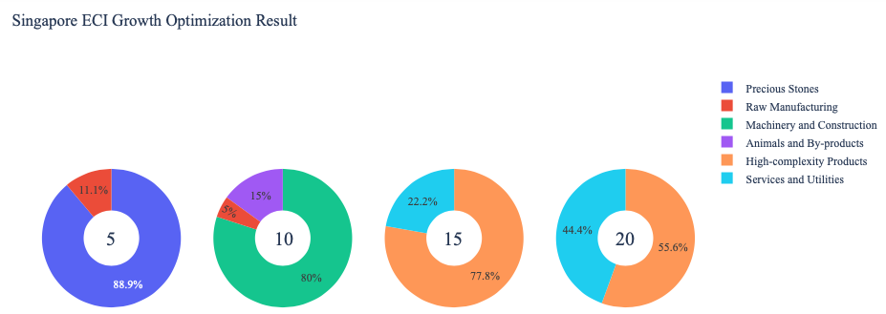

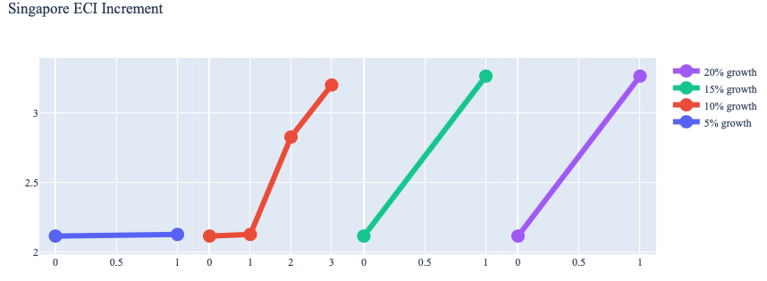

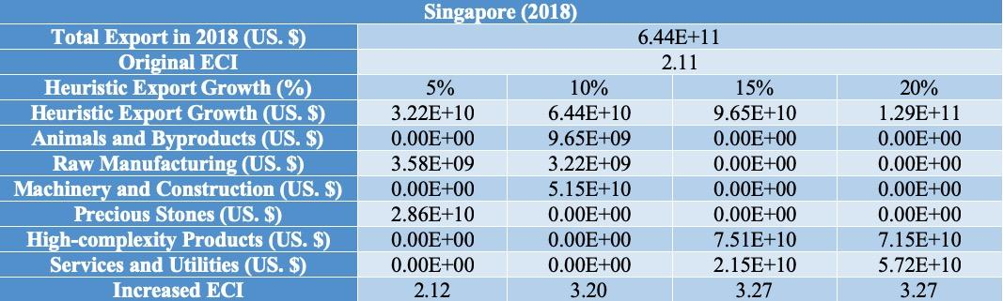

4.3 Sensitivity Analysis
In the following section our broad aim is to understand how sensitive Singapore is to changes in export in various industries. While the Economic Complexity Index has been shown to contain valuable information about the economic strength/capacity of a country, little has been said as to the stability of the measure itself. We seek to uncover the main drivers of stability under a country's ECI score and better understand longer-term projections for ECI growth. Additionally, gaining an intuition on the industries that are bolstering an economy and the industries that offer the greatest return per unit of investment is best done through visualization of industry specific sensitivity. To this end, we have developed two categories of sensitivity analysis.
ECI Sensitivity Graph
Firstly, in order to assess the effect particular industries have on each respective country, we developed ECI Sensitivity graphs. We use shocking methodology to increment or decrement an industry’s export level by a certain percentage and recalculate the ECI all else being equal. While freezing the export dynamics of the rest of the world and enacting an instantaneous shock in export for a particular industry and country may not reflect real-life dynamics, what it does offer us is an understanding of a country’s level of dependency on an industry in the context of ECI. The shocking is done in small percentage increments in order to smooth out the resulting curve. Additionally, a recurring theme one will see is that for most industries, a breaking point occurs where the ECI either jumps upwards or downwards, creating a hockey stick shape rather than a linear trend. While the inflection point may not be accurate in context of real life, comparing the various inflection points across industries can give us valuable insight.
The graphs are formulated as follows: There are four ECI Sensitivity graphs. The first two represent data from 2018. The first chart shows positive shocking in which export numbers are shocked upwards per industry. The X-axis is in terms of percentage shock per current dollar value of export. The Y-axis is the recalculated ECI level post-shocking. The second chart follows the same format except the X-axis represents negative shocking. In other words, exports for each industry are decremented and the ECI is accordingly recomputed. The final two sensitivity graphs show the same results using 2013 data. Below is an example of an ECI sensitivity graph.

Example 2018 (Incremental ECI Sensitivity)

SDV sensitivity
Secondly, we analyze the sensitivity of the SDV to changes in export levels. The goal is to understand how export level changes for a particular industry can affect the marginal opportunity gain for other industries. We will be using specifically High Complexity Products and Food and Preparations as our base industries. We will be increasing or decreasing the absolute export level in both of these industries and observing the effects on the SDV.
When the opportunity gain of an industry is negative, the SDV sensitivity approximates how an over-development of the industry jeopardizes the economic structure of a country. When the opportunity gain of the industry is zero, the SDV sensitivity determines whether the further development of the industry shapes the country with a better economic structure and predicts how the SDV would change accordingly. Specifically, as we reduce the export of such an industry to 25%-50% of its original value, a few other industries originally with negative opportunity gain could likely become profitable.
Similar to the ECI sensitivity graphs above, we will be shocking export of High Complexity Products and Food and Preparations in small percentage increments. A new SDV, represented by a new column in the charts, is recorded only when a certain level of shock changes the structure of the SDV. In effect we are incrementing or decrementing export levels of two industries until the marginal opportunity gain of any industry changes in category (positive, negative, or neutral). Below is an example of a SDV Sensitivity chart with Positive Shocking. Industries with positive marginal opportunity gain are colored blue, neutral is colored white and negative is colored red.
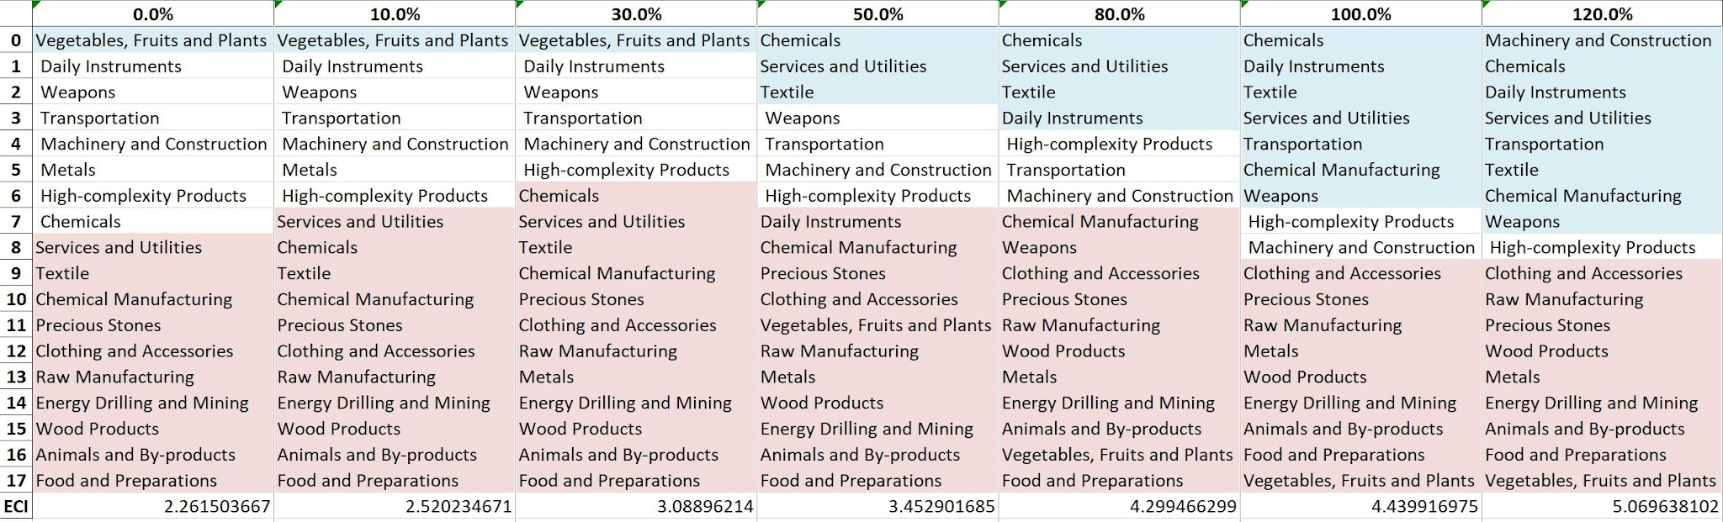
Example High-complexity Products 2018 (Incremental SDV Sensitivity)

4.3 Sensitivity Analysis Results and Interpretation

Below is Singapore’s 2018 ECI Sensitivity Charts. Firstly in the positive chart, we notice immediately that an increase in exports of High Complexity Products, Transportation and Machinery give significant increases in ECI with fairly small increases in absolute export value. Quite a few other industries also have the potential to increase ECI however the majority of them require over 100% increase in export value to experience the gains in ECI.

Next we consider Singapore’s 2018 Negative Shock chart. We can see that Singapore is highly sensitive to High Complexity Products, Transportation and Machinery. This is expected from a well-diversified, developed country. Additionally, decreases in export of Energy & Drilling, Services and Utilities and Chemicals seem to increase the overall ECI score.

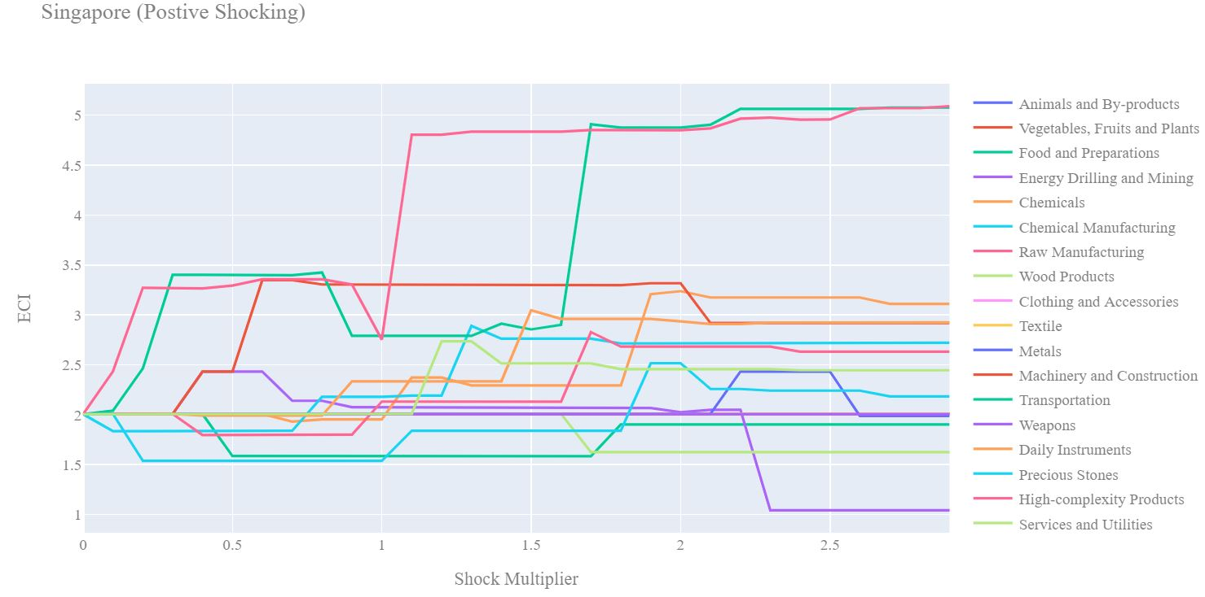
Singapore 2018 (Incremental ECI Sensitivity)

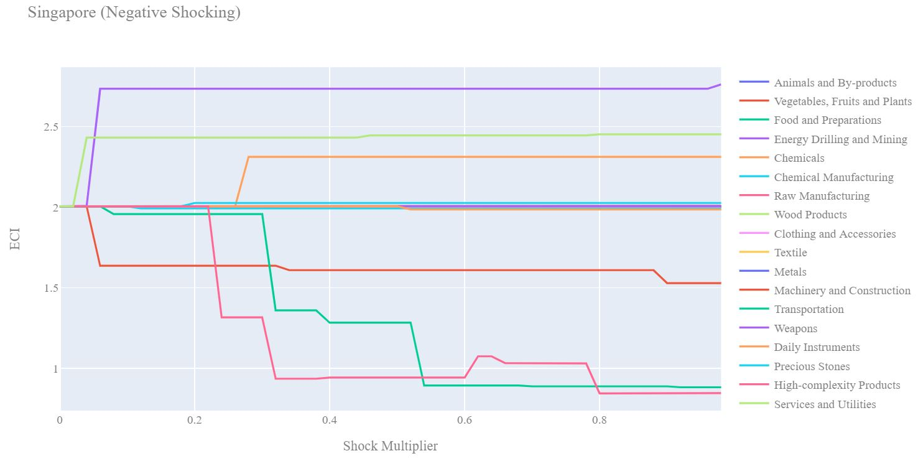
Singapore 2018 (Decremental ECI Sensitivity)

Next we consider the 2013 ECI Sensitivity graphs. We see that in the positive shocking case most industries giver either no benefit or cause drawdowns in the ECI. However increased export of High Complexity Products can lead to higher ECI but over 250% increase in export is required.

In the 2013 negative shocking case, we see that again Singapore is marginally less sensitive to downturns than in the 2018 sensitivity profile. This suggests that Singapore has become more sensitive to export downturns in High Complexity Products and Transportation in the recent past as their economy begins to rely more heavily on these industries to bolster their ECI score.

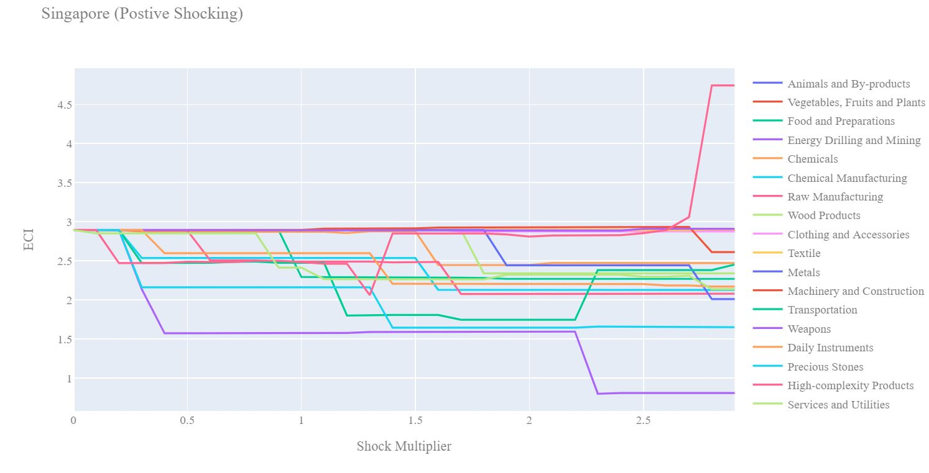
Singapore 2013 (Incremental ECI Sensitivity)

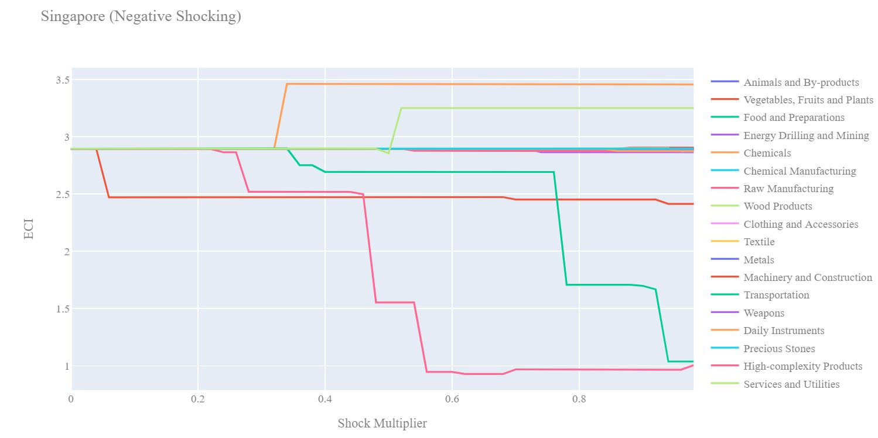
Singapore 2013 (Decremental ECI Sensitivity)

Below we see the SDV sensitivity charts for High Complexity Products. We see that fairly small decreases in export of High Complexity Products makes room for other industries to shift from the negative opportunity gain to neutral opportunity gain territory. No industries become immediately attractive after a drawdown of High Complexity Products.

Considering the positive SDV sensitivity chart we observe that as exports of High Complexity products increases industries that were not worth investing begin to shift to the positive opportunity gain region. Intuitively as High Complexity Products become a stronger industry for Singapore, other industries start to become viable industries to pursue.

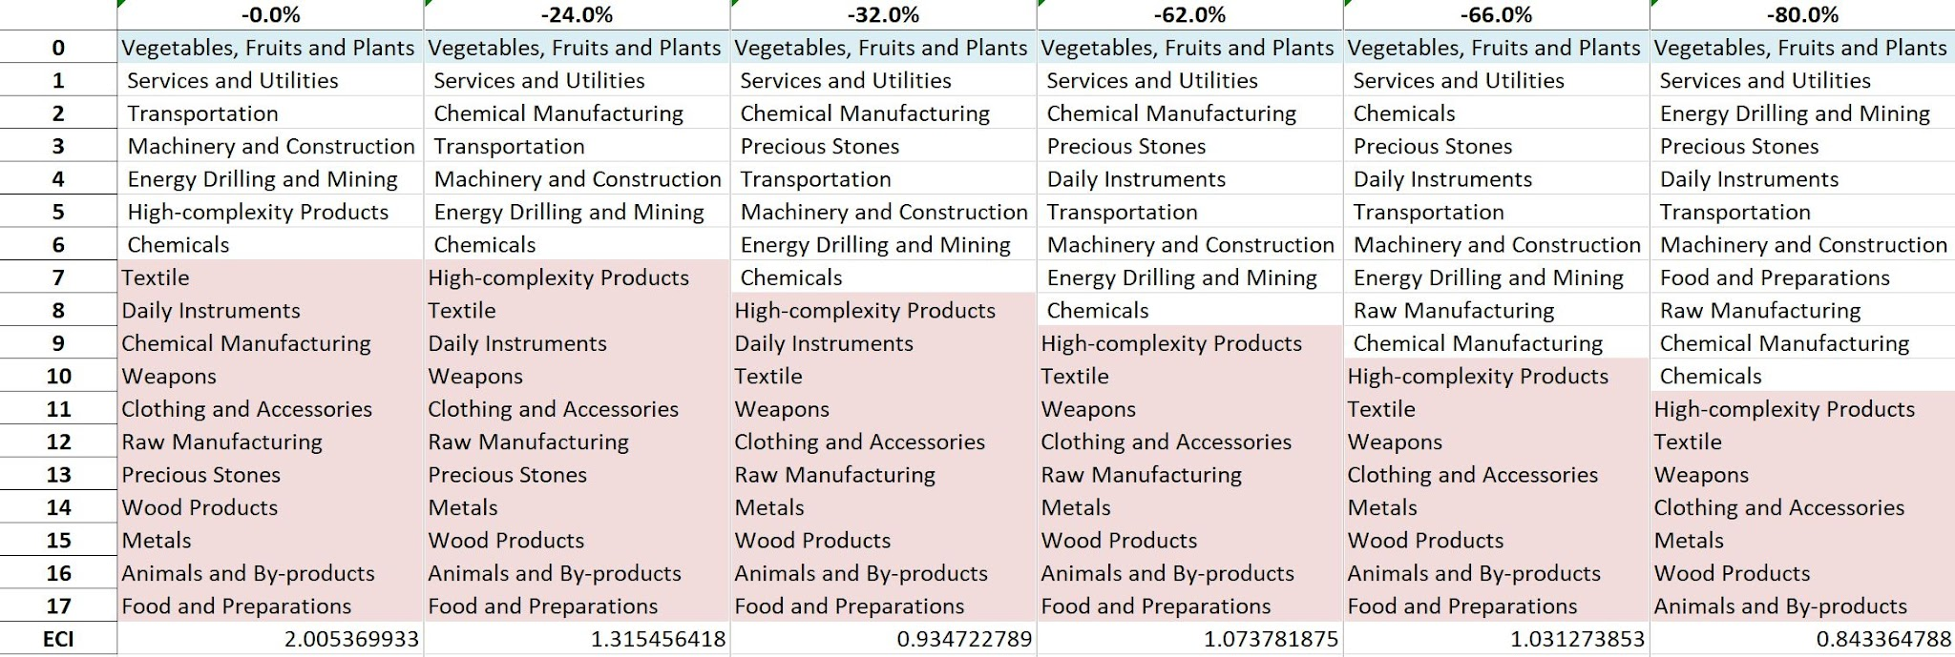
Singapore High-complexity Products 2018 (Decremental SDV Sensitivity)

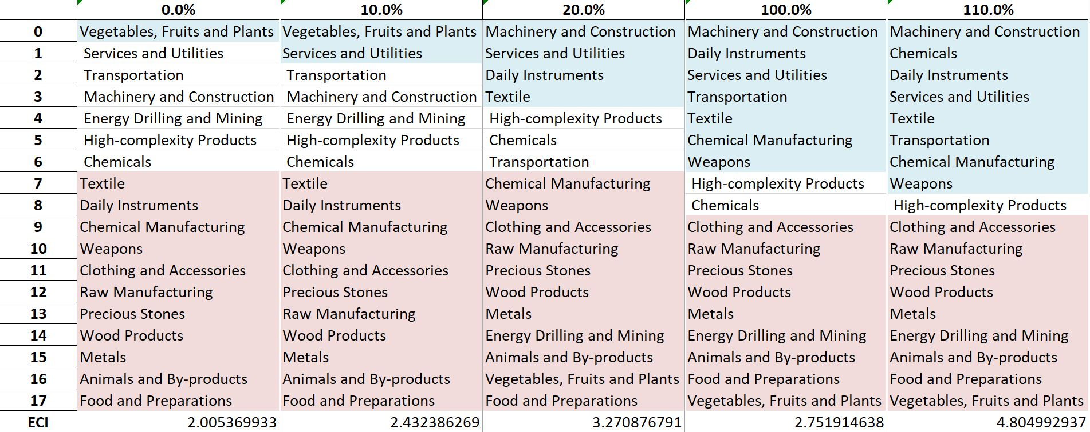
Singapore High-complexity Products 2018 (Incremental SDV Sensitivity)

Below we see the SDV sensitivity charts for Food and Preparations. As expected for a developed country, Singapore is not very sensitive in both the positive shocking and negative shocking case to Food and Preparations. The country's SDV is largely unaffected by this particular industry.

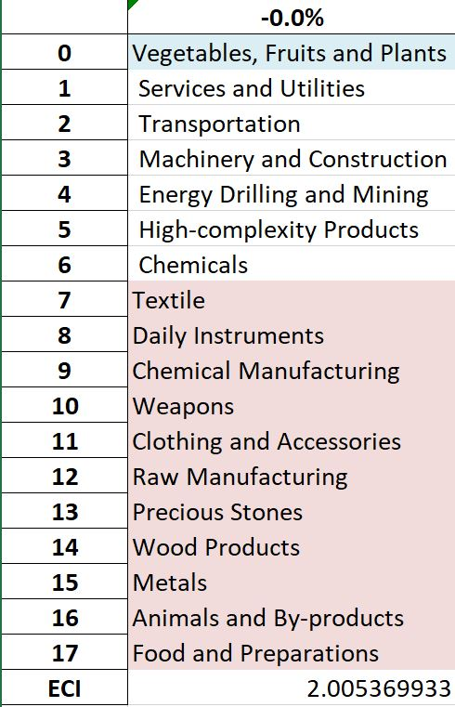
Singapore Food and Preparations 2018 (Decremental SDV Sensitivity)

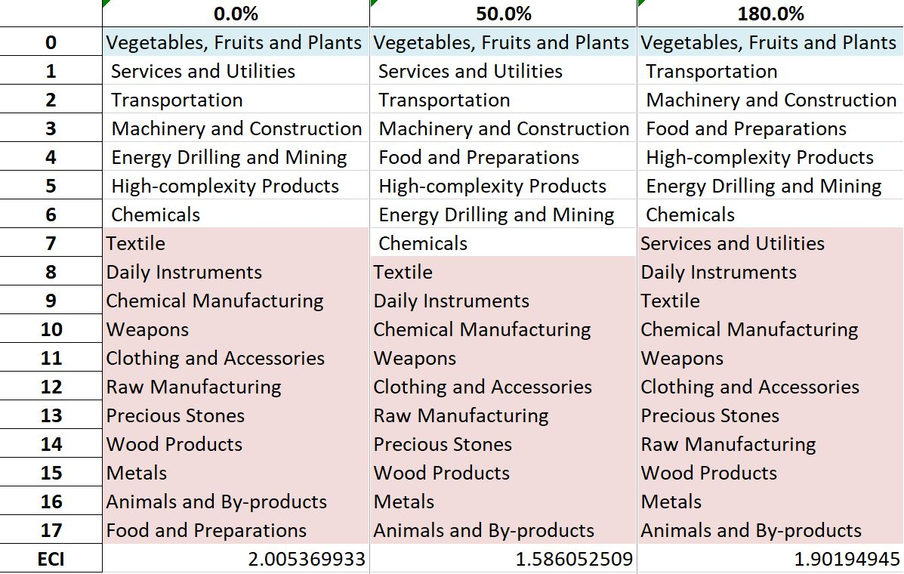
Singapore Food and Preparations 2018 (Incremental SDV Sensitivity)

4.4 Contingency Strategy
Decreasing export of each industry in [Country]’s current production space by 60% respectively, we derive the contingency strategy shown below.

Product Names | 0 | 1 | 2
Animal and By-products | [Product Group *] | [Product Group *] | [Product Group *]
Vegetables, Fruits and Plants | [Product Group *] | [Product Group *] | [Product Group *]
Food and Preparations | [Product Group *] | [Product Group *] | [Product Group *]
Energy Drilling and Mining | [Product Group *] | [Product Group *] | [Product Group *]
Chemicals | [Product Group *] | [Product Group *] | [Product Group *]
Chemical Manufacturing | [Product Group *] | [Product Group *] | [Product Group *]
Raw Manufacturing | [Product Group *] | [Product Group *] | [Product Group *]
Wood Products | [Product Group *] | [Product Group *] | [Product Group *]
Clothing and Accessories | [Product Group *] | [Product Group *] | [Product Group *]
Textile | [Product Group *] | [Product Group *] | [Product Group *]
Metals | [Product Group *] | [Product Group *] | [Product Group *]
Machinery and Construction | [Product Group *] | [Product Group *] | [Product Group *]
Transportation | [Product Group *] | [Product Group *] | [Product Group *]
Weapons | [Product Group *] | [Product Group *] | [Product Group *]
Daily Instruments | [Product Group *] | [Product Group *] | [Product Group *]
Precious Stones | [Product Group *] | [Product Group *] | [Product Group *]
High-complexity Products | [Product Group *] | [Product Group *] | [Product Group *]
Services and Utilities | [Product Group *] | [Product Group *] | [Product Group *]
Table 13. [Country]’s Contingency Strategy (2018)

5. Macro-level Predictions

5.1 Structural Optimality Index
Indeed, such choice of prioritization has proven to be a significant factor in deciding the economic outcomes of countries. In order to quantitatively evaluate how effective our development strategies are and how deviations from the suggested developmental path will lead to suboptimal growth results, we define the measure – Structural Optimality Index (SOI) – on a country level as the Adjusted R-Square obtained from regressing the country’s realized industry development over the suggested development strategy. Both strategies are quantified in nature, with the realized development represented by export increase in every major industry group and the suggested development strategy represented by the opportunity gains of developing the corresponding industry groups as calculated in previous sections. The adjusted R-square from the regression thus provides us with a quantified measure of how the development path adopted by the country has fitted with/differed from calculations on a complexity level.

After obtaining this measure for all countries in our database, we further regress countries’ five-year economic growth, which is defined as the percent increase in GDP (USD), over their SOI. Figure 6 illustrates the regression output, which shows a strong positive correlation between countries’ SOI and their five-year GDP growth, significant at the 1% level and achieving an adjusted R² of 4.5%. In other words, the more a country develops as suggested by calculations on a complexity level, the better economic outcomes it achieves.

Table 18: OLS Regression Results
Dep. Variable: GDP | F-Statistic: 5.963
R²: 0.054 | Prob (F-Stat): 0.0163
Adj R²: 0.045 | No. Observations: 106

Figure 2: Regression of Five-year GDP Growth over SOI

5.2 SOI of Singapore and Its Implications
Singapore, for instance, has a relatively low level of structural optimality as compared with its peers. As the regression in Figure 7 suggests (the orange curve represents export increase and the blue curve stands for opportunity gain of the corresponding industry), Singapore demonstrates a low level of correlation with the suggested developmental path, having an adjusted R-square of around -5.1% and a 5-year growth rate of 28.2%. Here the SOI underestimates the expected growth of the country. This is in direct contrast to emerging economies such as Turkey, where there is a high SOI of around 21.8% and a corresponding 5-year GDP growth of 36.7%, making it one of the fastest developing economies during the period. In sum, Singapore’s stagnant economic progress from 2013 to 2018 can be at least partially explained by a mismatched development strategy that demonstrates a considerable level of deviations from our suggested developmental path. In specific, Singapore invested heavily in the Transportation industry, while it should have focused more on industry groups such as Machinery and Construction.
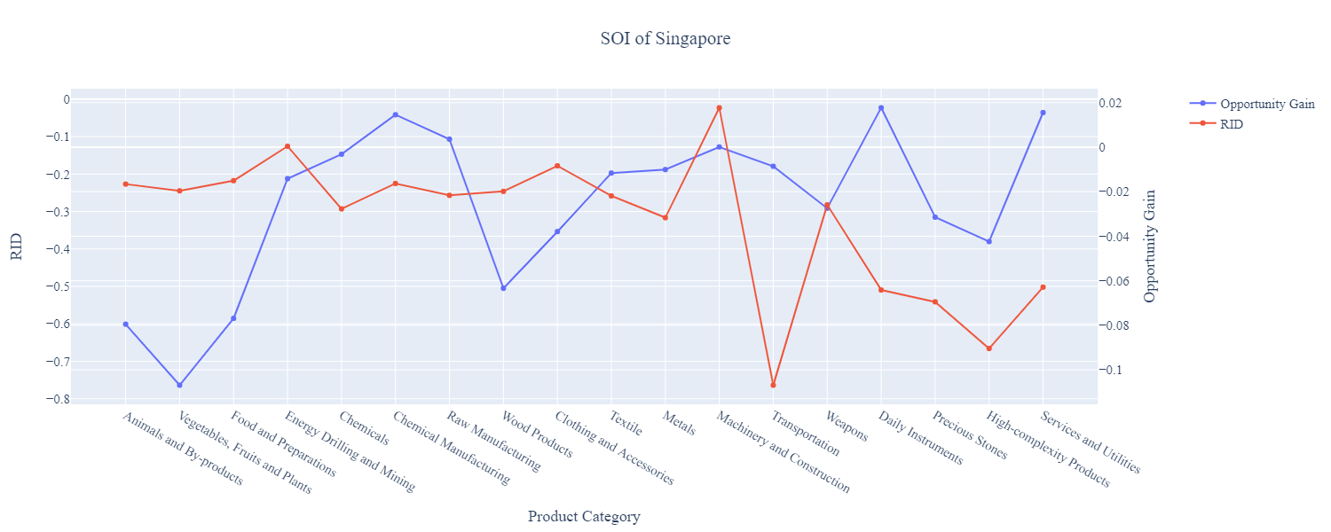
Figure 7: SOI of Singapore (2009-2014)

6. Concluding Remarks

In conclusion, Singapore has demonstrated a low level of economic growth in terms of GDP during the period from 2013 to 2018, concurrent with a stagnation in economic complexity as compared with other major Asian economies.

The level of economic progress during the period, we believe, can be partially explained through analysis of the economic and product complexity structure of Singapore on the industry group level. The product classification system we adopt allows us to measure the realized industry development for various industry groups and to observe that Singapore invested heavily in developing Transportation, High-complexity Products during the period.

Based on our analysis of the opportunity gain and a sensitivity analysis of major industry groups, Singapore can further its gains by prioritizing Chemicals, Machinery and Construction. We further note that Singapore has a slightly mismatched development strategy that indicates a moderate level of structural optimality on the complexity level, having an adjusted R-square of around -5.1%. Since a significant positive correlation exists between five-year GDP growth and the structural optimality index of an economy as we define and calculate, Singapore indeed has a suboptimal growth experience as compared with fast-growing economies both on a regional scale and on a global scale, and has the potential to further its economic gains through industrial structure optimization as suggested in the paper.

References

Hausmann, R., Hidalgo, C., Bustos, S., Coscia, M., Chung, S., Jimenez, J., Simoes, A. and Yıldırım, M. (2007). The Atlas of Economic Complexity. [online] Atlas.cid.harvard.edu. Available at: http://atlas.cid.harvard.edu/.

Balassa, B., “The Purchasing Power Parity Doctrine - A Reapprais- al,” Journal of Political Economy 72, 584-596 (1964).

Feenstra, R.; Lipsey, R.; Deng, H.; Ma, A. & Mo, H. “World Trade Flows: 1962-2000” NBER working paper 11040. National Bureau of Economic Research, Cambridge MA (2005).

United Nations Commodity Trade Statistics Database (http://comtrade.un.org/db/), accessed in August 2019.

The World Economic Forum, “The global competitiveness report,” (various years).

Barro, R. & Lee, J-W. “A New Data Set of Educational Attainment in the World, 1950-2010,” NBER Working Paper No. 1590 (2010).

Kaufmann, D. & Kraay, A. “Governance Indicators: Where Are We, Where Should We Be Going?” Policy Research Working Paper 4370. Washington, DC: World Bank (2008).

Hanushek, E.A. & Woessmann, L. “The Role of Cognitive Skills in Economic Development,” Journal of Economic Literature 46(3), 607- 668 (2008).

