
https://atlas.cid.harvard.edu/

Overview
─
The Economic Complexity Lab - Columbia University

Ajit Akole, Alex Wei-Liang Ku, Sannidhya Modi, Nouhaila Elmajidi, Alexandra Garcia

Contents

- Contents Overview 2

- Economic Complexity Index Framework 3

- Economic Complexity…………………………………………….3
- Production Matrix…………………………………………………4
- Diversity and Ubiquity…………………………………………….5
- Economic Complexity Index and Product Complexity Index…….6
- Proximity and Distance……………………………………………6
- Opportunity Gain………………………………………………….7

- Production Analysis 7

- Product Categorization…………………………………………….7
- Realized Industry Development………………………..………….9
- Regional and Global Comparison..………………………………10

- Product Space Design 11

- Suggested Development Vector………………………………….11
- Budgeted Industry Development Strategy …..…………………..11
- Sensitivity Analysis………………………………………………13
- Contingency Plan ……………………………………………… 17

- Macro-level Predictions 19

- Structural Optimality Index (SOI) ………………………………19
- SOI Examples and Implications………………………………….20

- Concluding Remarks 22

- References 23

An Overview of Complexity-based

Economic Report and Production Analysis

1. Contents Overview

Centuries of scientific exploration and technological progress have led the world into the era of globalization. With international trade and communication at their highest, diversification dominates production patterns on a global scale. National specialization begets diversity at a global level. For geopolitical and historical reasons, countries face different economic obstacles for which they have developed their own strategic solutions through trials. To ensure the economic wellbeing of their country, governments require a reliable metric to assess their strategy so that they can make proper adjustments promptly. This report aims to foreground such a metric by tracing countries’ economic paths and accordingly putting forward macro-level strategies and contingency plans.

We examine the period of 2013 to 2018 from the perspective of Gross Domestic Production per Capita and product space. GDP per Capita, a monetary measure of the market value of all final goods and services produced divided by population, reflects countries’ production capability, but fails to take into account the structure of the product space. The product space is the set of industries a country has productive knowledge on, weighted by the relative abundance of such knowledge. Equivalently, we can define the product space as the set of products a country is capable of producing, such that it can determine the potential and sustainability of an economy. The structure of the product space indicates the amount, quality and “shape” of productive knowledge amassed by countries. Concretely, we can observe the prolonged challenges of Arab oil-exporting countries due to their heavy dependence on oil production and relative lack of other productive knowledge, which has shown to induce unemployment, vulnerability to oil prices changes, unsustainability of economic growth, and difficulty of shifting to high-end industries.

As in the case of oil-exporting countries, others have each accumulated specific production knowledge and industrial infrastructure. Consequently, the underlying cost of developing an industry, as well as the profitability of investing in an unfamiliar product, can vary extensively across countries. If a country does not have a robust machinery manufacturing industry as support, it has to invest enormously to excel at developing high complexity products. We maintain that the productive knowledge embedded in an industry has the potential to enable a country’s expansion into a wide variety of higher-complexity products and thus carries a significance far greater than the monetary benefits added to GDP per Capita.

Therefore, we implement the Economic Complexity Index framework established in The Atlas of Economic Complexity Index Mapping Paths to Prosperity to evaluate the structure of product space and industries for countries. These are calculated as Economic Complexity Index (ECI) and Product Complexity Index (PCI), respectively. Their specific mathematical definition and derivation will be covered in Section 2.

Subsequent sections discuss how we construct the ECI framework from which we derive an optimal industry development strategy and prove its relaxed optimality by contrasting it with the real-world industry development strategy. We put forward the optimal budgeted industry development strategy for less developed countries to optimize the expansion process of their product space. Furthermore, we conduct sensitivity analysis to prepare developed and fast developing countries for upheavals in their product space, such as a potential collapse of their cornerstone industries.

The path of economic development is rife with uncertainty and misleading signals. All strategies and descriptions derived in national reports are not one hundred percent precise or determined; thus, the report includes key hindrances that may engender such bias. Notwithstanding, the aim is for our report to provide valuable reference as to the effectiveness of economic development from a structural perspective.

2. Economic Complexity Index Framework

2.1.1 Economic Complexity
The production of goods can be decomposed into a bundle of productive knowledge pieces. For instance, the production of a book requires papers and ink, etc. To further break it down, the production of paper relies on the agricultural knowledge of planting trees, machinery knowledge of building printers, and a wide range of expertise, such as papermaking. We can treat a product as a composition of relative productive knowledge, just as a manufactured combination of raw materials. The total quantity and range of productive knowledge determines the product space and productivity of a country. The complexity of an economy is, therefore, related to the multiplicity of productive knowledge amassed. To be more specific, Economic Complexity is a measure of the capability for an economy to structure and utilize the productive knowledge it has acquired.

2.1.2 Explicit and Tacit Knowledge
Productive knowledge can be classified into two categories based on the difficulty of transferring such knowledge. Explicit knowledge is the knowledge that can be transferred easily by reading and listening, while tacit knowledge requires systematic teaching and learning process. For instance, weather forecasting and bus schedules are typical explicit knowledge. In contrast, semiconductor manufacturing and shell oil drilling are examples of tacit knowledge. A lack of tacit knowledge is the source of hindrance that an economy faces in its development and growth. Embedding tacit knowledge is a long and costly process, so people are trained for specific tasks and organizations are geared towards specific goals.

2.1.3 Capability
We define capability as modularized chunks of knowledge that are fully necessary for someone to perform certain functions. Nowadays, the society coins more capability modules and further breaks down existing modules into branches to follow the rapid technological development. As an analogy, to respond to the increasing knowledge and complexity of jobs, the university system doesn’t lengthen the time it takes to get a college degree. Instead, the universities are splitting majors into more specific branches. For instance, breaking the natural philosophy into physics, chemistry, mathematics, etc. Moreover, the university is adding new subjects, such as financial engineering.

2.1.4 Personbyte
Most products, nevertheless, require more knowledge than that can be mastered by any individual. Therefore, those products require that individuals with different capabilities interact. A product that requires 100 different personbytes cannot be made by a micro-entrepreneur working on her own. Instead, it has to be made collectively either by an organization with at least 100 individuals or by a network of organizations that can aggregate these 100 personbytes of knowledge. A deep division of labor enables individuals to become experts in small pieces of the available knowledge. Then, the labor forces aggregate their personbytes into peoplebytes through cooperation across organizations.

2.1.5 Economic Complexity Index
As aforementioned, the Economic Complexity Index is a standardized measure of the capacity of a country to hold and combine knowledge. Economic Complexity Index (ECI) can account for a significant fraction of the cross-country variation in income per capita and economic growth, and that the ECI is a much stronger predictor of growth than other
commonly used indicators that measure human capital, governance or competitiveness.

2.2 Production Matrix: M_{cp}
With no authoritative and universal data source regarding production by industries, we estimate the production by volume of export provided by UN COMTRADE. This rough approximation is a major source of discrepancy. Export is affected by political, geographical and all kinds of factors, hence cannot precisely represent the production. In the scope of the report, the production and export are the same measurement. For those readers who indeed have access to the production data, replacing the export by production dataset should enhance the performance of the metric to a great extent.

Instead of absolute advantage in production, we are more interested in the comparative advantage when we discuss how dominant a country is with respect to a product. Due to the size and population, China is likely to have a larger volume of export in almost every product compared to Cambodia. However, in practice, Cambodia is always comparatively dominant in some products of which the national production divided by the sum of national production of all products are higher than China. Similarly, we use comparative measure to offset the fact that some products are always produced in a larger quantity across countries.

Balassa defines Revealed Comparative Advantage (RCA) as “a country has Revealed Comparative Advantage in a product if it exports more than its “fair” share, that is, a share that is equal to the share of total world trade that the product represents.”
Formally, given the volume of production for a pair of country c and product p, we define RCA_{cp} as

${RCA}_{cp}=\frac{X_{cp}}{\sum_{c}{}X_{cp}}/\frac{\sum_{p}{}X_{cp}}{\sum_{c,p}{}X_{cp}}$

Accordingly, we define the matrix of comparative advantage in production for countries and products. “1” indicates the advantage, while “0” indicates the opposite.

$M_{cp}=\{ 1 { RCA}_{cp}≥1 0 Otherwise$

2.3 Diversity and Ubiquity
We definitely can use a sword to peel an apple, since the sword is sharp, portable and qualified in all extents for peeling an apple. Analogically, a sword has all the ‘productive knowledge’ required to peel an apple. In contrast, your laptop or Calculus textbook may not be good choices.
In contrast, as long as we have access to handy peelers and knives, we are less likely to use the sword, because peeling an apple doesn’t seem to be a difficult task and we have tons of options. However, if we live in a world with only a sword, laptop, Calculus textbook, and apples, then sword suddenly becomes the most “elegant” apple peeler. Whether a sword is good at peeling apples also depends on the amount and competitiveness of other candidates.

Analogically, when we want to determine how dominant a country is in making a certain product, we have to consider the variety of productive knowledge the country holds, and the difficulty of making the product defined by the productive knowledge required in production.
Diversity and Ubiquity are respectively such crude estimators that are formally defined below:

$Diversity=k_{c,0}=\sum_{p}{}M_{cp}$ (1)
$Ubiquity=k_{p,0}=\sum_{c}{}M_{cp}$ (2)

As shown in the apple peeler analogy, the Diversity and Ubiquity are a pair of complements and can be used to iteratively correct each other. For a country with high Diversity, we go through the Ubiquity of all products the country makes to determine whether the high Diversity attributes to exceptional productivity or a mass production of low-end products. For a product with high Ubiquity, we examine the Diversity of all its production sources to determine whether the high Ubiquity indicates the product to be high-end or just less demanded. In a few iterations, the effectiveness of correction converges to zero and the cross-correction process terminates.

$k_{c,N}={\frac{1}{k_{c,0}}\sum_{p}{}M_{cp} k}_{p,N-1}$ (3)
$k_{p,N}={\frac{1}{k_{p,0}}\sum_{c}{}M_{cp} k}_{c,N-1}$ (4)

Plug the value of $k_{p,N}$ into the equation of $k_{c,N}$, we derive

$k_{c,N}=\frac{1}{k_{c,0}}\sum_{p}{}M_{cp}{\frac{1}{k_{p,0}}\sum_{c'}{}M_{c'p} k}_{c',N-2}$ (5)
$k_{c,N}=\sum_{c'}{}k_{c^{'},N-2}\sum{}\frac{{M_{cp}M}_{c'p}}{k_{c,0}k_{p,0}}$ (6)

Or for simplicity,

$k_{c,N}=\sum_{c'}{}M_{cc'}k_{c^{'},N-2}$ (7)

where $M_{cc'}=\sum_{p}{}\frac{{M_{cp}M}_{c'p}}{k_{c,0}k_{p,0}}$ (8)

2.4 Economic Complexity Index and Product Complexity Index
The largest eigenvector of M_{cc’} is a vector of ones, which satisfies equation (7)
By definition, the second largest eigenvector $\vec{K}$ best preserves information on variance of the system. Hence, we define the Economic Complexity Index ( ECI) as:

$ECI=\frac{\vec{K}-<\vec{K}>}{stdev(\vec{K})}$ (9)

where < > stands for numeric mean, and stdev stands for the standard deviation.

By the same token, we plug $k_{c,N}$ into the equation of $k_{p,N}$ , calculate the second largest eigenvector $\vec{Q}$ of M_{pp’,} and define Product Complexity Index ( PCI) as

$PCI=\frac{\vec{Q}-<\vec{Q}>}{stdev(\vec{Q})}$ (10)

Where < > stands for numeric mean, and stdev stands for the standard deviation.

2.5 Proximity and Distance
As aforementioned, an economy always faces multiple paths in the journey of its development, or equivalently, expansion of product space. While a certain sequence is efficient and reasonable for some countries, it may not be the case for others. Certain products are close substitute. They share high proximity in a sense that possessing the productive knowledge embedded in their production makes it easier to produce the others. We then define connectedness of z product as the numeric average of proximity of it to all other products. After calculation, high-end products clearly exhibit high connectedness, while rudimental products tend to be far away from other products. The intuition is to use the joint probability of co-producing two products as the estimator of proximity. However, this doesn’t work out well. Instead, we use the minimum between the conditional probability of exporting product p given the country is currently exporting product p’ and that of exporting p’ given the country is exporting p, as our measure. We choose the minimum of each pair of conditional probability to minimize the false positive rate.

$∅_{pp'}=\frac{\sum_{c}{}{M_{cp}M}_{cp'}}{{max(k}_{p,0,}k_{p',0)}}$ (11)

The difficulty for a country to produce a product outside its product space is simply the connectedness of the product to all products currently in the product space. We normalize this measure and formally define Distance as follows.

$d_{cp}=\frac{\sum_{p'}{}{(1-M}_{cp'})∅_{pp'}}{\sum_{p'}{}∅_{pp'}}$ (12)

2.6 Opportunity Gain
We are still in need of an estimator of profitability. Again, the profit of exploring a new product is not limited to the increase of GDP, or any figures on fiscal report. It’s more about the decrement of Distance to all other products far away from the product space. Such products should not be weighted uniformly. The more complex a product is, the higher value it should be assigned with. We first calculate the total unexploited value for a country c, before and after the advance of a new product. The difference should be the “revenue” for the country c to develop product p. The “cost” is just a measurement of the difficulty of developing the product. The Opportunity Gain is simply the “revenue” net of “cost”. There is a trade-off between the increment of Total Unexploited Value and the difficulty of developing the product. While the advance of a new product draws all products closer to the product space, the low complexity and huge distance of the product also incur a cost. If the product is an extreme outlier far from the product space, and is loosely connected to other products, the Opportunity Gain can even go negative.

$Total Unexploited Value=\sum_{p'}{}{(1-d}_{cp'}){(1-M}_{cp'}){PCI}_{p'}$ (13)
${Opportunity Gain}_{cp}=\sum_{p'}{}{\frac{∅_{pp'}}{\sum_{p''}{}∅_{p''p'}} (1-M}_{cp'}){PCI}_{p'}-$ ${(1-d}_{cp}) {PCI}_{p}$ (14)

The concept of Opportunity Gain, as well as ECI, is the foundation of the metrics we introduce in the report. It’s important for us to understand that Opportunity Gain is only a conceptual estimate of the net gain of developing a product. It’s not measured in dollars or any real-world units. It is expressed in terms of productive knowledge, and is too conceptual to be implemented in strategy-making process directly. That’s why we further elaborate on the Opportunity Gain to calculate the marginal Opportunity Gain later in Section 4.

3. Production Analysis

3.1 Product Categorization
Our main data source in this research is the UN Comtrade Website (https://comtrade.un.org), which provides us with valuable information on countries’ export data on an annual basis, including highly specific export data for more than 5000 categories of products. In order to have a holistic vision of the product space of a country, however, a level of categorization is required. Product groups in UN Comtrade are labelled from 010000-999999, with the first two-digits representing a general category to which the product belongs. Based on the 99 categories as extracted from the label, we further group the products into 18 major and widely-accepted industry categories, as summarized in Table 1.

Note that the high-complexity industry group is not a distinct industry but rather an aggregated industry that encompasses the most complicated products from the most technologically-advanced industries (as measured by PCI). This industry serves as an indicator for us to quantitatively evaluate how well a country has performed in developing cutting-edge technologies and closing its technical gap with advanced economies, which has become a topic of wide concern today. Indeed, when we rank the 18 categories based on PfCI (i.e., Product Family Complexity Index, an equivalent concept of PCI calculated based on the 18 categorized product families), high-complexity industry has the highest PfCI among all industry families.

Category | Description
Animals and By-products | All kinds of meat, livestock and related by-products
Vegetables, Fruits and Plants | All kinds of plants, edible vegetables and fruits
Food and Preparations | Edible preparations, raw cooking materials and appliances
Clothing and Accessories | All kinds of fabrics, filament, clothing and accessories
Textiles | All kinds of textile articles and related products
Wood Products | Book, paper and other elementary products related to wood
Metals | Mining of all sorts of raw Metals
Refined and Processed Stones | Refined or processed stone products such as pearl and ceramics
Energy Drilling and Mining | Mining industry for energy, minerals, stone materials, etc.
Daily Instruments | Basic daily instruments such as sport requisites, timing and measuring tools
Raw Manufacturing | Basic products made from plastic, rubber, leather, etc.
Chemical Manufacturing | Advanced chemical products and pharmaceutical products
Chemicals | Raw chemical materials and by-products
Machinery and Construction | Machinery and mechanical appliances, including electrical equipment
Transportation | Vehicles and locomotives including aircraft, ship, railway, etc.
Weapons | Explosives, arms and ammunition
Services and Utilities | Financial, business, legal, communication, travel Services and Utilities, etc.
High-complexity Products | Agglomeration of advanced products with highest PCIs

Table 1: Categorization of Products

We further observe a positive correlation between the GDP and the export of High-complexity Products. A higher adjusted R-square exists between GDP and High-complexity Products exports, indicating that more successful economics, as measured by GDP, tend to be those that are capable of producing and exporting High-complexity Products as we define them. The Figure 3 and 4 show the OLS results in a universe of 107 and 21 typical countries respectively.

 | High-complexity Products | Food and Preparations | Animals and By-products
Adj.R-squared | 0.075 | 0.006 | 0.002
F-statistic | 9.556 | 1.638 | 1.175
No. Observations | 107 | 107 | 107

 | High-complexity Products | Food and Preparations | Animals and By-products
Adj.R-squared | 0.149 | 0.003 | -0.012
F-statistic | 4.510 | 1.059 | 0.7542
No. Observations | 21 | 21 | 21

Figure 1: OLS Regression of GDP and Percentage Products Exports

3.2 Realized Industry Development
Based on the product categorization aforementioned, the first step to understanding the prodict space of different economies is to capture their production strategies between 2013 and 2018 on a complexity level. In Hausmann and Hidalgo (2009), distance is defined to be a measure of how far a country is from a certain product not in its product space, as in (12). We extend this concept to all product families and quantify how technically equipped a country is to develop the corresponding product families. In other words, the shorter the distance between a country and a product group, the more capable a country is in developing products within that group.

Based on this concept of distance between countries and product families, we define the net distance change between two periods as the Realized Industry Developmental (RID), which measures by how much a country has moved in the direction of a certain product family in its product space during the period. Our export data allow us to calculate and compare RID of countries over the 18 product groups from 2013 to 2018, where a positive RID indicates a shortening of the distance (i.e., relative advancement of the industry), and a negative RID indicates the reverse. Note that this number is a normalized value that represents relative distance change in a global scale, and thus a negative value implies not an absolute degeneration of a certain industry, but rather a relative prioritization of other industries.

As shown by the example of China in Table 2, during the period from 2013 to 2018, China has focused on products with a moderate level of complexity and those requiring intermediate skills, including Services and Utilities, Machinery and Construction and High-complexity Products, which are rather advanced among developing economies. By advancing into 8 out of the 18 industry families, China has increased its distances from the other industries ranked below.

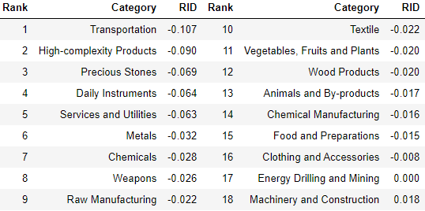
Table 2: Realized Industry Development (RID) of Singapore

3.3 Regional and Global Comparison
The next question to ask is how the strategies adopted by countries differ from each other and what trends we can observe. Table 3 and 4 below summarize the production strategies, as measured by RID, adopted by a selected group of developed and emerging economies in the world, respectively. It can be directly observed that leading economies, such as the United States and Germany, in general focus on products with higher level of complexity. However, variations also exist and some developed economies, such as France, still give a considerable level of attention to product families of intermediate-level complexity, such as raw manufacturing and chemicals.

Ranking | France | The United States | Germany
1 | High-complexity Products | Services and Utilities | High-complexity Products
2 | Chemical Manufacturing | Weapons | Transportation
3 | Daily Instruments | Raw Manufacturing | Wood Products
4 | Animals and By-products | Precious Stones | Metals
5 | Food and Preparations | Animals and By-products | Food and Preparations

Table 3: RID Comparison across Leading Economies

Ranking | China | South Korea | Singapore
1 | High-complexity Products | Transportation | Transportation
2 | Transportation | Textile | High-complexity Products
3 | Machinery and Construction | High-complexity Products | Precious Stones
4 | Energy Drilling and Mining | Chemical Manufacturing | Daily Instruments
5 | Daily Instruments | Machinery and Construction | Services and Utilities

Table 4: RID Comparison across Emerging Economies

Table 4 further examines the development strategies adopted by emerging economies in the world. Reasonably, emerging economies such as China, South Korea, Singapore and India have devoted the majority of their efforts into intermediate industry groups while developed economies rely more on advanced industry groups. This trend holds true in general, regardless of the continent or the time period, and thus serves as an indicator for which phase of development a country is currently in as evaluated from its production strategy. Nevertheless, in order to more quantitatively evaluate the effectiveness of different development strategies, we dive into the product space in depth in the next section to understand how countries should develop on an individual basis.

4. Product Space Design

4.1 Suggested Development Vector
As aforementioned, distance gives us an idea of how far each new product is from a country’s current mix of exports. As defined in Hausmann and Hidalgo (2009), distance is “the weighted proportion of products connected to goods p that country c is not exporting, i.e., MCP=0.” Based on this definition, the distance between a country and any product that the country is currently exporting (i.e., the country is a significant exporter in the product as compared to global average) is zero. Similarly, opportunity gain quantifies the contribution of a new product in terms of opening up the doors to more and more complex products, as in (14). Intuitively, a product that a country is currently exporting (i.e., MCP=1) has an opportunity gain of zero. And unreasonable investment on certain product p would lead to a relative decrease in export of more profitable products, and therefore lead to a negative opportunity gain of product p. The opportunity gain is not the only estimator of a country’s level of economic development. However, among countries with comparable economics quantities, those having higher ECI often have economics structures that are in better shape.

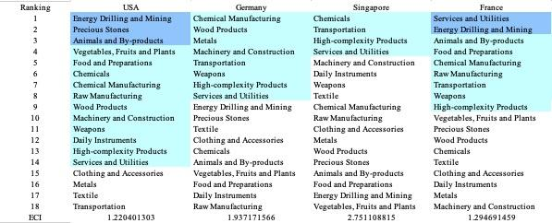
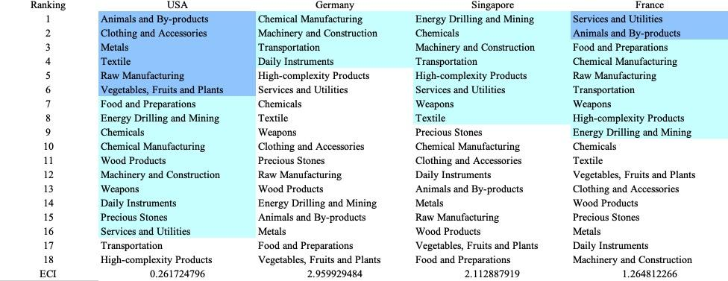

Table 5: Opportunity Gain Ranking of Leading Economies for 2013(up) and 2018(down)

We define the ranking of opportunity gain for a country c, as the Suggested Development Vector (SDV) of c. Table 5 summarizes the SDV of leading economies in the world, with the industry groups ranked in decreasing order of significance. Dark blue indicates positive opportunity gain, light blue indicates zero opportunity gains, and white indicates negative opportunity gains. The result shows that leading countries barely have any industries with positive opportunity gain. In other words, those countries are already in the most stable and efficient economic structure. Without the necessity of economic transition, those countries merely need to maintain a steady and balanced economic development. In contrast, developing countries such as Brazil and India have nearly half of industries with positive opportunity gain, and share common interests in manufacturing and machinery, as shown below in Table 6. It is noteworthy that not all leading economies have reached a stable equilibrium in terms of their economic structure, and in fact, it is possible for developing economies to have better balanced economic structures, despite the fact that their output quantities might not be as significant on a global scale. The result shows that the analysis conducted on an economic complexity level might serve as a complement to existing economic indicators such as GDP, which provide information on quantity but not quality of countries’ economic progress.

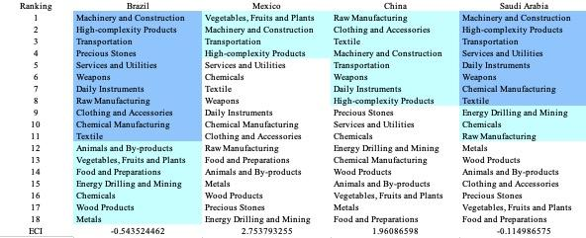
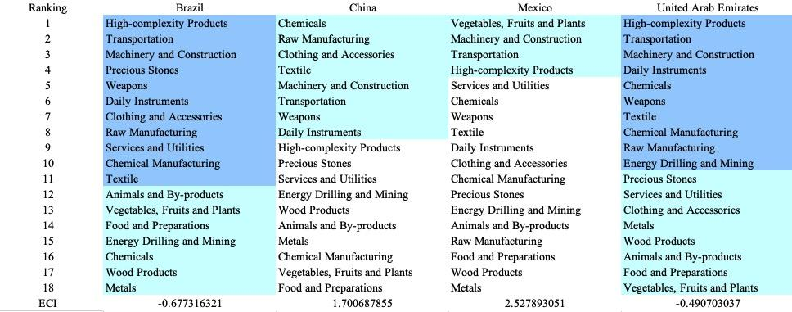

Table 6: Opportunity Gain Ranking of Emerging Economies for 2013(up) and 2018(down)

The aforementioned differences in economic structure between relatively advanced economies and developing economies imply that we need to adopt different methods for analyzing economies in different stages. For countries that have a large number of industries with positive opportunity gains, we need a sequential strategy that allows prioritization of certain industries to develop in the first stage. On the other hand, for countries that have already obtained a relatively stable economic structure, it is more important to answer questions such as how sensitive the countries are to shocks in various industries and what their contingency plans should be in those cases. Therefore, the rest of section 4 provides methods and examples to analyze those two groups of countries in a separate manner.

4.2 Budgeted Industry Development Strategy and Interpretation

The optimal budgeted industry development strategy aims to solve the most efficient allocations under the budgeted constraint of different situations of heuristic total export growth. In order to obtain such an allocation portfolio, we formulate an optimization problem as the following:



where k(x) is the second largest eigenvector of $M_{CC'}$ after adding $x$ to the original export vector, C is the country that we are interested in, P is the product space, B is the heuristic budget.

If we can solve this problem, then we can know what the largest ECI that a country can improve to. Accordingly, the optimal solution $x*$ that we obtain here is exactly our optimal allocation. However, the biggest problem is that the objective function is not convex. Therefore, we cannot apply the classical tools for convex optimization on this problem. In order to solve this problem, our idea is to use greedy algorithms. The way that we apply greedy algorithm is that firstly we separate the total budget into k equal parts, and then for the first equal part we try to search for the product that can optimize our objective function by iterating through each $p∈P$. After we find the optimal product p for this equal part, we add the amount back to the export value of this product p and update the ECI for this country. If we observe that ECI does not change after iterating all the products, then we can add up one more equal part to invest. Until we find there is an ECI increment, we add the amount now to that product. The rest equal parts can be done in the same way.

However, as is known to all, greedy algorithm is a kind of local search algorithm, which is pretty possible to run into a local minimum. Therefore, for local search algorithms, one typical way is to keep it away from the local minimum is to enhance the vision of the algorithm by looking more steps forward. In our setting, whenever we obtain an increment of ECI, we mark down the required amount of export growth. Simultaneously, we continue searching for the next ECI increment point, compare the ratios of these two possibilities and pick the largest one. The ratio is defined as the following:


where ${ECI}_{p}$ is just the ECI of the country after adding some amount of export increment to product $p$, which is exactly the amount that is able to make ECI change. Also, we can express it in the way of $||$$x_{p}-x_{0}$${||}_{1}$.

In this way, we can obtain a further sighted greedy algorithm. Also, the number of parts that we would like to separate the budget into also matters. In order to solve this problem, we added a stabilizer on top of the enhanced greedy algorithm, by running the algorithm for different number of parts and selecting the portfolio with the largest ECI increment and most complex economic structure.

Besides, it is quite common that there is a surplus for the budget. To deal with the surplus, we just add it to the product which needs the least amount of dollar to make $M_{cp}$ = 1, (i.e., the smallest amount of required export increase).

Economic Panel:

As stated above, the enhanced greedy algorithm is developed mainly for solving the optimal allocation strategy. In order to visualize this allocation, an economic panel is created, consisting of a pie chart, a line chart and a table. Firstly, a pie chart is used to show the percentage of each product in the optimal portfolio. The number located in the center of the circle denotes the heuristic growth of total export, which is also our budget. For example, for the first pie chart below, it shows we should allocate 25% for food and preparations, animals and by-products, and chemicals. In addition, we should allocate 12.5% for raw manufacturing and chemical manufacturing. The lines below the pie charts show how the ECI changes during the searching process of the greedy algorithm. For example, in the last pie chart, we can see there are three components, but there are four increments in the last line chart. That is just because many equalized amounts have been invested in high-complexity products. Even though sometimes people may feel 15% and 20% is nonsense to developed countries, yet it can also give a sense of how a country should develop in the long term. Eventually, the graph in the end is just for numerical explanation for the pie charts.

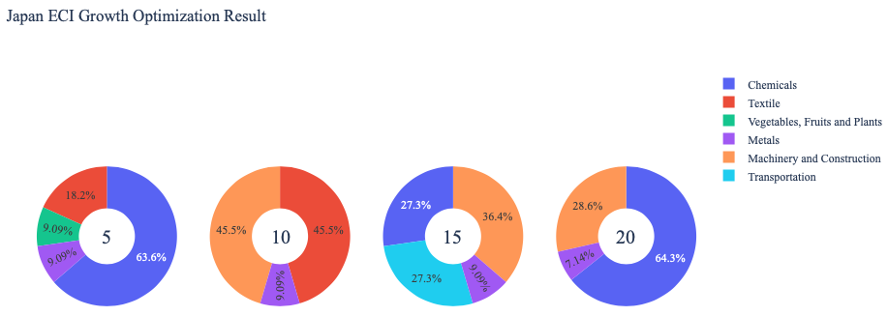
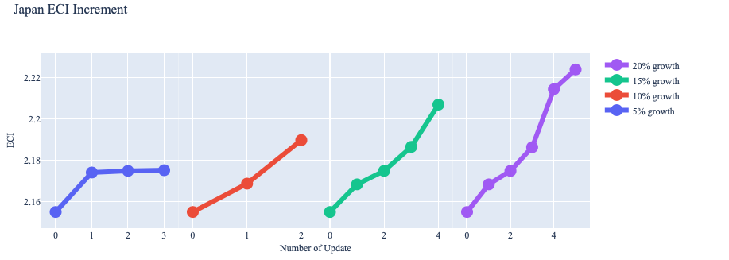
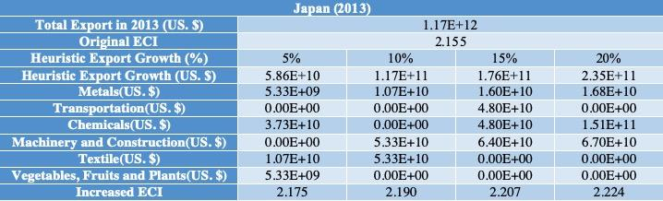

Example:

Below is the economic panel for China in 2013, we can see that for different percentages of heuristic total export growth, the ECI of China will have a different amount of increments. From the first two pie charts, we can see that ECI does not increase a lot. Also the budget is basically scattering into some basic industries, for example textile. However, for 15 percentage growth and 20 percentage growth, we can see that the slope of increment of ECI becomes greater and greater. This adequately explains the rapid development of China between 2009 and 2014. The green part of the pie chart denotes the product of machinery and construction. For the case of 15 percentage growth and 20 percentage growth, many of the increments in the line graph are caused by continuous investment in machinery and construction, which is exactly the industry that China relied most on during the rapid development.

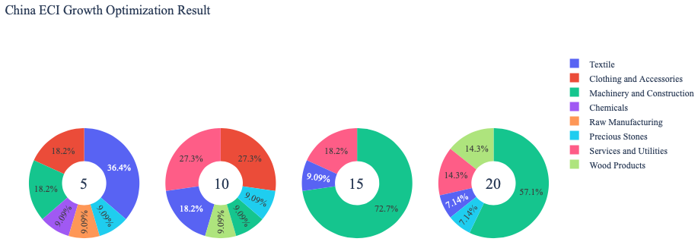
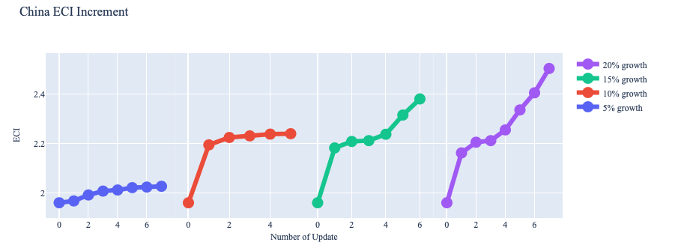
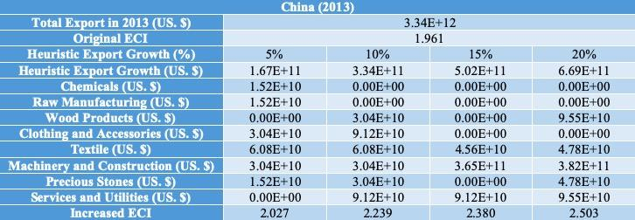

For further suggestions on China’s development in the future. We also offer the optimization result of China based on China’s export data in 2018. Below is the economic panel for China in 2018, we can see that for different percentages of heuristic total export growth, the ECI of China will have a different amount of increments. Different from the situation of 2013, we can see that for 5 percent total export growth, China is already able to have great increment in ECI by developing mostly services and utilities, as well as textile. For the rest of the three pie charts, it shows that even though China can still earn increments in ECI by further developing machinery and construction, the effect becomes gradually diminishing, but it is still one of the directions for great development. Therefore, we suggest under the budget of 5 percentage or more export growth, focusing on developing machinery, services and textile can optimize the development.

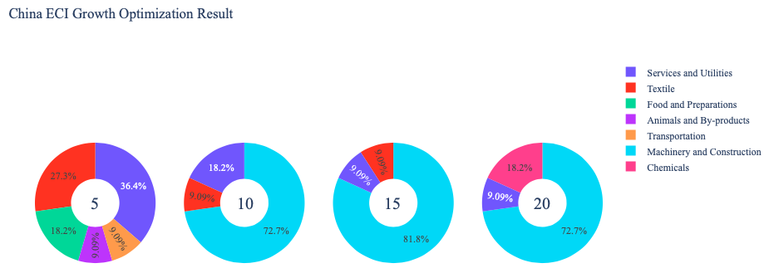
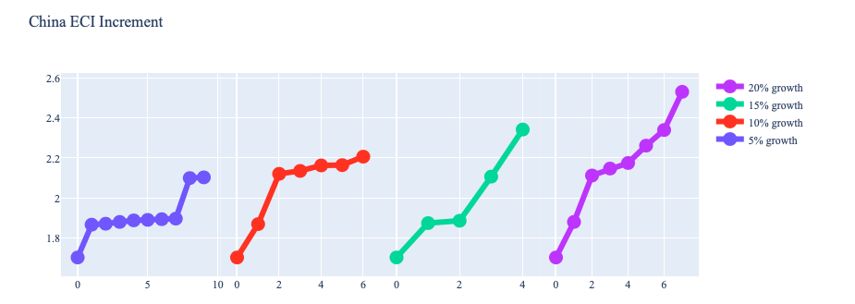

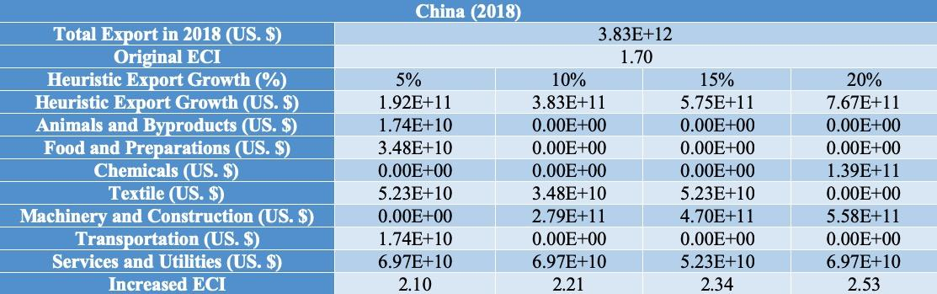

4.3 Sensitivity Analysis
In the following section our broad aim is to understand how sensitive a country is to changes in export in various industries. While the Economic Complexity Index has been shown to contain valuable information about the economic strength/capacity of a country, little has been said as to the stability of the measure itself. We seek to uncover the main drivers of stability under a country's ECI score and better understand longer-term projections for ECI growth. Additionally, gaining an intuition on the industries that are bolstering an economy and the industries that offer the greatest return per unit of investment is best done through visualization of industry specific sensitivity.
ECI Sensitivity Graph
Firstly, in order to assess the effect particular industries have on each respective country, we developed ECI Sensitivity graphs. We use shocking methodology to increment or decrement an industry’s export level by a certain percentage and recalculate the ECI all else being equal. While freezing the export dynamics of the rest of the world and enacting an instantaneous shock in export for a particular industry and country may not reflect real-life dynamics, what it does offer us is an understanding of a country’s level of dependency on an industry in the context of ECI. The shocking is done in small percentage increments in order to smooth out the resulting curve. Additionally, a recurring theme one will see is that for most industries, a breaking point occurs where the ECI either jumps upwards or downwards, creating a hockey stick shape rather than a linear trend. While the inflection point may not be accurate in context of real life, comparing the various inflection points across industries can give us valuable insight.
The graphs are formulated as follows: There are four ECI Sensitivity graphs. The first two represent data from 2018. The first chart shows positive shocking in which export numbers are shocked upwards per industry. The X-axis is in terms of percentage shock per current dollar value of export. The Y-axis is the recalculated ECI level post-shocking. The second chart follows the same format except the X-axis represents negative shocking. In other words, exports for each industry are decremented and the ECI is accordingly recomputed. The final two sensitivity graphs show the same results using 2013 data. Below is an example of an ECI sensitivity graph.

Example 2018 (Incremental ECI Sensitivity)
SDV Sensitivity
Secondly, we analyze the sensitivity of the SDV to changes in export levels. The goal is to understand how export level changes for a particular industry can affect the marginal opportunity gain for other industries. We will be using specifically High Complexity Products and Food and Preparations as our base industries. We will be increasing or decreasing the absolute export level in both of these industries and observing the effects on the SDV.
When the opportunity gain of an industry is negative, the SDV sensitivity approximates how an over-development of the industry jeopardizes the economic structure of a country. When the opportunity gain of the industry is zero, the SDV sensitivity determines whether the further development of the industry shapes the country with a better economic structure and predicts how the SDV would change accordingly. Specifically, as we reduce the export of such an industry to 25%-50% of its original value, a few other industries originally with negative opportunity gain could likely become profitable.
Similar to the ECI sensitivity graphs above, we will be shocking export of High Complexity Products and Food and Preparations in small percentage increments. A new SDV, represented by a new column in the charts, is recorded only when a certain level of shock changes the structure of the SDV. In effect we are incrementing or decrementing export levels of two industries until the marginal opportunity gain of any industry changes in category (positive, negative, or neutral). Below is an example of a SDV Sensitivity chart with Positive Shocking. Industries with positive marginal opportunity gain are colored blue, neutral is colored white and negative is colored red.


Example High-complexity Products 2018 (Incremental SDV Sensitivity)
4.4 Contingency Strategy
Contingency Plan
The Contingency Plan aims to present a set of solutions with respect to upheavals in different industries. Instead of compensating for the declining production directly, the best strategy is to develop those incipiently profitable industries. In this manner, we can derive the contingency strategy for countries to deal with possible abrupt declines of crucial industries. In some cases, the SDV remains unchanged even when a zero-opportunity-gain industry declines to its 20% in terms of export. We can then conclude the industry is not indispensable to the country. As a clarification, the three consecutive N/As means that the country doesn’t even need to respond to a collapse in the industry. Countries tend to have distinct solutions to the up and down of the same industry. To create the contingency strategy table we decrease the export level for each industry in the country’s current production space by 60% respectively. The three highest ranking industries in the new SDV are then returned.

Example Contingency Strategy 2018

5. Macro-level Predictions

5.1 Structural Optimality Index
Indeed, such choice of prioritization has proven to be a significant factor in deciding the economic outcomes of countries. In order to quantitatively evaluate how effective our development strategies are and how deviations from the suggested developmental path will lead to suboptimal growth results, we define the measure – Structural Optimality Index (SOI) – on a country level as the Adjusted R-Square obtained from regressing the country’s realized industry development over the suggested development strategy. Both strategies are quantified in nature, with the realized development represented by export increase in every major industry group and the suggested development strategy represented by the opportunity gains of developing the corresponding industry groups as calculated in previous sections. The adjusted R-square from the regression thus provides us with a quantified measure of how the development path adopted by the country has fitted with/differed from calculations on a complexity level.

After obtaining this measure for all countries in our database, we further regress countries’ five-year economic growth, which is defined as the net increase in GDP (USD), over their SOI. Figure 6 illustrates the regression output, which shows a strong positive correlation between countries’ SOI and their five-year GDP growth, significant at the 1% level and achieving an adjusted R² of 4.5%. In other words, the more a country develops as suggested by calculations on a complexity level, the better economic outcomes it achieves. This R² is much lower than what we found in previous results, especially from 2008 to 2013, this is due to two sets of factors. First, we have changed our definition of SOI, using RDI instead of change in Exports. Secondly, the global, especially western and developed, economy has seen a long run of growth with lower than expected inflation. Many central banks have thus kept interest rates very low, leading to strong growth in countries where a lower rate of growth would be expected. 2013 to 2018 has also seen much political change in both developed and developing economies, including but not limited to contentious elections, wars and refugee crisis, and trade conflicts. These could be factors that have contributed to a less than expected correlation between SOI and 5-year GDP growth rate.

Table 18: OLS Regression Results
Dep. Variable: GDP | F-Statistic: 5.963
R²: 0.054 | Prob (F-Stat): 0.0163
Adj R²: 0.045 | No. Observations: 106

Figure 2: Regression of Five-year GDP Growth over SOI

5.2 SOI Examples and Implications
To explain this finding in a more intuitive way, we take Turkey and Japan as a comparison. As Figure 3 suggests, the RDI of Turkey in various industries demonstrate a high level of correlation with the opportunity gains of those industries, having an adjusted R-square (i.e., SOI) of around 21.8%. In fact, Turkey ranks among the fastest growing countries, 36.7% GDP Growth from 2013 to 2018, and has one of the highest SOI’s, which is consistent with the regression result in Figure 6.
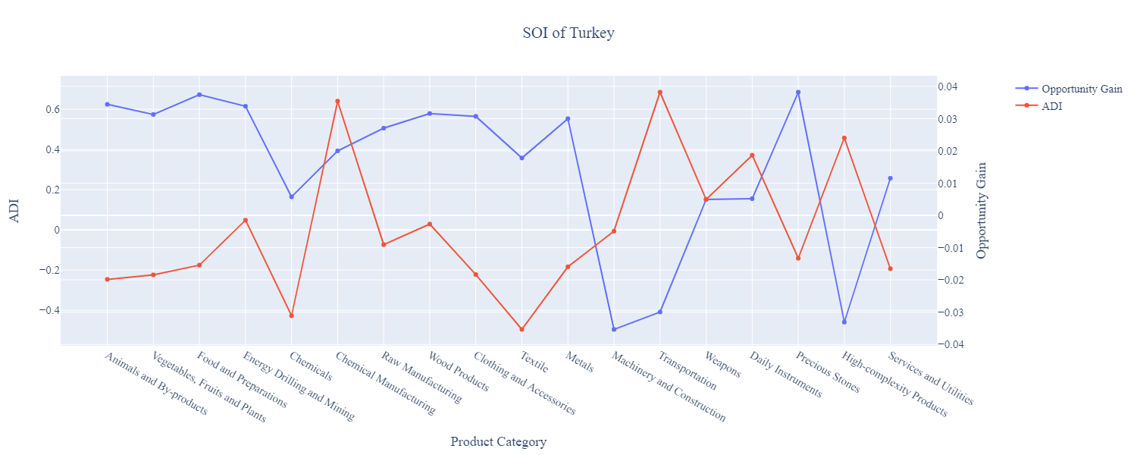
Figure 3: SOI of Turkey (2013-2018)

The situation in Turkey is in direct contrast to that in developed economies such as Japan, where there is a small SOI of around -4.8% and a corresponding 5-year growth rate of merely 9.0%, ranking it a slow-developing economy during the period. In sum, Japan’s stagnant economic progress from 2013 to 2018 can be at least partially explained by a mismatched development strategy that demonstrates a considerable level of deviations from the suggested developmental path as calculated through opportunity gains. In specific, Figure 8 shows that Japan invested heavily in the transportation industry, while it should have focused more on industry groups such as Daily Instruments, which actually have higher opportunity gains based on calculations.

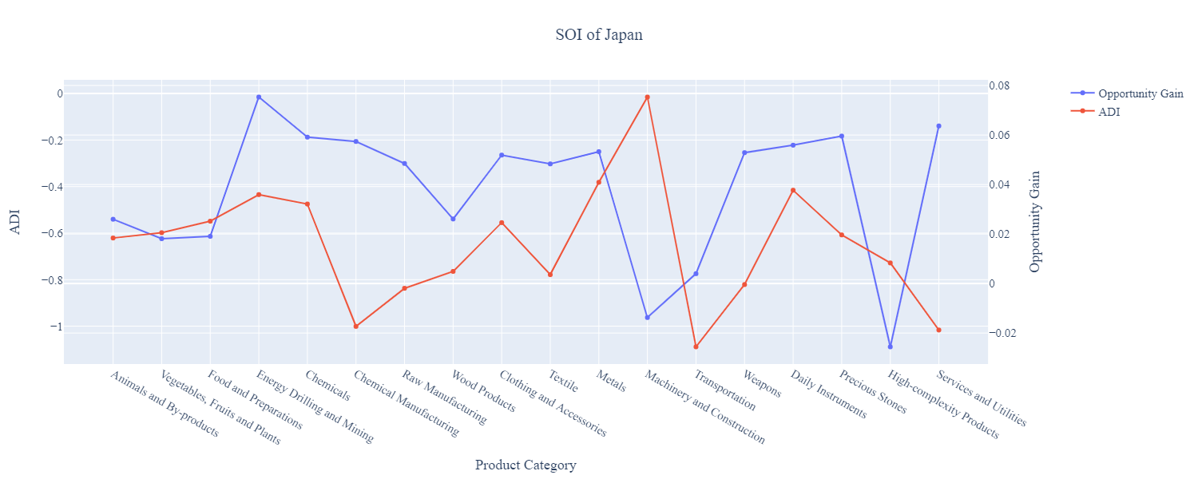

Figure 4: SOI of Japan (2013-2018)

The contrast of situations in Turkey and France offers a glimpse of the relationship summarized in the regression in Figure 6, and shows that the economic outcome of countries is positively associated with their structural optimality. In particular, countries such as Turkey tend to have better growth, as measured by GDP, when they follow industry prioritization strategies closely based on opportunity gains, and the reverse is true for countries such as France. While a strict causality is hard to be established in this case because it is hard to control variables in such natural experiments, the correlated phenomenon is widely observed across different time spans of our interest. This implies that the calculations and further research on a complexity level are of importance and great values to countries, and may offer a guide for them to properly access and prioritize certain industries in face of practical constraints such as time and budget. Still we do find results contradictory to our hypothesis, for example, Brazil. Brazil has one of the highest SOI’s among countries observed, yet still it has had one of the lowest rates of GDP growth. This is in direct contrast to the period from 2008 to 2013, where Brazil was one of the fastest growing countries. As mentioned in the previous section, some of this disparity may be explained by political factors.

6. Concluding Remarks

In conclusion, we build on previous works related to the Economic Complexity Index and add analyses on the product space for each country into the general framework. In particular, we categorized the highly specific global export data available on UN Comtrade to 18 manageable and intuitive industry categories. Extending the definitions of product complexity index to product families, we calculate the distance between countries and product families and observe how countries have positioned themselves in their product space during the time span of our interest.

We then dive into the question of how countries should develop given their current position and solve for strategies that countries can pursue on an individual basis. We propose an optimal budgeted industry development strategy for developing economies to prioritize certain industries in the expansion of their product space. We also put forward sensitivity analyses and contingency plans to prepare developed and fast developing countries for upheavals in their product space. This includes solutions to deal with a possible collapse of their cornerstone industries. More detailed analyses of select countries can be found in the appendix of this report – these largely represent how countries of each kind should develop in this ever-changing global market.

Additionally, we use a Structural Optimality Index (SOI) to quantitatively measure and compare the strategies adopted by countries against the suggested developmental path. Regression shows a strong positive correlation between countries’ structural optimality and their economic outcomes, measured by GDP growth. This suggests that countries’ product spaces, as well as decisions to be made on the product space, are of great research value to economies. However, more work remains to be done in order to obtain a deeper understanding of how countries interact on the global production network.

References

Hausmann, R., Hidalgo, C., Bustos, S., Coscia, M., Chung, S., Jimenez, J., Simoes, A. and Yıldırım, M. (2007). The Atlas of Economic Complexity. [online] Atlas.cid.harvard.edu. Available at: http://atlas.cid.harvard.edu/.

Balassa, B., “The Purchasing Power Parity Doctrine - A Reapprais- al,” Journal of Political Economy 72, 584-596 (1964).

Feenstra, R.; Lipsey, R.; Deng, H.; Ma, A. & Mo, H. “World Trade Flows: 1962-2000” NBER working paper 11040. National Bureau of Economic Research, Cambridge MA (2005).

United Nations Commodity Trade Statistics Database (http://comtrade.un.org/db/), accessed in August 2019.

The World Economic Forum, “The global competitiveness report,” (various years).

Barro, R. & Lee, J-W. “A New Data Set of Educational Attainment in the World, 1950-2010,” NBER Working Paper No. 1590 (2010).

Kaufmann, D. & Kraay, A. “Governance Indicators: Where Are We, Where Should We Be Going?” Policy Research Working Paper 4370. Washington, DC: World Bank (2008).

Hanushek, E.A. & Woessmann, L. “The Role of Cognitive Skills in Economic Development,” Journal of Economic Literature 46(3), 607- 668 (2008).

