
https://atlas.cid.harvard.edu/

Optimal Industry Development Strategy Using Economic and Product Complexity

Addendum Report Concerning Economic Bloc of United States, Mexico, Canada

─
The Economic Complexity Lab - Columbia University
Ajit Akole, Alex Wei-Liang Ku, Sannidhya Modi, Nouhaila Elmajidi, Alexandra Garcia
Optimal Industry Development Strategy for USMCA

0. Executive Summary

In this report, we uncover the economic path of the bloc of countries consisting of the United States, Mexico and Canada (USMCA), while comparing/contrasting development from the perspective of ECI to the individual countries that comprise the bloc. We also aim to understand how analyzing a bloc of countries (rather than the individual countries) changes suggested strategies for optimizing growth and complexity. We find that during the period of our interest, USMCA as a whole demonstrated a moderate level of economic growth with an average annual GDP growth rate of 3.32%, which falls right in between those of the US (3.39%) and Mexico (3.29%), with Canada lagging behind at 2.36%.

The lack of progress during the period is in line with the moderate/slow growth of the bloc’s constituent countries, and can be further explained through analysis of the economic and product complexity structure of USMCA on the industry group level. The product classification system we adopt allows us to measure the realized industry development for various industry groups and to observe that USMCA as a whole consistently relied on developing the Services and Utilities industry during the period, which is in line with the US and Mexico’s existing development paths.

Based on our analysis of the opportunity gain and a sensitivity analysis of major industry groups, this bloc can further its gains by prioritizing Transportation and High-Complexity Products. We further note that the USMCA has a slightly mismatched development strategy that indicates a moderately high (compared to other developed countries) level of structural optimality on the complexity level, having an adjusted R-square of around 1.2%. A significant positive correlation exists between five-year GDP growth and the structural optimality index of an economy as we define and calculate, but the USMCA still has a suboptimal growth experience. However, the bloc has the potential to further its economic gains through industrial structure optimization as suggested in the paper.

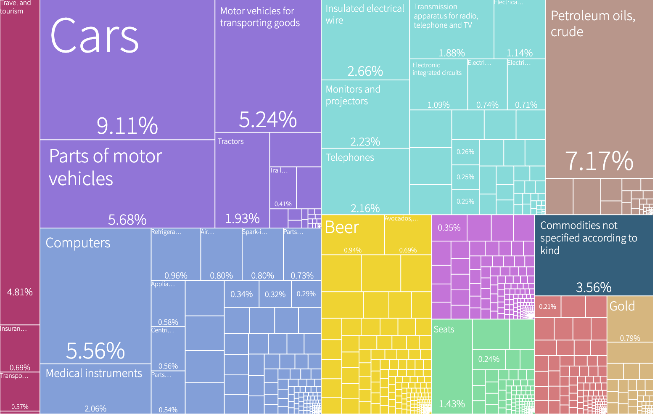
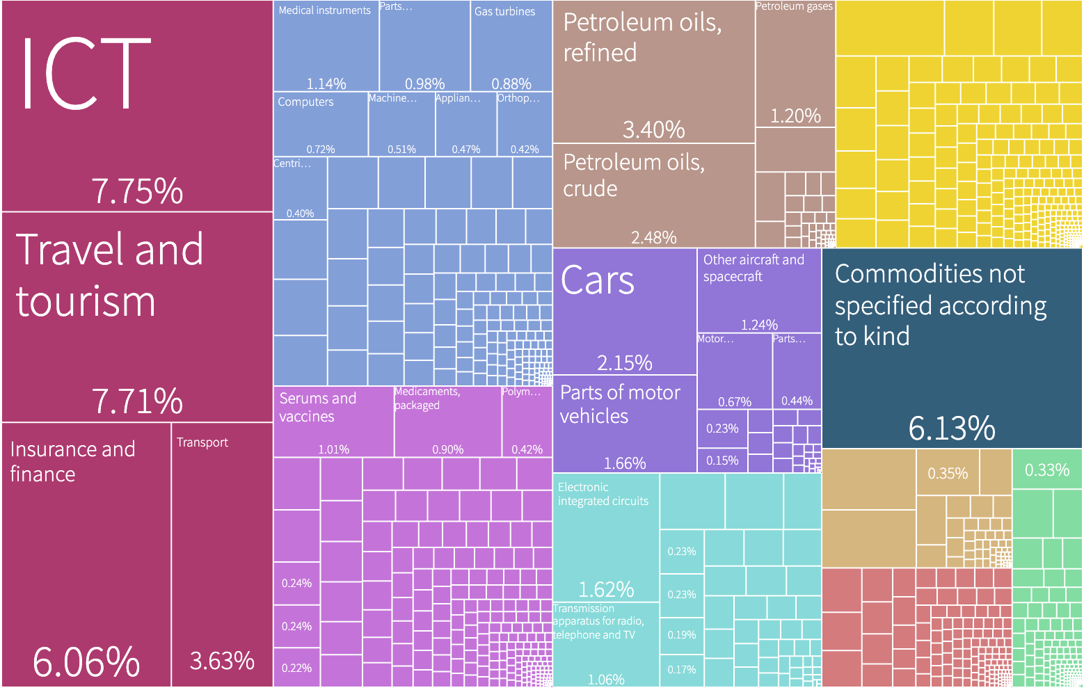
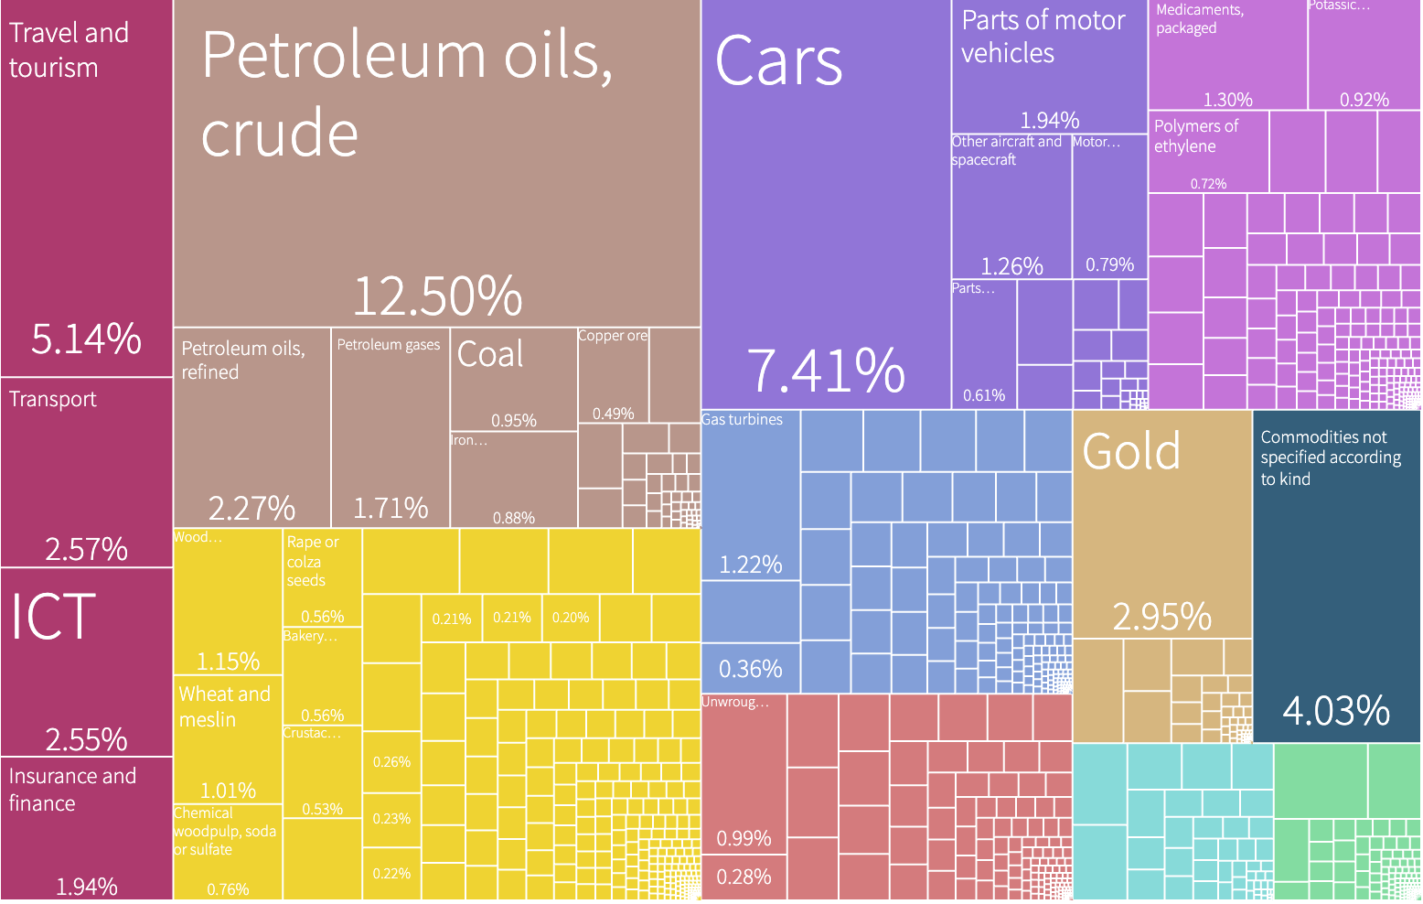
Export Baskets of US, Canada and Mexico (in Order)

1. Report Overview

In this report, we aim to compare the economic path that the USMCA bloc went through during the period from 2013 to 2018 to those of its constituent country from the perspective of both Gross Domestic Product (GDP) and Economic Complexity Index (ECI), which reflect countries’ production capability and production structure, respectively. We then analyze the industrial framework and changes of this bloc as a whole during the period by comparing it to constituent countries on the basis of quantitative measures such as Product Complexity Index (PCI) and Product Family Complexity Index (PfCI), in addition to development strategies as quantitatively measured by opportunity gains on an industry-level. We conclude our report by comparing the macro-level results and predictions of this bloc, as deduced from regression models we have established, to the predicted path of individual constituents.

2. Macroeconomic Results

2.1 GDP Ranking and Changes
Figure 1 illustrates the time-series GDP results for the USMA and its constituent countries from 2013-2018. USMCA has trended upwards in GDP over the years, with the US accounting for the majority of the growth, with an average annual growth rate of 3.39%. Mexico and Canada grew at average rates of 3.29% and 2.26%, respectively, averaging out to a growth rate of 3.32% for the bloc as a whole from the period of 2013-2018.

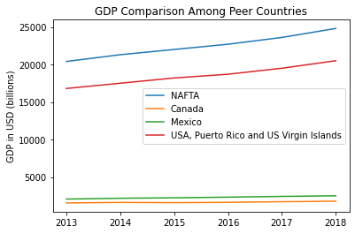
Figure 1: GDP Comparison Among Constituent Countries

2.2 ECI Ranking and Changes
The Economic Complexity Index (ECI), as defined by Ricardo Hausmann and Cesar Hidalgo in 2009 to explain the knowledge accumulated in a country's population, exhibits a similar growth pattern for Bolivia. As illustrated in Figure 2 below, USMCA (-51.69% ECI change) exhibited a decrease in terms of its production capability from 2013 to 2018, which is in line with the US (-81.01%), Canada (-31.31%) and Mexico (-42.68%).

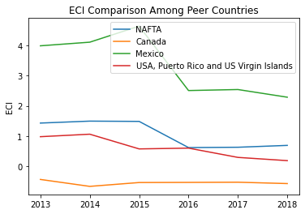
Figure 2: ECI Comparison

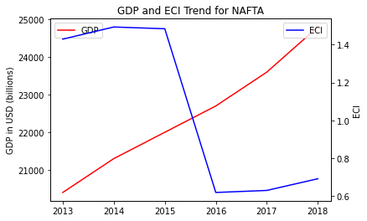
Figure 3: GDP Growth and ECI (USMCA)

Figure 3 offers a further comparison of GDP Growth and ECI over the time span from 2013 to 2018 for USMCA. The steady increase in GDP during the period from 2013 to 2018 is accompanied by a sharp decline in ECI from 2015 to 2016. The results are in line with the constituent nations, as all three countries mirrored the trend of the bloc, as seen in Figure 4.

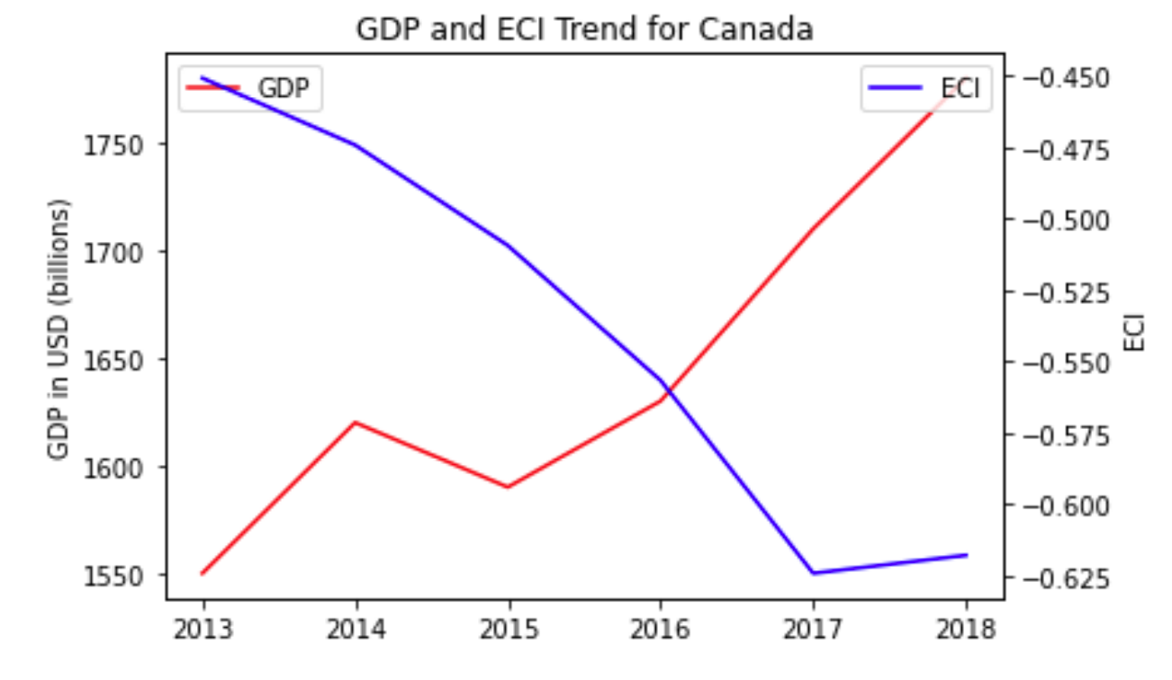
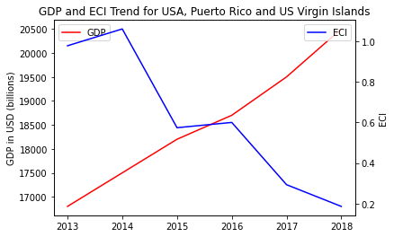
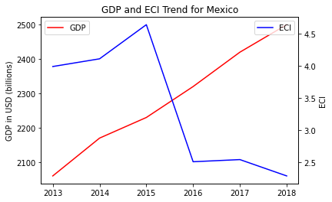
Figure 4: GDP Growth and ECI for Canada, US and Mexico (Clockwise, top left to bottom)

3. Production Analysis

3.1 Realized Industry Development Comparison
Based on the product categorization described by our reports, we aim to capture USMCA’s realized industry production strategy between 2013 and 2018 on a complexity level and compare it to constituent countries. As seen in Table 2,

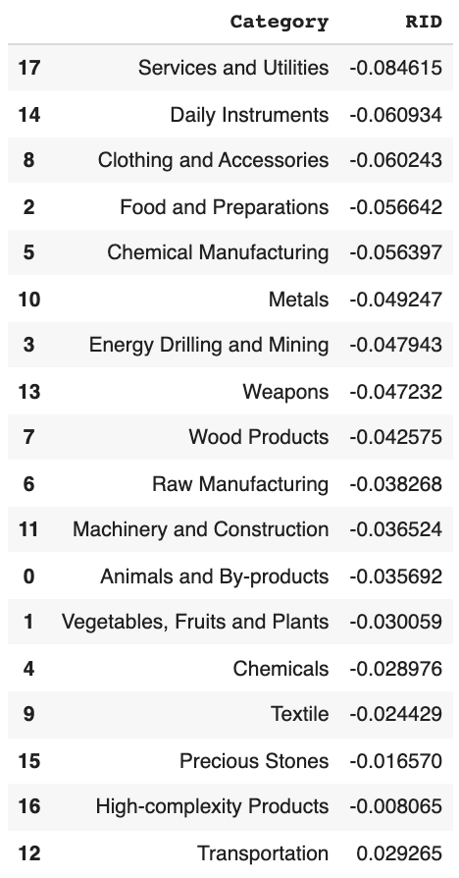
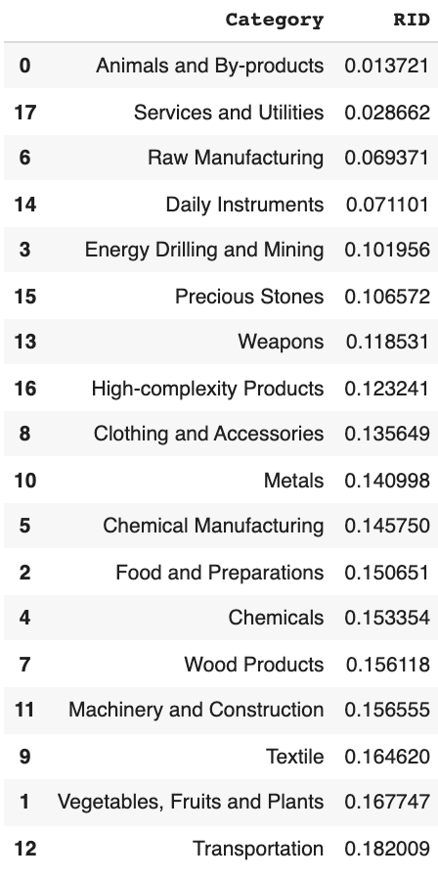
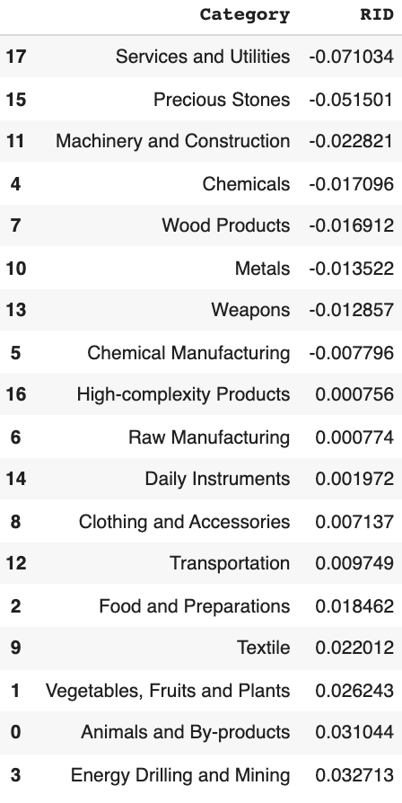
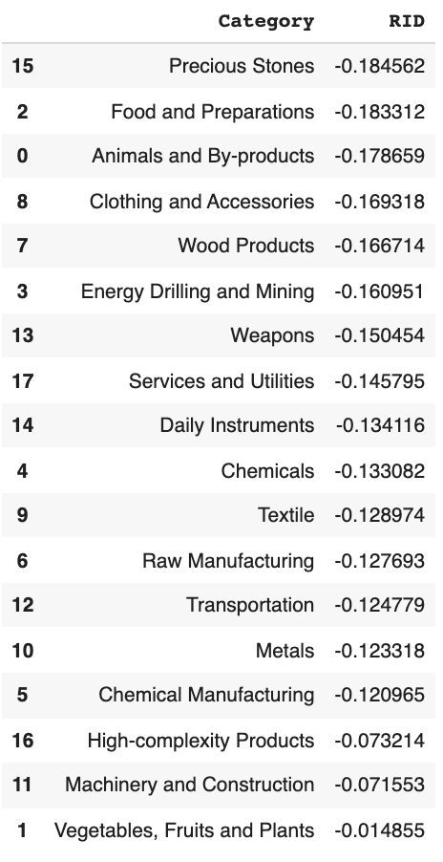
Table 2: Realized Industry Development of USMCA, compared with US, Mexico and Canada

4. Product Space Design

4.1 Suggested Development Vector Comparison

As explained in our individual reports, we define the ranking of opportunity gain for a country c, as the Suggested Development Vector (SDV) of c. Table 5 summarizes how the SDV of USMCA compares with its constituent countries, with the industry groups ranked in decreasing order of significance. Dark blue indicates positive opportunity gain, light blue indicates zero opportunity gains, and white indicates negative opportunity gains.

The result shows that analyzing the optimal path for development from the perspective of a bloc opens many more positive opportunity-gain industries for further investment. While Canada did have a higher number of industries that remain positive compared to the bloc case, both the US and Mexico see a higher number of opportunities which are positive. In fact, Mexico initially had no positive opportunity-gain industries to develop.

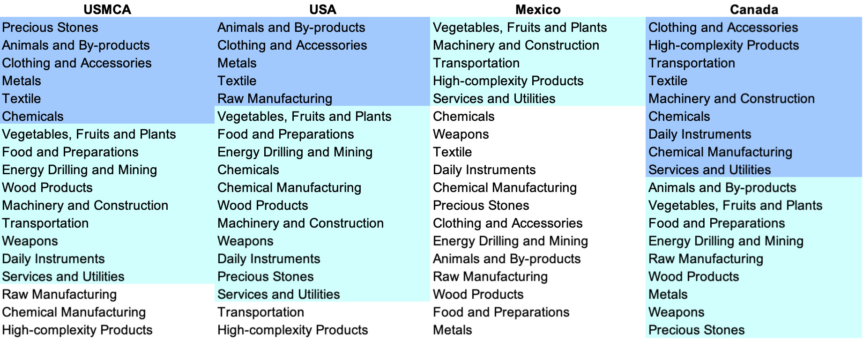
Table 5: SDV of USMCA compared to constituents

4.2 Budgeted Industry Development Strategy Comparison

The optimal budgeted industry development strategy aims to solve the most efficient allocations under the budgeted constraint of different situations of heuristic total export growth. Based on the greedy allocation framework suggested in the individual country reports, we see the following results for USMCA compared to constituents in 2018:
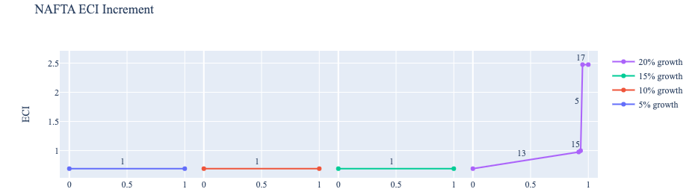
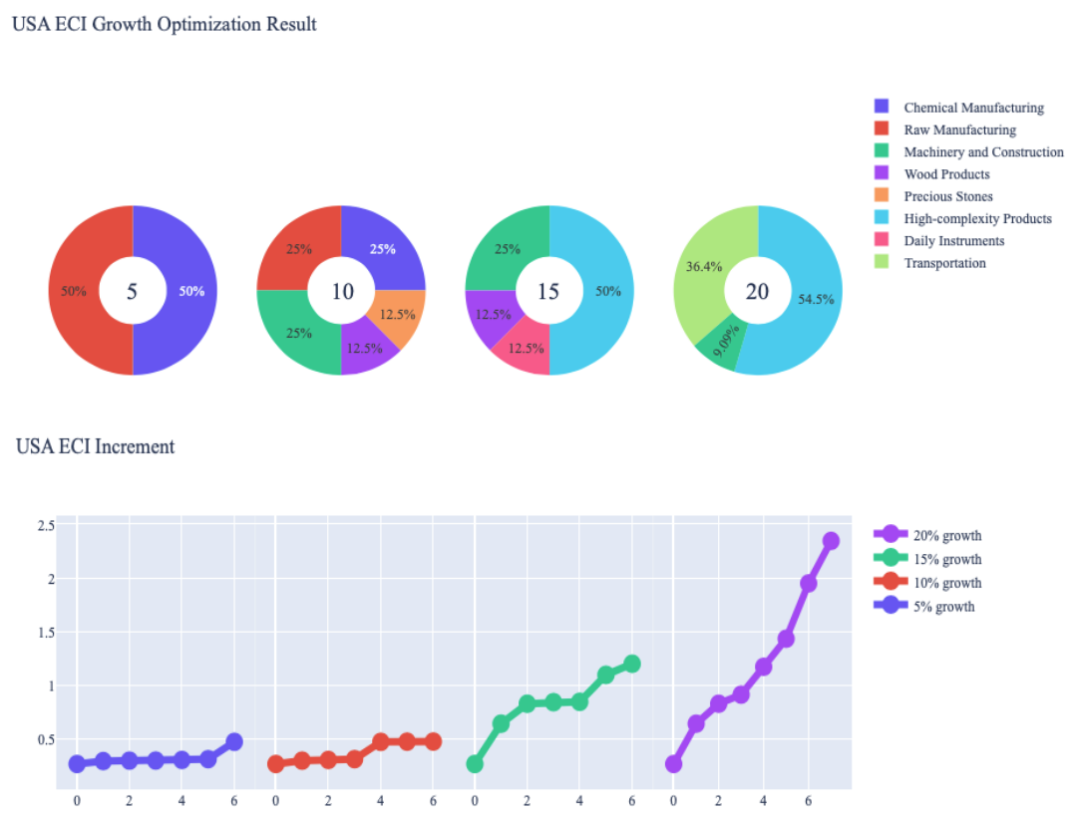
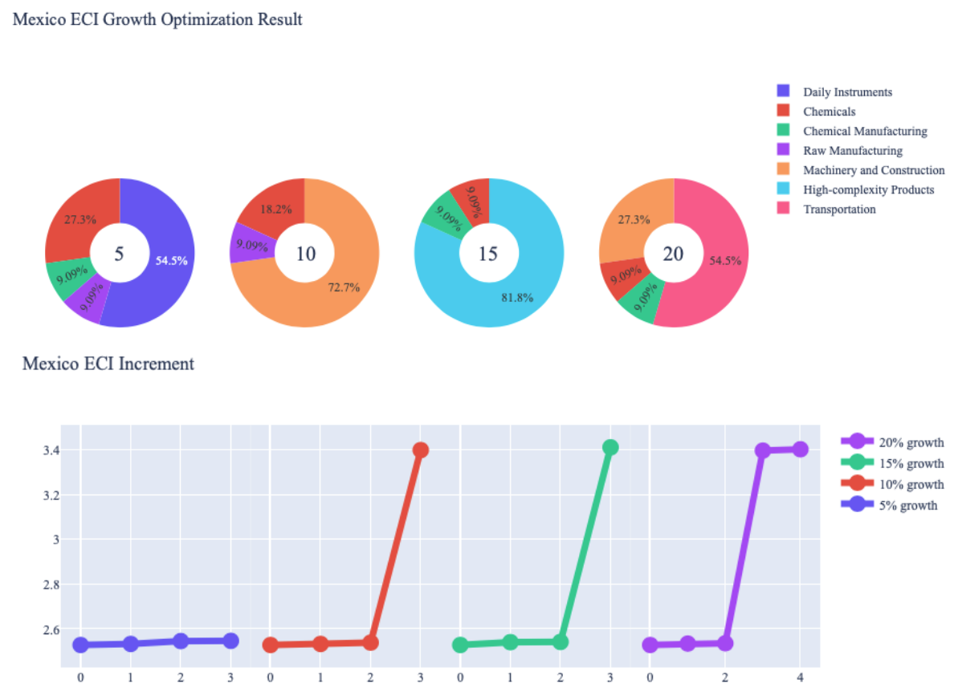
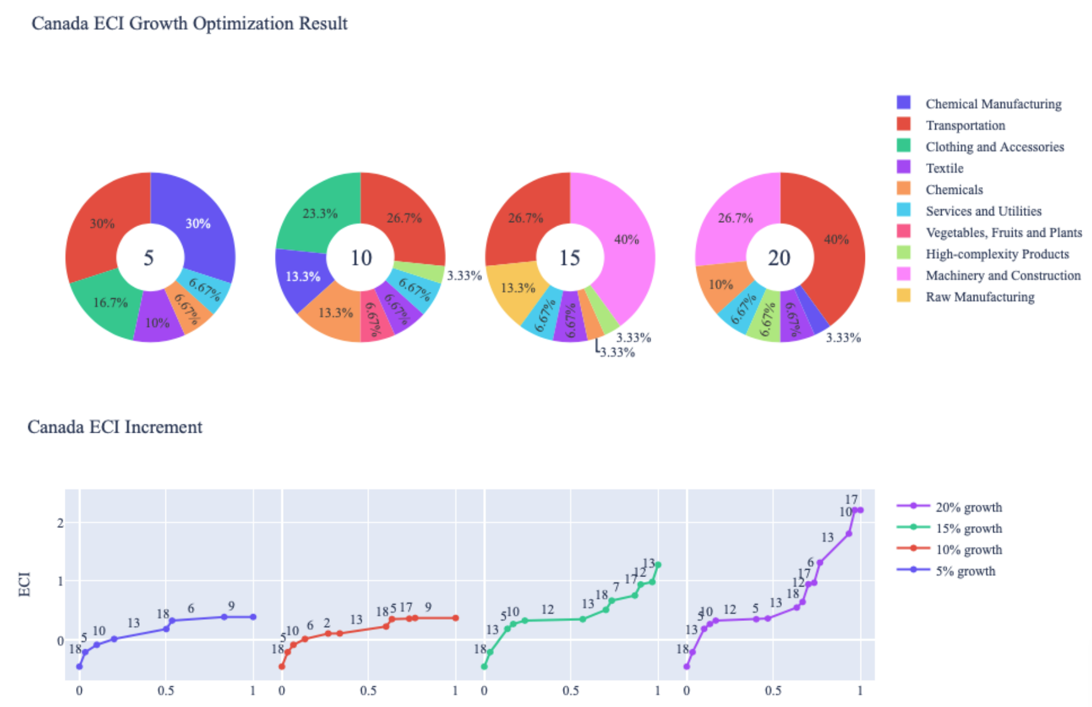
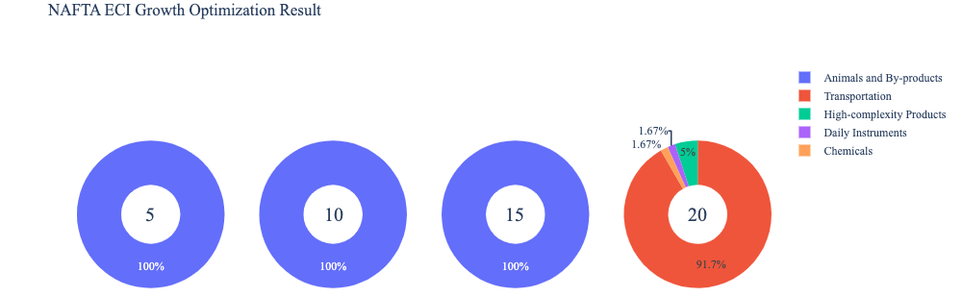
Figure 5: Greedy Optimization results for USMCA (NAFTA), Canada, Mexico and US

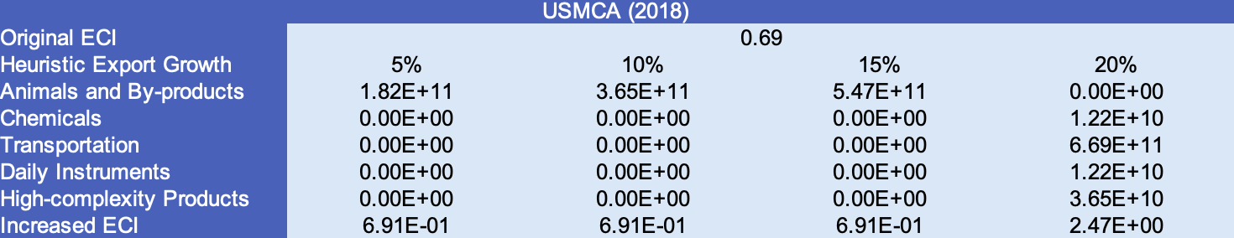
Table 3: Economic Panel for USMCA

Clearly, as seen above, the ECI of USMCA does not increase much for different percentages of heuristic total export growth. In fact, at 5, 10, and 15 percent growths, we see a similar ECI change pattern, in that ECI is not increased at these growth rates. Instead, we only see an increase in ECI at a 20 percent growth, going from 0.69 to 2.47. This can be rationalized by the fact that as seen in the constituent optimization strategies, the suggested paths for development are so drastically different. As a result, allocating budget to one particular industry group may be beneficial for a single country and boost the total export growth of the bloc, but the bloc’s complexity will not be affected as the industry set is now so much more diverse.

For the case of 5, 10, and 15 percent growth, our current greedy strategy suggests investment in Animal and By-products. Although this is not an optimal path for individual constituents, we are aiming for a fairly low development trajectory across the entirety of these three countries, and so allocating budget to an industry that has low development across all constituents will accomplish the desired growth. However, at a higher trajectory of 20%, we see a sharp change in suggested industries to allocate a budget to, as Transportation and High-Complexity Products become the primary industries for optimal development. This makes sense because with more budgets, a country should definitely focus more on the development of high-end product spaces.

4.3 Sensitivity Analysis and Contingency Strategy
In the following section our broad aim is to understand how sensitive the bloc of USMCA is to changes in export in various industries, especially relative to constituent nations. While we have seen how allocation strategies have changed drastically, we seek to uncover deeper ways of understanding how stable an ECI score can be in reality, as countries are rarely operating in isolation, but rather in trade blocs that can better sustain against specific kinds of economic shocks. We shall analyze this from both the perspective of the Sensitivity Graphs, as well as a Contingency Plan.

ECI Sensitivity Graph
Firstly, in order to assess the effect particular industries have on each respective country, we developed ECI Sensitivity graphs. We use shocking methodology to increment or decrement an industry’s export level by a certain percentage and recalculate the ECI all else being equal.
Below are the 4 sets of Sensitivity graphs, corresponding to increments and decrements in both 2018 and 2013

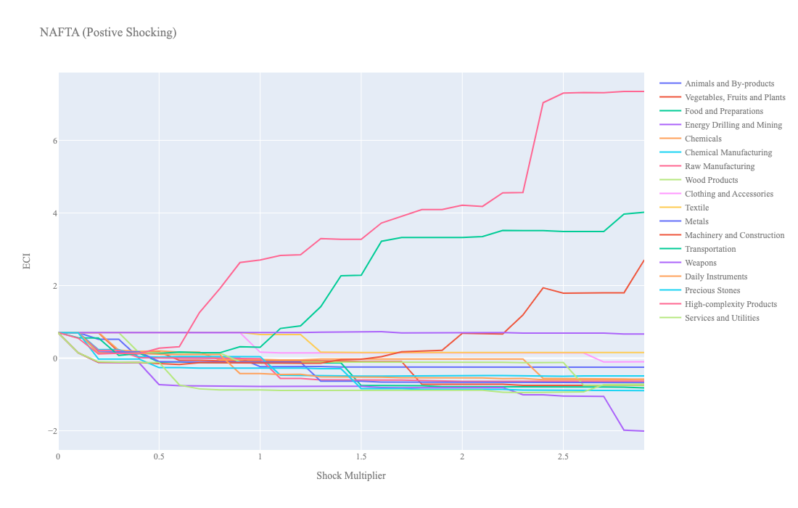
2018 Incremental:
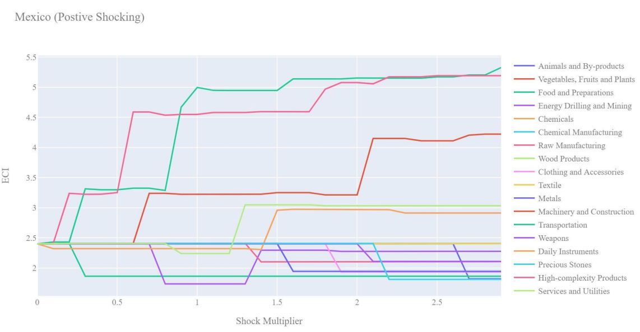
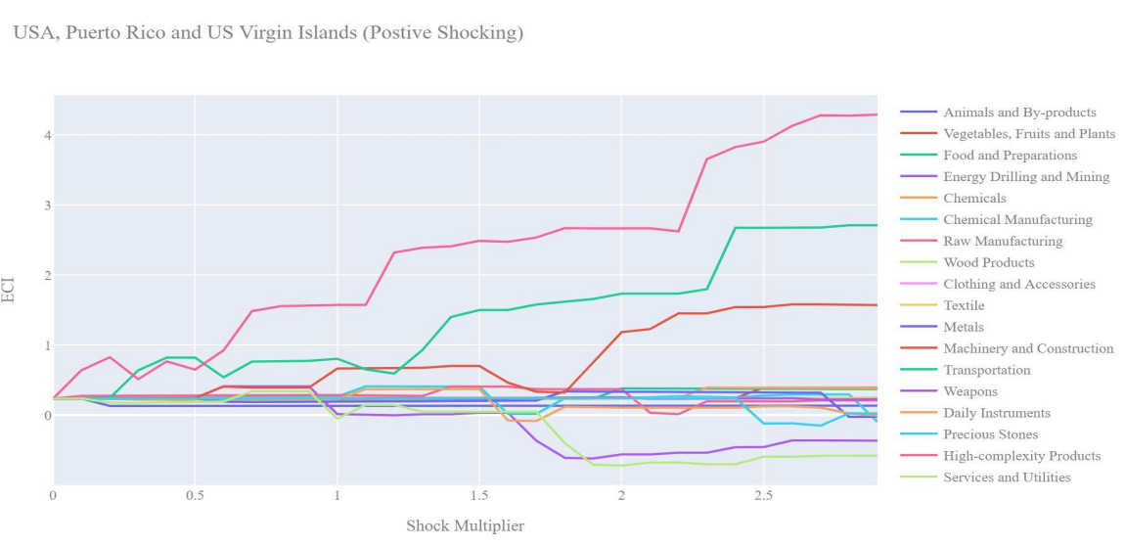
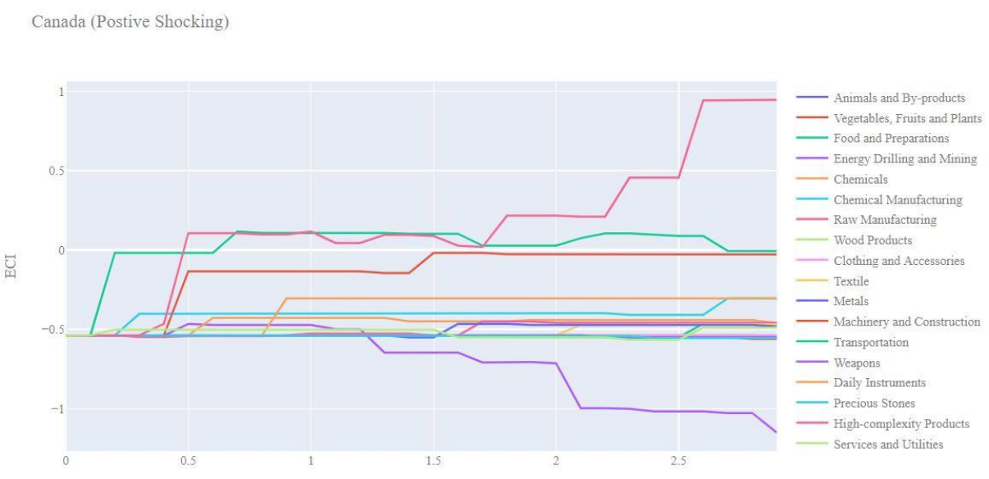
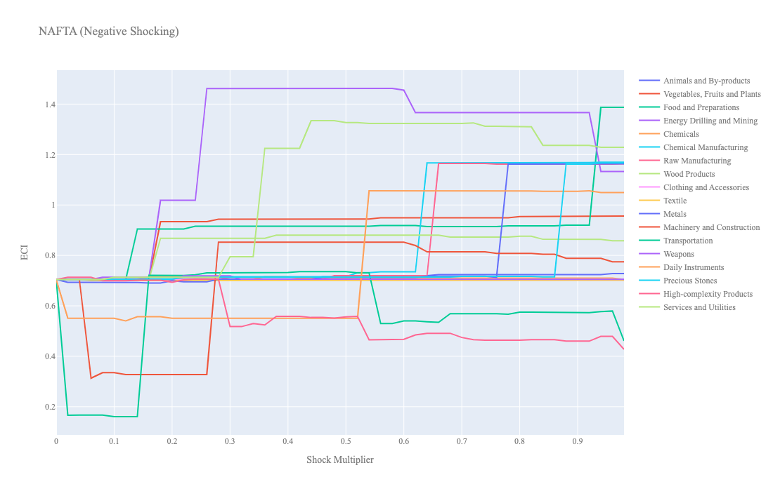
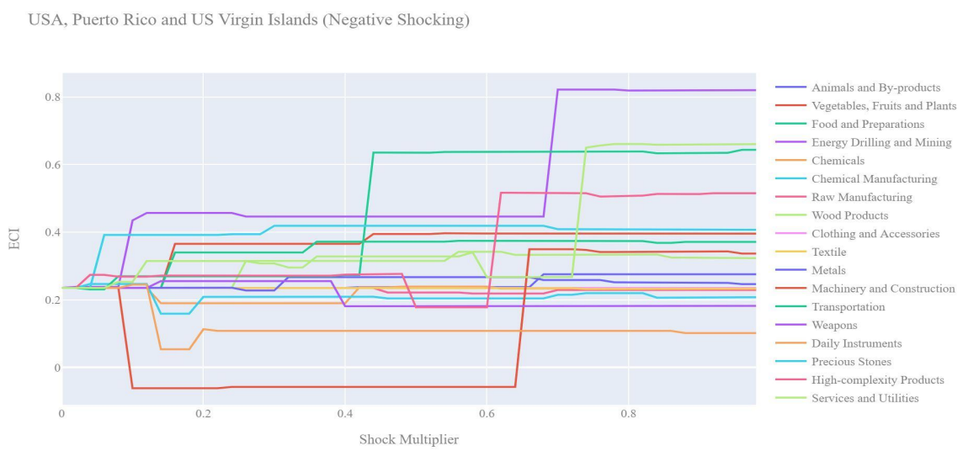
2018 Decremental:
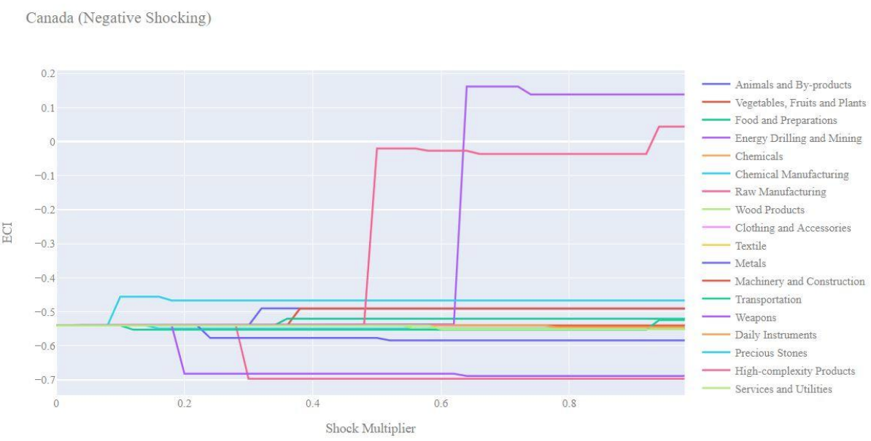
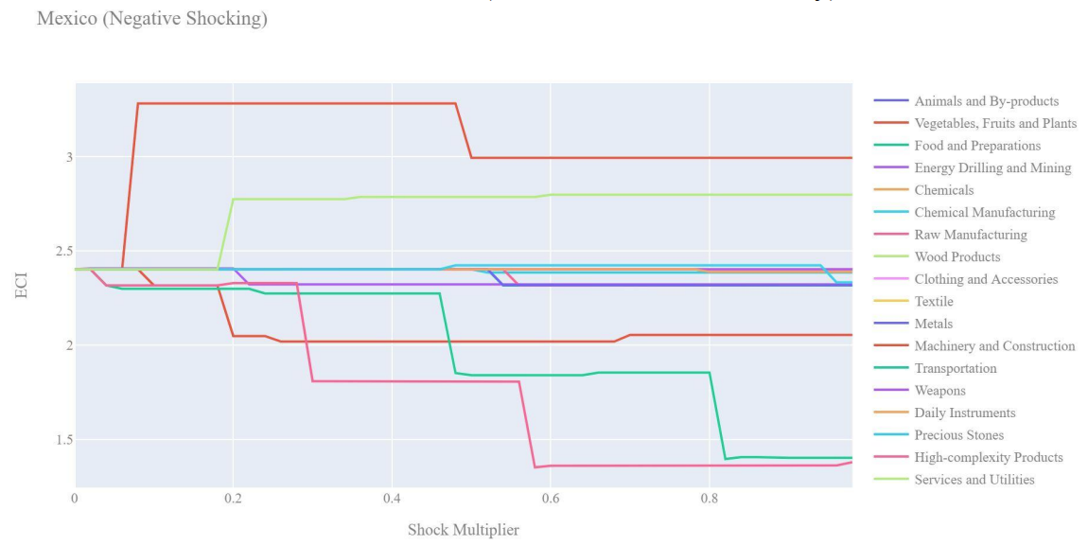
In 2018, as seen above, USMCA has a high positively-correlated sensitivity to High-complexity Products and Transportation, which is exactly in line with its constituents. What is interesting, however, is that the percent increase in ECI due to shocks in these categories is much higher for the bloc as a whole. Again, this is what we would expect, as improvements in ECI should be magnified for larger economic blocs.
For a decremental sensitivity, we see that as expected, High-complexity Products and Transportation are also correlated with a decrease in ECI. More surprising, however, is that large decreases in Energy and Drilling and Food and Preparations seems to increase ECI for the bloc as a whole. This is in stark contrast to Canada, which heavily relies on energy and drilling as improving its ECI. As a result, while it may be beneficial for the bloc to cut back on exports in Energy and Drilling, this may not be necessarily true for individual constituents.

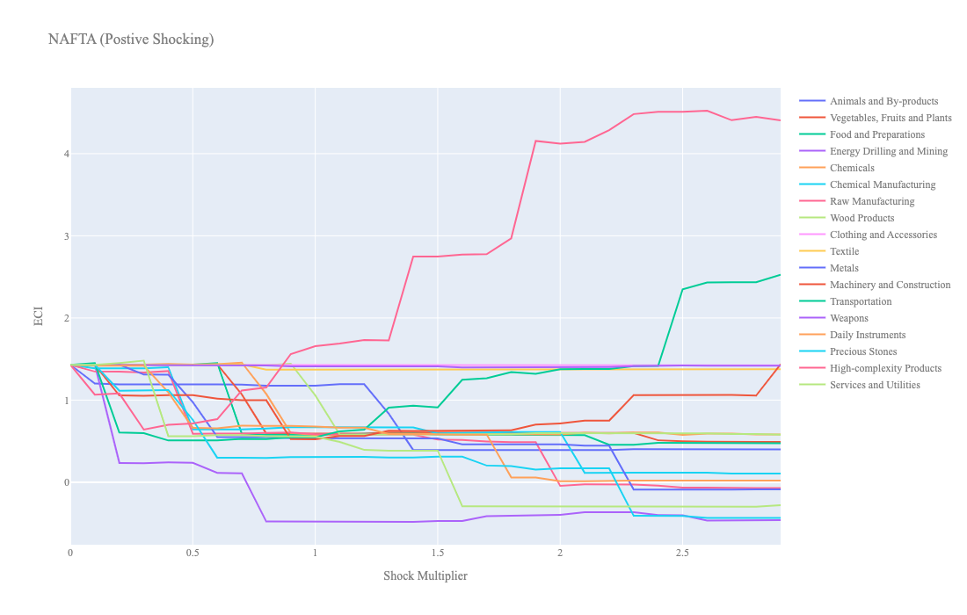
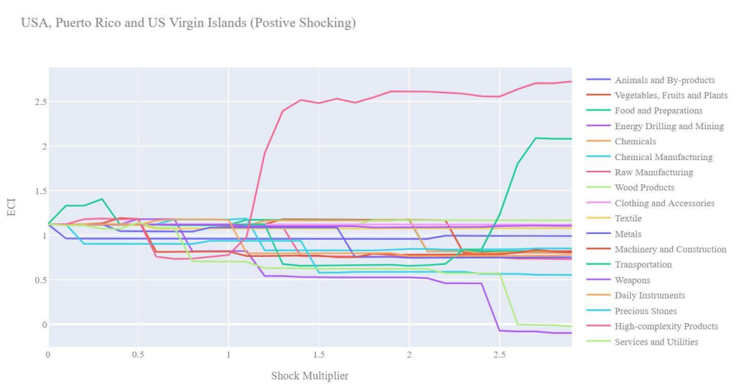
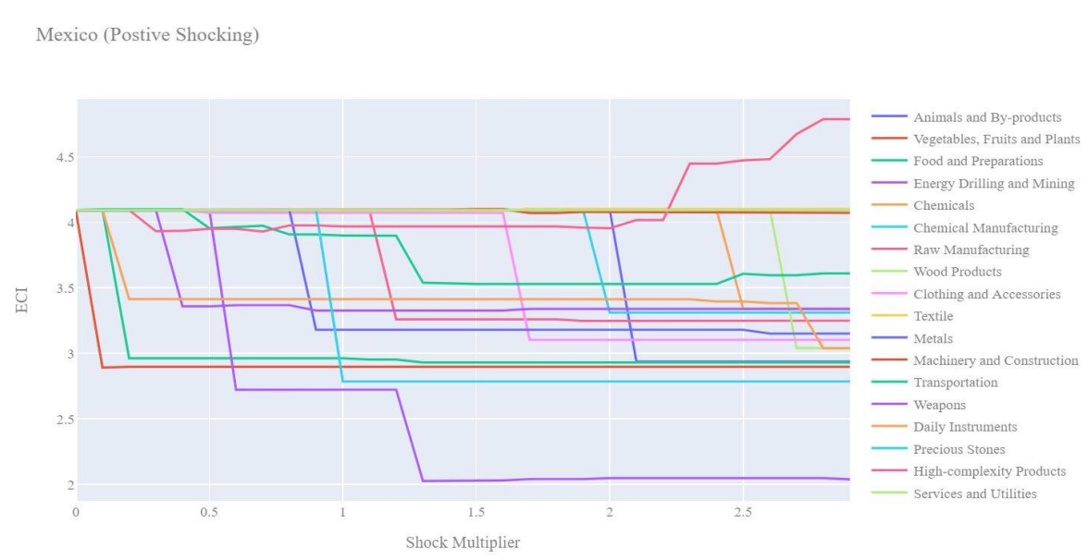
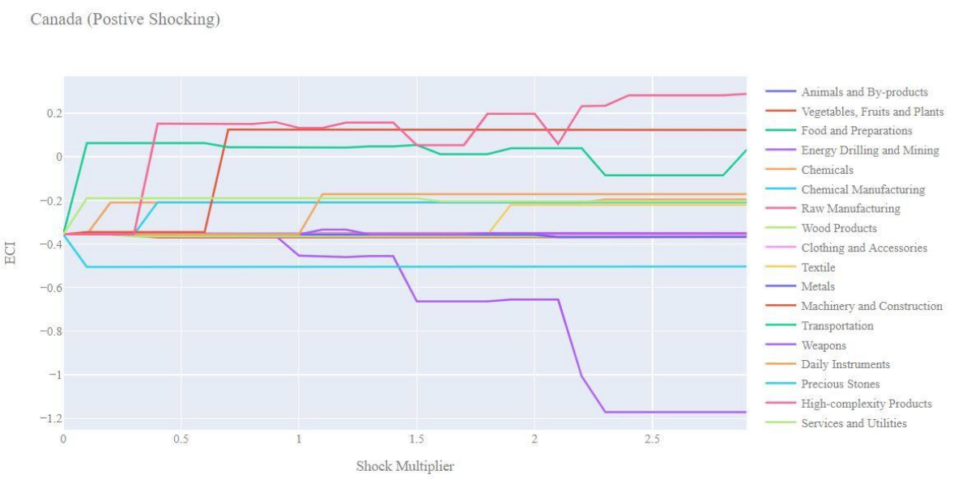
2013 Incremental:

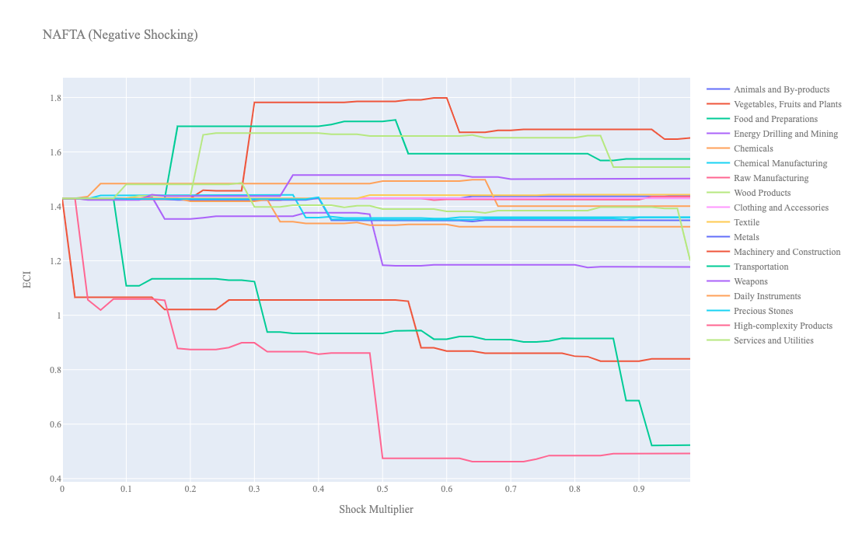
2013 Decremental:
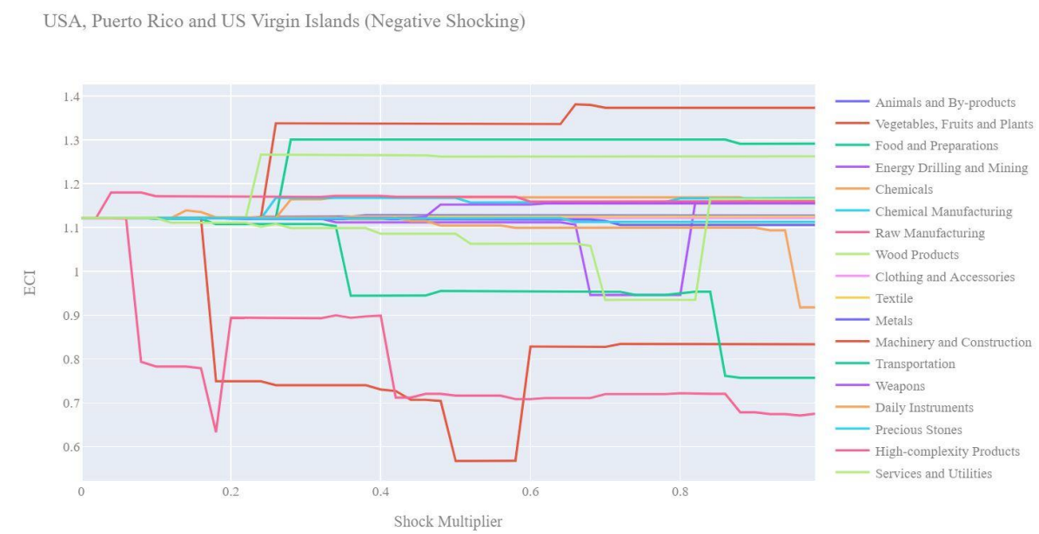
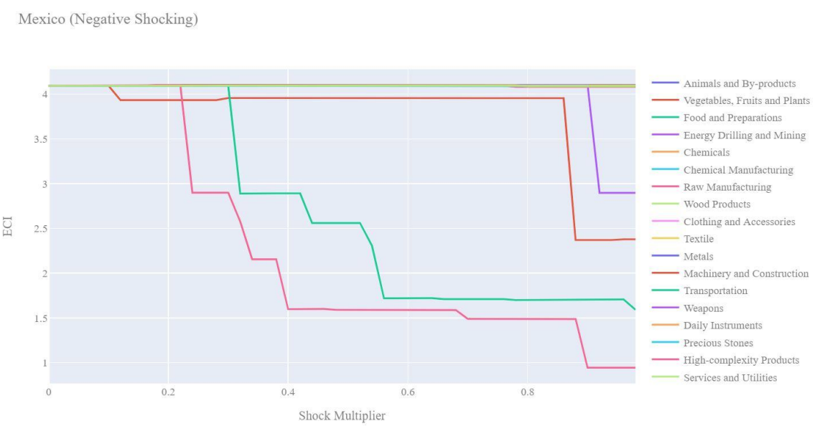
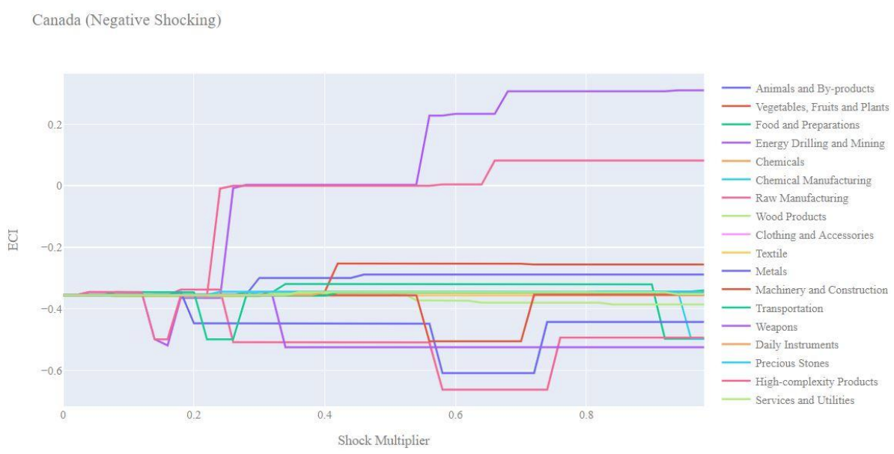
In 2013, once again, USMCA has a high positively-correlated sensitivity to High-complexity Products and Transportation, which is exactly in line with its constituents. This is also expected with economic blocs that are already highly developed and have high levels of complexity. Additionally, much like in 2018, as improvements in ECI are magnified for the economic bloc over its constituents.
For a decremental sensitivity, once again, High-complexity Products and Transportation are correlated with a decrease in ECI. Unlike 2018, however, large decreases in Vegetables/Fruits/Plants and Food and Preparations seems to increase ECI for the bloc as a whole. This means that in 2013, decreasing economic investment in Food/Preparations and Vegetables/Fruits/Plants, and instead focusing on High-complexity products and Transportation would lead to optimal gains in ECI.

Contingency Plan
We then aim to compare how the contingency plan for an entire bloc is different from those for its constituent countries. To recall, the contingency plan aims to present a set of solutions with respect to upheavals in different industries. Instead of compensating for the declining production directly, the best strategy is to develop those incipiently profitable industries. In this manner, we can derive the contingency strategy for countries to deal with possible abrupt declines of crucial industries.

The Contingency Plan aims to present a set of solutions with respect to upheavals in different industries. Instead of compensating for the declining production directly, the best strategy is to develop those incipiently profitable industries. In this manner, we can derive the contingency strategy for countries to deal with possible abrupt declines of crucial industries. In some cases, the SDV remains unchanged even when a zero-opportunity-gain industry declines to its 20% in terms of export. We can then conclude the industry is not indispensable to the country. As a clarification, the three consecutive N/As means that the country doesn’t even need to respond to a collapse in the industry. Countries tend to have distinct solutions to the up and down of the same industry. To create the contingency strategy table we decrease the export level for each industry in the country’s current production space by 60% respectively. The three highest ranking industries in the new SDV are then returned.

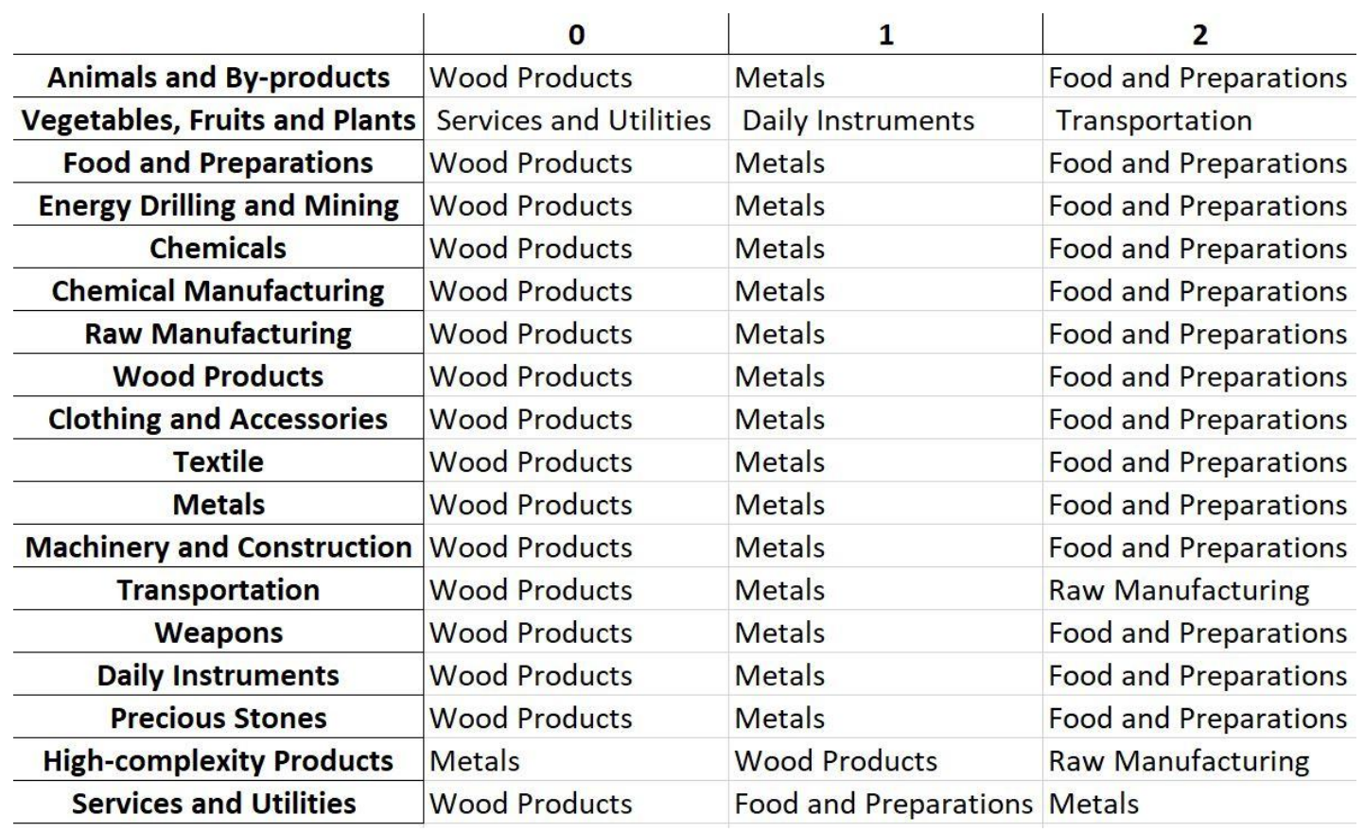
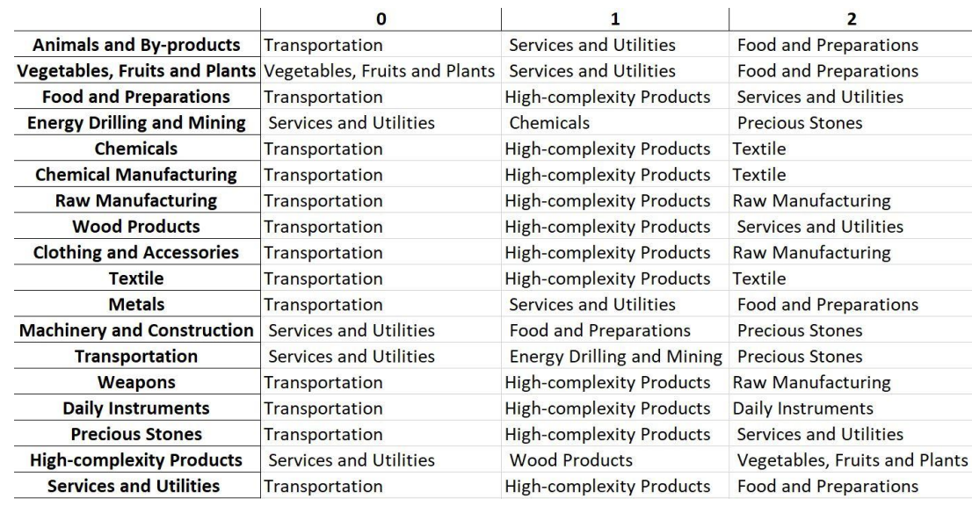
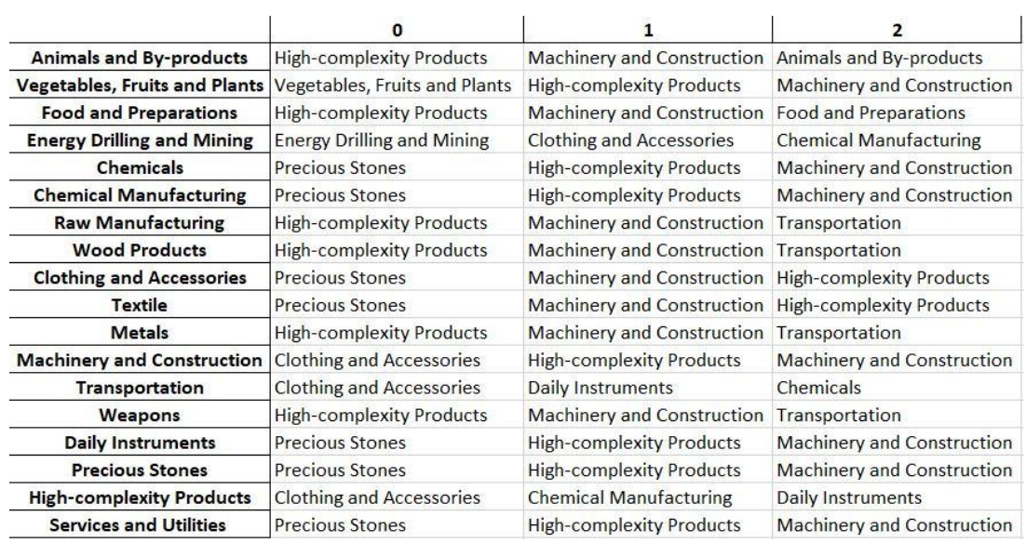
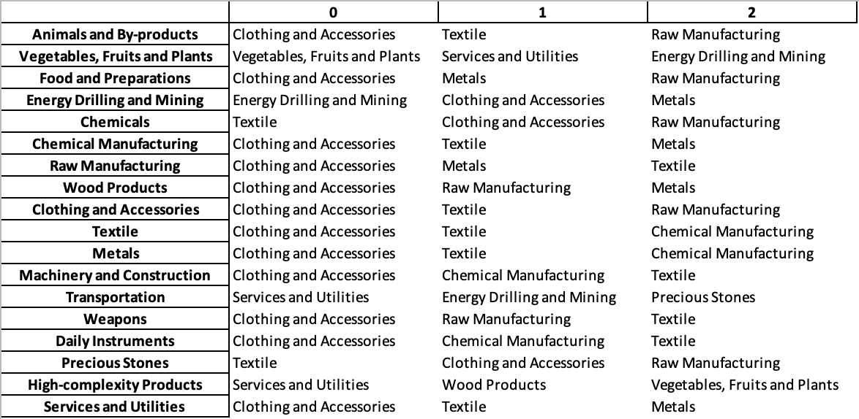
Figure 10: Contingency Strategies of USMCA, USA, Mexico, Canada (L to R, from top to bottom)

As seen by the contingency strategies of USMCA and its constituent countries, there is clearly a significant amount of variation as to what industries can act as solutions to shocks in individual industries. As a result, these results may provide an alternative form of a contingency plan for countries hoping to optimize gains for a whole bloc.

5. Macro-level Predictions

5.1 Structural Optimality Index
In order to quantitatively evaluate how effective our development strategies are and how deviations from the suggested developmental path will lead to suboptimal growth results, we define the measure – Structural Optimality Index (SOI) – on a country level as the Adjusted R-Square obtained from regressing the country’s realized industry development over the suggested development strategy. Both strategies are quantified in nature, with the realized development represented by export increase in every major industry group and the suggested development strategy represented by the opportunity gains of developing the corresponding industry groups as calculated in previous sections. The adjusted R-square from the regression thus provides us with a quantified measure of how the development path adopted by the country has fitted with/differed from calculations on a complexity level.

After obtaining this measure for all countries in our database, we further regress countries’ five-year economic growth, which is defined as the percent increase in GDP (USD), over their SOI. Figure 6 illustrates the regression output, which shows a strong positive correlation between countries’ SOI and their five-year GDP growth, significant at the 1% level and achieving an adjusted R² of 4.5%. In other words, the more a country develops as suggested by calculations on a complexity level, the better economic outcomes it achieves.

Table 18: OLS Regression Results
Dep. Variable: GDP | F-Statistic: 5.963
R²: 0.054 | Prob (F-Stat): 0.0163
Adj R²: 0.045 | No. Observations: 106

Figure 2: Regression of Five-year GDP Growth over SOI

5.2 SOI of USMCA and Its Implications
The USMCA has a moderate level of structural optimality, much like its constituent countries. As the regression in Figure 7 suggests (the red curve represents export increase and the blue curve stands for opportunity gain of the corresponding industry), USMCA demonstrates a low level of correlation with the suggested developmental path, having an adjusted R-square of around 1.25%. As seen in the charts below, this is very much in line with constituent countries, which also do a poor job of following the suggested development path. In fact, Mexico has the lowest level of correlation within the set, and Canada has the highest. In sum, this bloc’s mixed economic progress from 2013 to 2018 can be at least partially explained by a development strategy that demonstrates a poor level of matches with our suggested developmental path. In specific, the USMCA as a whole invested heavily in the Transportation industry, while it should have focused more on more industry groups such as Services and Utilities and Precious Stones. That being said, it stayed fairly in line with our expectations in the Energy Drilling/Mining and Weapons industries.

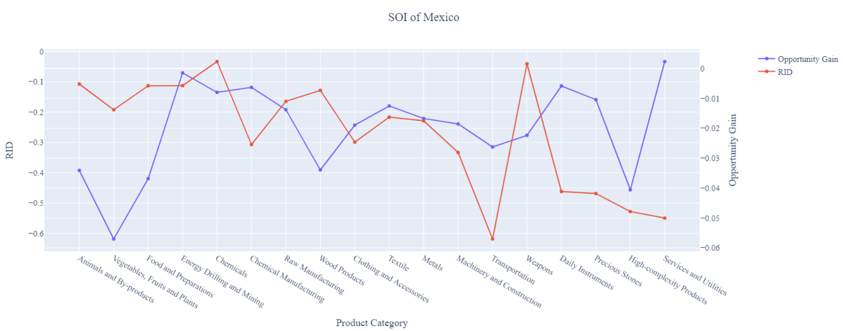
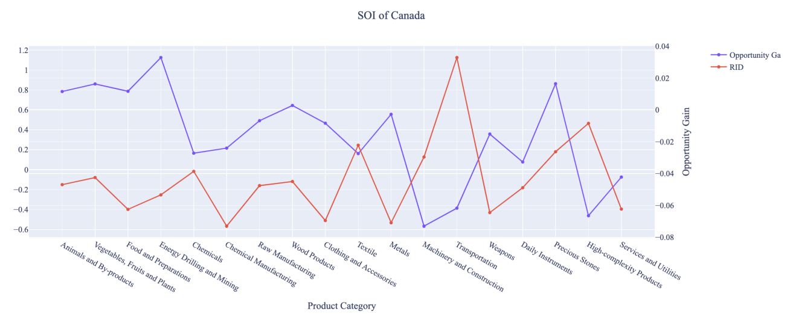
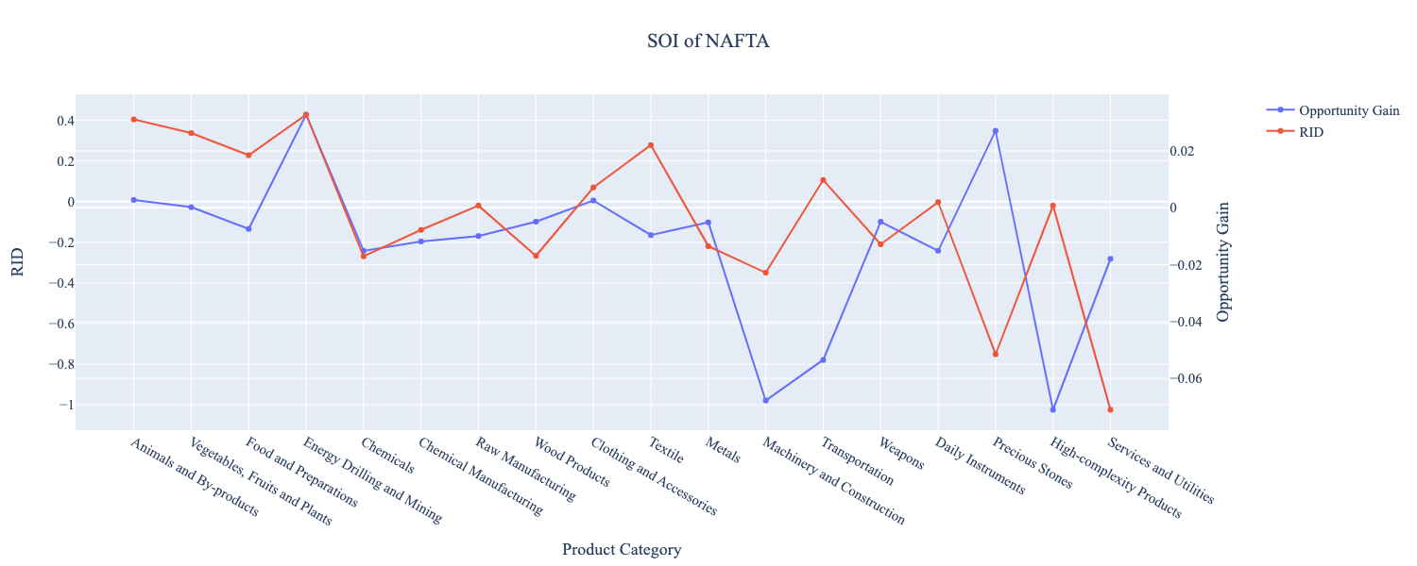
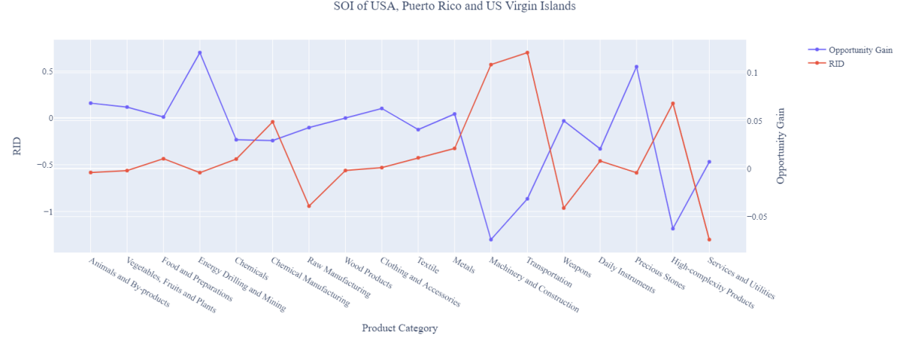
Figure 7: SOI of USMCA and Constituent Nations

6. Concluding Remarks

In conclusion, USMCA has demonstrated a low-moderate level of economic growth in terms of annual GDP increase during the period from 2013 to 2018, concurrent with a decrease in economic complexity as compared with other major developed regions.

Our analysis shows that the bloc as a whole behaves as a weighted structure of its constituents, and the resulting paths that we suggest are based upon this. We find that within the SDV, there is an increase in the number of positive-opportunity gain industries for both Mexico and the US when we look at the bloc as a whole. Additionally, we see that the allocation strategies as per our greedy algorithm are also in line with the majority of the constituent countries, but primarily the US (focus on High-complexity Products and Transportation). Finally, we note how sensitivities to industry shocks are magnified when we analyze the entire economic bloc. Additionally, industries which may be detrimental to the overall ECI of the bloc may not be as impactful on an individual country basis, as we see in the sensitivities, as well. Overall, we see that while there are certainly various paths for individual nations to optimize their ECI, alternative routes can be explored when we study entire blocs. Although they may not align to optimally enhance the ECI of any single nation, we see that by treating a bloc as a single nation, mutually beneficial paths are optimized.

References

Hausmann, R., Hidalgo, C., Bustos, S., Coscia, M., Chung, S., Jimenez, J., Simoes, A. and Yıldırım, M. (2007). The Atlas of Economic Complexity. [online] Atlas.cid.harvard.edu. Available at: http://atlas.cid.harvard.edu/.

Balassa, B., “The Purchasing Power Parity Doctrine - A Reapprais- al,” Journal of Political Economy 72, 584-596 (1964).

Feenstra, R.; Lipsey, R.; Deng, H.; Ma, A. & Mo, H. “World Trade Flows: 1962-2000” NBER working paper 11040. National Bureau of Economic Research, Cambridge MA (2005).

United Nations Commodity Trade Statistics Database (http://comtrade.un.org/db/), accessed in August 2019.

The World Economic Forum, “The global competitiveness report,” (various years).

Barro, R. & Lee, J-W. “A New Data Set of Educational Attainment in the World, 1950-2010,” NBER Working Paper No. 1590 (2010).

Kaufmann, D. & Kraay, A. “Governance Indicators: Where Are We, Where Should We Be Going?” Policy Research Working Paper 4370. Washington, DC: World Bank (2008).

Hanushek, E.A. & Woessmann, L. “The Role of Cognitive Skills in Economic Development,” Journal of Economic Literature 46(3), 607- 668 (2008).

