
https://atlas.cid.harvard.edu/

Optimal Industry Development Strategy Using Economic and Product Complexity

Estonia

─
The Economic Complexity Lab - Columbia University
Alexandra Garcia, Kelly Mi, Margarita Demkina, Allison Lin, Jane Zhang, Daniel Xu, Ryo Shibata, Navia Zhang
Haoxian Chen, Davepriyan Gunaratnam, Rohan Macherla, Ajit Akole, Shomik Ghose, Alex Wei-Liang Ku, Sannidhya Modi, Xilin Wang
Optimal Industry Development Strategy for Estonia

0. Executive Summary

In this report, we uncover the economic path Estonia went through during the period from 2013 to 2022. Specifically, we dive into the topic through a macroeconomic overview of Estonia from the perspective of Gross Domestic Product (GDP) and Economic Complexity Index (ECI), which reflect countries’ production capability and production structure, respectively. We divide the period into two subperiods: 2013-2018 and 2019-2022. These subperiods are meant to capture differences in pre- and post-pandemic economic progress and resulting optimal development paths. We find that during the period of our interest, Estonia demonstrated a moderate level of economic growth with an average annual GDP growth rate of 2.36% between 2013 and 2018 and 5.48% between 2019 and 2022, concurrent with a decrease in economic complexity in both periods, as compared with other major developed economies.

The lack of progress during the period, we believe, can be partially explained through analysis of the economic complexity structure of Estonia on the industry group level. The product classification system we adopt allows us to measure the realized development for various industry groups and to observe that Estonia consistently relied on developing the Transportation industry during the 2013-2018 period and the Textile industry in the 2019-2022 period, while its developed counterparts and emerging economies around the globe have adopted much more complex and progressive paths.

Based on our analysis of the opportunity gain and a sensitivity analysis of major industry groups, Estonia can further its gains by prioritizing Energy Drilling and Mining and Precious Stones. We further note that Estonia has a slightly mismatched development strategy that indicates a moderately high (compared to other developed countries) level of structural optimality on the complexity level, having an adjusted R-square of around 4.8% in 2018 and 4.7% in 2022. A significant positive correlation exists between GDP growth and the structural optimality index of an economy as we define and calculate, but Estonia still has a suboptimal growth experience as compared with fast-growing economies both on a regional scale and on a global scale. However, the country has the potential to further its economic gains through industrial structure optimization as suggested in the paper.

1. Report Overview

We aim to uncover the economic path Estonia went through during the periods from 2013 to 2018 and 2019 to 2022. Specifically, we dive into the topic through a macroeconomic overview of Estonia from the perspective of Gross Domestic Product (GDP) and Economic Complexity Index (ECI), which reflect countries’ production capability and production structure, respectively. We then analyze the industrial framework of Estonia during the period based on quantitative measures such as Product Complexity Index (PCI) and Product Family Complexity Index (PfCI), followed by a detailed analysis of how changes to this framework have matched with development strategies as quantitatively measured by opportunity gains on an industry-level. We conclude our report with macro-level results and predictions of Estonia, as deduced from regression models we have established on a global scale, which take into account countries’ stances in their product space.

2. Macroeconomic Results

2.1 GDP Ranking and Changes
Figure 1a illustrates the time-series GDP results for Estonia and two of its peer countries (the Lithuania, Latvia) from 2013-2018. Similar to other Baltic countries, Estonia has seen steady growth in GDP. In fact, Estonia’s average annual growth rate of 4.58% over the five-year period is clearly higher than its peers, which are 4.21% and 3.87% for Latvia and Lithuania, respectively.

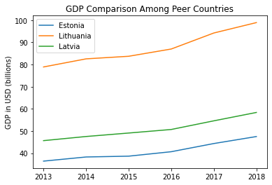

Figure 1a: GDP Comparison Among Peer Countries (2013-2018)

Figure 1b illustrates the time-series GDP results for the period of 2019-2022. Estonia observes a higher average annual growth rate of 5.48% than in the previous period. Its performance is average relative to its peers, with Latvia growing at 4.79% and Lithuania at 6.63%.
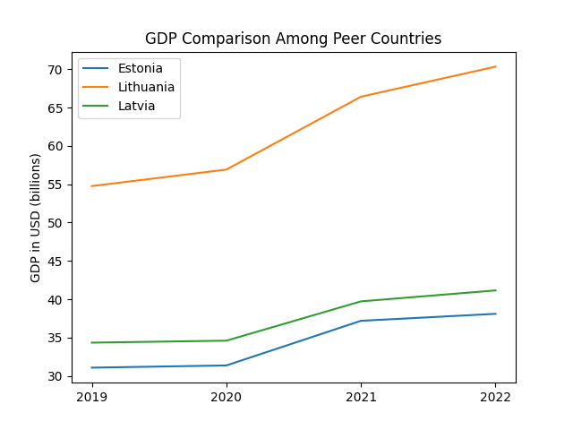

Figure 1b: GDP Comparison Among Peer Countrie (2019-2022)

2.2 ECI Ranking and Changes
The Economic Complexity Index (ECI), as defined by Ricardo Hausmann and Cesar Hidalgo in 2009 to explain the knowledge accumulated in a country's population, exhibits a similar growth pattern for Estonia. As illustrated in Figure 2a below, Estonia (-140.32% ECI change) exhibited a significant decrease in terms of its production capability from 2013 to 2018, which is similar to Lithuania (-169.63%), and similar, but significantly better than Latvia (-446.78%).
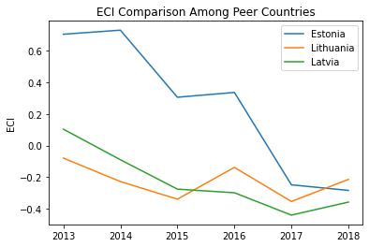

Figure 2a: ECI Comparison (2013-2018)

Figure 2b illustrates ECI changes from 2019 to 2022. Estonia exhibited a significant decrease of 338.09%, while Lithuania performed slightly better with a decrease of 170.09% and Latvia saw the only increase of 104.82%.

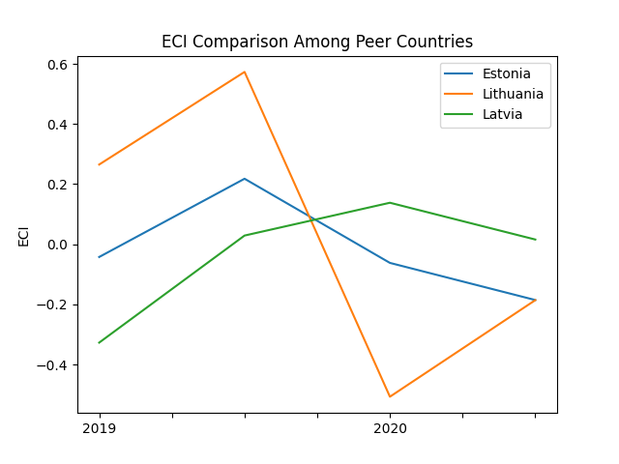

Figure 2b: ECI Comparison (2019-2022)

Figure 3a offers a further comparison of GDP Growth and ECI over the time span from 2013 to 2018 for Estonia. The increase in GDP during the period from 2013 to 2018 is accompanied by a sharp decline in ECI. The results show that the economic growth experienced by Estonia during the period from 2013 to 2018 is not very consistent with the predictions by ECI and Estonia did not effectively make strides to develop a competitive product space that helps to accumulate complicated knowledge and technology.

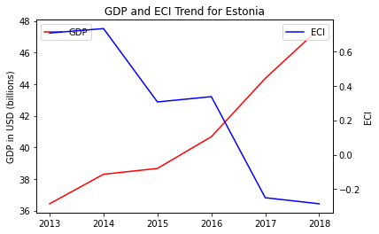

Figure 3a: GDP Growth and ECI (2013-2018)

The increase in GDP during the period from 2019 to 2022 is again accompanied by a sharp decline in ECI. The results show that the economic growth experienced by Estonia during this period is again inconsistent with the predictions by ECI. In order to provide a more concrete answer to why this has happened, we will dive into an analysis of Estonia’s production structure and its product space designs in the next few chapters.

Figure 3b: GDP Growth and ECI (2019-2022)

3. Production Analysis

3.1 Product Categorization
Our main data source in this research is the UN Comtrade Website (https://comtrade.un.org), which provides us with valuable information on countries’ export values on an annual basis, including highly specific export data for more than 5000 categories of products. In order to have a holistic vision of the product space of a country, however, a level of categorization is required. Products in our data source are labelled from 010000-999999, with the first two-digits representing a general category to which the product belongs. Based on the 99 categories as extracted from the label, we further group the products into 18 most widely-accepted industries, as summarized in Table 1.

Note that the High-complexity Products industry group is not a distinct industry but rather an aggregated industry that encompasses the most complicated products from the most technologically-advanced industries (as measured by PCI). This industry serves as an indicator for us to quantitatively evaluate how well a country has performed in developing cutting-edge technologies and closing its technical gap with advanced economies, which has become a topic of wide concern today. Indeed, when we rank the 18 categories based on PfCI (an equivalent concept of PCI as calculated based on the 18 categorized product groups), the High-complexity Products industry has the highest PfCI among all industry groups.

Category | Description
Animals and By-products | All kinds of meat, livestock and related by-products
Vegetables, Fruits and Plants | All kinds of plants, edible vegetables and fruits
Food and Preparations | Edible preparations, raw cooking materials and appliances
Clothing and Accessories | All kinds of fabrics, filament, clothing and accessories
Textiles | All kinds of textile articles and related products
Wood Products | Book, paper and other elementary products related to wood
Metals | Mining of all sorts of raw Metals
Refined and Processed Stones | Refined or processed stone products such as pearl and ceramics
Energy Drilling and Mining | Mining industry for energy, minerals, stone materials, etc.
Daily Instruments | Basic daily instruments such as sport requisites, timing and measuring tools
Raw Manufacturing | Basic products made from plastic, rubber, leather, etc.
Chemical Manufacturing | Advanced chemical products and pharmaceutical products
Chemicals | Raw chemical materials and by-products
Machinery and Construction | Machinery and mechanical appliances, including electrical equipment
Transportation | Vehicles and locomotives including aircraft, ship, railway, etc.
Weapons | Explosives, arms and ammunition
Services and Utilities | Financial, business, legal, communication, travel Services and Utilities, etc.
High-complexity Products | Agglomeration of advanced products with highest PCIs

Table 1: Categorization of Products

We further observe a positive correlation between the GDP and the export of High-complexity Products. A higher adjusted R-square exists between GDP and High-complexity Products exports, indicating that more successful economics, as measured by GDP, tend to be those that are capable of producing and exporting High-complexity Products as we define them. The Figure 3 and 4 show the OLS results in a universe of 107 and 21 typical countries respectively.

 | High-complexity Products | Food and Preparations | Animals and By-products
Adj.R-squared | 0.075 | 0.006 | 0.002
F-statistic | 9.556 | 1.638 | 1.175
No. Observations | 107 | 107 | 107

Figure 4a: OLS Regression Results of GDP against Percentage Volume of Exports

 | High-complexity Products | Food and Preparations | Animals and By-products
Adj.R-squared | 0.149 | 0.003 | -0.012
F-statistic | 4.510 | 1.059 | 0.7542
No. Observations | 21 | 21 | 21

Figure 4b: OLS Regression Results of GDP against Volume of Percentage Exports

3.2 Realized Industry Development
Based on the product categorization aforementioned, we aim to capture Estonia’s realized industry production strategy between 2013 and 2022 on a complexity level. In Hausmann and Hidalgo (2009), distance is defined to be a measure of how far a country is from a certain product not in its product space. We extend this concept to all product groups and quantify how technically equipped a country is to develop the corresponding product groups. In other words, the shorter the distance between a country and a product group, the more capable a country is in developing products within that group. Defining this net distance change as the Realized Industry Development (RID), our export data allow us to calculate and compare RID of US and the 18 product groups in 2013 and 2018 through subtraction, where a positive RID indicates a shortening of the distance (i.e., advancement of the industry), and a negative RID indicates the reverse.

Category | RID (2018) | RID (2022)
Daily Instruments | 0.175102 | -042325
Chemicals | 0.150246 | -0.008332
Weapons | 0.137998 | 0.015829
Wood Products | 0.202939 | 0.017904
Transportation | 0.141621 | -0.032846
Machinery and Construction | 0.122645 | -0.027080
Metals | 0.125644 | -0.03086
Raw Manufacturing | 0.142083 | -0.007151
Services and Utilities | 0.139673 | -0.069871
Clothing and Accessories | 0.090298 | 0.033331
Chemical Manufacturing | 0.117899 | -0.019605
Food and Preparations | 0.151571 | -0.005756
Textile | 0.121450 | 0.033331
High-complexity Products | 0.232603 | -0.004501
Vegetables, Fruits and Plants | 0.153446 | 0.014096
Animals and By-products | 0.145257 | 0.005136
Energy Drilling and Mining | 0.119497 | -0.006490
Precious Stones | 0.124609 | -0.042874

Table 2: Realized Industry Development (RID) of Estonia (2018 & 2022)

3.3 Regional and Global Comparison
Table 3 and 4 below summarize how the production strategy adopted by Estonia compares with leading economies and a selected group of emerging economies in the world, as measured in RID.

Ranking | France | US | Germany
1 | High-complexity Products | Services and Utilities | High-complexity Products
2 | Chemical Manufacturing | Weapons | Transportation
3 | Daily Instruments | Raw Manufacturing | Wood Products
4 | Animals and By-products | Precious Stones | Metals
5 | Food and Preparations | Animals and By-products | Food and Preparations

Table 3: RID Comparison across Leading Economies (2018)

Ranking | China | South Korea | Singapore
1 | High-complexity Products | Transportation | Transportation
2 | Transportation | Textile | High-complexity Products
3 | Machinery and Construction | High-complexity Products | Precious Stones
4 | Energy Drilling and Mining | Chemical Manufacturing | Daily Instruments
5 | Daily Instruments | Machinery and Construction | Services and Utilities

Table 4: RID Comparison across Emerging Economies (2018)

Table 4 further examines Estonia’s development strategy against those of emerging economies on a global scale. Reasonably, emerging economies such as China, South Korea, Singapore and India have devoted the majority of their efforts into intermediate industry groups.

4. Product Space Design

4.1 Suggested Development Vector
As aforementioned, distance gives us an idea of how far each new product is from a country’s current mix of exports. As defined in Hausmann and Hidalgo (2009), distance is “the weighted proportion of products connected to goods p that country c is not exporting, i.e., MCP=0.” Based on this definition, the distance between a country and any product that the country is currently exporting (i.e., the country is a significant exporter in the product as compared to global average) is zero. Similarly, opportunity gain quantifies the contribution of a new product in terms of opening up the doors to more and more complex products. Intuitively, a product that a country is currently exporting (i.e., MCP=1) has an opportunity gain of zero. And unreasonable investment on certain product p would lead to a relative decrement in export of more profitable products, and therefore lead to a negative opportunity gain of product p. The opportunity gain is not the only estimator of a country’s level of economic development. However, among countries with comparable economics strength, those having higher ECI, or in other words, more reasonable economics structures are often in better shape.
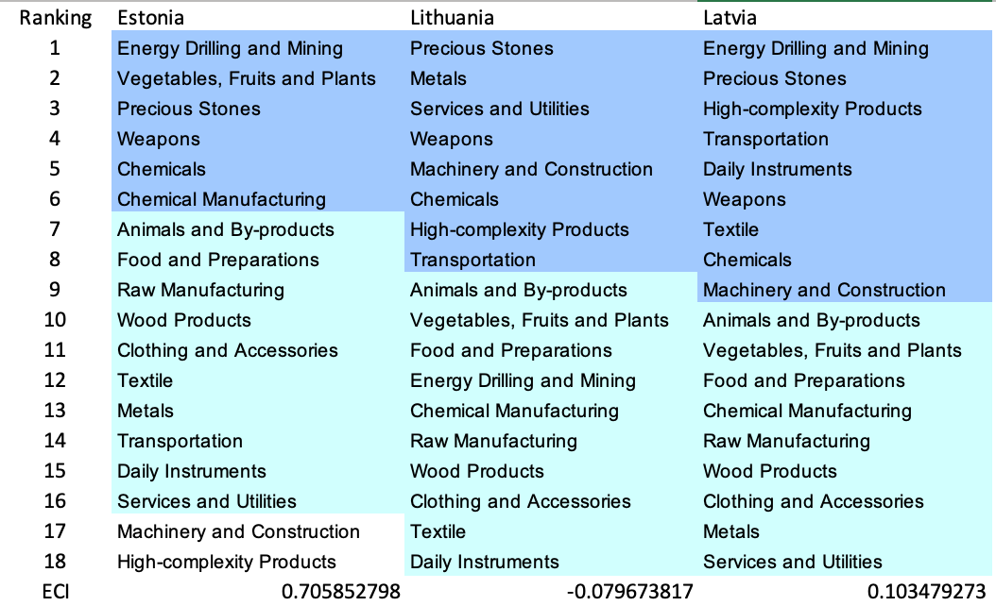

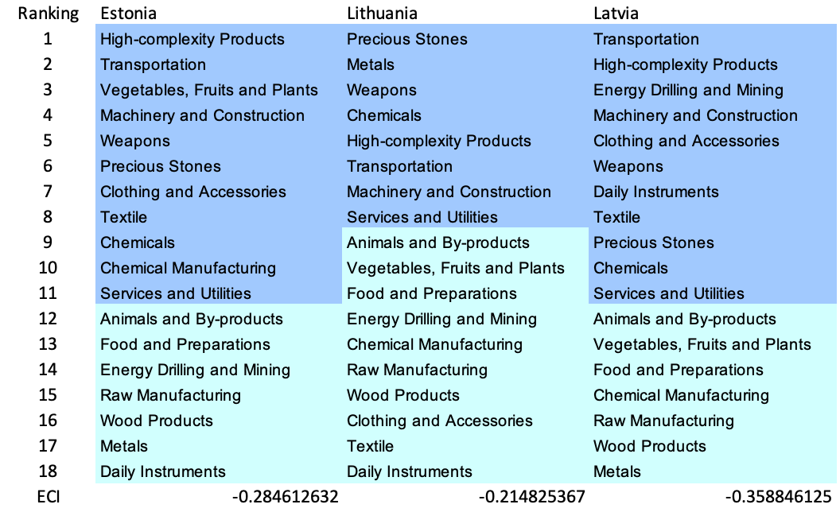

Table 5: SDV of High E_{f}CI Countries 2013(up), 2018(down)

We define the ranking of opportunity gain for a country c, as the Suggested Development Vector (SDV) of c. Table 5 and 6 summarize how the SDV of Estonia compares with a selected group of comparable and leading economies in the world, with the industry groups ranked in decreasing order of significance. Dark blue indicates positive opportunity gain, light blue indicates zero opportunity gains, and white indicates negative opportunity gains. The result shows that leading countries barely have any industries with positive opportunity gain. In other words, those countries are already in the most stable and efficient economic structure. Without the necessity of economic transition, those countries merely need to maintain a steady and balanced economic development. In contrast, developing countries have nearly half of industries with positive opportunity gain, and share common interests in industrial manufacturing and High-complexity Products industries. It can be concluded that Canada shares the characters of developing countries, with a balanced economics structure that leans towards intermediate-level industries.



Table 6: SDV of Other Typical Countries 2013

4.2 Budgeted Industry Development Strategy and Interpretation

The optimal budgeted industry development strategy aims to solve the most efficient allocations under the budgeted constraint of different situations of heuristic total export growth. In order to obtain such an allocation portfolio, we formulate an optimization problem as the following:



where k(x) is the second largest eigenvector of $M_{CC'}$ after adding $x$ to the original export vector, C is the country that we are interested in, P is the product space, B is the heuristic budget.

If we can solve this problem, then we can know what the largest ECI that a country can improve to. Accordingly, the optimal solution $x*$ that we obtain here is exactly our optimal allocation. However, the biggest problem is that the objective function is not convex. Therefore, we cannot apply the classical tools for convex optimization on this problem. In order to solve this problem, our idea is to use greedy algorithm. The way that we apply greedy algorithm is that firstly we separate the total budget into k equal parts, and then for the first equal part we try to search for the product that can optimize our objective function by iterating through each $p∈P$. After we find the optimal product p for this equal part, we add the amount back to the export value of this product p and update the ECI for this country. If we observe that ECI does not change after iterating all the products, then we can add up one more equal part to invest. Until we find there is an ECI increment, we add the amount now to that product. The rest equal parts can be done in the same way.

However, as is known to all, greedy algorithm is a kind of local search algorithm, which is pretty possible to run into a local minimum. Therefore, for local search algorithms, one typical way is to keep it away from the local minimum is to enhance the vision of the algorithm by looking more steps forward. In our setting, whenever we obtain an increment of ECI, we mark down the required amount of export growth. Simultaneously, we continue searching for the next ECI increment point, compare the ratios of these two possibilities and pick the largest one. The ratio is defined as the following:


where ${ECI}_{p}$ is just the ECI of the country after adding some amount of export increment to product $p$, which is exactly the amount that is able to make ECI change. Also, we can express it in the way of $||$$x_{p}-x_{0}$${||}_{1}$.

In this way, we can obtain a further sighted greedy algorithm. Also, the number of parts that we would like to separate the budget into also matters. In order to solve this problem, we added a stabilizer on top of the enhanced greedy algorithm, by running the algorithm for different numbers of parts and selecting the portfolio with the largest ECI increment and most complex economic structure.

Besides, it is quite common that there is a surplus for the budget. To deal with the surplus, we just add it to the product which needs the least amount of dollar to make $M_{cp}$ = 1, (i.e., the smallest amount of required export increase).

Interpretation:

For the purpose of a clear explanation of the line charts, we try to label all the products in Table 7. Please refer to this table when trying to understand the investment trajectories in the line charts.

Label | Product Names
1 | Animals and By-products
2 | Vegetables, Fruits and Plants
3 | Food and Preparations
4 | Energy Drilling and Mining
5 | Chemicals
6 | Chemical Manufacturing
7 | Raw Manufacturing
8 | Wood Products
9 | Clothing and Accessories
10 | Textile
11 | Metals
12 | Machinery and Construction
13 | Transportation
14 | Weapons
15 | Daily Instruments
16 | Precious Stones
17 | High-complexity Products
18 | Services and Utilities

Table 7: Products Labeling

Below is the economic panel for Estonia in 2013. We can see that for different percentages of heuristic total export growth, the ECIs of Estonia have a similar level of increment. Overall, 5 and 10 percent export growth result in ECI improvement from 1.12 to 1.15. However, 15 and 20 percent export growth do not experience any obvious ECI improvement, as the ECI stays at 1.15 for both.

For the case of 5 percent export growth, Machinery & Construction accounts for most of the portfolio. For 10 percent export growth, in addition to the industries that we mentioned before, more weight is put into Chemical Manufacturing. In the first ECI improvement trajectory, we also notice that the largest improvement comes from Machinery & Construction, suggesting that with a low economic improvement anticipation, Estonia should focus more on developing the industry of services and utilities. For the case of 15 and 20 percent increment budgets, we realize that the development trajectories are in a similar pattern except that there are a few additional steps when there are more budgets. Different from the previous two cases, the solutions suggest that Estonia should invest more on Vegetables, Fruits and Plants, in addition to Chemical Manufacturing. A more detailed numerical representation of the portfolio is shown in Table 8.

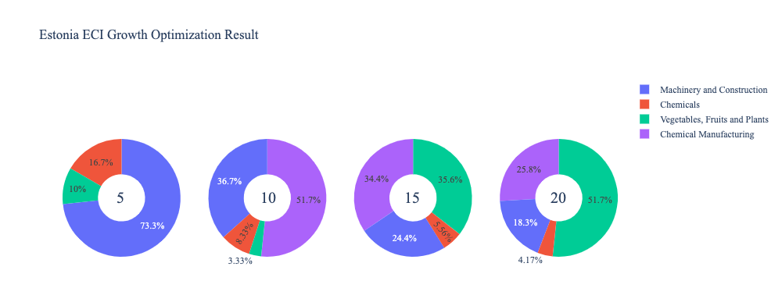
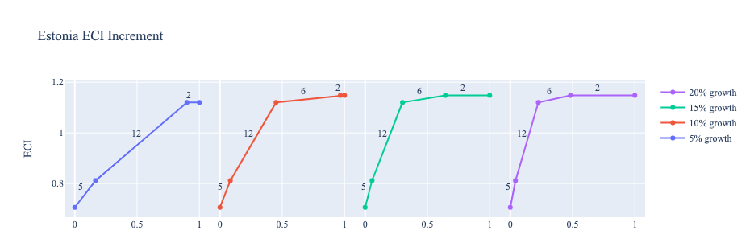

Figure 5a: Greedy Based ECI Improvement Results of Estonia in 2013 with Different Budgets

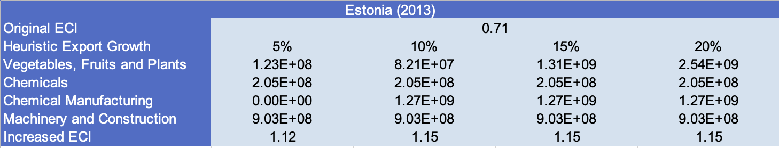

Table 8a: Portfolio of Estonia (2013)

Below is the optimization result of Estonia based on export data in 2018. There is a similar pattern for the ECI improvement trajectories, which is that the improvements in 5 and 10 percent export growth are similar, and the ones in 15 and 20 are similar. But one difference is that the main components that result in ECI improvements are not quite similar. For a 5 and 10 percent export growth, the main component includes Vegetables, Fruits and Plants. For situations with higher budgets of investment, like 15 or 20 percent of growth, the portfolios are more diverse than the previous two cases, and High-Complexity Products is the most favored industry, which makes sense as a higher budget encourages more complex production. A more detailed numerical representation of the portfolio is shown in Table 9.
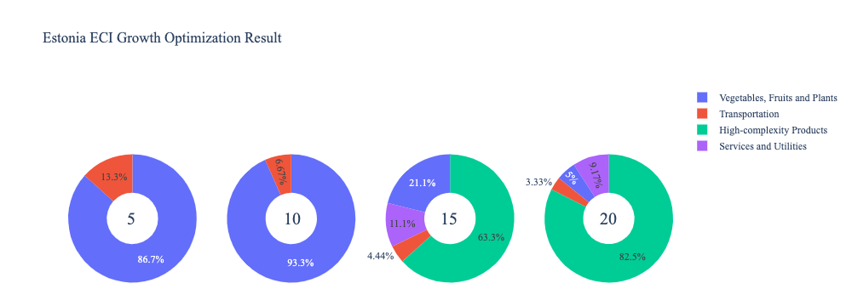
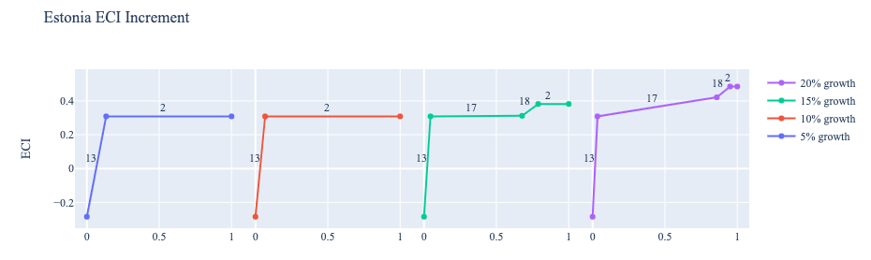

Figure 5b: Greedy Based ECI Improvement Results of Estonia in 2018 with Different Budgets

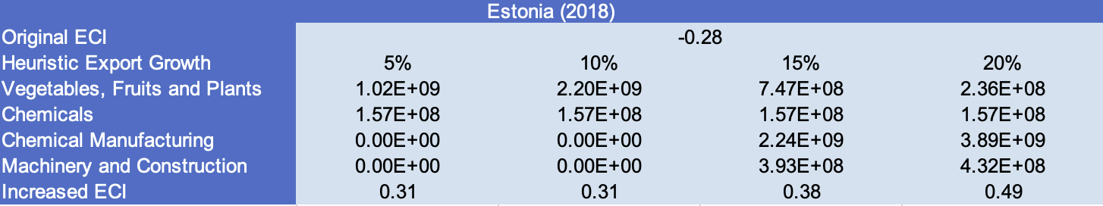
Table 8b: Portfolio of Estonia (2018)

Finally, ECI optimization based on 2022 export data is shown below. The optimal trajectory has changed significantly, with Weapons and Precious Stones becoming key industries for a 5% export growth; Machinery and Construction leading the way for 10% export growth; Weapons again dominating for 15% export growth; and finally a mix of Machinery and Construction, Textile, and High-Complexity Products optimizing the 20% export grow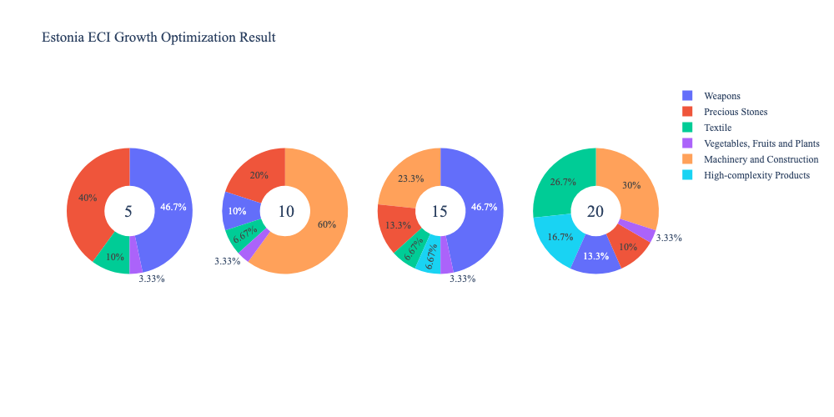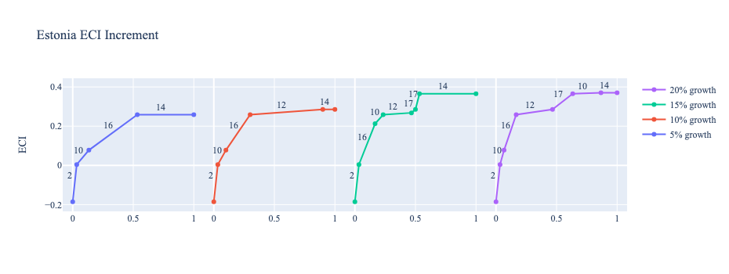
Figure 5c: Greedy Based ECI Improvement Results of Estonia in 2022 with Different Budgets

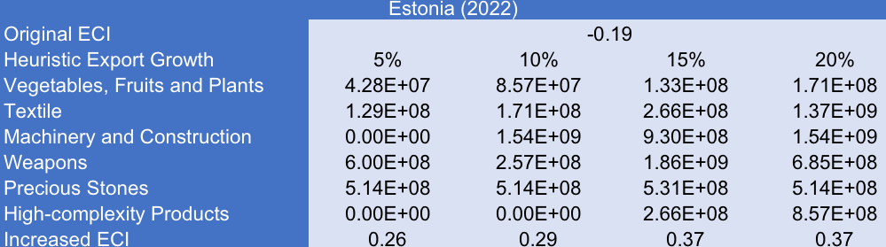Table 8c. Portfolio of Estonia (2022)

4.3 Sensitivity Analysis and Contingency Strategy
In the following section our broad aim is to understand how sensitive Estonia is to changes in export in various industries. While the Economic Complexity Index has been shown to contain valuable information about the economic strength/capacity of a country, little has been said as to the stability of the measure itself. We seek to uncover the main drivers of stability under a country's ECI score and better understand longer-term projections for ECI growth. Additionally, gaining an intuition on the industries that are bolstering an economy and the industries that offer the greatest return per unit of investment is best done through visualization of industry specific sensitivity. To this end, we have developed two categories of sensitivity analysis.
ECI Sensitivity Graph
Firstly, in order to assess the effect particular industries have on each respective country, we developed ECI Sensitivity graphs. We use shocking methodology to increment or decrement an industry’s export level by a certain percentage and recalculate the ECI all else being equal. While freezing the export dynamics of the rest of the world and enacting an instantaneous shock in export for a particular industry and country may not reflect real-life dynamics, what it does offer us is an understanding of a country’s level of dependency on an industry in the context of ECI. The shocking is done in small percentage increments in order to smooth out the resulting curve. Additionally, a recurring theme one will see is that for most industries, a breaking point occurs where the ECI either jumps upwards or downwards, creating a hockey stick shape rather than a linear trend. While the inflection point may not be accurate in the context of real life, comparing the various inflection points across industries can give us valuable insight.
The graphs are formulated as follows: There are four ECI Sensitivity graphs. The first two represent data from 2018. The first chart shows positive shocks in which export numbers are shocked upwards per industry. The X-axis is in terms of percentage shock per current dollar value of export. The Y-axis is the recalculated ECI level post-shocking. The second chart follows the same format except the X-axis represents negative shocking. In other words, exports for each industry are decremented and the ECI is accordingly recomputed. The final two sensitivity graphs show the same results using 2013 data. Below is an example of an ECI sensitivity graph.

Example 2018 (Incremental ECI Sensitivity)

SDV sensitivity
Secondly, we analyze the sensitivity of the SDV to changes in export levels. The goal is to understand how export level changes for a particular industry can affect the marginal opportunity gain for other industries. We will be using specifically High Complexity Products and Food and Preparations as our base industries. We will be increasing or decreasing the absolute export level in both of these industries and observing the effects on the SDV.
When the opportunity gain of an industry is negative, the SDV sensitivity approximates how an over-development of the industry jeopardizes the economic structure of a country. When the opportunity gain of the industry is zero, the SDV sensitivity determines whether the further development of the industry shapes the country with a better economic structure and predicts how the SDV would change accordingly. Specifically, as we reduce the export of such an industry to 25%-50% of its original value, a few other industries originally with negative opportunity gain could likely become profitable.
Similar to the ECI sensitivity graphs above, we will be shocking the export of High Complexity Products and Food and Preparations in small percentage increments. A new SDV, represented by a new column in the charts, is recorded only when a certain level of shock changes the structure of the SDV. In effect we are incrementing or decrementing export levels of two industries until the marginal opportunity gain of any industry changes in category (positive, negative, or neutral). Below is an example of a SDV Sensitivity chart with Positive Shocking. Industries with positive marginal opportunity gain are colored blue, neutral is colored white and negative is colored red.


Example High-complexity Products 2018 (Incremental SDV Sensitivity)

Contingency Plan
The Contingency Plan aims to present a set of solutions with respect to upheavals in different industries. Instead of compensating for the declining production directly, the best strategy is to develop those incipiently profitable industries. In this manner, we can derive the contingency strategy for countries to deal with possible abrupt declines of crucial industries. In some cases, the SDV remains unchanged even when a zero-opportunity-gain industry declines to its 20% in terms of export. We can then conclude the industry is not indispensable to the country. As a clarification, the three consecutive N/As means that the country doesn’t even need to respond to a collapse in the industry. Countries tend to have distinct solutions to the up and down of the same industry. To create the contingency strategy table we decrease the export level for each industry in the country’s current production space by 60% respectively. The three highest ranking industries in the new SDV are then returned.

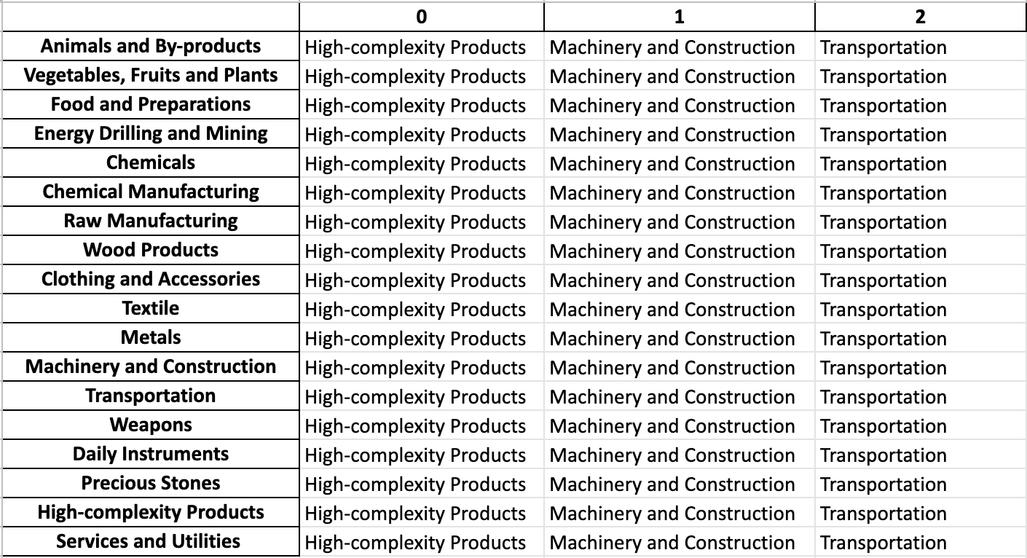
Example Contingency Strategy 2018

4.3 Sensitivity Analysis Results and Interpretation

Below are Estonia’s 2022 ECI Sensitivity Charts. The chart showing sensitivity to a positive shocking illustrates how increases in Energy Drilling and Mining leads to the most significant uptrend in ECI.

The Negative Shock chart shows again that Estonia is highly sensitive regarding the Energy Drilling and Mining industry, which significantly decreases ECI in the case of a drawdown.
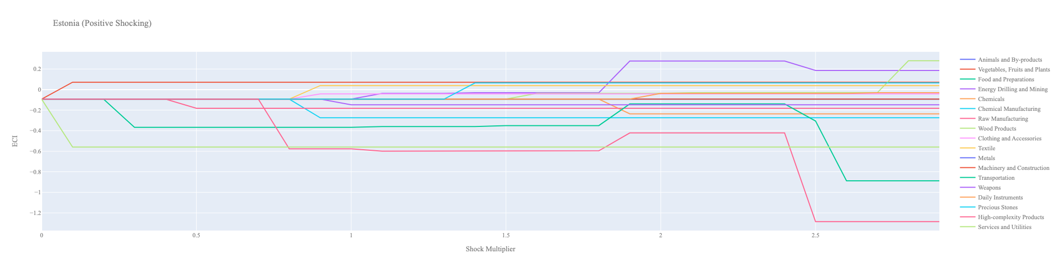Estonia Incremental ECI Sensitivity (2022)

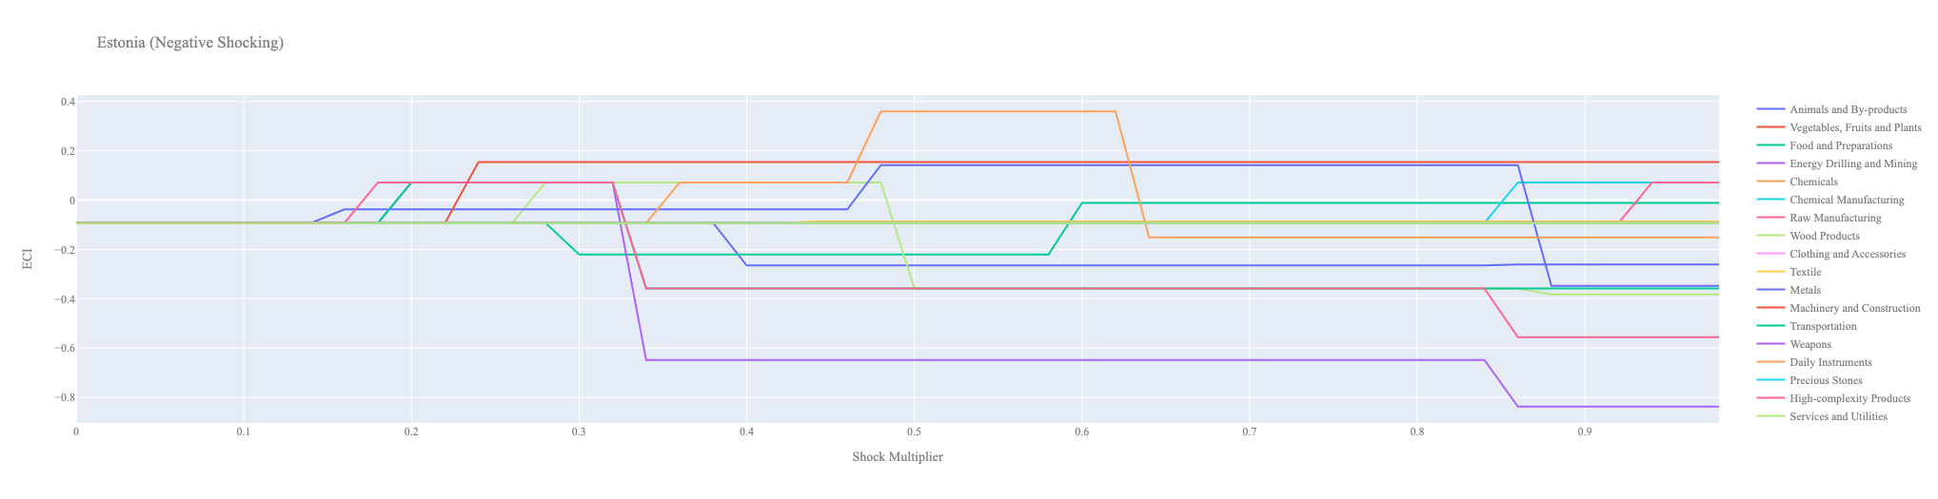
Estonia Decremental ECI Sensitivity (2022)

Estonia’s 2018 ECI Sensitivity Charts. Firstly in the positive chart, we notice immediately that increases in High Complexity Product, Food and Preparations, and Machinery lead to an uptrend in ECI. High Complexity Products offer the best ECI growth per unit of export increase. All other industries tend to not greatly affect the ECI level making it fairly clear which industries to pursue.

Next we consider Estonia’s 2018 Negative Shock chart. We see that Estonia’s ECI is slightly sensitive to drawdowns in Wood Products and Animals / By-products. More interestingly, we see that large decreases in Energy, Drilling, and Mining, Metals and Food / Preparations seem to greatly increase the ECI score. These industries are three very important industries for Estonia’s economy and thus the results that are reflected in the chart may be suggesting that there is another industry that could be very beneficial for Estonia that is far in proximity from Metals and the Energy industry.

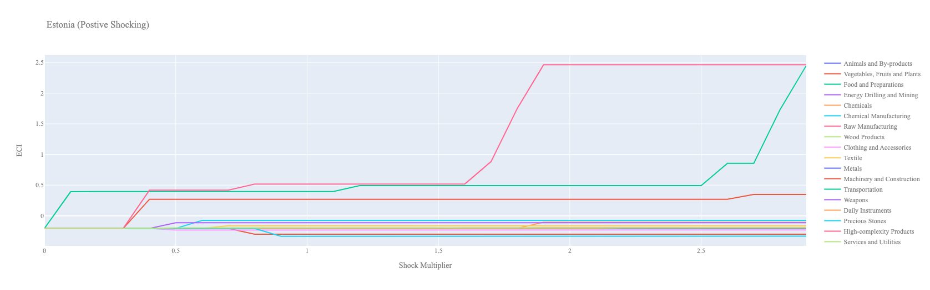
Estonia Incremental ECI Sensitivity (2018)
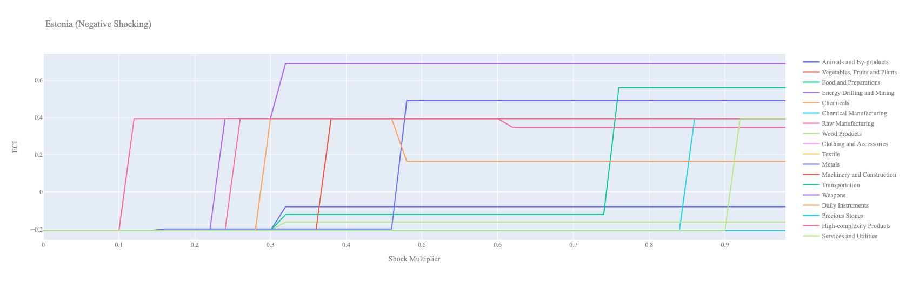
Estonia Decremental ECI Sensitivity (2018)

Next we consider the 2013 ECI Sensitivity graphs. We see that in the positive shocking case, the landscape of ECI sensitivity changes a bit over the five year period, with High complexity products and Machinery seeming to offer the best ECI growth prospects. Transportation does not affect ECI levels as positively as in 2018.

In the 2013 negative shocking case, we see that again Estonia is very sensitive to drawdowns in High Complexity Products and Energy, Drilling, and Mining.

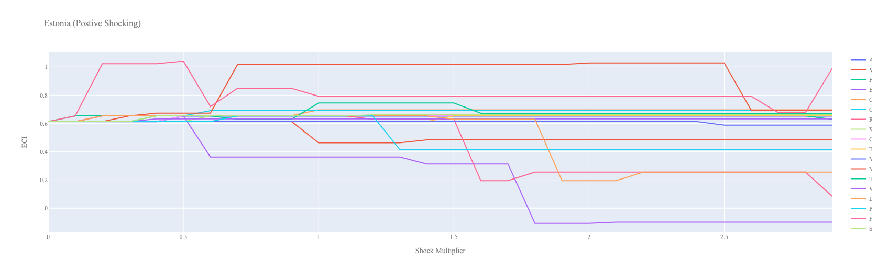
Estonia Incremental ECI Sensitivity (2013)

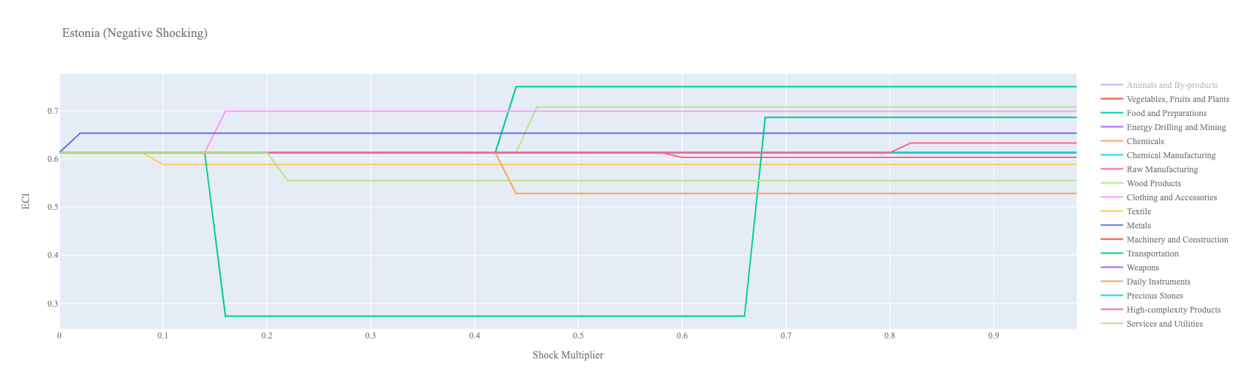

Estonia Decremental ECI Sensitivity (2013)

Below we see the SDV sensitivity charts for High Complexity Products. We see that increasing the export of High Complexity Products opens up few positive opportunity gain industries for Estonia to move into. After about a 150% increase, no industries within the SDV have positive opportunity gain.

In the negative High Complexity Product SDV chart, we see that as we decrease the export of High Complexity Products, the number of industries with positive opportunity gain shrink suggesting that the opportunities available to Estonia are highly dependent on its High Complexity Product footprint.

Concerning Precious Stones, Canada seems to be mostly insensitive to this industry suggesting that this is not an important industry in terms of the stability of its SDV.

Estonia High-complexity Products 2018 (Incremental SDV Sensitivity)

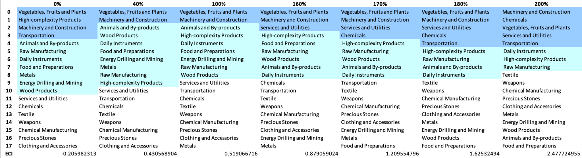
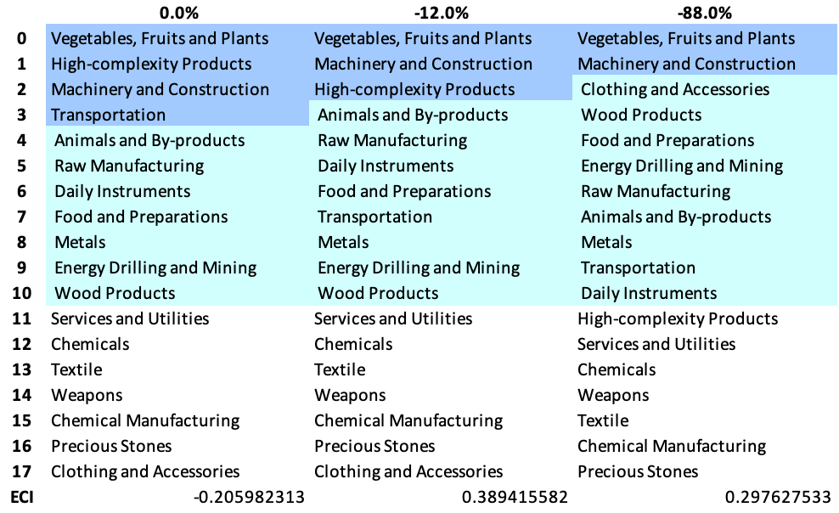
Estonia High-complexity Products 2018 (Decremental SDV Sensitivity)
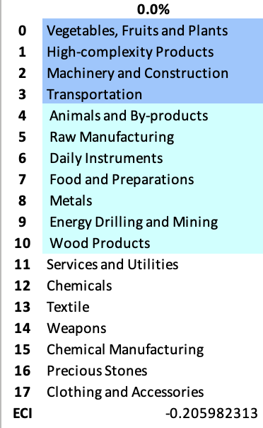
Estonia Precious Stones 2018 (Incremental SDV Sensitivity)

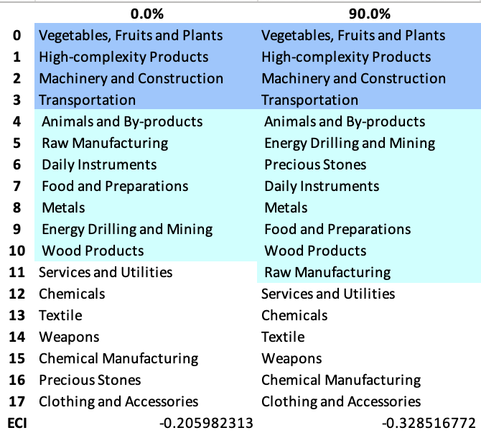
Estonia Precious Stones 2018 (Decremental SDV Sensitivity)

4.4 Contingency Strategy

Decreasing export of each industry in Estonia’s 2018 production space by 60%, we derive the contingency strategy shown below.

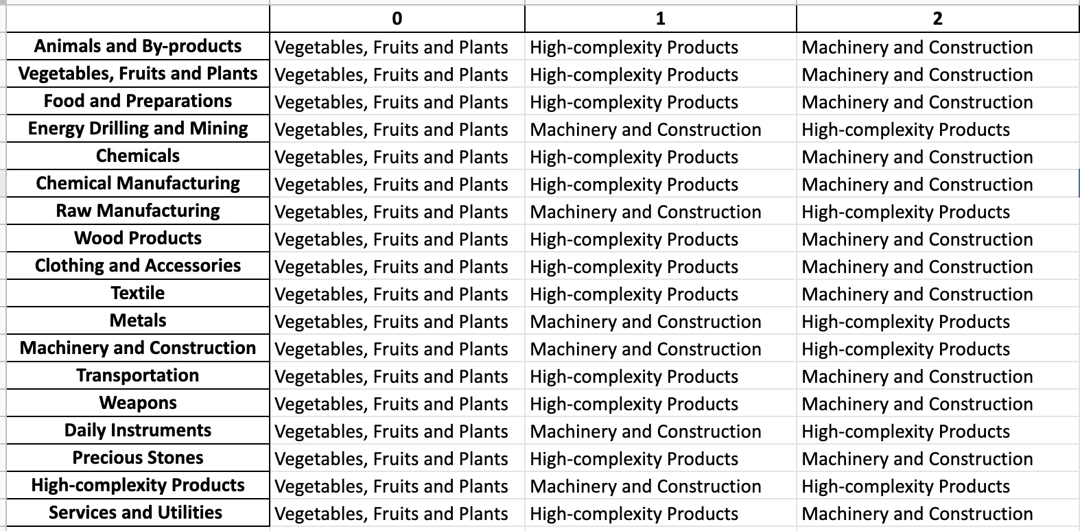

Estonia Contingency Strategy (2018)

We suspect this contingency strategy would have been an optimal implementation during the economic shock brought upon by the 2020 COVID-19 pandemic. Yet, as shown in the following section on structural optimality, Estonia’s industry development strategy during the period of 2019-2022 did not follow such a path. This may be a reason for its lower ECI at the end of this period.

5. Macro-level Predictions

5.1 Structural Optimality Index
Indeed, such choice of prioritization has proven to be a significant factor in deciding the economic outcomes of countries. In order to quantitatively evaluate how effective our development strategies are and how deviations from the suggested developmental path will lead to suboptimal growth results, we define the measure – Structural Optimality Index (SOI) – on a country level as the Adjusted R-Square obtained from regressing the country’s realized industry development over the suggested development strategy. Both strategies are quantified in nature, with the realized development represented by export increase in every major industry group and the suggested development strategy represented by the opportunity gains of developing the corresponding industry groups as calculated in previous sections. The adjusted R-square from the regression thus provides us with a quantified measure of how the development path adopted by the country has fitted with/differed from calculations on a complexity level.

After obtaining this measure for all countries in our database, we further regress countries’ five-year economic growth, which is defined as the percent increase in GDP (USD), over their SOI. Figure 6 illustrates the regression output, which shows a strong positive correlation between countries’ SOI and their five-year GDP growth, significant at the 1% level and achieving an adjusted R² of 4.5%. In other words, the more a country develops as suggested by calculations on a complexity level, the better economic outcomes it achieves.

Table 18: OLS Regression Results
Dep. Variable: GDP | F-Statistic: 5.963
R²: 0.054 | Prob (F-Stat): 0.0163
Adj R²: 0.045 | No. Observations: 106

Figure 6: 2013-2018 Regression of Five-year GDP Growth over SOI

5.2 SOI of Estonia and Its Implications
Estonia for instance, has a low level of structural optimality as compared with its developing peers. As the regression in Figure 7a suggests (the red curve represents export increase and the blue curve stands for opportunity gain of the corresponding industry), Estonia demonstrates a low level of correlation with the suggested developmental path, having an adjusted R-square of around 4.8% in 2018 and 4.7% in 2022. Estonia ranks in the bottom half among all countries in terms of SOI but has made a consistent rate of economic progress among its developed peers with an average annual GDP growth rate of 2.36% between 2013 and 2018 and 5.48% between 2019 and 2022, consistent with the regression result in Figure 6. In sum, Estonia’s mixed economic progress from 2013 to 2022 can be at least partially explained by a development strategy that demonstrates a decent, but not perfect, level of matches with our suggested developmental path. Specifically, during 2013-2018, Estonia invested heavily in the High-complexity Products industry, while it should have focused more on less complex industry groups such as Energy Drilling and Mining and Precious Stones. In 2019-2022, Estonia focused on the Clothing and Accessories and Textile industries, while it should have again invested in the Energy Drilling and Mining and Precious Stones industries, as depicted in Figure 7b.

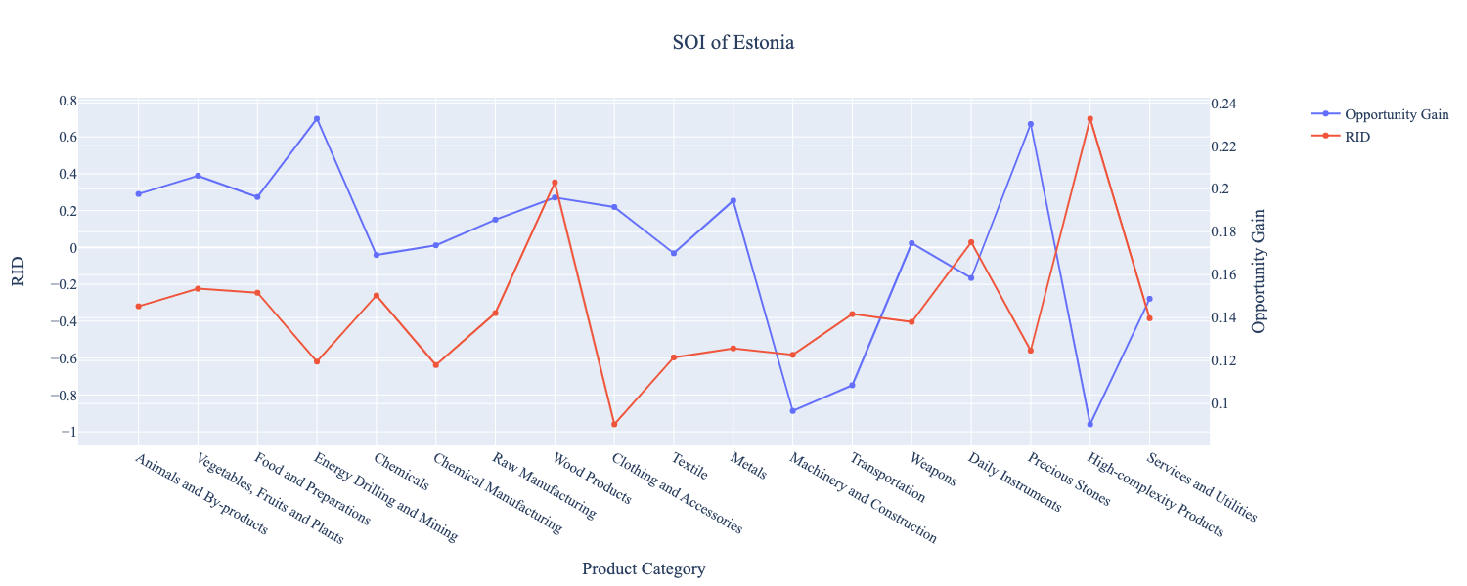
Figure 7a: SOI of Estonia (2013-2018)

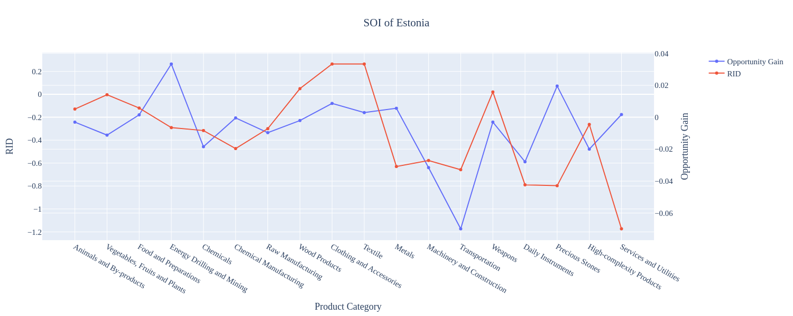
Figure 7b: SOI of Estonia (2019-2022)

6. Concluding Remarks

In conclusion, Estonia has demonstrated a mixed level of economic growth in terms of annual GDP increase during the period from 2013 to 2022, as it attempts to increase economic complexity as compared to other major developing economies.

The mixed rate of progress during the period, we believe, can be partially explained through analysis of the economic and product complexity structure of Estonia on the industry group level. The product classification system we adopt allows us to measure the realized industry development for various industry groups and to observe that Estonia consistently relied on developing High-complexity products during the period of 2013-2018 and Textile and Clothing and Accessories during the period of 2019-2022. While this did allow for strong economic growth, development was not optimal.

Based on our analysis of the opportunity gain and a sensitivity analysis of major industry groups, Estonia can further its gains by prioritizing Energy Drilling and Mining, as well as Precious Stones industries. We further note that Estonia has a highly mismatched development strategy that indicates an average (compared to other developed countries) level of structural optimality on the complexity level, having an adjusted R-square of around 4.8% and 4.7% for 2013-2018 and 2019-2022, respectively. Since a significant positive correlation exists between five-year GDP growth and the structural optimality index of an economy as we define and calculate, Estonia has a suboptimal growth experience as compared with fast-growing economies both on a regional scale and on a global scale, and has the potential to further its economic gains through industrial structure optimization as suggested in the paper.

References

Hausmann, R., Hidalgo, C., Bustos, S., Coscia, M., Chung, S., Jimenez, J., Simoes, A. and Yıldırım, M. (2007). The Atlas of Economic Complexity. [online] Atlas.cid.harvard.edu. Available at: http://atlas.cid.harvard.edu/.

Balassa, B., “The Purchasing Power Parity Doctrine - A Reapprais- al,” Journal of Political Economy 72, 584-596 (1964).

Feenstra, R.; Lipsey, R.; Deng, H.; Ma, A. & Mo, H. “World Trade Flows: 1962-2000” NBER working paper 11040. National Bureau of Economic Research, Cambridge MA (2005).

United Nations Commodity Trade Statistics Database (http://comtrade.un.org/db/), accessed in August 2019.

The World Economic Forum, “The global competitiveness report,” (various years).

Barro, R. & Lee, J-W. “A New Data Set of Educational Attainment in the World, 1950-2010,” NBER Working Paper No. 1590 (2010).

Kaufmann, D. & Kraay, A. “Governance Indicators: Where Are We, Where Should We Be Going?” Policy Research Working Paper 4370. Washington, DC: World Bank (2008).

Hanushek, E.A. & Woessmann, L. “The Role of Cognitive Skills in Economic Development,” Journal of Economic Literature 46(3), 607- 668 (2008).

