
https://atlas.cid.harvard.edu/

Optimal Industry Development Strategy Using Economic and Product Complexity

Finland

─
The Economic Complexity Lab - Columbia University
Alexandra Garcia, Kelly Mi, Margarita Demkina, Allison Lin, Helena Yang, Jane Zhang, Daniel Xu, Ryo Shibata, Navia Zhang
Haoxian Chen, Davepriyan Gunaratnam, Rohan Macherla, Ajit Akole, Shomik Ghose, Alex Wei-Liang Ku, Sannidhya Modi, Xilin Wang
Optimal Industry Development Strategy for Finland

0. Executive Summary

In this report, we aim to uncover the economic path Finland went through during the period from 2013 to 2022. Specifically, we dive into the topic through a macroeconomic overview of Finland from the perspective of Gross Domestic Product (GDP) and Economic Complexity Index (ECI), which reflect countries’ production capability and production structure, respectively. We find that during the period of our interest, Finland demonstrated a declining level of economic growth with an average annual GDP growth rate of 2.84% between 2013 and 2018 and 1.22% between 2019 and 2022, with a much lower economic complexity compared to other major Scandinavian economies.

The lack of progress during the period can be partially explained through analysis of the economic and product complexity structure of Finland on the industry group level. The product classification system we adopt allows us to measure the realized development for various industry groups and to observe that Finland consistently relied on developing the Vegetables, Fruits, and Plants industry during the period, while its developed counterparts and emerging economies around the globe have adopted much more complex and progressive paths.

Based on our analysis of the opportunity gain and a sensitivity analysis of major industry groups, Finland can further its gains by prioritizing High Complexity Products and Transportation. We further note that Finland has a strongly mismatched development strategy that indicates a low (compared to other developed countries) level of structural optimality on the complexity level, having an adjusted R-square of around 0.64%. A significant positive correlation exists between five-year GDP growth and the structural optimality index of an economy as we define and calculate, but Finland has a suboptimal growth experience as compared with fast-growing economies both on a regional scale and on a global scale. However, the country has the potential to further its economic gains through industrial structure optimization as suggested in the paper.

Four years later, in 2022, its focus should have shifted to Textile and Chemical Manufacturing industries, which are also one of the more developed industries at the time. We further note that Finland has a slightly mismatched development strategy that indicates a similar lower level (compared to other Scandinavian countries) of structural optimality on the complexity level, having an adjusted R-square of around 0.064 in 2018 and a much higher score of 0.090 in 2022, demonstrating a very slight improvement in development. Since a significant positive correlation exists between GDP growth and the structural optimality index of an economy as we define and calculate, Finland indeed has a suboptimal growth experience as compared with fast-growing economies both on a regional scale and on a global scale and has the potential to further its economic gains through industrial structure optimization as suggested in the paper.

The four years between 2019 and 2022 showed a subtle improvement in Finland's economic growth, boosting its position on the global scale. Its GDP slightly surpassed the pre-pandemic levels, but it saw a significant decline in the ECI in line to its peer countries. Its current strategy still has little viable potential upside to increase country’s performance and optimize its structure further.

1. Report Overview

In this report, we aim to uncover the economic path Finland went through during the period from 2019 to 2022, before and after the COVID pandemic and Russia’s invasion of Ukraine, compared to its performance from 2013 to 2018. Specifically, we dive into the topic through a macroeconomic overview of Finland from the perspective of Gross Domestic Product (GDP) and Economic Complexity Index (ECI), which reflect countries’ production capability and production structure, respectively. We then analyze the industrial framework and changes of Finland during the period based on quantitative measures such as the Product Complexity Index (PCI) and Product Family Complexity Index (PfCI), followed by a detailed analysis of how such changes have matched with development strategies as quantitatively measured by opportunity gains on an industry-level. We conclude our report with macro-level results and predictions of Finland, as deduced from regression models we have established on a global scale, which take into account countries’ stances in their product space.

2. Macroeconomic Results

2.1 GDP Ranking and Changes
Figure 1a illustrates the time-series GDP results for Finland and three of its peer countries (Sweden, Norway, and Denmark) from 2013 to 2018. Similar to the other countries, Finland displayed an eventual upward trend over the period; however, its growth was lower than its peers’ growth. Finland’s average annual GDP growth rate (2.84%) is in the less that 3.44%, 0.54%, and 3.57% for Sweden, Norway, and Denmark respectively.

Figure 1b shows the GDP levels for Finland and its peer countries from 2019 to 2022. Unlike the other countries, Finland displayed a slight growth in GDP from 2019 to 2020 despite of the pandemic, with GDPs declining in 2022. Over these four years, Finland’s average annual GDP growth rate (1.22%) is again less than its peers with 2.72%, 10.32%, and 3.49% for Sweden, Norway, and Denmark respectively. It is notable that the GDP levels in Finland only slightly improved since 2013.

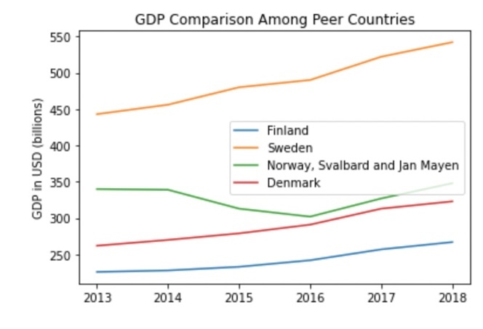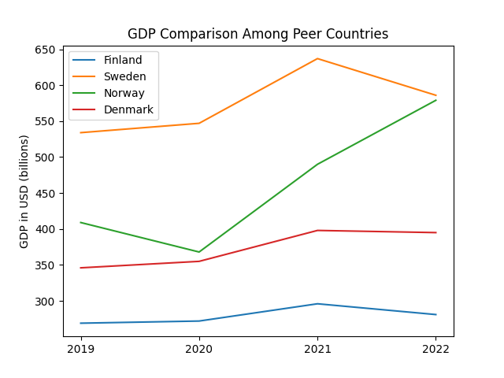
Figures 1a and 1b. GDP Comparison Among Peer Countries (left: 2013-2018; right: 2019-2022)

2.2 ECI Ranking and Changes
The Economic Complexity Index (ECI), as defined by Ricardo Hausmann and Cesar Hidalgo in 2009 to explain the knowledge accumulated in a country's population, is illustrated in Figures 2a and 2b.

As shown, Finland (-30.73% ECI change) exhibited a decrease in terms of its production capability from 2013 to 2018, which is somewhat similar to Sweden (-23.78%), and Denmark (-40.2%) but different from Norway (-275.6%). Ultimately, Finland performs moderately amongst its peer country set, as it displays a median GDP growth rate and ECI change across the period.

The comparable countries experienced a small increase in ECI level between 2019 and 2020, with a sharp decrease between 2020 and 2022. Finland exhibits an even larger decrease in production capability in 2022 with poor post-COVID recovery and the Russian-Ukrainian war being some of the reasons. Finland has seen a 264.2% decrease in its ECI, which is less than 266.9% for Sweden, but more than Denmark’s’ -218.1% and Norway’s’ +230.0%.

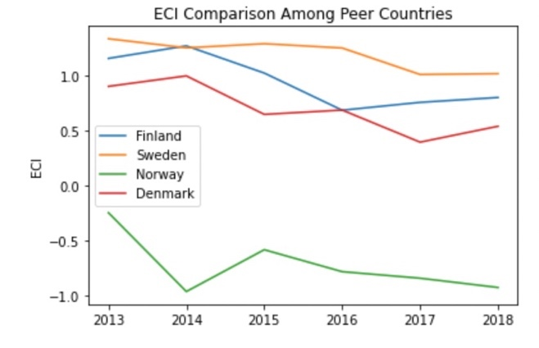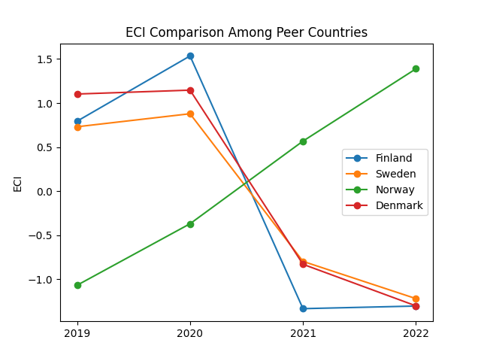
Figures 2a and 2b. ECI Comparison Among Peer Countries (left: 2013-2018; right: 2019-2022)

Figures 3a and 3b offer a further comparison of GDP Growth and ECI over the time span from 2013 to 2022 for Finland. Similar to the GDP slight increase and further drop from 2013 to 2018, the GDP growth during the period from 2019 to 2022 is accompanied by a similarly volatile decrease in ECI. The results show that the economic growth experienced by Finland during the period from 2013 to 2018 is consistent with the predictions by ECI and that Finland made weak progress towards effectively developing a competitive product space that helps to accumulate complicated knowledge and technology. For the period 2019 to 2022, the ECI had opposite of GDP trends, which can be interpreted as mixed advancement in production. In order to provide a more concrete answer to why this has happened, we will dive into an analysis of Finland’s production structure and its product space designs in the next few sections.

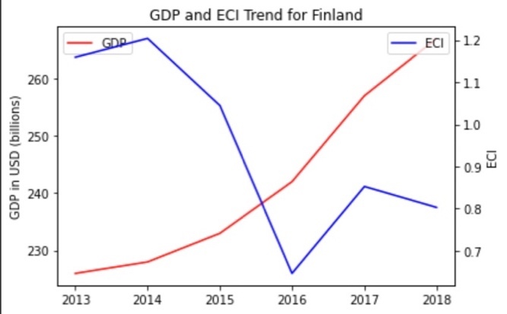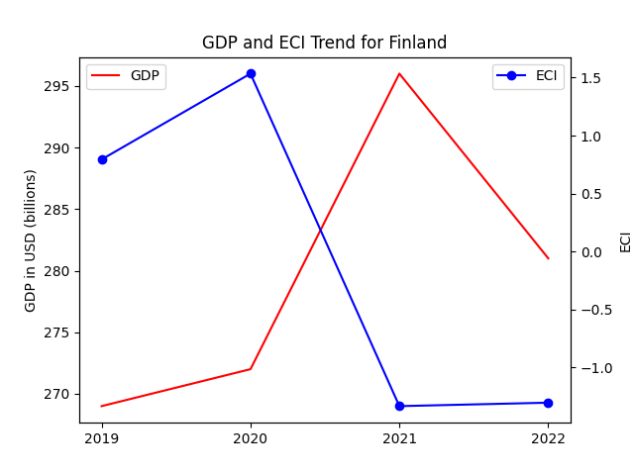
Figures 3a and 3b. GDP Growth and ECI for Finland (left: 2013-2018; right: 2019-2022)

3. Production Analysis

3.1 Product Categorization
Our main data source in this research is the UN Comtrade Website (https://comtrade.un.org), which provides us with valuable information on countries’ export values on an annual basis, including highly specific export data for more than 5000 categories of products. In order to have a holistic vision of the product space of a country, however, a level of categorization is required. Products in our data source are labeled from 010000-999999, with the first two digits representing a general category to which the product belongs. Based on the 99 categories extracted from the label, we further group the products into the 18 most widely-accepted industries, as summarized in Table 1.

Note that the High-complexity Products industry group is not a distinct industry but rather an aggregated industry that encompasses the most complicated products from the most technologically-advanced industries (as measured by PCI). This industry serves as an indicator for us to quantitatively evaluate how well a country has performed in developing cutting-edge technologies and closing its technological gap with advanced economies, which has become a topic of wide concern today. Indeed, when we rank the 18 categories based on PfCI (an equivalent concept of PCI as calculated based on the 18 categorized product groups), the High-complexity Products industry has the highest PfCI among all industry groups.

Category | Description
Animals and By-products | All kinds of meat, livestock and related by-products
Vegetables, Fruits and Plants | All kinds of plants, edible vegetables and fruits
Food and Preparations | Edible preparations, raw cooking materials and appliances
Clothing and Accessories | All kinds of fabrics, filament, clothing and accessories
Textiles | All kinds of textile articles and related products
Wood Products | Book, paper and other elementary products related to wood
Metals | Mining of all sorts of raw Metals
Refined and Processed Stones | Refined or processed stone products such as pearl and ceramics
Energy Drilling and Mining | Mining industry for energy, minerals, stone materials, etc.
Daily Instruments | Basic daily instruments such as sport requisites, timing and measuring tools
Raw Manufacturing | Basic products made from plastic, rubber, leather, etc.
Chemical Manufacturing | Advanced chemical products and pharmaceutical products
Chemicals | Raw chemical materials and by-products
Machinery and Construction | Machinery and mechanical appliances, including electrical equipment
Transportation | Vehicles and locomotives including aircraft, ship, railway, etc.
Weapons | Explosives, arms and ammunition
Services and Utilities | Financial, business, legal, communication, travel Services and Utilities, etc.
High-complexity Products | Agglomeration of advanced products with highest PCIs
Table 1. Categorization of Products

We further observe a positive correlation between the GDP and the export of High-complexity Products. A higher adjusted R-square exists between GDP and High-complexity Products exports, indicating that more successful economics, as measured by GDP, tend to be those that are capable of producing and exporting High-complexity Products as we define them. Tables 2a and 2b show the OLS results in a universe of 107 and 21 typical countries respectively.

 | High-complexity Products | Food and Preparations | Animals and By-products
Adj. R-squared | 0.075 | 0.006 | 0.002
F-statistic | 9.556 | 1.638 | 1.175
No. Observations | 107 | 107 | 107
Table 2a. OLS Regression Results of GDP against Percentage Volume of Exports

 | High-complexity Products | Food and Preparations | Animals and By-products
Adj. R-squared | 0.149 | 0.003 | -0.012
F-statistic | 4.510 | 1.059 | 0.7542
No. Observations | 21 | 21 | 21
Table 2b. OLS Regression Results of GDP against Volume of Percentage Exports

3.2 Realized Industry Development
Based on the aforementioned product categorization, we aim to capture Finland's realized industry production strategy between 2013 and 2022 on a complexity level. In Hausmann and Hidalgo (2009), distance is defined to be a measure of how far a country is from a certain product, not in its product space. We extend this concept to all product groups and quantify how technically equipped a country is to develop the corresponding product groups. In other words, the shorter the distance between a country and a product group, the more capable a country is of developing products within that group. Defining this net distance change as the Realized Industry Development (RID), our export data allow us to calculate and compare the RID of Finland and the 18 product groups in 2022 and 2018 through the difference, where a positive RID indicates a shortening of the distance (i.e., advancement of the industry), and a negative RID indicates the reverse. It is notable that the number of industries with positive RID has decreased from one to almost a half from 2018 to 2022.

Category | RID (2022) | RID (2018)
Transportation | -0.055391552 | 0.009579
Machinery and Construction | -0.041574817 | 0.011666
Weapons | -0.036059906 | 0.124761
Daily Instruments | -0.028299819 | 0.009435
High-complexity Products | -0.028138528 | 0.007813
Metals | -0.009378629 | 0.036869
Wood Products | -0.008422439 | -0.022524
Clothing and Accessories | -0.006697928 | 0.063008
Food and Preparations | -0.001534126 | 0.08787
Vegetables, Fruits and Plants | 0.003314144 | 0.12647
Precious Stones | 0.004795488 | 0.040988
Animals and By-products | 0.00494191 | 0.112406
Chemicals | 0.007447339 | 0.088174
Services and Utilities | 0.007877242 | 0.089972
Energy Drilling and Mining | 0.011076488 | 0.057744
Raw Manufacturing | 0.012959945 | 0.126073
Textile | 0.016721904 | 0.094679
Chemical Manufacturing | 0.022671757 | 0.023736
Table 3. Realized Industry Development (RID) of Finland

3.3 Regional and Global Comparison
Tables 4a and 4b below summarize how the production strategy adopted by Finland compares with selected leading economies in the world across different years, as measured in RID. It can be directly observed that Finland shifted its focus from a great mix of products in 2018 away to more specialized industries (such as Chemical Manufacturing) in 2022, when compared against leading economies such as France, the United States and Germany, which gave a considerable level of attention to more advanced product groups such as Weapons and High-Complexity Products in 2018 and Services and Utilities, Precious Stones, and High-Complexity Products in 2021.

Ranking | France | the UK | Germany
1 | High-complexity Products | Services and Utilities | High-complexity Products
2 | Chemical Manufacturing | Weapons | Transportation
3 | Daily Instruments | Raw Manufacturing | Wood Products
4 | Animals and By-products | Precious Stones | Metals
5 | Food and Preparations | Animals and By-products | Food and Preparations
Table 4a. RID Comparison across Leading Economies (2018)

Ranking | France | the UK | Germany
1 | Services and Utilities | Precious Stones | Daily Instruments
2 | Precious Stones | High-complexity Products | Transportation
3 | High-complexity Products | Services and Utilities | Chemicals
4 | Energy Drilling and Mining | Energy Drilling and Mining | Chemical Manufacturing
5 | Machinery and Construction | Wood Products | Clothing and Accessories
Table 4b. RID Comparison across Leading Economies (2021)

Tables 4c and 4d further examine Finland’s development strategy against those of emerging economies on a global scale. Reasonably, emerging economies such as China, South Korea, and Singapore, have devoted the majority of their efforts to intermediate industry groups, showing drastic shifts in strategies over the course of four years. Economies similar to Finland should have relied more on advanced industry groups - the shift in focus visible from 2018 to 2021. This trend holds true in general, regardless of the continent or the time period, and serves as an indicator for which phase of development a country is currently in as evaluated from its production strategy. Based on this standard, Finland is not adopting a similar strategy that could development in industry groups with a lower level of complexity than it should.

Ranking | China | South Korea | Singapore
1 | High-complexity Products | Transportation | Transportation
2 | Transportation | Textile | High-complexity Products
3 | Machinery and Construction | High-complexity Products | Precious Stones
4 | Energy Drilling and Mining | Chemical Manufacturing | Daily Instruments
5 | Daily Instruments | Machinery and Construction | Services and Utilities
Table 4c. RID Comparison across Emerging Economies (2018)

Ranking | China | South Korea | Singapore
1 | Chemicals | Chemicals | Weapons
2 | Daily Instruments | Daily Instruments | Energy Drilling and Mining
3 | Transportation | Transportation | Transportation
4 | Raw Manufacturing | Textile | Machinery and Construction
5 | Weapons | Raw Manufacturing | High-complexity Products
Table 4d. RID Comparison across Emerging Economies (2021)

4. Product Space Design

4.1 Suggested Development Vector
As outlined above, distance gives us an idea of how far each new product is from a country’s current mix of exports. As defined in Hausmann and Hidalgo (2009), distance is “the weighted proportion of products connected to goods p that country c is not exporting, i.e., MCP = 0.” Based on this definition, the distance between a country and any product that the country is currently exporting (i.e., the country is a significant exporter of the product as compared to the global average) is zero. Similarly, opportunity gain quantifies the contribution of a new product in terms of opening up the doors to more and more complex products. Intuitively, a product that a country is currently exporting (i.e., MCP = 1) has an opportunity gain of zero. An unreasonable investment in a certain product p would lead to a relative decrement in the export of more profitable products and therefore lead to a negative opportunity gain of product p. The opportunity gain is not the only estimator of a country’s level of economic development. However, among countries with comparable economic strength, those having higher ECI, or in other words, more reasonable economic structures are often in better shape.
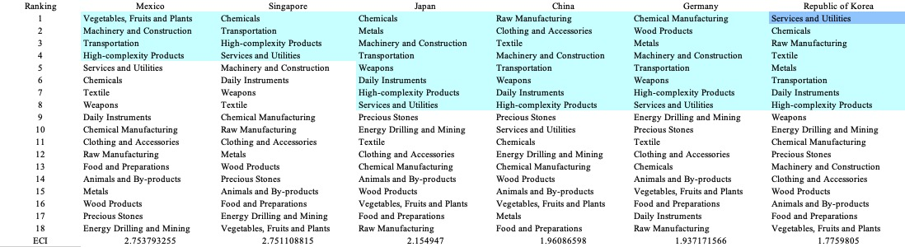
Table 5a. SDV of High ECI Countries (2013)

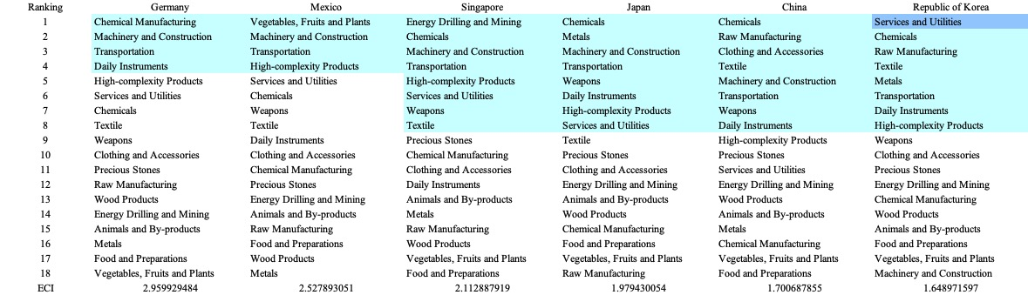
Table 5b. SDV of High ECI Countries (2018)
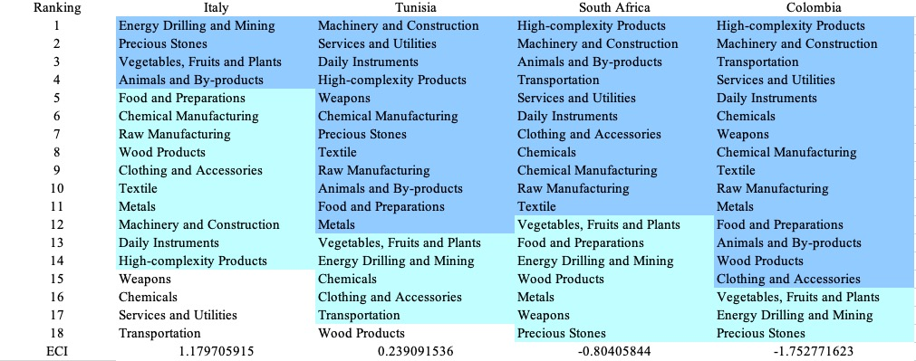
Table 5c. SDV of Other Sample Countries (2013)

We define the ranking of opportunity gain for a country c, as the Suggested Development Vector (SDV) of c. Tables 5a-5d summarize how the SDV of Finland compares with a selected group of comparable and leading economies in the world, with the industry groups ranked in decreasing order of significance. We focus on SDV results for 2018 because they give the most accurate snapshot of complexity for global comparison in the absence of the irregular effects of the COVID-19 pandemic observed in 2021.

Dark blue indicates positive opportunity gains, light blue indicates zero opportunity gains, and white indicates negative opportunity gains. The result shows that leading countries barely have any industries with positive opportunity gain. In other words, those countries are already in the most stable and efficient economic structure. Without the necessity of economic transition, those countries merely need to maintain a steady and balanced economic development. In contrast, developing countries have nearly half of industries with positive opportunity gain and share common interests in industrial manufacturing and High-complexity Products industries. It can be concluded that Finland shares some of the characteristics of leading countries, with a growing imbalanced economic structure that leans towards intermediate and high-level industries.

4.2 Budgeted Industry Development Strategy and Interpretation
The optimal budgeted industry development strategy aims to solve the most efficient allocations under the budgeted constraint of different situations of heuristic total export growth. In order to obtain such an allocation portfolio, we formulate an optimization problem as the following:



where k(x) is the second largest eigenvector of $M_{CC'}$ after adding $x$ to the original export vector, C is the country that we are interested in, P is the product space, B is the heuristic budget.

If we can solve this problem, then we can know what the largest ECI to which a country can improve. Accordingly, the optimal solution $x*$ that we obtain here is exactly our optimal allocation. However, the biggest problem is that the objective function is not convex. Therefore, we cannot apply the classical tools for convex optimization to this problem. In order to solve this problem, our idea is to use a greedy algorithm. The way that we apply the greedy algorithm is that firstly we separate the total budget into k equal parts, and then for the first equal part we try to search for the product that can optimize our objective function by iterating through each $p∈P$. After we find the optimal product p for this equal part, we add the amount back to the export value of this product p and update the ECI for this country. If we observe that ECI does not change after iterating all the products, then we can add up one more equal part to invest. Until we find there is an ECI increment, we add the amount now to that product. The equal rest parts can be done in the same way.

By definition, a greedy algorithm is a kind of local search algorithm that is possible to run into a local minimum. Therefore, for local search algorithms, one typical way to keep it away from the local minimum is to enhance the vision of the algorithm by looking more steps forward. In our setting, whenever we obtain an increment of ECI, we mark down the required amount of export growth. Simultaneously, we continue searching for the next ECI increment point, compare the ratios of these two possibilities and pick the largest one. The ratio is defined as the following:

where ${ECI}_{p}$ is just the ECI of the country after adding some amount of export increment to product $p$, which is exactly the amount that is able to make ECI change. Also, we can express it in the way of $||x_{p}-x_{0}{||}_{1}$.

In this way, we can obtain a further sighted greedy algorithm. Also, the number of parts that we would like to separate the budget into also matters. In order to solve this problem, we added a stabilizer on top of the enhanced greedy algorithm by running the algorithm for different numbers of parts and selecting the portfolio with the largest ECI increment and most complex economic structure.

Besides, it is quite common that there is a surplus in the budget. To deal with the surplus, we just add it to the product which needs the least amount of dollars to make $M_{cp}$ = 1 (i.e., the smallest amount of required export increase).

Economic Panel
As stated above, the enhanced greedy algorithm is developed mainly for solving the optimal allocation strategy. In order to visualize this allocation, an economic panel is created, consisting of a pie chart, a line chart and a table. First, a pie chart is used to show the percentage of each product in the optimal portfolio. The number located in the center of the circle denotes the heuristic growth of total export, which is also our budget. Each category in the chart has a determined percentage of the allocated budget. The lines below the pie charts show how the ECI changes during the searching process of the greedy algorithm. Even though sometimes an increase of the export by 15% or 20% does not seem reasonable to developed countries, yet it can also give a sense of how a country should develop in the long term. Eventually, the graph in the end is just for numerical explanation for the pie charts.

Interpretation
For the purpose of a clear explanation of the line charts, we label all the products in Table 7. Please refer to this table when trying to understand the investment trajectories in the line charts.

Label | Product Names
1 | Animal and By-products
2 | Vegetables, Fruits and Plants
3 | Food and Preparations
4 | Energy Drilling and Mining
5 | Chemicals
6 | Chemical Manufacturing
7 | Raw Manufacturing
8 | Wood Products
9 | Clothing and Accessories
10 | Textile
11 | Metals
12 | Machinery and Construction
13 | Transportation
14 | Weapons
15 | Daily Instruments
16 | Precious Stones
17 | High-complexity Products
18 | Services and Utilities
Table 7. Products Labeling

Figures 4a-4c show an economic panel for Finland in 2013, 2018, and 2022. We can see that for different percentages of heuristic total export growth, the ECIs of Finland have different amounts of increments. A 5% export growth results in an ECI improvement pattern of around 1.159 and ends at around 1.417. However, 10, 15, and 20 percent export growth are unable to result in significant ECI improvement trajectories. For 10, 15, and 20 percent growth budgets, ECI of Finland ends at around 1.89.

For the case of 5 percent export growth, Machinery and Construction and Daily Instruments account for most of the portfolio. For 10 percent export growth, more weight is awarded to high-complexity products, suggesting that with a low economic improvement anticipation, Finland should focus more on developing this industry. For the case of 15 and 20 percent increment budgets, we realize that the development trajectories are in a similar pattern to a 5% increment budget except that there are a few additional steps when there are more budgets. Similar to the first case, the solutions suggest that Finland should invest more on Machinery and Construction and Daily Instruments. This makes sense because with more budgets, a country should definitely focus more on the development of high-end product spaces. A more detailed numerical representation of the portfolio is shown in Table 8a and 8b.

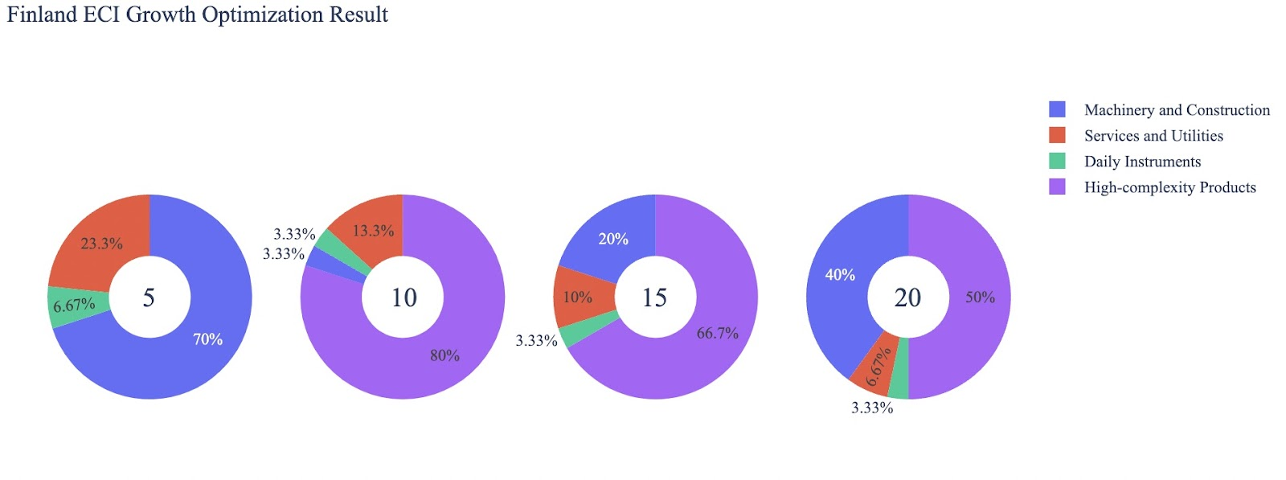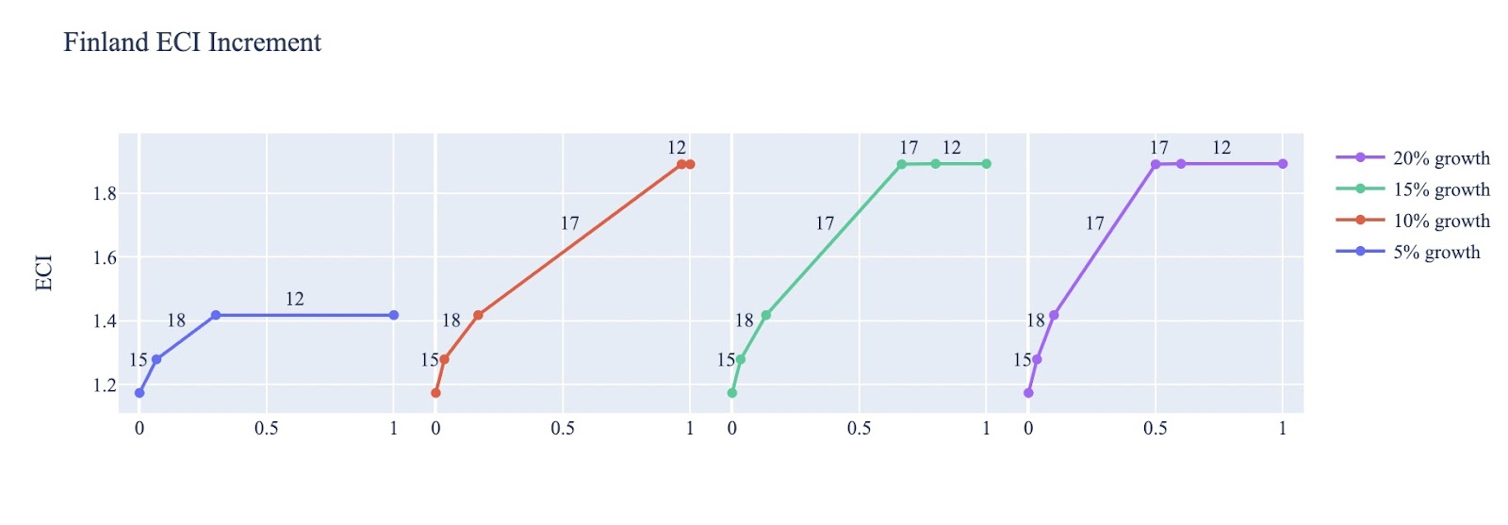
Figure 4a. Greedy-Based ECI Improvement Results of Finland with Different Budgets (2013)
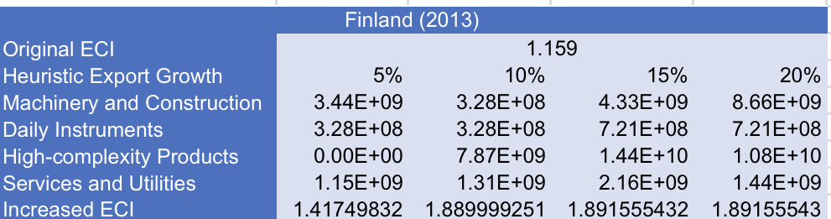 Table 8a. Portfolio of Finland (2013)

For further suggestions on Finland’s development in the future. We also offer the optimization result of Finland based on export data in 2018. Below is the economic panel for Finland in 2018. We can see that there is a similar pattern for the ECI improvement trajectories, which is that the improvements in 10, 15, and 20 are similar. The main differences are the components that result in ECI improvements. For a 5 percent export growth, the improvement is concentrated in machinery and construction, while for 10, 15, and 20 percent growth, it is limited to transportation and high-complexity products. A more detailed numerical representation of the portfolio is shown in Table 8b.

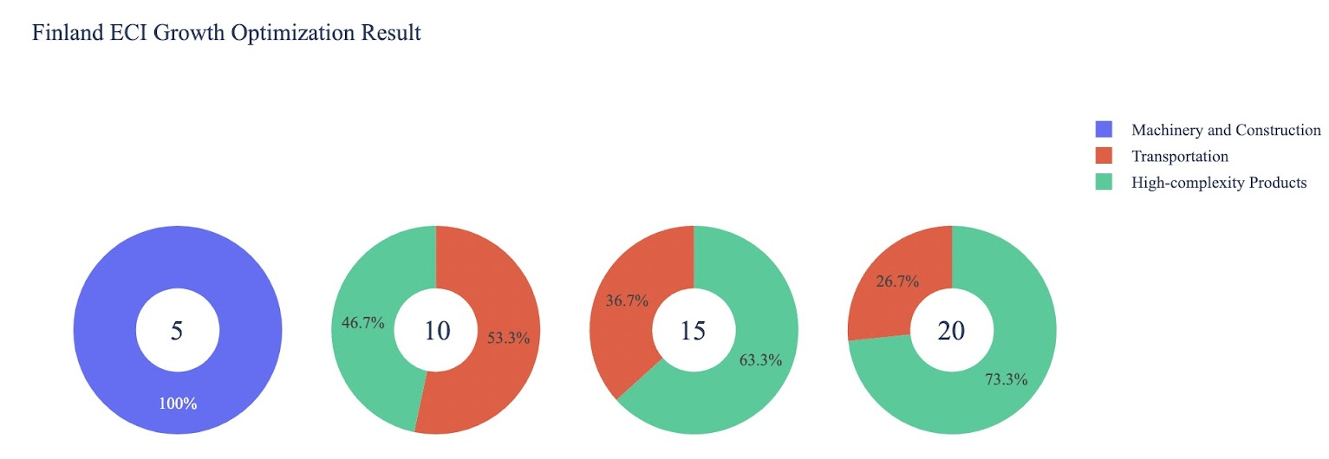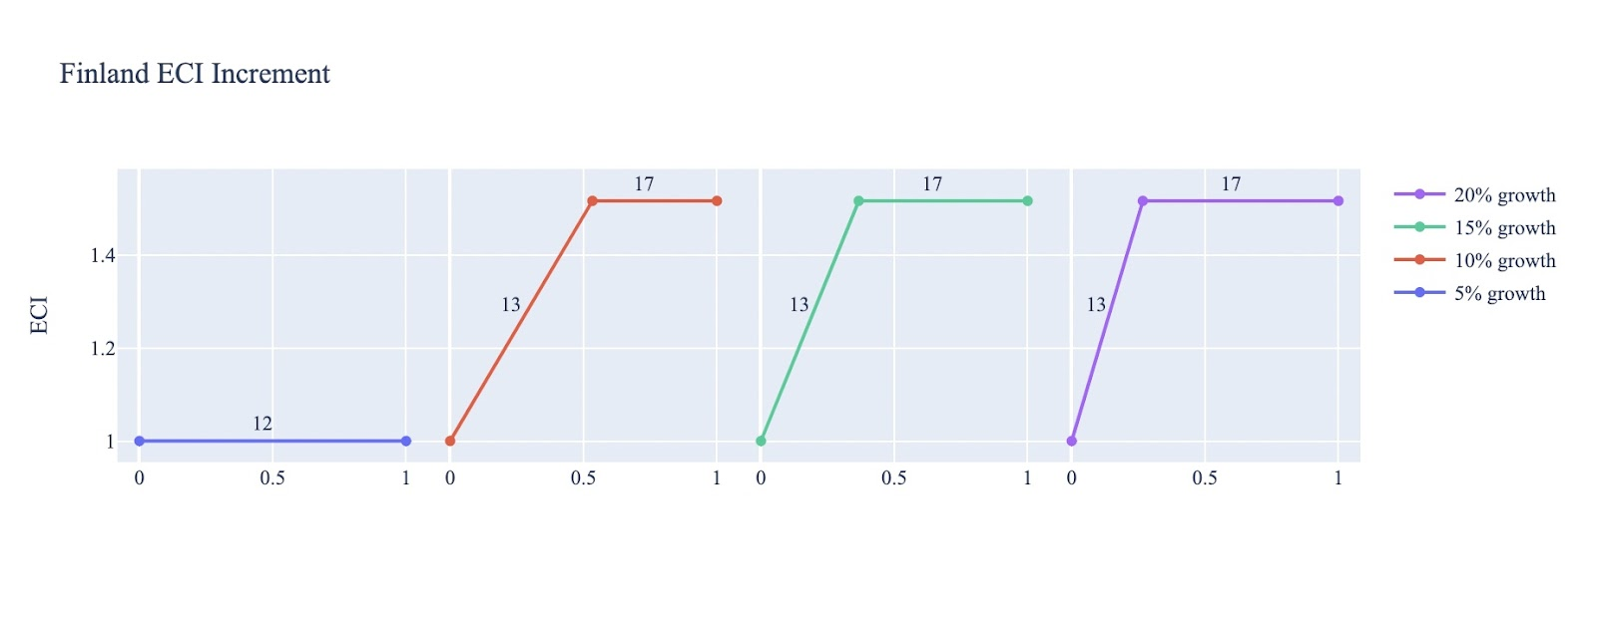
Figure 4b. Greedy-Based ECI Improvement Results of Finland with Different Budgets (2018)
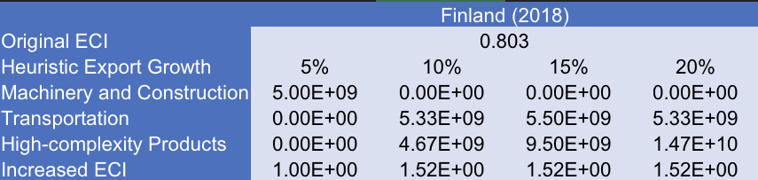
Table 8b. Portfolio of Finland (2018)

To compare with the performance in 2013 and 2018, we also re-examine suggested strategies for 2022. For 2022, a 5 percent increase in export would emphasize Machinery and Construction, followed by Animals and By-Products, Precious Stones 6, and Animals and By-Products for 10, 15, and 20 percent export growth respectively. These strategies go in line with the suggested trajectories based on ECI. We note a strong and repeated overlap in certain product groups, emphasizing their potential in economic improvement. A more detailed numerical representation of the portfolio for Finland is shown in Table 8c.
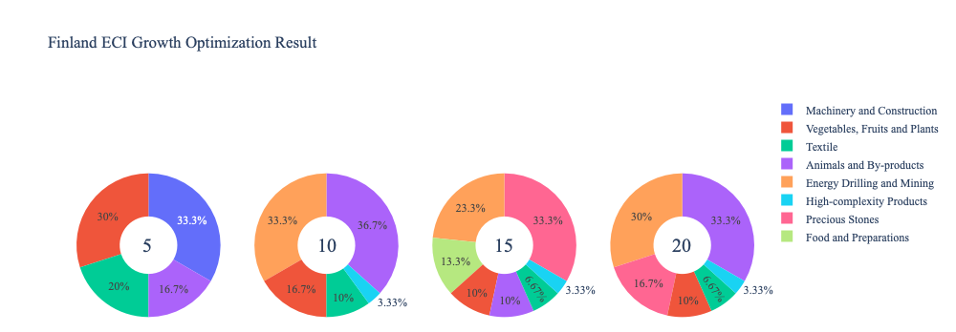
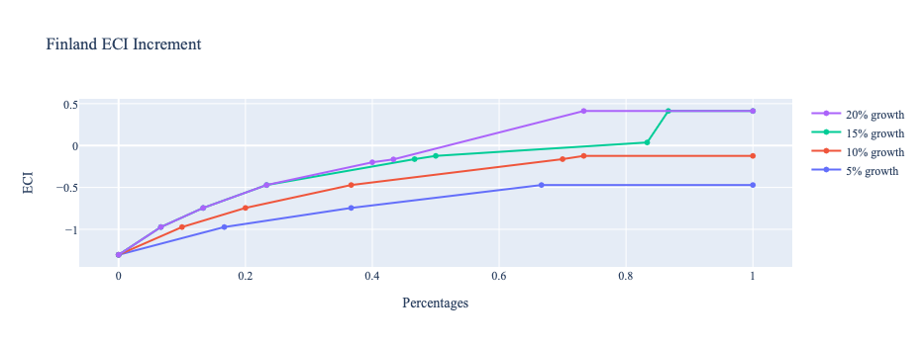
Figure 4c. Greedy-Based ECI Improvement Results of Finland with Different Budgets (2022)

Finland (2022)
Original ECI | 1.3889
Heuristic Export Growth | 5% | 10% | 15% | 20%
Animals and By-products | 8.46E+08 | 4.10E+09 | 1.52E+09 | 7.22E+09
Vegetables, Fruits and Plants | 1.52E+09 | 1.86E+09 | 1.52E+09 | 2.17E+09
Food and Preparations | 0.00E+00 | 0.00E+00 | 2.03E+09 | 0.00E+00
Energy Drilling and Mining | 0.00E+00 | 3.72E+09 | 3.55E+09 | 6.50E+09
Textile | 1.02E+09 | 1.12E+09 | 1.02E+09 | 1.44E+09
Machinery and Construction | 1.69E+09 | 0.00E+00 | 0.00E+00 | 0.00E+00
Table 8c. Portfolio of Finland (2022)

4.3 Sensitivity Analysis and Contingency Strategy
In the following section, our broad aim is to understand how sensitive Finland is to changes in export in various industries. While the Economic Complexity Index has been shown to contain valuable information about the economic strength/capacity of a country, little has been said as to the stability of the measure itself. We seek to uncover the main drivers of stability under a country's ECI score and better understand longer-term projections for ECI growth. Additionally, gaining an intuition on the industries that are bolstering an economy and the industries that offer the greatest return per unit of investment is best done through visualization of industry-specific sensitivity. To this end, we have developed two categories of sensitivity analysis.
ECI Sensitivity Graph
First, in order to assess the effect particular industries have on each respective country, we developed ECI Sensitivity graphs (Figure 5). We use the shocking methodology to increment or decrement an industry’s export level by a certain percentage and recalculate the ECI, all else being equal. While freezing the export dynamics of the rest of the world and enacting an instantaneous shock in export for a particular industry and country may not reflect real-life dynamics, what it does offer us is an understanding of a country’s level of dependency on an industry in the context of ECI. The shocking is done in small percentage increments in order to smooth out the resulting curve. Additionally, a recurring theme one will see is that for most industries, a breaking point occurs where the ECI either jumps upwards or downwards, creating a hockey stick shape rather than a linear trend. While the inflection point may not be accurate in the context of real life, comparing the various inflection points across industries can give us valuable insight.

Figure 5. Sample ECI Sensitivity Graph (2018)
The graphs are formulated as follows. There are six ECI Sensitivity graphs, two for each of the following years: 2022, 2018, and 2013. The first chart, Incremental ECI Sensitivity, shows positive shocking in which export numbers are shocked upwards per industry. The X-axis is in terms of percentage shock per current dollar value of export. The Y-axis is the recalculated ECI level post-shocking. The second chart, Decremental ECI Sensitivity, follows the same format except the X-axis represents negative shock. In other words, exports for each industry are decremented, and the ECI is accordingly recomputed.
SDV Sensitivity
Secondly, we analyze the sensitivity of the SDV to changes in export levels. The goal is to understand how export level changes for a particular industry can affect the marginal opportunity gain for other industries. We will be using specifically High-Complexity Products and Clothing and Accessories as our base industries. We will be increasing or decreasing the absolute export level in both of these industries and observing the effects on the SDV.
When the opportunity gain of an industry is negative, the SDV sensitivity approximates how an over-development of the industry jeopardizes the economic structure of a country. When the opportunity gain of the industry is zero, the SDV sensitivity determines whether the further development of the industry shapes the country with a better economic structure and predicts how the SDV would change accordingly. Specifically, as we reduce the export of such an industry to 25% - 50% of its original value, a few other industries originally with negative opportunity gain could likely become profitable.
Similar to the ECI sensitivity graphs above, we will be shocking the export of High-Complexity Products and Clothing and Accessories in small percentage increments. A new SDV, represented by a new column in the charts, is recorded only when a certain level of shock changes the structure of the SDV. In effect, we are incrementing or decrementing export levels of two industries until the marginal opportunity gain of any industry changes in category (positive, negative, or neutral). Below is an example of an SDV Sensitivity chart with Positive Shocking. Industries with positive marginal opportunity gain are colored blue, neutral is colored white, and negative is colored red.

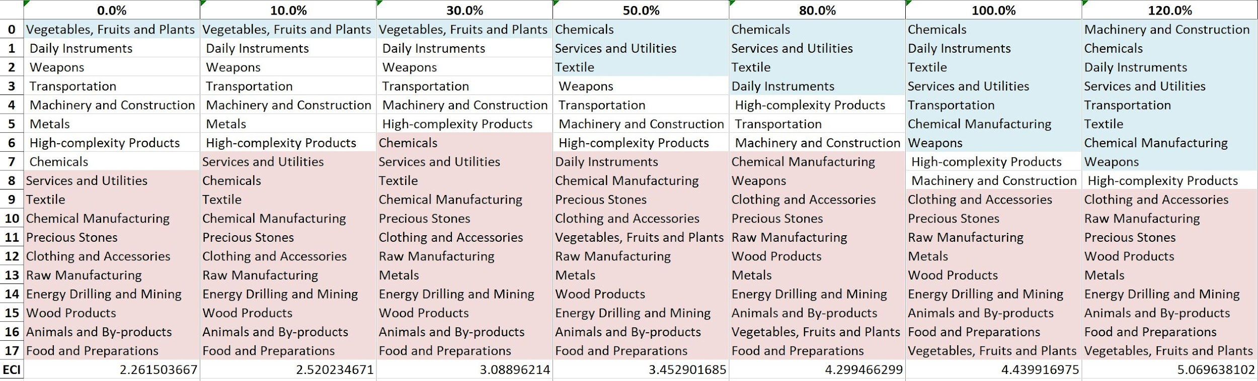
Table 9. Sample Incremental SDV Sensitivity for High-Complexity Products (2018)

Contingency Plan
The Contingency Plan aims to present a set of solutions with respect to upheavals in different industries. Instead of compensating for the declining production directly, the best strategy is to develop those incipiently profitable industries. In this manner, we can derive a contingency strategy for countries to deal with possible abrupt declines of crucial industries. In some cases, the SDV remains unchanged even when a zero-opportunity-gain industry declines to 20% in terms of export. We can then conclude the industry is not indispensable to the country. As a clarification, the three consecutive N/As mean that the country doesn’t even need to respond to a collapse in the industry. Countries tend to have distinct solutions to the ups and downs of the same industry. To create the contingency strategy table, we decrease the export level for each industry in the country’s current production space by 60% respectively. The three highest-ranking industries in the new SDV are then returned.

Product Names | 0 | 1 | 2
Animal and By-products | Services and Utilities | Daily Instruments | Weapons
Vegetables, Fruits and Plants | Services and Utilities | Daily Instruments | Weapons
Food and Preparations | Services and Utilities | Daily Instruments | Weapons
Energy Drilling and Mining | Services and Utilities | Daily Instruments | Weapons
Chemicals | Services and Utilities | Daily Instruments | Weapons
Chemical Manufacturing | Services and Utilities | Daily Instruments | Weapons
Raw Manufacturing | Services and Utilities | Daily Instruments | Weapons
Wood Products | Services and Utilities | Daily Instruments | Weapons
Clothing and Accessories | Services and Utilities | Daily Instruments | Weapons
Textile | Services and Utilities | Daily Instruments | Weapons
Metals | Services and Utilities | Daily Instruments | Weapons
Machinery and Constructions | Services and Utilities | Daily Instruments | Weapons
Transportation | Services and Utilities | Raw Manufacturing | Daily Instruments
Weapons | Services and Utilities | Daily Instruments | Transportation
Daily Instruments | Services and Utilities | Weapons | Transportation
Precious Stones | Services and Utilities | Daily Instruments | Weapons
Daily Instruments | Services and Utilities | Daily Instruments | Weapons
Services and Utilities | Daily Instruments | Weapons | Transportation
Table 10. Sample Contingency Strategy (2018)

4.3 Sensitivity Analysis Results and Interpretation
We examine Finland's ECI Decremental and Incremental Sensitivity Charts for 2022. A decrease in High-Complexity Products will lead to the highest decrease in ECI, with no possibilities for improvement. The strong effect of lack of improvement options changes previous years. For the negative shock cases, no feasible strong improvement exist either, a new trend across the data emerging from the previous years. The rest of the industries do not appear to have the same level of sensitivity.

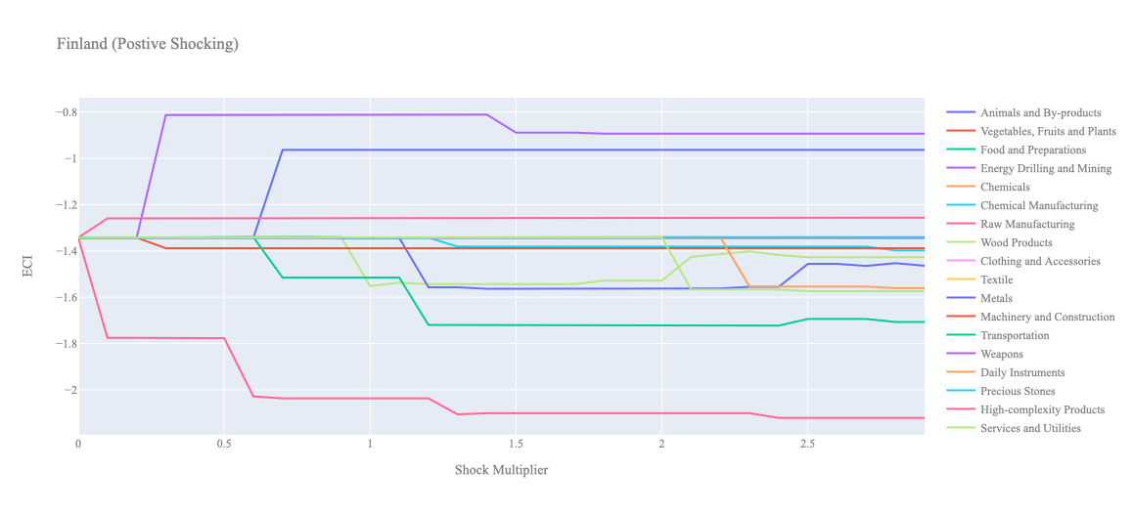
Figure 6a. Incremental ECI Sensitivity for Finland (2022)
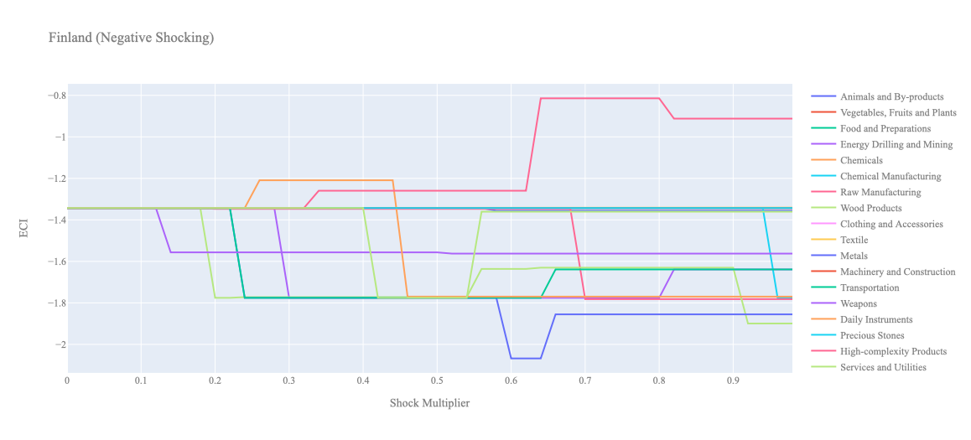
Figure 6b. Decremental ECI Sensitivity for Finland (2022)

Below is Finland’s 2018 ECI Sensitivity Charts. First in the positive chart, we notice immediately that increases in High Complexity Products and Transportation lead to an uptrend in ECI. High Complexity Products offer the best ECI growth per unit of export increase. All other industries tend to not greatly affect the ECI level making it fairly clear which industries to pursue.

Next, we consider Finland’s 2018 Negative Shock chart. We see that Finland’s ECI is highly sensitive to drawdowns in Vegetables, Fruits, and Plants and High-Complexity Products. More interestingly we see large decreases in Wood Products and Animals and By-products, and Services and Utilities seem to greatly increase the ECI score. These industries are very important industries for Finland’s economy and thus the results that are reflected in the chart may be suggesting that there is another industry that could be very beneficial for Finland that is far in proximity from the Wood Products and Animals and By-products industries.

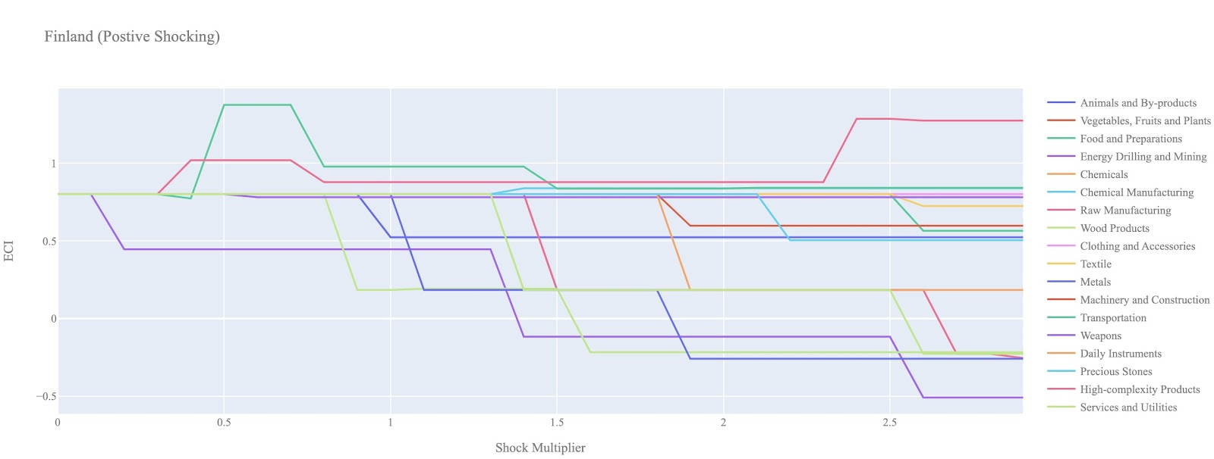
Figure 7a. Incremental ECI Sensitivity for Finland (2018)

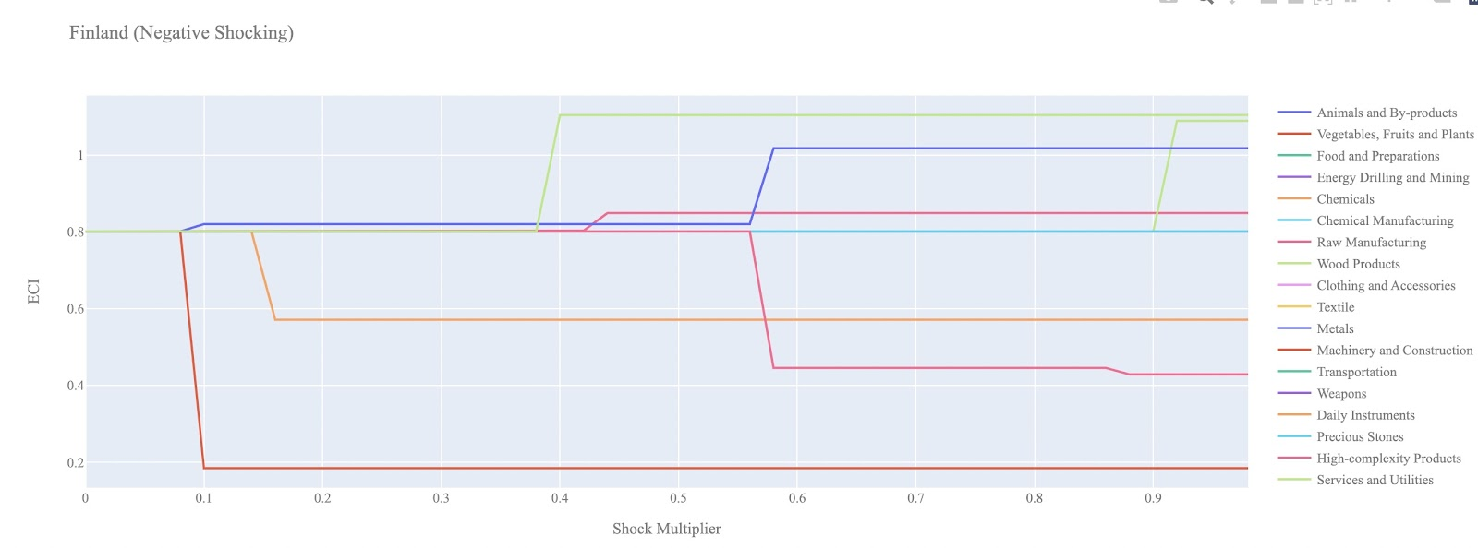
Figure 7b. Decremental ECI Sensitivity for Finland (2018)

Next we consider the 2013 ECI Sensitivity graphs. We see that in the positive shocking case, the landscape of ECI sensitivity has not altered significantly over the five year period. High complexity products and Transportation seem to offer the best ECI growth prospects.

In the 2013 negative shocking case, we see that again Finland is very sensitive to drawdowns in Vegetables, Fruits, and Plants and High-Complexity Products.

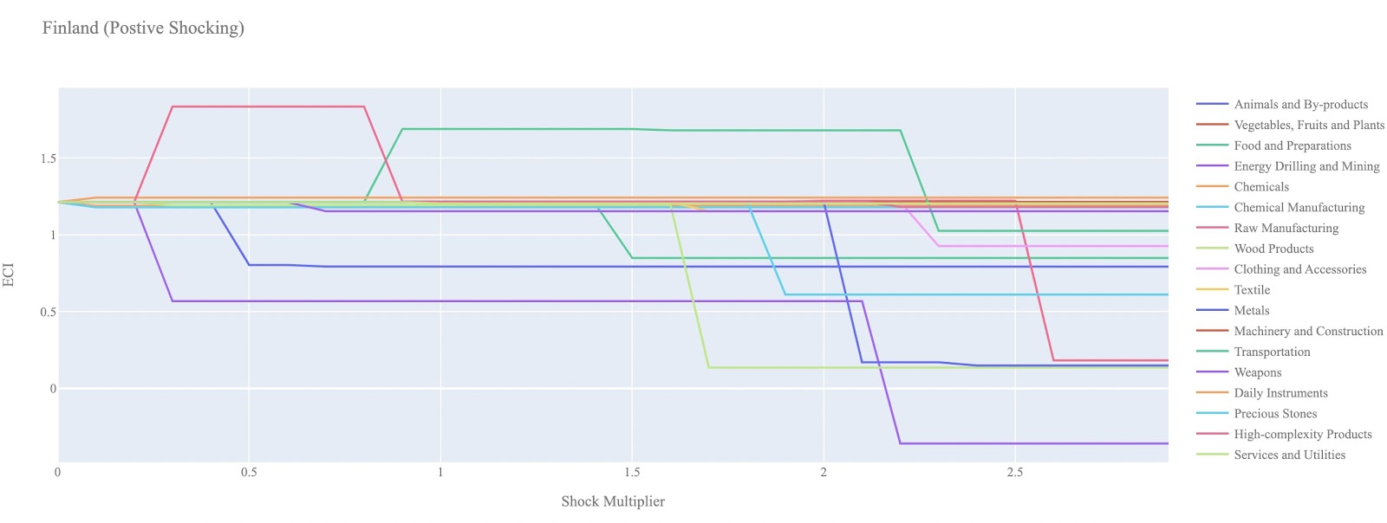
Figure 8a. Incremental ECI Sensitivity for Finland (2013)

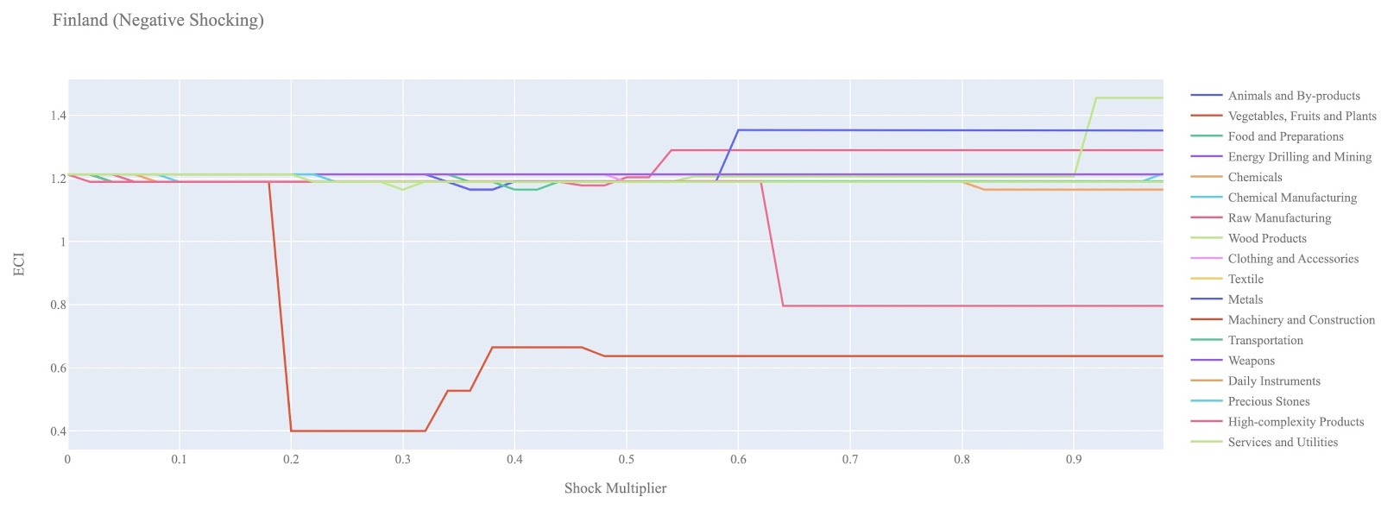
Figure 8b. Decremental ECI Sensitivity for Finland (2013)

Below we see the SDV sensitivity charts for High Complexity Products. We see that increasing the export of High Complexity Products opens up many positive opportunity gain industries for Finland to move into.

In the negative High Complexity Product SDV chart, we see that as we decrease the export of High Complexity Products, the exact opposite happens. The number of industries with positive opportunity gain shrink suggesting that the opportunities available to Finland are highly dependent on its High Complexity Product footprint.

Concerning Food and Preparations, Finland seems to be mostly insensitive to this industry suggesting that this is not an important industry in terms of the stability of its SDV.

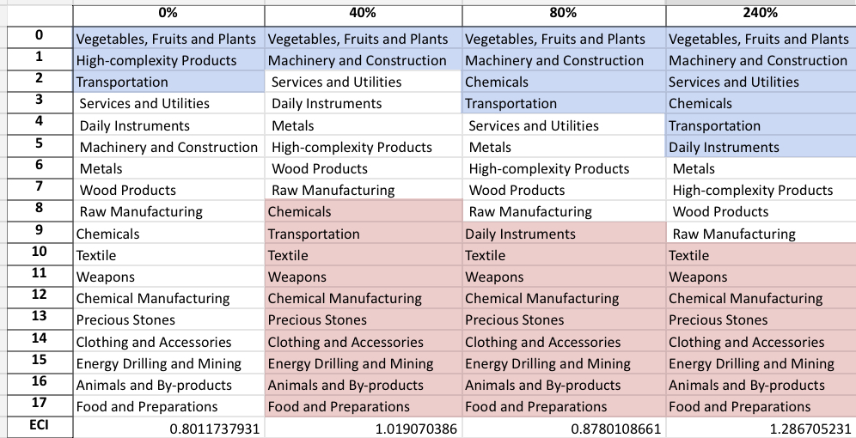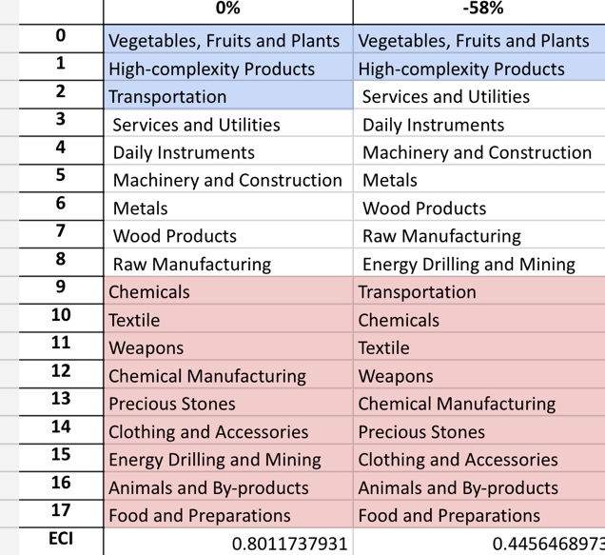
Table 11. Finland’s SDV Sensitivities for High-Complexity Products (2018)

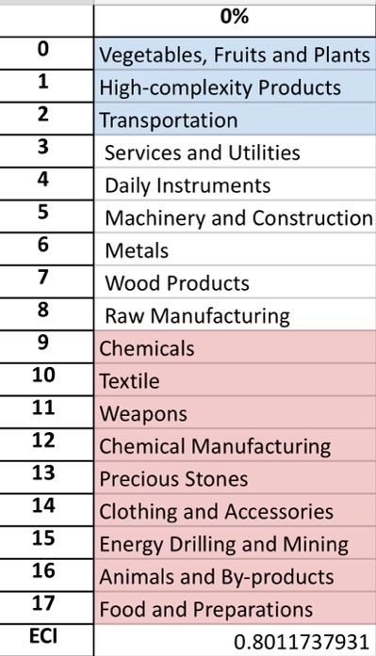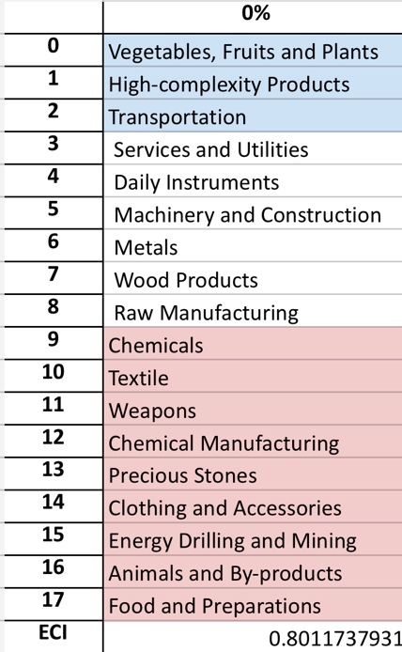
Table 12. Finland’s SDV Sensitivities for Clothing and Accessories (2018)

4.4 Contingency Strategy
Decreasing export of each industry in Finland’s current production space by 60% respectively, we derive the contingency strategy shown below.

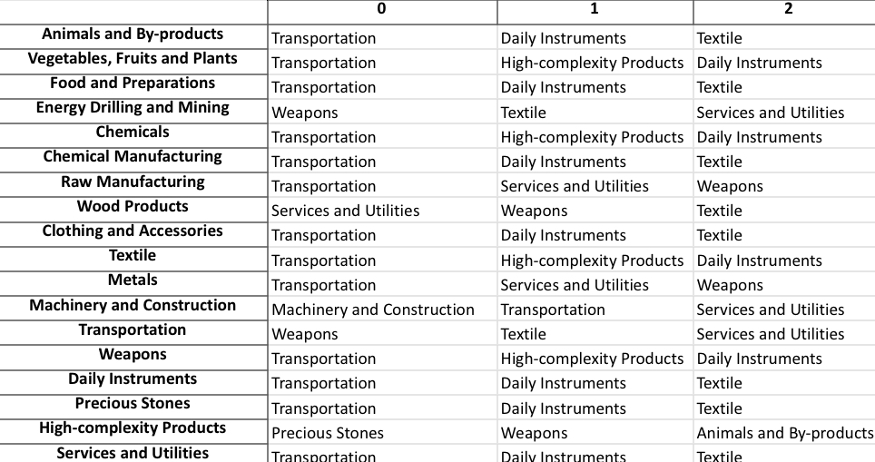
Table 13. Finland’s Contingency Strategy (2018)

We suspect this contingency strategy would have been an optimal implementation during the economic shock brought upon by the 2020 COVID-19 pandemic. Yet, as shown in the following section on structural optimality, Finland’s industry development strategy during the period of 2019-2022 did not follow such a path. This may be a reason for its lower ECI at the end of this period.

5. Macro-level Predictions

5.1 Structural Optimality Index
ECI sensitivity described in the section before has proven to be a significant factor in deciding the economic outcomes of countries. In order to quantitatively evaluate how effective our development strategies are and how deviations from the suggested developmental path will lead to suboptimal growth results, we define the measure – Structural Optimality Index (SOI) – on a country level as the Adjusted R-Square obtained from regressing the country’s realized industry development over the suggested development strategy. Both strategies are quantified in nature, with the realized development represented by increasing export in every major industry group and the suggested development strategy represented by the opportunity gains of developing the corresponding industry groups as calculated in previous sections. The adjusted R-square from the regression thus provides us with a quantified measure of how the development path adopted by the country has fitted with/differed from calculations on a complexity level.

After obtaining this measure for all countries in our database, we further regress countries’ five-year economic growth, which is defined as the percent increase in GDP (USD), over their SOI. Figure 9 illustrates the regression output, which shows a strong positive correlation between countries’ SOI and their five-year GDP growth, significant at the 1% level and achieving an adjusted R² of 4.5%. In other words, the more a country develops, as suggested by calculations on a complexity level, the better economic outcomes it achieves.

Table 14: OLS Regression Results
Dep. Variable: GDP | F-Statistic: 5.963
R²: 0.054 | Prob (F-Stat): 0.0163
Adj R²: 0.045 | No. Observations: 106


Figure 9. Regression of Five-Year GDP Growth over SOI (2013-2018)

5.2 SOI of Finland and Its Implications
During the first examined period, Finland, for instance, has a low level of structural optimality as compared with its developed peers. As the regression in Figure 7 suggests (the orange curve represents export increase and the blue curve stands for opportunity gain of the corresponding industry), Finland demonstrates a low level of correlation with the suggested developmental path, having an adjusted R-square of around 0.64%. Finland ranks in the lower quartile among all countries in terms of SOI and has made a low rate of economic progress below its developed peers from 2013 to 2018 with a 5-year GDP growth rate of 2.84%, which is consistent with the regression result in Figure 6. This is in direct contrast to other developed economies such as Japan, where there is low SOI of around -5.7% and a corresponding GDP growth of 9.05% from 2013 to 2018, making Finland a much slower developing economy during the period. In sum, Finland’s mixed economic progress from 2013 to 2018 can be at least partially explained by a development strategy that demonstrates a suboptimal level of matches with our suggested developmental path. In specific, Finland invested heavily in the Wood Products industry, while it should have focused more on more complex industry groups such as Energy Drilling and Mining. That being said, it stayed fairly in line with our expectations in the Precious Stones industry.

Specifically, Finland's slow economic progress from 2013 to 2018 can be at least partially explained by a development strategy that demonstrates a subtle level of matches with our suggested developmental path. In specific, Finland invested lightly in the Transportation industry, while it should have focused more on it.

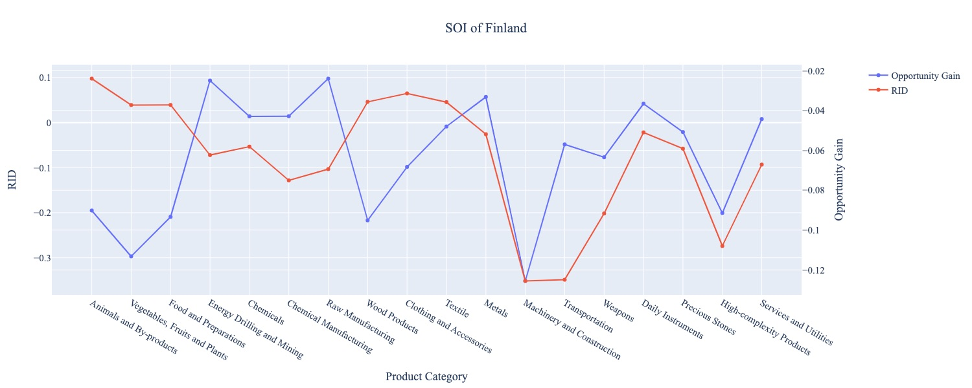
Figure 10a. SOI of Finland (2009-2014)

For the 2019-2022 years, Finland has a strong presence in the Chemical Manufacturing and Textile industries, but they seem to be overdeveloped when considering their lower opportunity gain relative to RID. It also could consider Machinery and Construction and Weapons to improve its growth. Finland has seen a subtle average growth in GDP over those four years of 1.22%, compared to 2.84% for the average yearly growth for the five years prior. Finland also ranked in the middle among all countries in terms of SOI.

Slightly higher than before, its adjusted R-squared value of 0.090 still indicates a very low correlation between the GDP growth and the implemented development path. Progress is slow on a global scale during this period, but Finland demonstrates a similar ability to adjust to negative economic shocks by improving SOI and increasing GDP growth than it did between 2013 and 2018.

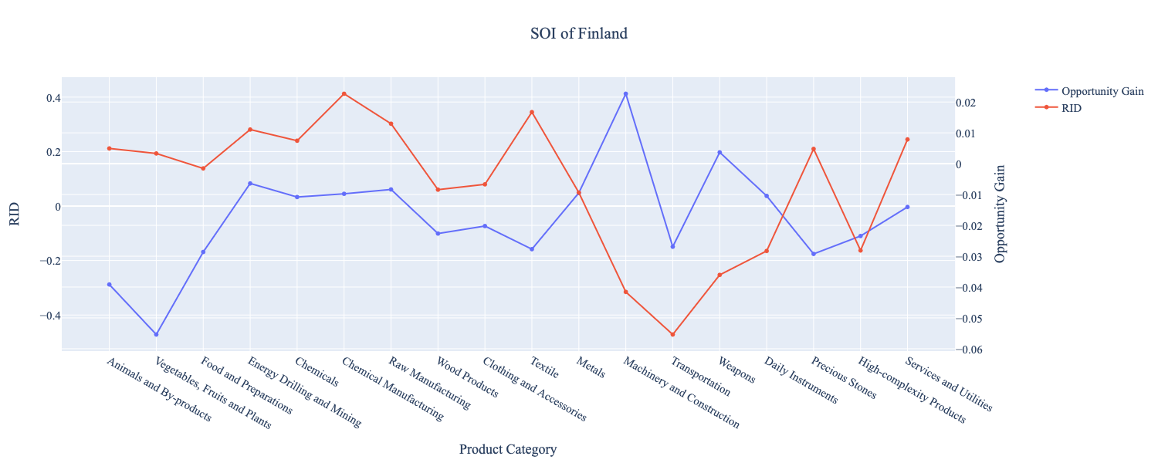
Figure 10b. SOI of Finland (2019-2022)

6. Concluding Remarks

In conclusion, Finland. has demonstrated a moderate level of economic growth in terms of annual GDP increase during the period from 2013 to 2018, concurrent with a decrease in economic complexity as compared with other major developed economies.

The lack of progress during the period, we believe, can be partially explained through analysis of the economic and product complexity structure of Finland on the industry group level. The product classification system we adopt allows us to measure the realized industry development for various industry groups and to observe that Finland consistently relied on developing the Vegetables, Fruits, and Plants industry during the period, while its developed counterparts and emerging economies around the globe have adopted much more complex and progressive paths.

Based on our analysis of the opportunity gain and a sensitivity analysis of major industry groups, Finland can further its gains by prioritizing High Complexity Products, Transportation, and Machinery and Construction. We further note that Finland has a slightly mismatched development strategy that indicates a moderately high (compared to other developed countries) level of structural optimality on the complexity level, having an adjusted R-square of around 0.064. Since a significant positive correlation exists between five-year GDP growth and the structural optimality index of an economy as we define and calculate, Finland, however, still has a suboptimal growth experience as compared with fast-growing economies both on a regional scale and on a global scale, and has the potential to further its economic gains through industrial structure optimization as suggested in the paper.

During the second examined period from 2019 to 2022, Finland performed even weaker than before and compared to other countries, particularly Norway. We infer that during the COVID-19 period and since the Russian invasion of Ukraine, Finland focused on developing average complexity industries despite a lower demand for these industries given the global economic downturn. We also note that Finland has slightly increased its investment in the sectors identified earlier, leading to a subtle boost from Energy Drilling and Mining and Raw Manufacturing industries, leaving some room for strategic improvement. The ECI suggests that greater growth has little opportunities to be achieved. The decline barely affected the adjusted R-squared value of 0.090 in 2022 from 0.064 in 2018, demonstrating the pursued strategies did not significantly contribute to the GDP. With the revised focus, Finland has further potential to advance its economic growth to maintain its position among other countries to restart its economic expansion.

References

Hausmann, R., Hidalgo, C., Bustos, S., Coscia, M., Chung, S., Jimenez, J., Simoes, A. and Yıldırım, M. (2007). The Atlas of Economic Complexity. [online] Atlas.cid.harvard.edu. Available at: http://atlas.cid.harvard.edu/.

Balassa, B., “The Purchasing Power Parity Doctrine - A Reapprais- al,” Journal of Political Economy 72, 584-596 (1964).

Feenstra, R.; Lipsey, R.; Deng, H.; Ma, A. & Mo, H. “World Trade Flows: 1962-2000” NBER working paper 11040. National Bureau of Economic Research, Cambridge MA (2005).

United Nations Commodity Trade Statistics Database (http://comtrade.un.org/db/), accessed in August 2019.

The World Economic Forum, “The global competitiveness report,” (various years).

Barro, R. & Lee, J-W. “A New Data Set of Educational Attainment in the World, 1950-2010,” NBER Working Paper No. 1590 (2010).

Kaufmann, D. & Kraay, A. “Governance Indicators: Where Are We, Where Should We Be Going?” Policy Research Working Paper 4370. Washington, DC: World Bank (2008).

Hanushek, E.A. & Woessmann, L. “The Role of Cognitive Skills in Economic Development,” Journal of Economic Literature 46(3), 607- 668 (2008).

