20
https://atlas.cid.harvard.edu/

Optimal Industry Development Strategy Using Economic and Product Complexity

India

─
The Economic Complexity Lab - Columbia University
Alexandra Garcia, Kelly Mi, Margarita Demkina, Allison Lin, Helena Yang, Jane Zhang, Daniel Xu, Ryo Shibata, Navia Zhang, Haoxian Chen, Davepriyan Gunaratnam, Rohan Macherla, Ajit Akole, Shomik Ghose, Alex Wei-Liang Ku, Sannidhya Modi, Xilin Wang
Optimal Industry Development Strategy for India

0. Executive Summary

In this report, we aim to uncover the economic path India went through during the period from 2013 to 2022. Specifically, we dive into the topic through a macroeconomic overview of India from the perspective of Gross Domestic Product (GDP) and Economic Complexity Index (ECI), which reflect countries’ production capability and production structure, respectively. We find that during the period of our interest, India demonstrated a high level of economic growth with an average annual GDP growth rate of 7.75% between 2013 and 2018 and 4.90% between 2019 and 2022, with a similar economic complexity compared to other major emerging economies.

The mixed progress during the period, we believe, can be partially explained through the analysis of the economic and product complexity structure of India on the industry group level, as well as the macro and microeconomic strategies. The product classification system we adopt allows us to measure the realized industry development for various industry groups and to observe that India regressed in developing most of its industries during the period while its emerging counterparts and economies around the globe also adopted complex and progressive paths with variable degrees of success.

Based on our analysis of the opportunity gain and sensitivity analysis of major industry groups, India could have furthered its gains by prioritizing Weapons, Raw Manufacturing, and High-complexity Products in 2018. Three years later, in 2022, its focus should have shifted to the Weapons and Machinery and Construction industries, which are also one of the more developed industries at the time. We further note that India has a mismatched development strategy that indicates a low level (compared to other emerging countries) of structural optimality on the complexity level, having an adjusted R-square of around 0.126 in 2018 and a lower score of 0.090 in 2022, demonstrating degradation in development. Since a significant positive correlation exists between GDP growth and the structural optimality index of an economy as we define and calculate, India indeed has a suboptimal growth experience as compared with fast-growing economies both on a regional scale and on a global scale and has the potential to further its economic gains through industrial structure optimization as suggested in the paper.

The years between 2019 and 2022 showed a significant improvement in India's economic growth, boosting its position on the global scale. Its GDP recovered to above the pre-pandemic levels, and it saw a boost in the ECI, particularly compared to its peer countries. Its current strategy still has the viable potential upside to increase its performance and optimize its structure further.

1. Report Overview

In this report, we aim to uncover the economic path India went through during the period from 2019 to 2022, before and after the COVID pandemic, compared to its performance from 2013 to 2018, before and after the launch of the “Make in India” campaign. Specifically, we dive into the topic through a macroeconomic overview of India from the perspective of Gross Domestic Product (GDP) and Economic Complexity Index (ECI), which reflect countries’ production capability and production structure, respectively. We then analyze the industrial framework and changes of India during the period based on quantitative measures such as the Product Complexity Index (PCI) and Product Family Complexity Index (PfCI), followed by a detailed analysis of how such changes have matched with development strategies as quantitatively measured by opportunity gains on an industry-level. We conclude our report with macro-level results and predictions of India, as deduced from regression models we have established on a global scale, which take into account countries’ stances in their product space.

2. Macroeconomic Results

2.1 GDP Ranking and Changes
Figure 1a illustrates the time-series GDP results for India and three of its peer countries (Russia, China, and Japan) from 2013 to 2018. Similar to the other countries, India displayed an eventual upward trend over the period; however, its growth was less consistent than China’s growth. This is confirmed by India’s average annual growth rate of 7.75% over the five-year period, which is higher than that of Russia (1.31%) and Japan (1.46%), and similar to China’s (7.18%).

Figure 1b shows the GDP levels for India and its peer countries (Malaysia, Mexico, and China) from 2019 to 2022. Similar to the other countries, India displayed a drop in GDP from 2019 to 2020 because of the pandemic, with all GDPs rebounding in 2022. Over these three years, India’s average annual GDP growth rate (4.90%) is moderate, as it is greater than Malaysia’s (2.96%) and Mexico’s (3.34%), but less than China’s (6.25%).
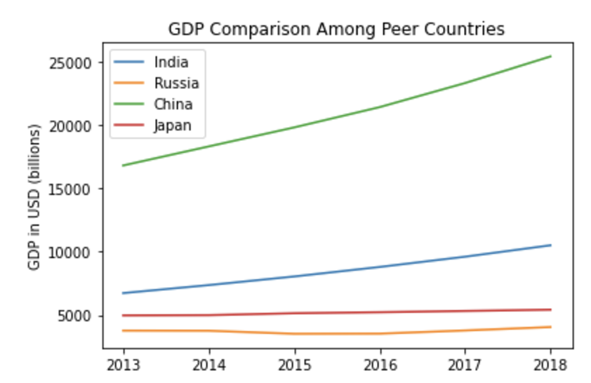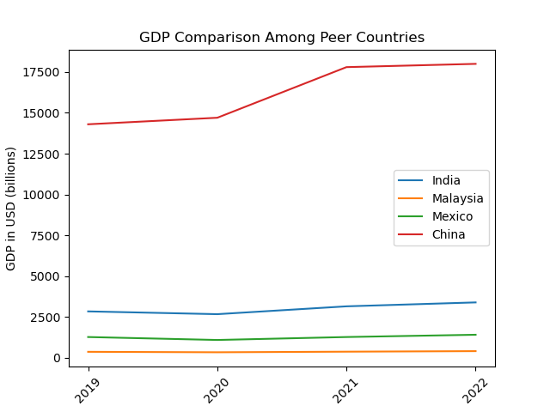
Figures 1a and 1b. GDP Comparison Among Peer Countries (left: 2013-2018; right: 2019-2022)

2.2 ECI Ranking and Changes
The Economic Complexity Index (ECI), as defined by Ricardo Hausmann and Cesar Hidalgo in 2009 to explain the knowledge accumulated in a country's population, is illustrated in Figures 2a and 2b.

As shown, India exhibits a decrease in production capability from 2013 to 2018. India is in a weak position in ECI terms, as its ECI change of -40.35% is lower than that of Russia (64.66%), China (-13.27%), and Japan (-8.79%).

The comparable countries decrease in ECI level between 2019 and 2020, with slight increases between 2020 and 2022. India exhibits an increase between 2019 and 2020, with growth in the technology sector being one of the reasons. India has seen a 215.84% increase in its ECI, which is greater than Malaysia’s (-166.2%), China’s (-158.24%), and Mexico’s (-202.7%).
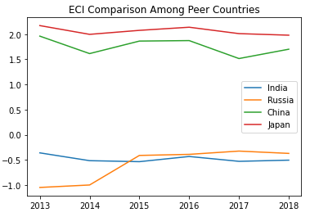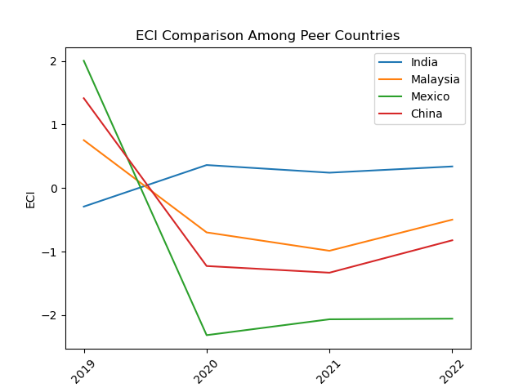
Figures 2a and 2b. ECI Comparison Among Peer Countries (left: 2013-2018; right: 2019-2022)

Figures 3a and 3b offer a further comparison of GDP Growth and ECI over the time span from 2013 to 2022 for India. Similar to the GDP drop and further increase from 2013 to 2018, the GDP growth during the period from 2019 to 2022 is accompanied by a similarly volatile increase in ECI. The results show that the economic growth experienced by India during the period from 2013 to 2018 is only slightly correlated with the predictions by ECI and that India made weak progress towards effectively developing a competitive product space that helps to accumulate complicated knowledge and technology. For the period 2019 to 2022, the ECI followed GDP trends, which can be interpreted as advancements in production. In order to provide a more concrete answer to why this has happened, we will dive into an analysis of India’s production structure and its product space designs in the next few sections.

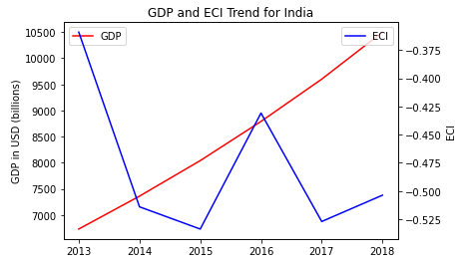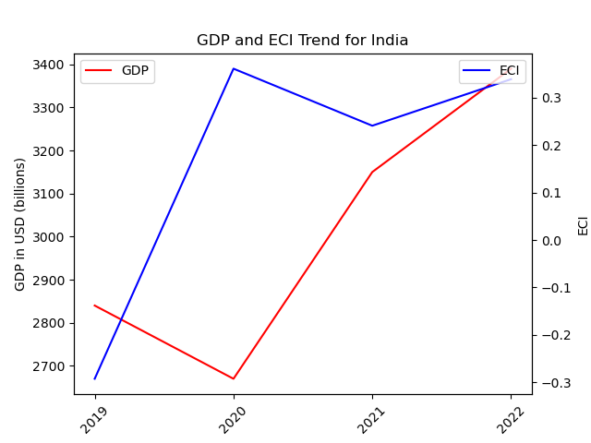
Figures 3a and 3b. GDP Growth and ECI for India (left: 2013-2018; right: 2019-2022)

3. Production Analysis

3.1 Product Categorization
Our main data source in this research is the UN Comtrade Website (https://comtrade.un.org), which provides us with valuable information on countries’ export values on an annual basis, including highly specific export data for more than 5000 categories of products. In order to have a holistic vision of the product space of a country, however, a level of categorization is required. Products in our data source are labeled from 010000-999999, with the first two digits representing a general category to which the product belongs. Based on the 99 categories extracted from the label, we further group the products into the 18 most widely-accepted industries, as summarized in Table 1.

Note that the High-complexity Products industry group is not a distinct industry but rather an aggregated industry that encompasses the most complicated products from the most technologically-advanced industries (as measured by PCI). This industry serves as an indicator for us to quantitatively evaluate how well a country has performed in developing cutting-edge technologies and closing its technological gap with advanced economies, which has become a topic of wide concern today. Indeed, when we rank the 18 categories based on PfCI (an equivalent concept of PCI as calculated based on the 18 categorized product groups), the High-complexity Products industry has the highest PfCI among all industry groups.

Category | Description
Animals and By-products | All kinds of meat, livestock and related by-products
Vegetables, Fruits and Plants | All kinds of plants, edible vegetables and fruits
Food and Preparations | Edible preparations, raw cooking materials and appliances
Clothing and Accessories | All kinds of fabrics, filament, clothing and accessories
Textiles | All kinds of textile articles and related products
Wood Products | Book, paper and other elementary products related to wood
Metals | Mining of all sorts of raw Metals
Refined and Processed Stones | Refined or processed stone products such as pearl and ceramics
Energy Drilling and Mining | Mining industry for energy, minerals, stone materials, etc.
Daily Instruments | Basic daily instruments such as sport requisites, timing and measuring tools
Raw Manufacturing | Basic products made from plastic, rubber, leather, etc.
Chemical Manufacturing | Advanced chemical products and pharmaceutical products
Chemicals | Raw chemical materials and by-products
Machinery and Construction | Machinery and mechanical appliances, including electrical equipment
Transportation | Vehicles and locomotives including aircraft, ship, railway, etc.
Weapons | Explosives, arms and ammunition
Services and Utilities | Financial, business, legal, communication, travel Services and Utilities, etc.
High-complexity Products | Agglomeration of advanced products with highest PCIs
Table 1. Categorization of Products

We further observe a positive correlation between the GDP and the export of High-complexity Products. A higher adjusted R-square exists between GDP and High-complexity Products exports, indicating that more successful economics, as measured by GDP, tend to be those that are capable of producing and exporting High-complexity Products as we define them. Tables 2a and 2b show the OLS results in a universe of 107 and 21 typical countries respectively.

 | High-complexity Products | Food and Preparations | Animals and By-products
Adj. R-squared | 0.075 | 0.006 | 0.002
F-statistic | 9.556 | 1.638 | 1.175
No. Observations | 107 | 107 | 107
Table 2a. OLS Regression Results of GDP against Percentage Volume of Exports

 | High-complexity Products | Food and Preparations | Animals and By-products
Adj. R-squared | 0.149 | 0.003 | -0.012
F-statistic | 4.510 | 1.059 | 0.7542
No. Observations | 21 | 21 | 21
Table 2b. OLS Regression Results of GDP against Volume of Percentage Exports

3.2 Realized Industry Development
Based on the aforementioned product categorization, we aim to capture India's realized industry production strategy between 2013 and 2022 on a complexity level. In Hausmann and Hidalgo (2009), distance is defined to be a measure of how far a country is from a certain product, not in its product space. We extend this concept to all product groups and quantify how technically equipped a country is to develop the corresponding product groups. In other words, the shorter the distance between a country and a product group, the more capable a country is of developing products within that group. Defining this net distance change as the Realized Industry Development (RID), our export data allow us to calculate and compare the RID of India and the 18 product groups in 2022 and 2018 through the difference, where a positive RID indicates a shortening of the distance (i.e., advancement of the industry), and a negative RID indicates the reverse. It is notable that the number of industries with positive RID has decreased from 2018 to 2022.

Category | RID (2022) | RID (2018)
Daily Instruments | 0.000850 | 0.020327
Chemicals | -0.046311 | -0.002772
Weapons | -0.017180 | -0.005812
Wood Products | 0.030216 | 0.006997
Transportation | -0.012925 | 0.053971
Machinery and Construction | -0.005397 | -0.013036
Metals | -0.002336 | -0.013561
Raw Manufacturing | -0.012870 | -0.011949
Services and Utilities | -0.003868 | -0.020676
Clothing and Accessories | -0.014967 | -0.032151
Chemical Manufacturing | -0.022936 | -0.009016
Food and Preparations | -0.004701 | -0.015875
Textile | -0.008554 | -0.035327
High-complexity Products | -0.012672 | 0.029753
Vegetables, Fruits and Plants | -0.010873 | -0.013117
Animals and By-products | -0.008646 | -0.021231
Energy Drilling and Mining | 0.013287 | -0.001932
Precious Stones | -0.019597 | -0.006538
Table 3. Realized Industry Development (RID) of India
3.3 Regional and Global Comparison
Tables 4a-4b below summarize how the production strategy adopted by India compares with selected leading economies in the world across different years, as measured in RID. Leading economies such as Germany, France, and Canada gave a considerable level of attention to more advanced product groups such as High-complexity Products in 2018 and Transportation in 2022.

Ranking | France | the UK | Germany
1 | High-complexity Products | Services and Utilities | High-complexity Products
2 | Chemical Manufacturing | Weapons | Transportation
3 | Daily Instruments | Raw Manufacturing | Wood Products
4 | Animals and By-products | Precious Stones | Metals
5 | Food and Preparations | Animals and By-products | Food and Preparations
Table 4a: RID Comparison across Leading Economies (2018)

Ranking | Canada | Germany
1 | Energy Drilling and Mining | Daily Instruments
2 | Animals and By-products | Chemicals
3 | Vegetables, Fruits and Plants | Transportation
4 | High-complexity Products | Chemical Manufacturing
5 | Wood Products | Metals
Table 4b: RID Comparison across Leading Economies (2022)

Tables 4c-4d further examine India's development strategy against those of emerging economies on a global scale. Reasonably, emerging economies such as China, South Korea, and Singapore have devoted the majority of their efforts to intermediate industry groups, showing moderate shifts in strategies over the course of four years.

Ranking | China | South Korea | Singapore
1 | High-complexity Products | Transportation | Transportation
2 | Transportation | Textile | High-complexity Products
3 | Machinery and Construction | High-complexity Products | Precious Stones
4 | Energy Drilling and Mining | Chemical Manufacturing | Daily Instruments
5 | Daily Instruments | Machinery and Construction | Services and Utilities
Table 4c: RID Comparison across Emerging Economies (2018)

Ranking | China | South Korea | Singapore
1 | Daily Instruments | Chemicals | Transportation
2 | Chemicals | Daily Instruments | Weapons
3 | Raw Manufacturing | Metals | High-complexity Products
4 | Metals | Raw Manufacturing | Energy Drilling and Mining
5 | Machinery and Construction | Machinery and Construction | Machinery and Construction
Table 4d: RID Comparison across Emerging Economies (2022)

4. Product Space Design

4.1 Suggested Development Vector
As outlined above, distance gives us an idea of how far each new product is from a country’s current mix of exports. As defined in Hausmann and Hidalgo (2009), distance is “the weighted proportion of products connected to goods p that country c is not exporting, i.e., MCP = 0.” Based on this definition, the distance between a country and any product that the country is currently exporting (i.e., the country is a significant exporter of the product as compared to the global average) is zero. Similarly, opportunity gain quantifies the contribution of a new product in terms of opening up the doors to more and more complex products. Intuitively, a product that a country is currently exporting (i.e., MCP = 1) has an opportunity gain of zero. An unreasonable investment in a certain product p would lead to a relative decrement in the export of more profitable products and therefore lead to a negative opportunity gain of product p. The opportunity gain is not the only estimator of a country’s level of economic development. However, among countries with comparable economic strength, those having higher ECI, or in other words, more reasonable economic structures are often in better shape.

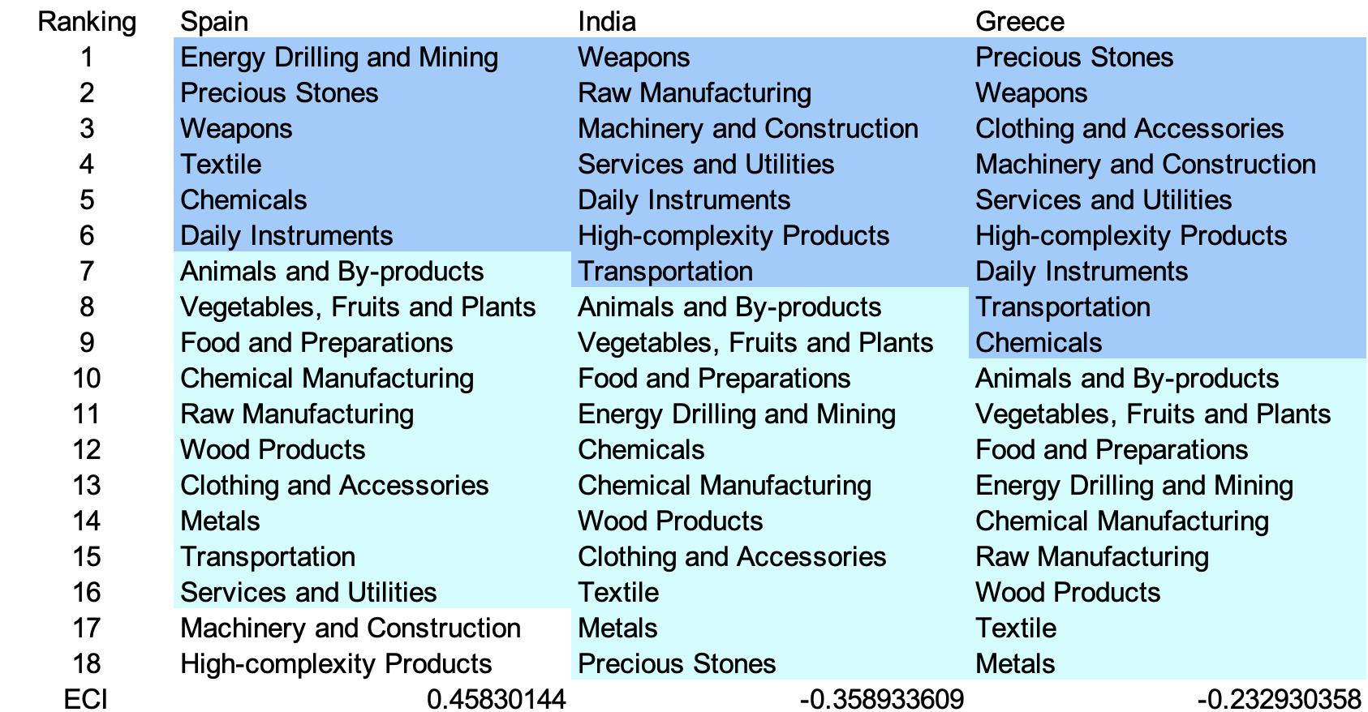Table 5a. Opportunity Gain Ranking on a Comparable Scale (2013)
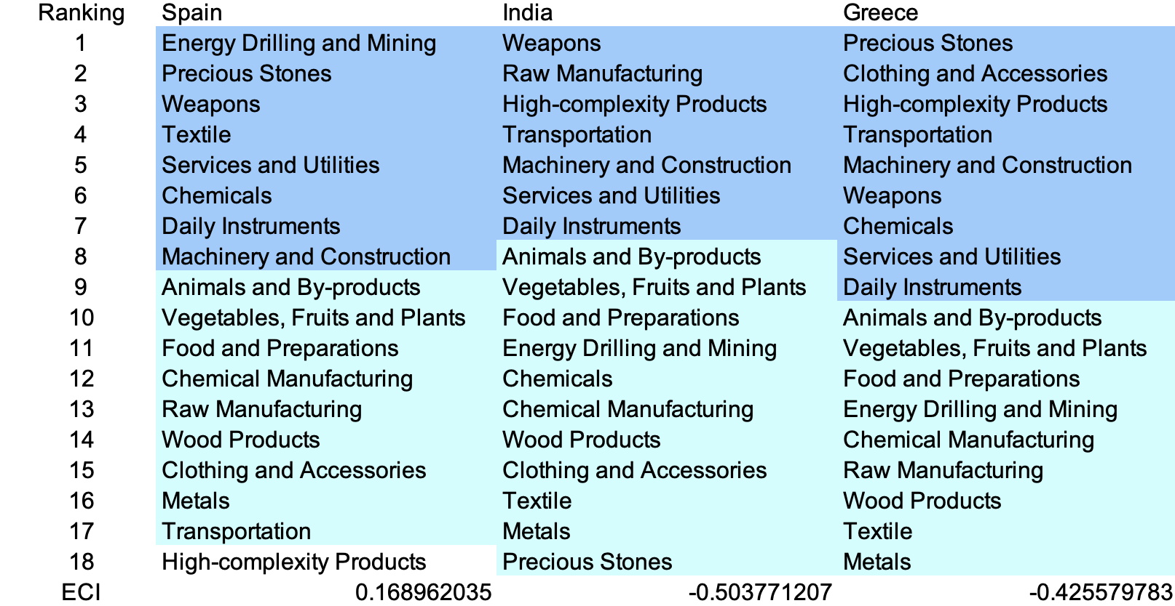Table 5b. Opportunity Gain Ranking on a Comparable Scale (2018)

Rank | India | Malaysia | Togo
1 | Weapons | Services and Utilities | Weapons
2 | Machinery and Construction | Chemical Manufacturing | Vegetables, Fruits and Plants
3 | Food and Preparations | High-complexity Products | Machinery and Construction
4 | Raw Manufacturing | Precious Stones | Wood Products
5 | Wood Products | Chemicals | Services and Utilities
6 | Services and Utilities | Vegetables, Fruits and Plants | Precious Stones
7 | Daily Instruments | Animals and By-products | Chemicals
8 | Transportation | Machinery and Construction | Daily Instruments
9 | High-complexity Products | Wood Products | Metals
10 | Animals and By-products | Textile | Transportation
11 | Vegetables, Fruits and Plants | Food and Preparations | High-complexity Products
12 | Energy Drilling and Mining | Energy Drilling and Mining | Animals and By-products
13 | Chemicals | Raw Manufacturing | Food and Preparations
14 | Chemical Manufacturing | Metals | Energy Drilling and Mining
15 | Clothing and Accessories | Transportation | Chemical Manufacturing
16 | Textile | Weapons | Raw Manufacturing
17 | Metals | Daily Instruments | Clothing and Accessories
18 | Precious Stones | Clothing and Accessories | Textile
ECI | 0.338973 | -0.498173 | 0.315147
Table 5c. Opportunity Gain Ranking on a Comparable Scale (2022)

We define the ranking of opportunity gain for a country c, as the Suggested Development Vector (SDV) of c. Tables 5a-5c summarize how the SDV of India compares with a selected group of comparable and leading economies in the world, with the industry groups ranked in decreasing order of significance.

Dark blue indicates positive opportunity gains, light blue indicates zero opportunity gains, and white indicates negative opportunity gains. The result shows that leading countries barely have any industries with positive opportunity gain. In other words, those countries are already in the most stable and efficient economic structure. Without the necessity of economic transition, those countries merely need to maintain a steady and balanced economic development. In contrast, developing countries have nearly half of industries with positive opportunity gain and share common interests in Machinery and Construction. It can be concluded that India shares the characteristics of developing countries, with a balanced economic structure.

Table 6. SDV of Other Sample Countries (2019)

4.2 Budgeted Industry Development Strategy and Interpretation
The optimal budgeted industry development strategy aims to solve the most efficient allocations under the budgeted constraint of different situations of heuristic total export growth. In order to obtain such an allocation portfolio, we formulate an optimization problem as the following:



where k(x) is the second largest eigenvector of $M_{CC'}$ after adding $x$ to the original export vector, C is the country that we are interested in, P is the product space, B is the heuristic budget.

If we can solve this problem, then we can know what the largest ECI to which a country can improve. Accordingly, the optimal solution $x*$ that we obtain here is exactly our optimal allocation. However, the biggest problem is that the objective function is not convex. Therefore, we cannot apply the classical tools for convex optimization to this problem. In order to solve this problem, our idea is to use a greedy algorithm. The way that we apply the greedy algorithm is that firstly we separate the total budget into k equal parts, and then for the first equal part we try to search for the product that can optimize our objective function by iterating through each $p∈P$. After we find the optimal product p for this equal part, we add the amount back to the export value of this product p and update the ECI for this country. If we observe that ECI does not change after iterating all the products, then we can add up one more equal part to invest. Until we find there is an ECI increment, we add the amount now to that product. The equal rest parts can be done in the same way.

By definition, a greedy algorithm is a kind of local search algorithm that is possible to run into a local minimum. Therefore, for local search algorithms, one typical way to keep it away from the local minimum is to enhance the vision of the algorithm by looking more steps forward. In our setting, whenever we obtain an increment of ECI, we mark down the required amount of export growth. Simultaneously, we continue searching for the next ECI increment point, compare the ratios of these two possibilities and pick the largest one. The ratio is defined as the following:

where ${ECI}_{p}$ is just the ECI of the country after adding some amount of export increment to product $p$, which is exactly the amount that is able to make ECI change. Also, we can express it in the way of $||$$x_{p}-x_{0}$${||}_{1}$.

In this way, we can obtain a further sighted greedy algorithm. Also, the number of parts that we would like to separate the budget into also matters. In order to solve this problem, we added a stabilizer on top of the enhanced greedy algorithm by running the algorithm for different numbers of parts and selecting the portfolio with the largest ECI increment and most complex economic structure.

Besides, it is quite common that there is a surplus in the budget. To deal with the surplus, we just add it to the product which needs the least amount of dollars to make $M_{cp}$ = 1 (i.e., the smallest amount of required export increase).

Economic Panel
As stated above, the enhanced greedy algorithm is developed mainly for solving the optimal allocation strategy. In order to visualize this allocation, an economic panel is created, consisting of a pie chart, a line chart and a table. First, a pie chart is used to show the percentage of each product in the optimal portfolio. The number located in the center of the circle denotes the heuristic growth of total export, which is also our budget. Each category in the chart has a determined percentage of the allocated budget. The lines below the pie charts show how the ECI changes during the searching process of the greedy algorithm. Even though sometimes an increase of the export by 15% or 20% does not seem reasonable to developed countries, yet it can also give a sense of how a country should develop in the long term. Eventually, the graph in the end is just for numerical explanation for the pie charts.

Interpretation
For the purpose of a clear explanation of the line charts, we label all the products in Table 7. Please refer to this table when trying to understand the investment trajectories in the line charts.

Label | Product Names
1 | Animal and By-products
2 | Vegetables, Fruits and Plants
3 | Food and Preparations
4 | Energy Drilling and Mining
5 | Chemicals
6 | Chemical Manufacturing
7 | Raw Manufacturing
8 | Wood Products
9 | Clothing and Accessories
10 | Textile
11 | Metals
12 | Machinery and Construction
13 | Transportation
14 | Weapons
15 | Daily Instruments
16 | Precious Stones
17 | High-complexity Products
18 | Services and Utilities
Table 7. Products Labeling

Figures 4a-4c show an economic panel for India in 2013, 2018, and 2022. We can see that for different percentages of heuristic total export growth, the ECIs of India actually have different increments.

For 2013, in the case of 5 percent export growth, Raw Manufacturing is one of the main components. With a budget of 10 percent export growth, Weapons and Daily Instruments account for most of the portfolio. As the budget increases to 15 percent, the portfolio becomes significantly more diverse, with key industries including machinery and construction, daily instruments, and raw manufacturing. When the budget rises to 20 percent, the portfolio becomes even more comprehensive, with metals added as a critical industry for development. In addition to the previously mentioned sectors, products such as chemical manufacturing and high-complexity goods are also considered. Among the four ECI improvement trajectories, the most significant gains are observed in raw manufacturing, services, and utilities. This suggests that, with lower expectations for economic improvement, India should focus more on developing these sectors. A more detailed numerical representation of the portfolio is shown in Table 8a.
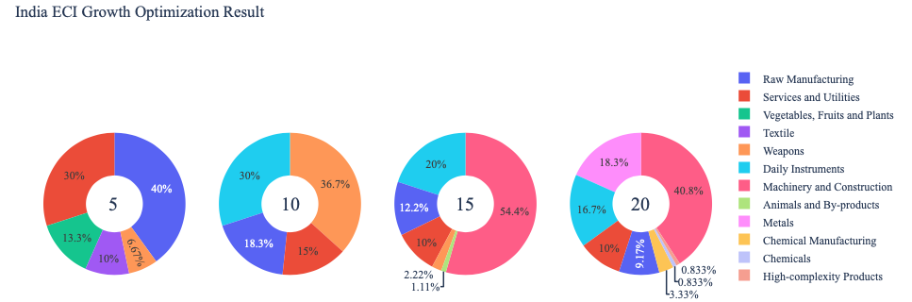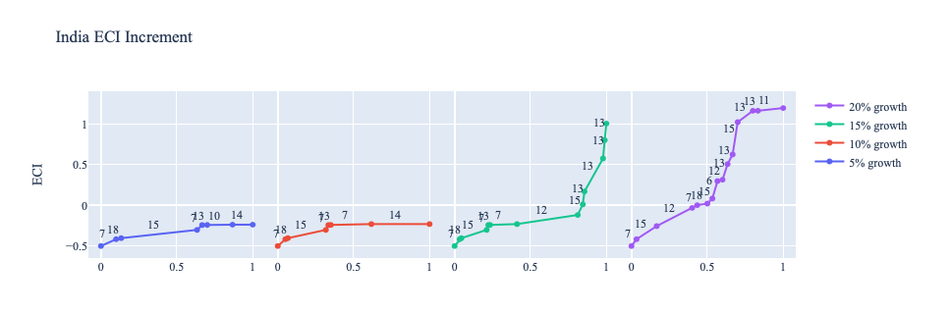

Figure 4a. Greedy-Based ECI Improvement Results of India with Different Budgets (2013)
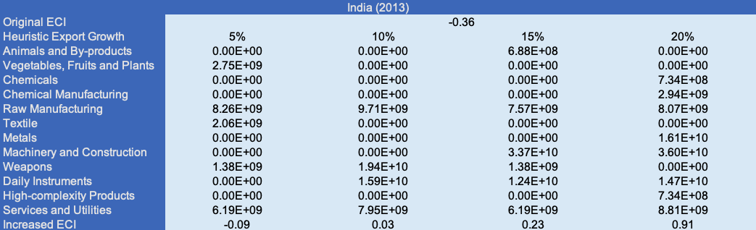
Table 8a. Portfolio of India (2013)

For further suggestions on India’s development in the future, we also offer the optimization result based on its export data in 2018. Below is the economic panel for India in 2018. For the cases of 5% and 10% export growth, while the ECI improvement trajectories are relatively similar, the main components of the portfolio are quite distinct. At 5% growth, daily instruments and textiles dominate the portfolio, whereas at 10% growth, weapons and raw manufacturing take precedence. As the export growth budget increases to 15% or 20%, India’s ECI improves significantly, rising from -0.50 to 1.00 or even 1.20. With a 15% export growth budget, the portfolio is primarily composed of machinery and construction, raw manufacturing, and daily instruments. However, when the budget increases to 20%, the portfolio becomes more balanced, with machinery and construction, daily instruments, transportation, and metals emerging as the key components, each holding a similar weight. A more detailed numerical representation of the portfolio is shown in Table 8b.

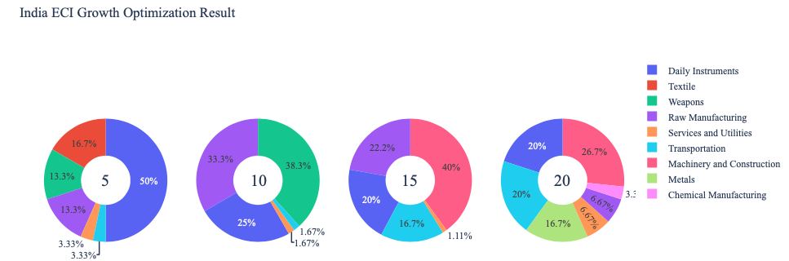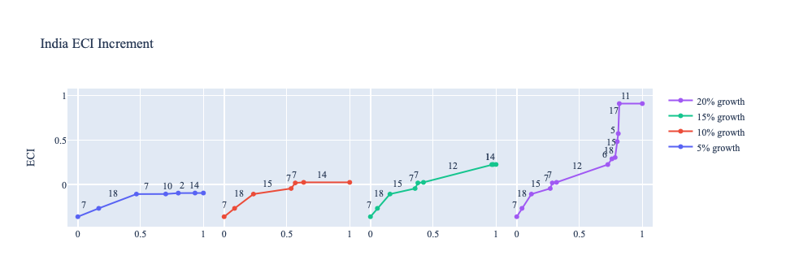
Figure 4b. Greedy-Based ECI Improvement Results of India with Different Budgets (2018)

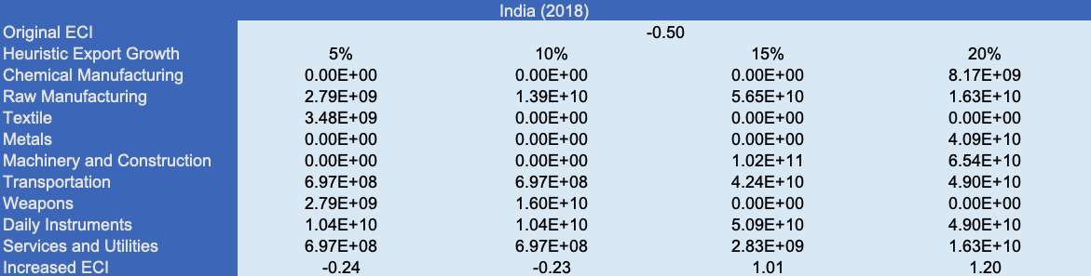
Table 8b. Portfolio of India (2018)

To compare with the performance in 2013 and 2018, we also re-examine suggested strategies for 2022. For 2022, a 5 percent increase in export would emphasize Textiles, followed by Food and Preparations, and Chemicals for 10, 15, and 20 percent export growth respectively. These strategies go in line with the suggested trajectories based on ECI. As export growth increases to 15 and 20 percent, Chemicals emerge as a key focus, reflecting the need for higher complexity and technological advancement in the portfolio. The investment strategies follow this trajectory, with a progressive shift toward industries that contribute to economic complexity and growth. A more detailed numerical representation of the portfolio for India is shown in Table 8c.
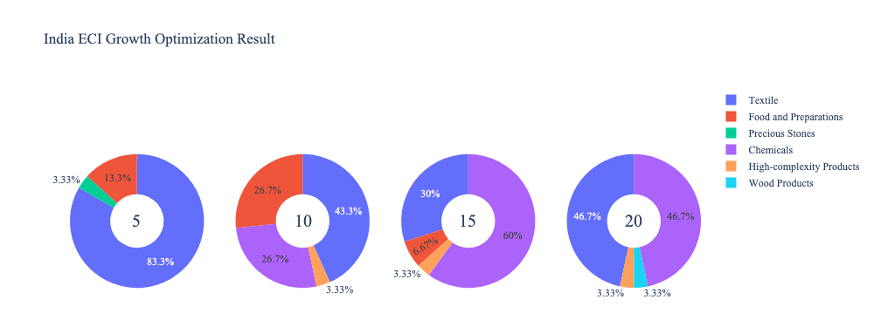
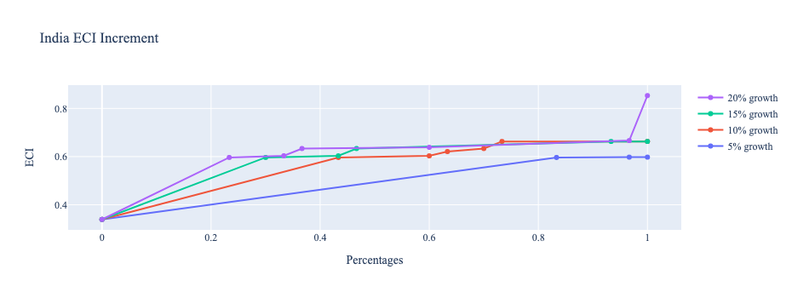
Figure 4c. Greedy-Based ECI Improvement Results of India with Different Budgets (2022)

India (2022)
Original ECI | 0.339
Heuristic Export Growth | 5% | 10% | 15% | 20%
Food and Preparations | 3.52E+09 | 2.87E+10 | 7.23E+09 | 0.00E+00
Chemicals | 0.00E+00 | 2.87E+10 | 6.51E+10 | 6.42E+10
Wood Products | 0.00E+00 | 0.00E+00 | 0.00E+00 | 4.59E+09
Textile | 2.25E+10 | 4.66E+10 | 3.25E+10 | 6.42E+10
Precious Stone | 8.82E+08 | 0.00E+00 | 0.00E+00 | 0.00E+00
Increased ECI | 0.598 | 0.663 | 0.663 | 0.853
Table 8c. Portfolio of India (2022)

4.3 Sensitivity Analysis and Contingency Strategy
In the following section, our broad aim is to understand how sensitive India is to changes in export in various industries. While the Economic Complexity Index has been shown to contain valuable information about the economic strength/capacity of a country, little has been said as to the stability of the measure itself. We seek to uncover the main drivers of stability under a country's ECI score and better understand longer-term projections for ECI growth. Additionally, gaining an intuition on the industries that are bolstering an economy and the industries that offer the greatest return per unit of investment is best done through visualization of industry-specific sensitivity. To this end, we have developed two categories of sensitivity analysis.
ECI Sensitivity Graph
First, in order to assess the effect particular industries have on each respective country, we developed ECI Sensitivity graphs (Figure 5). We use the shocking methodology to increment or decrement an industry’s export level by a certain percentage and recalculate the ECI, all else being equal. While freezing the export dynamics of the rest of the world and enacting an instantaneous shock in export for a particular industry and country may not reflect real-life dynamics, what it does offer us is an understanding of a country’s level of dependency on an industry in the context of ECI. The shocking is done in small percentage increments in order to smooth out the resulting curve. Additionally, a recurring theme one will see is that for most industries, a breaking point occurs where the ECI either jumps upwards or downwards, creating a hockey stick shape rather than a linear trend. While the inflection point may not be accurate in the context of real life, comparing the various inflection points across industries can give us valuable insight.

Figure 5. Sample ECI Sensitivity Graph (2018)
The graphs are formulated as follows. There are six ECI Sensitivity graphs, two for each of the following years: 2022, 2018, and 2013. The first chart, Incremental ECI Sensitivity, shows positive shocking in which export numbers are shocked upwards per industry. The X-axis is in terms of percentage shock per current dollar value of export. The Y-axis is the recalculated ECI level post-shocking. The second chart, Decremental ECI Sensitivity, follows the same format except the X-axis represents negative shock. In other words, exports for each industry are decremented, and the ECI is accordingly recomputed.
SDV Sensitivity
Secondly, we analyze the sensitivity of the SDV to changes in export levels. The goal is to understand how export level changes for a particular industry can affect the marginal opportunity gain for other industries. We will be using specifically High Complexity Products and Food and Preparations as our base industries. We will be increasing or decreasing the absolute export level in both of these industries and observing the effects on the SDV.
When the opportunity gain of an industry is negative, the SDV sensitivity approximates how an over-development of the industry jeopardizes the economic structure of a country. When the opportunity gain of the industry is zero, the SDV sensitivity determines whether the further development of the industry shapes the country with a better economic structure and predicts how the SDV would change accordingly. Specifically, as we reduce the export of such an industry to 25%-50% of its original value, a few other industries originally with negative opportunity gain could likely become profitable.
Similar to the ECI sensitivity graphs above, we will be shocking export of High Complexity Products and Food and Preparations in small percentage increments. A new SDV, represented by a new column in the charts, is recorded only when a certain level of shock changes the structure of the SDV. In effect we are incrementing or decrementing export levels of two industries until the marginal opportunity gain of any industry changes in category (positive, negative, or neutral). Below is an example of a SDV Sensitivity chart with Positive Shocking. Industries with positive marginal opportunity gain are colored blue, neutral is colored white and negative is colored red.


Table 9. Sample Incremental SDV Sensitivity for High-Complexity Products (2018)

Contingency Plan
The Contingency Plan aims to present a set of solutions with respect to upheavals in different industries. Instead of compensating for the declining production directly, the best strategy is to develop those incipiently profitable industries. In this manner, we can derive a contingency strategy for countries to deal with possible abrupt declines of crucial industries. In some cases, the SDV remains unchanged even when a zero-opportunity-gain industry declines to 20% in terms of export. We can then conclude the industry is not indispensable to the country. As a clarification, the three consecutive N/As mean that the country doesn’t even need to respond to a collapse in the industry. Countries tend to have distinct solutions to the ups and downs of the same industry. To create the contingency strategy table, we decrease the export level for each industry in the country’s current production space by 60% respectively. The three highest-ranking industries in the new SDV are then returned.

Product Names | 0 | 1 | 2
Animal and By-products | Services and Utilities | Daily Instruments | Weapons
Vegetables, Fruits and Plants | Services and Utilities | Daily Instruments | Weapons
Food and Preparations | Services and Utilities | Daily Instruments | Weapons
Energy Drilling and Mining | Services and Utilities | Daily Instruments | Weapons
Chemicals | Services and Utilities | Daily Instruments | Weapons
Chemical Manufacturing | Services and Utilities | Daily Instruments | Weapons
Raw Manufacturing | Services and Utilities | Daily Instruments | Weapons
Wood Products | Services and Utilities | Daily Instruments | Weapons
Clothing and Accessories | Services and Utilities | Daily Instruments | Weapons
Textile | Services and Utilities | Daily Instruments | Weapons
Metals | Services and Utilities | Daily Instruments | Weapons
Machinery and Constructions | Services and Utilities | Daily Instruments | Weapons
Transportation | Services and Utilities | Raw Manufacturing | Daily Instruments
Weapons | Services and Utilities | Daily Instruments | Transportation
Daily Instruments | Services and Utilities | Weapons | Transportation
Precious Stones | Services and Utilities | Daily Instruments | Weapons
Daily Instruments | Services and Utilities | Daily Instruments | Weapons
Services and Utilities | Daily Instruments | Weapons | Transportation
Table 10. Sample Contingency Strategy (2018)

4.3 Sensitivity Analysis Results and Interpretation
We examine India's ECI Decremental and Incremental Sensitivity Charts for 2022. An increase in Raw Manufacturing will lead to the highest change in ECI, followed by Chemicals. The strong sensitivity effect of manipulating the Raw Manufacturing category changes from previous years. For the negative shock cases, Weapons becomes most impactful, which is a new trend. The rest of the industries do not appear to have the same level of sensitivity.

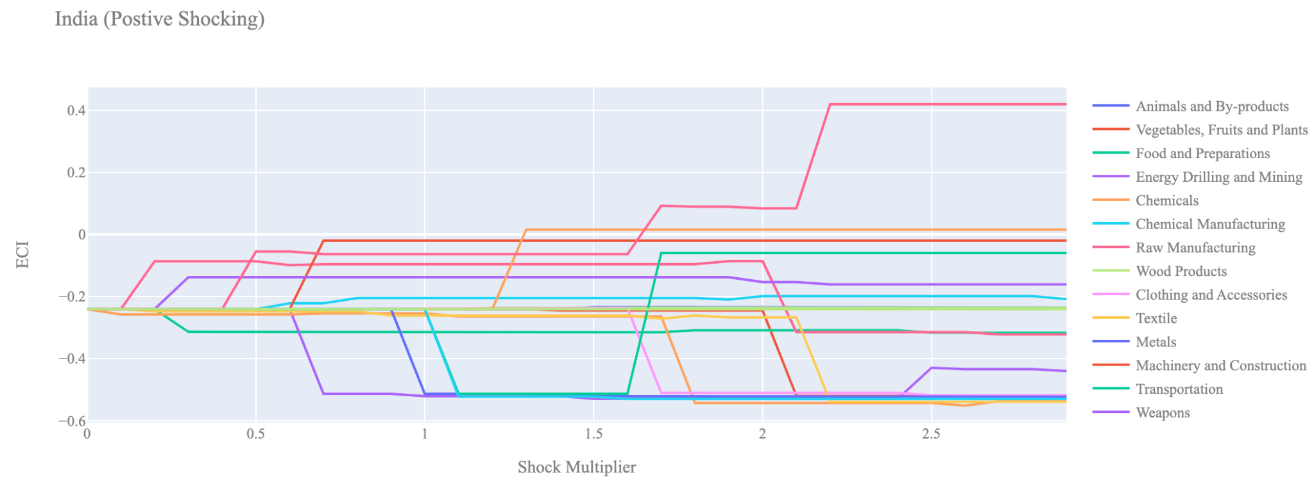
Figure 6a. Incremental ECI Sensitivity for India (2022)
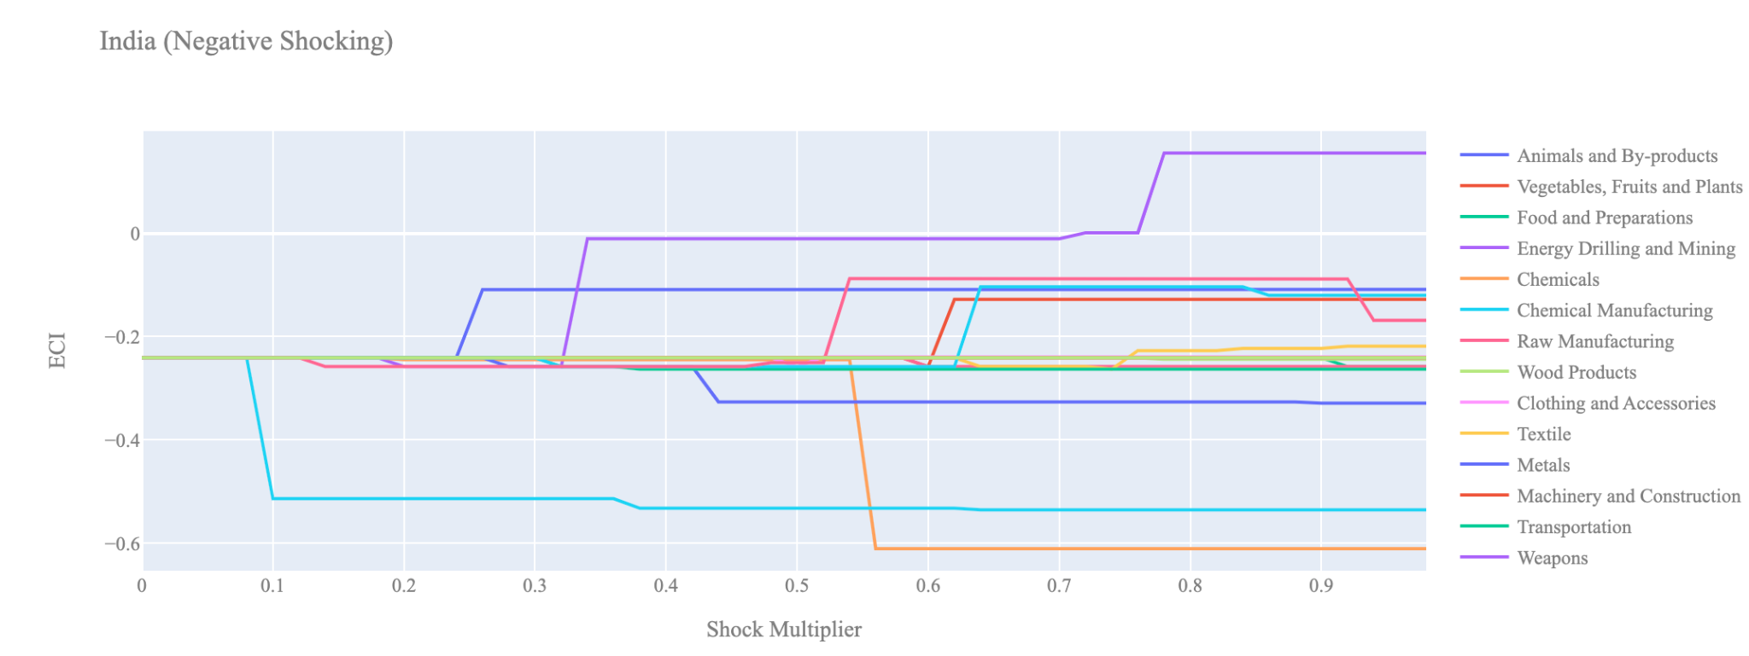
Figure 6b. Decremental ECI Sensitivity for India (2022)

Below are India’s 2018 ECI Sensitivity Charts. In the positive chart, we immediately observe that increases in High Complexity Products, Transportation, and Machinery contribute to higher ECI levels. This combination of industries is typical for well-developed countries. High Complexity Products, in particular, offer the greatest ECI growth per unit of export increase. Other industries, however, have a minimal impact on ECI, making it clear which sectors India should prioritize to improve its economic complexity.
Turning to India’s 2018 Negative Shock chart, we find that the country is most sensitive to declines in Chemical Manufacturing and Textiles. Interestingly, despite the negative ECI, reducing exports in certain industries that do not significantly contribute to the ECI score results in notable improvements in the overall ECI level. This highlights the potential for India to enhance its economic complexity by scaling back on less impactful sectors.

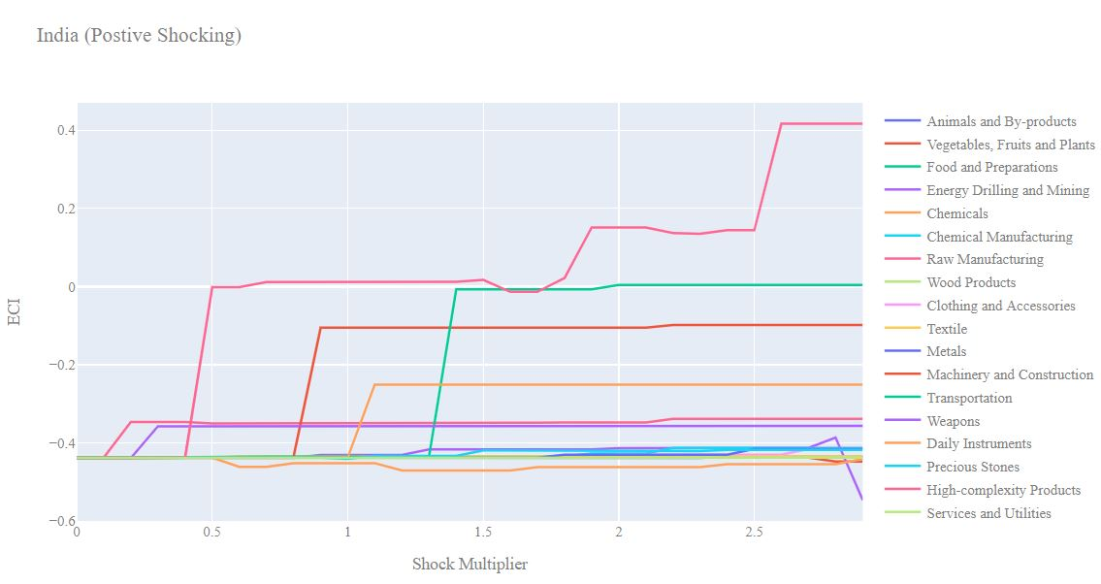
Figure 7a. Incremental ECI Sensitivity for India (2018)

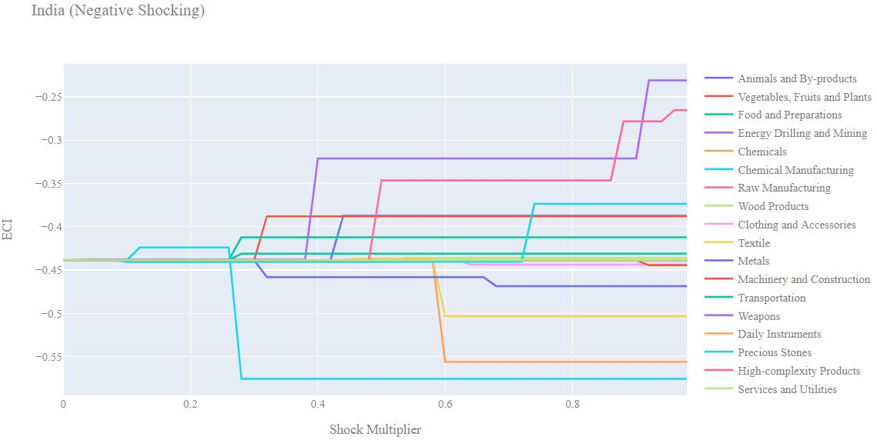
Figure 7b. Decremental ECI Sensitivity for India (2018)

Next, we examine the 2013 ECI Sensitivity graphs. In the positive shock scenario, we observe that the ECI sensitivity landscape has not changed significantly over the five-year period. High Complexity Products continue to offer the best prospects for ECI growth. Additionally, as in 2018, Transportation and Machinery also have a positive impact on ECI levels.
In the 2013 negative shock scenario, India shows sensitivity to reductions in Chemical Manufacturing and Textiles, similar to the pattern in 2018. However, in 2013, we also observe that India is somewhat sensitive to declines in the Metals sector, a factor not as pronounced in 2018.
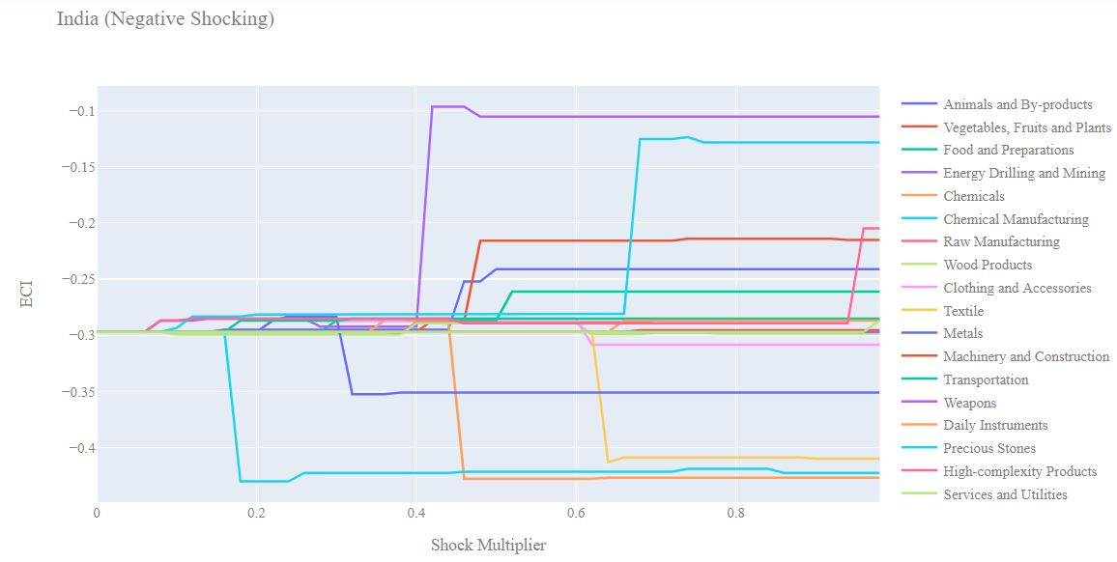
Figure 8a. Incremental ECI Sensitivity for India (2013)

Figure 8b. Decremental ECI Sensitivity for India (2013)

Below we see the SDV sensitivity charts for High Complexity Products in 2018. India’s SDV is somewhat sensitive to changes in High Complexity products since the Indian economy is dependent on the export of products from this industry. If High Complexity Products are shocked upwards far enough we see that many industries start having negative opportunity gains since at that point India’s economy will become heavily dependent on High Complexity Products and the industries that are within close proximity.

Considering the Negative SDV sensitivity chart we observe that decreases in High Complexity Products only makes High Complexity Products an even more beneficial space to enter. This phenomenon is observed during the pandemic period, as India managed to increase its ECI despite the drawdown in High Complexity Products. We can see from the Food and Preparations SDV sensitivity chart that India is not especially dependent on this industry causing it’s SDV to be fairly stable in the face of shocks to this industry.

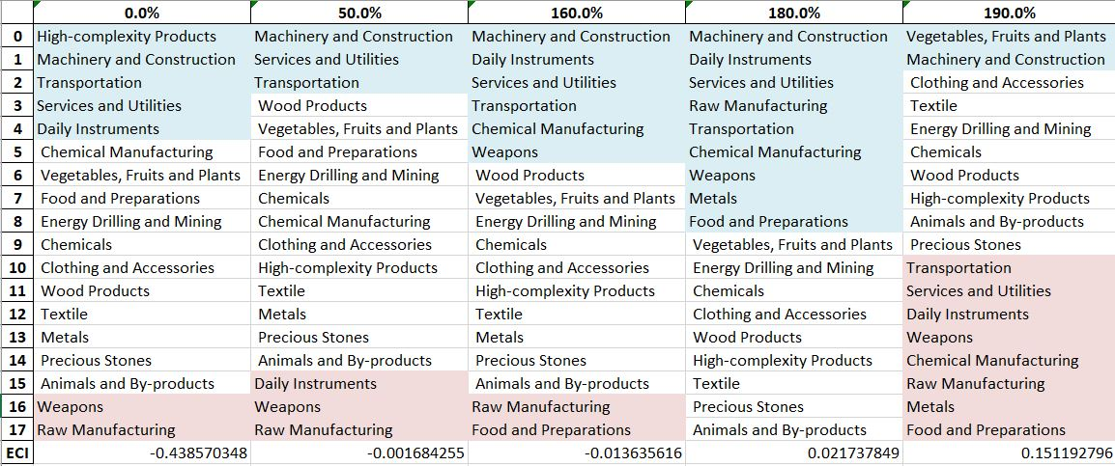
Table 11. India’s Incremental SDV Sensitivities(2018)
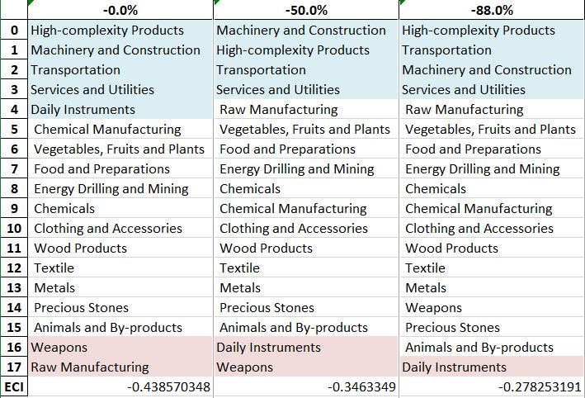
Table 12. India’s Decremental SDV Sensitivities (2018)

4.4 Contingency Strategy
Decreasing export of each industry in India’s current production space by 60% respectively, we derive the contingency strategy shown below.
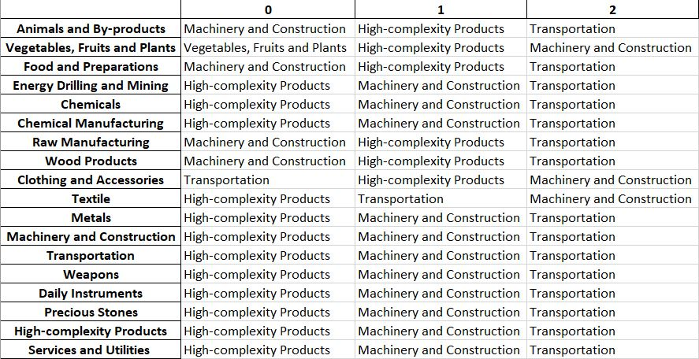
Table 13. India’s Contingency Strategy (2018)

5. Macro-level Predictions

5.1 Structural Optimality Index
ECI sensitivity described in the section before has proven to be a significant factor in deciding the economic outcomes of countries. In order to quantitatively evaluate how effective our development strategies are and how deviations from the suggested developmental path will lead to suboptimal growth results, we define the measure – Structural Optimality Index (SOI) – on a country level as the Adjusted R-Square obtained from regressing the country’s realized industry development over the suggested development strategy. Both strategies are quantified in nature, with the realized development represented by increasing export in every major industry group and the suggested development strategy represented by the opportunity gains of developing the corresponding industry groups as calculated in previous sections. The adjusted R-square from the regression thus provides us with a quantified measure of how the development path adopted by the country has fitted with/differed from calculations on a complexity level.

After obtaining this measure for all countries in our database, we further regress countries’ five-year economic growth, which is defined as the percent increase in GDP (USD), over their SOI. Figure 9 illustrates the regression output, which shows a strong positive correlation between countries’ SOI and their five-year GDP growth, significant at the 1% level and achieving an adjusted R² of 4.5%. In other words, the more a country develops, as suggested by calculations on a complexity level, the better economic outcomes it achieves.

Table 14: OLS Regression Results
Dep. Variable: GDP | F-Statistic: 5.963
R²: 0.054 | Prob (F-Stat): 0.0163
Adj R²: 0.045 | No. Observations: 106


Figure 9. Regression of Five-Year GDP Growth over SOI (2013-2018)

5.2 SOI of India and Its Implications
During the first examined period, India, for instance, has a low level of structural optimality as compared with its developed peers. As the regression in Figure 10a suggests (the red curve represents export increase and the blue curve stands for opportunity gain of the corresponding industry), India demonstrates a moderate level of correlation with the suggested developmental path, having an adjusted R-square of around 0.126.

India ranks highly among all countries in terms of SOI and has made a fast rate of economic progress among its emerging peers from 2013 to 2018 with a 5 year GDP growth of 56.0%, which is consistent with the regression result in Figure 4b.This is in direct contrast to developed economies such as Japan, where there is moderate SOI of around -4.8% and a corresponding 5-year growth rate of 9.0%.

Specifically, India's economic progress from 2013 to 2018 can be at least partially explained by a development strategy that demonstrates a considerable but not perfect level of matches with our suggested developmental path. In fact, India invested heavily in the Transportation industry, while our model suggested focusing more on moderately complex industry groups such as Energy drilling/mining.

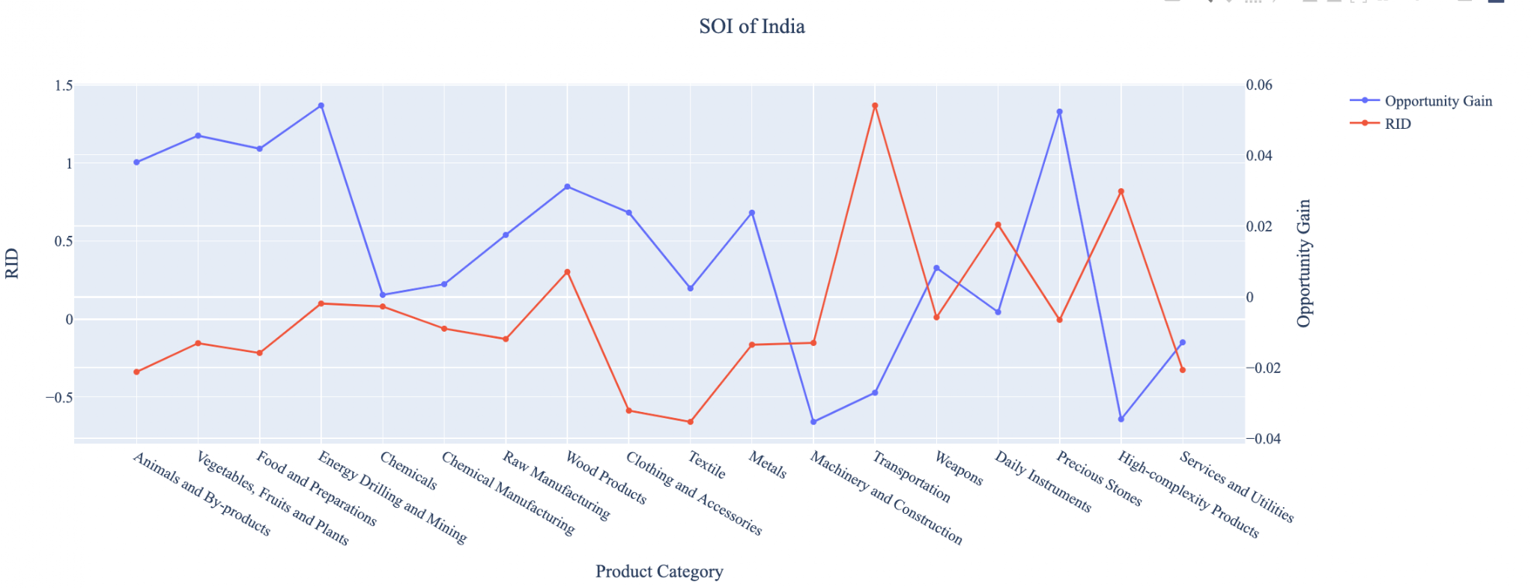
Figure 10a. SOI of India (2013-2018)

For the 2019-2022 years, India has continued to exhibit strong growth while progress is slow on a global scale during this period; India has adjusted well to negative economic shocks by decreasing SOI and period-over-period GDP growth.

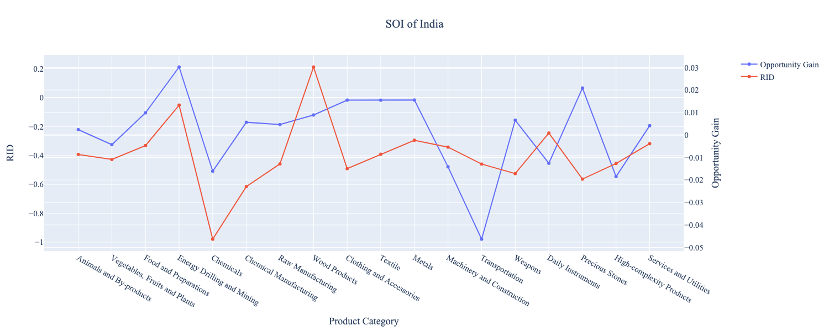
Figure 10b. SOI of India (2019-2022)

6. Concluding Remarks

In conclusion, India has demonstrated a high level of economic growth in terms of annual GDP increase during the period from 2013 to 2018, concurrent with an increase in economic complexity as compared with major developed economies. For 2019-2022, the growth in GDP has slowed alongside a large boost in ECI, higher than many comparable economies.

We believe that the mixed progress during the first period can be partially explained through the analysis of the economic and product complexity structure of India on the industry group level. The product classification system we adopt allows us to measure the realized industry development for various industry groups and to observe that India regressed in developing many of its industries across this period.

The mixed progress observed during this period can be partially explained by analyzing India's economic and product complexity structure at the industry group level. The product classification system we use enables us to assess the actual development of various industry groups and observe that India consistently focused on developing the Transportation, High-Complexity Products, and Daily Instruments sectors. In contrast, both developed countries and emerging economies globally pursued more complex and advanced industry paths. In 2022, this mixed progress was driven by India prioritizing the development of higher-complexity industries, despite global demand for basic, low-complexity products. As a result, while India's ECI improved, its GDP growth slowed compared to previous years and lagged behind some of its emerging economy counterparts.

Based on our analysis of opportunity gains and a sensitivity analysis of major industry groups, India could have furthered its progress by prioritizing High-Complexity Products, Transportation, and Machinery prior to the pandemic. However, given the economic disruptions caused by COVID-19, India now has an opportunity to enhance its gains by focusing on sectors such as Textiles and Chemicals. Additionally, we observe that India’s development strategy appears somewhat misaligned, as indicated by its relatively low level of structural optimality compared to other emerging economies. The adjusted R-square for structural optimality was around 12.6% from 2013-2018 and dropped to just 9.0% in 2022. Since a significant positive correlation exists between five-year GDP growth and the structural optimality index, India’s suboptimal growth experience—when compared to fast-growing economies both regionally and globally—becomes evident. This suggests that India has substantial potential to boost its economic performance through further optimization of its industrial structure, as proposed in this paper.

References

Hausmann, R., Hidalgo, C., Bustos, S., Coscia, M., Chung, S., Jimenez, J., Simoes, A. and Yıldırım, M. (2007). The Atlas of Economic Complexity. [online] Atlas.cid.harvard.edu. Available at: http://atlas.cid.harvard.edu/.

Balassa, B., “The Purchasing Power Parity Doctrine - A Reapprais- al,” Journal of Political Economy 72, 584-596 (1964).

Feenstra, R.; Lipsey, R.; Deng, H.; Ma, A. & Mo, H. “World Trade Flows: 1962-2000” NBER working paper 11040. National Bureau of Economic Research, Cambridge MA (2005).

United Nations Commodity Trade Statistics Database (http://comtrade.un.org/db/), accessed in August 2019.

The World Economic Forum, “The global competitiveness report,” (various years).

Barro, R. & Lee, J-W. “A New Data Set of Educational Attainment in the World, 1950-2010,” NBER Working Paper No. 1590 (2010).

Kaufmann, D. & Kraay, A. “Governance Indicators: Where Are We, Where Should We Be Going?” Policy Research Working Paper 4370. Washington, DC: World Bank (2008).

Hanushek, E.A. & Woessmann, L. “The Role of Cognitive Skills in Economic Development,” Journal of Economic Literature 46(3), 607- 668 (2008).

