Tab 1


https://atlas.cid.harvard.edu/

Optimal Industry Development Strategy Using Economic and Product Complexity

Niger

─
The Economic Complexity Lab - Columbia University
Alexandra Garcia, Kelly Mi, Margarita Demkina, Allison Lin, Helena Yang, Jane Zhang, Daniel Xu, Ryo Shibata, Navia Zhang, Haoxian Chen, Davepriyan Gunaratnam, Rohan Macherla, Ajit Akole, Shomik Ghose, Alex Wei-Liang Ku, Sannidhya Modi, Xilin Wang
Optimal Industry Development Strategy for Niger

0. Executive Summary

In this report, we aim to uncover the economic path Niger went through during the period from 2013 to 2022. Specifically, we dive into the topic through a macroeconomic overview of Niger from the perspective of Gross Domestic Product (GDP) and Economic Complexity Index (ECI), which reflect countries’ production capability and production structure, respectively. We find that during the period of our interest, Niger demonstrated a moderate level of economic growth with an average annual GDP growth rate of 4.69% between 2019 and 2021, with a greater economic complexity compared to other major developed economies.

The positive progress during the period (particularly in 2021-2022), we believe, can be partially explained through the analysis of the economic and product complexity structure of Niger on the industry group level, as well as the improved macro and microeconomic strategies. The product classification system we adopt allows us to measure the realized industry development for various industry groups and to observe that Niger progressed in developing most of its industries during the period while its developing counterparts and economies around the globe also adopted complex and progressive paths with variable degrees of success.

Based on our analysis of the opportunity gain and sensitivity analysis of major industry groups, Niger could further its gains by prioritizing Weapons, Machinery and Construction, and Services and Utilities in 2019. Three years later, in 2022, its focus should shift to the Chemicals and Daily Instruments industries, which are also one of the more developed industries at the time. We further note that Niger has a heavily mismatched development strategy that indicates a low level (compared to other developing countries) of structural optimality on the complexity level, having an adjusted R-square of around 0.72% in 2018 and a much higher score of 2.14% in 2021, demonstrating a shift and improvement in development. Since a significant positive correlation exists between GDP growth and the structural optimality index of an economy as we define and calculate, Niger indeed has a [suboptimal/optimal] growth experience as compared with fast-growing economies both on a regional scale and on a global scale and has the potential to further its economic gains through industrial structure optimization as suggested in the paper.

The three years between 2019 and 2022 showed a significant improvement in Niger’s economic growth, boosting its position on the global scale. Its GDP recovered to above the pre-pandemic levels, and it saw a significant boost in the ECI, particularly compared to its peer countries. Its current strategy still has the viable potential upside to increase its performance and optimize its structure further.

1. Report Overview

In this report, we aim to uncover the economic path Niger went through during the period from 2019 to 2022, before and after the COVID pandemic, compared to its performance from 2013 to 2018, before and after the Boko Haram Insurgency. Specifically, we dive into the topic through a macroeconomic overview of Niger from the perspective of Gross Domestic Product (GDP) and Economic Complexity Index (ECI), which reflect countries’ production capability and production structure, respectively. We then analyze the industrial framework and changes of Niger during the period based on quantitative measures such as the Product Complexity Index (PCI) and Product Family Complexity Index (PfCI), followed by a detailed analysis of how such changes have matched with development strategies as quantitatively measured by opportunity gains on an industry-level. We conclude our report with macro-level results and predictions of Niger, as deduced from regression models we have established on a global scale, which take into account countries’ stances in their product space.

2. Macroeconomic Results

2.1 GDP Ranking and Changes
Figure 1a illustrates the time-series GDP results for Niger and two of its peer countries (Nigeria and Ethiopia) from 2013 to 2018. Similar to the other countries, Niger displayed an eventual upward trend over the period; however, its growth was slightly less consistent than both Nigeria and Ethiopia’s growth. Niger’s average annual GDP growth rate of 5.0% over the five-year period is greater than Nigeria’s rate (1.9%) but less than Ethiopia’s rate 7.7%.

Figure 1b shows the GDP levels for Niger and its peer countries (Nigeria, Ethiopia, and Togo) from 2019 to 2022. Similar to the other countries, Niger displayed a drop in GDP from 2019 to 2020 because of the pandemic, with all GDPs rebounding in 2021. Over these three years, Niger’s average annual GDP growth rate (4.69%) is in the higher end, as it is greater than Nigeria and Togo’s average annual GDP growth rate of 1.725% and 4.67%, respectively, but less than Ethiopia’s 6.35%. It is notable that the GDP levels in Niger and Togo almost evened out after 2018.
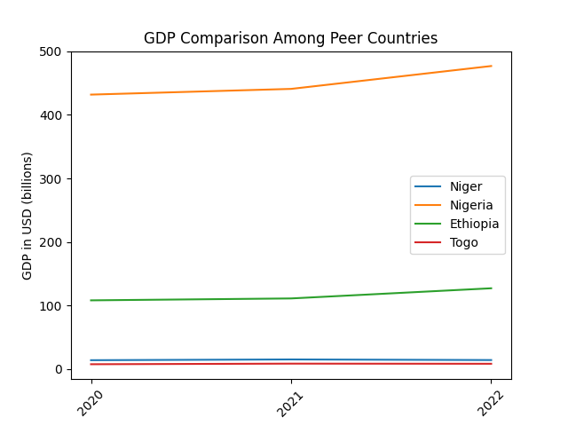
Figure 1. GDP Comparison Among Peer Countries (2019-2022)

2.2 ECI Ranking and Changes
The Economic Complexity Index (ECI), as defined by Ricardo Hausmann and Cesar Hidalgo in 2009 to explain the knowledge accumulated in a country's population, exhibits a similar growth pattern for Niger. As illustrated in Figure 2 below, Niger (1.78% ECI change) exhibited a small increase in production capability from 2013 to 2018, which is different from both Ethiopia (13.2%) and Nigeria (-3.4%). Niger is in a strong position in ECI terms, as its ECI change is consistently above average within its peer group in terms of GDP growth rate and ECI change across the period. .

The comparable countries maintain a small change in ECI level between 2019 and 2020, with a sharp change between 2020 and 2022. Niger exhibits a large increase in production capability in 2021 to levels not seen prior, with extensive microeconomic stimulus packages being one of the reasons. Niger has seen a 178.83% increase in its ECI, which is greater than Nigeria's (55.39%), but less than Ethiopia and Togo’s 204.55% and 205.18%, respectively.
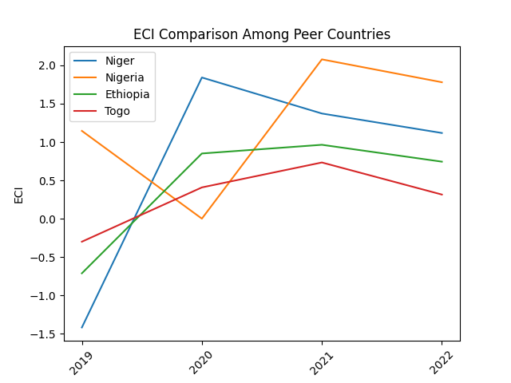
Figure 2. ECI Comparison Among Peer Countries (2019-2022)

Figures 3a and 3b offer a further comparison of GDP Growth and ECI over the time span from 2013 to 2022 for Niger. Similar to the GDP drop and further increase from 2013 to 2018, the GDP growth during the period from 2019 to 2021 is accompanied by a similarly volatile increase in ECI. The results show that the economic growth experienced by Niger during the period from 2013 to 2018 is only partially consistent with the predictions by ECI and that Niger made moderate progress towards effectively developing a competitive product space that helps to accumulate complicated knowledge and technology. For the period 2019 to 2021, the ECI followed GDP trends, which can be interpreted as advancements in production. In order to provide a more concrete answer to why this has happened, we will dive into an analysis of Niger’s production structure and its product space designs in the next few sections.
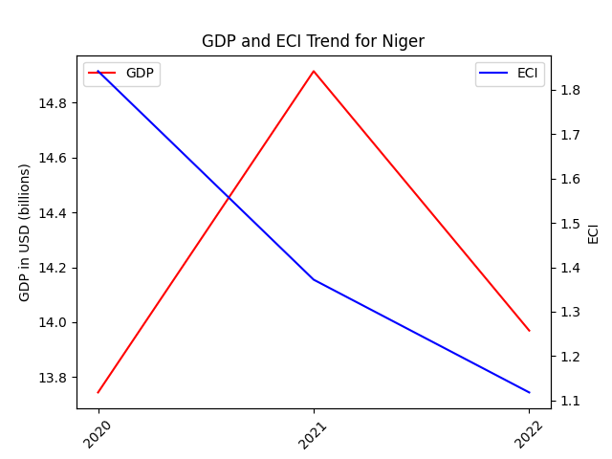
Figure 3. GDP Growth and ECI for Niger (right: 2019-2021)
3. Production Analysis

3.1 Product Categorization
Our main data source in this research is the UN Comtrade Website (https://comtrade.un.org), which provides us with valuable information on countries’ export values on an annual basis, including highly specific export data for more than 5000 categories of products. In order to have a holistic vision of the product space of a country, however, a level of categorization is required. Products in our data source are labeled from 010000-999999, with the first two digits representing a general category to which the product belongs. Based on the 99 categories extracted from the label, we further group the products into the 18 most widely-accepted industries, as summarized in Table 1.

Note that the High-complexity Products industry group is not a distinct industry but rather an aggregated industry that encompasses the most complicated products from the most technologically-advanced industries (as measured by PCI). This industry serves as an indicator for us to quantitatively evaluate how well a country has performed in developing cutting-edge technologies and closing its technological gap with advanced economies, which has become a topic of wide concern today. Indeed, when we rank the 18 categories based on PfCI (an equivalent concept of PCI as calculated based on the 18 categorized product groups), the High-complexity Products industry has the highest PfCI among all industry groups.

Category | Description
Animals and By-products | All kinds of meat, livestock and related by-products
Vegetables, Fruits and Plants | All kinds of plants, edible vegetables and fruits
Food and Preparations | Edible preparations, raw cooking materials and appliances
Clothing and Accessories | All kinds of fabrics, filament, clothing and accessories
Textiles | All kinds of textile articles and related products
Wood Products | Book, paper and other elementary products related to wood
Metals | Mining of all sorts of raw Metals
Refined and Processed Stones | Refined or processed stone products such as pearl and ceramics
Energy Drilling and Mining | Mining industry for energy, minerals, stone materials, etc.
Daily Instruments | Basic daily instruments such as sport requisites, timing and measuring tools
Raw Manufacturing | Basic products made from plastic, rubber, leather, etc.
Chemical Manufacturing | Advanced chemical products and pharmaceutical products
Chemicals | Raw chemical materials and by-products
Machinery and Construction | Machinery and mechanical appliances, including electrical equipment
Transportation | Vehicles and locomotives including aircraft, ship, railway, etc.
Weapons | Explosives, arms and ammunition
Services and Utilities | Financial, business, legal, communication, travel Services and Utilities, etc.
High-complexity Products | Agglomeration of advanced products with highest PCIs
Table 1. Categorization of Products

We further observe a positive correlation between the GDP and the export of High-complexity Products. A higher adjusted R-square exists between GDP and High-complexity Products exports, indicating that more successful economics, as measured by GDP, tend to be those that are capable of producing and exporting High-complexity Products as we define them. Tables 2a and 2b show the OLS results in a universe of 107 and 21 typical countries respectively.

 | High-complexity Products | Food and Preparations | Animals and By-products
Adj. R-squared | 0.075 | 0.006 | 0.002
F-statistic | 9.556 | 1.638 | 1.175
No. Observations | 107 | 107 | 107
Figure 4. OLS Regression Results of GDP against Percentage Volume of Exports

 | High-complexity Products | Food and Preparations | Animals and By-products
Adj. R-squared | 0.149 | 0.003 | -0.012
F-statistic | 4.510 | 1.059 | 0.7542
No. Observations | 21 | 21 | 21
Figure 5. OLS Regression Results of GDP against Volume of Percentage Exports

3.2 Realized Industry Development
Based on the aforementioned product categorization, we aim to capture Niger's realized industry production strategy between 2013 and 2021 on a complexity level. In Hausmann and Hidalgo (2009), distance is defined to be a measure of how far a country is from a certain product, not in its product space. We extend this concept to all product groups and quantify how technically equipped a country is to develop the corresponding product groups. In other words, the shorter the distance between a country and a product group, the more capable a country is of developing products within that group. Defining this net distance change as the Realized Industry Development (RID), our export data allow us to calculate and compare the RID of Niger and the 18 product groups in 2021 and 2018 through the difference, where a positive RID indicates a shortening of the distance (i.e., advancement of the industry), and a negative RID indicates the reverse. It is notable that the number of industries with positive RID has decreased from 2018 to 2021.

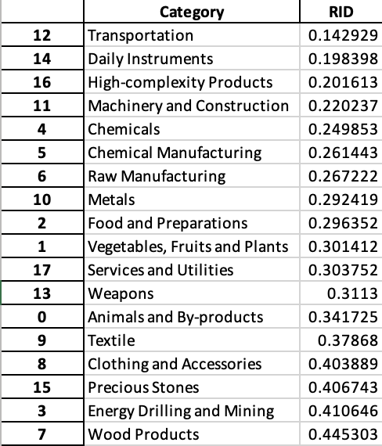
Table 3. Realized Industry Development (RID) of Niger

3.3 Regional and Global Comparison
Table 4a below summarizes how the production strategy adopted by Niger compares with selected leading economies in the world across different years, as measured in RID. Leading economies such as Bolivia, Peru, and Uruguay gave a considerable level of attention to more advanced product groups.

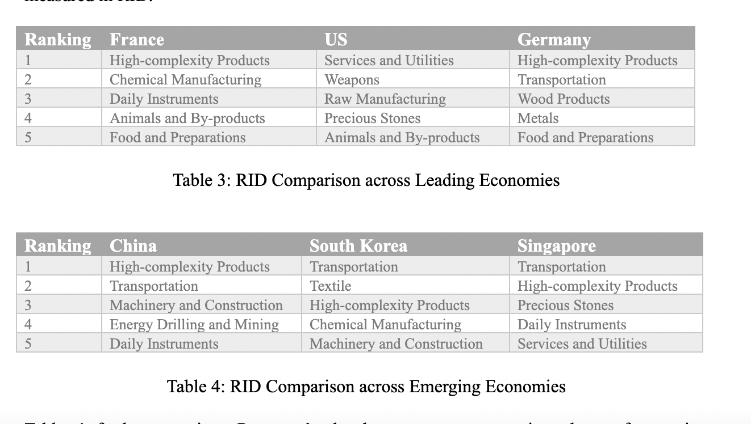

4. Product Space Design

4.1 Suggested Development Vector
As outlined above, distance gives us an idea of how far each new product is from a country’s current mix of exports. As defined in Hausmann and Hidalgo (2009), distance is “the weighted proportion of products connected to goods p that country c is not exporting, i.e., MCP = 0.” Based on this definition, the distance between a country and any product that the country is currently exporting (i.e., the country is a significant exporter of the product as compared to the global average) is zero. Similarly, opportunity gain quantifies the contribution of a new product in terms of opening up the doors to more and more complex products. Intuitively, a product that a country is currently exporting (i.e., MCP = 1) has an opportunity gain of zero. An unreasonable investment in a certain product p would lead to a relative decrement in the export of more profitable products and therefore lead to a negative opportunity gain of product p. The opportunity gain is not the only estimator of a country’s level of economic development. However, among countries with comparable economic strength, those having higher ECI, or in other words, more reasonable economic structures are often in better shape.

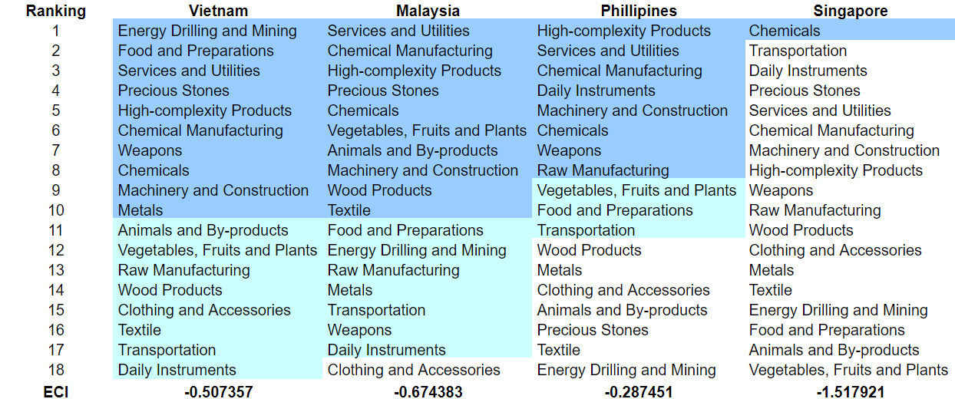
Table 5. Opportunity Gain Ranking on a Comparable Scale (2022)

We define the ranking of opportunity gain for a country c, as the Suggested Development Vector (SDV) of c. Table 5 summarizes how the SDV of Niger compares with a selected group of comparable and leading economies in the world, with the industry groups ranked in decreasing order of significance.

Dark blue indicates positive opportunity gains, light blue indicates zero opportunity gains, and white indicates negative opportunity gains. The result shows that leading countries barely have any industries with positive opportunity gain. In other words, those countries are already in the most stable and efficient economic structure. Without the necessity of economic transition, those countries merely need to maintain a steady and balanced economic development. In contrast, developing countries have nearly half of industries with positive opportunity gain and share common interests in Chemicals and Mining industries. It can be concluded that Niger shares the characteristics of developing countries, with a balanced economic structure that leans towards developing-level industries.


Table 6. SDV of Other Sample Countries (2019)

4.2 Budgeted Industry Development Strategy and Interpretation
The optimal budgeted industry development strategy aims to solve the most efficient allocations under the budgeted constraint of different situations of heuristic total export growth. In order to obtain such an allocation portfolio, we formulate an optimization problem as the following:



where k(x) is the second largest eigenvector of $M_{CC'}$ after adding $x$ to the original export vector, C is the country that we are interested in, P is the product space, B is the heuristic budget.

If we can solve this problem, then we can know what the largest ECI to which a country can improve. Accordingly, the optimal solution $x*$ that we obtain here is exactly our optimal allocation. However, the biggest problem is that the objective function is not convex. Therefore, we cannot apply the classical tools for convex optimization to this problem. In order to solve this problem, our idea is to use a greedy algorithm. The way that we apply the greedy algorithm is that firstly we separate the total budget into k equal parts, and then for the first equal part we try to search for the product that can optimize our objective function by iterating through each $p∈P$. After we find the optimal product p for this equal part, we add the amount back to the export value of this product p and update the ECI for this country. If we observe that ECI does not change after iterating all the products, then we can add up one more equal part to invest. Until we find there is an ECI increment, we add the amount now to that product. The equal rest parts can be done in the same way.

By definition, a greedy algorithm is a kind of local search algorithm that is possible to run into a local minimum. Therefore, for local search algorithms, one typical way to keep it away from the local minimum is to enhance the vision of the algorithm by looking more steps forward. In our setting, whenever we obtain an increment of ECI, we mark down the required amount of export growth. Simultaneously, we continue searching for the next ECI increment point, compare the ratios of these two possibilities and pick the largest one. The ratio is defined as the following:

where ${ECI}_{p}$ is just the ECI of the country after adding some amount of export increment to product $p$, which is exactly the amount that is able to make ECI change. Also, we can express it in the way of $||$$x_{p}-x_{0}$${||}_{1}$.

In this way, we can obtain a further sighted greedy algorithm. Also, the number of parts that we would like to separate the budget into also matters. In order to solve this problem, we added a stabilizer on top of the enhanced greedy algorithm by running the algorithm for different numbers of parts and selecting the portfolio with the largest ECI increment and most complex economic structure.

Besides, it is quite common that there is a surplus in the budget. To deal with the surplus, we just add it to the product which needs the least amount of dollars to make $M_{cp}$ = 1 (i.e., the smallest amount of required export increase).

Economic Panel
As stated above, the enhanced greedy algorithm is developed mainly for solving the optimal allocation strategy. In order to visualize this allocation, an economic panel is created, consisting of a pie chart, a line chart and a table. First, a pie chart is used to show the percentage of each product in the optimal portfolio. The number located in the center of the circle denotes the heuristic growth of total export, which is also our budget. Each category in the chart has a determined percentage of the allocated budget. The lines below the pie charts show how the ECI changes during the searching process of the greedy algorithm. Even though sometimes an increase of the export by 15% or 20% does not seem reasonable to developed countries, yet it can also give a sense of how a country should develop in the long term. Eventually, the graph in the end is just for numerical explanation for the pie charts.

Interpretation
For the purpose of a clear explanation of the line charts, we label all the products in Table 7. Please refer to this table when trying to understand the investment trajectories in the line charts.

Label | Product Names
1 | Animal and By-products
2 | Vegetables, Fruits and Plants
3 | Food and Preparations
4 | Energy Drilling and Mining
5 | Chemicals
6 | Chemical Manufacturing
7 | Raw Manufacturing
8 | Wood Products
9 | Clothing and Accessories
10 | Textile
11 | Metals
12 | Machinery and Construction
13 | Transportation
14 | Weapons
15 | Daily Instruments
16 | Precious Stones
17 | High-complexity Products
18 | Services and Utilities
Table 7. Products Labeling

Figures 4 shows an economic panel for Niger in 2022. We can see that for different percentages of heuristic total export growth, the ECIs of Niger actually have different increments.

For 2022, it’s interesting to see that Energy Drilling and Mining contributes to 100% of growth optimization for all 5%, 10%, 15%, and 20% cases. This is different from other countries’ growth optimization industry portfolios, with a unique push for Energy Drilling and Mining. These strategies go in line with the suggested trajectories based on ECI.

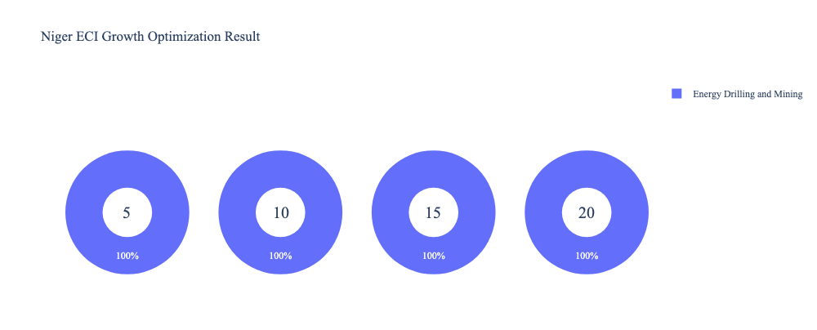
Figure 4a. Greedy-Based ECI Improvement Results of Niger with Different Budgets (2022)
Table 8a. Portfolio of Niger (2013)

4.3 Sensitivity Analysis and Contingency Strategy
In the following section, our broad aim is to understand how sensitive Niger is to changes in export in various industries. While the Economic Complexity Index has been shown to contain valuable information about the economic strength/capacity of a country, little has been said as to the stability of the measure itself. We seek to uncover the main drivers of stability under a country's ECI score and better understand longer-term projections for ECI growth. Additionally, gaining an intuition on the industries that are bolstering an economy and the industries that offer the greatest return per unit of investment is best done through visualization of industry-specific sensitivity. To this end, we have developed two categories of sensitivity analysis.
ECI Sensitivity Graph
First, in order to assess the effect particular industries have on each respective country, we developed ECI Sensitivity graphs (Figure 5). We use the shocking methodology to increment or decrement an industry’s export level by a certain percentage and recalculate the ECI, all else being equal. While freezing the export dynamics of the rest of the world and enacting an instantaneous shock in export for a particular industry and country may not reflect real-life dynamics, what it does offer us is an understanding of a country’s level of dependency on an industry in the context of ECI. The shocking is done in small percentage increments in order to smooth out the resulting curve. Additionally, a recurring theme one will see is that for most industries, a breaking point occurs where the ECI either jumps upwards or downwards, creating a hockey stick shape rather than a linear trend. While the inflection point may not be accurate in the context of real life, comparing the various inflection points across industries can give us valuable insight.

Figure 5. Sample ECI Sensitivity Graph (2018)
The graphs are formulated as follows. There are six ECI Sensitivity graphs, two for each of the following years: 2022, 2018, and 2013. The first chart, Incremental ECI Sensitivity, shows positive shocking in which export numbers are shocked upwards per industry. The X-axis is in terms of percentage shock per current dollar value of export. The Y-axis is the recalculated ECI level post-shocking. The second chart, Decremental ECI Sensitivity, follows the same format except the X-axis represents negative shock. In other words, exports for each industry are decremented, and the ECI is accordingly recomputed.
4.3 Sensitivity Analysis Results and Interpretation
We examine Niger's ECI Decremental and Incremental Sensitivity Charts for 2021. An increase in Energy Drilling and Mining will lead to the highest change in ECI, followed by Chemical Manufacturing and Wood Products. The strong sensitivity effect of manipulating the Wood Product category remains consistent with previous years. For the negative shock cases, Transportation becomes most impactful, a new trend exhibited by the plethora of transportation projects initiated by the Niger government, including the Benin-Niger Regional Transport Compact. The rest of the industries do not appear to have the same level of sensitivity.

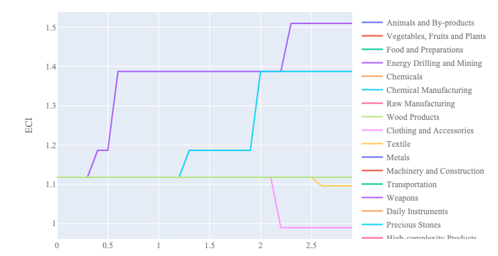
Figure 6a. Incremental ECI Sensitivity for Niger (2021)
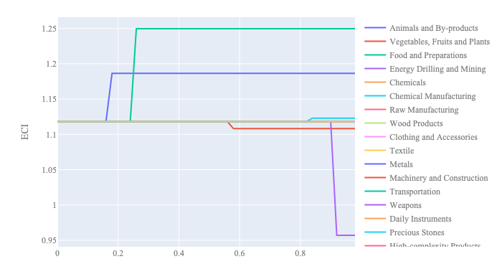
Figure 6b. Decremental ECI Sensitivity for Niger (2021)

Below is Niger's 2018 ECI Sensitivity Charts. First, in the positive chart, we notice immediately that increases in Food and Preparations, Vegetables/Fruits/Plants, and Energy Drilling and Mining lead to an uptrend of ECI. The agriculture-adjacent product categories seem to give the most immediate increase in ECI for only a 20-30% increase in export magnitude.

Next, we consider Niger's 2018 Negative Shock chart. We see that Niger is sensitive to changes in export levels in Energy Drilling and Mining, Wood Products, and Chemical Manufacturing as well as Transportation and Precious Stones. Interestingly, Niger is highly insensitive to changes in most other industries suggesting that Niger has a good blend of industries that complement each other and are able to compensate for reductions in other industries.

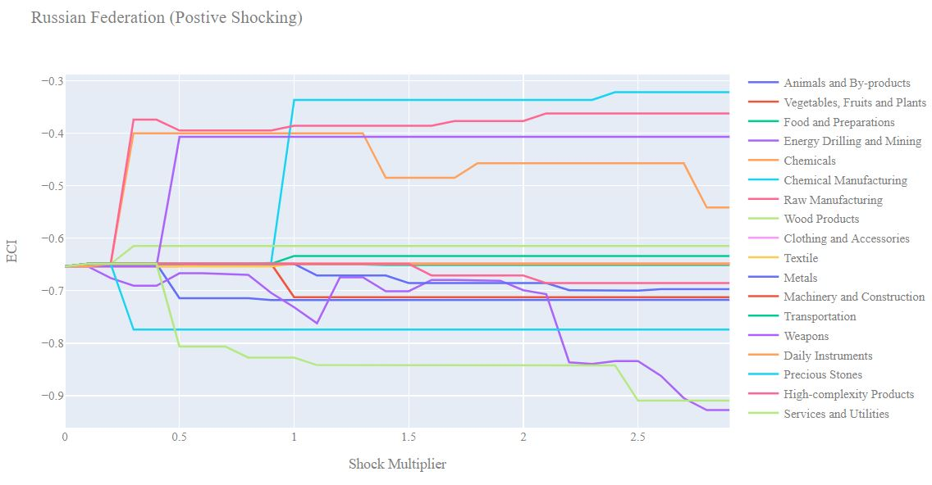
Figure 7a. Incremental ECI Sensitivity for Niger (2018)

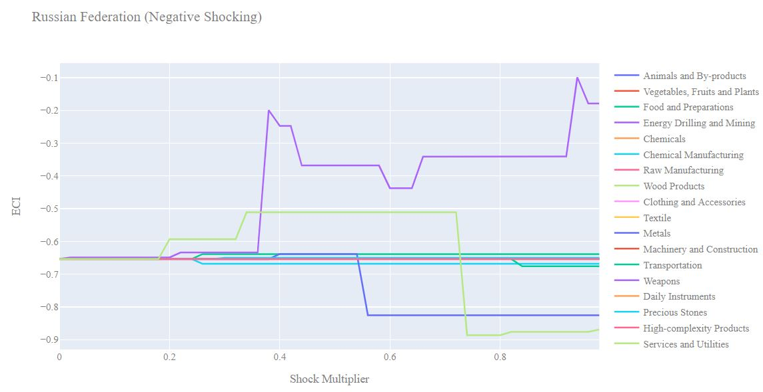
Figure 7b. Decremental ECI Sensitivity for Niger (2018)
5. Macro-level Predictions

5.1 Structural Optimality Index
ECI sensitivity described in the section before has proven to be a significant factor in deciding the economic outcomes of countries. In order to quantitatively evaluate how effective our development strategies are and how deviations from the suggested developmental path will lead to suboptimal growth results, we define the measure – Structural Optimality Index (SOI) – on a country level as the Adjusted R-Square obtained from regressing the country’s realized industry development over the suggested development strategy. Both strategies are quantified in nature, with the realized development represented by increasing export in every major industry group and the suggested development strategy represented by the opportunity gains of developing the corresponding industry groups as calculated in previous sections. The adjusted R-square from the regression thus provides us with a quantified measure of how the development path adopted by the country has fitted with/differed from calculations on a complexity level.

After obtaining this measure for all countries in our database, we further regress countries’ five-year economic growth, which is defined as the percent increase in GDP (USD), over their SOI. Figure 9 illustrates the regression output, which shows a moderate positive correlation between countries’ SOI and their five-year GDP growth, significant at the 45% level and achieving an adjusted R² of 18.4%. In other words, the more a country develops, as suggested by calculations on a complexity level, the better economic outcomes it achieves.

Table 14: OLS Regression Results
Dep. Variable: GDP | F-Statistic: 0.4508
R²: 0.184 | Prob (F-Stat): 0.571
Adj R²: -0.224 | No. Observations: 4

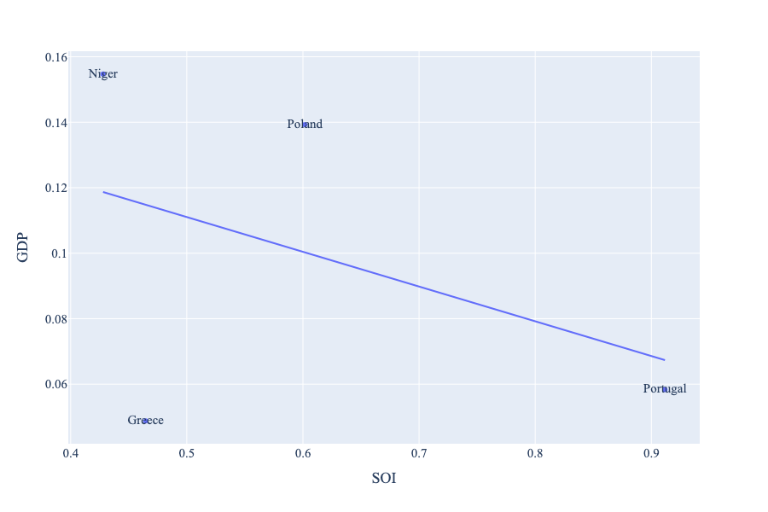
Figure 9. Regression of Five-Year GDP Growth over SOI (2013-2018)

5.2 SOI of Niger and Its Implications
During the first examined period, Niger, for instance, has a low level of structural optimality as compared with its developing peers. Niger demonstrates a low level of correlation with the suggested developmental path, having an adjusted R-square of around 18.4%. Niger ranks in the bottom half among all countries in terms of SOI and has made an accelerated rate of economic progress among its emerging peers from 2013 to 2018 with a 5-year GDP growth rate of almost 6%. This is in direct contrast to emerging economies such as Togo, where there is a high SOI of around 5% and corresponding GDP growth of 4% from 2013 to 2018, making it one of the fastest developing economies during the period.

In sum, Niger's slow economic progress from 2013 to 2018 can be at least partially explained by a development strategy that demonstrates a considerable but not perfect level of matches with our suggested developmental path. In specific, Niger invested heavily in the Wood Products industry, while it should have focused more on industry groups such as Metals to further maximize ECI.

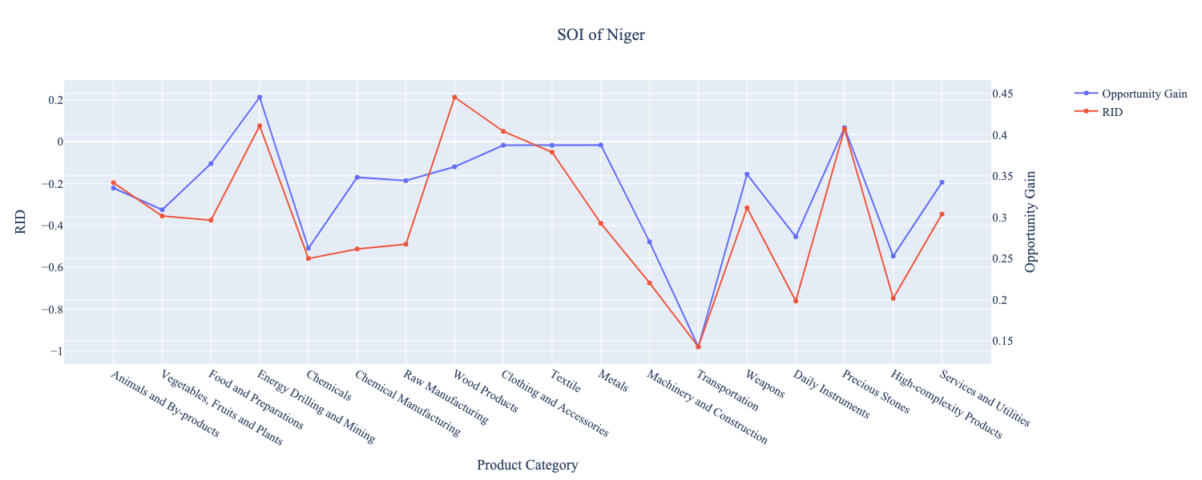

Figure 10. SOI of Niger (2019-2021)

6. Concluding Remarks

In conclusion, Niger has demonstrated a moderate level of economic growth in terms of annual GDP increase during the period from 2013 to 2018, concurrent with an increase in economic complexity as compared with comparable developing economies. For 2019-2021, the growth in GDP has increased alongside a large boost in ECI, in line with its comparable countries and higher than many of the leading economies in the world.

We believe that the mixed progress during the first period can be partially explained through the analysis of the economic and product complexity structure of Niger on the industry group level. The product classification system we adopt allows us to measure the realized industry development for various industry groups and to observe that Niger progressed in developing most of its industries during the period, while its developed counterparts and emerging economies around the globe adopted much more complex and progressive paths.

Based on our analysis of the opportunity gain and sensitivity analysis of major industry groups for 2013-2018, Niger can further its gains by prioritizing Energy Drill and Mining, Metals, and Transportation. We further note that Niger has a heavily mismatched that indicates a low level (compared to other developed countries) of structural optimality on the complexity level, having an adjusted R-square of around 0.184%. Since a strong positive correlation exists between five-year GDP growth and the structural optimality index of an economy as we define and calculate, Niger indeed has an optimal growth experience as compared with fast-growing economies both on a regional scale and on a global scale and has the potential to further its economic gains through industrial structure optimization as suggested in the paper.

During the second examined period from 2019 to 2021, Niger performed much stronger than before and compared to other countries, particularly Togo. We infer that during the COVID-19 period, Niger focused on developing higher complexity industries despite a lower demand for these industries given the global economic downturn/lower complexity industries, in line with lower demand for these industries given the global economic downturn. We also note that Niger has increased its investment in the sectors identified earlier, leading to a strong boost from Transportation and Agriculture industries, leaving some room for strategic improvement. It did invest in the industries which contributed the most to its advancements, such as Energy Drill and Mining and Metals industries. The ECI suggests that greater growth could have been achieved through an even stronger push for Metals, followed by Wood Products. The surprising growth also increased the adjusted R-squared value to 0.184% in 2022, demonstrating the pursued strategies contributed to the GDP. With the revised focus, Niger has further potential to advance its economic growth to maintain its position among other countries to continue its ongoing economic expansion.

References

Hausmann, R., Hidalgo, C., Bustos, S., Coscia, M., Chung, S., Jimenez, J., Simoes, A. and Yıldırım, M. (2007). The Atlas of Economic Complexity. [online] Atlas.cid.harvard.edu. Available at: http://atlas.cid.harvard.edu/.

Balassa, B., “The Purchasing Power Parity Doctrine - A Reapprais- al,” Journal of Political Economy 72, 584-596 (1964).

Feenstra, R.; Lipsey, R.; Deng, H.; Ma, A. & Mo, H. “World Trade Flows: 1962-2000” NBER working paper 11040. National Bureau of Economic Research, Cambridge MA (2005).

United Nations Commodity Trade Statistics Database (http://comtrade.un.org/db/), accessed in August 2019.

The World Economic Forum, “The global competitiveness report,” (various years).

Barro, R. & Lee, J-W. “A New Data Set of Educational Attainment in the World, 1950-2010,” NBER Working Paper No. 1590 (2010).

Kaufmann, D. & Kraay, A. “Governance Indicators: Where Are We, Where Should We Be Going?” Policy Research Working Paper 4370. Washington, DC: World Bank (2008).

Hanushek, E.A. & Woessmann, L. “The Role of Cognitive Skills in Economic Development,” Journal of Economic Literature 46(3), 607- 668 (2008).

