
https://atlas.cid.harvard.edu/

Optimal Industry Development Strategy Using Economic and Product Complexity

Senegal

─
The Economic Complexity Lab - Columbia University
Alexandra Garcia, Kelly Mi, Margarita Demkina, Allison Lin, Helena Yang, Jane Zhang, Daniel Xu, Ryo Shibata, Navia Zhang
Optimal Industry Development Strategy for Senegal

0. Executive Summary

In this report, we aim to uncover the economic path Senegal went through during the period from 2019 to 2023. Specifically, we dive into the topic through a macroeconomic overview of Senegal from the perspective of Gross Domestic Product (GDP) and Economic Complexity Index (ECI), which reflect countries’ production capability and production structure, respectively. We find that during the period of our interest, Senegal demonstrated a relatively solid level of economic growth with an average annual GDP growth rate of 6.01% between 2019 and 2023, with a similar economic complexity compared to other developing African economies.

The positive progress during the period, we believe, can be partially explained through the analysis of the economic and product complexity structure of Senegal on the industry group level, as well as the improving macro and microeconomic strategies. The product classification system we adopt allows us to measure the realized industry development for various industry groups and to observe that Senegal progressed in developing most of its industries during the period while its emerging counterparts and economies around the globe also adopted complex and progressive paths with variable degrees of success.

Based on our analysis of the opportunity gain and sensitivity analysis of major industry groups, Senegal could further its gains by prioritizing Energy Mining and Drilling and Precious Stones now in 2023. We further note that Senegal has a slightly mismatched development strategy that indicates a lower level compared to other emerging countries of structural optimality on the complexity level, having an adjusted R-square of around 0.109 in 2023. Since a low positive correlation exists between GDP growth and the structural optimality index of an economy as we define and calculate, Senegal has a relatively suboptimal growth experience as compared with emerging African economies both on a regional scale and on a global scale and has the potential to further its economic gains through industrial structure optimization as suggested in the paper.

The five years between 2019 and 2023 showed a significant improvement in Senegal's economic growth, boosting its position on the global scale. Its GDP recovered to above the pre-pandemic levels, and it saw a significant boost in the ECI, particularly compared to its peer countries. Its current strategy still has the viable potential upside to increase its performance and optimize its structure further.

1. Report Overview

In this report, we aim to uncover the economic path Senegal went through during the period from 2019 to 2023, before and after the COVID pandemic. Specifically, we dive into the topic through a macroeconomic overview of Senegal from the perspective of Gross Domestic Product (GDP) and Economic Complexity Index (ECI), which reflect countries’ production capability and production structure, respectively. We then analyze the industrial framework and changes of Senegal during the period based on quantitative measures such as the Product Complexity Index (PCI) and Product Family Complexity Index (PfCI), followed by a detailed analysis of how such changes have matched with development strategies as quantitatively measured by opportunity gains on an industry-level. We conclude our report with macro-level results and predictions of Senegal, as deduced from regression models we have established on a global scale, which take into account countries’ stances in their product space.

2. Macroeconomic Results

2.1 GDP Ranking and Changes
Figure 1a illustrates the time-series GDP results for Senegal and three of its peer countries (Nigeria, Ethiopia and Benin) from 2019 to 2023. Similar to Benin, Senegal’s GDP remained relatively steady while Nigeria and Ethiopia’s GDPs declined and rebounded respectively in 2023. Its growth was thus inconsistent with all three countries’ growth. Senegal’s average annual GDP growth rate (6.01%) is in the middle, as it is greater than Nigeria rate (-3.36%) but lower than Ethiopia’s rate (11.58%) and Benin’s (6.15%).

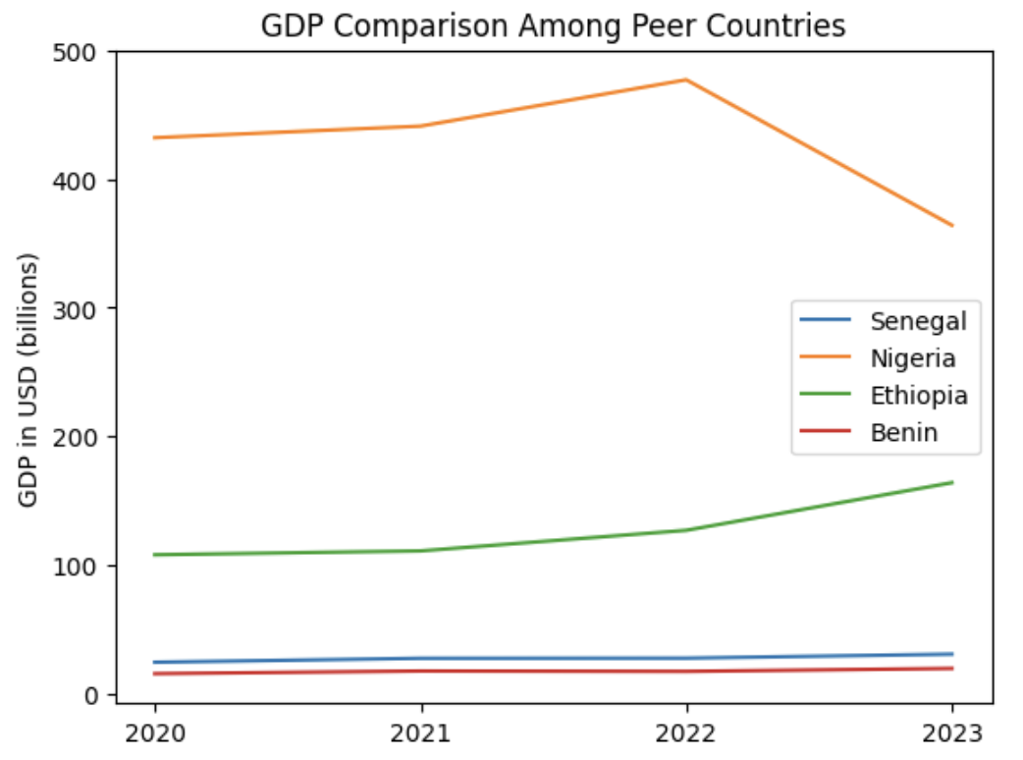
Figures 1. GDP Comparison Among Peer Countries (2019-2023)

2.2 ECI Ranking and Changes
The Economic Complexity Index (ECI), as defined by Ricardo Hausmann and Cesar Hidalgo in 2009 to explain the knowledge accumulated in a country's population, is illustrated in Figure 2.

As shown, Senegal exhibits a large increase in production capability from 2019 to 2023. Senegal is in a strong position in ECI terms, as its ECI change of 188% from -0.87 to 0.99 is much greater than Nigeria (84%) and similar to Ethiopia (185%) and Benin (168%). Senegal exhibits a large increase in production capability in 2021 to levels not seen prior, with extensive microeconomic stimulus packages delivered by the UN being one of the reasons, and has maintained a steady ECI since.

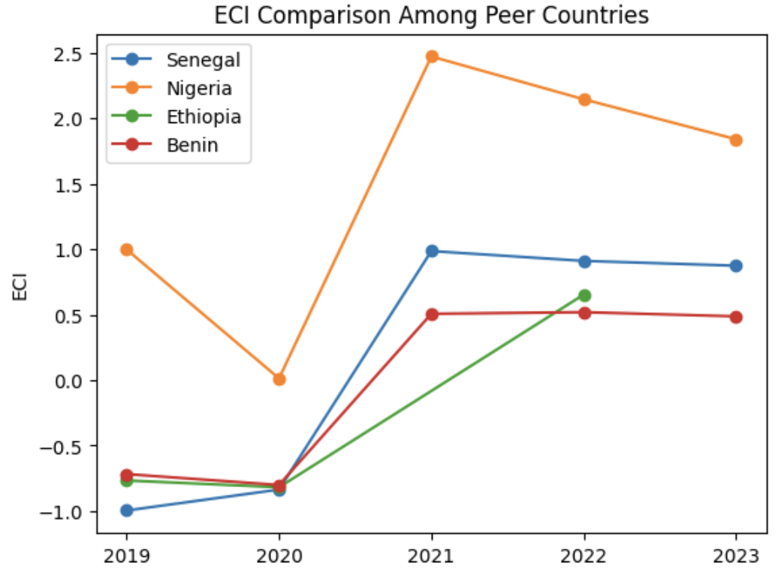
Figures 2. ECI Comparison Among Peer Countries (2019-2023)

Figure 3 offers a further comparison of GDP Growth and ECI over the time span from 2019 to 2023 for Senegal. Similar to the GDP plateau and increase between 2019-2021 and 2021-2023 respectively, the GDP growth during the period from 2019 to 2023 is accompanied by a similarly volatile increase in ECI. The results show that the economic growth experienced by Senegal during the period from 2019 to 2023 is consistent with the predictions by ECI that Senegal made moderate progress towards effectively developing a competitive product space that helps to accumulate complicated knowledge and technology. For the period 2019 to 2023, the ECI largely followed GDP trends, which can be interpreted as advancements in production. In order to provide a more concrete answer to why this has happened, we will dive into an analysis of Senegal’s production structure and its product space designs in the next few sections.

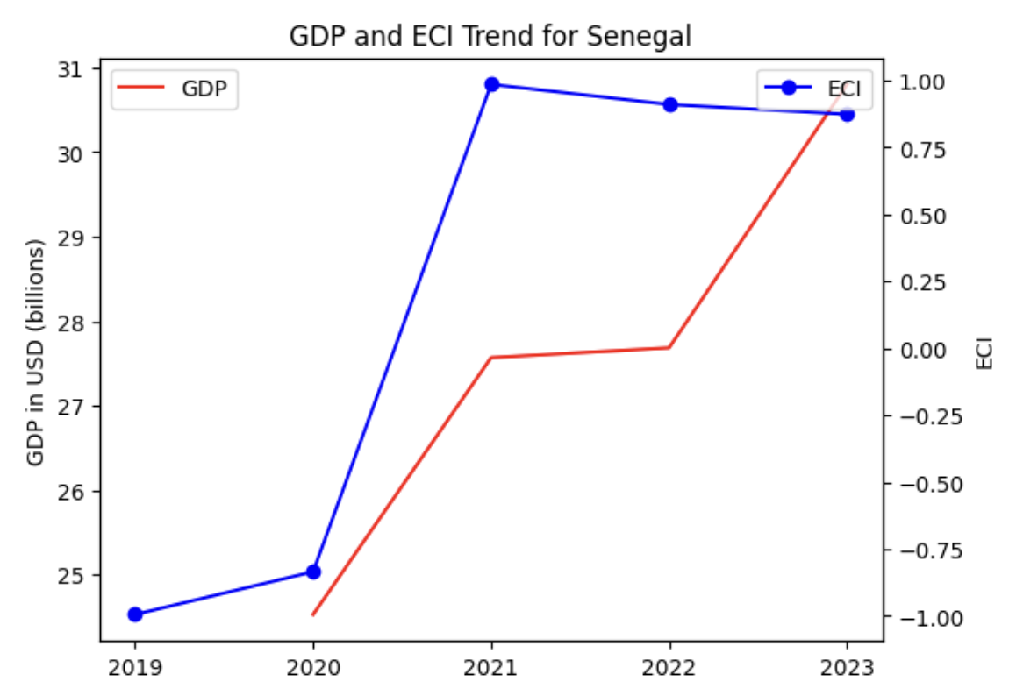

Figures 3. GDP Growth and ECI for Senegal (2019-2023)
3. Production Analysis

3.1 Product Categorization
Our main data source in this research is the UN Comtrade Website (https://comtrade.un.org), which provides us with valuable information on countries’ export values on an annual basis, including highly specific export data for more than 5000 categories of products. In order to have a holistic vision of the product space of a country, however, a level of categorization is required. Products in our data source are labeled from 010000-999999, with the first two digits representing a general category to which the product belongs. Based on the 99 categories extracted from the label, we further group the products into the 18 most widely accepted industries, as summarized in Table 1.

Note that the High-complexity Products industry group is not a distinct industry but rather an aggregated industry that encompasses the most complicated products from the most technologically advanced industries (as measured by PCI). This industry serves as an indicator for us to quantitatively evaluate how well a country has performed in developing cutting-edge technologies and closing its technological gap with advanced economies, which has become a topic of wide concern today. Indeed, when we rank the 18 categories based on PfCI (an equivalent concept of PCI as calculated based on the 18 categorized product groups), the High-complexity Products industry has the highest PfCI among all industry groups.

Category | Description
Animals and By-products | All kinds of meat, livestock and related by-products
Vegetables, Fruits and Plants | All kinds of plants, edible vegetables and fruits
Food and Preparations | Edible preparations, raw cooking materials and appliances
Clothing and Accessories | All kinds of fabrics, filament, clothing and accessories
Textiles | All kinds of textile articles and related products
Wood Products | Book, paper and other elementary products related to wood
Metals | Mining of all sorts of raw Metals
Refined and Processed Stones | Refined or processed stone products such as pearl and ceramics
Energy Drilling and Mining | Mining industry for energy, minerals, stone materials, etc.
Daily Instruments | Basic daily instruments such as sport requisites, timing and measuring tools
Raw Manufacturing | Basic products made from plastic, rubber, leather, etc.
Chemical Manufacturing | Advanced chemical products and pharmaceutical products
Chemicals | Raw chemical materials and by-products
Machinery and Construction | Machinery and mechanical appliances, including electrical equipment
Transportation | Vehicles and locomotives including aircraft, ship, railway, etc.
Weapons | Explosives, arms and ammunition
Services and Utilities | Financial, business, legal, communication, travel Services and Utilities, etc.
High-complexity Products | Agglomeration of advanced products with highest PCIs
Table 1. Categorization of Products

We further observe a positive correlation between the GDP and the export of High-complexity Products. A higher adjusted R-square exists between GDP and High-complexity Products exports, indicating that more successful economics, as measured by GDP, tend to be those that are capable of producing and exporting High-complexity Products as we define them. Tables 2a and 2b show the OLS results in a universe of 107 and 21 typical countries respectively.

 | High-complexity Products | Food and Preparations | Animals and By-products
Adj. R-squared | 0.075 | 0.006 | 0.002
F-statistic | 9.556 | 1.638 | 1.175
No. Observations | 107 | 107 | 107
Table 2a. OLS Regression Results of GDP against Percentage Volume of Exports

 | High-complexity Products | Food and Preparations | Animals and By-products
Adj. R-squared | 0.149 | 0.003 | -0.012
F-statistic | 4.510 | 1.059 | 0.7542
No. Observations | 21 | 21 | 21
Table 2b. OLS Regression Results of GDP against Volume of Percentage Exports

3.2 Realized Industry Development
Based on the aforementioned product categorization, we aim to capture Senegal's realized industry production strategy between 2019 and 2023 on a complexity level. In Hausmann and Hidalgo (2009), distance is defined to be a measure of how far a country is from a certain product, not in its product space. We extend this concept to all product groups and quantify how technically equipped a country is to develop the corresponding product groups. In other words, the shorter the distance between a country and a product group, the more capable a country is of developing products within that group. Defining this net distance change as the Realized Industry Development (RID), our export data allow us to calculate and compare the RID of Senegal and the 18 product groups in 2023, where a positive RID indicates a shortening of the distance (i.e., advancement of the industry), and a negative RID indicates the reverse. It is notable that the number of industries with positive RID is low in 2023.

Category | RID (2023)
Daily Instruments | -0.067577
Chemicals | -0.082348
Weapons | -0.137916
Wood Products | -0.046450
Transportation | -0.073962
Machinery and Construction | -0.161922
Metals | -0.072033
Raw Manufacturing | -0.143070
Services and Utilities | -0.024110
Clothing and Accessories | -0.117340
Chemical Manufacturing | -0.057420
Food and Preparations | -0.065028
Textile | -0.023561
High-complexity Products | -0.011255
Vegetables, Fruits and Plants | -0.088074
Animals and By-products | -0.084253
Energy Drilling and Mining | -0.058870
Precious Stones | -0.063421
Table 3. Realized Industry Development (RID) of Senegal

3.3 Regional and Global Comparison
Tables 4a-4b below summarize how the production strategy adopted by Senegal compares with selected leading economies in the world in 2023, as measured in RID. Leading economies such as France, USA, and Germany gave a considerable level of attention to more advanced product groups such as Machinery & Construction, Energy Drilling and High-Complexity Products in 2023.

Ranking | France | USA | Germany
1 | Machinery & Construction | Precious Stones | Transportation
2 | Services and Utilities | Wood Products | Machinery & Construction
3 | High-complexity Products | Machinery & Construction | Daily Instruments
4 | Textile | High-Complexity Products | High-Complexity Products
5 | Transportation | Chemical Manufacturing | Clothing & Accessories
Table 4a. RID Comparison across Leading Economies (2023)

Table 4b further examines Senegal's development strategy against those of emerging economies on a global scale. Reasonably, emerging economies such as China and Singapore have devoted the majority of their efforts to intermediate industry groups, showing moderate shifts in strategies over the course of three years.

Ranking | China | Singapore
1 | Weapons | High-complexity Products
2 | Machinery | Transportation
3 | Chemicals | Energy Drilling & Mining
4 | Raw Manufacturing | Raw Manufacturing
5 | Clothing & Accessories | Chemical Manufacturing
Table 4b. RID Comparison across Emerging Economies (2023)

4. Product Space Design

4.1 Suggested Development Vector
As outlined above, distance gives us an idea of how far each new product is from a country’s current mix of exports. As defined in Hausmann and Hidalgo (2009), distance is “the weighted proportion of products connected to goods p that country c is not exporting, i.e., MCP = 0.” Based on this definition, the distance between a country and any product that the country is currently exporting (i.e., the country is a significant exporter of the product as compared to the global average) is zero. Similarly, opportunity gain quantifies the contribution of a new product in terms of opening up the doors to more and more complex products. Intuitively, a product that a country is currently exporting (i.e., MCP = 1) has an opportunity gain of zero. An unreasonable investment in a certain product p would lead to a relative decrement in the export of more profitable products and therefore lead to a negative opportunity gain of product p. The opportunity gain is not the only estimator of a country’s level of economic development. However, among countries with comparable economic strength, those having higher ECI, or in other words, more reasonable economic structures are often in better shape.

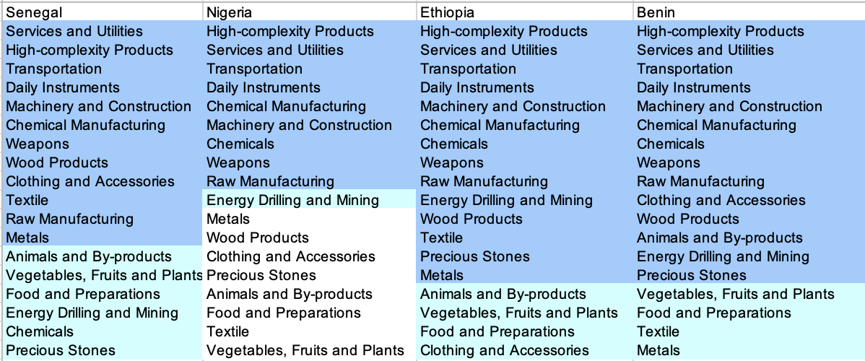

Table 5. Opportunity Gain Ranking on a Comparable Scale (2023)

We define the ranking of opportunity gain for a country c, as the Suggested Development Vector (SDV) of c. Tables 5 and 6 summarize how the SDV of Senegal compares with a selected group of comparable and leading economies in the world, with the industry groups ranked in decreasing order of significance.

Dark blue indicates positive opportunity gains, light blue indicates zero opportunity gains, and white indicates negative opportunity gains. The result shows that leading countries barely have any industries with positive opportunity gain. In other words, those countries are already in the most stable and efficient economic structure. Without the necessity of economic transition, those countries merely need to maintain a steady and balanced economic development. In contrast, developing countries have majority of industries with positive opportunity gain and share common interests in Highly-complex Products and Services and Utilities industries. It can be concluded that Senegal shares the characteristics of developing countries, with a balanced economic structure that leans towards Highly-complex Products-level industries.

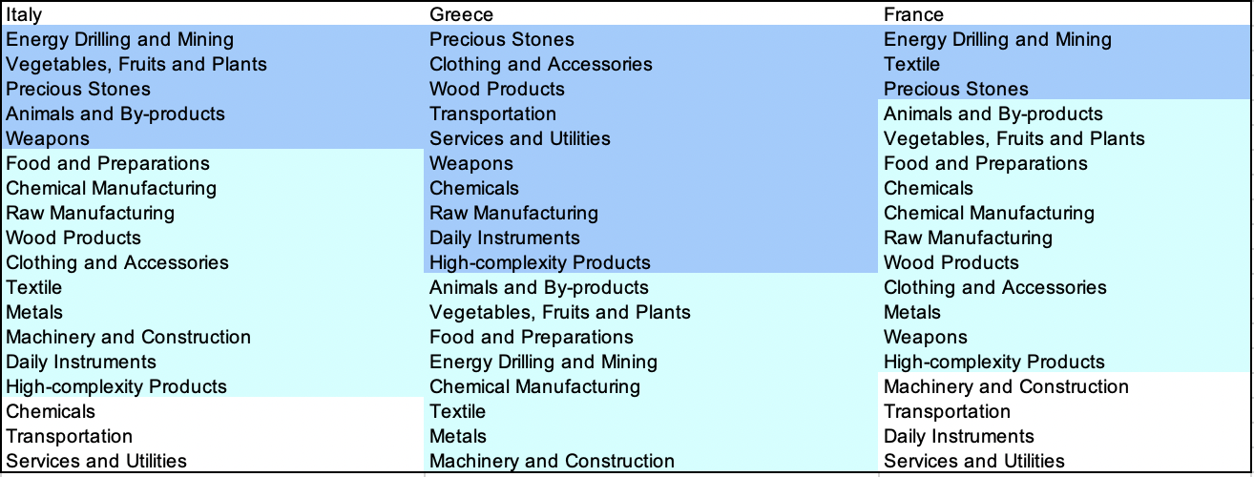
Table 6. SDV of Other Sample Countries (2023)

4.2 Budgeted Industry Development Strategy and Interpretation
The optimal budgeted industry development strategy aims to solve the most efficient allocations under the budgeted constraint of different situations of heuristic total export growth. In order to obtain such an allocation portfolio, we formulate an optimization problem as the following:



where k(x) is the second largest eigenvector of $M_{CC'}$ after adding $x$ to the original export vector, C is the country that we are interested in, P is the product space, B is the heuristic budget.

If we can solve this problem, then we can know what the largest ECI to which a country can improve. Accordingly, the optimal solution $x*$ that we obtain here is exactly our optimal allocation. However, the biggest problem is that the objective function is not convex. Therefore, we cannot apply the classical tools for convex optimization to this problem. In order to solve this problem, our idea is to use a greedy algorithm. The way that we apply the greedy algorithm is that firstly we separate the total budget into k equal parts, and then for the first equal part we try to search for the product that can optimize our objective function by iterating through each $p∈P$. After we find the optimal product p for this equal part, we add the amount back to the export value of this product p and update the ECI for this country. If we observe that ECI does not change after iterating all the products, then we can add up one more equal part to invest. Until we find there is an ECI increment, we add the amount now to that product. The equal rest parts can be done in the same way.

By definition, a greedy algorithm is a kind of local search algorithm that is possible to run into a local minimum. Therefore, for local search algorithms, one typical way to keep it away from the local minimum is to enhance the vision of the algorithm by looking more steps forward. In our setting, whenever we obtain an increment of ECI, we mark down the required amount of export growth. Simultaneously, we continue searching for the next ECI increment point, compare the ratios of these two possibilities and pick the largest one. The ratio is defined as the following:

where ${ECI}_{p}$ is just the ECI of the country after adding some amount of export increment to product $p$, which is exactly the amount that is able to make ECI change. Also, we can express it in the way of $||$$x_{p}-x_{0}$${||}_{1}$.

In this way, we can obtain a further sighted greedy algorithm. Also, the number of parts that we would like to separate the budget into also matters. In order to solve this problem, we added a stabilizer on top of the enhanced greedy algorithm by running the algorithm for different numbers of parts and selecting the portfolio with the largest ECI increment and most complex economic structure.

Besides, it is quite common that there is a surplus in the budget. To deal with the surplus, we just add it to the product which needs the least amount of dollars to make $M_{cp}$ = 1 (i.e., the smallest amount of required export increase).

Economic Panel
As stated above, the enhanced greedy algorithm is developed mainly for solving the optimal allocation strategy. In order to visualize this allocation, an economic panel is created, consisting of a pie chart, a line chart and a table. First, a pie chart is used to show the percentage of each product in the optimal portfolio. The number located in the center of the circle denotes the heuristic growth of total export, which is also our budget. Each category in the chart has a determined percentage of the allocated budget. The lines below the pie charts show how the ECI changes during the searching process of the greedy algorithm. Even though sometimes an increase of the export by 15% or 20% does not seem reasonable to developed countries, it can also give a sense of how a country should develop in the long term. Eventually, the graph in the end is just for numerical explanation of the pie charts.

Interpretation
For the purpose of a clear explanation of the line charts, we label all the products in Table 7. Please refer to this table when trying to understand the investment trajectories in the line charts.

Label | Product Names
1 | Animal and By-products
2 | Vegetables, Fruits and Plants
3 | Food and Preparations
4 | Energy Drilling and Mining
5 | Chemicals
6 | Chemical Manufacturing
7 | Raw Manufacturing
8 | Wood Products
9 | Clothing and Accessories
10 | Textile
11 | Metals
12 | Machinery and Construction
13 | Transportation
14 | Weapons
15 | Daily Instruments
16 | Precious Stones
17 | High-complexity Products
18 | Services and Utilities
Table 7. Products Labeling

Figure 4 shows an economic panel for Senegal in 2023. We can see that for different percentages of heuristic total export growth, the ECIs of Senegal have gradually increasing increments. At first, Precious Stones was the main and entire component, but High-Complexity Products became the majority for 15% and decreased to around a third in 20%. A more detailed numerical representation of the portfolio is shown in Table 8.
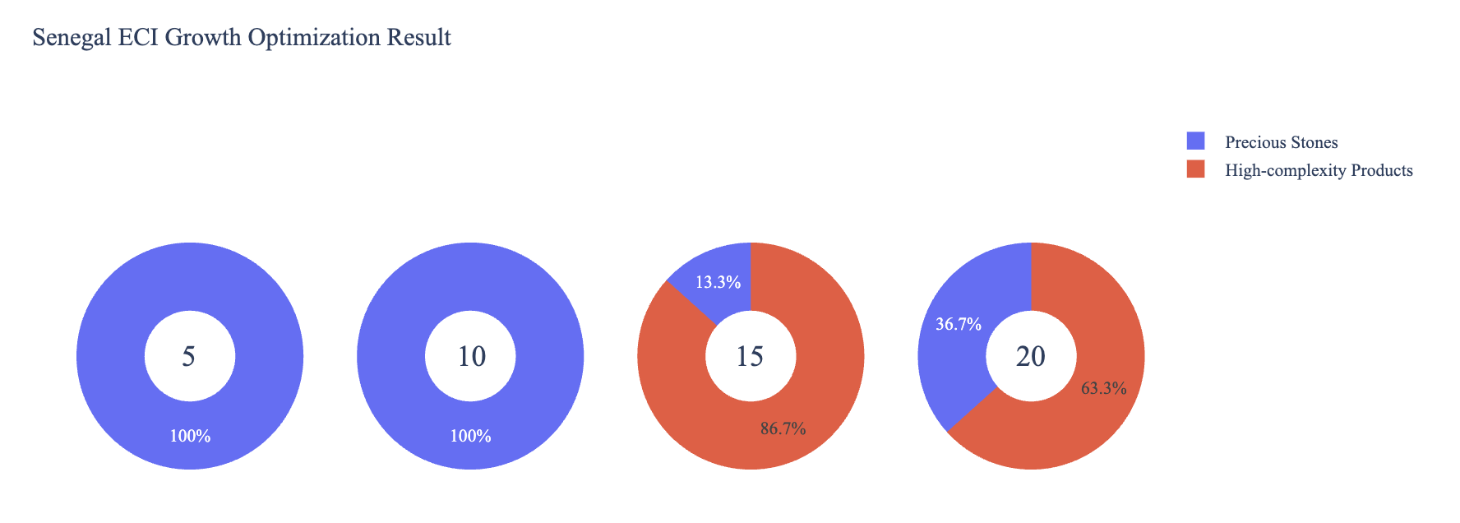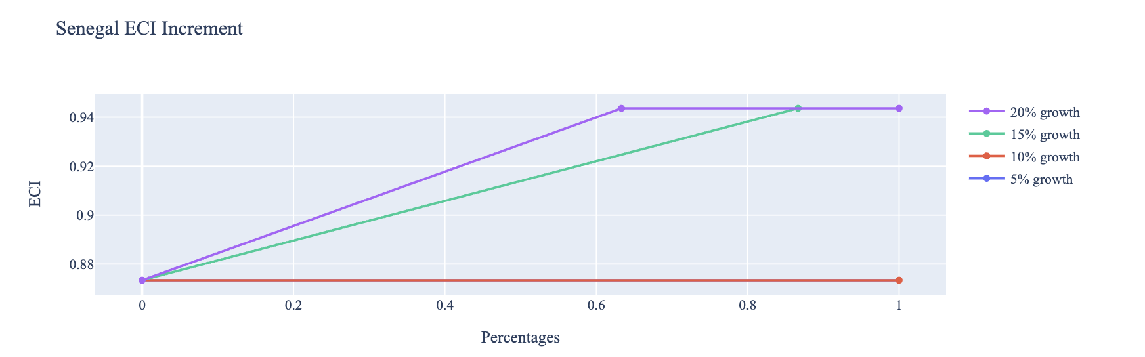

Figure 4. Greedy-Based ECI Improvement Results of Senegal with Different Budgets (2023)

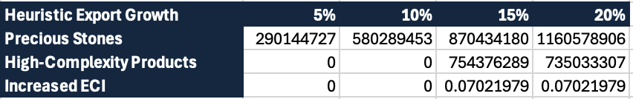
Table 8. Portfolio of Senegal (2023)

4.3 Sensitivity Analysis and Contingency Strategy
In the following section, our broad aim is to understand how sensitive Senegal is to changes in export in various industries. While the Economic Complexity Index has been shown to contain valuable information about the economic strength/capacity of a country, little has been said as to the stability of the measure itself. We seek to uncover the main drivers of stability under a country's ECI score and better understand longer-term projections for ECI growth. Additionally, gaining an intuition on the industries that are bolstering an economy and the industries that offer the greatest return per unit of investment is best done through visualization of industry-specific sensitivity. To this end, we have developed two categories of sensitivity analysis.
ECI Sensitivity Graph
First, in order to assess the effect particular industries have on each respective country, we developed ECI Sensitivity graphs (Figure 5). We use the shocking methodology to increment or decrement an industry’s export level by a certain percentage and recalculate the ECI, all else being equal. While freezing the export dynamics of the rest of the world and enacting an instantaneous shock in export for a particular industry and country may not reflect real-life dynamics, what it does offer us is an understanding of a country’s level of dependency on an industry in the context of ECI. The shocking is done in small percentage increments in order to smooth out the resulting curve. Additionally, a recurring theme one will see is that for most industries, a breaking point occurs where the ECI either jumps upwards or downwards, creating a hockey stick shape rather than a linear trend. While the inflection point may not be accurate in the context of real life, comparing the various inflection points across industries can give us valuable insight.

Figure 5. Sample ECI Sensitivity Graph (2023)
The graphs are formulated as follows. There are six ECI Sensitivity graphs, two for each in 2023. The first chart, Incremental ECI Sensitivity, shows positive shocking in which export numbers are shocked upwards per industry. The X-axis is in terms of percentage shock per current dollar value of export. The Y-axis is the recalculated ECI level post-shocking. The second chart, Decremental ECI Sensitivity, follows the same format except the X-axis represents negative shock. In other words, exports for each industry are decremented, and the ECI is accordingly recomputed.
SDV Sensitivity
Secondly, we analyze the sensitivity of the SDV to changes in export levels. The goal is to understand how export level changes for a particular industry can affect the marginal opportunity gain for other industries. We will be increasing or decreasing the absolute export level in these industries and observing the effects on the SDV.
When the opportunity gain of an industry is negative, the SDV sensitivity approximates how an over-development of the industry jeopardizes the economic structure of a country. When the opportunity gain of the industry is zero, the SDV sensitivity determines whether the further development of the industry shapes the country with a better economic structure and predicts how the SDV would change accordingly. Specifically, as we reduce the export of such an industry to 25% - 50% of its original value, a few other industries originally with negative opportunity gain could likely become profitable.
Similar to the ECI sensitivity graphs above, we will be shocking the export of Energy Drilling and Mining in small percentage increments. A new SDV, represented by a new column in the charts, is recorded only when a certain level of shock changes the structure of the SDV. In effect, we are incrementing or decrementing export levels of two industries until the marginal opportunity gain of any industry changes in category (positive, negative, or neutral). Below is an example of an SDV Sensitivity chart with Positive Shocking. Industries with positive marginal opportunity gain are colored blue, neutral is colored white, and negative is colored red.


Table 9. Sample Incremental SDV Sensitivity for High-Complexity Products (2023)

Contingency Plan
The Contingency Plan aims to present a set of solutions with respect to upheavals in different industries. Instead of compensating for the declining production directly, the best strategy is to develop those incipiently profitable industries. In this manner, we can derive a contingency strategy for countries to deal with possible abrupt declines of crucial industries. In some cases, the SDV remains unchanged even when a zero-opportunity-gain industry declines to 20% in terms of export. We can then conclude the industry is not indispensable to the country. As a clarification, the three consecutive N/As mean that the country doesn’t even need to respond to a collapse in the industry. Countries tend to have distinct solutions to the ups and downs of the same industry. To create the contingency strategy table, we decrease the export level for each industry in the country’s current production space by 60% respectively. The three highest-ranking industries in the new SDV are then returned.

Product Names | 0 | 1 | 2
Animal and By-products | Services and Utilities | Daily Instruments | Weapons
Vegetables, Fruits and Plants | Services and Utilities | Daily Instruments | Weapons
Food and Preparations | Services and Utilities | Daily Instruments | Weapons
Energy Drilling and Mining | Services and Utilities | Daily Instruments | Weapons
Chemicals | Services and Utilities | Daily Instruments | Weapons
Chemical Manufacturing | Services and Utilities | Daily Instruments | Weapons
Raw Manufacturing | Services and Utilities | Daily Instruments | Weapons
Wood Products | Services and Utilities | Daily Instruments | Weapons
Clothing and Accessories | Services and Utilities | Daily Instruments | Weapons
Textile | Services and Utilities | Daily Instruments | Weapons
Metals | Services and Utilities | Daily Instruments | Weapons
Machinery and Constructions | Services and Utilities | Daily Instruments | Weapons
Transportation | Services and Utilities | Raw Manufacturing | Daily Instruments
Weapons | Services and Utilities | Daily Instruments | Transportation
Daily Instruments | Services and Utilities | Weapons | Transportation
Precious Stones | Services and Utilities | Daily Instruments | Weapons
Daily Instruments | Services and Utilities | Daily Instruments | Weapons
Services and Utilities | Daily Instruments | Weapons | Transportation
Table 10. Sample Contingency Strategy (2023)

4.3 Sensitivity Analysis Results and Interpretation
We examine Senegal's ECI Decremental and Incremental Sensitivity Charts for 2023. An increase in Textile will lead to the highest change in ECI, followed by Wood Products and Clothing and Accessories. The strong sensitivity effect of manipulating the Textile category remains consistent with previous years. For the negative shock cases, Chemicals become most impactful, a new trend across the data emerging from the previous years. The rest of the industries do not appear to have the same level of sensitivity.

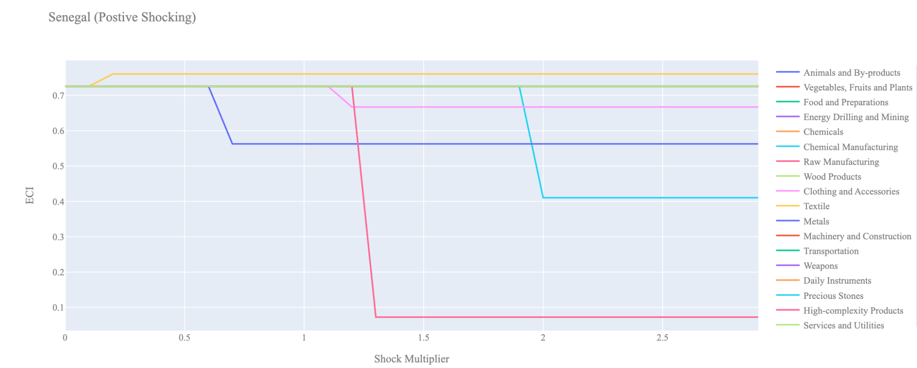
Figure 6a. Incremental ECI Sensitivity for Senegal (2023)
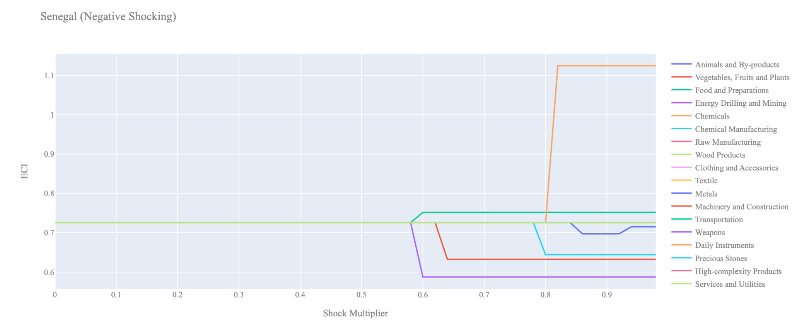
Figure 6b. Decremental ECI Sensitivity for Senegal (2023)

Below is Nigeria’s 2023 ECI Sensitivity Charts. First, in the positive chart, we notice immediately that increases in Energy Drilling and Mining and Wood Products lead to an uptrend of ECI. They seem to give the most immediate increase in ECI for only a 20-30% increase in export magnitude.

Next, we consider Nigeria's 2023 Negative Shock chart. We see that Nigeria is sensitive to changes in export levels in Weapons. Interestingly, Nigeria is highly insensitive to changes in most other industries suggesting that Nigeria has a good blend of industries that complement each other and are able to compensate for reductions in other industries.
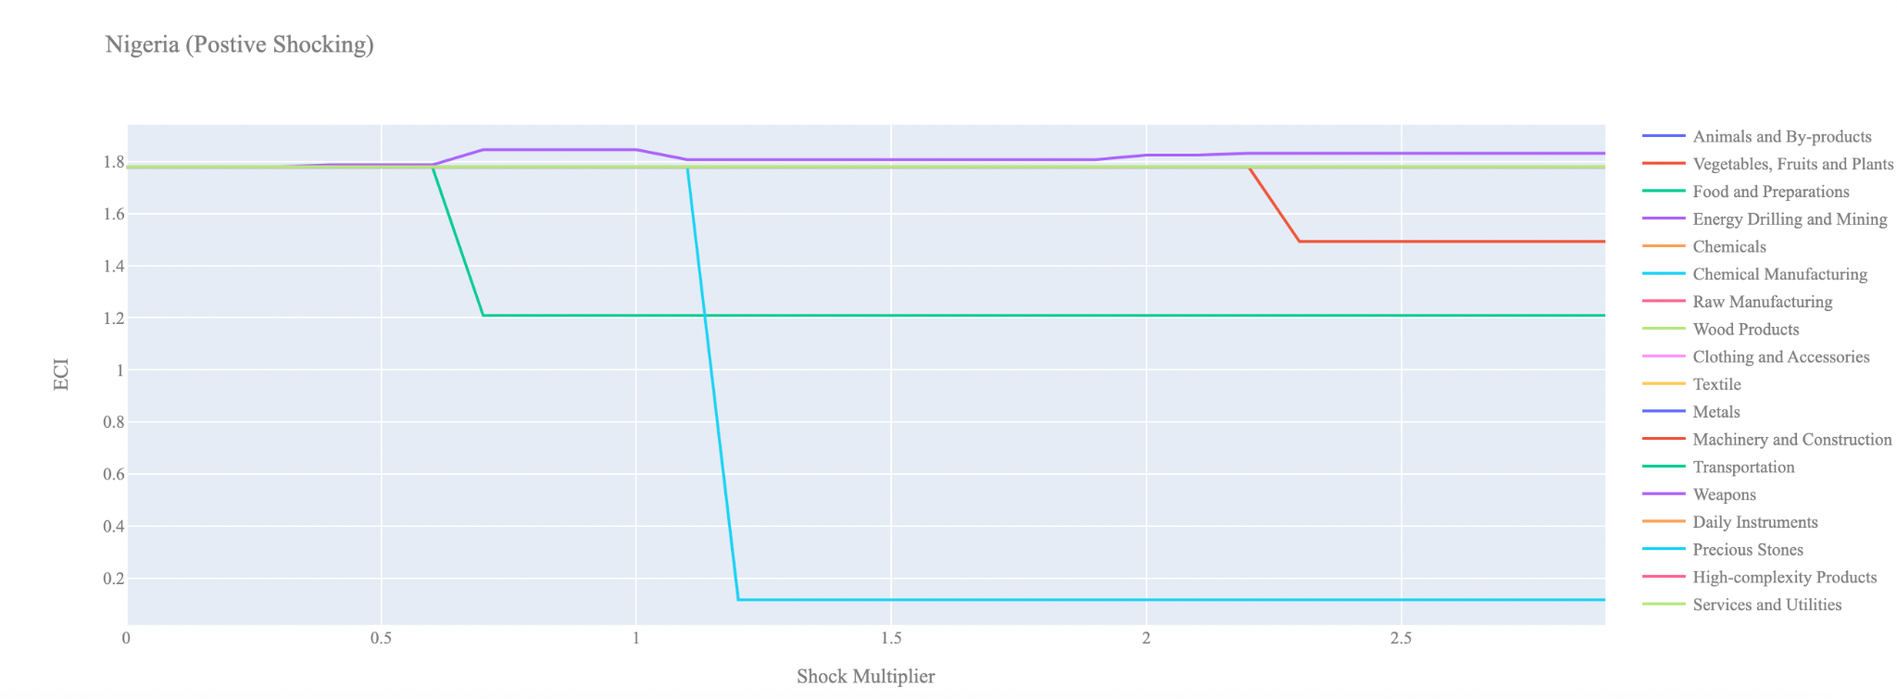
Figure 7a. Incremental ECI Sensitivity for Nigeria (2023)

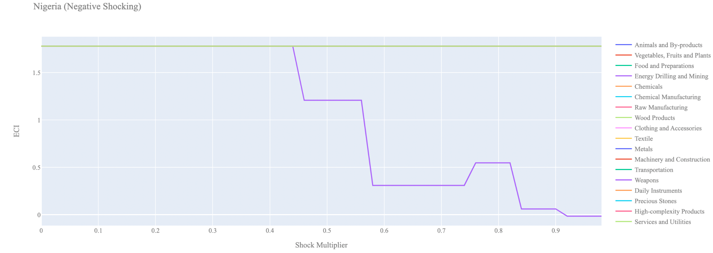
Figure 7b. Decremental ECI Sensitivity for Nigeria (2023)

Next, we consider the 2023 ECI Sensitivity graphs for Ethiopia (Figures 8a and 8b). We see that in the positive shocking case, Vegetable, Fruits, and Plants lead to an uptrend in ECI.

In the 2023 negative shocking case, we see that again Ethiopia is very sensitive to drawbacks in Machinery and Vegetable, Fruits, and Plants. Again, we see that Ethiopia is highly insensitive to drawdowns in the majority of its industries.
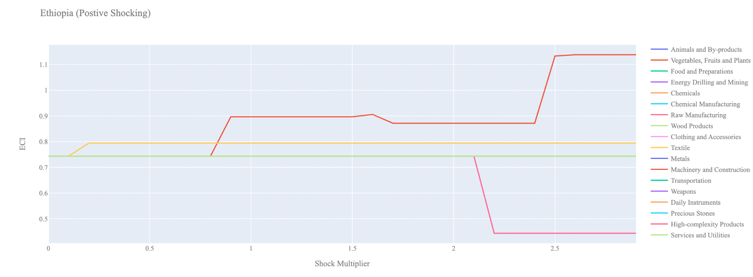
Figure 8a. Incremental ECI Sensitivity for Ethiopia (2023)

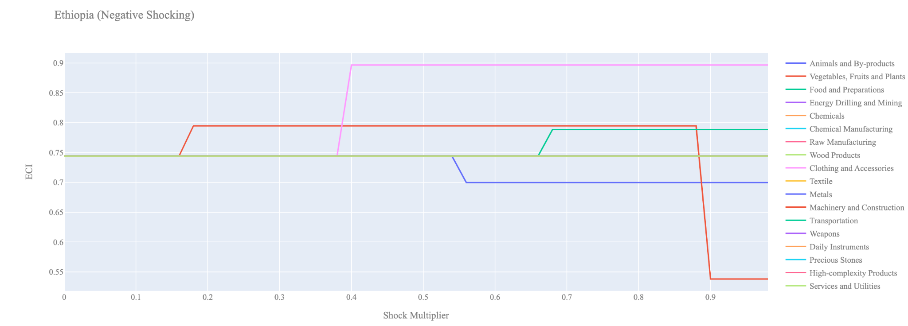
Figure 8b. Decremental ECI Sensitivity for Ethiopia (2023)

Below we see the SDV sensitivity charts by industry (Table 11). Senegal’s SDV is quite insensitive to changes in Vegetable Fruits and Plants, Chemicals, Energy Drilling and Mining, Precious Stones, Food Preparations, and Animals and by-products since they do not seem to be a key industry for their economy. In both the positive and negative SDV sensitivity chart we see that the SDV does not change for any level of shock to the export level of these industries.

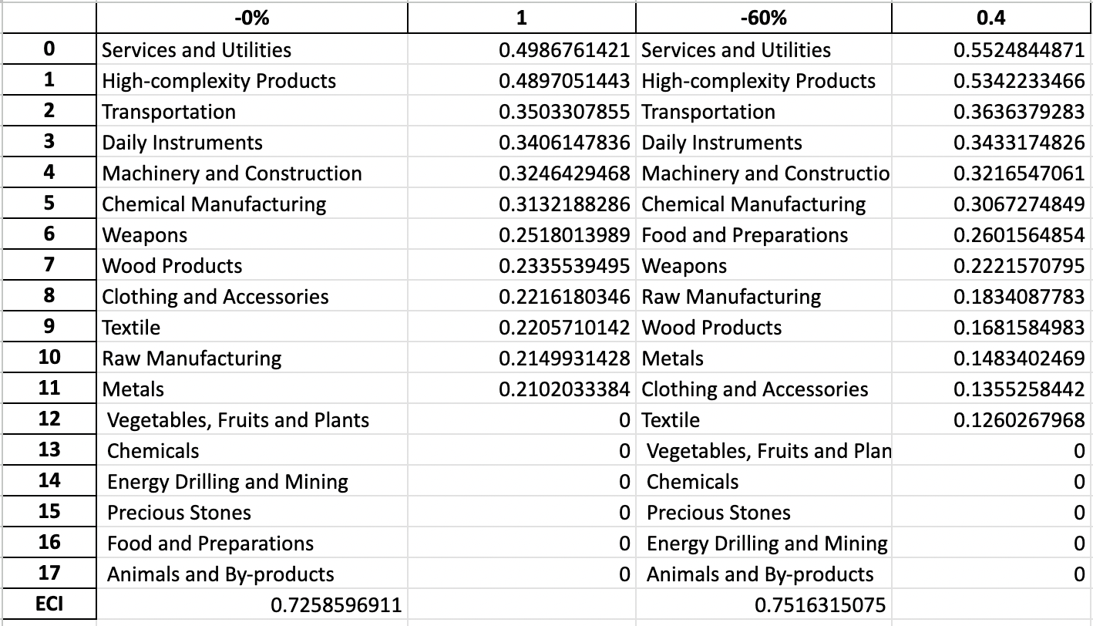Table 11. Senegal’s SDV Sensitivities by Industry (2023)

4.4 Contingency Strategy

Decreasing export of each industry in Senegal’s current production space by 60% respectively, we derive the contingency strategy shown below.

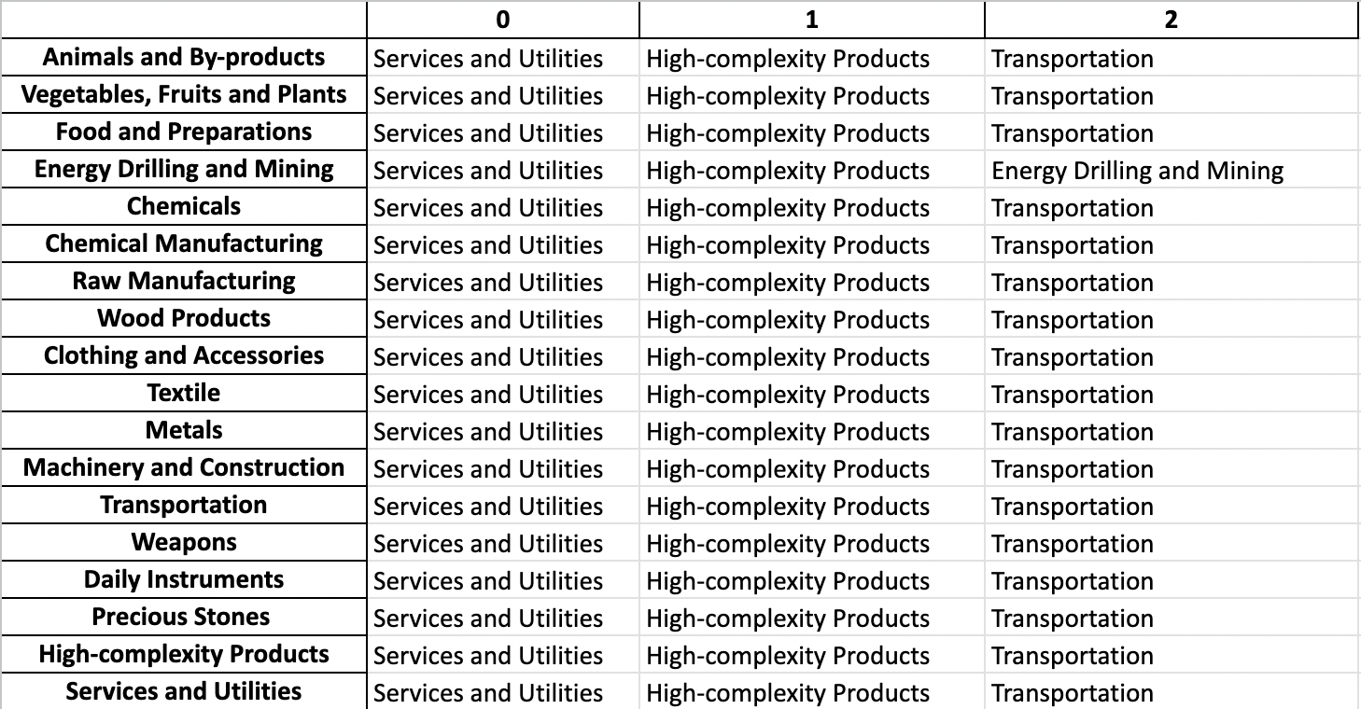
Table 13. Senegal’s Contingency Strategy (2023)

5. Macro-level Predictions

5.1 Structural Optimality Index
ECI sensitivity described in the section before has proven to be a significant factor in deciding the economic outcomes of countries. In order to quantitatively evaluate how effective our development strategies are and how deviations from the suggested developmental path will lead to suboptimal growth results, we define the measure – Structural Optimality Index (SOI) – on a country level as the Adjusted R-Square obtained from regressing the country’s realized industry development over the suggested development strategy. Both strategies are quantified in nature, with the realized development represented by increasing export in every major industry group and the suggested development strategy represented by the opportunity gains of developing the corresponding industry groups as calculated in previous sections. The adjusted R-square from the regression thus provides us with a quantified measure of how the development path adopted by the country has fitted with/differed from calculations on a complexity level.

After obtaining this measure for all countries in our database, we further regress countries’ five-year economic growth, which is defined as the percent increase in GDP (USD), over their SOI. Figure 9 illustrates the regression output, which shows a strong positive correlation between countries’ SOI and their five-year GDP growth, significant at the 25% level and achieving an adjusted R² of 0.109. In other words, the more a country develops, as suggested by calculations on a complexity level, the better economic outcomes it achieves.

Table 14: OLS Regression Results
Dep. Variable: GDP | F-Statistic: 0.9310
R²: 0.109 | Prob (F-Stat): 0.337
Adj R²: -0.001 | No. Observations: 100

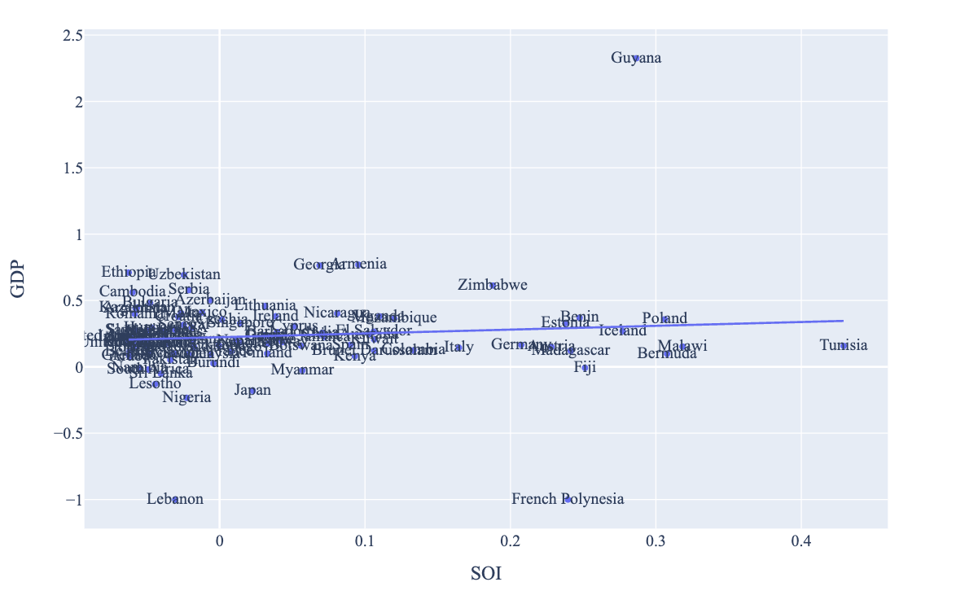Figure 9. Regression of Five-Year GDP Growth over SOI (2019-2023)

5.2 SOI of Senegal and Its Implications
During the first examined period, Senegal, for instance, has a moderate level of structural optimality as compared with its developed peers. As the regression in Figure 10a suggests (the red curve represents export increase and the blue curve stands for opportunity gain of the corresponding industry), Senegal demonstrates a low level of correlation with the suggested developmental path, having an adjusted R-square of around 0.109.

Senegal ranks in the second quartile among all countries in terms of SOI and has made a fast rate of economic progress among its emerging peers from 2019-2023 with a 5-year GDP growth rate of 18%, which is consistent with the regression result in Figure 4b.

Specifically, Senegal's slow economic progress from 2019 to 2023 can be at least partially explained by a development strategy that demonstrates a considerable but not perfect level of matches with our suggested developmental path. Specifically, Senegal invested heavily in the Textile and High-Complexity Products industries, while it should have focused more on industry groups such as Precious Stones and Energy Drilling and Mining.

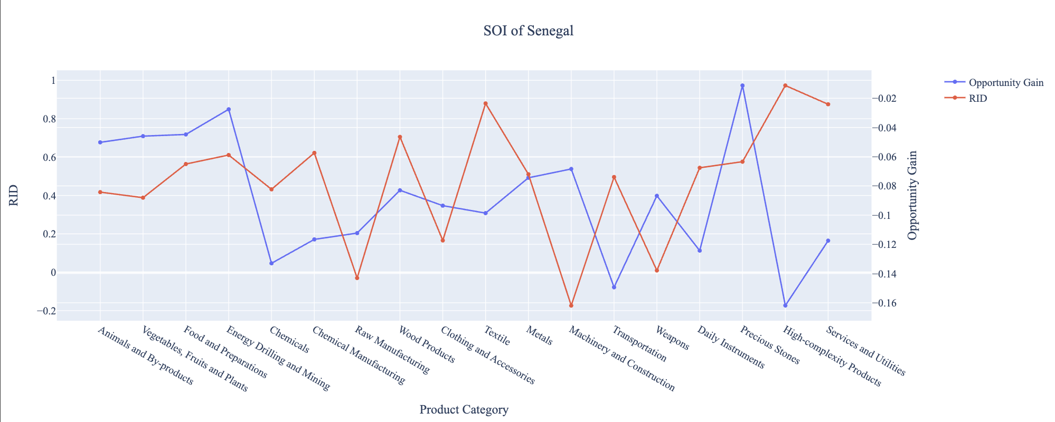
Figure 10a. SOI of Senegal (2019-2023)

Slightly lower than before, its adjusted R-squared value now indicates a lower correlation between the GDP growth and the implemented development path. Progress is slow on a global scale during this period, but Senegal demonstrates a moderate ability to adjust to negative economic shocks by maintaining SOI and GDP growth compared to previous years.

6. Concluding Remarks

In conclusion, Senegal has demonstrated a solid level of economic growth in terms of annual GDP increase during the period from 2019-2023, concurrent with an increase in economic complexity as compared with major developing economies.

We believe that the consistent progress during the period can be partially explained through the analysis of the economic and product complexity structure of Senegal on the industry group level. The product classification system we adopt allows us to measure the realized industry development for various industry groups and to observe that Senegal progressed in developing most of its industries during the period, while its developed counterparts and emerging economies around the globe adopted much more complex and progressive paths.

Based on our analysis of the opportunity gain and sensitivity analysis of major industry groups for 2019-2023, Senegal can further its gains by prioritizing Energy Mining and Drilling and Precious Stones. We further note that Senegal has a somewhat mismatched development strategy that indicates a lower level (compared to other developing countries) of structural optimality on the complexity level, having an adjusted R-square of around 0.109. Since a low correlation exists between five-year GDP growth and the structural optimality index of an economy as we define and calculate, Senegal indeed has a relatively suboptimal growth experience as compared with fast-growing economies both on a regional scale and on a global scale and has the potential to further its economic gains through industrial structure optimization as suggested in the paper. With the revised focus, Senegal has further potential to advance its economic growth to maintain its position among other countries to continue its post-pandemic recovery and ongoing economic expansion.

References

Hausmann, R., Hidalgo, C., Bustos, S., Coscia, M., Chung, S., Jimenez, J., Simoes, A. and Yıldırım, M. (2007). The Atlas of Economic Complexity. [online] Atlas.cid.harvard.edu. Available at: http://atlas.cid.harvard.edu/.

Balassa, B., “The Purchasing Power Parity Doctrine - A Reapprais- al,” Journal of Political Economy 72, 584-596 (1964).

Feenstra, R.; Lipsey, R.; Deng, H.; Ma, A. & Mo, H. “World Trade Flows: 1962-2000” NBER working paper 11040. National Bureau of Economic Research, Cambridge MA (2005).

United Nations Commodity Trade Statistics Database (http://comtrade.un.org/db/), accessed in August 2019.

The World Economic Forum, “The global competitiveness report,” (various years).

Barro, R. & Lee, J-W. “A New Data Set of Educational Attainment in the World, 1950-2010,” NBER Working Paper No. 1590 (2010).

Kaufmann, D. & Kraay, A. “Governance Indicators: Where Are We, Where Should We Be Going?” Policy Research Working Paper 4370. Washington, DC: World Bank (2008).

Hanushek, E.A. & Woessmann, L. “The Role of Cognitive Skills in Economic Development,” Journal of Economic Literature 46(3), 607- 668 (2008).

