Prob 2.3

% main function for problem 2

fry = [0, pi/12, pi/8, pi/6, pi/4, pi/2, pi, 1.5*pi];

s = rand(3,1)

p0 = rand(3,1)

% plot the axis
quiver3(0, 0, 0, s(1), s(2), s(3));
hold on
plot3(p0(1), p0(2), p0(3), '*')

for i = 1:1:8
R = R_solve(s, fry(i));
p1 = R*p0;
plot3(p1(1), p1(2), p1(3), 'ro')

end

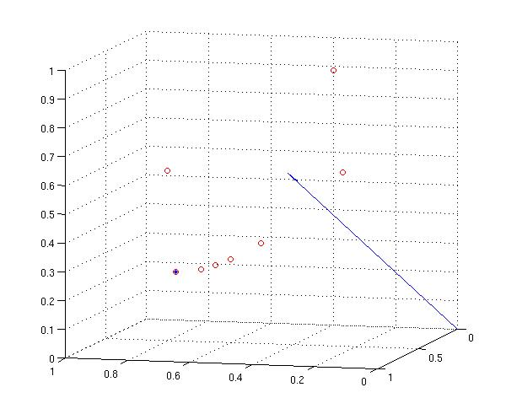

prob 2.6

function [s,phi] = rot_to_ax_phi(R)
[V,D] = eig(R);
tr = 0;
s = zeros(3,1);
for i = 1:1:3
if (abs(D(i,i)-1.0) < 1e-10)
s = V(:,i);
end
tr = tr + D(i,i);
end
phi = acos(0.5*(tr - 1));
end

prob 3

Example 1

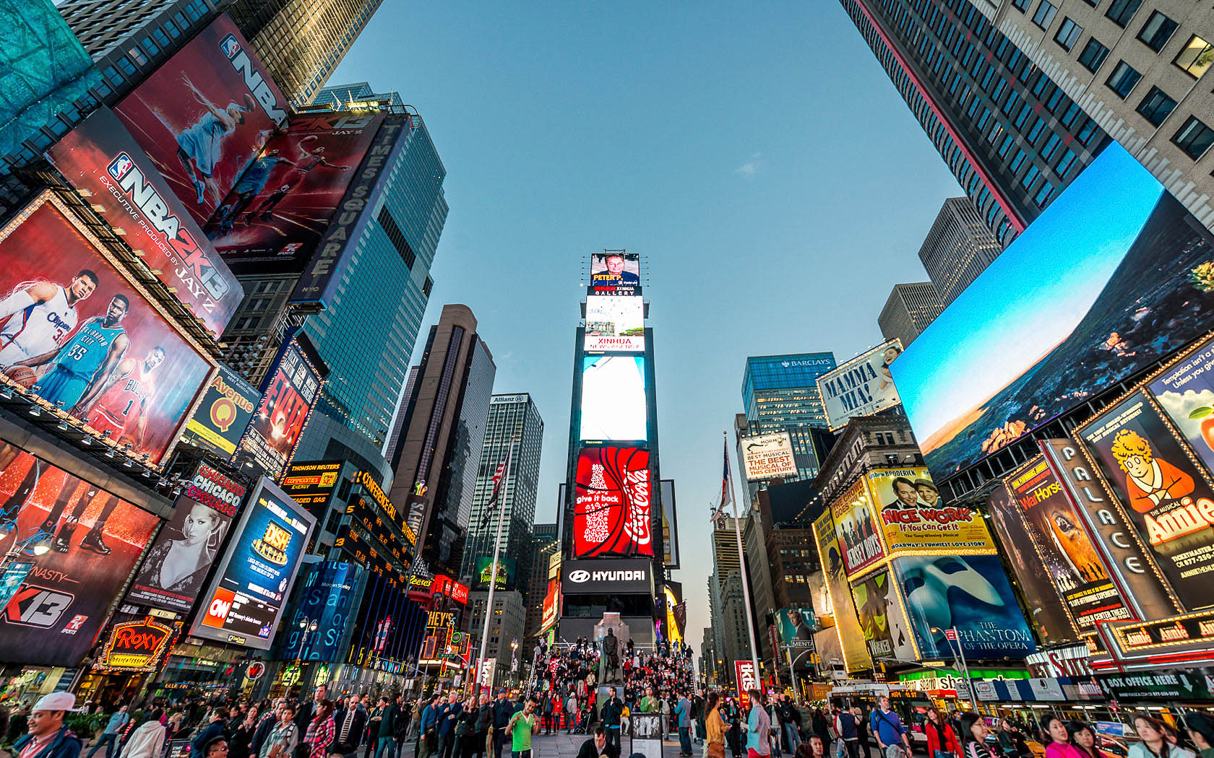

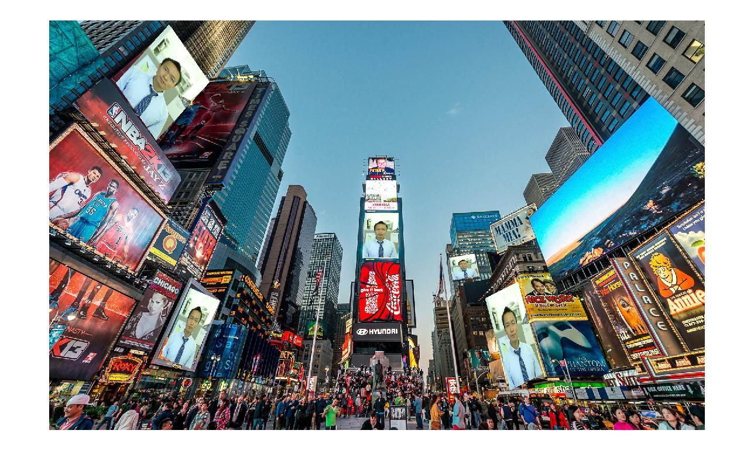

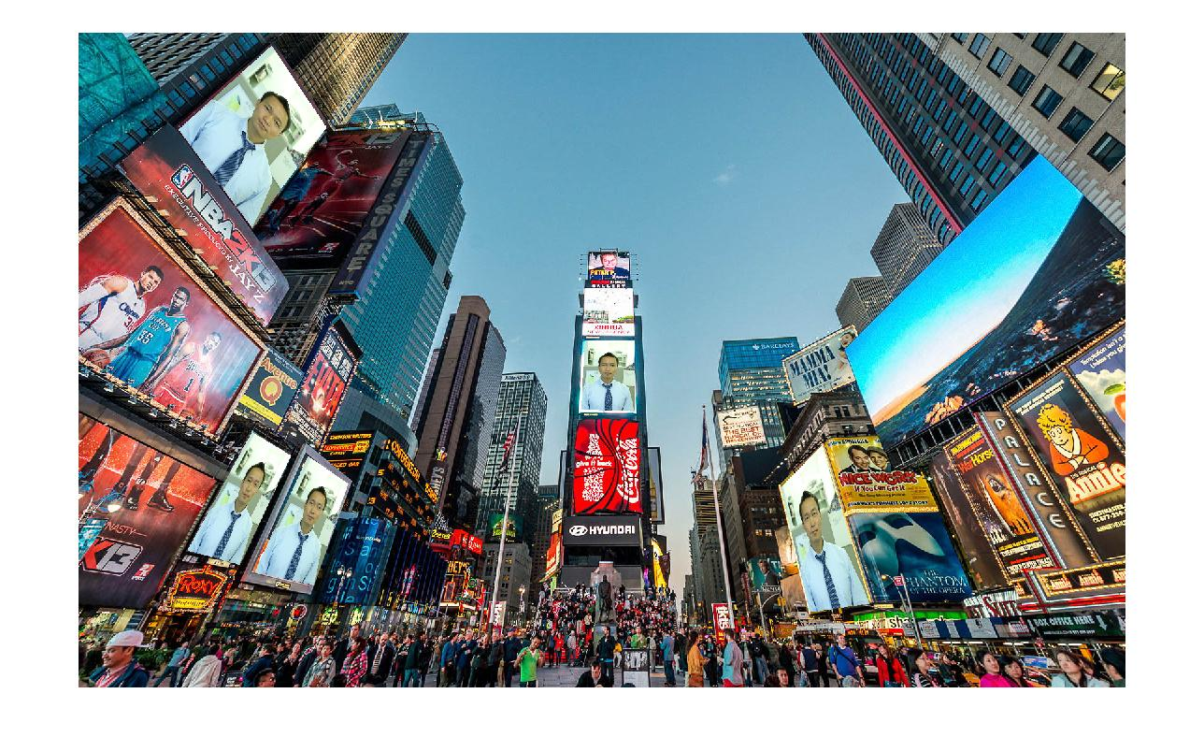
Affline results

homography results

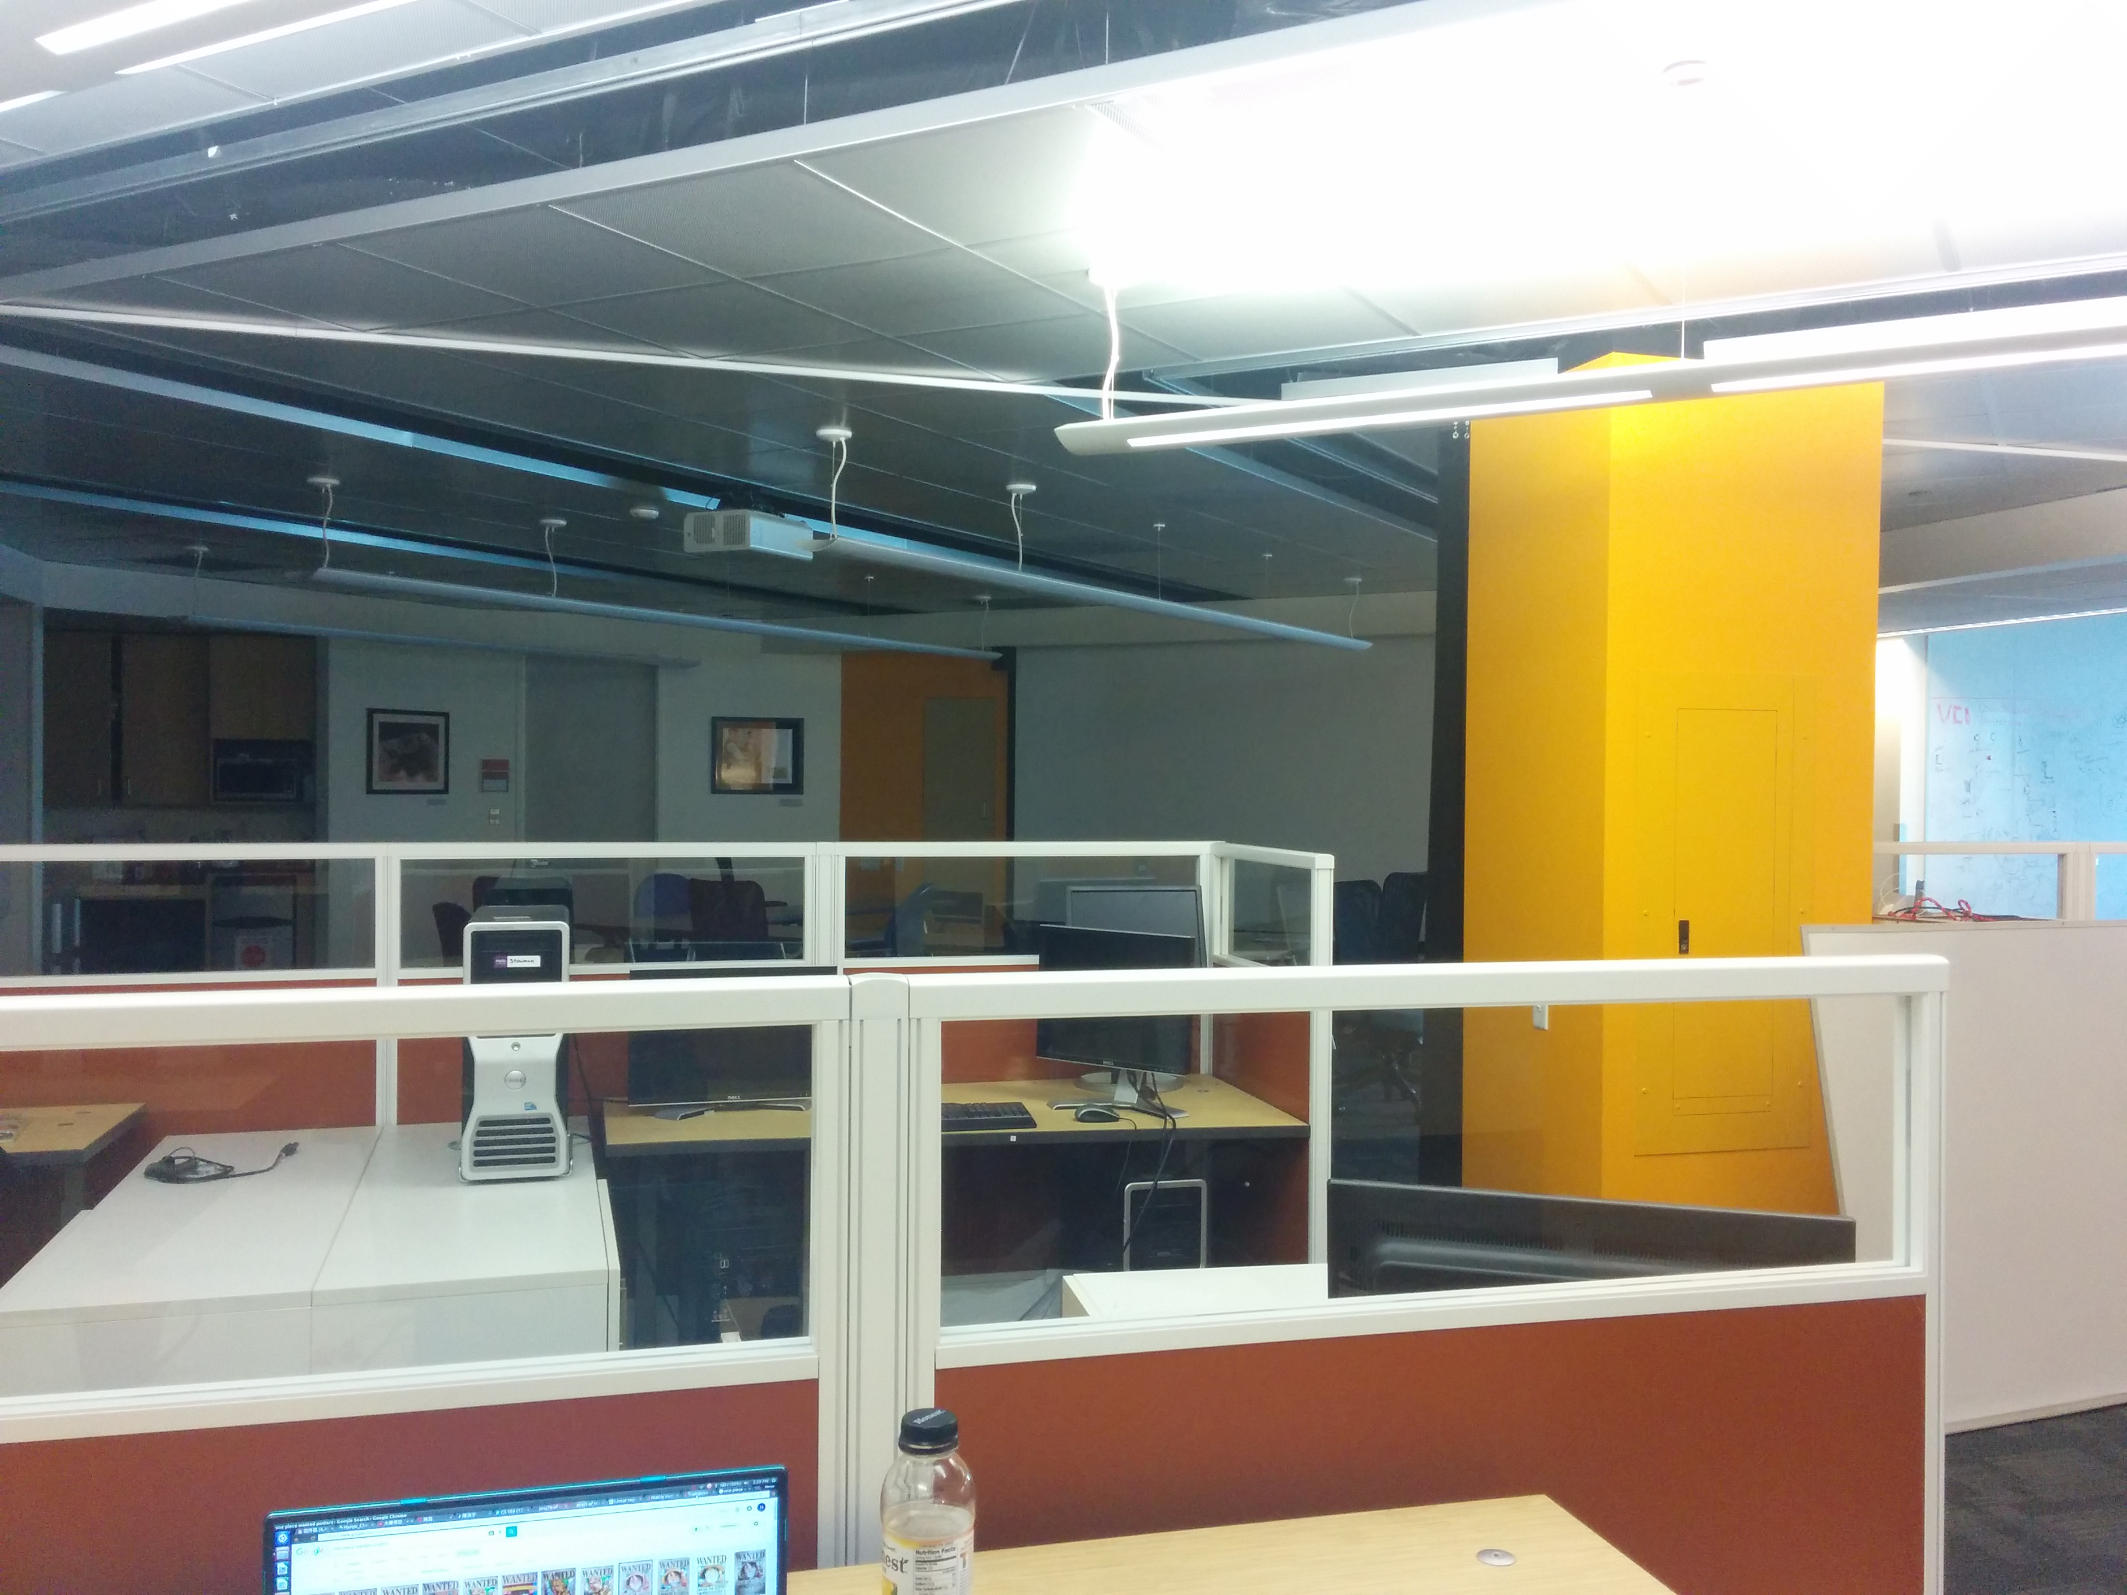
Example 2

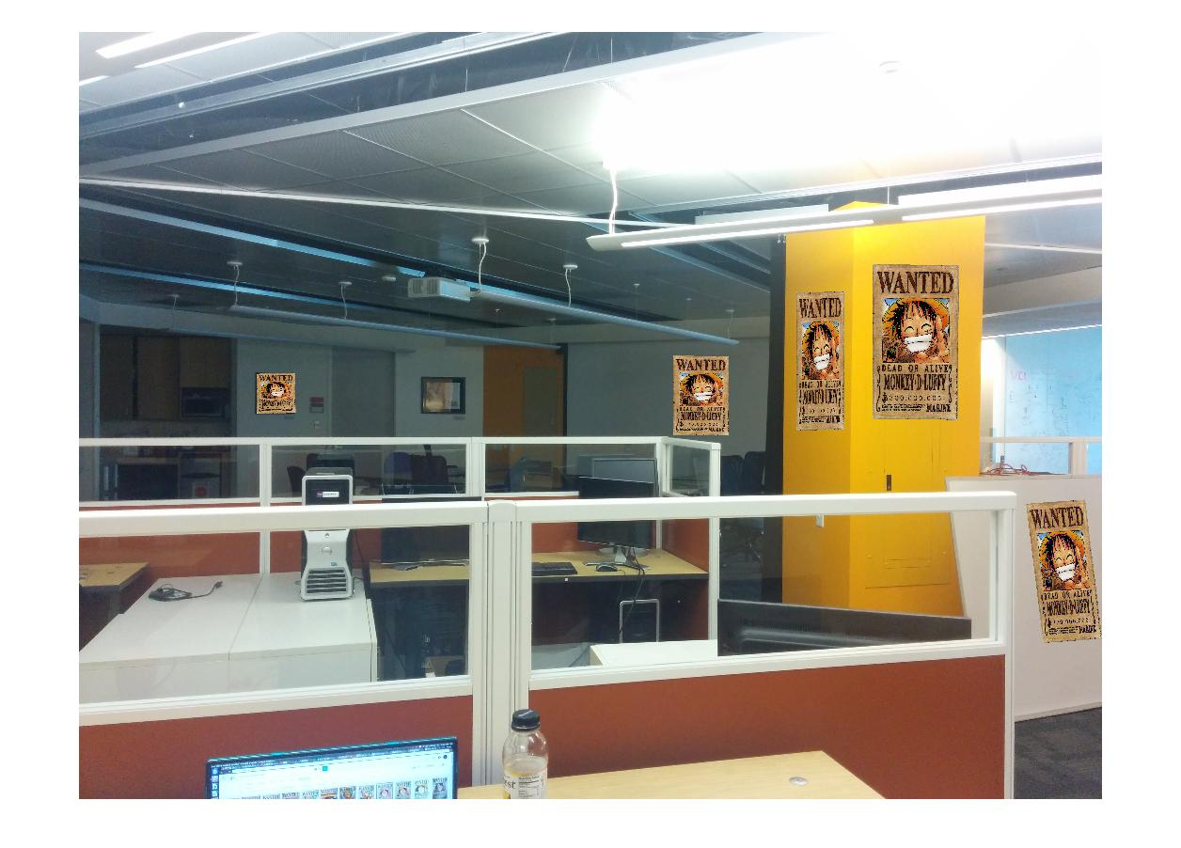

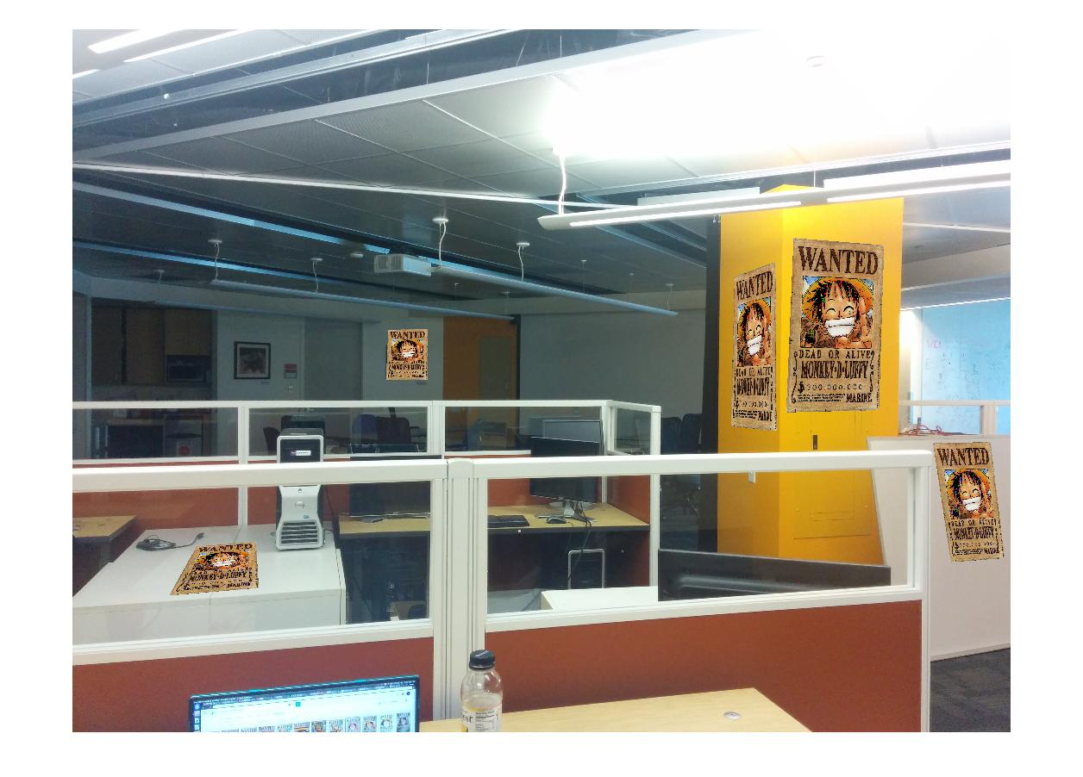
Affline results

Homograph result

problem 3.4

function ans = affine_solve(u, v)

% assume v = Hu
N = size(u,1);

X = zeros(2*N, 6);
Y = zeros(2*N, 1);
for i = 1:1:N
X(2*i - 1, :) = [u(i,1), u(i,2), 1, 0, 0, 0];
Y(2*i - 1) = v(i, 1);
X(2*i, :) = [0, 0, 0, u(i, 1), u(i, 2), 1];
Y(2*i) = v(i, 2);
end

% do Linear regression here
% Y = X*beta
beta = inv(X.'*X)*(X.')*Y;

ans = zeros(3,3);
ans(1, :) = [beta(1), beta(2), beta(3)];
ans(2, :) = [beta(4), beta(5), beta(6)];
ans(3, :) = [0, 0, 1];

end

function H = homography_solve(u,v)

% v = H u
N = size(u,1);

X = zeros(2*N, 8);
Y = zeros(2*N, 1);
for i = 1:1:N
X(2*i - 1, :) = [u(i,1), u(i,2), 1, 0, 0, 0, -u(i, 1) * v(i,1), -u(i,2)*v(i,1)];
Y(2*i - 1) = v(i, 1);
X(2*i, :) = [0, 0, 0, u(i, 1), u(i, 2), 1, -u(i,1)*v(i,2), -u(i,2)*v(i,2)];
Y(2*i) = v(i, 2);
end

% do Linear regression here
% Y = X*beta
beta = inv(X.'*X)*(X.')*Y;

H = zeros(3,3);
H(1, :) = [beta(1), beta(2), beta(3)];
H(2, :) = [beta(4), beta(5), beta(6)];
H(3, :) = [beta(7), beta(8), 1];

end

function v = homography_transform(u,H)
N = size(u,2);
u_new = ones(3, N);
u_new(1:2, :) = u;
v_new = H*u_new;

v(1,:) = v_new(1,:)./v_new(3,:);
v(2,:) = v_new(2,:)./v_new(3,:);

Appendix of Prob 3
% main func for the prob 3

% read the imgs
im1 = imread('../images/onePieceWanted.jpg');
im1 = im2double(im1);
im2 = imread('../images/VCL.jpg');
im2 = im2double(im2);

% for five surface
for s = 1:1:5
% get the four key pnts

n = 4;
pntSet1 = getPntSet(im1, n);
pntSet2 = getPntSet(im2, n);
w = size(im2,2);
h = size(im2,1);
H = homography_solve(pntSet1, pntSet2);
% H = affine_solve(pntSet1, pntSet2);
im_new = imwarped(im1, H,w, h);

for k = 1:1:3
for i = 1:1:h
for j = 1:1:w
if (im_new(i,j,k)> 1)
im_new(i,j,k) = 1;
elseif (im_new(i,j,k) < 0)
im_new(i,j,k) = 0;
end
if (im2(i,j,k)> 1)
im2(i,j,k) = 1;
elseif (im2(i,j,k) < 0)
im2(i,j,k) = 0;
end
end
end
end

im_background = im2;
im_object = im_new;

im2 = combineImage(im2, im_new);

imshow(im2);
end
------------------------------------------------------------------------------------------
function pntSet = getPntSet(im, n)
disp('choose the key pnt')
figure(), hold off, imshow(im), axis image
for i = 1:1:n
[x, y, b] = ginput(1);
if b=='q'
break;
end
pntSet(i,1) = x;
pntSet(i,2) = y;
hold on, plot(pntSet(1:i,1), pntSet(1:i,2), '*-');

end

end
-----------------------------------------------------------------------------------------------------------
function res = imwarped(im, H,w,h)

%p' = Hp;
H_re = inv(H);

res = zeros(h,w, size(im,3));
pnt = zeros(size(res,1)*size(res,2),3);
pnt_new = pnt;
k = 1;
for i = 1:1:size(res,1)
for j = 1:1:size(res,2)
pnt(k,1) = j;
pnt(k,2) = i;
pnt(k,3) = 1;
k = k+1;
end
end

pnt_new = H_re*pnt';
pnt_new = pnt_new';
pnt_new(:,1) = pnt_new(:,1)./pnt_new(:,3);
pnt_new(:,2) = pnt_new(:,2)./pnt_new(:,3);

for k = 1:1:size(im,3)
val = interp2(im(:,:,k),pnt_new(:,1),pnt_new(:,2));
cont = 1;
for i = 1:1:size(res,1)
for j = 1:1:size(res,2)
if (val(cont) <= 10 && val(cont) >= -10)
res(i,j,k) = val(cont);
else
res(i,j,k) = 0;
end
cont = cont+1;
end
end
end

end
--------------------------------------------------------------------------------------------------------
function res = combineImage(background, smaller)

%combine 2 ims
res = zeros(size(background,1),size(background,2),size(background,3));

for k = 1:1:size(res,3)
for i = 1:1:size(res,1)
for j = 1:1:size(res,2)
%num = 1;
%val = im(i,j,k,1);
if (smaller(i, j, k) ~= 0)
res(i,j,k) = smaller(i, j, k);
else
res(i,j,k) = background(i,j,k);
end
end
end

end

