Initial Research

Background
Why are semiconductors more useful than a simple conductor?
Simple conductors conduct electricity all the time, however semiconductors can both conduct and not conduct electricity, this provides a potential function to it by controlling its conductivity, i.e. to be a switch or an amplifier.
How can the conductivity of a semiconductor be deliberately changed?
Conductivity of a semiconductor depends on
How does doping a semiconductor affect its’ charge carries?
Doping a semiconductor adds impurities (substance with an imbalanced amount of charge carrier) to the pure base semiconductor
A N-doped semiconductor has excess negative charge.
A P-doped semiconductor has excess positive holes.
What materials might be used for the P and N-type regions?
Silicon or Germanium, GaAs or GaN
Why are depletion regions found at the interface of PN junctions?
Depletion is the region when excess carrier combine with the majority carries, there’re no free charge carriers in this junction, it acts as an insulating barrier.
How do PN junctions behave under forward and reverse bias? Why is this helpful for transistor operation?
Under forward bias, electron and hole currents related.
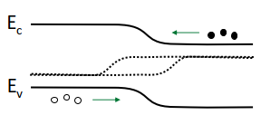
Under reverse bias, current depend on carriers in the depletion region.
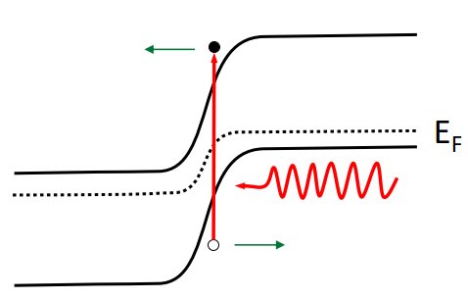

BJT
What are the different use cases for NPN and PNP transistors?

How do the doping concentrations and physics dimensions of each region differ and why?
Primary Charge Carriers: NPN – electrons, PNP – positive holes
How does the physical structure and doping of a BJT allow a small base current to control larger collector currents?
BJT are made up of three layers: emitter, base and collector.
What are the operating modes of a BJT? How do they differ and what are their use cases?
Saturation
Active – transistor can amplify signals
Cutoff -

MOSFET
What important device characteristics are used to classify the performance of a MOSFET? Why are they important?
- Threshold Voltage ($$V_{th}$$): The minimum gate-to-source voltage required to create a conducting channel between the source and drain.
- Drain Current ($$I_{D}$$): The current flowing between the drain and source when the MOSFET is operating.
- On-resistance ($$R_{DS\left(on\right)}$$):The resistance between the drain and source when the MOSFET is fully switched on. A lower resistance reduces power losses and heat generation.
- Maximum Drain-Source Voltage ($$V_{DS\left(\max{}\right)}$$): The maximum voltage the MOSFET can withstand between its drain and source without breaking down.
- Switching Speed: How quickly the MOSFET can switch between ON and OFF states. Important for high-frequency applications and efficient switching.
- Power Dissipation: The maximum power the MOSFET can safely dissipate without overheating or becoming damaged.
What advantages and disadvantages do MOSFETs have over BJTs?
Advantages:
- MOSFETs are voltage-controlled devices, requiring very little steady-state input current.
- Higher input impedance, meaning less power is required to control the device.
- Generally faster switching speeds, making them useful in high-frequency applications.
- More efficient for many switching applications due to low on-state resistance.
- Easier to integrate into large-scale integrated circuits.
Disadvantages:
- MOSFETs can be sensitive to electrostatic discharge (ESD), which can damage the thin insulating gate oxide.
- Can have higher on-resistance than a BJT's saturation resistance in some applications.
- Gate capacitance must be charged and discharged when switching, which can require significant current during fast switching.
- BJTs can provide better linearity and gain in certain analogue applications.
How does a MOSFET utilise an electric field to control current?
The gate is separated from the semiconductor via an insulating dielectric. In an N-type MOSFET, once the gate-to-source voltage is sufficiently positive, the field produced by the gate changes the carrier distribution. As gate voltage increases, holes are depleted from the semiconductor surface and electroncs accumulate near the semicdoncutor-dielectric interface. When sufficient inversion occurrs, an electron inversion channel connects the soruce and drain. Applying a drain-to-source voltge can then produce current through this channel.

