**PDS ANCOV Assignment**

In your personal data set you have scores on two continuous variables and two dichotomous variables. For this assignment you are to conduct bivariate correlation analysis to test the effects of one of your dichotomous variable (*rpb*) and one of your continuous variables (*r*) on the other continuous variable and an analysis of covariance predicting one of the continuous variables from one of the dichotomous variables and the other continuous variable (serving as a “covariate”). In the PDS-ANCOV forum in BlackBoard, create a new thread, with your last name as the title, and post a summary statement like that shown at the bottom of this document.

You may use SAS, SPSS, or R to conduct the analysis. Here I illustrate the use of SAS to conduct the analysis.

The data used here were obtained during research by Michael Nethercutt. The outcome variable is score on a measure of receptivity to [pseudoprofound bullshit](http://journal.sjdm.org/15/15923a/jdm15923a.pdf) (PPBS). The covariate will be score on a measure of spirituality.

**Proc** **Corr**; Var PPBS Sex Spirit; **run**;

| **Pearson Correlation Coefficients  Prob > |r| under H0: Rho=0  Number of Observations** | | | |
| --- | --- | --- | --- |
|  | **PPBS** | **Sex** | **Spirit** |
| |  | | --- | | **PPBS** | | PPBS | | |  | | --- | | 1.00000 | |  | | 283 | | |  | | --- | | 0.19761 | | 0.0009 | | 277 | | |  | | --- | | 0.54528 | | <.0001 | | 278 | |
| |  | | --- | | **Sex** | | Sex | | |  | | --- | | 0.19761 | | 0.0009 | | 277 | | |  | | --- | | 1.00000 | |  | | 278 | | |  | | --- | | 0.16804 | | 0.0050 | | 277 | |
| |  | | --- | | **Spirit** | | Spirit | | |  | | --- | | 0.54528 | | <.0001 | | 278 | | |  | | --- | | 0.16804 | | 0.0050 | | 277 | | |  | | --- | | 1.00000 | |  | | 280 | |

Sex was coded 1 = male, 2 = female. Accordingly the point biserial correlation coefficients here show that women had significantly higher scores than did men on both PPBS and spirituality. Furthermore, PPBS was strongly correlated with spirituality.

**Proc** **Ttest**; Class Sex; Var PPBS; **run**;

The TTEST Procedure

Variable: PPBS (PPBS)

| **Sex** | **N** | **Mean** | **Std Dev** | **Std Err** | **Minimum** | **Maximum** |
| --- | --- | --- | --- | --- | --- | --- |
| **Male** | 121 | 2.5484 | 0.8536 | 0.0776 | 1.0769 | 4.9231 |
| **Female** | 156 | 2.9003 | 0.8807 | 0.0705 | 1.0769 | 4.9231 |
| **Diff (1-2)** |  | -0.3519 | 0.8690 | 0.1053 |  |  |

| **Sex** | **Method** | **Mean** | **95% CL Mean** | | **Std Dev** | **95% CL Std Dev** | |
| --- | --- | --- | --- | --- | --- | --- | --- |
| **Male** |  | 2.5484 | 2.3948 | 2.7021 | 0.8536 | 0.7579 | 0.9771 |
| **Female** |  | 2.9003 | 2.7610 | 3.0396 | 0.8807 | 0.7926 | 0.9910 |
| **Diff (1-2)** | **Pooled** | -0.3519 | -0.5591 | -0.1447 | 0.8690 | 0.8020 | 0.9482 |
| **Diff (1-2)** | **Satterthwaite** | -0.3519 | -0.5584 | -0.1454 |  |  |  |

| **Method** | **Variances** | **DF** | **t Value** | **Pr > |t|** |
| --- | --- | --- | --- | --- |
| **Pooled** | Equal | 275 | -3.34 | 0.0009 |
| **Satterthwaite** | Unequal | 261.8 | -3.36 | 0.0009 |

Notice that the *p* for the *t* test comparing the sexes is identical to the *p* from the *rpb* relating sex to PPBS. The independent samples *t* test is just a special case of a correlation/regression analysis.

| **Equality of Variances** | | | | |
| --- | --- | --- | --- | --- |
| **Method** | **Num DF** | **Den DF** | **F Value** | **Pr > F** |
| **Folded F** | 155 | 120 | 1.06 | 0.7224 |

Compared to men, women scored significantly higher (by .3519) on PPBS.

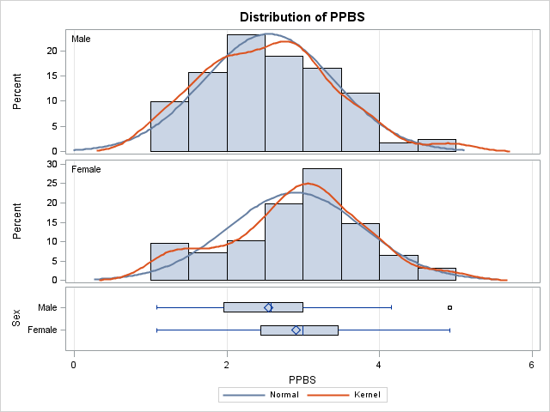

**Proc** **Reg**; Model PPBS = Sex; **run**; **quit**;

The REG Procedure

Model: MODEL1

Dependent Variable: PPBS PPBS

|  |  |
| --- | --- |
| **Number of Observations Read** | 291 |
| **Number of Observations Used** | 277 |
| **Number of Observations with Missing Values** | 14 |

| **Analysis of Variance** | | | | | |
| --- | --- | --- | --- | --- | --- |
| **Source** | **DF** | **Sum of Squares** | **Mean Square** | **F Value** | **Pr > F** |
| **Model** | 1 | 8.43838 | 8.43838 | 11.17 | 0.0009 |
| **Error** | 275 | 207.65783 | 0.75512 |  |  |
| **Corrected Total** | 276 | 216.09622 |  |  |  |

|  |  |  |  |
| --- | --- | --- | --- |
| **Root MSE** | 0.86898 | **R-Square** | 0.0390 |
| **Dependent Mean** | 2.74662 | **Adj R-Sq** | 0.0356 |

| **Parameter Estimates** | | | | | | |
| --- | --- | --- | --- | --- | --- | --- |
| **Variable** | **Label** | **DF** | **Parameter Estimate** | **Standard Error** | **t Value** | **Pr > |t|** |
| **Intercept** | Intercept | **1** | 2.19655 | 0.17264 | 12.72 | <.0001 |
| **Sex** | Sex | **1** | 0.35190 | 0.10527 | 3.34 | 0.0009 |

Predictor variables in regression analysis may be continuous or dichotomous. When there is a single predictor variable and it is dichotomous, the regression analysis is identical to the traditional pooled variances independent samples *t* test. Here the value of the *t* and *p* are identical to what we got earlier with Proc Ttest. Also note that the slope, .3519, is equal to the difference between the two means.

**Proc** **Reg**; Model PPBS = Sex Spirit / stb scorr2; **run**; **quit**;

The regression analysis here is an analysis of covariance, since the predictors include at least one dichotomous variable and one continuous variable.

The REG Procedure

Model: MODEL1

Dependent Variable: PPBS PPBS

|  |  |
| --- | --- |
| **Number of Observations Read** | 291 |
| **Number of Observations Used** | 276 |
| **Number of Observations with Missing Values** | 15 |

| **Analysis of Variance** | | | | | |
| --- | --- | --- | --- | --- | --- |
| **Source** | **DF** | **Sum of Squares** | **Mean Square** | **F Value** | **Pr > F** |
| **Model** | 2 | 66.31487 | 33.15744 | 60.46 | <.0001 |
| **Error** | 273 | 149.71691 | 0.54841 |  |  |
| **Corrected Total** | 275 | 216.03178 |  |  |  |

|  |  |  |  |
| --- | --- | --- | --- |
| **Root MSE** | 0.74055 | **R-Square** | 0.3070 |
| **Dependent Mean** | 2.74570 | **Adj R-Sq** | 0.3019 |
| **Coeff Var** | 26.97121 |  |  |

| **Parameter Estimates** | | | | | | | | |
| --- | --- | --- | --- | --- | --- | --- | --- | --- |
| **Variable** | **Label** | **DF** | **Parameter Estimate** | **Standard Error** | **t Value** | **Pr > |t|** | **Standardized Estimate** | **Squared Semi-partial Corr Type II** |
| **Intercept** | Intercept | **1** | 1.25920 | 0.17323 | 7.27 | <.0001 | 0 | . |
| **Sex** | Sex | **1** | 0.19921 | 0.09120 | 2.18 | 0.0298 | 0.11162 | 0.01211 |
| **Spirit** | Spirit | **1** | 0.33489 | 0.03264 | 10.26 | <.0001 | 0.52435 | 0.26725 |

When controlling for each other, both sex and spirituality have significant effects. Notice that the effect of sex (slope = .19921) is less when we control for sex differences in spirituality than when we did not (slope = .35190). Part, but not all, of the sex difference in PPBS is due to (redundant with) a sex difference in spirituality.

**Proc** **GLM**; Model PPBS = Sex Spirit / SS3; LSMEANS Sex; **run**; **quit**;

Proc GLM can also be used to conduct regression analyses. It provides some optional output not available with Proc Reg.

The GLM Procedure

| **Class Level Information** | | |
| --- | --- | --- |
| **Class** | **Levels** | **Values** |
| **Sex** | 2 | Female Male |

|  |  |
| --- | --- |
| **Number of Observations Read** | 291 |
| **Number of Observations Used** | 276 |

The GLM Procedure

Dependent Variable: PPBS PPBS

| **Source** | **DF** | **Sum of Squares** | **Mean Square** | **F Value** | **Pr > F** |
| --- | --- | --- | --- | --- | --- |
| **Model** | 2 | 66.3148708 | 33.1574354 | 60.46 | <.0001 |
| **Error** | 273 | 149.7169123 | 0.5484136 |  |  |
| **Corrected Total** | 275 | 216.0317831 |  |  |  |

| **R-Square** | **Coeff Var** | **Root MSE** | **PPBS Mean** |
| --- | --- | --- | --- |
| 0.306968 | 26.97121 | 0.740550 | 2.745704 |

| **Source** | **DF** | **Type III SS** | **Mean Square** | **F Value** | **Pr > F** |
| --- | --- | --- | --- | --- | --- |
| **Sex** | 1 | 2.61636277 | 2.61636277 | 4.77 | 0.0298 |
| **Spirit** | 1 | 57.73531846 | 57.73531846 | 105.28 | <.0001 |

The GLM Procedure

Least Squares Means

| **Sex** | **PPBS LSMEAN** |
| --- | --- |
| **Female** | 2.83231633 |
| **Male** | 2.63310843 |

Least-squares means (also called adjusted means) are estimates of what the differences in group means would be if the groups did not differ on the covariate(s). Notice that the difference here is 2.83231633 - 2.63310843 = .19921, identical to the value of the slope for sex in the results from Proc Reg.

Summary Statement

Women scored significantly higher than did men on receptivity to pseudoprofound bullshit (*rpb* = .198, *p* < .001) and spirituality (*rpb* = .168, *p* = .005). Spirituality was strongly correlated with receptivity to pseudoprofound bullshit (*r* = .545, *p* < .001). Analysis of covariance was employed to test the unique effects of sex and spirituality on receptivity to pseudoprofound bullshit. Controlling for sex differences in spirituality, women scored significantly higher on receptivity to pseudoprofound bullshit (adj *M* = 2.832) than did men (adj *M* = 2.633), *sr* = .110, *t*(273) = 4.77, *p* = .030). The unique effect of spirituality was considerably stronger than that of sex, *sr* =.517, *t*(273) = 10.26, *p* < .001).

I reported *sr* here rather than beta or *sr2* because one can use Cohen’s guidelines for the size of a correlation coefficient with *sr* but not with beta. Using those guidelines, the effect of sex is small but the effect of spirituality is large.

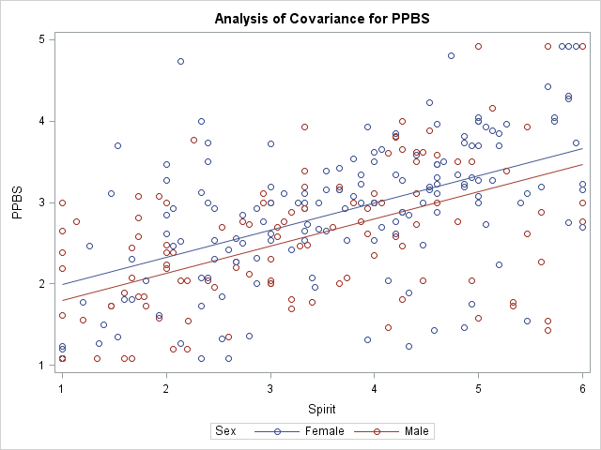

**ANCOV with SPSS**

|  |  |
| --- | --- |
|  |  |

|  |  |  |  |  |  |  |
| --- | --- | --- | --- | --- | --- | --- |
| **Tests of Between-Subjects Effects** | | | | | | |
| Dependent Variable: PPBS | | | | | | |
| Source | Type III Sum of Squares | df | Mean Square | F | Sig. | Partial Eta Squared |
| Corrected Model | 66.315a | 2 | 33.157 | 60.461 | .000 | .307 |
| Intercept | 89.331 | 1 | 89.331 | 162.890 | .000 | .374 |
| Spirit | 57.735 | 1 | 57.735 | 105.277 | .000 | .278 |
| Sex | 2.616 | 1 | 2.616 | 4.771 | .030 | .017 |
| Error | 149.717 | 273 | .548 |  |  |  |
| Total | 2296.766 | 276 |  |  |  |  |
| Corrected Total | 216.032 | 275 |  |  |  |  |
| a. R Squared = .307 (Adjusted R Squared = .302) | | | | | | |

I am not fond of fully partial effect size estimates. You can get the *sr2* by taking the *SSEffect* and dividing by the *SSCorrected_Total*. For sex, *sr2* = 2.616/216.032 = .0121. Take the square root and get sr = .110. For spirituality, *sr* = SQRT(57.735/216.032) = .517.

|  |  |  |  |  |
| --- | --- | --- | --- | --- |
| **Sex** | | | | |
| Dependent Variable: PPBS | | | | |
| Sex | Mean | Std. Error | 95% Confidence Interval | |
| Lower Bound | Upper Bound |
| Male | 2.633a | .068 | 2.499 | 2.767 |
| Female | 2.832a | .060 | 2.715 | 2.950 |
| a. Covariates appearing in the model are evaluated at the following values: Spirit = 3.5077. | | | | |

These are the adjusted means (least squares means).

You can get the semipartial correlations using the linear regression module:

REGRESSION

/MISSING LISTWISE

/STATISTICS COEFF OUTS R ANOVA ZPP

/CRITERIA=PIN(.05) POUT(.10)

/NOORIGIN

/DEPENDENT PPBS

/METHOD=ENTER Sex Spirit.

|  |  |  |  |  |  |  |  |
| --- | --- | --- | --- | --- | --- | --- | --- |
| Model | | Standardized Coefficients | t | Sig. | Correlations | | |
| Beta | Zero-order | Partial | Part |
| 1 | (Constant) |  | 7.269 | .000 |  |  |  |
| Sex | .112 | 2.184 | .030 | .199 | .131 | .110 |
| Spirit | .524 | 10.260 | .000 | .543 | .528 | .517 |

SPSS calls semipartial correlations “part” correlations.