The outcome variable is PercentSalaryHike. Predictors are TrainingTimesLastYear and OverTime.

Overtime was coded as 1 for No overtime and 2 for Yes overtime.

Pearson correlation coefficients show no significant interactions:

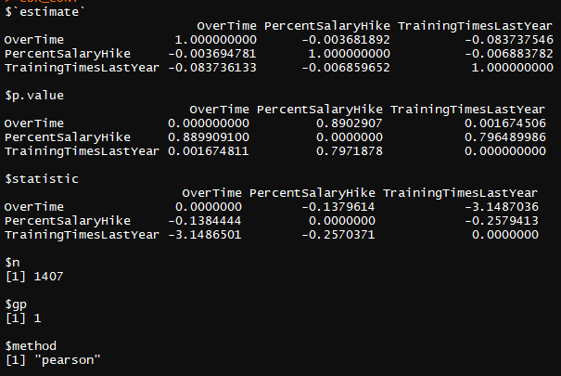

Model with interaction between PercentSalaryHike and predictor variables did not indicate any significant interactions, either between each predictor variable and PercentSalaryHike individually, or with the interaction of both predictor variables and the PercentSalaryHike variable:

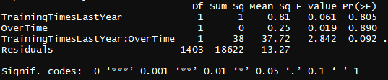

Model without interaction between categorical and predictor variables:



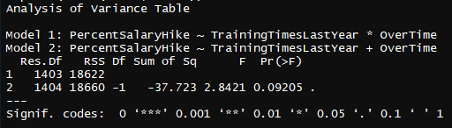

T-tests relating each continuous variable to the dichotomous variable (Overtime Y/N):

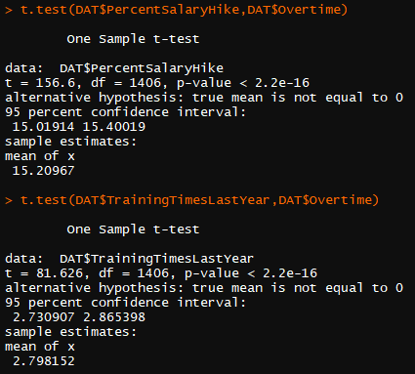

Employee status of having performed overtime did not have a significant relationship with their percentage salary hike (*rpb* = -.004, *p* = .890), and employees who worked overtime had a significantly lower number of training sessions last year (*rpb* = -.084, *p* <.005). Percentage salary hike did not have a significant relationship withnumber of training sessions last year (*r* = -.007, *p* = .796). Analysis of covariance was employed to test the unique effects of having performed overtime number of training sessions last year to percentage salary hike.Controlling for overtime status differences in number of training sessions last year, people who worked overtime did not score significantly differently than people who did not work overtime (*p* = .092).

