**Examining and importing the dataset:**

I inspected the dataset in Excel, seeing that all the variables were named correctly.

I imported the dataset using the following code, telling R that missing data is coded as “-999”.



**Reverse scored variables:**

I used the alpha() function to conduct an initial factor analysis and look for reverse-scored variables. All Cronbach’s alpha values were positive, indicating that there were no reverse-scored variables.

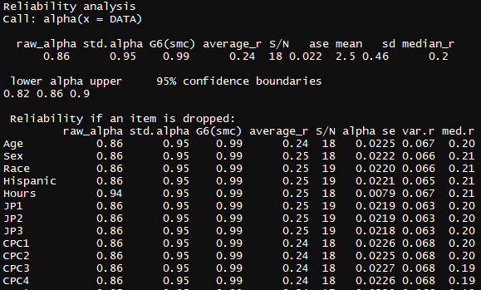

However, you will see in my code that I did at first read the output incorrectly, thinking that some variables were reverse scored. I used the reverse.code() function at first, but then used # to comment out the code I created for future reference.



**Individual internal consistency / reliability analysis:**

After this, I created objects for each construct, separating them for individual reliability analyses. In retrospect, there are more efficient ways I could have done this but I believe this way works.

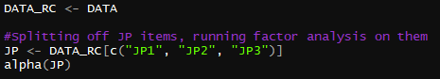

The PIB (Perceived Incivility Behaviors) Construct had chronbach’s alphas above 70 but below 80 on all items. While adequate as applied to this dataset for which they were likely trained, these statistics indicate that when applied to create new data these items may not measure the PIB construct adequately. The researcher might consider removing the item PIB2.

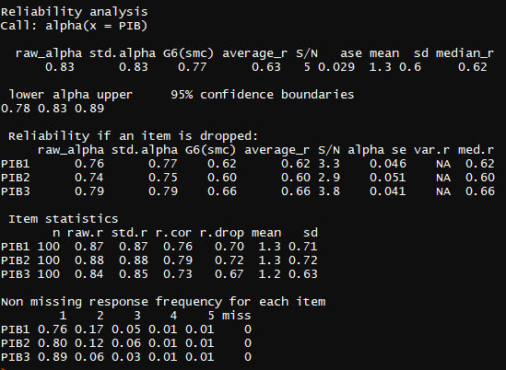

CPC2 and CPC4 both had alphas above 70 but below 80. They are likely high enough to be applied.

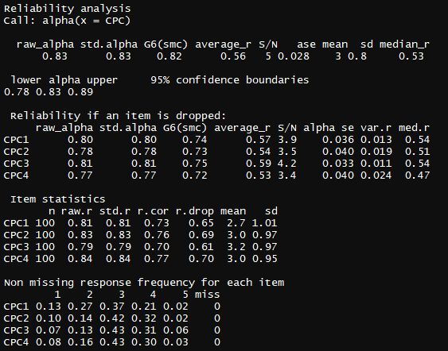

The other constructs had alpha values of over 90 both for individual items and overall construct reliability, except WRB which had alphas in the 80 range; all more than adequate for application.

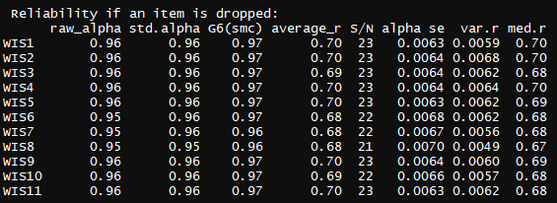

**Git repository:**

https://github.com/WillEddy/PSYC_6327-Psychometrics/tree/master/1_27_2019-Assignment_4_First_Factor_Analysis

**Full code:**

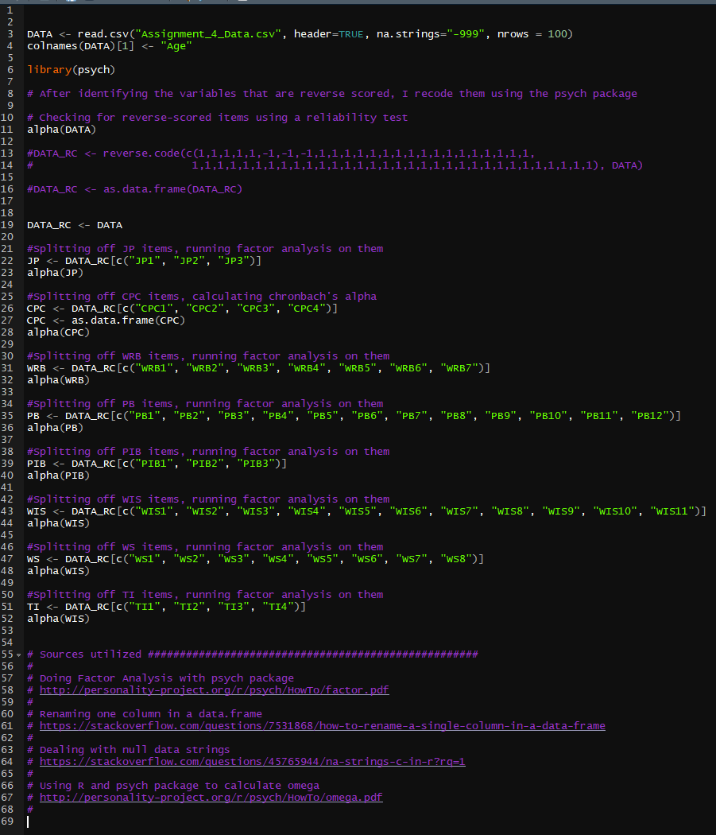

**Full output:**

