**Kaiser criterion:**

Using the scree() function from the psych package in R, I conducted an initial factor analysis on the provided data. This resulted in the following array of eigen values:

*5.32 2.16 1.03 0.93 0.72 0.66 0.46 0.30 0.21 0.17 -0.01 -0.06 -0.13 -0.14*

*-0.18 -0.24 -0.25 -0.29 -0.35 -0.38 -0.41 -0.48 -0.49 -0.55 -0.55 -0.65 -0.70 -0.79*

***THIS IS DIFFERENT THAN EIGENVALUES SPSS OUTPUTS. WHAT DOES THIS PACKAGE DO DIFFERNTLY, OR WHAT DID I DO WRONG?***

As shown, examining the dataset results in three eigenvalues exceeding the 1.0 Kaiser criterion, and therefore based on this analysis I recommend examining 3 factors in this dataset.

**Scree Plot:**

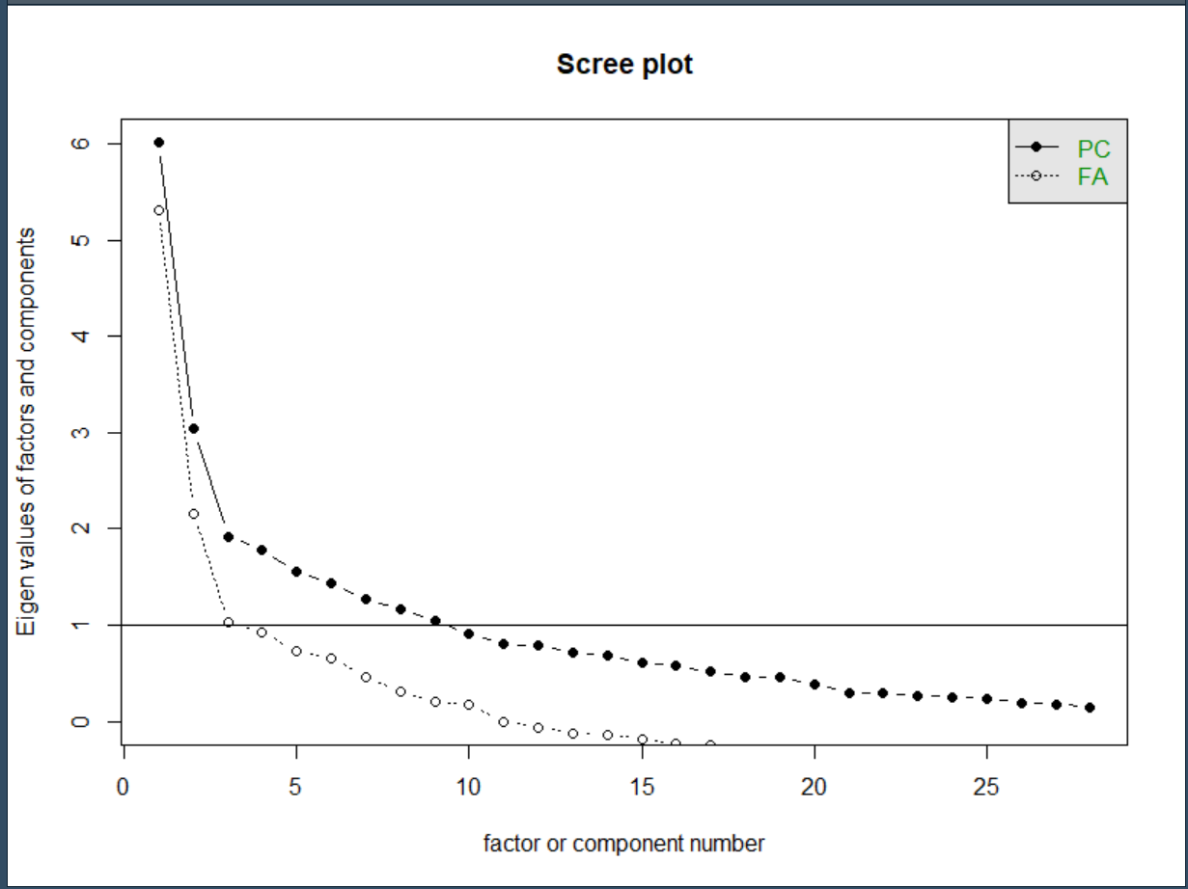

A visual evaluation of the scree plot above indicates 2 factors, confirming the Kaiser criterion evaluation.

**Parallel Analysis**

I went on to use the fa.parallel () function from the psych package in R to conduct a parallel analysis. I used the default factor method, which is minres. All other settings used were the default. Parallel analysis suggests that the dataset contains 6 factors to extract.

**Parallel analysis demo in class indicated 5 factors. However, close enough to be rounding error?**

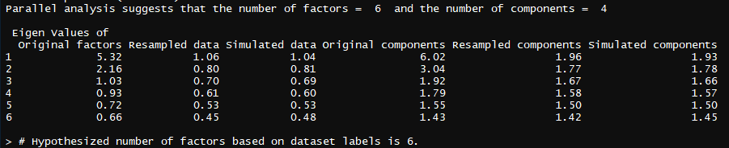

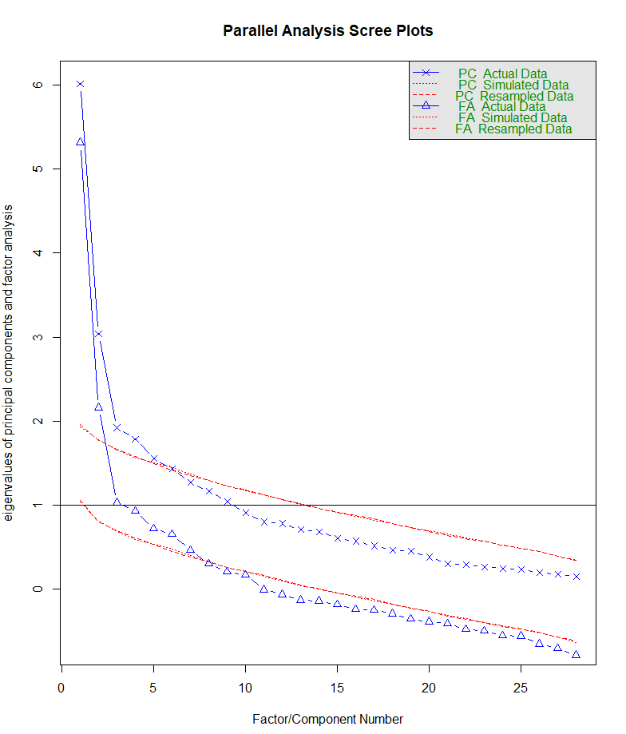

**MAP Test**

For the Velicer Minimum Average Partial criterion (MAP) test, I used the VSS() function from the psych package. This function outputs results from a variety of exploratory factor analysis techniques. Used default factoring technique minres.

Results with oblmin rotation, target factor number 4:

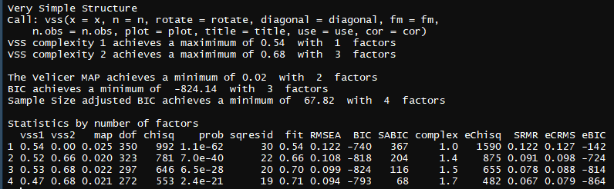

MAP test results in 2 factors to extract. **Where is the revised MAP in my readout?**

Parsomony - Simplest explanation - encourages smallest.

Logic of newest technique would be revised MAP and Parallel analysis

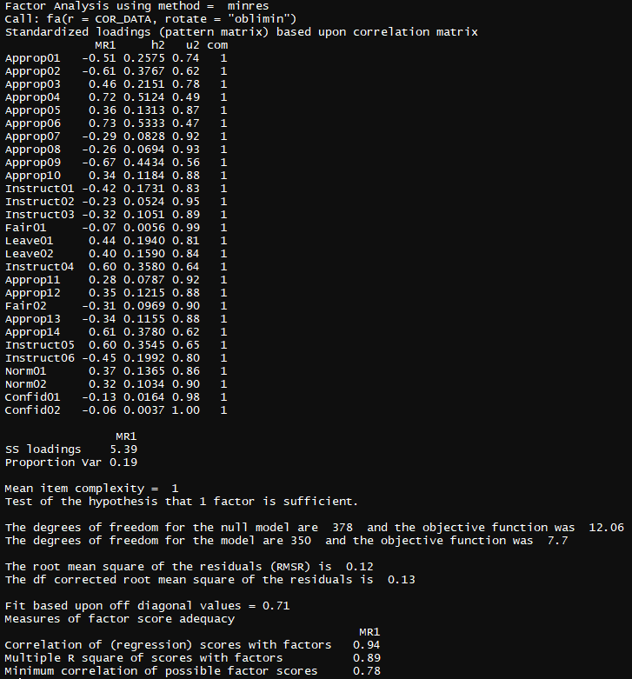

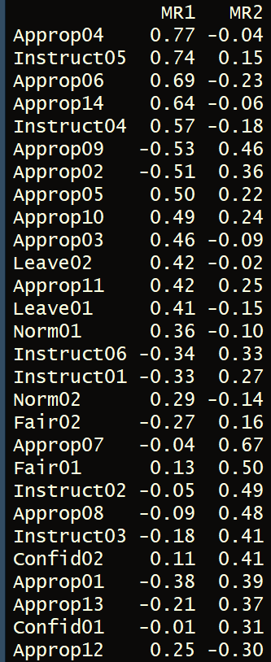

3 factor version, oblmin rotation

