Split-half internal consistency for Time 1:

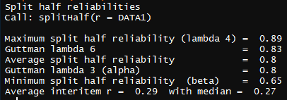

Split-half internal consistency for Time 2:

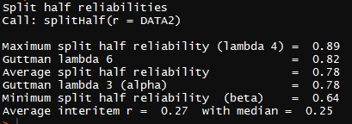

What is the test-retest reliability of the measure?

Individual item correlations with sum of all scores, Time 1:

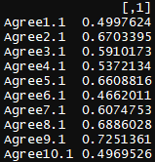

Individual item correlations with sum of all scores, Time 2:

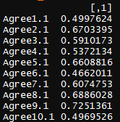

Correlation between 2 correlation tables:

