**Question 1: Internal Consistency and Test-Retest Reliability**

1. *Internal consistency and b. Suggested item-level improvements*

Time 1 internal consistency as expressed by Cronbach’s Alpha is adequate, measuring .754:

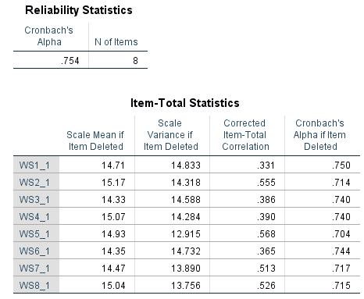

For Time 1, internal consistency as measured by Cronbach’s Alpha would not be improved by removing any of the items.

Time 2 internal consistency as expressed by Cronbach’s Alpha is adequate, measuring .743:

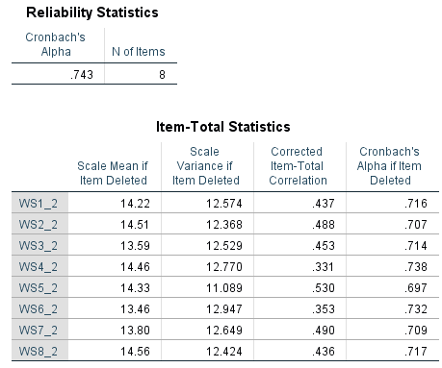

For Time 2, internal consistency as measured by Cronbach’s Alpha would not be improved by removing any of the items.

1. *What is the test-retest reliability of the measure?*

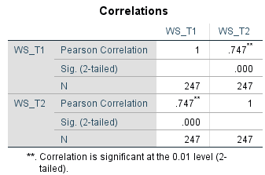

Test-retest reliability measured as 0 .747. This is an adequate level of reliability.

1. *95% Confidence Intervals*

What is the 95% confidence interval for any score X obtained at Time 1?

Syntax utilized: 

Confidence interval for a given score in Time 1 is +/- 0.25

What is the 5% confidence interval for any score X obtained at Time 2?

Syntax utilized: 

Confidence interval for a given score in Time 1 is +/- 0.27