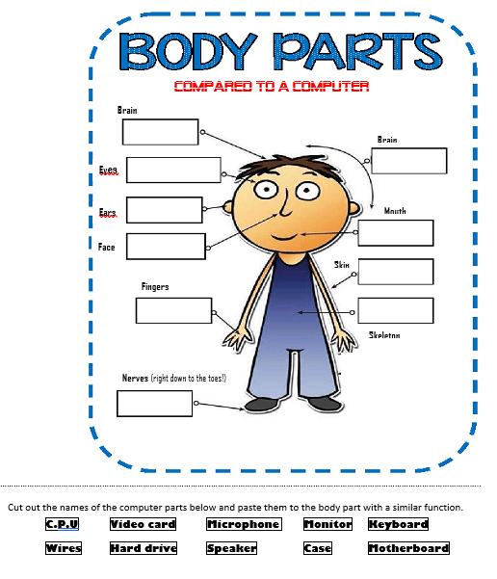

N/A

Input

Input/Output

Process

Process

Output

Output

Input

Input

Process/Input/Output