Muon Lifetime (MUO)

Data Acquisition Electronics

The data you will be analyzing has been collected with the electronics described below.

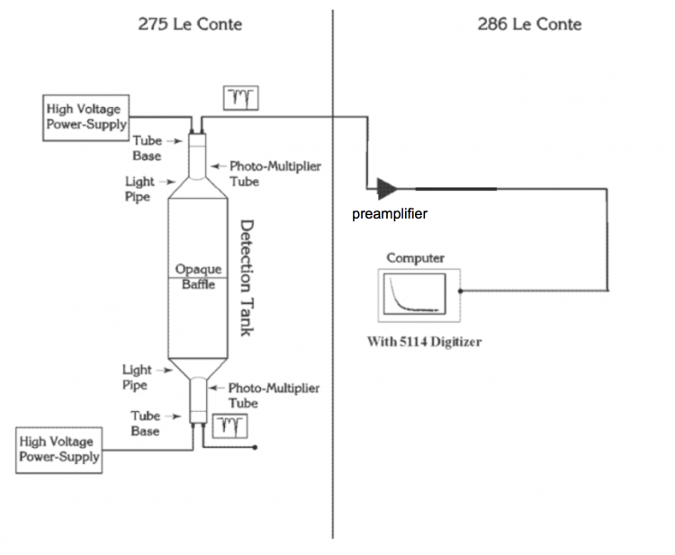

Figure 5: Block Diagram of the Muon Lifetime Experiment

(from the pre-covid lab manual http://experimentationlab.berkeley.edu/sites/default/files/writeups/MUO.pdf)

Only the top half of the "Detection Tank" in 275 LeConte shown above was utilized, so you will see in the data file that columns referring to the bottom photomultiplier tube signals are zeros. The high voltage supply settings are visible in the photograph below, which was taken during data collection. Nothing is seen connected to the HV output on the front because the HV is also present on the back and that is the output being used to power the PMT.

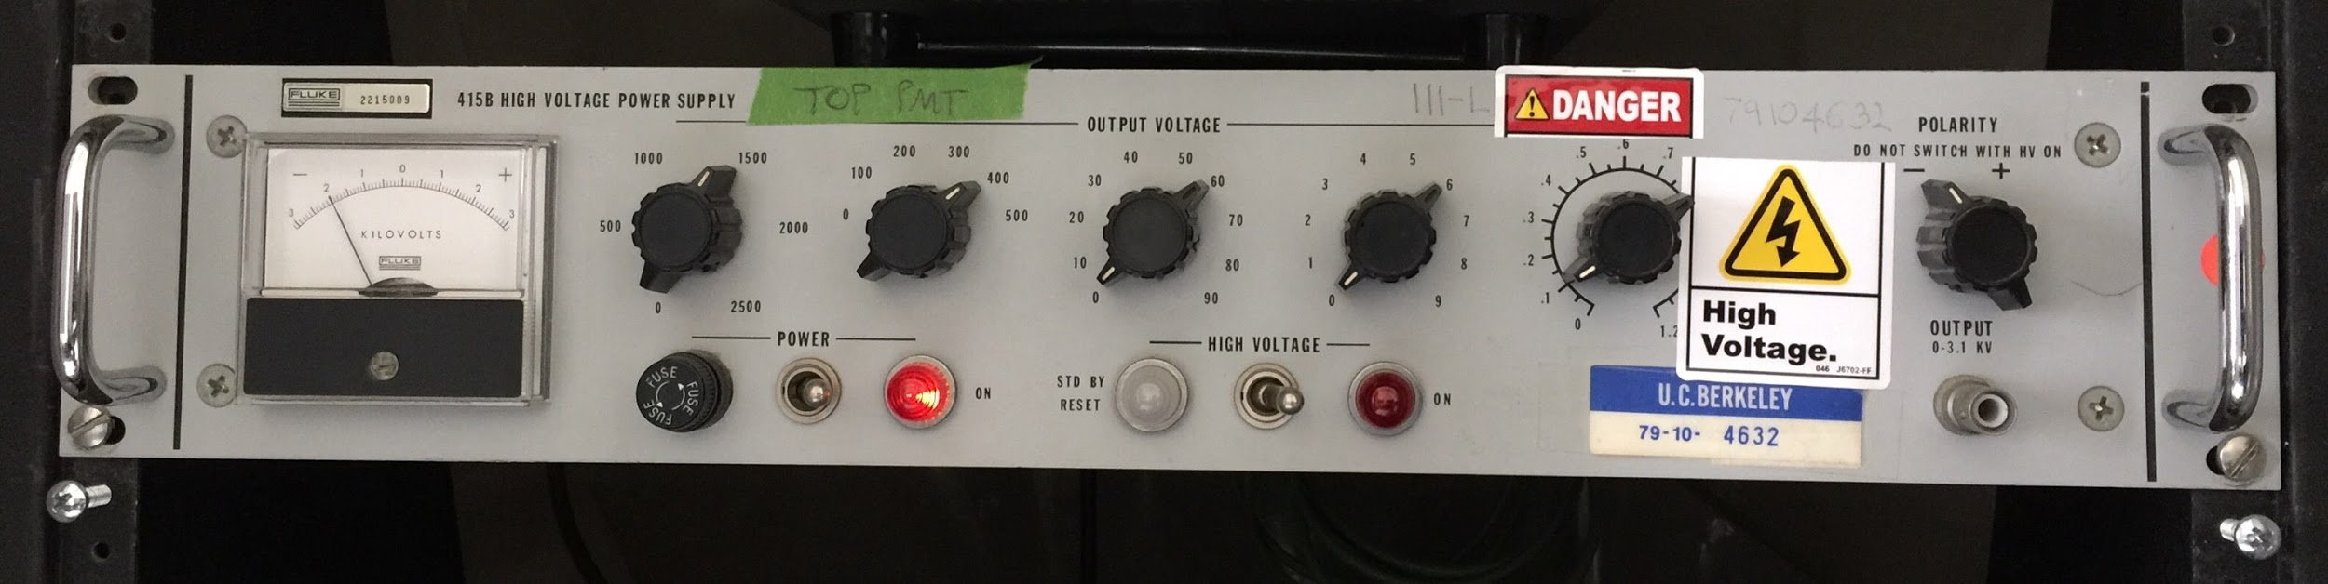

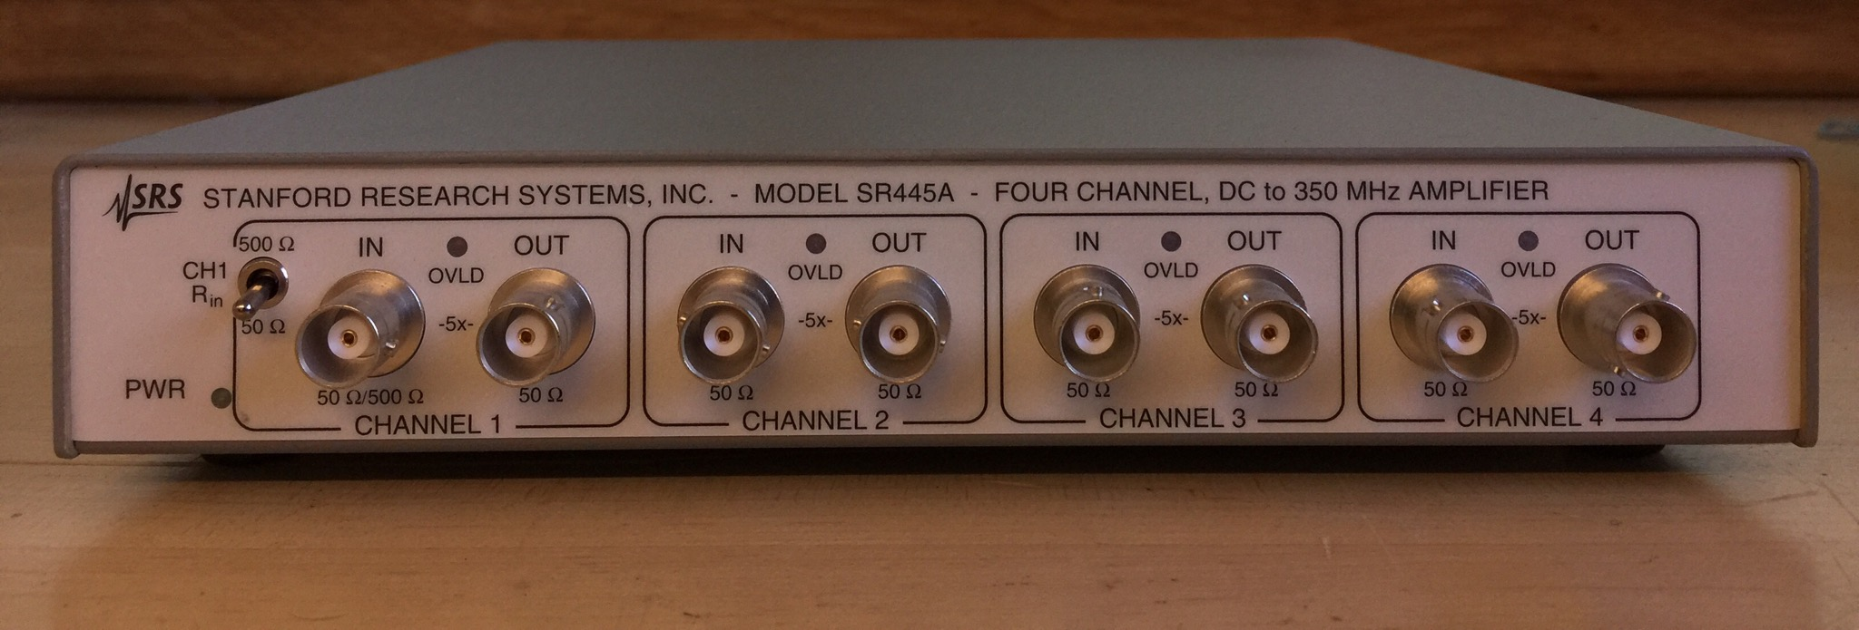

Above is a photo of an SRS SR445A amplifier, used as the "preamplifier" shown in Figure 5. Only one of the four SR445A amplification stages was used, with input and output impedances both 50 ohms. Everything is interconnected via 50-ohm coaxial cables. The photomultiplier tube (PMT) has a 50 ohm output impedance. And the PCI-5114 input impedance is 50 ohms.

The "5114 Digitizer" referred to in Figure 5 is an NI-PCI-5114 card plugged into the computer, enabling LabVIEW code to acquire pulse waveforms after amplification by the preamplifier. The PCI card is shown below.

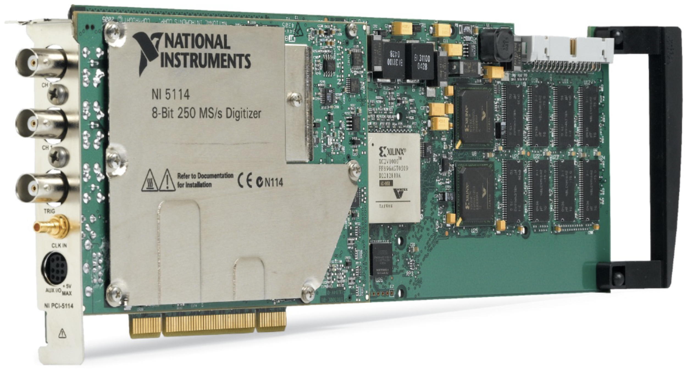

# PCI-5114 Oscilloscope Device

(Image from https://www.ni.com/en-us/support/model.pci-5114.html)

Software, written in LabVIEW, interfaces with the PCI-5114 card, directing it to collect data continuously into what's known as a circular buffer until a trigger condition is met. When that trigger occurs, the PCI card takes about 40 uS more data and stops so as not to overwrite the digitized waveform just collected, which spans from several uS before the trigger to 40uS after the trigger. Readout by the LabVIEW software takes considerably longer than the ~50uS during which the data was collected, after which the PCI-5114 is enabled again by the LabVIEW program to sample the input waveform and again await the trigger condition.

Once read into LabVIEW, the waveform data is analyzed to look for peaks. The peak detection criteria used for the data you are being given requires that two pulses be detected. How large a pulse must be in order to be counted is set by the threshold levels on the front panel of the LabVIEW program. Each time this occurred, a line of data was written into the data file. The LabVIEW front panel interface displays an "Output Count" which is the number of lines of data collected to be written to the file, and above that number is shown the "Trigger Count" which is the number of triggers, most of which did not meet the two-pulse criterion. The image below was captured shortly before completion of the 50-hour data collection run.

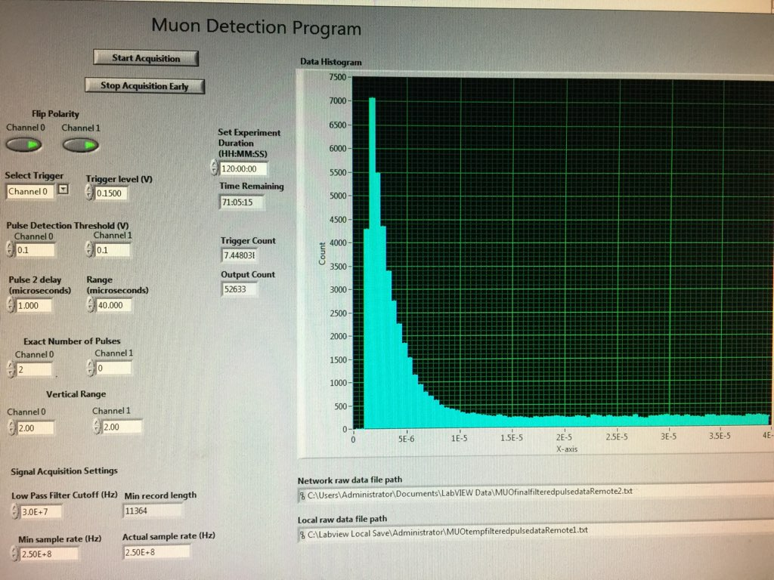

In the plot portion of the above image, the horizontal axis is seconds between the first and second of the two pulses. The vertical axis is the number of occurrences detected where that time difference was within a specific range. The left edge of each bar in that plot represents the center of that bin of times. Thus in this plot the bin containing about 1500 counts, just to the right of the 5E-6 (5 microseconds) mark, is the number of occurrences where the time difference between the two pulse arrivals was between 4.75 and 5.25 microseconds.

The above image shows the Trigger level set to 0.15 Volts, and the Pulse Detection Thresholds set to 0.1 Volts. A second 69-hour set of data is being collected with Trigger at 0.1 Volts and Thresholds at 0.06 Volts.

Calibration

Time sensitivity calibration with the Trigger at 0.1 Volts and Thresholds at 0.06 Volts was performed by adding a signal from the signal generator to the signal already coming from the PMT via the preamplifier. To do this a 1.02 k Ohm resistor was connected from the signal generator output to the muon signal line via a "Tee" connector. The produced additional signal was a -100mV pulse with width 30nS. This amplitude was selected to be insufficient to trigger the software, however once triggered by a detection at the PMT this generated pulse acts as a pretend muon decay pulse and is counted by the software as the second pulse needed to output data to the file. The signal generator's rate was set to 12500 Hz so that up to half the time that a trigger (due to the PMT signal) occurs, a second pulse will be seen within the approximately 50 microsecond digitized waveform.

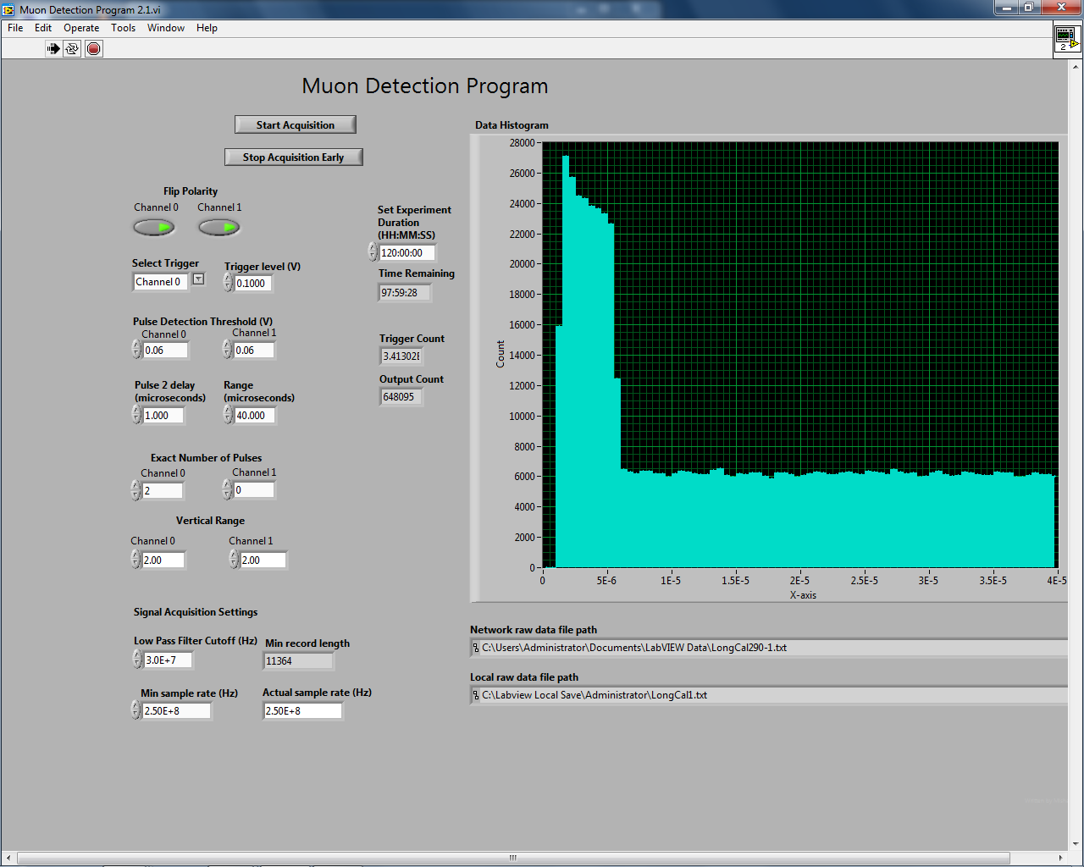

The above image is a screenshot taken at the conclusion of this 22-hour calibration run. Initially I puzzled over the taller bins of counts registered during the first 5 microseconds or so, until I ran with two signal generators instead of one signal generator and one muon signal. When the too-small-to-trigger pulse from the signal generator arrives first, as it will with equal likelihood as any other time, then the time between the two pulses registered in the above plot is tTriggerPulse - tSmallPulse. However this ought to be interpreted as a negative time. I expect if you look at the amplitudes of the pulses in the calibration data file, you will find the PMT pulse will always exceed some trigger level (perhaps not the nominal 100mV displayed in the software) and the signal generator pulse will be at a lower level, thus you can tell them apart. Note that although the signal generator's rate has been selected so that you will never get two pulses from it during one 50 uS window, the PMT signal from flashes of light in the scintillator is under no such constraint.