Insights into Spectra-Physics’ InSight DeepSee

William Giang

2022-09-25

Table of contents

## Overview

We thought the Nikon A1R MP’s laser system, the Spectra-Physics InSight DeepSee, was in need of repair. After contacting the service engineer for Spectra-Physics, we learned two laser diodes were already replaced with a bill of $30k. We were also warned that the laser power had been reduced, but otherwise the DeepSee should be functional.

* The liquid in the chiller unit has been flushed and replaced with coolant.
* After turning on the microscope and laser systems, it took several days for the laser’s humidity to reach acceptable levels
* The power output has been reduced

|  |
| --- |
| Image of A1plus MP GUI |

import pandas as pd  
import seaborn as sns  
import matplotlib.pyplot as plt

## How long does the InSight DeepSee need to effectively warm up?

Sept 20: Turned on all scope components and noticed humidity was too high, so I started logging it

humidity_csv = "Time_since_DeepSee_turn_on.csv"  
humidity_df = pd.read_csv(humidity_csv)  
  
humidity_plot = sns.scatterplot(data = humidity_df,  
 x = "Time [Minutes]",  
 y = "Relative Humidity [%]",  
 )  
  
humidity_plot.set_title("Four days for humidity to stabilize from start-up")  
humidity_plot.set_xlim(0, 4500)

(0.0, 4500.0)

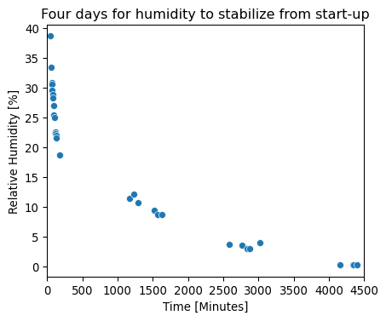

## How much power did we lose as a function of wavelength?

* Digitized the theoretical tuning power from the manual
* There also appears to be a warmup time after turning emission ON
* Severe drop in power when laser is tuned above 1000nm

data_csv = "2022-09-23_laser-power-vs-wavelength_with-theoretical.csv"  
df = pd.read_csv(data_csv)  
  
palette = sns.color_palette("mako_r", 5)  
sns.set_theme(style="whitegrid")  
  
g = sns.scatterplot(data = df,  
 x = "Wavelength [nm]",  
 y = "Power [mW]",  
 hue = "Replicate",  
 style = "Replicate",  
 palette = palette,  
 )  
  
g.set_title("InSight DeepSee far from spec \nat $\lambda$ > 1000nm")  
g.set_xlim(700, 1100)  
g.set_ylim(-20, 1400)

(-20.0, 1400.0)

