Spinning Disk Confocal PSFs with PSFmodels

William Giang

2023-06-04

Table of contents

## Motivation

Obtaining an accurate point spread function (PSF) is vital for good deconvolution.

Here’s how to obtain the pinhole_au parameter for generating a [confocal PSF](https://github.com/tlambert03/PSFmodels/blob/a7815b2d256bca501aff674e059dc9685631b942/src/psfmodels/_core.py#L575) in [Talley Lambert’s PSFmodels](https://github.com/tlambert03/PSFmodels).

## Theory

A measure of confocality (in Airy units) is the ratio between the back projected pinhole radius and the radius of the Airy disk.

Since the back projected pinhole radius ($R_{BP}$) is the size of the pinhole radius projected on the sample plane, it can be calculated with the pinhole radius ($R_{PR}$) divided by the total magnification between the pinhole(s) and the sample, which includes the objective’s magnification ($M_{O}$) and other potential sources of intermediate magnification ($M_{I}$)

$$ R_{BP} = {R_{PR} \over M_{O} * M_{I}} $$

The radius of an Airy disk ($R_{A}$) is equivalent to Rayleigh’s lateral resolution criterion which is the product of 0.61 and wavelength ($λ$) divided by the numerical aperture ($NA$)

$$ R_{A} = 0.61 {\lambda \over NA } $$

## Confocality with Yokogawa CSU-X1

With a physical pinhole radius of 25 microns, the Yokogawa CSU-X1 spinning disk unit is optimized for high resolution live-cell imaging, so we should expect a smaller confocality value when imaging with a high resolution objective than with a lower resolution objective.

Let’s compare the confocality between two objectives (100x/1.49 and 20x/0.75) when imaging EGFP (emission peak wavelength at 509nm).

| Objective Mag | Objective NA | $λ$ (um) | Back Projected Pinhole Radius (um) | Airy Disk Radius (um) | Confocality (Airy units) |
| --- | --- | --- | --- | --- | --- |
| 20x | 0.75 | 0.509 | 1.25 | 0.414 | 3 |
| 100x | 1.49 | 0.509 | 0.166 | 0.208 | 1.2 |

import psfmodels as psfm  
import numpy as np  
import matplotlib.pyplot as plt  
from matplotlib.colors import PowerNorm  
  
def backProjectedPinholeRadius(PinholeRadius, MagObjective, MagIntermediate=1):  
 """  
 Return the back projected pinhole radius for a spinning disk confocal unit.  
   
 Parameters  
 ----------  
 PinholeRadius : float  
 Physical radius of the pinhole  
 MagObjective : int  
 Magnification of the objective  
 MagIntermediate : float  
 Other magnification between the spinning disk and sample  
   
 Returns  
 -------  
 float  
 The `pinholeRadius` divided by both `MagObjective` and `MagIntermediate`  
   
 Examples  
 --------  
 >>> backProjectedPinholeRadius(25, 100)  
 0.25  
 >>> backProjectedPinholeRadius(25, 100, 1.5)  
 0.16666666666666666  
 """  
 return PinholeRadius / (MagObjective*MagIntermediate)  
  
def airyDiskRadius(wavelength, NA):  
 """  
 Return the radius of an Airy Disk given a wavelength and numerical aperture.  
   
 Parameters  
 ----------  
 wavelength : float  
 Wavelength  
 NA : float  
 Numerical aperture of the objective  
   
 Returns  
 -------  
 float  
 0.61 multiplied by `wavelength` and divided by `NA`  
   
 Examples  
 --------  
 >>> airyDiskRadius(509, 1.49)  
 208.38  
 >>> airyDiskRadius(509, 0.75)  
 413.99  
 """  
 return 0.61 * wavelength / NA  
  
def confocality(BackProjectedPinholeRadius, AiryDiskRadius):  
 """  
 Return the confocality (in Airy Units) for a spinning disk confocal  
   
 Parameters  
 ----------  
 BackProjectedPinholeRadius : float  
 The pinhole radius projected on the sample plane  
 AiryDiskRadius : float  
 The radius of an Airy Disk (also equivalent to Rayleigh's lateral resolution)  
   
 Returns  
 -------  
 float  
 The `BackProjectedPinholeRadius` divided by the `AiryDiskRadius`  
   
 Examples  
 --------  
 >>> confocality(0.25, 0.208)  
 1.2  
 >>> confocality(1.25, 0.6)  
 2.1  
 """  
 return BackProjectedPinholeRadius/AiryDiskRadius  
  
def plotConfocalPSF(params):  
 """  
 Returns the confocal PSF while plotting lateral and axial views.  
 """  
 nz = params["nx"]  
   
 ConfocalPSF = psfm.confocal_psf(**params)  
 fig, (ax1, ax2) = plt.subplots(1, 2)  
 ax1.imshow(ConfocalPSF[nz//2], norm = PowerNorm(gamma=0.4))  
 ax2.imshow(ConfocalPSF[:,params["nx"]//2], norm = PowerNorm(gamma=0.4))  
   
 ax1.set_title("lateral")  
 ax2.set_title("axial")  
   
 figtitle1 = "NA:{} | pinhole_au:{} | em_wvl:{}\n".format(  
 params["NA"],  
 round(params["pinhole_au"], 2),  
 params["em_wvl"],  
 )  
 figtitle2 = "sample RI:{} | immersion medium RI:{}\n".format(  
 params["ns"],  
 params["ni"]  
 )  
 figtitle3 = "depth:{} | model:{}".format(  
 params["pz"],  
 params["model"],  
 )  
   
 fig.suptitle(figtitle1 + figtitle2 + figtitle3  
 )  
   
 return ConfocalPSF

#### Optimal imaging with an oil immersion objective at the coverslip

First, let’s consider an optimal PSF where the location is right at the coverslip and the sample is mounted in an RI-matched solution.

ex_wvl = 0.488  
em_wvl = 0.509  
pinhole_radius = 25  
mag_objective = 100  
NA = 1.49  
pinhole_radius_BP = backProjectedPinholeRadius(pinhole_radius, mag_objective)  
airy_disk_radius = airyDiskRadius(em_wvl, NA)  
  
pinhole_au = confocality(pinhole_radius_BP, airy_disk_radius)  
  
oil_RI = 1.515  
pz = 0  
  
X1Params_high_res_index_matched = {  
 "nx" : 51, # XY size of output PSF in pixels, must be odd  
 "pz" : pz, # depth of point source relative to coverslip (um)  
 "NA" : NA, # numerical aperture  
 "ti0": 150, # working distance of the objective (um)  
 "ni" : oil_RI, # immersion medium refractive index, experimental value  
 "ni0": oil_RI, # immersion medium refractive index, design value  
 "ex_wvl" : ex_wvl, # excitation wavelength (um)  
 "em_wvl" : em_wvl, # emission wavelength (um)  
 "ns" : oil_RI, # sample refractive index  
 "pinhole_au" : pinhole_au, # pinhole size (Airy units)  
 "model" : "vectorial",  
}  
  
PSF_fixed = plotConfocalPSF(X1Params_high_res_index_matched)

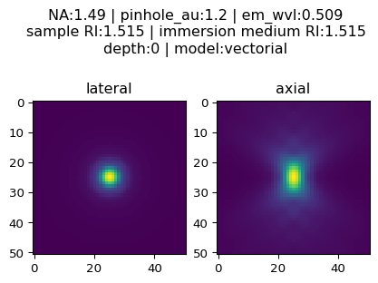

Note the symmetrical nature of the axial view when things are optimal.

#### Imaging with an oil immersion objective, depth=2

Even at a depth of 2 microns away from the coverslip, not much changes if the RI of the sample matches the RI of the immersion oil

ex_wvl = 0.488  
em_wvl = 0.509  
pinhole_radius = 25  
mag_objective = 100  
NA = 1.49  
pinhole_radius_BP = backProjectedPinholeRadius(pinhole_radius, mag_objective)  
airy_disk_radius = airyDiskRadius(em_wvl, NA)  
  
pinhole_au = confocality(pinhole_radius_BP, airy_disk_radius)  
  
oil_RI = 1.515  
pz = 2  
  
X1Params_high_res_index_matched_2um = {  
 "nx" : 51, # XY size of output PSF in pixels, must be odd  
 "pz" : pz, # depth of point source relative to coverslip (um)  
 "NA" : NA, # numerical aperture  
 "ti0": 150, # working distance of the objective (um)  
 "ni" : oil_RI, # immersion medium refractive index, experimental value  
 "ni0": oil_RI, # immersion medium refractive index, design value  
 "ex_wvl" : ex_wvl, # excitation wavelength (um)  
 "em_wvl" : em_wvl, # emission wavelength (um)  
 "ns" : oil_RI, # sample refractive index  
 "pinhole_au" : pinhole_au, # pinhole size (Airy units)  
 "model" : "vectorial",  
}  
  
PSF_fixed_2um = plotConfocalPSF(X1Params_high_res_index_matched_2um)

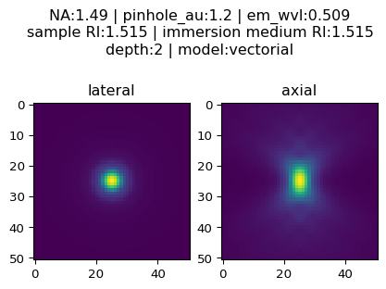

#### Imaging in DMEM with an oil objective at depth = 0

Then, let’s consider a realistic example: live-cell imaging in DMEM

ex_wvl = 0.488  
em_wvl = 0.509  
pinhole_radius = 25  
mag_objective = 100  
NA = 1.49  
pinhole_radius_BP = backProjectedPinholeRadius(pinhole_radius, mag_objective)  
airy_disk_radius = airyDiskRadius(em_wvl, NA)  
  
pinhole_au = confocality(pinhole_radius_BP, airy_disk_radius)  
  
oil_RI = 1.515  
DMEM_RI = 1.34 # DMEM with 10% FBS  
pz = 0  
  
X1Params_livecell = {  
 "nx" : 51, # XY size of output PSF in pixels, must be odd  
 "pz" : pz, # depth of point source relative to coverslip (um)  
 "NA" : NA, # numerical aperture  
 "ti0": 150, # working distance of the objective (um)  
 "ni" : oil_RI, # immersion medium refractive index, experimental value  
 "ni0": oil_RI, # immersion medium refractive index, design value  
 "ex_wvl" : ex_wvl, # excitation wavelength (um)  
 "em_wvl" : em_wvl, # emission wavelength (um)  
 "ns" : DMEM_RI, # sample refractive index  
 "pinhole_au" : pinhole_au, # pinhole size (Airy units)  
 "model" : "vectorial",  
}  
  
  
PSF_livecell = plotConfocalPSF(X1Params_livecell)

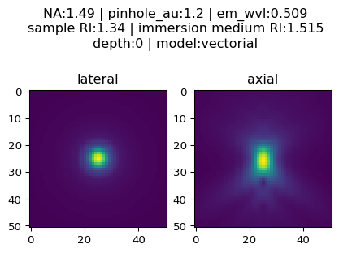

#### Imaging in DMEM with an oil objective at depth = 2

Axial resolution will deteriorate as the focus position moves away from the coverslip.

Let’s consider imaging at a depth of two microns

ex_wvl = 0.488  
em_wvl = 0.509  
pinhole_radius = 25  
mag_objective = 100  
NA = 1.49  
pinhole_radius_BP = backProjectedPinholeRadius(pinhole_radius, mag_objective)  
airy_disk_radius = airyDiskRadius(em_wvl, NA)  
  
pinhole_au = confocality(pinhole_radius_BP, airy_disk_radius)  
  
oil_RI = 1.515  
DMEM_RI = 1.34 # DMEM with 10% FBS  
pz = 2  
  
X1Params_livecell_2um = {  
 "nx" : 51, # XY size of output PSF in pixels, must be odd  
 "pz" : pz, # depth of point source relative to coverslip (um)  
 "NA" : NA, # numerical aperture  
 "ti0": 150, # working distance of the objective (um)  
 "ni" : oil_RI, # immersion medium refractive index, experimental value  
 "ni0": oil_RI, # immersion medium refractive index, design value  
 "ex_wvl" : ex_wvl, # excitation wavelength (um)  
 "em_wvl" : em_wvl, # emission wavelength (um)  
 "ns" : DMEM_RI, # sample refractive index  
 "pinhole_au" : pinhole_au, # pinhole size (Airy units)  
 "model" : "vectorial",  
}  
  
  
PSF_livecell_2um = plotConfocalPSF(X1Params_livecell_2um)

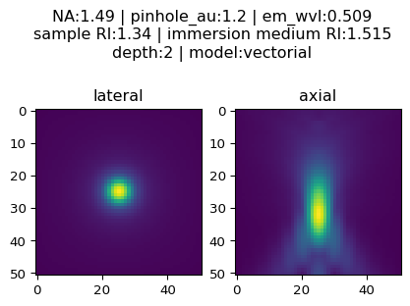

Note how much worse the axial performance is from the spherical aberration induced by RI-mismatch between the sample and immersion oil!